Game Design Document
Fill up the following document

- Write the title of your project.
Ready To Fire

- What is the goal of the game?
To understand how hard life of running.

- Write a brief story of your game.
A soldier is running out of bullets. Help him to cross the enemies who

Trying to attack him. Croos the finish line to end the game.

One the way, many try to hit you on the way. Escape, if you can try
The soldier to away

- Which are the playing characters of this game?
- Playing characters are the ones who respond to the user based on the input from the user.
- Cars, monkeys, dinos, wizards, etc., are the playing characters in the game.

Number | Character Name | What can this character do?
1 | soldier | Main character
2 | enemy | Ther opposing character(NPC)
3
4
5
6
7
8

- Which are the Non-Playing Characters of this game?
- Non-Playing characters are the ones that don't have an action or behavior when the user interacts with the game.
- Hurdles, stones, bananas, coins, etc., are non-playing characters in the game.

Number | Character Name | What can this character do?
1 | Stones | Hit he player to reduce points
2 | The boosts and more add while creating game
3
4
5
6
7
8

Draw your imagination of this game. What does this game look like?
- Draw the game either on your computer or on paper.
- Add images of the game scenes to show each of the playing and non-playing characters at least once.
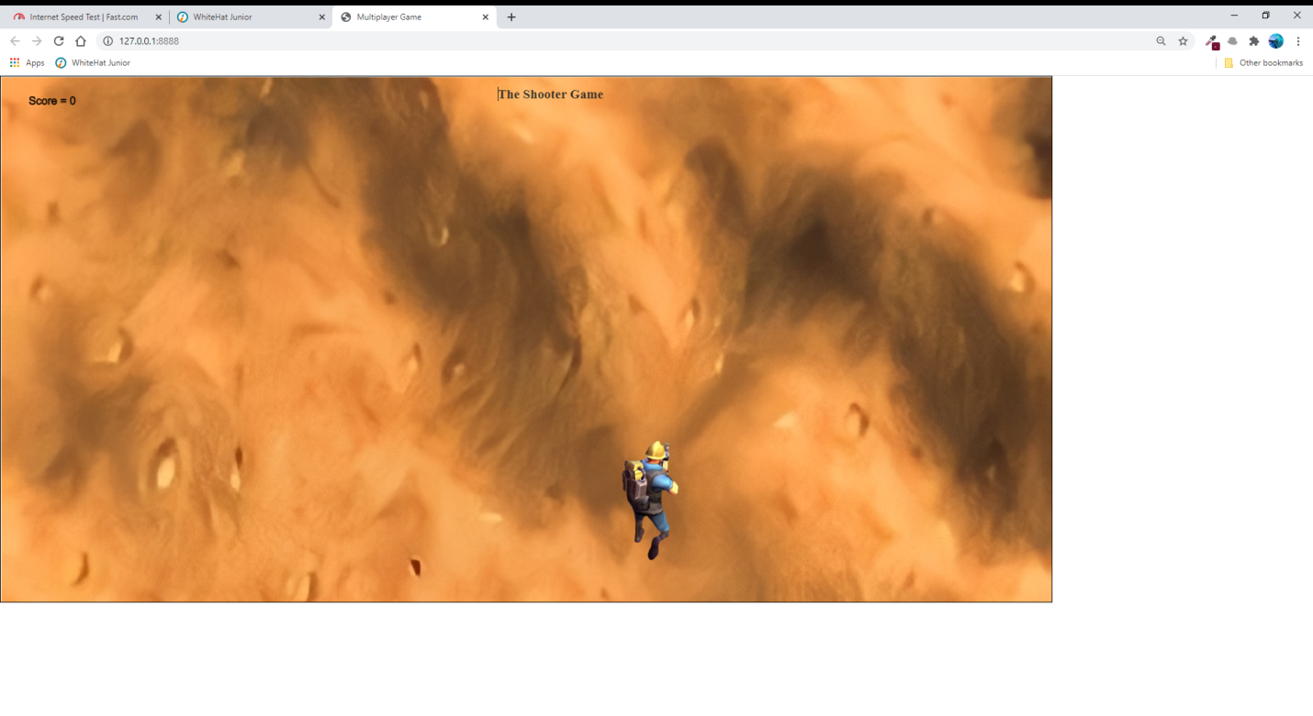

How do you plan to make your game engaging?

Iam trying enhance game by adding difficulties

