## How to choose the best forex broker?

With so many forex brokers to choose form these days, it is very important that you research the different options available to you and choose a forex broker that meets your needs. In addition to this, it can be beneficial to choose a forex broker that is regulated. A regulated broker has to stick to strict regulatory guidelines which can give clients peace of mind and protection should something go wrong.



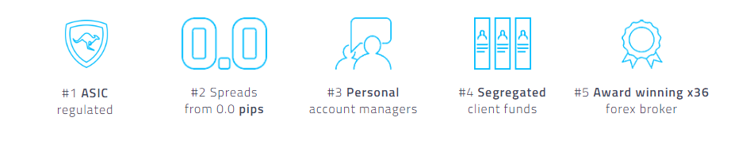

One of the **best forex brokers** who are regulated that I have reviewed is FP Markets. They have a great range of trading instruments, platforms, tools and educational resources. They have won multiple awards for their trading conditions and customer support which is excellent. The spreads are tight, execution speeds fast and commissions competitive. You can read more about them in my **FP Markets review** or **click here to open a forex broker account** with them today.

## What is the forex market?

The Forex (FX) is a currency trading market. The forex market is the largest financial market in the world in terms of trading volume with trillions of dollars traded every day. The forex market does not have a centralized location, instead it is an electronic network consisting of participants who have foreign exchange currency needs such banks, financial institutions, brokers and speculative retail traders.

The key forex markets are located in major global locations including London, New York, Singapore, Tokyo, Frankfurt, Hong Kong, and Sydney. The forex markets liquidity is usually at its peak when these markets are open or overlap. Some of the primary factors that can cause movements in the forex market are retail trader speculation, economic growth/strength and differentiating interest rates.

Forex market participants usually buy and sell currencies from each other via a forex broker. The forex market is open 24/5 except for holidays. The availability and deep liquidity of the forex market help to make it an appealing choice for online traders.

## What is a forex broker?

Before we go into what makes a good forex broker, lets briefly cover what exactly a forex broker is! In a nutshell, a forex broker acts as an intermediary that buys and sells FX currency pairs on behalf of its traders for a small commission fee and/or spread mark-up. Forex brokers have enabled individuals to trade the forex market online through the trading platforms that they provide. All you need is an internet connection, account with a **forex broker** and a trading platform to trade forex online.



The foreign exchange used to only be traded on the interbank market by bigger clients including banks and multinational corporations who would trade for commercial purposes and to hedge against risks of fluctuating currencies. Since the 1990’s, retail forex trading has been introduced through forex brokers who have improved their services and offerings over the years. As technology has improved along with the demands of traders, so have online brokerage services.

## What to look for in a forex broker?

There are many things you may want to consider when choosing a forex broker for **trading online** with. Here we will look at some of the most important factors worth considering when searching for the best forex brokers. If you don’t have time to read on, you may wish to check out one of my personal favourite forex brokers, **FP Markets.**

### Regulation

You should consider using a forex broker that is regulated and must therefore follow strict rules and regulations put in place to protect investors. When using a regulated broker, you get the peace of mind that the broker must operate with transparency and integrity. Should anything go wrong, the regulator can have procedures in help to protect the client funds. Some of the most widely regarded forex broker regulators include the FCA, CySEC and ASIC. **FP Markets** is authorised and regulated by the Australian Securities and Investment Commission (ASIC) and Cyprus Securities and Exchange Commission (CySEC) making them a popular choice amongst traders.

### Trading Platforms

There are a variety of different forex trading platforms available to trade online with. Most brokers will offer the popular and user friendly MetaTrader platforms. This platform developed by software company MetaQuotes is used by millions of traders around the globe and is known to have an abundance of trading tools and quick learning curve. If you are new to trading online, you may want to consider a **MetaTrader broker** due to its intuitive interface and many platform tutorials available online. Whilst MetaTrader is likely to have more than enough tools for the average retail trader, if you require additional functionalities such as FIX API access then you may want to consider a broker who provides an alternative platform. Other options include the powerful Iress platform offered by **FP Markets**.

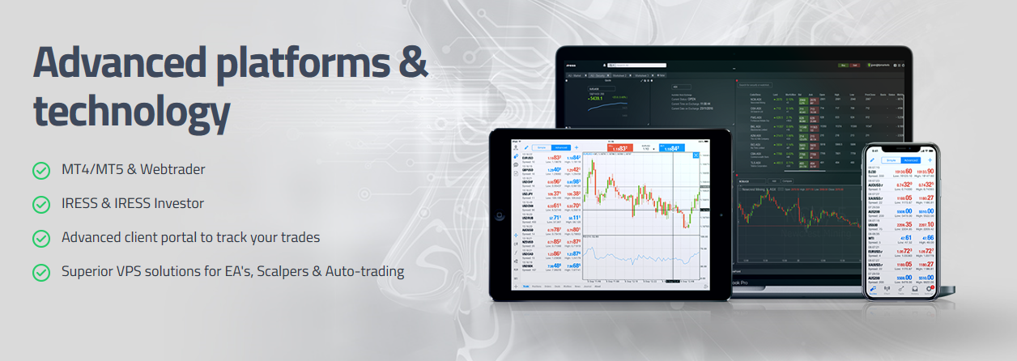

### Currency Pairs

Forex is usually traded as a currency pair, also known as a currency cross. E.g. EURUSD, GBPUSD, EURJPY, USDCAD, USDCHF, etc. There are plenty of major, minor and exotic currency pairs to choose from. Thus, it is important to choose a forex broker who offers the currency pairs you would consider trading now and in the future. **FP Markets** have one of the largest ranges of FX currency pairs for trading online in addition to an impressive 13,000+ trading products across multiple global markets including Forex pairs, Metals, Commodities, Indices, Equities and Cryptocurrencies.

### Commissions

Forex brokers usually charge a commission for placing trades through their trading platforms. Commission fees can vary depending on the broker. The lower the commission the better as it saves on your trading costs. You should check the forex broker you are considering has a competitive commission rate. Some brokers even offer commission free accounts as they will mark-up spreads to compensate. **FP Markets** offer commission free accounts and accounts with raw spreads that charge a very competitive commission.

### Spreads

Another cost when you **trade forex online** is the bid/ask spread. This is the difference between the buy and sell price. Again, the lower the spread the better. Spreads can impact trading strategies that rely on tight spreads such as scalping strategies. You should check if the broker offers variable or fixed spreads and the size of these spreads on the forex currency pairs that you wish to trade. Usually, the more liquidity providers and deeper a liquidity pool that a forex broker has, the tighter the spreads they can source are. **FP Markets** utilise some of the biggest liquidity providers enabling them to offer some of the lowest spreads and fastest execution speeds of any forex broker.

### Leverage

Forex trading online is a leveraged product which can increase profits and also increase risks. Leverage lets you trade a position size larger than you would be able to without it. You should be aware of the risks involved with trading leverage positions and choose a level of leverage that you feel comfortable with. **FP Markets** offer leverage of up to 1:500.

### Order Types

Brokers will offer multiple order types such as instant execution, pending, limit, trailing, stop, hedging, etc. You should check that the broker you are considering support the type of order that you plan on using.

### Trading Tools

The brokers forex trading platform is likely to have more than enough trading tools built into it for most retail trader needs. However, if you would like some additional trading tools to support you with your online forex trading then you should check if the broker has any. Other tools include economic calendars, sentiment analysis, trading calculator, trading signals, social trading, etc. **FP Markets** have one of the largest selections of additional trading tools I have seen from any **forex broker**.

### Educational Materials

The **best forex broker** should have a good collection of educational materials to help traders learn about trading forex, trading platforms, strategies, risk management, market analysis, etc. This can include tutorial videos, trading guides, seminars, webinars and dedicated client support. **FP Markets** have a great selection of educational materials for traders. This shows that they have client interests in mind and want to educate traders so that they can trade with confidence and the relevant knowledge.

### Funding Options

You will find that nearly all forex brokers support wire transfer and credit/debit card deposits. Some forex brokers will also offer account funding options from online payment processors including PayPal, Skrill, Neteller, etc. It may be a wise idea to choose a forex broker that provides a funding method which is convenient to your needs. **FP Markets** has a variety of funding methods to support traders across the globe, including Neteller and Skrill.

### Customer Service

The broker should have a customer support team that is fast, polite and accurate with their responses to all general, technical and account related questions. You may want to check that the broker offers live chat, telephone and email support. If there is a method you prefer, it would be ideal to confirm that this form of customer support is available. **FP Markets** have an award-winning support team that can be reached using all of the aforementioned methods.

## How do I start trading forex online?

To start trading forex online you just need to choose a forex broker such as FP Markets. You will then need to follow the brokers quick and easy account opening process. Once your trading account has been approved you will be able to start trading forex online via the brokers trading platforms. **Click here** to open a forex trading account with one of my personal best forex brokers.

