Nexus Platform
Overview and Security / Risk Assessment
Prepared for: Executive Leadership · Information Security · Cybersecurity · Risk Management · Internal Audit · Compliance · Legal & Privacy · IT / Technology Management
Subject system: “Nexus” — the internal merchant-analytics and card-acquiring reporting platform (engineering codebase: Acquira)
Assessment basis: Review of the application source code, build configuration, and Kubernetes / AWS deployment manifests in the project repository
Status: Internal working document — for review and due diligence, not a final sign-off
Date: 30 August 2026

How to read this document
This is an internal assessment of a system the organization builds and operates itself, so most technical statements here are drawn directly from the source code and can be verified in the repository. A security assessment, however, also covers operational practice — backups, penetration testing, staff vetting, certifications — that a codebase cannot show. To keep the two clearly apart, every material statement is tagged:
Tag | Meaning
[Confirmed – code] | Directly evidenced in the source code, build files, or deployment manifests.
[Design inference] | A reasonable conclusion from the architecture, not an explicit statement. Should be validated.
[Requires confirmation] | An operational or contractual fact not determinable from code. The owner must confirm it.

A note on naming: throughout this document “Nexus” refers to the platform whose engineering codebase is named Acquira (Java package com.acquira). The business name and the code name should be reconciled and stated consistently in the final version. [Requires confirmation]

1 Executive summary
What Nexus is. Nexus is an in-house web platform that ingests raw card-payment transaction files from acquiring / processing operations, prices each transaction (interchange, scheme fees, merchant service fees, VAT), and turns the result into merchant-level analytics, dashboards, and formatted PDF reports. It is a multi-tenant system: several operating entities / countries (observed: UAE, Bahrain, Egypt, Oman) are served from one deployment, with each tenant's data logically separated. [Confirmed – code]
Problem it solves. Payment acquirers receive large, inconsistent transaction files and must (a) calculate what each transaction actually earns after network and interchange costs, and (b) give internal teams, relationship managers, and merchants a clear view of volumes, revenue, and margins. Nexus automates that pricing and reporting, replacing manual spreadsheet work with a repeatable pipeline and self-service dashboards.
Who uses it. Internal staff — analysts, finance, relationship managers, and administrators — authenticate and view dashboards or generate reports. Administrators manage tenants, users, role / menu grants, and rate cards. There is no evidence in the code of direct external merchant self-service login; merchant-facing output is produced as PDF reports. [Design inference]
How it is built and run. A Java 21 / Spring Boot 3.2 backend (modules: acquira-core, acquira-batch, acquira-pdf, acquira-common) with a React 19 single-page frontend, backed by PostgreSQL. It is packaged as containers and deployed on Kubernetes, with manifests written to target AWS (RDS for the database, S3 and AWS Secrets Manager referenced, an ALB / ingress front door). [Confirmed – code]
Information it processes. Payment transaction records (card scheme, masked card metadata, amounts, currencies, merchant / terminal identifiers, dates / times), merchant master data, fee / rate configuration, and platform user accounts (usernames, hashed passwords, email addresses, roles). This is card-acquiring transaction data — commercially sensitive and, depending on file contents, potentially within PCI-DSS scope. Whether full primary account numbers (PANs) are present in ingested files is the single most important data-sensitivity question to resolve. [Requires confirmation]
Security posture — headline. The application shows deliberate, above-average attention to multi-tenant isolation and injection defense: tenant scoping is enforced both in application code and by PostgreSQL row-level security, security response headers are set, passwords are hashed with a modern encoder, and authentication is stateless JWT with an email one-time-password MFA option. Balanced against this, several items typical of a self-hosted platform still need attention or confirmation: default / example credentials in committed manifests, a single-replica core service (no built-in high availability), a database schema-init switch that can be destructive if mis-set, broad statement timeouts during ingestion, and the operational controls (backups, DR, penetration testing, logging retention) that cannot be judged from code.
Compliance and privacy — headline. As a system processing financial transaction data for regulated payment entities, the relevant regimes are likely PCI-DSS, local data-protection law (e.g. Bahrain PDPL, and GDPR where EU cardholders are involved), and the operating entities' financial-regulator obligations. Personal data is limited but present (staff accounts, potentially cardholder-linked identifiers). Formal DPA / subprocessor governance and a data-classification decision on ingested files are the key gaps.
In one line. A well-engineered application whose operational and configuration controls now need to be confirmed to match the quality of the code — best characterized as approvable with conditions rather than ready for unconditional sign-off.

2 What Nexus is (plain-language overview)
Nexus answers, at scale, the two questions acquirers care about most: how much did we process, and how much did we actually make after the card networks took their cut? The everyday flow is:
- Files come in. Transaction files (Excel / CSV) are uploaded through the web application or pulled automatically from source systems. Different countries and processors use different layouts, and Nexus normalizes them into a common shape. [Confirmed – code]
- Transactions are priced. Each transaction is matched to the applicable rate card and its fees are computed — interchange (paid to the issuer), scheme fees (paid to Visa / Mastercard / local networks), the merchant service fee (charged to the merchant), and VAT. [Confirmed – code]
- Data is summarized. Priced transactions are rolled up into daily and monthly warehouse tables (by bank, merchant, scheme, channel, industry, terminal, destination) so dashboards load quickly over long time ranges. [Confirmed – code]
- People see it. Users log in and view dashboards, leaderboards, and trend charts, or generate polished PDF reports for a specific merchant or period. [Confirmed – code]
Because it serves multiple operating entities from one system, a central design goal is that one tenant can never see another tenant's data — enforced in more than one layer (see Section 6).
Deployment model. Nexus is an internally developed, self-hosted application — not a purchased SaaS product. It runs as containers on Kubernetes, and the deployment manifests are written to run on AWS. The organization is therefore both the vendor and the operator; “vendor risk” here is largely internal build-and-run risk plus cloud-provider (AWS) risk, not third-party SaaS risk. [Confirmed – code / Design inference]

3 Business use case and operational impact
Why it exists. It removes manual, error-prone fee reconciliation and reporting, gives finance a defensible revenue / margin picture per merchant and per network, gives relationship managers merchant-level performance views, and produces consistent merchant reports without hand-built spreadsheets.
Who depends on it. Finance and revenue assurance, sales / relationship management, operations, and management reporting. Because it computes fee and margin figures used for internal decisions (and potentially merchant-facing statements), the accuracy of its pricing logic is itself a business risk, independent of security.
Impact if unavailable. Short outages are tolerable — this is an analytics / reporting system, not a real-time payment-authorization system, so cardholder transactions are unaffected by a Nexus outage. [Design inference] A longer outage means delayed reporting, delayed month-end fee / margin figures, and loss of self-service analytics — an operational and reporting inconvenience rather than a payment-processing failure. This should be confirmed against how the outputs are actually used (if any merchant billing or settlement depends on Nexus figures, the impact rating rises). [Requires confirmation]

4 Solution architecture
The diagram below reflects the components and integrations evidenced in the codebase and deployment manifests.
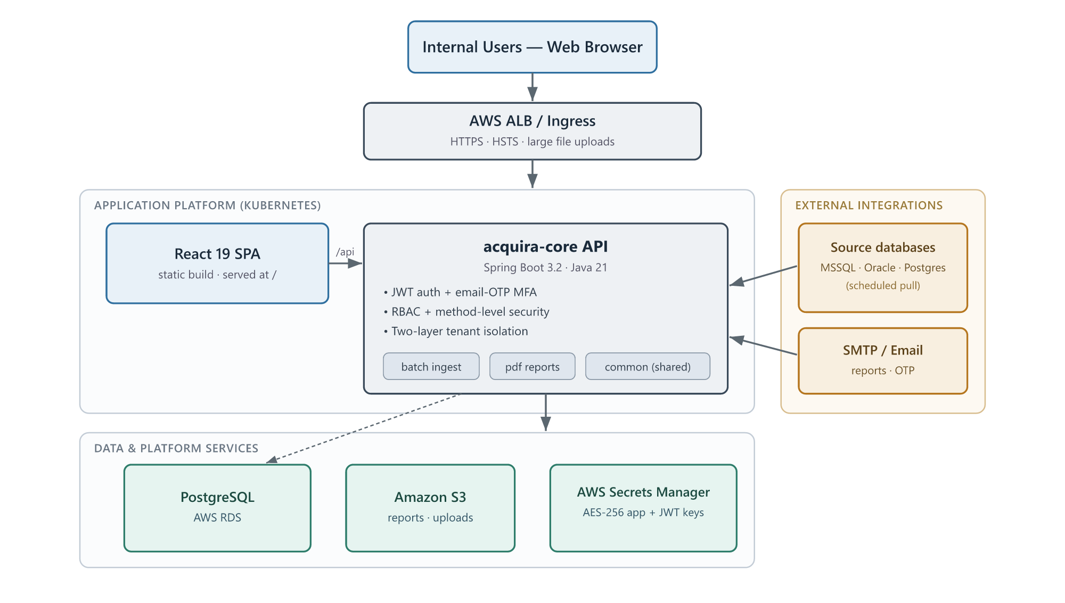
Figure 1 — Nexus system architecture (components and integrations evidenced in the repository).
Confirmed from the codebase and manifests:
- Frontend: React 19 single-page application (Vite build, MUI components, Recharts), served as static files behind the ingress and talking to the backend over HTTPS REST under /api. [Confirmed – code]
- Backend: Java 21, Spring Boot 3.2, multi-module Maven build — acquira-core (main web API, dashboards, scheduling, ingestion orchestration, email, external-DB pulls), acquira-batch (Spring Batch file ingestion and fee / summary computation), acquira-pdf (report generation; Playwright / Chromium renders HTML to PDF), and acquira-common (shared models, security, tenant context). [Confirmed – code]
- Database: PostgreSQL 16 (local container for development; AWS RDS in the target deployment), holding staging, priced “fact”, summary / warehouse, and dimension / reference tables. [Confirmed – code]
- Storage: a persistent volume for generated reports and uploads; S3 is referenced for the AWS deployment. [Confirmed – code]
- Edge: ingress-nginx locally, written to swap to an AWS ALB; large upload bodies (2 GB) and long timeouts (600 s) are configured for batch / PDF calls. [Confirmed – code]
- Secrets: Kubernetes Secrets locally, written to be replaced by AWS Secrets Manager via External Secrets in production; a dedicated AES-256 application key encrypts stored integration secrets (SMTP / S3 / source-DB credentials). [Confirmed – code]
- Authentication: self-contained — Spring Security with JWT bearer tokens and a database-backed user store, plus email OTP for MFA. No external identity-provider integration is present in the code. [Confirmed – code]
- External integrations: scheduled ingestion can pull from external MSSQL, Oracle, and PostgreSQL source databases; SMTP for email. [Confirmed – code]
Notable facts for reviewers:
- The acquira-core service is deliberately pinned to a single replica (it runs the email queue, external-DB pulls, schedulers, and batch jobs, which would duplicate or collide if run twice). Horizontal scaling / high availability would require a web/worker split that is not yet built — a documented availability single point of failure. [Confirmed – code]
- The build includes OWASP dependency-check as a Maven plugin, indicating dependency-vulnerability scanning is part of the build. [Confirmed – code]
- Health probes are TCP-only (no Spring Actuator on the classpath), so orchestration knows the port is open but not whether the app is internally healthy. [Confirmed – code]
To be requested: a current architecture / network diagram, the actual AWS account / region layout, RDS configuration (Multi-AZ? encryption? backup retention?), S3 bucket configuration, and whether any component is exposed to the public internet beyond the intended web front door. [Requires confirmation]

5 Data: what it holds, how it flows, how sensitive it is
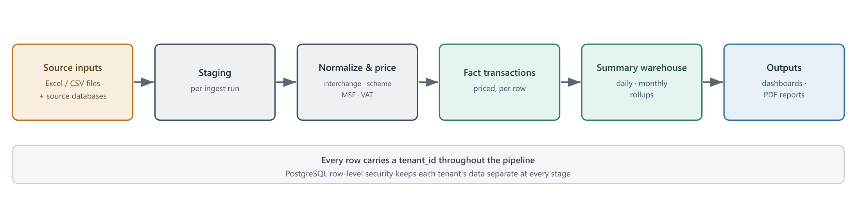
Figure 2 — Logical data flow, from source inputs to dashboards and reports.
Data categories and sensitivity:
Category | In Nexus? | Sensitivity
Payment transaction records (amounts, currency, scheme, card type, terminal / merchant IDs, timestamps) | Yes [code] | High — commercially sensitive; possible PCI scope
Full card numbers (PAN) / sensitive authentication data | Unknown — confirm | Critical if present; drives PCI-DSS scope
Merchant master data (names, MIDs, MCC, city, risk level, sales owner) | Yes [code] | Medium–High (confidential business data)
Fee / rate-card configuration | Yes [code] | High (competitively sensitive; integrity-critical)
Platform user accounts (username, email, hashed password, roles, MFA tokens) | Yes [code] | High (credentials / PII)
System / application logs | Yes [code] | Medium (may contain identifiers)

Highest impact if compromised: (1) any cardholder PAN data, if present; (2) the rate-card / fee configuration (integrity — wrong rates silently corrupt revenue reporting); (3) user credentials and tenant-scoping metadata (a break here is a cross-tenant data exposure).
Trust boundaries to note: browser ↔ web front door; front door ↔ backend; backend ↔ PostgreSQL; backend ↔ external source databases (pull); backend ↔ SMTP; backend ↔ S3 / Secrets Manager. Each boundary is a place to confirm encryption in transit and least-privilege credentials.

6 Identity, access, and multi-tenant isolation
This is the strongest part of the platform, and worth describing in detail because multi-tenant isolation is the dominant risk for a shared analytics system.
- Authentication: stateless JWT bearer tokens (no server sessions, no cookies). Passwords use Spring Security's delegating (bcrypt-family) encoder. [Confirmed – code]
- MFA: an email one-time-password second factor, tenant-configurable, on a dedicated token table, designed to fail closed if email delivery is unavailable. [Confirmed – code]
- Authorization: role-based (ADMIN / SUPER_ADMIN plus menu / feature grants), enforced both at URL level and via method-level annotations. Admin and batch endpoints require elevated roles. [Confirmed – code]
- Tenant isolation — defense in depth: every tenant-scoped query carries an explicit tenant_id predicate in application code, and the database applies PostgreSQL row-level security using a per-request app.current_tenant setting on the connection. Two independent layers must both fail for cross-tenant leakage. [Confirmed – code]
- Transport & headers: X-Frame-Options: DENY, X-Content-Type-Options: nosniff, HSTS (one year, includeSubDomains), and no-store cache control are set centrally. CSRF is intentionally disabled (justified for a stateless, header-based token API). CORS is centrally configured and origin-restricted. [Confirmed – code]
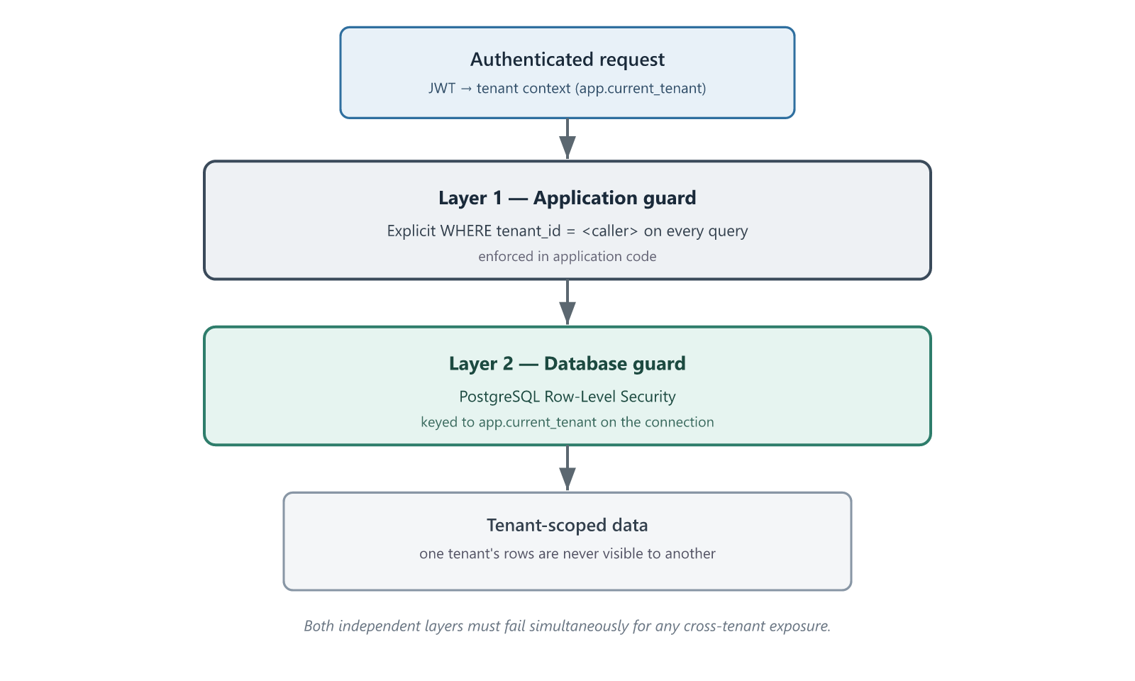
Figure 3 — Two independent layers enforce tenant isolation.
Points to confirm or watch:
- No integration with an enterprise identity provider (Entra ID, Okta, SAML / OIDC) exists in the code. If corporate SSO is required, it is not present today. [Confirmed – code]
- Account provisioning / deprovisioning, dormant-account handling, password-policy specifics, session / token lifetime, and privileged-account review cadence are operational and should be confirmed. [Requires confirmation]
- CORS allowCredentials is enabled with a configurable origin list, so the production origin allow-list must be tightly set — verify it is not permissive in production. [Requires confirmation]

7 Encryption and secrets
- In transit: HTTPS at the edge with HSTS enforced; external calls (source databases) use TLS endpoints. Internal service-to-database transport encryption for the RDS connection should be confirmed. [Confirmed – code / Requires confirmation on internal legs]
- At rest: application-managed AES-256 encryption protects stored integration secrets (SMTP, S3, source-DB credentials) via a resolver supporting plain / encrypted / AWS-backed values. Database-level and S3-level encryption at rest depend on RDS / S3 configuration and must be confirmed. [Confirmed – code / Requires confirmation on infrastructure]
- Key management: the design expects secrets in AWS Secrets Manager in production, with a single AES application key that must be identical across pods and never rotated carelessly (rotating it without re-encrypting makes stored secrets undecryptable — a documented operational hazard). JWT signing uses a configured secret key. [Confirmed – code]
Questions for the security team: Is RDS storage encryption enabled with a customer-managed KMS key? Is S3 encryption enabled? How is the AES application key generated, stored, and rotated? Is the JWT signing key unique per environment and at least 32 bytes of real entropy (the committed value is a placeholder)? [Requires confirmation]

8 Logging, monitoring, and audit trail
- Present: application logging throughout (SLF4J), and an audit-log capability (one row per action, with username and action category). [Confirmed – code]
- Not determinable from code: centralized log aggregation / SIEM integration, log retention period, log immutability / integrity protection, alerting thresholds, and who can access or alter logs. Health monitoring is currently TCP-probe level only. [Requires confirmation]
Assessment: the building blocks for a usable audit trail exist (actor, action, timestamp). Whether logs are shipped somewhere tamper-evident, retained long enough for forensic / compliance needs, and alerted on, is an operational gap to confirm. For audit and incident-response readiness, SIEM integration and a defined retention policy should be treated as required, not optional.

9 Compliance, privacy, availability, and continuity
Compliance framing. Nexus processes financial transaction data for regulated payment entities, so the standards most likely to apply are PCI-DSS (scope contingent on whether PANs are present), local data-protection law (Bahrain PDPL; GDPR where EU data subjects are involved), and the operating entities' own regulatory obligations (e.g. central-bank requirements for payment processors). Nothing in the code should be read as a certification. The organization should decide, per standard, whether it is supporting, compliant with, or certified against it — today none of these are evidenced in code. [Requires confirmation]
Privacy. Personal data is limited (staff accounts; potentially cardholder-linked identifiers depending on file contents). A data-classification decision on ingested files is the pivotal privacy question and also drives whether a Data Protection Impact Assessment is required. Data-subject-rights handling, lawful basis, and retention are operational and should be documented. [Requires confirmation]
Data residency. The deployment targets AWS; the specific region(s), and therefore where transaction and personal data reside and are processed, must be confirmed against the operating entities' residency requirements. Cross-border considerations arise if any AWS region or support access sits outside the permitted jurisdiction. [Requires confirmation]
Backup, recovery, DR, availability. Not determinable from code. The single-replica core service is a known availability limitation. RPO / RTO, backup frequency and testing, RDS Multi-AZ, and a documented BCP / DR plan are all open items and are high-priority evidence to gather. [Requires confirmation]
Incident response. No incident-response runbook is visible in the repository. Detection / notification / escalation processes, and any regulatory breach-notification obligations for the operating entities, must be confirmed. No publicly documented security incident is applicable here — this is an internal, non-public system. [Requires confirmation]

10 Key risks and open items
Risk register (initial)
ID | Risk & affected area | Likelihood | Impact | Rating | Mitigation / gap
R1 | Card PAN data present but PCI scope unmanaged — Data / Compliance | Unknown | Critical | To confirm | Decide data classification; scope PCI; confirm no raw PAN stored
R2 | Default / example secrets or destructive SQL_INIT_MODE=always reach production — Config / Integrity | Low–Med | Critical | High | Verify prod uses Secrets Manager + SQL_INIT_MODE=never; pipeline checks
R3 | Single-replica core → outage / processing stall — Availability | Medium | Med–High | Med–High | Define RTO; plan web / worker split; confirm RDS HA
R4 | No backup / DR evidence; unknown RPO / RTO — Continuity | Unknown | High | To confirm | Obtain backup schedule, DR plan, restore-test results
R5 | Logging without confirmed SIEM / retention / integrity — Monitoring / Audit | Medium | Medium | Medium | Add SIEM shipping, retention policy, tamper-evidence
R6 | Rate-card integrity error → wrong revenue figures — Data integrity | Medium | High | Med–High | Four-eyes control on rate changes; reconciliation
R7 | No enterprise SSO / centralized deprovisioning — IAM | Medium | Medium | Medium | Consider SSO / OIDC; define joiner / mover / leaver process
R8 | Broad statement_timeout=0 during ingestion — Availability | Low–Med | Medium | Low–Med | Review global timeout; bound long-running jobs
Ratings are indicative. Items marked “To confirm” must not be assigned a final rating until evidence is available.
Gaps requiring confirmation
Topic | Currently known | Missing | Question for the owner | Priority
Card-data scope | Transaction records ingested | Whether PANs / SAD are present | What card fields enter Nexus, and is PAN ever stored? | Critical
Production secrets | Secrets Manager intended | Actual prod configuration | Confirm no default secrets; KMS-backed keys | High
Schema-init switch | “always” locally, “never” intended on AWS | Prod value | Confirm SQL_INIT_MODE=never in production | High
Backup / DR | Nothing in code | RPO / RTO, backups, DR test | Provide backup schedule, DR plan, last restore test | High
Logging / SIEM | App + audit logging present | Aggregation, retention, integrity | Where do logs go, how long, and are they tamper-evident? | High
Data residency | AWS-targeted | Region(s) | Which AWS region(s) hold and process the data? | Medium
SSO / joiner-leaver | JWT + RBAC + MFA | IdP integration, deprovisioning | Is corporate SSO required? How are leavers offboarded? | Medium
Penetration testing | OWASP dep-check in build | Independent test results | Has an independent pen test been done? Executive summary? | Medium
Certifications | None in code | SOC 2 / ISO / PCI status | What (if any) attestations apply to hosting / operation? | Medium

11 Recommendations
Before approval (mandatory evidence)
- Resolve the card-data classification and PCI-DSS scope question (R1).
- Confirm production secrets come from AWS Secrets Manager with KMS-backed keys, and that no default / example secret can reach production (R2).
- Confirm SQL_INIT_MODE=never and RDS-based schema migration in production (R2).
- Obtain backup, DR, and availability evidence — RPO / RTO, RDS Multi-AZ, last successful restore test (R3, R4).
Before production use (technical controls)
- Lock the CORS origin allow-list, and set unique per-environment JWT and AES keys.
- Enforce MFA for administrative accounts; document password and session policies.
- Ship logs to a SIEM with defined retention and integrity protection; add real health / alerting beyond TCP probes.
- Put a four-eyes control on rate-card changes.
After implementation (ongoing)
- Periodic user-access and privileged-access reviews; a joiner / mover / leaver process.
- Dependency-vulnerability remediation SLAs (the OWASP scan already runs — define what happens to findings).
- Monitor the AWS and source-database dependencies as critical services.
Annual review
- Independent penetration test; DR restore test; access recertification; review of any certifications / attestations; re-run of this assessment.

12 Overall assessment
Based on the information currently available from the source code:
- From a build-quality and application-security perspective, Nexus is better engineered for security than a typical internal tool. Multi-tenant isolation is enforced in two independent layers, injection surfaces are guarded, credentials are hashed, MFA exists, and modern security headers are in place. These are genuine strengths, visible in the code — not marketing claims.
- From an operational, audit, and compliance perspective, the platform cannot yet be signed off, because the controls that matter most to those functions — backups and DR, logging retention and SIEM, penetration testing, secrets hygiene in production, and above all the card-data classification that decides PCI scope — are not determinable from code and are currently unconfirmed.
- The primary residual risks are: unresolved PCI / data-classification scope; the possibility of default secrets or a destructive schema-init switch reaching production; the single-replica availability limitation; and the absence of confirmed backup / DR and logging / monitoring evidence.
This is therefore best characterized as “Further assessment required — approvable with conditions.” The conditions are the “Before approval” items in Section 11. Nothing in the code review suggests the platform is unsafe by design; the outstanding work is to confirm that the operational and configuration controls match the quality of the application itself.
This assessment reflects the state of the repository as reviewed on 30 August 2026 and should be revalidated once the confirmation items above are answered.

