

DATABASE DESIGN SPECIFICATIONS

FOR

JURONG PORT
Cargo Entry/Exit Tracking System
(CETS)

Reference ID:
Version: 0.3
Date Prepared: 07 Dec 2009
Prepared By: FPT Software
ChANGE HISTORY 3
Database Design Change History 4
STATIC TABLES 5
Database Diagram 6
Sub ADP Details [SUB_ADP] 7
Sub ADP Details Transaction [SUB_ADP_TXN] 8
Unloading Advice for Tenant Details [TENANT_UA] 9
JP/Tenant Pass Out Note Details [PASSOUT_NOTE] 10
Gate In Event Log table [GATE_IN_EVENT] 11
Gate Out Event Log table [GATE_OUT_EVENT] 12
Gate Out Event Details table [GATE_OUT_EVENT_DETAILS] 12
Gate User Transaction table [GATE_USER_TXN] 13
Delivery Note table [DN_DETAILS] 14
Delivery Note Transaction table [DN_DETAILS_TRANS] 14
Unloading Advice table [UA_DETAILS] 15
Unloading Advice Transaction table [UA_DETAILS_TRANS] 15

ChANGE HISTORY

Database Design Change History

Rev | Date | Changes | Type (M, A, D) | By Who
0.1.2 | 20 Nov 2009 | - | - | TuanNA
0.2 | 23 Nov 2009 | GATE_OUT_EVENT_DETAILS  GATE_USER_TXN | A | TuanNA
 |  | PON → PASSOUT_NOTE  UAT → TENANT_UA  SUB_ADP_DETAILS → SUB_ADP  SUB_ADP_DETAILS_TRANS → SUB_ADP_TXN | M | TuanNA
 |  | UAT_DETAILS_TRANS  PON_DETAILS_TRANS | D | TuanNA
0.2.2 | 25 Nov 2009 | Change Timestamp to Date  Change field size to consistent with existing data | M | TuanNA
0.2.3 | 30 Nov 2009 | Following Vani’s comments. Update some fields’ size | M | TuanNA
0.2.4 | 04 Dec 2009 | Following Jacky’s comments. | M | AnhNH
0.3 | 07 Dec 2009 | Update diagram | M | TuanNA

STATIC TABLES

Database Diagram

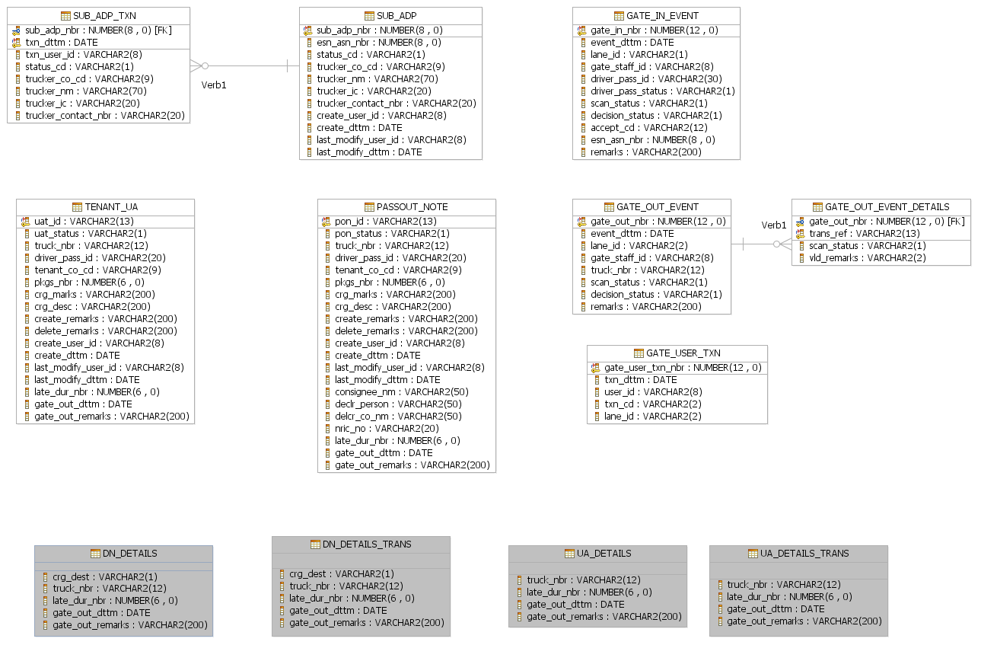

Sub ADP Details [SUB_ADP]

Purpose
Store information about nomindated Sub Authorized Delivery Party.

Composition

No | Field Name | Type | Size | Nullable | Description
01 | sub_adp_nbr | number | 8,0 | No | Running number
02 | esn_asn_nbr | number | 8,0 | No | ESN number
03 | status_cd | varchar2 | 1 | No | Status of this record.  A – Active (default)  X – Cancelled
04 | trucker_co_cd | varchar2 | 9 | No | Trucker company code
05 | trucker_nm | varchar2 | 70 | No | Sub-Authorized Delivery Party’s Name
06 | trucker_ic | varchar2 | 20 | No | Sub-Authorized Delivery Party’s TDB.CR. No./ UEN No./ IC No
07 | trucker_contact_nbr | varchar2 | 20 | No | Sub-Authorized Delivery Party’s contact number
08 | create_user_id | varchar2 | 8 | No | User Id of the person who nominate this
09 | create_dttm | date | NA | No | Nominatetion date time
10 | last_modify_user_id | varchar2 | 8 | No | Last modify by
11 | last_modify_dttm | date | NA | No | Last modify date time

Index
No | Type | Characteristics | Fields
01 | Primary Key | Unique, Not Null | sub_adp_nbr

Sub ADP Details Transaction [SUB_ADP_TXN]

Purpose
This table stores all transactions of SUB_ADP table, every creations, updates of SUB_ADP will be stored here

Composition

No | Field Name | Type | Size | Nullable | Description
01 | sub_adp_nbr | number | 8,0 | No | Foreign key, refer to SUB_ADP.sub_adp_nbr
02 | txn_dttm | date | NA | No | Transaction date time
03 | txn_ user_id | varchar2 | 10 | No | User Id of the person who nominate this
04 | status_cd | varchar2 | 1 | No | Status of this record.  A – Active (default)  X – Cancelled
05 | trucker_co_cd | varchar2 | 9 | No | Trucker’s company code
06 | trucker_nm | varchar2 | 70 | No | Sub-Authorized Delivery Party’s Name
07 | trucker_ic | varchar2 | 20 | No | Sub-Authorized Delivery Party’s TDB.CR. No./ UEN No./ IC No
08 | trucker_contact_nbr | varchar2 | 20 | No | Sub-Authorized Delivery Party’s contact number

Index
No | Type | Characteristics | Fields
01 | Primary Key | Unique, Not Null | sub_adp_nbr
02 | Primary Key | Unique, Not Null | txn_dttm
03 | Foreign Key | Refer to SUB_ADP.sub_adp_nbr | sub_adp_nbr

Unloading Advice for Tenant Details [TENANT_UA]

Purpose
Store all information about Unloading Advice for Tenant information

Composition

No | Field Name | Type | Size | Nullable | Description
01 | uat_id | varchar2 | 13 | No | Trans reference number
02 | uat_status | varchar2 | 1 | No | UAT status  A – Active  X – Cancelled
03 | truck_nbr | varchar2 | 12 | No | Truck license plate number
04 | driver_pass_id | varchar2 | 20 | No | Dirver’s pass
05 | tenant_co_cd | varchar2 | 9 | No | Teanant company code
06 | pkgs_nbr | number | NA | No | Number of package
07 | crg_marks | varchar2 | 200 | No | Cargo marks & no
08 | crg_desc | varchar2 | 200 | Yes | Cargo destination
09 | create_remarks | varchar2 | 200 | No | Remarks
10 | delete_remarks | varchar2 | 200 | Yes | Remarks for deletion
11 | create_user_id | varchar2 | 8 | No | Created by user id
12 | create_dttm | date | NA | No | Created date time
13 | last_modify_user_id | varchar2 | 8 | No | Last modify by user id
14 | last_modify_dttm | date | NA | No | Last modify date time
15 | late_dur_nbr | Number | 6 | Yes | By minutes, Duration of truck inside the port
16 | gate_out_dttm | date | NA | Yes | Gate out date time. The time that successfully gated out
15 | gate_out_remarks | varchar2 | 200 | Yes | Remarks when gate out

Index
No | Type | Characteristics | Fields
01 | Primary Key | Unique, Not Null | uat_id

JP/Tenant Pass Out Note Details [PASSOUT_NOTE]

Purpose
Store all information about JP/Tenant Passout Note

Composition

No | Field Name | Type | Size | Nullable | Description
01 | pon_id | varchar2 | 13 | No | Trans reference number
02 | pon_status | varchar2 | 1 | No | UAT status  A – Active  X – Cancelled
03 | truck_nbr | varchar2 | 12 | No | Truck license plate number
04 | driver_pass_id | varchar2 | 20 | No | Dirver’s pass
05 | tenant_co_cd | varchar2 | 9 | No | Teanant company code
06 | pkgs_nbr | number | 12,0 | No | Number of package
07 | crg_marks | varchar2 | 200 | No | Cargo marks & no
08 | crg_desc | varchar2 | 200 | Yes | Cargo destination
09 | create_remarks | varchar2 | 200 | No | Remarks
10 | delete_remarks | varchar2 | 200 | Yes | Remarks for deletion
11 | create_user_id | varchar2 | 8 | No | Created by user id
12 | create_dttm | date | NA | No | Created date time
13 | last_modify_user_id | varchar2 | 8 | No | Last modify by user id
14 | last_modify_dttm | date | NA | No | Last modify date time
15 | consignee_nm | varchar2 | 50 | No | Name of consignee
16 | declr_person_nm | varchar2 | 50 | No | Name of declaration person
17 | declr_co_nm | varchar2 | 50 | No | Company name of person making declaration
18 | nric_id | varchar2 | 20 | No | NRIC/Work permit Nuber
19 | late_dur_nbr | Number | 6 | Yes | By minutes, Duration of truck inside the port
20 | gate_out_dttm | date | NA | Yes | Gate out date time. The time that successfully gated out
21 | gate_out_remarks | varchar2 | 200 | Yes | Remarks when gate out

Index
No | Type | Characteristics | Fields
01 | Primary Key | Unique, Not Null | pon_id

Gate In Event Log table [GATE_IN_EVENT]

Purpose
Store all event information about gate-in process

Composition

No | Field Name | Type | Size | Nullable | Description
01 | gate_in_nbr | number | 8,0 | No | Sequence number
02 | event_dttm | date | NA | No | Scan date time
03 | lane_id | varchar2 | 2 | No | Lane number: I1 → I6, O1 → O6
04 | gate_staff_id | varchar2 | 8 | No | Id of the login user
05 | driver_pass_id | varchar2 | 30 | No | Driver’s pass number
06 | driver_pass_status | varchar2 | 1 | No | Pass status
07 | scan_status | varchar2 | 1 | No | Status of scanning  P – Passed  F - Failed
08 | decision_status | varchar2 | 1 | No | A – Approve  R - Reject
09 | accept_cd | varchar2 | 12 | Yes | Link to misc event lock table
10 | esn_asn_nbr | number | 8,0 | No | ESN number
12 | remarks | varchar2 | 200 | Yes

Index
No | Type | Characteristics | Fields
01 | Primary Key | Unique, Not Null | gate_in_nbr

Gate Out Event Log table [GATE_OUT_EVENT]

Purpose
Store all event information about gate-out process

Composition

No | Field Name | Type | Size | Nullable | Description
01 | gate_out_nbr | number | 8,0 | No | Sequence number
02 | event_dttm | date | NA | No | Scan date time
03 | lane_id | varchar2 | 2 | No | Lane number: I1 → I6, O1 → O6
04 | gate_staff_id | varchar2 | 8 | No | Id of the login user
05 | truck_nbr | varchar2 | 12 | No | Truck license plate number
06 | scan_status | varchar2 | 1 | No | Status of scanning  P – Passed  F – Failed  W - Warning
07 | decision_status | varchar2 | 1 | No | A – Approve  R - Reject
08 | remarks | varchar2 | 200 | Yes | Remarks when accept or deletw

Index
No | Type | Characteristics | Fields
01 | Primary Key | Unique, Not Null | gate_out_nbr

Gate Out Event Details table [GATE_OUT_EVENT_DETAILS]

Purpose
Store all event information about gate-out process

Composition

No | Field Name | Type | Size | Nullable | Description
01 | gate_out_nbr | number | 12,0 | No | Refer to GATE_OUT_EVENT table
02 | trans_ref | varchar2 | 13 | No | Trans Reference Number
03 | scan_status | varchar2 | 1 | No | Status of scan: F or P
04 | vld_cd | varchar2 | 2 | No | DU – Duplicated DN  LG – Late Gate Out  DE - Destination

Index
No | Type | Characteristics | Fields
01 | Primary Key | Unique, Not Null | gate_out_nbr
02 | Primary Key | Unique, Not Null | trans_ref
03 | Foreign Key | Refer to GATE_OUT_EVENT | gate_out_nbr

Gate User Transaction table [GATE_USER_TXN]

Purpose
Store all event information about gate-out process

Composition

No | Field Name | Type | Size | Nullable | Description
01 | gate_user_txn_nbr | number | 8,0 | No | Sequence number
02 | txn_dttm | date | NA | No | Transaction date time
03 | user_id | varchar2 | 13 | No | Logged in user id
04 | txn_cd | varchar2 | 1 | No | - C: Change password  - L: Login  - O: Logout
05 | lane_id | varchar2 | 2 | No | Lane number: I1 → I6, O1 → O6

Index
No | Type | Characteristics | Fields
01 | Primary Key | Unique, Not Null | gate_user_txn_nbr

Delivery Note table [DN_DETAILS]

Purpose
Store information of delivery notes

Note: here is only new fields for this table

Composition

No | Field Name | Type | Size | Nullable | Description
01 | crg_dest | varchar2 | 1 | No | Cargo Destination  O – Out of JP  L – Leased Area  V – Vessel
02 | truck_nbr | varchar2 | 12 | Yes | Truck number
03 | late_dur_nbr | Number | 6 | Yes | By minutes, Duration of truck inside the port
04 | gate_out_dttm | date | NA | Yes | Gate out date time. The time that successfully gated out
05 | gate_out_remarks | varchar2 | 200 | Yes | Remarks when gate out

Delivery Note Transaction table [DN_DETAILS_TRANS]

Purpose
Store history information of delivery notes

Note: here is only new fields for this table

Composition

No | Field Name | Type | Size | Nullable | Description
01 | crg_dest | varchar2 | 1 | No | Cargo Destination  O – Out of JP  L – Leased Area  V - Vessel
02 | truck_nbr | varchar2 | 12 | Yes | Truck number
03 | late_dur_nbr | Number | 6 | Yes | By minutes, Duration of truck inside the port
04 | gate_out_dttm | date | NA | Yes | Gate out date time. The time that successfully gated out
03 | gate_out_remarks | varchar2 | 200 | Yes | Remarks when gate out

Unloading Advice table [UA_DETAILS]

Purpose
Store information of Unloading Advices

Note: here is only new fields for this table

Composition

No | Field Name | Type | Size | Nullable | Description
01 | truck_nbr | varchar2 | 12 | Yes | Truck number
02 | late_dur_nbr | Number | 6 | Yes | By minutes, Duration of truck inside the port
03 | gate_out_dttm | date | NA | Yes | Gate out date time. The time that successfully gated out
04 | gate_out_remarks | varchar2 | 200 | Yes | Remarks when gate out

Unloading Advice Transaction table [UA_DETAILS_TRANS]

Purpose
Store all history information of Unloading Advice

Note: here is only new fields for this table

Composition

No | Field Name | Type | Size | Nullable | Description
01 | truck_nbr | varchar2 | 12 | Yes
02 | late_dur_nbr | Number | 6 | Yes | By minutes, Duration of truck inside the port
03 | gate_out_dttm | date | NA | Yes | Gate out date time. The time that successfully gated out
04 | gate_out_remarks | varchar2 | 200 | Yes | Remarks when gate out

