

**JOCKEY**

**Google conversion value integration**

**Low Level Design Document**

**Revalsys**

REVISION HISTORY:

|  |  |  |  |
| --- | --- | --- | --- |
| Version | Date Modified | Author | Reason for Change |
| 1.0 | 14-11-2017 | Shivaji K | Creation |

This document has been reviewed and accepted:

|  |  |  |  |
| --- | --- | --- | --- |
| Version | Date Reviewed | Reviewer Name | Title |
| 1.0 | 29-11-2017 | Govind G | Developer |

# CONTENTS

CONTENTS 3

1. Introduction: 4

1.1 Overview: 4

1.2 Purpose: 4

2. Scope Inclusion: 4

3. Context Diagram (High –Level approach): 4

3.1 Current Context (in-case of re-engineering project): 4

3.2 Context diagrams: 4

4. Standards, Conventions and Procedures: 4

4.1 Development Language: 4

4.2 Design/Programming Standards/Naming Conventions: 4

4.3 Authentication Mechanism: 4

4.4 Exception Handling/Logging: 4

4.5 Session Management: 5

4.6 Database Calls: 5

4.7 Configuration Parameters: 5

5. Framework Components: 5

6. Database: 5

6.1 Database schema: 5

6.2 Data Tables: 5

6.3 Table Structure: 5

7. Screen/ETL Design 5

7.1 Sample screen: 5

7.2. Business Components: 9

8. Methods: 9

9. Validations: 9

10. Request & Response: 10

11. Stored Procedures: 10

# Introduction:

## 1.1 Overview:

The main overview of this document is to implement track the every order total amount and pushing total price of the order.

## 1.2 Purpose:

The objective of this documentation is to implement track the every order total amount.

# Scope Inclusion:

Scope of the document is to pass implement track the every order total amount.

# 3. Context Diagram (High –Level approach):

## 3.1 Current Context (in-case of re-engineering project):

NA

## 3.2 Context diagrams:

NA

# 4. Standards, Conventions and Procedures:

## 4.1 Development Language:

Angularjs 1.5x

## 4.2 Design/Programming Standards/Naming Conventions:

\\revalserv\Live\CodingStandards\CodingStandards.odt

## 4.3 Authentication Mechanism:

NA

## 4.4 Exception Handling/Logging:

4.4.1 **Unhandled exception logging**

NA

4.4.2 **Handled exception logging**:

NA

4.4.**3 General logging**:

NA

4.4. 4 **Displaying Error Messages to Users**:

NA

## 4.5 Session Management:

NA

## 4.6 Database Calls:

NA

## 4.7 Configuration Parameters:

NA

# 5. Framework Components:

Used Angularjs 1.5x, JQuery, Bootstrap, Html, Css.

# 6. Database:

## **6.1 Database schema**:

NA

## 6.2 Data Tables:

NA

## 6.3 Table Structure:

**NA**

# 7. Screen/ETL Design

## 7.1 Sample screen:

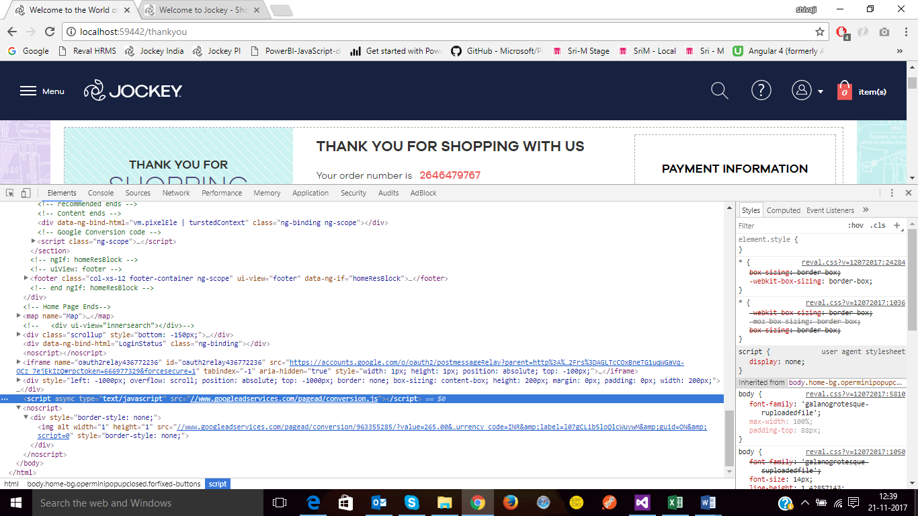

## 7.2. Business Components:

**API’s:**

1. GetStoreOrderDetails

**Controllers:**

1. Thankyou Controller

**Partials:**

1. Thankyou

# 8. Methods:

1. **GetStoreOrderDetails api in thankyou page**

|  |  |
| --- | --- |
| **Function name** | **getStoreOrderDetails Api** |
| **Purpose** | Displaying successful order product details |
| **Function Parameters** | StoreOrderNumber |
| **Pseudo Code** | 1. After getting API response will check the total order amount then place below code   var google_conversion_id = 963355285;  var google_conversion_language = "en";  var google_conversion_format = "3";  var google_conversion_color = "ffffff";  var google_conversion_label = l07gCLib5loQlcWuywM";  var google_conversion_value = vm.thankYouContent.Total.replace('Rs. ', '') + '.00';  var google_conversion_currency = "INR";  var google_remarketing_only = false;   1. Create below script element and append to body   <script type=”text/javascript” src=”//www.goggleadservices.com/pagead/conversion.js”> |

1. **Thankyou html changes**

* Added below script element in bottom

<script>

function googleConversionCreation(price) {

var google_conversion_id = 963355285;

var google_conversion_language = "en";

var google_conversion_format = "3";

var google_conversion_color = "ffffff";

var google_conversion_label = "l07gCLib5loQlcWuywM";

var google_conversion_value = price;

var google_conversion_currency = "INR";

var google_remarketing_only = false;

var gcs = document.createElement('script');

gcs.async = true;

gcs.type = "text/javascript";

gcs.src = "//www.googleadservices.com/pagead/conversion.js";

document.getElementsByTagName('body')[0].appendChild(gcs);

var gcn = document.createElement('noscript');

var gcn_div = document.createElement('div');

gcn_div.style = "border-style:none;";

var gcn_img = document.createElement('img');

gcn_img.alt = "";

gcn_img.width = "1";

gcn_img.height = "1";

gcn_img.style = "border-style:none;";

gcn_img.src = "//www.googleadservices.com/pagead/conversion/963355285/?value="+ price +"&amp;currency_code=INR&amp;label=l07gCLib5loQlcWuywM&amp;guid=ON&amp;script=0";

gcn_div.appendChild(gcn_img);

gcn.appendChild(gcn_div);

document.getElementsByTagName('body')[0].appendChild(gcn);

# }

</script>

# 9. Validations:

* After order placing check the googleadservices js is appended in body or not.

# 10. Request & Response: Modified API’s

NA

**11. Stored Procedures**

NA