Explorative Data Analysis on Retail sales of Windows.

----Date----

27 March 2019,

By

Shiva,

Ghouse,

Hemanth,

Krishna

The given dataset contains the data related to sales of windows by different dealers and the organization itself. Dataset has 229 rows and 40 columns. We need to perform Exploratory Data Analysis (EDA) on the dataset to find the good performing and ill performing dealers.

This is done by plotting graphs and charts among different variables. By observing these plots, inferences and conclusions are made. To improve the order quantity of the ill performing dealers, recommendations are also given to the organization.

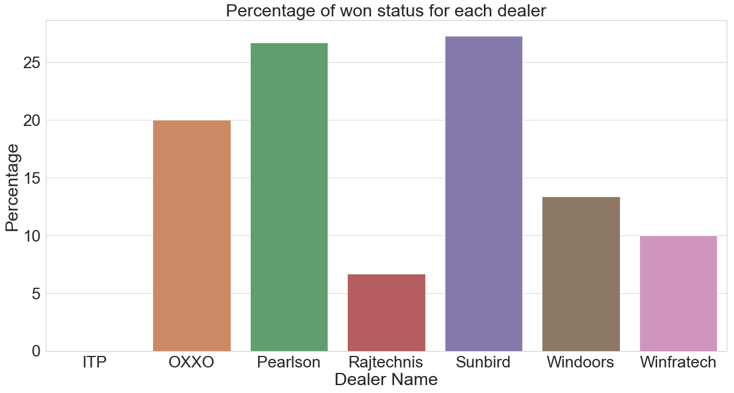

INFERENCE: Dealer name with percentage who as more number of won Status.

From the above figure we can infer that dealer Sunbird is having the maximum percentage with won status.

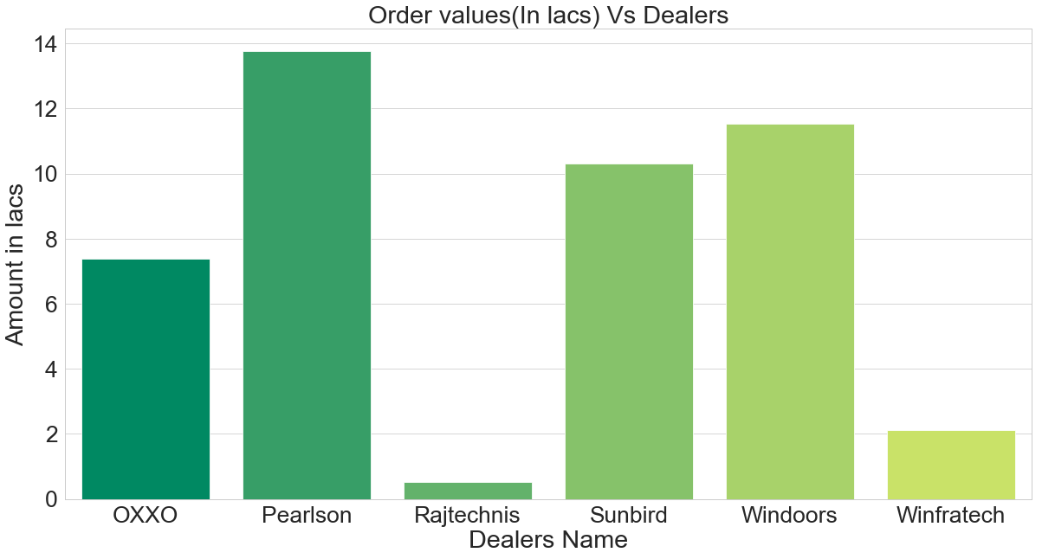

INFERENCE : The above plot gives us the information regarding each dealer’s order value.

From the above plot, we can observe that Pearlson has made the highest order value while Rajtechnis has the lowest. The justification for this observation will be given in the next plots.

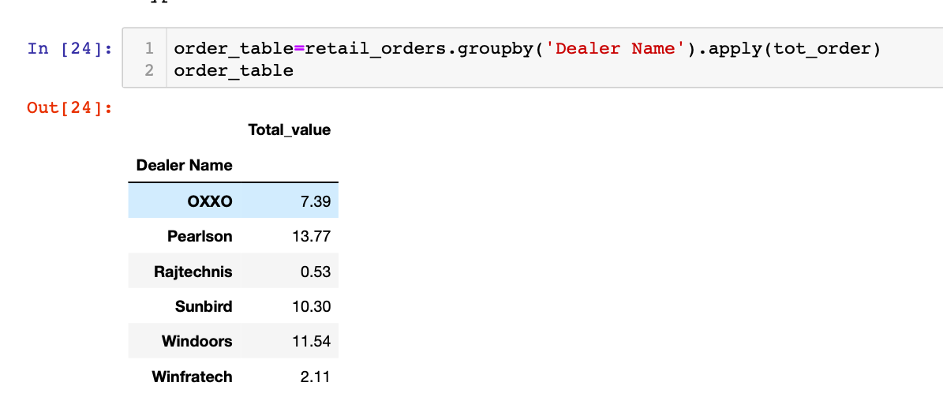

INFERENCE :

From the Data above the If total order value of the dealer is less the average 7.606 then that dealer should be considered as the low performer. The Below screenshot it clearly states that the OXXO,Rajtechnis,Winfratech and ITP are the Low performers in the data(as we know the ITP dealer has no orders received so no total that’s why not shown in below table .)

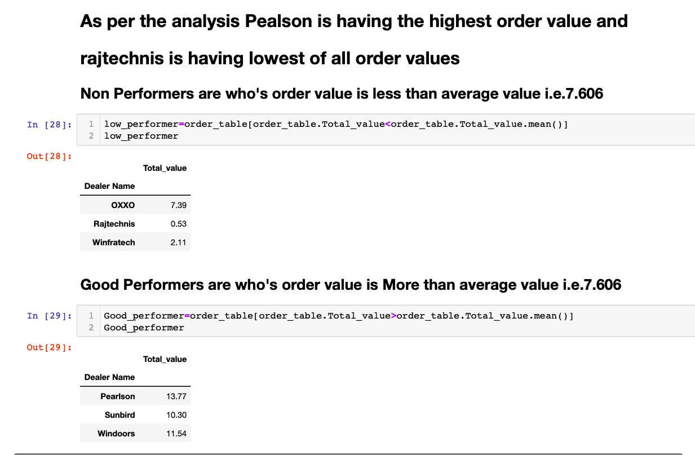

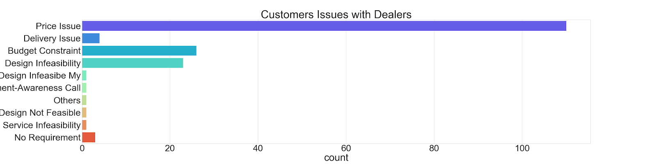

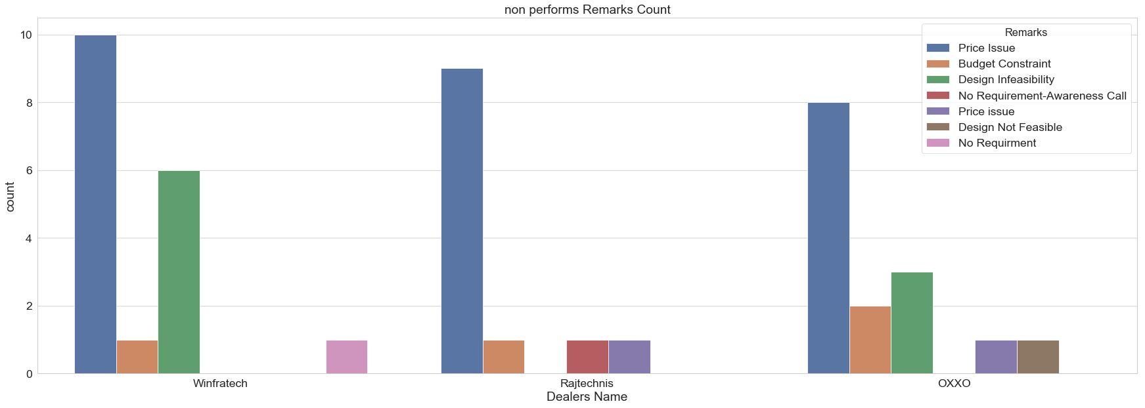

Inference:

As we can infere from the above plot clearly the price issue is effecting the performance of the dealers a lot. And Secondly the budget constrain of the customer and Design infeasibility effecting dealers to lost their orders primarily.

**Analysing the Dealers monthly wise performance:**

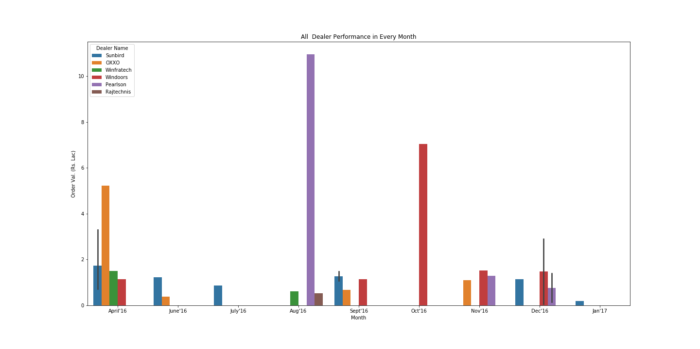

INFERENCE:

In the month of April the performance windoors performance is low when compared to the other dealers.

In the month of June’16 the Winfratech,Pearlson,Rajtechnis are not having any orders making them as least performer of the month June.

In the month of the July’16 Only Sunbird is having the orders other dealers are not having any order.

In the month of Aug’16 the Pearlson is having highest of orders in the all month.

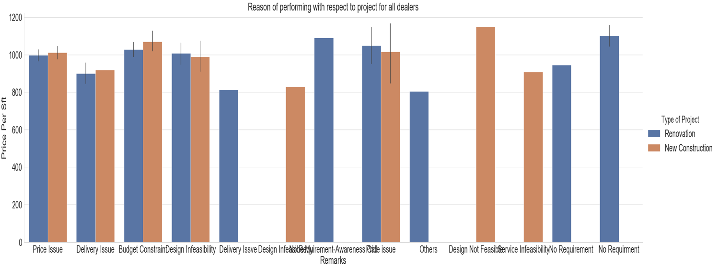

The insight that we came to know in the correlation of Price values per sqf and type of projects is, it is partially shows that Renovation project and the New Construction Project price is slightly less which leads more of the orders to lost(just assumption from the graph above).

**Where There are not performing well?**

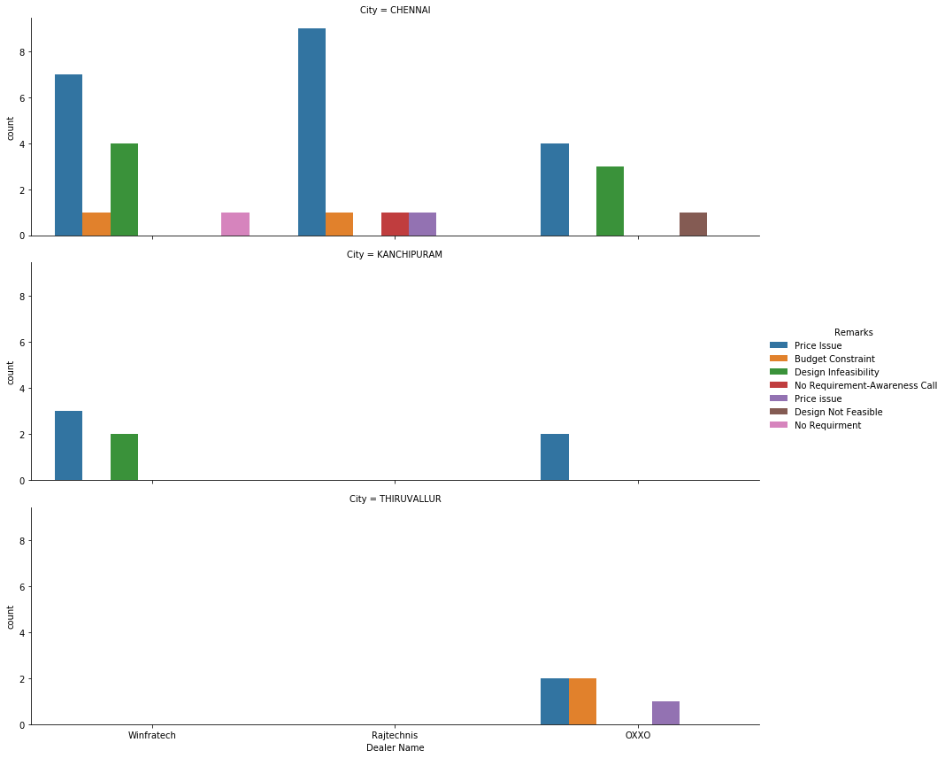

# INFERENCE: From above plot we can say that in Chennai Dealers having the Price issue more and design feasibility issue also more

# In Chennai winfratech,OXXO,Rajtechnis Dealers are not performing well.

# In Tiruvallur OXXO having some issues in performance.

# In Kanchipuram Winfratech and OXXO.

**In Which City more lost are there?**

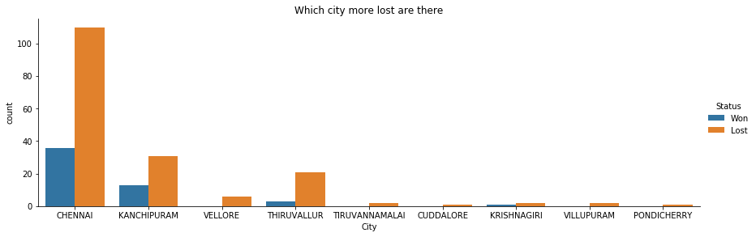

**INFERENCE:** From the above plot we can refer that in which city we got maximum number of loss and won. In the above plot as we can see that for Chennai, we got a greater number of lost when compared to the other cities.

**Loss of Deals due to unavailability of window materials.**

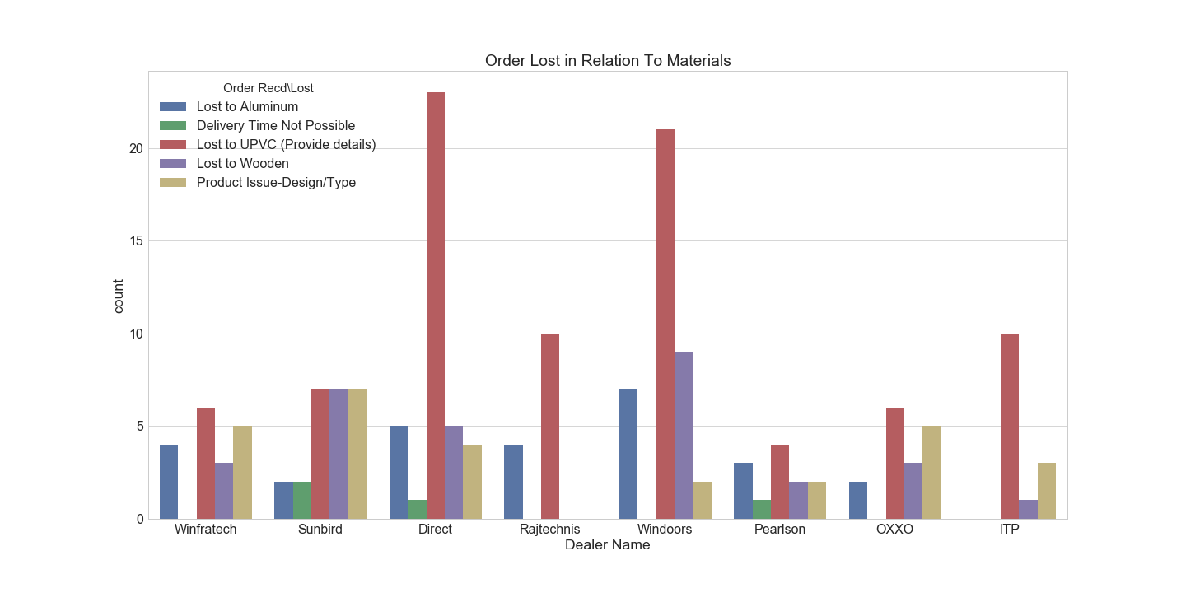

**INFERENCE:**

**From the above plot, we can observe that the most number of losses by any dealer or the organization itself is due to unavailability of windows made of UPVC material.  We can also observe that Sunbird and Pearlson are facing issues due to unavailability of all the materials.**

**Marketing Strategy:**

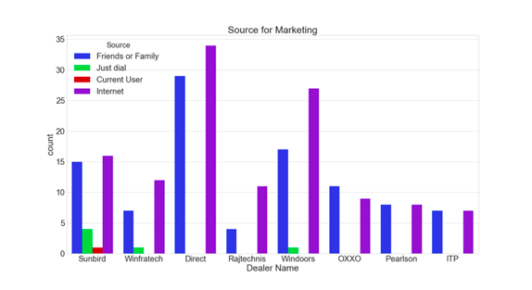

***Plot showing marketing strategy of each dealer***

INFERENCE:

From the above plot, we can observe that the red bar which represents the marketing through internet has got the dealers successful deals. The strategy that got the dealers the least deals is through just dial and the current user.

We can also co relate that organization which made considerable contribution in the good deals has sales by marketing through internet. On the other hand, ITP which has the least contribution in the sales has second least marketing strategy through internet. Other major good marketing strategy is through Friends and family which can be achieved through goodwill of the organization.

**RECOMANDATIONS:**

1. We would suggest all the dealers to transit the marketing strategy through internet as soon as possible to gain more attention of customers and to highlight our products.
2. To increase the availability of windows made of UPVC and Aluminium if possible wooden as well.
3. The major issue reported by the customers Is related to the high prices of the products which can be solved by giving discounts.
4. We have also observed a contradiction in data, Mostly the Remarks from the customers are related to high price but sale of the dealers who’s prices are comparatively less are low.