Building LLMs from Scratch
Series Documentation | Topic 16 | Stage 3
Shortcut Connections

Also known as Skip or Residual Connections.
The mechanism that makes it possible to train 12 stacked transformer blocks: add the layer input directly to its output, giving gradients an unobstructed path back to early layers.

Author | SHIVA KIRAN DADISHETTY
Series | Building LLMs from Scratch
Topic | 16 of 36 — Stage 3: LLM Architecture
Also Known As | Skip Connections · Residual Connections
Builds On | Topics 14–15 — LayerNorm and FeedForward (both wrapped by shortcuts)
Key Addition 1 | x = x + layer_output — the shortcut addition in every transformer block
Key Addition 2 | Condition: x.shape == layer_output.shape before applying shortcut

1. Where Shortcut Connections Sit in the Architecture
Shortcut connections wrap every sub-block inside the transformer block. They appear twice per block — once around the masked multi-head attention, and once around the feed-forward network. Both shortcut additions happen after dropout.

Transformer Block (×12)
├── LayerNorm 1
├── Masked Multi-Head Attention
├── Dropout
├── + ←──────────── Shortcut 1: adds block input to attention output
├── LayerNorm 2
├── Feed-Forward Network (Linear → GELU → Linear)
├── Dropout
└── + ←──────────── Shortcut 2: adds attention output to FFN output

In code:
shortcut_output = x + sub_block(x) ← the entire mechanism in one line

What Makes Shortcut Connections Different from Regular Connections
A regular connection passes data forward through a layer:
output = layer(input)

A shortcut connection adds the ORIGINAL INPUT to the LAYER OUTPUT:
output = layer(input) + input

The original input bypasses the layer entirely and is added at the end.
This creates two paths for information — one through the layer, one around it.
It also creates two paths for gradients during backpropagation.
The path around the layer (the shortcut) is always gradient = 1.0.

2. The Vanishing Gradient Problem
Shortcut connections were first proposed in the field of computer vision to solve the problem of vanishing gradients. Understanding this problem precisely explains why shortcuts are not optional — they are load-bearing.

2.1 How Gradients Flow During Backpropagation
During the backward pass, gradients flow from the output layer back to the input layer — right to left. At each layer, the gradient is multiplied by the partial derivative of that layer's output with respect to its input.

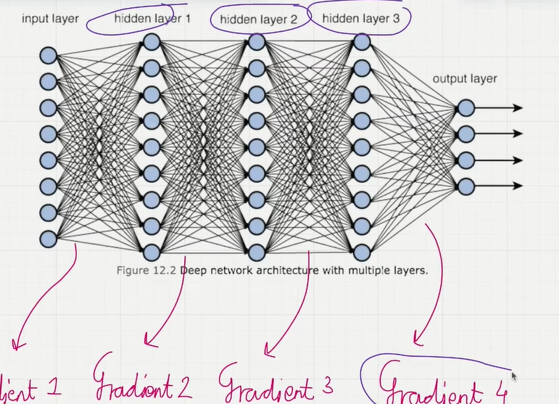
Figure 1: Deep network architecture with multiple layers. During backpropagation, gradients flow right to left — Gradient 4 (output layer) back through Gradient 3, Gradient 2, to Gradient 1 (input layer). At each step the gradient is multiplied by the layer local derivative. If any layer has a small derivative, the gradient shrinks, and by Gradient 1 it may be effectively zero — the vanishing gradient problem.

Forward pass: Input → Layer 1 → Layer 2 → Layer 3 → Layer 4 → Layer 5 → Output
Backward pass: Gradient flows right to left:

gradient_1 = gradient_2 × ∂(Layer2_output)/∂(Layer2_input)
= gradient_2 × (small number)

If each layer multiplies the gradient by 0.1:
gradient_5 = 1.0
gradient_4 = 1.0 × 0.1 = 0.1
gradient_3 = 0.1 × 0.1 = 0.01
gradient_2 = 0.01 × 0.1 = 0.001
gradient_1 = 0.001× 0.1 = 0.0001 ← effectively zero

→ Weights in Layer 1 barely update.
→ The model stops learning in its early layers.
→ Training is not progressing — local minima reached prematurely.

2.2 The Weight Update Consequence
When gradients vanish, the weight update rule breaks down completely:

Weight update rule:
w_new = w_old - (learning_rate × gradient)

If gradient → 0:
w_new = w_old - (learning_rate × 0.0000)
w_new = w_old ← no update happens

The weights in early layers never change.
Training is not happening.
The model reaches a point where it cannot proceed further.

→ Early layers become frozen.
→ The model cannot learn long-range dependencies.
→ Stacking more layers makes the problem worse, not better.

Why Deep Networks Suffer More
A 2-layer network: gradient reaches Layer 1 after 1 multiplication.
A 12-layer network: gradient reaches Layer 1 after 11 multiplications.

GPT-2 small has 12 transformer blocks. Without shortcut connections,
each block introduces additional gradient decay.
By the time the gradient reaches the first block, it may be
effectively zero — making those layers impossible to train.

This is precisely the problem shortcut connections solve.
First proposed in computer vision (ResNets) to enable 100+ layer networks.
Adopted in transformers for the same fundamental reason.

3. How Shortcut Connections Solve the Vanishing Gradient Problem
Shortcut connections create an alternative path for the gradient to flow by skipping one or more layers. This is achieved by adding the output of one layer to the output of a later layer. They play a crucial role in preserving the flow of gradients during the backward pass.

3.1 The Mechanism — One Line of Code
The entire mechanism is a single addition:

# Without shortcut:
x = layer(x) # gradient flows only through the layer

# With shortcut:
x = x + layer(x) # gradient flows through layer AND directly

# In the ExampleDeepNeuralNetwork:
layer_output = layer(x) # compute layer output
if self.use_shortcut and x.shape == layer_output.shape:
x = x + layer_output # add input to output → shortcut applied
else:
x = layer_output # no shortcut (shapes don't match)

3.2 The Gradient Comparison — Without vs With Shortcuts
Using ExampleDeepNeuralNetwork with layer_sizes=[3,3,3,3,3,1], sample_input=[[1., 0., -1.]], torch.manual_seed(123). The gradient values below are the mean absolute gradients of each layer's weight matrix:

Layer | Without Shortcut | With Shortcut | Ratio (×)
layers.0 (first) | 0.00020 | 0.22170 | ×1,100 ← gradient preserved
layers.1 | 0.00012 | 0.20694 | ×1,724 ← gradient preserved
layers.2 | 0.00072 | 0.32897 | ×457 ← gradient preserved
layers.3 | 0.00140 | 0.26657 | ×190 ← gradient preserved
layers.4 (last) | 0.00505 | 1.32585 | ×263 ← gradient preserved

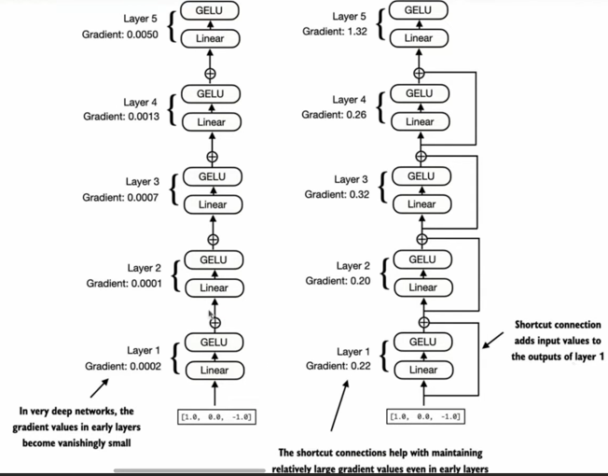
Figure 2: Side-by-side gradient comparison. Left — without shortcut connections: gradient values collapse to near-zero in early layers (Layer 1: 0.0002, Layer 2: 0.0001). In very deep networks the gradient values in early layers become vanishingly small. Right — with shortcut connections: all layers maintain usable gradient values (Layer 1: 0.22, Layer 2: 0.20). The shortcut connection adds input values to the outputs of each layer, helping maintain relatively large gradient values even in early layers.

Without shortcuts: Layer 0 gradient = 0.00020 — vanishingly small. Early layers barely update.
With shortcuts: Layer 0 gradient = 0.22170 — large and usable. All layers learn effectively.

The Critical Observation
WITHOUT shortcuts:
Gradient at Layer 0 = 0.00020 (smallest)
Gradient at Layer 4 = 0.00505 (largest)
Ratio Layer4/Layer0 = 25× → severe decay across layers

WITH shortcuts:
Gradient at Layer 0 = 0.22170 (stable)
Gradient at Layer 4 = 1.32585 (largest)
Ratio Layer4/Layer0 = 6× → much more stable across layers

The shortcut connections help maintaining relatively large gradient
values in early layers, enabling effective training throughout.

4. Mathematical Understanding — Why the "+1" Saves Gradients
The mathematical derivation shows precisely why shortcut connections prevent vanishing gradients. It reduces to a single additional term in the gradient expression that is always equal to 1.

4.1 The Forward Pass with Shortcut
With a shortcut connection, the output of layer L+1 is:

y_{L+1} = f(y_L) + y_L

where:
y_L = input to layer L (also the shortcut value)
f(y_L) = output of layer L's computation (Linear + GELU)
y_{L+1} = final output = layer computation + original input

4.2 The Backward Pass — Chain Rule Expansion
During backpropagation, the gradient of the loss with respect to y_L is computed using the chain rule:

∂L/∂y_L = (∂L/∂y_{L+1}) × (∂y_{L+1}/∂y_L)

Expanding ∂y_{L+1}/∂y_L:
Since y_{L+1} = f(y_L) + y_L:

∂y_{L+1}/∂y_L = ∂f(y_L)/∂y_L + ∂y_L/∂y_L
= ∂f(y_L)/∂y_L + 1

Therefore:
∂L/∂y_L = (∂L/∂y_{L+1}) × (∂f(y_L)/∂y_L + 1)

→ This "+1" term is always present regardless of ∂f(y_L)/∂y_L.
→ Even if ∂f(y_L)/∂y_L → 0, the gradient is still:
∂L/∂y_L = (∂L/∂y_{L+1}) × (0 + 1) = ∂L/∂y_{L+1}
→ The gradient passes through unchanged.
→ Keeps the gradient flowing throughout the network.

4.3 Without Shortcut — What Changes
Without the shortcut connection, y_{L+1} = f(y_L) only:

Without shortcut:
y_{L+1} = f(y_L)

∂L/∂y_L = (∂L/∂y_{L+1}) × ∂f(y_L)/∂y_L

If ∂f(y_L)/∂y_L is small (e.g. 0.1):
→ gradient multiplied by 0.1 at every layer
→ 12 layers: 0.1^12 = 10^-12 → effectively zero

With shortcut:
∂L/∂y_L = (∂L/∂y_{L+1}) × (∂f(y_L)/∂y_L + 1)

Minimum multiplier is 1.0 even when ∂f(y_L)/∂y_L → 0.
→ Gradient can never vanish due to the shortcut path alone.

The "+1" in Plain English
The shortcut connection adds a direct copy of y_L to the output.
When differentiating this addition with respect to y_L, the
derivative of the copy term is exactly 1.

This "+1" acts as a minimum gradient floor.
No matter how small ∂f(y_L)/∂y_L becomes, the total gradient
is always at least: (∂L/∂y_{L+1}) × 1 = ∂L/∂y_{L+1}.

The gradient from the next layer passes through unchanged.
This is why shortcut connections keep gradients flowing throughout
the entire network, regardless of how many layers are stacked.

5. Complete Implementation — ExampleDeepNeuralNetwork
The ExampleDeepNeuralNetwork class demonstrates shortcut connections on a 5-layer network. The use_shortcut flag controls whether shortcuts are applied, enabling a direct comparison of gradient magnitudes with and without the mechanism.

class ExampleDeepNeuralNetwork(nn.Module):
def __init__(self, layer_sizes, use_shortcut):
super().__init__()
self.use_shortcut = use_shortcut
self.layers = nn.ModuleList([
nn.Sequential(nn.Linear(layer_sizes[0], layer_sizes[1]), GELU()),
nn.Sequential(nn.Linear(layer_sizes[1], layer_sizes[2]), GELU()),
nn.Sequential(nn.Linear(layer_sizes[2], layer_sizes[3]), GELU()),
nn.Sequential(nn.Linear(layer_sizes[3], layer_sizes[4]), GELU()),
nn.Sequential(nn.Linear(layer_sizes[4], layer_sizes[5]), GELU())
])

def forward(self, x):
for layer in self.layers:
layer_output = layer(x)
# Apply shortcut ONLY if shapes match
if self.use_shortcut and x.shape == layer_output.shape:
x = x + layer_output # shortcut: add input to output
else:
x = layer_output # no shortcut (last layer: [1,3]→[1,1])
return x

# ─── Gradient comparison ────────────────────────────────────────────────────
def print_gradients(model, x):
output = model(x)
target = torch.tensor([[0.]])
loss = nn.MSELoss()(output, target)
loss.backward() # computes gradients for all parameters
for name, param in model.named_parameters():
if "weight" in name:
# Mean absolute gradient of the weight matrix
print(f"{name}: {param.grad.abs().mean().item()}")

layer_sizes = [3, 3, 3, 3, 3, 1]
sample_input = torch.tensor([[1., 0., -1.]])

# WITHOUT shortcuts
torch.manual_seed(123)
model_without = ExampleDeepNeuralNetwork(layer_sizes, use_shortcut=False)
print_gradients(model_without, sample_input)
# layers.0.0.weight: 0.00020 ← vanishingly small
# layers.1.0.weight: 0.00012
# layers.2.0.weight: 0.00072
# layers.3.0.weight: 0.00140
# layers.4.0.weight: 0.00505

# WITH shortcuts
torch.manual_seed(123)
model_with = ExampleDeepNeuralNetwork(layer_sizes, use_shortcut=True)
print_gradients(model_with, sample_input)
# layers.0.0.weight: 0.22170 ← preserved and usable
# layers.1.0.weight: 0.20694
# layers.2.0.weight: 0.32897
# layers.3.0.weight: 0.26657
# layers.4.0.weight: 1.32585

6. The Shape Condition — When Shortcuts Apply
The shortcut connection requires the input and output tensors to have identical shapes. If they do not match, the addition x + layer_output is mathematically undefined. The code checks this explicitly before applying the shortcut.

if self.use_shortcut and x.shape == layer_output.shape:
x = x + layer_output # shortcut applied
else:
x = layer_output # shortcut skipped

In ExampleDeepNeuralNetwork with layer_sizes = [3, 3, 3, 3, 3, 1]:

Layer 0: input [1, 3] → output [1, 3] → shapes match → shortcut APPLIED
Layer 1: input [1, 3] → output [1, 3] → shapes match → shortcut APPLIED
Layer 2: input [1, 3] → output [1, 3] → shapes match → shortcut APPLIED
Layer 3: input [1, 3] → output [1, 3] → shapes match → shortcut APPLIED
Layer 4: input [1, 3] → output [1, 1] → shapes differ → shortcut SKIPPED

In GPT-2 transformer blocks:
Input shape: [batch, num_tokens, 768]
Output shape: [batch, num_tokens, 768] → always match → shortcut ALWAYS applied
This is guaranteed by the d_in = d_out design of every sub-block.

7. The Loss Landscape — Visualizing Why Shortcuts Help
The research paper "Visualizing the Loss Landscape of Neural Nets" (Li et al., 2018) provides a powerful visual explanation of why shortcut connections improve training. The loss landscape is the surface of the loss function over all possible weight values.

Without Skip Connections  Jagged loss landscape | The loss surface has many sharp peaks and deep, narrow valleys.  Gradients point in unpredictable directions — sometimes toward local minima that are not the global minimum.  Optimization is chaotic. The model can get stuck, oscillate, or diverge.  Gradient flow is poor — the surface curvature causes gradient directions to vary wildly across layers.
With Skip Connections  Smooth loss landscape | The loss surface becomes much smoother — broader valleys, fewer sharp ridges.  Since the loss function landscape becomes smooth, gradient flow also becomes smooth.  Gradient descent finds good solutions reliably and efficiently.  This smoothness is directly caused by the shortcut connections providing stable gradient paths.

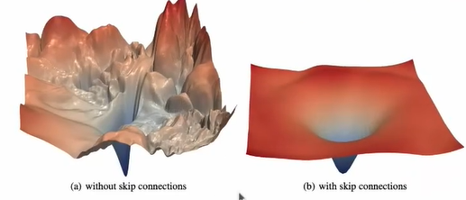
Figure 3: Loss landscape visualization from Li et al. (2018) — Visualizing the Loss Landscape of Neural Nets. (a) Without skip connections: the loss surface is chaotic and jagged with many sharp peaks — gradient descent struggles to navigate toward the minimum. (b) With skip connections: the loss surface becomes smooth and bowl-shaped — gradient flow is stable and optimization proceeds reliably. This visual proof shows exactly why shortcut connections improve training.

The visual intuition: without shortcuts, navigating the loss landscape is like hiking through jagged mountain terrain in fog. With shortcuts, the same landscape becomes rolling hills — the path to the minimum is clear and navigable.

8. Key Observations

- x = x + layer_output is the entire mechanism — one addition in the forward pass. This trivially simple operation has profound consequences for gradient flow. The shortcut does not add parameters, does not change shapes, and costs almost nothing computationally. Yet it is the reason GPT-2's 12 stacked blocks can all be trained effectively.
- The "+1" in the gradient expression is the mathematical core — the shortcut adds a constant 1 to every gradient multiplier throughout the network. This means no matter how small the layer-wise gradient becomes, the gradient from the next layer always passes through at full strength via the shortcut path. Vanishing gradients become impossible on the shortcut path.
- The shape condition is mandatory — x + layer_output requires identical shapes. In GPT-2 this is guaranteed because d_in = d_out throughout. In the example network, the last layer (3→1) has mismatched shapes and the shortcut is correctly skipped. In real transformer blocks, LayerNorm and FeedForward both preserve [b, tokens, 768], so shortcuts always apply.
- Shortcut connections were first proposed in computer vision — ResNet (He et al., 2016) introduced skip connections to train networks with 100+ layers. Without them, networks deeper than ~20 layers showed worse performance than shallower ones (the degradation problem). Transformers adopted the same mechanism for the same reason: depth without shortcuts is untrainable.
- The loss landscape becomes smooth — "Visualizing the Loss Landscape of Neural Nets" (Li et al., 2018) shows this directly. With skip connections, the loss surface changes from jagged and chaotic to smooth and navigable. Smooth gradients mean reliable optimization, faster convergence, and better final performance.
- Shortcut connections are a core building block of LLMs — they ensure consistent gradient flow across all 12 transformer blocks when training GPT-2. Without them, the model could not learn from its first few transformer blocks at all. Every modern LLM — GPT-3, LLaMA, Mistral, Claude — uses residual connections throughout.

9. Research Paper Connections

- He et al. (2016) — Deep Residual Learning for Image Recognition — the foundational paper introducing skip/residual connections. Proposed to solve the degradation problem: deeper networks had higher training error than shallower ones, caused by vanishing gradients. The key equation y = F(x) + x is exactly what x = x + layer_output implements. ResNets with 152 layers won ImageNet 2015 using this mechanism. Transformers adopted it verbatim.
- Vaswani et al. (2017) — Attention Is All You Need — adopted residual connections in the original Transformer: "We employ a residual connection around each of the two sub-layers, followed by layer normalization." This is exactly the structure built in GPT-2: shortcut around attention, shortcut around FFN. The mathematical consequence — the "+1" gradient term — is implicit in this design.
- Li et al. (2018) — Visualizing the Loss Landscape of Neural Nets — provides the visual proof of why shortcut connections work. The paper shows the loss surface with and without skip connections. Without: chaotic, jagged. With: smooth, convex. The smoothness directly enables better gradient flow and faster convergence. This is the research paper your notes reference directly.
- Radford et al. (2019) — GPT-2 — uses shortcut connections in the same configuration as Vaswani et al. — one around the masked multi-head attention, one around the feed-forward network, per transformer block. With 12 stacked blocks, these shortcuts are what make the full model trainable. Topic 17 assembles all components including these shortcuts into the complete TransformerBlock class.

10. What Comes Next

- Topic 17 — Full Transformer Block — every component is now ready: LayerNorm (Topic 14), GELU + FeedForward (Topic 15), shortcut connections (Topic 16), and MultiHeadAttention (Topics 10-12). Topic 17 assembles all of these into a single TransformerBlock class that replaces DummyTransformerBlock. This is the complete, functional transformer block that GPT-2 stacks 12 times.
- Topic 18 — GPT-2 124M Parameter Model — with TransformerBlock complete, the DummyGPTModel from Topic 13 becomes a real GPTModel. The full architecture — token and positional embeddings, 12 stacked TransformerBlocks with shortcut connections at every level, final LayerNorm, output projection head — becomes operational. Stage 3 completes and Stage 4 (pretraining) opens.

