Building LLMs from Scratch
Series Documentation | Topic 9 | Stage 2
Self-Attention with Trainable Weights

Scaled Dot-Product Attention — the mechanism used in the original Transformer, GPT-2, and all modern LLMs.
Three trainable weight matrices. Query. Key. Value. This is where the intelligence begins.

Author | SHIVA KIRAN DADISHETTY
Series | Building LLMs from Scratch
Topic | 9 of 36 — Stage 2: Attention Mechanism
Also Known As | Scaled Dot-Product Attention
Used In | Original Transformer · GPT-2 · GPT-3 · All modern LLMs
Key Innovation | Three trainable weight matrices: W_q, W_k, W_v
Dimensions | d_in=3 → d_out=2 (GPT-like: d_in = d_out)

1. What This Topic Is — And Why It Is the Most Important
Topic 8 implemented simplified self-attention without trainable weights. The mechanism worked — but it was fundamentally limited. It could only attend to tokens that were semantically similar in the raw embedding space. It could not learn context-specific relationships. The 'warm/mat' example from Topic 8 illustrated this gap precisely.

Topic 9 resolves this limitation. This is the self-attention mechanism used in the original Transformer architecture, GPT-2, GPT-3, and all modern large language models. It is also called scaled dot-product attention. The critical addition is three trainable weight matrices — W_q, W_k, and W_v — that the model learns during training to produce context vectors that are genuinely useful for predicting the next token.

Why This Topic Is the Most Important in Stage 2
Topic 8 showed HOW attention works at a mathematical level.
Topic 9 shows HOW attention LEARNS — and why it can capture any relationship,
not just semantic similarity.

The three trainable matrices W_q, W_k, W_v are what separate a fixed
mathematical operation from a learning system.

These matrices are crucial so that the model can learn to produce
context vectors that are genuinely useful for the LLM to generate the next token.

Every attention head in every modern LLM — GPT, BERT, LLaMA, Claude —
is an instance of exactly what is implemented in this topic.

2. The Core Idea — Why Three Separate Matrices
In simplified self-attention (Topic 8), the same input vector x(i) played all three roles: it was the query, the key, and the value simultaneously. The dot product was computed between raw embeddings. This meant the model could not separate 'what am I looking for' from 'what do I have to offer'.

The Three Roles — Separated by Trainable Projection
QUERY (W_q): Projects each input token into a 'what am I looking for?' vector.
The query is derived from the current input token being processed.

KEY (W_k): Projects each input token into a 'what do I contain?' vector.
Keys are compared against the query to compute relevance scores.

VALUE (W_v): Projects each input token into a 'what do I contribute?' vector.
Values are the actual content extracted when a token is attended to.

In simplified attention: query = key = value = raw embedding (x)
In trainable attention: query = x @ W_q
key = x @ W_k
value = x @ W_v

The model LEARNS W_q, W_k, W_v during training.
Different weight matrices allow the model to learn what to look for,
what to match against, and what to extract — independently.

These three matrices are used to project the embedded input tokens x(i) into query, key, and value vectors. The implementation proceeds step by step by introducing all three trainable weight matrices and showing exactly how they transform the input.

3. The Weight Matrices — Initialization and Dimensions
The same sentence is used throughout this series: 'Your journey starts with one step.' Six tokens, each with a 3-dimensional embedding (d_in = 3). The output dimension is d_out = 2. Note that in GPT-like models, input and output dimensions are usually the same — d_in = d_out. Here d_in = 3 and d_out = 2 are chosen to be different for clarity of illustration.

import torch
import torch.nn as nn

inputs = torch.tensor([
[0.43, 0.15, 0.89], # 'Your' x(1)
[0.55, 0.87, 0.66], # 'journey' x(2) <- query token
[0.57, 0.85, 0.64], # 'starts' x(3)
[0.22, 0.58, 0.33], # 'with' x(4)
[0.77, 0.25, 0.10], # 'one' x(5)
[0.05, 0.80, 0.55], # 'step' x(6)
])

x_2 = inputs[1] # The second input element (query token)
d_in = inputs.shape[1] # 3 <- input embedding dimension
d_out = 2 # 2 <- output dimension

# Initialize three trainable weight matrices
torch.manual_seed(123)
W_query = torch.nn.Parameter(torch.rand(d_in, d_out), requires_grad=False)
W_key = torch.nn.Parameter(torch.rand(d_in, d_out), requires_grad=False)
W_value = torch.nn.Parameter(torch.rand(d_in, d_out), requires_grad=False)

# W_query shape: [3, 2]
print(W_query)
# tensor([[0.2961, 0.5166],
# [0.2517, 0.6886],
# [0.0740, 0.8665]])

# W_key shape: [3, 2]
print(W_key)
# tensor([[0.1366, 0.1025],
# [0.1841, 0.7264],
# [0.3153, 0.6871]])

# W_value shape: [3, 2]
print(W_value)
# tensor([[0.0756, 0.1966],
# [0.3164, 0.4017],
# [0.1186, 0.8274]])

Dimension Flow — Inputs Through the Three Weight Matrices
Inputs X: shape [6, 3] (6 tokens, each 3-dimensional)
W_q, W_k, W_v: shape [3, 2] (project from d_in=3 to d_out=2)

Queries Q = X @ W_q: shape [6, 2]
Keys K = X @ W_k: shape [6, 2]
Values V = X @ W_v: shape [6, 2]

The second input token x(2) = 'journey' serves as the
current input vector to create the query.
query q(2) = x(2) @ W_q -> shape [2]

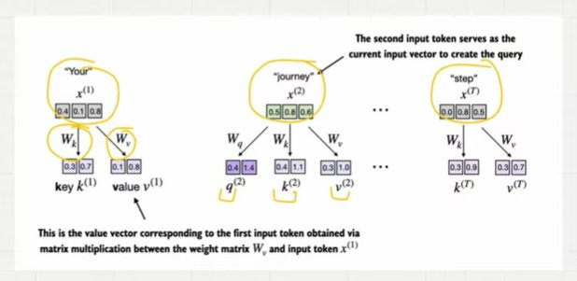
Figure 1: Each input token is projected into three separate vectors — query, key, and value — via the trainable weight matrices W_q, W_k, W_v. The second input token 'journey' x(2) serves as the current input vector to create the query q(2).

4. Step 1 — Computing the Query, Key, and Value Vectors
The first step projects the input embeddings through the three weight matrices to obtain query, key, and value vectors for every token in the sequence.

4.1 Single Token Projection — The Query for 'journey'
# Project x(2) = 'journey' to get query, key, value vectors
query_2 = x_2 @ W_query
key_2 = x_2 @ W_key
value_2 = x_2 @ W_value

print(query_2)
# tensor([0.4306, 1.4551]) <- q(2): what 'journey' is looking for

# q(2) shape: [2] (projected from 3-dim to 2-dim)
# This is the query derived from the second input token.
# It represents what 'journey' is 'asking for' when attending to the sequence.

4.2 All Tokens Projected — Queries, Keys, Values Matrices
# Project ALL tokens to get full Q, K, V matrices
queries = inputs @ W_query # [6, 3] @ [3, 2] = [6, 2]
keys = inputs @ W_key # [6, 3] @ [3, 2] = [6, 2]
values = inputs @ W_value # [6, 3] @ [3, 2] = [6, 2]

print('keys.shape: ', keys.shape) # torch.Size([6, 2])
print('values.shape: ', values.shape) # torch.Size([6, 2])
print('queries.shape:', queries.shape) # torch.Size([6, 2])

# Queries matrix Q (6x2) — from notes page 2 and page 4:
# [0.23, 1.09] <- 'Your' q(1)
# [0.43, 1.45] <- 'journey' q(2) <- the query row
# [0.43, 1.43] <- 'starts' q(3)
# [0.23, 0.79] <- 'with' q(4)
# [0.29, 0.65] <- 'one' q(5)
# [0.25, 1.05] <- 'step' q(6)

# Keys matrix K (6x2):
# [0.36, 0.76] <- 'Your' k(1)
# [0.44, 1.14] <- 'journey' k(2)
# [0.43, 1.11] <- 'starts' k(3)
# [0.24, 0.67] <- 'with' k(4)
# [0.18, 0.32] <- 'one' k(5)
# [0.32, 0.96] <- 'step' k(6)

# This is the value vector for first token obtained via
# matrix multiplication between W_v and input token x(1)

5. Step 2 — Computing Attention Scores
The attention scores are computed as dot products between the QUERY vector and every KEY vector. This is the unscaled attention score — it measures how much the query token should attend to each other token.

Query vs Key — The Critical Distinction from Topic 8
In Topic 8 (simplified attention):
attention_score(i, j) = x(i) . x(j) <- raw embeddings dotted together

In Topic 9 (trainable attention):
attention_score(i, j) = q(i) . k(j) <- PROJECTED vectors dotted together
where q(i) = x(i) @ W_q and k(j) = x(j) @ W_k

The unscaled attention score is computed as a dot product between
the query and the key vectors.

Since the query is derived from the current input token being processed,
and the model computes the context vector for the second input token,
the query is derived from that second input token.

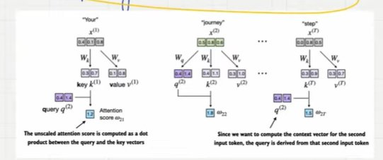
Figure 2: The query q(2) from 'journey' is dotted with each key vector k(1) through k(T). The unscaled attention score is the dot product between the query and the key vectors. w21=1.2 is the attention score between query q(2) and key k(1).

5.1 Computing Attention Scores for Query 'journey'
# Single attention score: query_2 dotted with key of 'journey' itself
keys_2 = keys[1] # k(2) = key for 'journey'
attn_score_22 = query_2.dot(keys_2) # q(2) . k(2)
print(attn_score_22) # tensor(1.8524)

# All attention scores for query 'journey' against all keys
attn_scores_2 = query_2 @ keys.T # [2] @ [2, 6] = [6]
print(attn_scores_2)
# tensor([1.2705, 1.8524, 1.8111, 1.0795, 0.5577, 1.5440])
# w21 w22 w23 w24 w25 w26
# 'your' 'journey' 'starts' 'with' 'one' 'step'

# w22 = 1.8524 <- highest: 'journey' attends most to itself
# w23 = 1.8111 <- second: close relation between 'journey' and 'starts'
# w25 = 0.5577 <- lowest: 'journey' has least relevance to 'one'

5.2 Full 6×6 Attention Score Matrix
# All attention scores for ALL query-key pairs
attn_scores = queries @ keys.T # [6, 2] @ [2, 6] = [6, 6]
print(attn_scores)
# Queries (6x2) x Keys.T (2x6) -> (6x6) attention score matrix
#
# tensor([[0.9231, 1.3545, 1.3241, 0.7910, 0.4032, 1.1330],
# [1.2705, 1.8524, 1.8111, 1.0795, 0.5577, 1.5440], <- row 2 = 'journey'
# [1.2544, 1.8284, 1.7877, 1.0654, 0.5508, 1.5238],
# [0.6973, 1.0167, 0.9941, 0.5925, 0.3061, 0.8475],
# [0.6114, 0.8819, 0.8626, 0.5121, 0.2707, 0.7307],
# [0.8995, 1.3165, 1.2871, 0.7682, 0.3937, 1.0996]])

# That attention score contains — when you look at query for 'journey' —
# how much importance should be given to other words.
# The (6x6) matrix is the FULL attention score matrix for all tokens.

6. Step 3 — Scaling and Softmax to Get Attention Weights
Before normalization is done, all attention scores are taken and scaled by the square root of the key dimension (sqrt(d_keys)). Currently the key dimension is 2. This is why this mechanism is called 'scaled dot-product attention'. The attention weights are then computed using the softmax function.

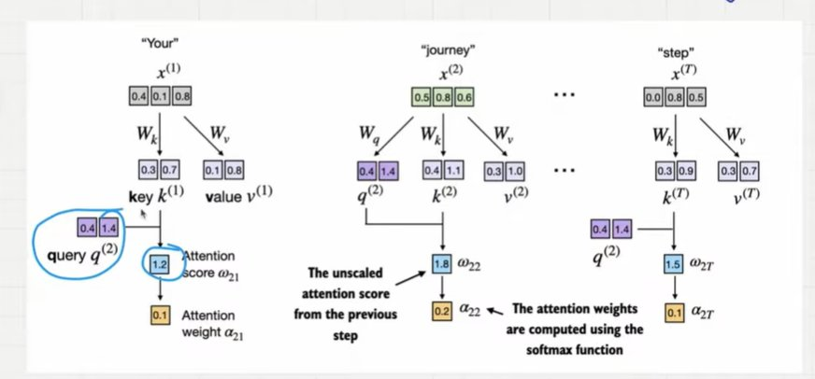
Figure 3: After computing unscaled attention scores, softmax is applied to obtain attention weights. Scores w21=1.2, w22=1.8, w2T=1.5 become weights a21=0.1, a22=0.2, a2T=0.1. The attention weights are computed using the softmax function.

6.1 Why Scale by sqrt(d_keys)? — Two Reasons

Reason 1: Stability in Learning
The softmax function is sensitive to the magnitudes of its inputs.
When inputs are large, softmax becomes 'peaky' — one value gets almost all
the probability mass and the rest receive very little.

Demonstration:
tensor = [0.1, -0.2, 0.3, -0.2, 0.5]
softmax(tensor): [0.19, 0.14, 0.24, 0.14, 0.29] <- balanced
softmax(tensor * 8): [0.03, 0.003, 0.16, 0.003, 0.80] <- peaky, unstable

These values are disproportionately high when scaling by 8.
Such sharp distributions make learning unstable.
Right now these attention weights are not optimized — they are optimized
during training. Stability in the softmax is critical for learning.

Reason 2: Variance Stability
The dot product of Q and K increases the variance because multiplying
two random numbers increases the variance.
The increase in variance grows with the dimension.

Demonstration (from code):
dim=5: variance before scaling = 4.63 | after scaling = 0.93
dim=100: variance before scaling = 95.1 | after scaling = 0.95

Dividing by sqrt(dimension) keeps the variance close to 1.
The reason that variance should be close to 1 is because it makes
learning stable — gradients flow properly during backpropagation.

This is why we divide by sqrt(d_keys), not just d_keys or any other factor.

# Scale by sqrt(d_keys) then apply softmax
d_k = keys.shape[-1] # d_k = 2
attn_weights_2 = torch.softmax(attn_scores_2 / d_k**0.5, dim=-1)
print(attn_weights_2)
# tensor([0.1500, 0.2264, 0.2199, 0.1311, 0.0906, 0.1820])

# Stability demonstration — why scaling matters:
tensor = torch.tensor([0.1, -0.2, 0.3, -0.2, 0.5])
print('Without scaling:', torch.softmax(tensor, dim=-1))
# tensor([0.1925, 0.1426, 0.2351, 0.1426, 0.2872]) <- balanced
print('With *8 scaling:', torch.softmax(tensor * 8, dim=-1))
# tensor([0.0326, 0.0030, 0.1615, 0.0030, 0.8000]) <- peaky, unstable

# Variance demonstration — why sqrt specifically:
# dim=5: before=4.63, after=0.93
# dim=100: before=95.1, after=0.95
# Dividing by sqrt(dim) keeps variance close to 1 regardless of dimension.

7. Step 4 — Computing the Context Vector from VALUE Vectors
This is the final step and the most important distinction between Topic 9 and Topic 8. The context vector is computed as a weighted sum of the VALUE vectors — NOT the raw input vectors. The value vectors are the projected versions of the input through W_v.

The Critical Distinction — Values vs Inputs
Topic 8 (simplified attention):
context_vec = attn_weights @ inputs <- weighted sum of RAW embeddings

Topic 9 (trainable attention):
context_vec = attn_weights @ values <- weighted sum of VALUE VECTORS
where values = inputs @ W_v

This distinction is what allows the model to learn what information
to EXTRACT from each token, independent of what it is SEARCHING for
(query) and what it is MATCHING against (key).

The last step is multiplying each VALUE vector with its respective
attention weight and then summing them to obtain the context vector.

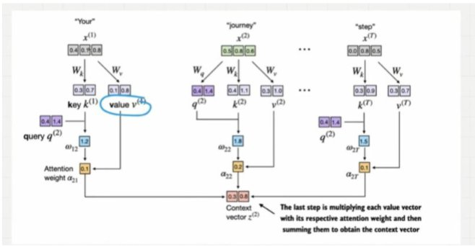
Figure 4: The last step is multiplying each value vector with its respective attention weight and then summing to obtain the context vector z(2). Value vector v(1) for 'Your' is highlighted — this is the value vector corresponding to the first input token obtained via matrix multiplication between W_v and input token x(1).

# Context vector as weighted sum of VALUE vectors
context_vec_2 = attn_weights_2 @ values
print(context_vec_2)
# tensor([0.3061, 0.8210])

# Compare with Topic 8's context vector:
# Topic 8 result: tensor([0.4419, 0.6515, 0.5683]) <- 3-dim (used raw inputs)
# Topic 9 result: tensor([0.3061, 0.8210]) <- 2-dim (uses value vectors)

# The context vector z(2) is an enriched embedding vector.
# It contains:
# -> Semantic meaning of 'journey'
# -> How all other words attend to journey (via attention weights)
# -> Information from the VALUE projections (not raw embeddings)

# None of the context vectors are optimized right now.
# When the LLM is trained, context vectors will be perfectly optimized
# because W_q, W_k, W_v will be learned end-to-end via backpropagation.

8. The Complete Pipeline — All Shapes Traced
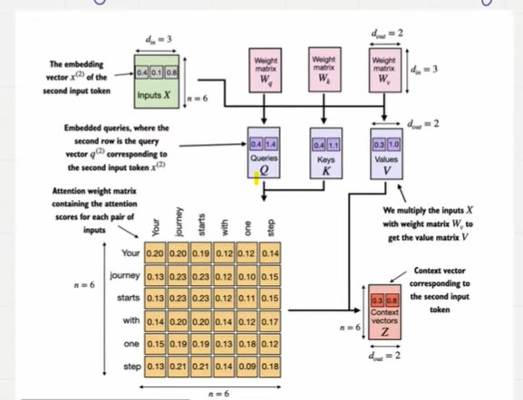
Figure 5: The complete self-attention architecture. Inputs X (6×3, d_in=3) are projected through three weight matrices W_q, W_k, W_v (each 3×2) to produce Queries Q (6×2), Keys K (6×2), and Values V (6×2). Q×K.T produces the 6×6 attention score matrix, softmax gives attention weights, and multiplying by V gives context vectors Z (6×2, d_out=2).

# THE COMPLETE SCALED DOT-PRODUCT ATTENTION PIPELINE

# Input: 6 tokens, each with 3-dimensional embedding
# d_in = 3, d_out = 2

# Step 1: Project inputs into Q, K, V
queries = inputs @ W_query # [6,3] @ [3,2] = [6,2] — QUERY matrix
keys = inputs @ W_key # [6,3] @ [3,2] = [6,2] — KEY matrix
values = inputs @ W_value # [6,3] @ [3,2] = [6,2] — VALUE matrix

# Step 2: Compute attention scores (unscaled)
attn_scores = queries @ keys.T # [6,2] @ [2,6] = [6,6]
# attn_scores[i,j] = q(i) . k(j) = how much token i attends to token j

# Step 3: Scale by sqrt(d_k) and apply softmax
d_k = keys.shape[-1] # d_k = 2
attn_weights = torch.softmax(attn_scores / d_k**0.5, dim=-1) # [6,6]
# Each row sums to 1.0

# Step 4: Compute context vectors as weighted sum of VALUE vectors
context_vecs = attn_weights @ values # [6,6] @ [6,2] = [6,2]
print(context_vecs)
# tensor([[0.2996, 0.8053],
# [0.3061, 0.8210], <- z(2) for 'journey'
# [0.3058, 0.8203],
# [0.2948, 0.7939],
# [0.2927, 0.7891],
# [0.2990, 0.8040]])

# Shape summary:
# inputs: [6, 3] d_in = 3
# W_q, W_k, W_v: [3, 2] d_out = 2
# Q, K, V: [6, 2]
# attn_scores: [6, 6] one score per token pair
# attn_weights: [6, 6] normalized (rows sum to 1)
# context_vecs: [6, 2] one enriched vector per token

9. SelfAttention_v1 — The Compact Class Implementation
The full mechanism is encapsulated in a PyTorch class. SelfAttention_v1 uses nn.Parameter with random initialization. This is a fully functional, trainable self-attention module.

import torch.nn as nn

class SelfAttention_v1(nn.Module):

def __init__(self, d_in, d_out):
super().__init__()
# Trainable weight matrices — updated during model training
self.W_query = nn.Parameter(torch.rand(d_in, d_out))
self.W_key = nn.Parameter(torch.rand(d_in, d_out))
self.W_value = nn.Parameter(torch.rand(d_in, d_out))

def forward(self, x):
keys = x @ self.W_key # Project to key space
queries = x @ self.W_query # Project to query space
values = x @ self.W_value # Project to value space

attn_scores = queries @ keys.T # Unscaled scores
attn_weights = torch.softmax(
attn_scores / keys.shape[-1]**0.5, # Scale by sqrt(d_k)
dim=-1
)
context_vec = attn_weights @ values # Weighted value sum
return context_vec

# Test
torch.manual_seed(123)
sa_v1 = SelfAttention_v1(d_in=3, d_out=2)
print(sa_v1(inputs))
# tensor([[0.2996, 0.8053],
# [0.3061, 0.8210],
# [0.3058, 0.8203],
# [0.2948, 0.7939],
# [0.2927, 0.7891],
# [0.2990, 0.8040]], grad_fn=<MmBackward0>)

10. SelfAttention_v2 — Using nn.Linear for Better Initialization
SelfAttention_v1 uses nn.Parameter with random initialization. SelfAttention_v2 improves this by using nn.Linear with bias disabled. The key advantage is that nn.Linear uses a more sophisticated weight initialization scheme — Kaiming uniform initialization — which contributes to more stable and effective model training.

class SelfAttention_v2(nn.Module):

def __init__(self, d_in, d_out, qkv_bias=False):
super().__init__()
# nn.Linear with bias=False performs: output = input @ W.T
# Uses Kaiming uniform initialization — better than random
self.W_query = nn.Linear(d_in, d_out, bias=qkv_bias)
self.W_key = nn.Linear(d_in, d_out, bias=qkv_bias)
self.W_value = nn.Linear(d_in, d_out, bias=qkv_bias)

def forward(self, x):
keys = self.W_key(x) # nn.Linear applies x @ W.T internally
queries = self.W_query(x)
values = self.W_value(x)

attn_scores = queries @ keys.T
attn_weights = torch.softmax(
attn_scores / keys.shape[-1]**0.5, dim=-1
)
context_vec = attn_weights @ values
return context_vec

torch.manual_seed(789)
sa_v2 = SelfAttention_v2(d_in=3, d_out=2)
print(sa_v2(inputs))
# tensor([[-0.0739, 0.0713],
# [-0.0748, 0.0703],
# [-0.0749, 0.0702],
# [-0.0760, 0.0685],
# [-0.0763, 0.0679],
# [-0.0754, 0.0693]], grad_fn=<MmBackward0>)

# Note: v1 and v2 give different outputs because they use different
# weight initialization schemes — different seeds produce different
# starting weights, leading to different initial context vectors.

Feature | SelfAttention_v1 | SelfAttention_v2
Weight type | nn.Parameter(torch.rand(...)) | nn.Linear(d_in, d_out, bias=False)
Initialization | Uniform random [0, 1] | Kaiming uniform (better for training)
Bias | No | No (qkv_bias=False)
Training | Both are trainable — requires_grad=True | Both are trainable — requires_grad=True
Preferred for | Illustration and understanding | Actual model training

11. Complete Shape Summary — Every Tensor Tracked

Tensor | Shape | Description
inputs X | [6, 3] | 6 input tokens, each with 3-dim embedding (d_in=3)
x(2) = 'journey' | [3] | Single query token embedding
W_q, W_k, W_v | [3, 2] | Trainable weight matrices (d_in=3, d_out=2)
query_2 = q(2) | [2] | Query vector for 'journey' — what it is looking for
keys K | [6, 2] | All key vectors — one per input token
values V | [6, 2] | All value vectors — one per input token
queries Q | [6, 2] | All query vectors — one per input token
attn_scores | [6, 6] | Q @ K.T — one score per query-key pair
attn_weights | [6, 6] | softmax(scores / sqrt(d_k)) — rows sum to 1
context_vecs Z | [6, 2] | attn_weights @ V — one enriched vector per token

12. Key Observations

- The three weight matrices W_q, W_k, W_v are the entire intelligence of self-attention. Everything else — dot products, softmax, weighted sums — is fixed arithmetic. Only these three matrices are learned during training. When the model improves at language generation, it does so by adjusting these weights.
- Separating query, key, and value allows the model to learn three different relationships independently: what to look for (query), what to match against (key), and what to extract (value). This separation is what allows attention to capture context far beyond simple embedding similarity.
- Dividing by sqrt(d_k) has two independent justifications: it prevents softmax from becoming peaky when attention scores are large, and it keeps the variance of the dot product close to 1 regardless of the key dimension. Both are required for stable training.
- None of the context vectors are optimized right now. When the LLM is trained, W_q, W_k, and W_v will be learned end-to-end via backpropagation, causing the context vectors to be perfectly optimized for the task of predicting the next token.
- In GPT-like models the input and output dimensions are usually the same — d_in = d_out = d_model. The example uses d_in=3 and d_out=2 only for clarity of illustration. In GPT-2 Small, d_model = 768, making all weight matrices 768×768.
- nn.Linear with bias=False is equivalent to matrix multiplication — it computes output = input @ W.T. The advantage over nn.Parameter is the optimized Kaiming uniform weight initialization, which leads to more stable training from the start.

13. Research Paper Connections

- Vaswani et al. (2017) — Attention Is All You Need: Section 3.2.1 defines Scaled Dot-Product Attention exactly as implemented here. The paper introduces the Q, K, V notation, the sqrt(d_k) scaling factor, and the softmax normalization. This topic is a direct, from-scratch implementation of Section 3.2.1.
- Radford et al. (2019) — GPT-2: Uses this exact mechanism — scaled dot-product attention — as the core of every Transformer block. GPT-2 Small has 12 attention heads per layer and 12 layers, each using independent W_q, W_k, W_v matrices of shape 768×64.
- Brown et al. (2020) — GPT-3: Scales the same mechanism to 175 billion parameters across 96 layers with 96 attention heads each. The Q/K/V mechanism is identical to what is implemented here — only the dimensions change.

14. What Comes Next
- Topic 10 — Causal Self-Attention: Adds the causal mask to the attention weight matrix. Before softmax, all future positions are set to negative infinity, ensuring the model only attends to previous and current tokens. This is the autoregressive constraint required for language generation.
- Topics 11-12 — Multi-Head Attention: Runs multiple instances of scaled dot-product attention in parallel, each with different learned W_q, W_k, W_v matrices. Each head learns to attend to different aspects of the input — some learn syntax, others semantics, others long-range structure. Their outputs are concatenated and projected into the final representation.

Building LLMs from Scratch — Research Documentation Series
Next: Topic 10 — Causal Self-Attention

