Building LLMs from Scratch
Series Documentation | Topic 19 | Stage 4
Next Token Prediction

Stage 4 Opens — Autoregressive Inference.
Coding GPT-2 to predict the next token: logits → softmax → argmax → decode. The model generates "Hello, I am Featureiman Byeswickattribute argue" because it has not been trained yet.

Author | SHIVA KIRAN DADISHETTY
Series | Building LLMs from Scratch
Topic | 19 of 36 — Stage 4: Pretraining
Also Known As | generate_text_simple — Greedy Decoding / Autoregressive Inference
Builds On | Topic 18 — GPTModel producing logits [batch, tokens, 50257]
Key Function | generate_text_simple(model, idx, max_new_tokens, context_size)
Key Insight | Model generates gibberish because weights are random — training not done yet

1. What an LLM Does — Autoregressive Token Generation
An LLM generates tokens given a certain sequence of input tokens. It generates one output token at a time. To generate one output token, the model is given the context size — that is the maximum number of tokens the model looks at before predicting the next token. GPT-2 has context_size = 1024.

The output logits shape is [batch_size, num_tokens, vocab_size]. Each element corresponds to the probability of it being the next token. For prediction, we look at the final row (the last token position) and find the token ID that gives the maximum value — that word would hopefully be the correct next word.

Output logits for 1 text sample — "Every effort moves you":
every → [---- 50257 values ----] each element = probability of being next token
effort → [---- 50257 values ----] after 3 predictions task
moves → [---- 50257 values ----] we come to main prediction task
you → [---- 50257 values ----] when "Every effort moves you" is input
we have predict output
1st batch → shape: 1 × 4 × 50257
2 batches → shape: 2 × 4 × 50257
↑ ↑ ↑
batch num vocab
size tokens size

2. Autoregressive Generation — The Growing Context
The key insight of autoregressive generation: the token generated in the previous round is appended to the input for the next iteration. The input context grows in each iteration.

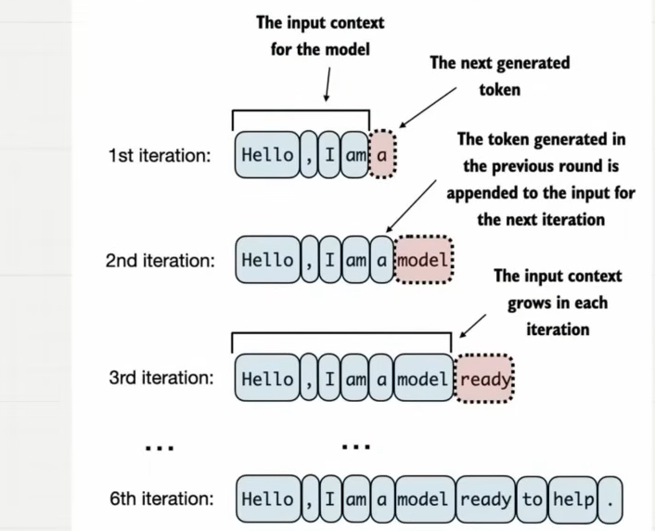
Figure 1: Autoregressive token generation. 1st iteration: model sees "Hello , I am" and predicts "a". 2nd iteration: "a" is appended — model sees "Hello , I am a" and predicts "model". 3rd iteration: "model" is appended — model sees "Hello , I am a model" and predicts "ready". By the 6th iteration, the model has generated "Hello , I am a model ready to help." — the predicted tokens accumulate as new context for each next prediction.

The Autoregressive Loop — Step by Step
Iteration 1: Context = [Hello, ",", I, am] → Predict: "a"
Append "a" to context

Iteration 2: Context = [Hello, ",", I, am, a] → Predict: "model"
Append "model" to context

Iteration 3: Context = [Hello, ",", I, am, a, model] → Predict: "ready"
Append "ready" to context

... (repeat for max_new_tokens iterations) ...

Iteration 6: Context = [Hello, ",", I, am, a, model, ready, to, help, "."]
Generated: "Hello, I am a model ready to help."

This step-by-step process enables the model to generate text sequentially,
building coherent phrases from the initial input context.
In practice, repeat over many iterations until we reach a user-specified
number of generated tokens (max_new_tokens).

3. The 6-Step Pipeline — Logits to Text
How do we go from the logits tensor produced by GPTModel to generated text? The notebook and your notes trace a 6-step pipeline. The diagram below shows the complete flow.

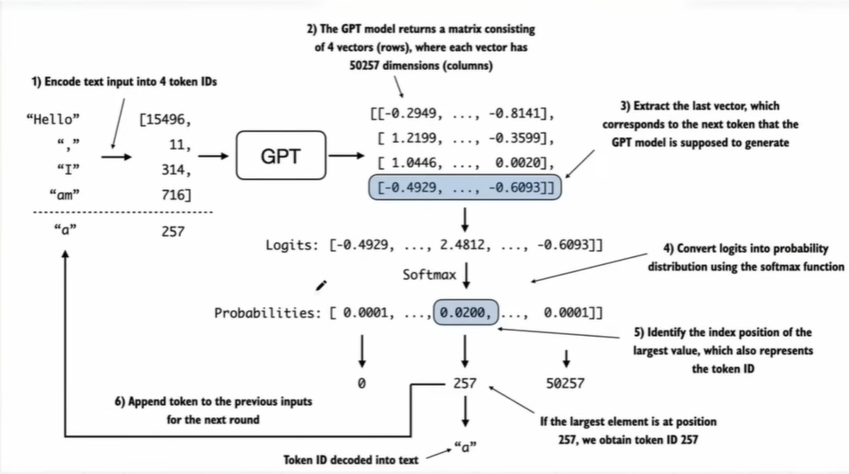
Figure 2: The 6-step logits-to-text pipeline. (1) Encode text input "Hello , I am" into token IDs [15496, 11, 314, 716]. (2) GPT model returns a matrix of 4 vectors (rows), each with 50257 dimensions — extract the last row [-0.4929, ..., -0.6093] corresponding to the next token prediction. (3) Extract the last vector. (4) Convert logits to probability distribution using softmax: [-0.4929, ..., 2.4812, ..., -0.6093] → probabilities [0.0001, ..., 0.0200, ..., 0.0001]. (5) Identify the index position of the largest value (position 257 → token ID 257). (6) Append token ID 257 (decoded as "a") to the previous inputs for the next round.

3.1 Step 1 — Encode Text Input into Token IDs
Convert raw text into token IDs using the GPT-2 tokenizer. Each word/subword maps to an integer index in the 50257-token vocabulary.

start_context = "Hello, I am"
encoded = tokenizer.encode(start_context)
print("encoded:", encoded)
# encoded: [15496, 11, 314, 716]

encoded_tensor = torch.tensor(encoded).unsqueeze(0) # add batch dimension
print("encoded_tensor.shape:", encoded_tensor.shape)
# encoded_tensor.shape: torch.Size([1, 4])

# "Hello" → 15496, "," → 11, "I" → 314, "am" → 716
# "a" (the next word) → 257

3.2 Step 2 — GPT Model Returns Matrix of 4 Vectors (50257 dims each)
The GPT model processes the 4 input tokens and returns a [batch, 4, 50257] tensor — 4 rows (one per token position), each with 50257 values (one per vocabulary token).

# GPT model output for "Hello , I am":
[[-0.2949, ..., -0.8141], # "Hello"
[ 1.2199, ..., -0.3599], # ","
[ 1.0446, ..., 0.0020], # "I"
[-0.4929, ..., -0.6093]] # "am" ← last row = next-token prediction

Shape: [1, 4, 50257]
These logits do NOT add up to 1.
Logits currently do NOT represent probabilities.

3.3 Step 3 — Extract the Last Vector
Focus on the last time step only. The last row corresponds to the next token that the GPT model is supposed to generate. Shape goes from [batch, n_tokens, vocab_size] → [batch, vocab_size].

# In generate_text_simple — Step 3:
logits = logits[:, -1, :] # (batch, n_tokens, vocab_size) → (batch, vocab_size)

# Last vector for "Hello, I am":
logits = [-0.4929, ..., 2.4812, ..., -0.6093]
# ↑
# position 257 has highest logit value (2.4812)

3.4 Step 4 — Convert Logits into Probabilities using Softmax
Apply softmax to convert raw logits into a proper probability distribution. After softmax, all values sum to 1 and represent probabilities.

# In generate_text_simple — Step 4:
probas = torch.softmax(logits, dim=-1) # (batch, vocab_size)

# Logits: [-0.4929, ..., 2.4812, ..., -0.6093]
# Probabilities: [ 0.0001, ..., 0.0200, ..., 0.0001]

# Note: softmax is monotonic — it preserves the ORDER of values.
# The position with highest logit = position with highest probability.
# Therefore softmax step is technically redundant (argmax gives same result).
# It is included to illustrate the full pipeline and add intuition.

3.5 Step 5 — Identify the Index Position of the Largest Value (Token ID)
The index of the maximum probability value IS the token ID. If the largest element is at position 257, we obtain token ID 257.

# In generate_text_simple — Step 5:
idx_next = torch.argmax(probas, dim=-1, keepdim=True) # (batch, 1)

# Probabilities: [ 0.0001, ..., 0.0200, ..., 0.0001]
# ↑ ↑ ↑
# 0 257 50257
# Largest value at position 257 → token ID = 257

# Token ID 257 decoded to text: "a"
# ("Hello, I am" → next word prediction = "a")

3.6 Step 6 — Append Token ID to Previous Inputs for the Next Round
The predicted token ID is appended to the current context sequence. The updated sequence becomes the input for the next iteration. This is the autoregressive loop.

# In generate_text_simple — Step 6:
idx = torch.cat((idx, idx_next), dim=1) # (batch, n_tokens+1)

# Before: idx = [[15496, 11, 314, 716]] shape [1, 4]
# Append: idx_next = [[257]] shape [1, 1]
# After: idx = [[15496, 11, 314, 716, 257]] shape [1, 5]

# "Hello , I am" + "a" → next iteration sees "Hello , I am a"
# Context grows by 1 token each iteration.

4. The Context Size Constraint — Cropping Long Sequences
GPT-2 has a context_size of 1024. If the input sequence grows longer than context_size (which happens after many iterations), the model must crop it — it can only look at the most recent context_size tokens when predicting the next word.

What if Context Size is 5?
Sequence: idx = [[10, 23, 45, 67, 89, 123, 56, 78]] # 8 tokens

idx[:, -context_size:] = idx[:, -5:]
→ [[67, 89, 123, 56, 78]]

We cannot look at 8 tokens before predicting the next word.
We can only look at the last 5 tokens (context_size = 5).
The earlier tokens [10, 23, 45] are cropped out.

GPT-2: context_size = 1024
After 1024+ tokens of generation, only the last 1024 are used as context.

# In generate_text_simple:
idx_cond = idx[:, -context_size:]
# Crop: only last context_size tokens used
# If LLM supports 5 tokens and context is 10 → only last 5 used

# Example from notes (context_size = 5):
idx = [[10, 23, 45, 67, 89, 123, 56, 78], # first sequence (8 tokens)
[ 9, 8, 7, 65, 4, 3, 2, 1]] # second sequence

idx_cond = idx[:, -5:]
# → [[67, 89, 123, 56, 78],
# [ 6, 5, 4, 3, 2]]

5. The generate_text_simple Function — Complete Implementation
The complete function from the notebook assembles all 6 steps inside an autoregressive loop. The function is called with model.eval() to disable dropout during inference.

def generate_text_simple(model, idx, max_new_tokens, context_size):
# idx is (batch, n_tokens) array of indices in the current context
for _ in range(max_new_tokens):

# Step 2: Crop current context if it exceeds context_size
# E.g. if LLM supports 5 tokens and context is 10 → only last 5 used
idx_cond = idx[:, -context_size:]

# Get predictions
with torch.no_grad():
logits = model(idx_cond)

# Step 3: Focus only on last time step
# (batch, n_tokens, vocab_size) → (batch, vocab_size)
logits = logits[:, -1, :]

# Step 4: Apply softmax to get probabilities
probas = torch.softmax(logits, dim=-1) # (batch, vocab_size)

# Step 5: Get idx of vocab entry with highest probability value
idx_next = torch.argmax(probas, dim=-1, keepdim=True) # (batch, 1)

# Step 6: Append sampled index to the running sequence
idx = torch.cat((idx, idx_next), dim=1) # (batch, n_tokens+1)

return idx

# ─── Test (from notebook) ──────────────────────────────────────────────────
start_context = "Hello, I am"
encoded = tokenizer.encode(start_context)
print("encoded:", encoded)
# encoded: [15496, 11, 314, 716]

encoded_tensor = torch.tensor(encoded).unsqueeze(0)
print("encoded_tensor.shape:", encoded_tensor.shape)
# encoded_tensor.shape: torch.Size([1, 4])

model.eval() # disable dropout during inference
out = generate_text_simple(
model=model,
idx=encoded_tensor,
max_new_tokens=6,
context_size=GPT_CONFIG_124M["context_length"]
)
print("Output:", out)
# Output: tensor([[15496, 11, 314, 716, 27018, 24086, 47843, 30961, 42348, 7267]])

print("Output Shape:", out.shape)
# Output Shape: torch.Size([1, 10]) # 4 original + 6 new tokens

decoded_text = tokenizer.decode(out.squeeze(0).tolist())
print(decoded_text)
# Hello, I am Featureiman Byeswickattribute argue

Why Does the Model Output Gibberish?
Output: "Hello, I am Featureiman Byeswickattribute argue"

The model generated gibberish — not coherent text.

Reason: the model has NOT been trained yet.
The GPT architecture was initialized with RANDOM WEIGHTS.
Random weights → random logits → random argmax → random tokens.

The architecture and the generation mechanism are both correct.
The weights are simply random — training (Stage 4) will fix this.

After training (Topics 20–26), the model will generate meaningful text.
After loading OpenAI pretrained weights (Topic 26):
"Hello, I am a model ready to help." ← coherent output

6. Iteration Trace — "Hello, I am" to "Hello, I am a model ready to help."
Your notes trace the full 6-iteration autoregressive generation, showing how the context grows at each step and what token is predicted. max_new_tokens = 6.

Iteration | Context (input) | Predicted token | Token IDs
1 | [15496, 11, 314, 716]  Hello, I am | [257]  "a" | [15496,11,314,716,257]
2 | [15496,11,314,716,257]  Hello, I am a | [2746]  "model" | [15496,11,314,716,257,2746]
3 | [15496,11,314,716,257,2746]  Hello, I am a model | [3492]  "ready" | [15496,...,257,2746,3492]
4 | ...  Hello, I am a model ready | [284]  "to" | [15496,...,3492,284]
5 | ...  Hello, I am a model ready to | [1037]  "help" | [15496,...,284,1037]
6 | [15496,...,3492,284,1037,13]  Hello, I am a model ready to help | [.]  period | [15496,...,1037,13]

After 6 iterations, max_new_tokens = 6 are generated. The output token IDs after 6 iterations: [15496, ..., 3492, 284, 1037, 13]. Decoded: "Hello, I am a model ready to help." — the generated new text.

7. Greedy Decoding — What generate_text_simple Does
The generate_text_simple function implements greedy decoding — at every step it picks the single token with the highest probability. This is the simplest possible decoding strategy.

Softmax is Monotonic — The argmax Shortcut
The softmax function is monotonic — it preserves the order of its inputs.
The position with the highest score in the softmax output tensor is the same
position in the original logit tensor.

Therefore: the softmax step is technically redundant.
We could apply torch.argmax directly to the logits tensor and get identical results.

Logits: [-0.49, ..., 2.48, ..., -0.61] → argmax at position 257
Probabilities: [0.001, ..., 0.02, ..., 0.001] → argmax at position 257 ← SAME

The softmax step is included to illustrate the full process of transforming
logits into probabilities — this adds intuition even if not strictly needed.
This kind of generation is known as greedy decoding.

Limitation: greedy decoding always picks the most likely next token.
This can lead to repetitive or unimaginative text.
Topic 23 (Temperature Scaling) and Topic 24 (Top-k Sampling) introduce
techniques to add variability and creativity to the generated text.

8. Key Observations

- LLM generates tokens one at a time — context grows with each step — each call to generate_text_simple runs max_new_tokens forward passes through the full GPTModel. Each pass produces one new token. The generated token is appended to the context before the next pass. This is why text generation is slow for long outputs — one complete forward pass per token.
- model.eval() is required before generation — calling model.eval() disables dropout. During training, dropout randomly zeros some activations. During inference, all neurons must be active for deterministic, full-power predictions. Forgetting eval() would give different outputs every call due to random dropout masks.
- torch.no_grad() eliminates unnecessary gradient computation — during inference (forward pass only), gradients are not needed. wrapping the model call in torch.no_grad() prevents PyTorch from building the computational graph for backpropagation, saving memory and computation.
- The context crop is essential for long generation — idx[:, -context_size:] ensures the model never receives more than context_size tokens. Without this, after 1025 tokens the input would exceed GPT-2's positional embedding table (which only has 1024 rows) and cause an index error.
- Gibberish output is expected — the architecture is correct — the model produces random-looking text because its weights are randomly initialized. The generation mechanism (argmax of softmax of last-row logits) is working perfectly. The weights need training to produce coherent output. This will be fixed in Topics 20–26.
- Softmax monotonicity means argmax can skip softmax — for greedy decoding, softmax is computationally unnecessary. torch.argmax(logits[:, -1, :], dim=-1) gives the same result as torch.argmax(softmax(logits[:, -1, :]), dim=-1). The softmax is kept to show the full probability pipeline clearly.

9. Research Paper Connections

- Radford et al. (2019) — GPT-2 — the autoregressive generation method implemented in generate_text_simple is exactly how GPT-2 generates text. The model is a decoder-only transformer that predicts the next token given all previous tokens (causal/autoregressive generation). Every word is generated one at a time by repeating the 6-step pipeline.
- Bengio et al. (2003) — A Neural Probabilistic Language Model — the foundational paper establishing that language models learn probability distributions over sequences of words. The output logit → softmax → probability distribution is the direct implementation of this idea. Each row in the [batch, tokens, 50257] output represents a probability distribution over the next token.
- Vinyals and Le (2015) — A Neural Conversational Model — greedy decoding (argmax selection at each step) was an early standard for autoregressive generation. The paper also identified its limitations — repetition and lack of diversity — motivating the sampling techniques in Topics 23 and 24.

10. What Comes Next

- Topic 20 — LLM Loss Function — cross-entropy loss measures how wrong the model's predictions are. For each token position, the model produces a 50257-dimensional probability distribution. The loss measures how far the predicted distribution is from the correct next token. This provides the training signal for all 163M parameters.
- Topic 22 — Full Pretraining Loop — the complete training loop: optimizer, learning rate scheduler, gradient clipping, training and validation loss tracking. After pretraining on real text, generate_text_simple will produce coherent English rather than gibberish.
- Topic 23 — Temperature Scaling — greedy decoding (argmax) always picks the most likely token — deterministic but repetitive. Temperature scaling modifies the logits before softmax to control the "creativity" of the model: lower temperature = more conservative, higher = more diverse/creative.
- Topic 26 — Loading OpenAI GPT-2 Weights — once OpenAI's pretrained weights are loaded into this exact GPTModel, generate_text_simple will produce coherent, fluent English — the same output as GPT-2 itself. This is the validation that the complete architecture is correct.

