Building LLMs from Scratch
Series Documentation | Topic 11 | Stage 2
Multi-Head Attention Part 1

Also known as the Wrapper Implementation.
Multiple parallel attention heads — each with independent weights, each asking a different question — concatenated into a unified context representation.

Author | SHIVA KIRAN DADISHETTY
Series | Building LLMs from Scratch
Topic | 11 of 36 — Stage 2: Attention Mechanism
Also Known As | Multi-Head Attention Wrapper Implementation
Builds On | Topic 10 — Causal Self-Attention with Mask and Dropout
Key Addition 1 | nn.ModuleList — stacking num_heads independent CausalAttention instances
Key Addition 2 | torch.cat(..., dim=-1) — concatenating head outputs along the embedding dimension

1. What Multi-Head Attention Is — And Why It Exists
Multi-head attention is a direct extension of the CausalAttention class built in Topic 10. Instead of running one attention operation with one set of learned weight matrices, the model runs multiple attention operations in parallel — each with its own independently trained W_Q, W_K, W_V matrices — and concatenates all their outputs into a single representation.

Each parallel attention operation is called a head. Every head receives the same input sequence but develops its own specialization because its weights are learned independently through separate gradient paths. The concatenated output contains all specializations simultaneously, giving the model a richer understanding of each token than any single head could provide.

The Core Constraint
SELF-ATTENTION (Topic 9):
One W_Q, W_K, W_V set — one attention matrix — one context vector per token

CAUSAL ATTENTION (Topic 10):
Same as above, but with causal mask and dropout — cannot attend to future

MULTI-HEAD ATTENTION (Topic 11):
num_heads independent sets of W_Q, W_K, W_V
num_heads causal attention matrices (each masked, each with dropout)
num_heads context vectors per token — concatenated into one final output

The causal mask from Topic 10 applies INSIDE each head independently.
Every head still obeys the same rule: cannot look to the right.

The Stage 2 Progression — Where We Are
Simplified self-attention → broad idea, no trainable weights
Self-attention → added W_Q, W_K, W_V projection matrices
Causal attention → extended with causal mask + dropout
Multi-head attention p1 → multiple parallel heads via wrapper ← THIS TOPIC
Multi-head attention p2 → efficient parallel implementation

2. Why Multiple Heads? The Specialization Argument
A single attention head produces one weighted average of value vectors — one perspective on every token. That perspective must simultaneously capture grammar, tense, semantics, co-reference, and every other linguistic relationship through a single set of weights. Multiple heads break this burden across specialized units. Two implementation approaches exist:

Approach 1 — Stacking (This Topic) | Create num_heads independent CausalAttention instances using nn.ModuleList. Run them sequentially in the forward pass. Concatenate outputs via torch.cat along dim=-1. Explicit, clear, and pedagogically transparent.
Approach 2 — Parallel (Topic 12) | Represent all heads as a single large weight matrix and split it via tensor reshaping. Process all heads simultaneously in one matrix multiplication. Mathematically identical to Approach 1 but computationally efficient. Used in production.

This can be computationally intensive relative to a single head, but it makes LLMs powerful at complex pattern recognition. The heads do not repeat the same computation — they learn fundamentally different functions because their gradients flow through separate weight spaces.

3. The Numerical Walkthrough — One Head, One Batch
Building from Topic 9: the self-attention with W_Q, W_K, W_V is already familiar. Multi-head attention runs that exact mechanism multiple times in parallel, each time with a different set of weight matrices. This section traces the complete computation using the actual values from the notebook (torch.manual_seed(123), d_in=3, d_out=2).

3.1 Weight Matrices (torch.manual_seed(123))
Three weight matrices are initialized. Each has shape [d_in=3, d_out=2]. These are the actual values produced by the notebook — each head in a multi-head setup would have its own independent set.

torch.manual_seed(123)
W_query = nn.Parameter(torch.rand(d_in, d_out), requires_grad=False)
W_key = nn.Parameter(torch.rand(d_in, d_out), requires_grad=False)
W_value = nn.Parameter(torch.rand(d_in, d_out), requires_grad=False)

W_query: [[0.2961, 0.5166], W_key: [[0.1366, 0.1025], W_value: [[0.0756, 0.1966],
[0.2517, 0.6886], [0.1841, 0.7264], [0.3164, 0.4017],
[0.0740, 0.8665]] [0.3153, 0.6871]] [0.1186, 0.8274]]
shape [3, 2] shape [3, 2] shape [3, 2]

3.2 Computing Query, Key, Value for Token 2 ("journey")
Using x_2 = inputs[1] = [0.55, 0.87, 0.66] (the "journey" token) as the query — the same example used in Topic 9:

x_2 = inputs[1] # "journey" → [0.55, 0.87, 0.66]

query_2 = x_2 @ W_query → tensor([0.4306, 1.4551])
key_2 = x_2 @ W_key
value_2 = x_2 @ W_value

# All queries, keys, values for the full sequence:
queries = inputs @ W_query shape [6, 2]
keys = inputs @ W_key shape [6, 2]
values = inputs @ W_value shape [6, 2]

3.3 Attention Scores and Scaling
The attention score between "journey" (query_2) and every token is the dot product of query_2 with each key. The score is then scaled by 1/sqrt(d_k) to prevent the softmax from becoming too peaked:

# Single score: query_2 against key_2 (journey against journey)
attn_score_22 = query_2.dot(keys[1]) → tensor(1.8524)

# All scores for query_2 against every key:
attn_scores_2 = query_2 @ keys.T
→ tensor([1.2705, 1.8524, 1.8111, 1.0795, 0.5577, 1.5440])
# Your journey starts with one step

# Full 6×6 attention score matrix (queries @ keys.T):
attn_scores = queries @ keys.T
→ tensor([[0.9231, 1.3545, 1.3241, 0.7910, 0.4032, 1.1330], # Your
[1.2705, 1.8524, 1.8111, 1.0795, 0.5577, 1.5440], # journey
[1.2544, 1.8284, 1.7877, 1.0654, 0.5508, 1.5238], # starts
[0.6973, 1.0167, 0.9941, 0.5925, 0.3061, 0.8475], # with
[0.6114, 0.8819, 0.8626, 0.5121, 0.2707, 0.7307], # one
[0.8995, 1.3165, 1.2871, 0.7682, 0.3937, 1.0996]]) # step

# Scale by 1/sqrt(d_k=2) and apply softmax to query_2 row:
d_k = keys.shape[-1] # = 2
attn_weights_2 = torch.softmax(attn_scores_2 / d_k**0.5, dim=-1)
→ tensor([0.1500, 0.2264, 0.2199, 0.1311, 0.0906, 0.1820])
# Sum = 1.0 ✅

# Context vector for "journey" = weighted sum of value vectors:
context_vec_2 = attn_weights_2 @ values
→ tensor([0.3061, 0.8210]) shape [2] — one per d_out dimension

3.4 From One Head to Multi-Head
Each CausalAttention head runs the above computation independently with its own W_query, W_key, W_value. The two heads produce Z1 and Z2, both of shape [6, 2]. Concatenated along dim=-1:

# Two heads, each with independent weights, run on the same batch:
batch = torch.stack((inputs, inputs), dim=0) # shape [2, 6, 3]

mha = MultiHeadAttentionWrapper(d_in=3, d_out=2, context_length=6,
dropout=0.0, num_heads=2)
context_vecs = mha(batch)

context_vecs.shape → torch.Size([2, 6, 4])
# 2 batches, 6 tokens, d_out×num_heads = 4

context_vecs =
tensor([[[-0.4519, 0.2216, 0.4772, 0.1063], # Your
[-0.5874, 0.0058, 0.5891, 0.3257], # journey
[-0.6300, -0.0632, 0.6202, 0.3860], # starts
[-0.5675, -0.0843, 0.5478, 0.3589], # with
[-0.5526, -0.0981, 0.5321, 0.3428], # one
[-0.5299, -0.1081, 0.5077, 0.3493]], # step
[identical values — same input stacked twice]])

First 2 values per token = Head 1 output (Z1)
Last 2 values per token = Head 2 output (Z2)

Main Idea — Vaswani et al. (2017)
Run the attention mechanism multiple times (in parallel) with
different, learned linear projections.

The results of multiplying input data (query, key, value vectors)
by a weight matrix are the projections.

Each head = one set of linear projections (W_Q, W_K, W_V).
Multi-head = multiple projections running simultaneously.
Output = concatenation of all projected context vectors.

4. GPT-2 Anatomy — How 12 Heads Process One Token
To make multi-head attention concrete: track the token "sat" from the 3-token sequence "The cat sat" through GPT-2 small (12 heads, 768-dimensional embeddings). The mechanism operates in three distinct phases.

4.1 The Slice (Input)
The model takes the 768-dimensional vector for "sat" and cuts it into 12 segments of 64 dimensions each. Each head operates exclusively on its own segment — it never sees the other 11 segments.

Segment 1 (Head 1) : gets dimensions 1 – 64
Segment 2 (Head 2) : gets dimensions 65 – 128
Segment 3 (Head 3) : gets dimensions 129 – 192
...
Segment 12 (Head 12): gets dimensions 705 – 768

Each head performs its Q/K/V math ONLY on its specific 64-dim slice.
This forces each head to develop a different specialization:
if a head only ever sees dimensions 1–64, it must extract everything
it needs from that subspace — so it learns a specific kind of question.

4.2 The Multi-Tasking (Processing)
Each head looks at its 64-dimensional slice and asks a fundamentally different question about "sat." These questions emerge from training — not from explicit programming.

Head 1 (Grammar): Is "sat" the verb for the noun "cat"?
Focuses on the syntactic dependency between "cat" and "sat".

Head 2 (Tense): Is this past, present, or future?
Identifies the "-at" ending as a past-tense marker.

Head 3 (Logic): Can a cat physically perform the action of sitting?
Checks for semantic plausibility of the verb-subject pair.

...all 12 heads run in parallel on their respective 64-dim slices...

4.3 The Re-Stitch (Output)
Each head produces a new 64-dimensional result based on its specific findings. The model concatenates all 12 outputs horizontally to restore the original 768 dimensions.

Head 1 outputs its 64-dim "grammar report"
Head 2 outputs its 64-dim "tense report"
Head 3 outputs its 64-dim "logic report"
...
Head 12 outputs its 64-dim report

The model glues them horizontally:
[Head1(64)] + [Head2(64)] + ... + [Head12(64)] = 768 total dimensions

"sat" is now a 768-wide vector containing 12 expert opinions about
its role in that specific sentence. This richer vector is passed to
the next layer to help predict the next word.

The diagram below shows this concatenation. Two heads each produce a context vector matrix (Z₁ and Z₂), which are then stacked horizontally into the final output Z.

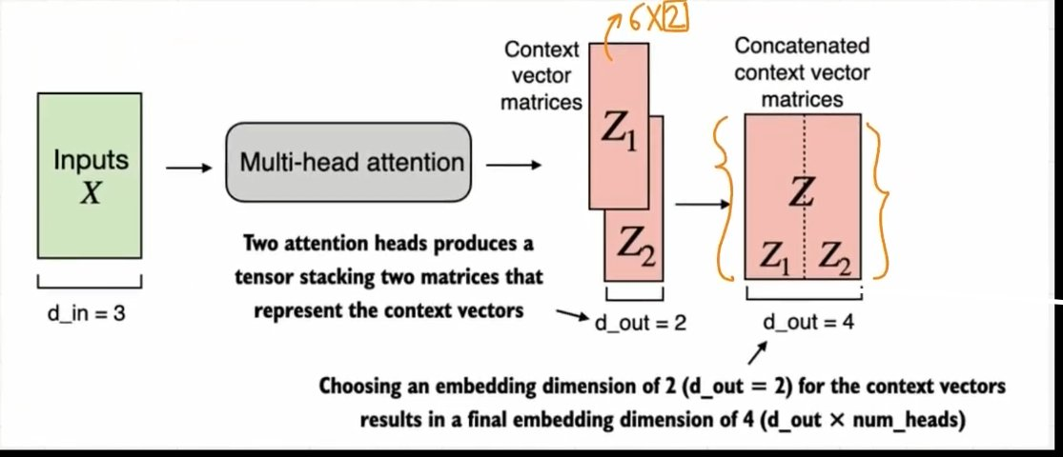
Figure 1: Two attention heads produce Z₁ and Z₂ (each shape 6×2, annotated "6×2" in orange). Concatenated horizontally to produce Z of shape 6×4. Final embedding dimension = d_out × num_heads = 2 × 2 = 4.

5. The Causal Constraint Across All Heads
GPT-2 is an autoregressive model — it generates one word at a time. It uses causal self-attention (masked self-attention) throughout — the mechanism built in Topic 10. Even though each head specializes on different patterns, all heads share one architectural rule.

The Mask Rule
Even though each of the 12 heads is looking at different things,
they are ALL forced to follow one rule: "you cannot look to the right."

BERT (bidirectional): a token CAN attend to everything — past AND future.

GPT-2 (causal): if the model could see future words, it would simply
cheat and copy them instead of learning to predict.
The causal mask prevents this entirely.

Basically: the 12 heads provide the DIVERSITY of what to look at.
The causal mask provides the DIRECTION (past only).

5.1 The Calculation
For any token at position i, it can only compute Query-Key scores with tokens at positions 1 through i. Attention scores for all future tokens are set to −∞ before softmax, making their probability exactly zero.

Sequence: [The, robot, is, eating]

When model processes "is" (position 3):
→ All 12 heads CAN see [The, robot, is] ← positions 1, 2, 3
→ All 12 heads are BLIND to [eating] ← position 4

Each head uses its 64-dim slice to find different patterns in those
three visible words to predict what word comes next.

5.2 Why the 12 Heads Are Still Vital
Even constrained to look backward only, heads still specialize on different parts of the past context. Each head independently chooses which past positions to weight heavily based on its learned function.

Head 1: might focus on the immediately preceding token
(to get grammar right — e.g., "an" before a vowel)

Head 2: might look all the way back to the first token of the paragraph
(to remember the overall topic)

Head 3: might look for the subject that appeared 10 words ago
(to make sure the verb agrees with it)

6. The MultiHeadAttentionWrapper Class — Complete Implementation
The MultiHeadAttentionWrapper class wraps multiple CausalAttention instances from Topic 10 using nn.ModuleList and concatenates their outputs along the embedding dimension. The full data flow is shown in the diagram below before the complete implementation.

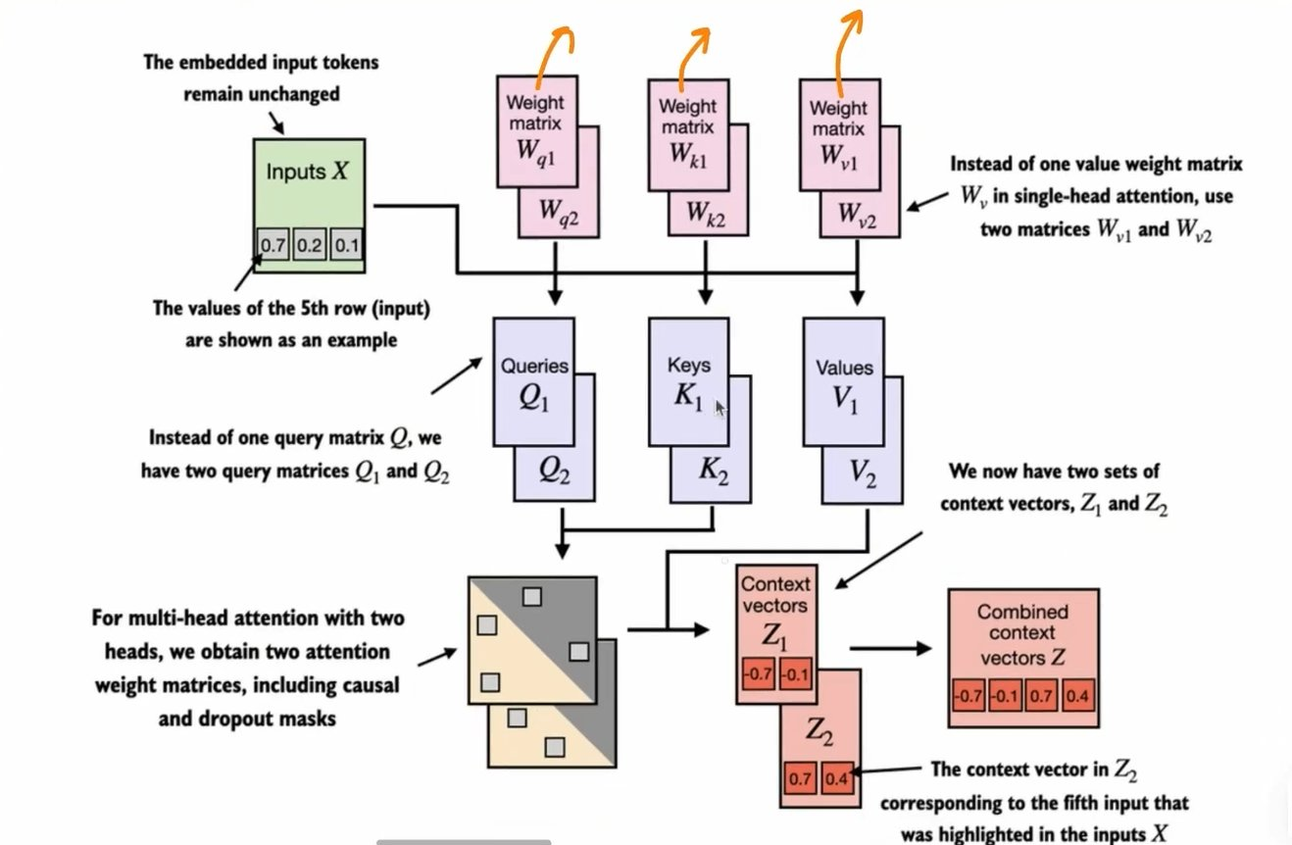
Figure 2: Full multi-head attention data flow. Input X is projected independently by two sets — W_q1/W_k1/W_v1 for Head 1 and W_q2/W_k2/W_v2 for Head 2. Each set produces Q/K/V matrices, computes causal+dropout attention, and outputs context vectors Z₁ and Z₂. These are combined into the final Z = [Z₁ | Z₂]. Instead of one W_v in single-head attention, two matrices W_v1 and W_v2 are used.

import torch
import torch.nn as nn

class MultiHeadAttentionWrapper(nn.Module):

def __init__(self, d_in, d_out, context_length,
dropout, num_heads, qkv_bias=False):
super().__init__()
# nn.ModuleList: registers each CausalAttention as a proper submodule
# Each head has its own W_query, W_key, W_value weight matrices
# Each head has its own register_buffer causal mask
self.heads = nn.ModuleList(
[CausalAttention(d_in, d_out, context_length, dropout, qkv_bias)
for _ in range(num_heads)]
)

def forward(self, x):
# Run each head independently, concatenate along dim=-1 (embedding dim)
return torch.cat([head(x) for head in self.heads], dim=-1)

# ─── Test ───────────────────────────────────────────────────────────────
inputs = torch.tensor(
[[0.43, 0.15, 0.89], # Your
[0.55, 0.87, 0.66], # journey
[0.57, 0.85, 0.64], # starts
[0.22, 0.58, 0.33], # with
[0.77, 0.25, 0.10], # one
[0.05, 0.80, 0.55]] # step
)
batch = torch.stack((inputs, inputs), dim=0) # shape: [2, 6, 3]

torch.manual_seed(123)
context_length = batch.shape[1] # 6
d_in, d_out = 3, 2
mha = MultiHeadAttentionWrapper(
d_in, d_out, context_length, dropout=0.0, num_heads=2
)
context_vecs = mha(batch)
print("context_vecs.shape:", context_vecs.shape)
# context_vecs.shape: torch.Size([2, 6, 4])
# 2 batches, 6 tokens each, 4-dimensional context vectors (d_out × num_heads)

print(context_vecs)
# tensor([[[-0.4519, 0.2216, 0.4772, 0.1063],
# [-0.5874, 0.0058, 0.5891, 0.3257],
# [-0.6300, -0.0632, 0.6202, 0.3860],
# [-0.5675, -0.0843, 0.5478, 0.3589],
# [-0.5526, -0.0981, 0.5321, 0.3428],
# [-0.5299, -0.1081, 0.5077, 0.3493]],
# [identical values for batch 2 — same input stacked twice]])

7. New Implementation Details — Two Critical Additions

7.1 nn.ModuleList — Why Not a Plain Python List
The heads are stored in nn.ModuleList, not a plain Python list. This is a critical design decision with direct consequences for training.

nn.ModuleList vs Plain Python List
Plain Python list:
PyTorch CANNOT track parameters stored inside a plain list.
→ mha.parameters() misses all W_Q, W_K, W_V weights from all heads
→ Optimizer cannot find or update head weights during training
→ model.state_dict() misses all head weights — save/load is broken
→ Training silently fails: parameters exist but optimizer cannot see them

nn.ModuleList:
PyTorch REGISTERS each CausalAttention as a proper submodule.
→ mha.parameters() includes ALL W_Q, W_K, W_V from ALL heads
→ Optimizer updates all head weights correctly during backpropagation
→ model.state_dict() includes all head weights — save/load works

Rule: any nn.Module stored as a list attribute must use nn.ModuleList.
Any nn.Module stored as a dict attribute must use nn.ModuleDict.

7.2 torch.cat — Concatenating Along the Embedding Dimension
The forward method collects context vectors from all heads and concatenates along dim=-1 — the last (embedding) dimension. The batch and token dimensions are preserved.

# With 2 heads, each producing output shape [batch, tokens, d_out]:

head_1_output → [2, 6, 2] (batch=2, tokens=6, d_out=2)
head_2_output → [2, 6, 2]

torch.cat([head_1_output, head_2_output], dim=-1)
→ [2, 6, 4] (d_out × num_heads = 2 × 2 = 4)

dim=-1 means: concatenate along the LAST dimension (embedding dim).
Batch dimension (0) and token dimension (1) are preserved unchanged.

# Common mistake — concatenating along wrong dimension:
torch.cat([...], dim=1) → [2, 12, 2] ← WRONG (stacks along token dim)
torch.cat([...], dim=-1) → [2, 6, 4] ← CORRECT

8. Shape Tracking — Complete Flow

Tensor | Shape | Description
batch input | [2, 6, 3] | 2 samples, 6 tokens each, d_in=3
Each head: queries | [2, 6, 2] | Input projected through W_query (d_out=2)
Each head: keys | [2, 6, 2] | Input projected through W_key (d_out=2)
Each head: values | [2, 6, 2] | Input projected through W_value (d_out=2)
Each head: attn_scores | [2, 6, 6] | queries @ keys.transpose(1,2) — one 6×6 matrix per batch item
mask (per head) | [6, 6] | Upper triangular — 1s above diagonal (from register_buffer)
masked attn_scores | [2, 6, 6] | Future positions filled with −inf (in-place masked_fill_)
attn_weights (per head) | [2, 6, 6] | After softmax — lower triangular, each row sums to 1
attn_weights (dropout) | [2, 6, 6] | Some positions zeroed, remaining rescaled by 1/dropout_rate
context_vec (per head) | [2, 6, 2] | attn_weights @ values — one context vector per token
context_vecs (all heads) | [2, 6, 4] | torch.cat across 2 heads along dim=-1: d_out × num_heads = 4

In GPT-2 small: d_model=768, num_heads=12, d_head=64. Output shape: [batch, context_length, 768]. Output dimension equals input dimension — this is why GPT-2 can stack 12 identical transformer layers; the embedding shape is preserved through every block.

Dimension Mathematics
This implementation (d_in=3, d_out=2, num_heads=2):
Per head: [2, 6, 3] × W_Q/K/V [3,2] → [2, 6, 2]
After cat: [2, 6, 2] + [2, 6, 2] → [2, 6, 4]
Final dim = d_out × num_heads = 2 × 2 = 4

GPT-2 small (d_model=768, num_heads=12, d_head=768/12=64):
Each head: [batch, tokens, 768] → operates on 64-dim slice
output: [batch, tokens, 64]
After cat: [batch, tokens, 64 × 12] = [batch, tokens, 768]
Output dim = input dim ✅ shape is preserved through all 12 layers.

9. Key Observations

- Multi-head attention is not just repeating attention multiple times — each head operates in a different learned subspace. Because W_Q, W_K, W_V are independent across heads and trained through separate gradient paths, each head naturally specializes on a different linguistic or semantic function.
- nn.ModuleList is non-negotiable — a plain Python list silently breaks training. Parameters stored in a plain list are invisible to PyTorch's parameter tracking, meaning the optimizer cannot find or update them. Always use nn.ModuleList for lists of nn.Module instances.
- The wrapper approach processes heads sequentially — [head(x) for head in self.heads] runs heads one after another, not simultaneously. This is mathematically correct but not the most efficient. Topic 12 derives the equivalent parallel implementation where all heads run in one matrix multiplication.
- The causal mask applies inside each CausalAttention instance independently — each head carries its own register_buffer mask from Topic 10. All heads obey the same constraint (no future tokens), but each applies the mask to its own attention score matrix separately.
- Output dimension grows as d_out × num_heads — in GPT-2, d_out = d_model / num_heads = 768 / 12 = 64 so that the concatenated output restores the original embedding dimension exactly. This dimensional symmetry enables stacking identical transformer blocks.
- Both batch items in the test produce identical outputs — because both inputs are the same tensor stacked twice. In real training each batch item is a different text sequence and the outputs diverge accordingly.

10. Research Paper Connections

- Vaswani et al. (2017) — Attention Is All You Need — Section 3.2.2: Multi-Head Attention — the paper states "Multi-head attention allows the model to jointly attend to information from different representation subspaces at different positions." It defines h parallel attention heads with d_k = d_v = d_model / h. The wrapper is the most direct reading of this formulation. The paper also defines the output projection matrix W^O introduced in Topic 12.
- Radford et al. (2019) — GPT-2: Language Models are Unsupervised Multitask Learners — uses 12 multi-head attention layers throughout. Each layer has 12 heads with d_head = 768 / 12 = 64. The causal mask from Topic 10 applies inside every head of every layer. The model is purely autoregressive — no bidirectional attention at any point.
- Srivastava et al. (2014) — Dropout: A Simple Way to Prevent Neural Networks from Overfitting — the dropout applied inside each CausalAttention head is unchanged from Topic 10. The scaling factor 1/p is applied automatically by PyTorch to rescale non-dropped values. During inference, dropout is turned off automatically.

11. What Comes Next

- Topic 12 — Multi-Head Attention Part 2 — the wrapper runs heads sequentially via [head(x) for head in self.heads]. Topic 12 derives the mathematically identical but efficient parallel implementation: a single large weight matrix is split into head-sized chunks via tensor reshaping, processing all heads simultaneously. Topic 12 also introduces the output projection matrix W^O from Vaswani et al.
- Topic 13 — Bird's Eye View of LLM Architecture — once both multi-head attention implementations are complete, Stage 2 closes and Stage 3 opens with the full GPT-2 Transformer block. The CausalAttention and MultiHeadAttention modules built across Topics 7–12 plug directly into the complete block alongside Layer Normalization, GELU, Feed-Forward layers, and Shortcut connections.
- Topic 18 — GPT-2, 124M Parameter Model — every design decision across Topics 7–11 — the Q/K/V projection matrices, the causal mask, the dropout, the multi-head concatenation — is precisely what defines GPT-2. By Topic 18 the complete 124M parameter model will be assembled from exactly these components, with all 12 transformer blocks preserving the residual stream shape [batch, context_length, 768].

