Building LLMs from Scratch
Series Documentation | Topic 15 | Stage 3
GELU Activation & Feed-Forward Network

GPT Architecture Part 3.
A small neural network sub-module inside every transformer block: Linear(768→3072) → GELU → Linear(3072→768). Expands, activates, contracts — all without changing the residual stream shape.

Author | SHIVA KIRAN DADISHETTY
Series | Building LLMs from Scratch
Topic | 15 of 36 — Stage 3: LLM Architecture
Also Known As | FeedForward with GELU — GPT Architecture Part 3
Builds On | Topic 14 — LayerNorm (LayerNorm 2 sits before this FFN block)
Key Addition 1 | GELU class — smooth activation: 0.5×x×(1+tanh(√(2/π)×(x+0.044715×x³)))
Key Addition 2 | FeedForward class — Linear(emb_dim→4×emb_dim) → GELU → Linear(4×emb_dim→emb_dim)

1. Where the Feed-Forward Block Sits in the Architecture
Every transformer block contains a small neural network sub-module called the Feed-Forward block. It sits after the masked multi-head attention and its associated LayerNorm. The feed-forward block is the last component inside each of the 12 transformer blocks before the shortcut connection.

Final GPT Architecture
└── Transformer Block (×12)
├── (2) Layer Normalization 1 (Topic 14)
├── Masked Multi-Head Attention (Topics 10–12)
├── Shortcut connection +
├── (2) Layer Normalization 2 (Topic 14)
├── (3) Feed-Forward Network ← THIS TOPIC
│ └── Linear(768→3072)
│ GELU activation
│ Linear(3072→768)
└── Shortcut connection +

The diagram below shows the complete transformer block. The Feed-Forward block (shown expanded on the right) contains three layers: Linear → GELU → Linear:

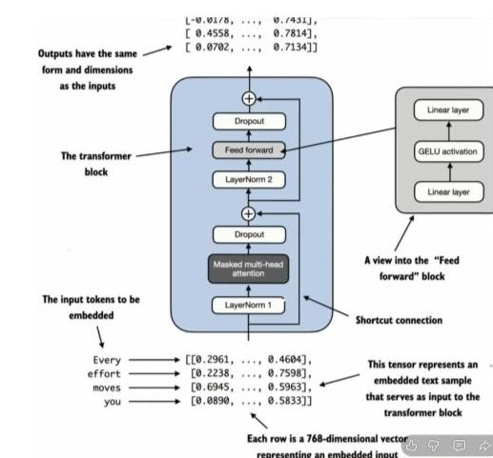
Figure 1: Complete transformer block with the Feed-Forward sub-block expanded on the right. The block processes tokens through LayerNorm 1 → Masked Multi-Head Attention → shortcut → LayerNorm 2 → Feed-Forward → shortcut. The feed-forward block itself: Linear layer → GELU activation → Linear layer. Outputs have the same form and dimensions as the inputs.

2. Two Activation Functions Commonly Implemented in LLMs
Two activation functions are commonly used in modern large language models. GPT-2 uses GELU. Both are significant improvements over simpler activations like sigmoid.

GELU  (Gaussian Error Linear Unit)  Used in GPT-2, BERT, GPT-3 | GELU(x) = x × Φ(x)  where Φ(x) is the CDF of the Standard Gaussian distribution.  Smooth and differentiable everywhere.  Allows small negative values to pass through (not hard zero).  Better gradient flow → better training.
SwiGLU  (Swish-Gated Linear Unit)  Used in LLaMA, Mistral, PaLM | SwiGLU(x, gate) = x × σ(gate)  Gated variant — uses two inputs.  More expressive than GELU.  Favored in most post-2022 frontier LLMs.  Not used in GPT-2 — covered for awareness.

3. ReLU — Why It Is Not Used in GPT-2
ReLU is the most widely used activation function in neural networks generally. Understanding its limitations explains exactly why GELU was chosen for GPT-2.

ReLU(x) = max(0, x)

↑ y
| /
| /
| /
─────|/──────→ x
0

ReLU(x) = x if x > 0
= 0 if x ≤ 0

Property 1: NOT differentiable at x = 0
The gradient is undefined at the kink point.

Property 2: Hard zero for all negative inputs
Any neuron with x < 0 outputs exactly 0.
Gradient through that neuron = 0.
→ Dead neuron problem.

The Dead Neuron Problem
If the output from a layer is negative, and ReLU activation is applied to it:
→ Output becomes exactly 0.
→ Gradient through that path = 0.
→ That neuron cannot update its weights during backpropagation.
→ The neuron associated with that particular output does not contribute
anything to the learning process.

Once a ReLU neuron "dies" (always outputs 0), it can never recover.
It is permanently disconnected from the gradient flow.
With many dead neurons, large portions of the network stop learning.

GELU solves this by never outputting exactly zero for negative values.

4. GELU — The Formula and Intuition
GELU stands for Gaussian Error Linear Unit. Its output is x multiplied by the CDF of the Standard Gaussian distribution evaluated at x.

4.1 The Exact Formula
The CDF of the standard Gaussian distribution is defined as:

GELU(x) = x × Φ(x)

where Φ(x) = ∫ from -∞ to x of (1/√(2π)) × e^(-t²/2) dt

Φ(x) is the Cumulative Distribution Function (CDF) of the
Standard Gaussian (Normal) distribution N(0,1).

Interpretation of Φ(x):
For positive x → Φ(x) → 1 → GELU(x) ≈ x × 1 = x
For negative x → Φ(x) → 0 → GELU(x) ≈ x × 0 = 0 (approximately)
But crucially: for negative x, GELU is NOT exactly zero.
It will be a small negative value.
→ Gradient is not zero → no dead neurons.

4.2 The Tanh Approximation Used to Train GPT-2
The exact GELU formula requires computing the Gaussian CDF, which is expensive. An approximation using tanh was used to train GPT-2:

GELU(x) ≈ 0.5 × x × (1 + tanh(√(2/π) × (x + 0.044715 × x³)))

This is the approximation used for training GPT-2.
The constant 0.044715 was determined empirically.
√(2/π) ≈ 0.7979

This approximation is very close to the exact GELU but much faster to compute.
tanh is differentiable everywhere → smooth gradients throughout.

5. GELU vs ReLU — Key Differences
The fundamental difference is what happens for negative input values. This one difference has major consequences for gradient flow during backpropagation.

x: [-3.0, -2.0, -1.0, -0.5, 0.0, 0.5, 1.0, 2.0, 3.0]
GELU: [-0.0036, -0.0454, -0.1588, -0.1543, 0.0, 0.3457, 0.8412, 1.9546, 2.9964]
ReLU: [ 0.0, 0.0, 0.0, 0.0, 0.0, 0.5, 1.0, 2.0, 3.0]

Key observations:
At x = -1: GELU = -0.1588 ← small but non-zero. Gradient can flow.
ReLU = 0.0000 ← hard zero. Gradient is zero = dead neuron.

At x = -3: GELU = -0.0036 ← very small but still non-zero.
ReLU = 0.0000 ← always zero for any negative value.

For positive values: GELU ≈ ReLU (nearly identical for x > 1)
At x = 0: both are exactly 0.

GELU is smooth (differentiable everywhere).
ReLU has a non-differentiable kink at x = 0.

GELU  Smooth activation | GELU(-1) = -0.1588 (not zero)  GELU(0) = 0.0000  GELU(1) = 0.8412  GELU(2) = 1.9546  GELU(3) = 2.9964  Small negative values pass through.  Gradient is never exactly zero.  No dead neurons. Smooth curve.
ReLU  Hard threshold | ReLU(-1) = 0.0000 (hard zero)  ReLU(0) = 0.0000  ReLU(1) = 1.0000  ReLU(2) = 2.0000  ReLU(3) = 3.0000  All negative values → exactly zero.  Gradient = 0 for all negative inputs.  Dead neurons possible. Hard kink at 0.

6. The GELU Class — Implementation
The GELU approximation is implemented as a PyTorch nn.Module so it can be used inside nn.Sequential like any other layer.

class GELU(nn.Module):
def __init__(self):
super().__init__()

def forward(self, x):
return 0.5 * x * (1 + torch.tanh(
torch.sqrt(torch.tensor(2.0 / torch.pi)) *
(x + 0.044715 * torch.pow(x, 3))
))

# The formula: GELU(x) ≈ 0.5 × x × (1 + tanh(√(2/π) × (x + 0.044715 × x³)))
# torch.pi = π = 3.14159...
# torch.sqrt(torch.tensor(2.0 / torch.pi)) = √(2/π) ≈ 0.7979
# torch.pow(x, 3) = x³
# torch.tanh is differentiable everywhere — no kinks, no dead neurons.

7. The Feed-Forward Network — Architecture
The FeedForward class implements the complete feed-forward sub-module that appears in every transformer block. It is a small neural network with two linear layers and one GELU activation between them.

7.1 The Expansion-Contraction Design
The key design principle is the 4× expansion and contraction. Input embeddings (768-dimensional in GPT-2) are first projected to a 4× larger space (3072-dimensional), then contracted back to the original dimension. This diagram shows the flow:

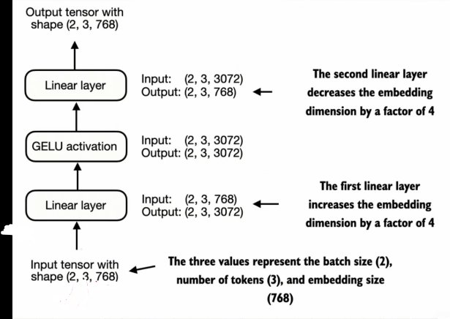
Figure 2: Feed-Forward block tensor flow. Input [2, 3, 768] → Linear layer 1 (increases embedding dimension by 4×) → [2, 3, 3072] → GELU activation → [2, 3, 3072] → Linear layer 2 (decreases embedding dimension by 4×) → Output [2, 3, 768]. Batch size=2, num_tokens=3, emb_dim=768.

And below, the same expansion-contraction shown as a neural network architecture — the inputs (768 nodes) are projected into 4× larger space (3072 nodes) by Linear Layer 1, then shrunk back to 768 by Linear Layer 2:

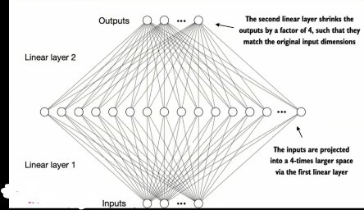
Figure 3: Feed-Forward network viewed as a neural network. Inputs (768-dimensional) are projected into a 4-times larger space via the first linear layer. The second linear layer shrinks the outputs by a factor of 4 to match the original input dimensions. This expansion allows for rich exploration of the representation space.

7.2 Why 4× Expansion?
The 4× expansion ratio comes from Vaswani et al. (2017). It gives the network capacity to learn complex, non-linear feature transformations in the larger space before projecting back. The intermediate 3072-dimensional representation allows the model to explore a richer feature space than 768 dimensions would permit.

Expansion and Contraction — The Key Insight
The feed-forward block works in three stages:

Stage 1 — Expansion: Linear(768 → 3072)
Projects each token's 768-dim vector into a 3072-dim space.
This larger space allows the model to explore richer representations.

Stage 2 — Non-linearity: GELU
Applies smooth non-linear transformation in the 3072-dim space.
Small negative values pass through — no dead neurons.
The model learns which features to activate and which to suppress.

Stage 3 — Contraction: Linear(3072 → 768)
Projects back to the original 768-dim embedding space.
Output shape matches input — residual stream is preserved.

"Expansion and contraction allows for a rich exploration space."

8. FeedForward Implementation and Shape Trace
The complete FeedForward class using nn.Sequential — the same design as the notebook implementation:

class FeedForward(nn.Module):
def __init__(self, cfg):
super().__init__()
self.layers = nn.Sequential(
nn.Linear(cfg["emb_dim"], 4 * cfg["emb_dim"]), # 768 → 3072 (expansion)
GELU(), # non-linear activation
nn.Linear(4 * cfg["emb_dim"], cfg["emb_dim"]), # 3072 → 768 (contraction)
)

def forward(self, x):
return self.layers(x)

# ─── Test ──────────────────────────────────────────────────────────────────
GPT_CONFIG_124M = {
"vocab_size": 50257, "context_length": 1024, "emb_dim": 768,
"n_heads": 12, "n_layers": 12, "drop_rate": 0.1, "qkv_bias": False
}

ffn = FeedForward(GPT_CONFIG_124M)
x = torch.rand(2, 3, 768) # batch=2, tokens=3, emb_dim=768
out = ffn(x)
print(out.shape)
# torch.Size([2, 3, 768]) ← same shape as input ✅

8.1 Shape Tracking

Layer | Shape | Description
Input tensor | [2, 3, 768] | batch=2, num_tokens=3, emb_dim=768
After Linear 1 | [2, 3, 3072] | 768 → 3072: ×4 expansion. Each token's vector grows from 768 to 3072 dimensions
After GELU | [2, 3, 3072] | Shape unchanged. Non-linear activation applied element-wise
After Linear 2 | [2, 3, 768] | 3072 → 768: ÷4 contraction. Back to original embedding dimension
Output tensor | [2, 3, 768] | Identical shape to input — shortcut connection requires this

8.2 Parameter Count
The FeedForward block is parameter-heavy — it contains the majority of parameters in each transformer block:

Linear 1 (768 → 3072):
Weights: 768 × 3072 = 2,359,296
Bias: + 3,072
Subtotal: 2,362,368 parameters

Linear 2 (3072 → 768):
Weights: 3072 × 768 = 2,359,296
Bias: + 768
Subtotal: 2,360,064 parameters

Total FeedForward parameters: 4,722,432 per transformer block
× 12 transformer blocks: 56,668,984 parameters from FFN alone
(approximately 46% of GPT-2 small's 124M total parameters)

9. Key Observations

- GELU never outputs exactly zero for negative inputs — this is the critical difference from ReLU. At x=-1, GELU=-0.1588. At x=-3, GELU=-0.0036. Small, but non-zero. The gradient can flow. No neuron ever permanently dies. This smooth behaviour throughout the entire input range is why GELU outperforms ReLU in language models.
- The 4× expansion ratio comes from Vaswani et al. (2017) — the original Transformer paper used d_ff = 4 × d_model. GPT-2 follows this directly: emb_dim=768, expanded dimension=3072 (=4×768). The ratio is not arbitrary — it provides enough capacity for the model to learn complex transformations while keeping parameter counts manageable.
- The FeedForward block accounts for ~46% of GPT-2's parameters — 4.7M parameters per block × 12 blocks ≈ 56.7M parameters from FFN alone, out of 124M total. Understanding this matters for research: if you want to make GPT-2 smaller or more efficient, the FFN is the dominant target. LoRA (Topic 36) targets both attention weights and FFN weights for this reason.
- Input shape = Output shape is mandatory — the FeedForward block is wrapped by a shortcut connection that adds the block's output to its input. Both must have identical shape [b, tokens, 768]. The expansion-contraction design guarantees this while still allowing rich internal computation.
- nn.Sequential makes the three layers a single callable — using nn.Sequential(Linear, GELU(), Linear) means the forward pass is simply return self.layers(x). PyTorch chains the layers automatically. This is clean, readable, and identical in behaviour to calling them sequentially.
- GELU is differentiable everywhere — because tanh is differentiable everywhere, the entire GELU approximation is differentiable everywhere. No kinks, no undefined gradients. This property is what makes GELU a drop-in improvement over ReLU for deep network training.

10. Research Paper Connections

- Hendrycks and Gimpel (2016) — Gaussian Error Linear Units (GELUs) — the paper introducing GELU. The key insight: rather than applying a hard gate (ReLU outputs exactly 0 or x), apply a smooth probabilistic gate: x × Φ(x), where Φ(x) is the probability of a standard Gaussian random variable being less than x. For large positive x, Φ(x)→1 so GELU(x)≈x. For large negative x, Φ(x)→0 so GELU(x)≈0 but never exactly. The tanh approximation implemented here is from Equation 2 of that paper.
- Vaswani et al. (2017) — Attention Is All You Need — Section 3.3: Position-wise Feed-Forward Networks — this is the origin of the 4× expansion design. The paper defines FFN(x) = max(0, xW1+b1)W2+b2 using ReLU. GPT-2 replaces ReLU with GELU but keeps the 4× expansion ratio. The FeedForward class implemented in this topic directly implements the GPT-2 variant of this architecture.
- Radford et al. (2019) — GPT-2: Language Models are Unsupervised Multitask Learners — GPT-2 uses GELU throughout all 12 transformer blocks, replacing the ReLU from the original Vaswani formulation. The emb_dim=768, expansion factor=4, giving d_ff=3072. The FeedForward class built here is what goes into every one of GPT-2's 12 transformer blocks. Topic 17 (Full Transformer Block) assembles this alongside LayerNorm and MultiHeadAttention.

11. What Comes Next

- Topic 16 — Shortcut Connections — the FeedForward block and the MultiHeadAttention block both have shortcut (residual) connections wrapped around them. The shortcut adds the block's input directly to its output before passing to the next layer. Topic 16 derives why this is essential for gradient flow through 12 stacked blocks and implements the shortcut mechanism.
- Topic 17 — Full Transformer Block — once LayerNorm (Topic 14), GELU + FeedForward (Topic 15), and shortcuts (Topic 16) are complete, the full TransformerBlock class replaces DummyTransformerBlock. This single class combines: LayerNorm 1 → MultiHeadAttention → shortcut → LayerNorm 2 → FeedForward → shortcut. That is the complete transformer block that GPT-2 stacks 12 times.
- Topic 18 — GPT-2 124M Parameter Model — with TransformerBlock complete, the DummyGPTModel from Topic 13 becomes a real GPTModel. The 12 stacked TransformerBlocks, the embedding layers, and the output projection head come together into a 124M parameter model. Stage 3 closes and Stage 4 (pretraining) opens.

