Building LLMs from Scratch
Series Documentation | Topic 10 | Stage 2
Causal Self-Attention

Also known as Masked Attention.
The autoregressive constraint that makes language generation possible.

Author | SHIVA KIRAN DADISHETTY
Series | Building LLMs from Scratch
Topic | 10 of 36 — Stage 2: Attention Mechanism
Also Known As | Masked Attention
Builds On | Topic 9 — Self-Attention with W_Q, W_K, W_V
Key Addition 1 | Causal mask — upper triangular -infinity mask
Key Addition 2 | Dropout — regularization during training

1. What Causal Attention Is — And Why It Must Exist
Causal attention, also known as masked attention, is a special form of self-attention. It introduces one critical constraint that makes language generation possible: the model is restricted to only consider previous and current inputs when processing any given token.

The Core Constraint
SELF-ATTENTION (Topic 9): Every token can attend to ALL other tokens
— past, present, and future positions

CAUSAL ATTENTION (Topic 10): Every token can only attend to tokens that
occur AT OR BEFORE the current position

This is the autoregressive constraint. It is not optional — it is required.
Without it, the model would see future tokens during training and simply
memorize them rather than learning to predict them.

When computing attention scores, the causal attention mechanism ensures that the model only factors in tokens that occur at or before the current token in the sequence. This is in contrast to the self-attention mechanism implemented in Topic 9, which allows access to the entire input sequence at once.

The Stage 2 Progression — Where We Are
Simplified self-attention → introduced the broad idea, no trainable weights
Self-attention → added W_Q, W_K, W_V trainable projection matrices
Causal attention → extended self-attention with causal mask + dropout ← THIS TOPIC
Multi-head attention → extend causal attention to run in parallel heads

2. The Problem — Why Unmasked Attention Cannot Generate Text
Consider the sentence 'Your journey starts with one step.' During training, the model sees the complete sentence. Without causal masking, when processing the token 'journey', the model would have access to 'starts', 'with', 'one', and 'step' — tokens that come AFTER it. This is information leakage.

# Full attention — NO causal mask (Topic 9 behavior):
# When processing 'journey' (position 2):
# Can attend to: 'Your' (past), 'journey' (self), 'starts' (FUTURE)
# 'with' (FUTURE), 'one' (FUTURE), 'step' (FUTURE)
#
# This is WRONG for language generation because:
# At inference time, future tokens DO NOT EXIST yet.
# The model is supposed to PREDICT them — not read them.
#
# If trained with access to future tokens:
# → Model learns to cheat by reading ahead
# → At inference time there is nothing to read ahead
# → Model fails completely
#
# Solution: MASK future tokens so they are invisible during training.
# This forces the model to learn genuine prediction from context.

3. Masking Strategy — Two Approaches
To achieve causal masking, future token positions in the attention weight matrix must be zeroed out. There are two equivalent approaches — a naive approach and a more efficient one that exploits the mathematical properties of softmax.

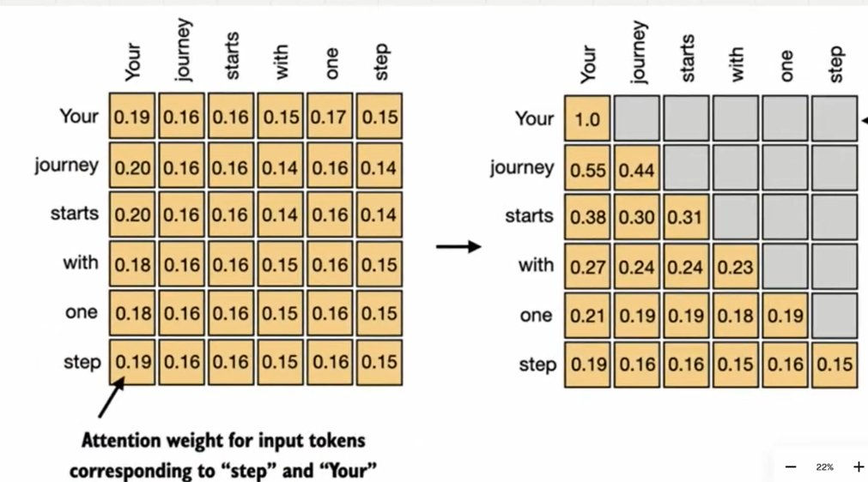
Figure 1: The full 6×6 attention weight matrix (left) becomes the causal masked lower-triangular matrix (right). Every position above the diagonal is zeroed — 'Your' can only see itself, 'journey' can see 'Your' and itself, and so on. The final row 'step' can see all previous tokens.

3.1 Approach 1 — Mask After Softmax (Naive)
The straightforward approach applies softmax first to get normalized attention weights, then multiplies by a lower-triangular mask to zero out future positions, then renormalizes so each row sums to 1 again.

# Step 1: Compute attention weights normally (from Topic 9)
attn_weights = torch.softmax(attn_scores / keys.shape[-1]**0.5, dim=1)
# All values between 0 and 1, each row sums to 1

# Step 2: Create lower-triangular mask (1s where allowed, 0s where masked)
context_length = attn_scores.shape[0] # 6
mask_simple = torch.tril(torch.ones(context_length, context_length))
print(mask_simple)
# tensor([[1., 0., 0., 0., 0., 0.],
# [1., 1., 0., 0., 0., 0.],
# [1., 1., 1., 0., 0., 0.],
# [1., 1., 1., 1., 0., 0.],
# [1., 1., 1., 1., 1., 0.],
# [1., 1., 1., 1., 1., 1.]])

# Step 3: Element-wise multiply — zeros out future positions
masked_simple = attn_weights * mask_simple
# Row 1 ('Your'): [0.19, 0.00, 0.00, 0.00, 0.00, 0.00]
# Row 2 ('journey'): [0.20, 0.17, 0.00, 0.00, 0.00, 0.00]

# Step 4: Renormalize so each row sums to 1 again
row_sums = masked_simple.sum(dim=1, keepdim=True)
masked_simple_norm = masked_simple / row_sums
# Row 1 ('Your'): [1.00, 0.00, 0.00, 0.00, 0.00, 0.00]
# Row 2 ('journey'): [0.55, 0.45, 0.00, 0.00, 0.00, 0.00]
# Row 6 ('step'): [0.19, 0.17, 0.17, 0.15, 0.17, 0.15] <- all visible

Why Renormalization Is Needed
After zeroing out future positions, the remaining values in each row no longer
sum to 1. They sum to a value less than 1 (the sum of only the non-masked weights).

Dividing by the row sum renormalizes so that each row sums to 1 again.
'Normalized' means the values in each row sum to 1.

This is necessary so that the attention weights remain interpretable as
a probability distribution over the visible tokens.

3.2 Approach 2 — Upper Triangular -Infinity Mask (Efficient)
The more efficient approach exploits a key mathematical property of softmax: when an input to softmax is negative infinity, the output is exactly zero (because e^(-∞) = 0). By filling future positions with -∞ BEFORE softmax, the normalization happens automatically — no separate renormalization step needed.

# Step 1: Create upper triangular mask (1s above diagonal = future positions)
mask = torch.triu(torch.ones(context_length, context_length), diagonal=1)
print(mask)
# tensor([[0., 1., 1., 1., 1., 1.],
# [0., 0., 1., 1., 1., 1.],
# [0., 0., 0., 1., 1., 1.],
# [0., 0., 0., 0., 1., 1.],
# [0., 0., 0., 0., 0., 1.],
# [0., 0., 0., 0., 0., 0.]])

# Step 2: Fill future positions with -infinity BEFORE softmax
masked = attn_scores.masked_fill(mask.bool(), -torch.inf)
print(masked)
# tensor([[0.2899, -inf, -inf, -inf, -inf, -inf],
# [0.4656, 0.1723, -inf, -inf, -inf, -inf],
# [0.4594, 0.1703, 0.1731, -inf, -inf, -inf],
# [0.2642, 0.1024, 0.1036, 0.0186, -inf, -inf],
# [0.2183, 0.0874, 0.0882, 0.0177, 0.0786, -inf],
# [0.3408, 0.1270, 0.1290, 0.0198, 0.1290, 0.0078]])

# Step 3: Apply softmax — -inf positions become exactly 0 automatically
attn_weights = torch.softmax(masked / keys.shape[-1]**0.5, dim=1)
print(attn_weights)
# tensor([[1.0000, 0.0000, 0.0000, 0.0000, 0.0000, 0.0000],
# [0.5517, 0.4483, 0.0000, 0.0000, 0.0000, 0.0000],
# [0.3800, 0.3097, 0.3103, 0.0000, 0.0000, 0.0000],
# [0.2758, 0.2460, 0.2462, 0.2319, 0.0000, 0.0000],
# [0.2175, 0.1983, 0.1984, 0.1888, 0.1971, 0.0000],
# [0.1935, 0.1663, 0.1666, 0.1542, 0.1666, 0.1529]])

# Each row already sums to 1 — NO separate renormalization needed!
# e^(-inf) = 0, so softmax handles the zeroing AND normalization in one step.

Why the -Infinity Trick Is Better
Approach 1: softmax → mask → renormalize (3 operations)
Approach 2: mask with -inf → softmax (2 operations, same result)

Mathematical reason: softmax(x_i) = exp(x_i) / sum(exp(x_j))
When x_i = -infinity: exp(-inf) = 0
So the softmax output is 0 for all masked positions automatically.
The remaining positions are automatically renormalized because
the denominator only includes non-zero (non-masked) terms.

Result: identical to Approach 1 but requires no separate renormalization step.
This is the approach used in all production implementations.

tril vs triu — The Difference
torch.tril(ones): lower triangular — 1s on and below diagonal (KEEP these)
torch.triu(ones, diagonal=1): strictly upper triangular — 1s above diagonal (MASK these)

For causal masking:
Use tril for the simple approach (multiply with 1s to keep)
Use triu with diagonal=1 for the efficient approach (fill 1s with -inf)

diagonal=1 means: main diagonal is excluded from the upper triangular fill.
This ensures tokens CAN attend to themselves (diagonal = current position).

4. Masking Additional Attention Weights with Dropout
After applying the causal mask, a second masking step is introduced: dropout. Dropout is a deep learning regularization technique where randomly selected units are ignored during training. This prevents overfitting and improves generalization performance.

What Dropout Does
Dropout randomly sets a fraction of values to ZERO during each training step.
The fraction zeroed out is controlled by the dropout rate (e.g. 0.5 = 50%).

IMPORTANT: The remaining non-zeroed values are SCALED UP to compensate.
With dropout rate 0.5: remaining values are multiplied by 1/0.5 = 2.
This scaling maintains the overall balance of the attention weights,
ensuring that the average influence remains consistent during training.

During INFERENCE (generating text): dropout is turned OFF automatically.
The model uses all attention weights — no random zeroing.

4.1 Where Dropout Is Applied in the Transformer
In Transformer architectures like GPT, dropout is applied in two specific areas of the attention mechanism:

Location | When Applied | Purpose
After attention scores | Before softmax normalization | Regularize the raw score distribution
After attention weights | After softmax, before context vector | Most common — regularize the weight distribution

Applying dropout after calculating attention weights is more common and is what is implemented in the CausalAttention class. The dropout mask zeros out random positions in the already-normalized attention weight matrix, then rescales the remaining values.

# Dropout demonstration
torch.manual_seed(123)
dropout = torch.nn.Dropout(0.5) # 50% dropout rate

# Applied to a 6x6 matrix of ones:
example = torch.ones(6, 6)
print(dropout(example))
# tensor([[2., 2., 0., 2., 2., 0.],
# [0., 0., 0., 2., 0., 2.],
# [2., 2., 2., 2., 0., 2.], ...
# Values are 0 (dropped) or 2 (scaled up: 1 / 0.5 = 2)

# Applied to causal attention weights:
torch.manual_seed(123)
print(dropout(attn_weights))
# tensor([[2.0000, 0.0000, 0.0000, 0.0000, 0.0000, 0.0000],
# [0.0000, 0.0000, 0.0000, 0.0000, 0.0000, 0.0000],
# [0.7599, 0.6194, 0.6206, 0.0000, 0.0000, 0.0000],
# [0.0000, 0.4921, 0.4925, 0.0000, 0.0000, 0.0000],
# [0.0000, 0.3966, 0.0000, 0.3775, 0.0000, 0.0000],
# [0.0000, 0.3327, 0.3331, 0.3084, 0.3331, 0.0000]])
# Additional elements zeroed out, remaining values rescaled by 2x

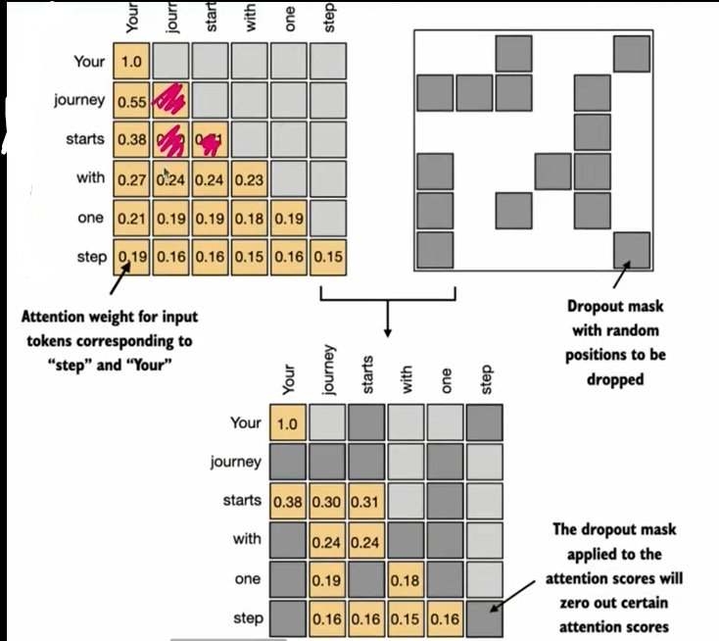
Figure 2: The causal attention weight matrix (top-left) combined with a random dropout mask (top-right) produces the final attention matrix (bottom) where certain positions are zeroed out. The dropout mask applied to the attention scores will zero out certain attention scores. The remaining non-zero values are rescaled upward to maintain the overall balance.

5. The CausalAttention Class — Complete Implementation
The CausalAttention class incorporates both the causal mask and dropout modifications into the self-attention class implemented in Topic 9. This is the complete, production-ready causal attention module used as the foundation for multi-head attention.

import torch
import torch.nn as nn

class CausalAttention(nn.Module):

def __init__(self, d_in, d_out, context_length, dropout, qkv_bias=False):
super().__init__()
self.d_out = d_out
# Three trainable projection matrices (from Topic 9)
self.W_query = nn.Linear(d_in, d_out, bias=qkv_bias)
self.W_key = nn.Linear(d_in, d_out, bias=qkv_bias)
self.W_value = nn.Linear(d_in, d_out, bias=qkv_bias)
# NEW: Dropout layer for regularization
self.dropout = nn.Dropout(dropout)
# NEW: Register causal mask as a buffer (not a parameter)
self.register_buffer(
'mask',
torch.triu(torch.ones(context_length, context_length), diagonal=1)
)

def forward(self, x):
b, num_tokens, d_in = x.shape # NEW: batch dimension b
keys = self.W_key(x) # [b, num_tokens, d_out]
queries = self.W_query(x) # [b, num_tokens, d_out]
values = self.W_value(x) # [b, num_tokens, d_out]

# Compute attention scores — transpose dims 1 and 2 (keep batch dim 0)
attn_scores = queries @ keys.transpose(1, 2) # [b, num_tokens, num_tokens]

# Apply causal mask — fill future positions with -inf (in-place)
attn_scores.masked_fill_(
self.mask.bool()[:num_tokens, :num_tokens], -torch.inf
)

# Scale and apply softmax — -inf positions become exactly 0
attn_weights = torch.softmax(
attn_scores / keys.shape[-1]**0.5, dim=-1
)

# Apply dropout to attention weights
attn_weights = self.dropout(attn_weights)

# Compute context vectors
context_vec = attn_weights @ values # [b, num_tokens, d_out]
return context_vec

# Test with batched input
batch = torch.stack((inputs, inputs), dim=0) # shape: [2, 6, 3]
print(batch.shape) # torch.Size([2, 6, 3])

torch.manual_seed(123)
context_length = batch.shape[1] # 6
ca = CausalAttention(d_in=3, d_out=2, context_length=6, dropout=0.0)
context_vecs = ca(batch)
print('context_vecs.shape:', context_vecs.shape)
# context_vecs.shape: torch.Size([2, 6, 2])
# 2 batches, 6 tokens, 2-dimensional context vectors

6. New Implementation Details — Three Critical Additions

6.1 register_buffer — Why Not nn.Parameter
The causal mask is registered as a buffer rather than a parameter. This is a critical design decision.

register_buffer vs nn.Parameter
nn.Parameter: Trainable — updated during backpropagation
register_buffer: Not trainable — fixed, but moves with the model

The causal mask should NOT be trained. It is a fixed constraint:
future positions are always masked, regardless of the data.

register_buffer ensures the mask:
-> Moves to GPU automatically when model.to('cuda') is called
-> Is included in model.state_dict() for saving/loading
-> Is NOT updated by the optimizer during training
-> Is shared correctly across batches

6.2 keys.transpose(1, 2) — Batch Dimension Handling
In Topic 9, inputs were 2D tensors [num_tokens, d_in]. In Topic 10, inputs are 3D tensors [batch, num_tokens, d_in]. The transpose must skip the batch dimension.

# Topic 9 (no batch): inputs shape = [6, 3]
# attn_scores = queries @ keys.T
# keys.T transposes both dimensions: [6, 2] -> [2, 6]

# Topic 10 (with batch): inputs shape = [2, 6, 3]
# attn_scores = queries @ keys.transpose(1, 2)
# keys.transpose(1, 2) transposes ONLY dims 1 and 2: [2, 6, 2] -> [2, 2, 6]
# Batch dimension (0) stays fixed.

# Result: attn_scores shape = [2, 6, 6]
# 2 batches, each with 6x6 attention score matrix

6.3 masked_fill_ — In-Place Operation
The underscore suffix in masked_fill_ indicates an in-place PyTorch operation. It modifies the tensor directly without creating a new copy, which saves memory — critical for large models.

# In-place operation (memory efficient):
attn_scores.masked_fill_(self.mask.bool()[:num_tokens, :num_tokens], -torch.inf)

# [:num_tokens, :num_tokens] slicing handles cases where the actual
# sequence is shorter than the maximum context_length.
# For example, if context_length=1024 but current batch has only 6 tokens,
# only the 6x6 portion of the mask is used.

# The trailing underscore means: modify attn_scores in-place
# Without underscore: would create a new tensor (wastes memory)

7. Shape Tracking — Complete Flow

Tensor | Shape | Description
batch input | [2, 6, 3] | 2 samples, 6 tokens each, d_in=3
queries, keys, values | [2, 6, 2] | Projected through W_Q, W_K, W_V (d_out=2)
attn_scores | [2, 6, 6] | queries @ keys.T — one matrix per batch item
mask | [6, 6] | Upper triangular — 1s above diagonal
masked attn_scores | [2, 6, 6] | Future positions filled with -inf
attn_weights | [2, 6, 6] | After softmax — lower triangular, rows sum to 1
attn_weights (dropout) | [2, 6, 6] | Some positions zeroed, remaining rescaled
context_vecs Z | [2, 6, 2] | Final output — 2 batches, 6 tokens, d_out=2

8. The Causal Mask — Reading the Lower Triangular Matrix
The causal attention weight matrix is a lower triangular matrix. Each row tells a different story about what that token is allowed to attend to.

# Your journey starts with one step
# Your [ 1.000 0.000 0.000 0.000 0.000 0.000 ]
# journey [ 0.552 0.448 0.000 0.000 0.000 0.000 ]
# starts [ 0.380 0.310 0.310 0.000 0.000 0.000 ]
# with [ 0.276 0.246 0.246 0.232 0.000 0.000 ]
# one [ 0.218 0.198 0.198 0.189 0.197 0.000 ]
# step [ 0.194 0.166 0.167 0.154 0.167 0.153 ]

# Row 1 'Your': Attends ONLY to itself. Nothing comes before it.
# Row 2 'journey': Attends to 'Your' and itself.
# Row 3 'starts': Attends to 'Your', 'journey', and itself.
# Row 6 'step': Attends to ALL tokens — it is the last in sequence.

# CRITICAL: Each row still sums to 1.0
# The weights are redistributed among the VISIBLE tokens only.
# 'step' sees all 6 tokens. 'Your' sees only 1.
# Both rows sum to 1.

9. Key Observations

- Causal masking is not an optional feature — it is the architectural requirement that makes autoregressive generation possible. Without it, the model would see future tokens during training and learn to cheat rather than learn to predict. This would cause complete failure at inference time.
- The -infinity trick is more efficient than mask-then-renormalize because it reduces three operations to two. The mathematical reason: exp(-∞) = 0, so softmax naturally assigns zero probability to masked positions and automatically renormalizes the remaining positions.
- register_buffer is the correct choice for the mask because the mask should not be trained. It is a fixed mathematical constraint, not a learned parameter. Using nn.Parameter would cause the optimizer to modify it during training, breaking the causal constraint.
- Dropout is applied AFTER computing attention weights, not before. This is the most common approach because it regularizes the final probability distribution over tokens. The rescaling factor (1/dropout_rate) ensures the expected value of the weights remains unchanged despite the random zeroing.
- The context_vecs output shape [2, 6, 2] represents 2 batch items, 6 tokens each, with 2-dimensional context vectors. In production GPT-2, this would be [batch_size, context_length, d_model] where d_model = 768.

10. Research Paper Connections

- Vaswani et al. (2017) — Attention Is All You Need: Section 3.2.3 describes Masked Multi-Head Attention — the causal masking mechanism implemented here. The paper describes the mask as preventing positions from attending to subsequent positions. The -infinity filling approach is the standard described in this section.
- Radford et al. (2019) — GPT-2: Uses causal self-attention throughout. Every attention layer in GPT-2 applies the causal mask — the model is purely autoregressive, attending only to past tokens. The register_buffer approach for storing the mask is the standard PyTorch implementation of the GPT-2 causal constraint.
- Srivastava et al. (2014) — Dropout: A Simple Way to Prevent Neural Networks from Overfitting: The foundational paper introducing dropout as a regularization technique. The scaling factor of 1/p (where p is the keep probability) described in this paper is exactly what PyTorch applies when rescaling non-dropped values.

11. What Comes Next
- Topics 11-12 — Multi-Head Attention: The CausalAttention class built here becomes the foundation of multi-head attention. Multiple instances of CausalAttention run in parallel, each learning to attend to different aspects of the input. Their outputs are concatenated and projected into the final representation.
- Topic 13 — Bird's Eye View of Architecture: Once multi-head attention is complete, Stage 3 begins. The attention module built across Topics 7-12 plugs directly into the full GPT-2 Transformer block. Every design decision made in these topics — the Q/K/V matrices, the causal mask, the dropout — flows through to the final 124M parameter model.

Building LLMs from Scratch — Research Documentation Series
Next: Topics 11-12 — Multi-Head Attention

