Building LLMs from Scratch
Series Documentation | Topic 13 | Stage 3
Bird's Eye View of LLM Architecture

Opening Stage 3.
Every component built in Stages 1 and 2 — tokenization, embeddings, masked multi-head attention — now connects into a single GPT-2 model architecture.

Author | SHIVA KIRAN DADISHETTY
Series | Building LLMs from Scratch
Topic | 13 of 36 — Stage 3: LLM Architecture
Also Known As | GPT Architecture Overview — DummyGPTModel
Builds On | Topics 1–12 — Tokenization, Embeddings, Masked Multi-Head Attention
Key Addition 1 | GPT_CONFIG_124M — the complete configuration dictionary for GPT-2 small
Key Addition 2 | DummyGPTModel — a placeholder architecture giving the full bird's eye view

1. Opening Stage 3 — What Has Been Built, What Comes Next
Stage 1 and Stage 2 are complete. Together they built every component the model needs to understand and process language. Stage 3 now assembles those components into the full GPT-2 Transformer architecture — and this topic provides the bird's eye view of how everything fits together before diving into each component in detail.

Things Covered So Far — Stages 1 and 2
(a) Input Tokenization:
Raw text → token IDs using BPE tokenizer (tiktoken, vocab size 50,257)

(b) Embedding (Token + Positional):
Token IDs → 768-dimensional dense vectors (token embedding)
Position information injected (positional embedding)
Combined: input to the model = token_embedding + positional_embedding

(c) Masked Multi-Head Attention:
CausalAttention — causal mask, dropout, register_buffer (Topic 10)
MultiHeadAttentionWrapper — sequential heads via nn.ModuleList (Topic 11)
MultiHeadAttention — efficient weight-split via .view() and .transpose() (Topic 12)

Things Yet To Cover — Stage 3
(a) Transformer blocks — the full block assembly connecting attention,
layer normalization, feed-forward network, and shortcut connections

(b) Scale up to the full GPT-2 small model → 124 million parameters

Reference paper: Radford et al. (2019)
"Language Models are Unsupervised Multitask Learners"

2. The Complete LLM Pipeline — All 5 Stages
Building an LLM from scratch follows a clear 5-stage pipeline. Each stage builds on the previous one. The diagram below shows the full scope of this series.

Stage | Topics | What It Builds
Stage 1 — Data Pipeline | 1–6 ✅ | Tokenization, BPE, DataLoader, token embeddings, positional embeddings, full preprocessing pipeline
Stage 2 — Attention | 7–12 ✅ | Simplified attention, self-attention with W_Q/W_K/W_V, causal masking, multi-head attention (wrapper + efficient)
Stage 3 — Architecture | 13–18 ← | Bird's eye view, layer norm, GELU, shortcut connections, full transformer block, GPT-2 124M model
Stage 4 — Pretraining | 19–26 | Next token prediction, loss function, training loop, temperature, top-k sampling, loading OpenAI GPT-2 weights
Stage 5 — Finetuning | 27–36 | Classification and instruction finetuning, Alpaca format, LoRA, evaluation

The goal of Stage 3 is to produce a GPT model that can be pretrained and finetuned. Stage 4 and Stage 5 require Stage 3 to be complete. This topic — Topic 13 — provides the full architectural picture before any individual components are built.

3. The GPT Model — Top-Level Architecture
The GPT model takes tokenized text as input, passes it through embedding layers, runs it through a stack of transformer blocks, and produces output logits — one per vocabulary token, for each position in the sequence. The goal: generate new text one word at a time.

The diagram below shows the top-level structure. The masked multi-head attention (built in Topics 10–12) lives inside each transformer block, which is a key component of every GPT-like LLM.

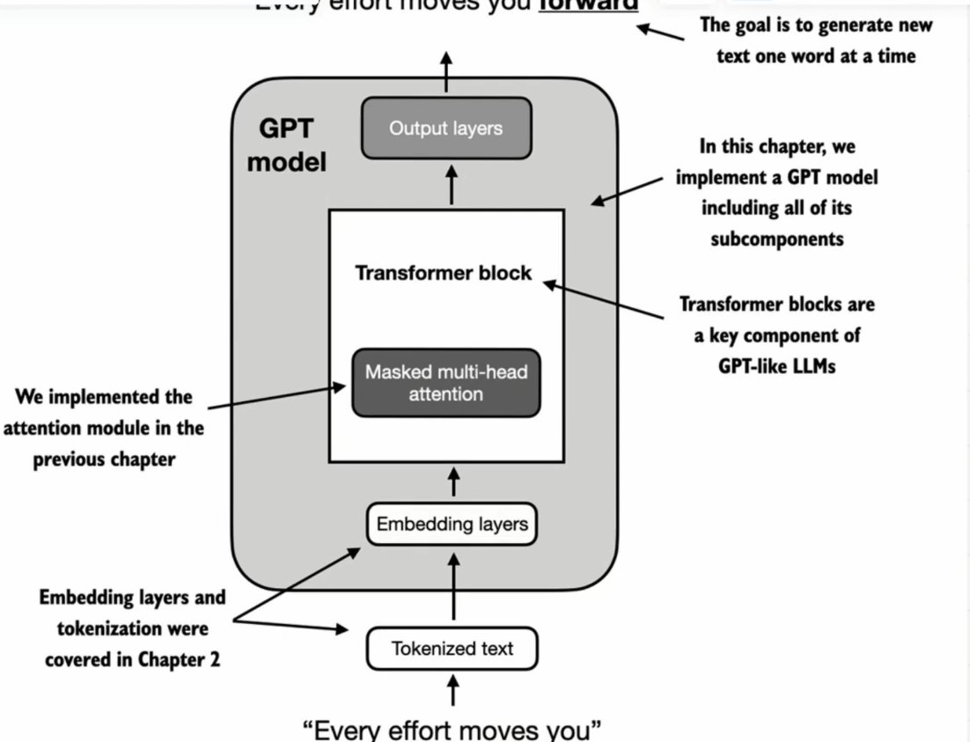
Figure 1: Top-level GPT model architecture. Tokenized text passes through embedding layers, then a stack of transformer blocks (each containing masked multi-head attention), then output layers producing logits. The input sentence "Every effort moves you" enters at the bottom; the goal is to predict the next word at each position. The attention mechanism built in Stage 2 lives inside the transformer block.

The two text samples used throughout this topic are "Every effort moves you" and "Every day holds a" — the same examples used in the notebook. After BPE tokenization:

tokenizer = tiktoken.get_encoding("gpt2")

txt1 = "Every effort moves you"
txt2 = "Every day holds a"

batch = torch.stack([
torch.tensor(tokenizer.encode(txt1)), # [6109, 3626, 6100, 345]
torch.tensor(tokenizer.encode(txt2)), # [6109, 1110, 6622, 257]
], dim=0)

print(batch)
# tensor([[6109, 3626, 6100, 345],
# [6109, 1110, 6622, 257]])
# shape: [2, 4] — 2 text samples, 4 tokens each

4. The Transformer Block — Internal Structure
Each transformer block in the GPT model contains the same sequence of components. Understanding this internal structure is the foundation of Stage 3. The diagram below shows the complete transformer block and its internal feed-forward sub-block.

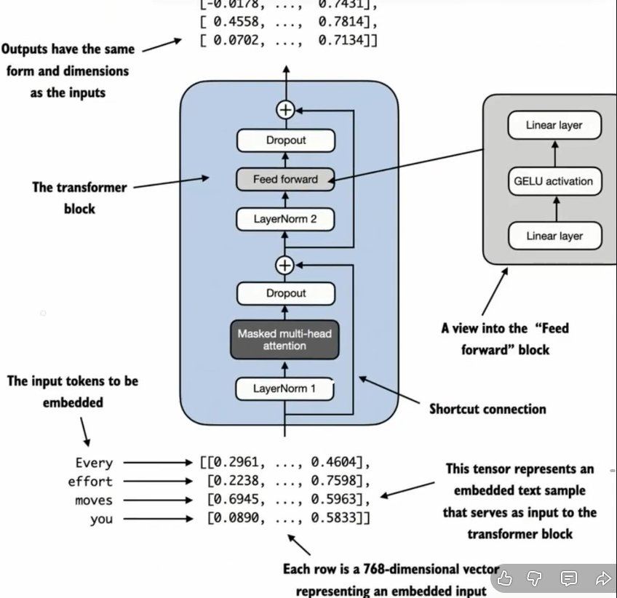
Figure 2: Complete transformer block (left) and feed-forward sub-block expanded (right). The block processes tokens through LayerNorm1 → Masked Multi-Head Attention → Dropout → shortcut connection (+). Then LayerNorm2 → Feed Forward → Dropout → shortcut connection (+). The feed-forward block itself is two linear layers with GELU activation in between. Critically: outputs have the same form and dimensions as the inputs — the residual stream is preserved. Input tokens "Every effort moves you" enter as 768-dimensional vectors and exit as 768-dimensional vectors.

Each component of the transformer block has a specific role:

Component | Position in Block | Role
LayerNorm 1 | Before attention | Normalize token embeddings before feeding into attention — Pre-LayerNorm style (GPT-2)
Masked Multi-Head Attention | After LayerNorm 1 | Compute context-aware representations using causal (masked) attention — built in Topics 10–12
Dropout | After attention | Regularization — randomly zero some activations during training to prevent overfitting
Shortcut Connection (+) | Around attention | Add input directly to attention output — preserves gradient flow through depth
LayerNorm 2 | Before feed-forward | Normalize again before the feed-forward network
Feed-Forward Network | After LayerNorm 2 | Two linear layers with GELU activation — expands then contracts: d_model → 4×d_model → d_model
Dropout | After feed-forward | Second regularization step
Shortcut Connection (+) | Around feed-forward | Second residual connection — adds input to feed-forward output

The Feed-Forward Sub-Block (expanded)
Inside each transformer block, the feed-forward network contains three layers:

Layer 1 — Linear: d_model → 4 × d_model (768 → 3072 in GPT-2 small)
Layer 2 — GELU: non-linear activation (Topics 14–15)
Layer 3 — Linear: 4 × d_model → d_model (3072 → 768 in GPT-2 small)

The 4× expansion is a design choice from Vaswani et al. (2017).
It gives the network capacity to learn complex feature transformations
before projecting back to the residual stream dimension.

The Critical Property: Input = Output Dimensions
The transformer block preserves the embedding dimension from input to output.

Input: [batch, num_tokens, d_model] e.g. [2, 4, 768]
Output: [batch, num_tokens, d_model] e.g. [2, 4, 768] ← identical shape

This is why GPT-2 can stack 12 identical transformer blocks.
Every block receives the same shape and outputs the same shape.
The residual stream (the tensor flowing through the network) is never reshaped.
This property is enforced by the shortcut connections.

5. GPT-2 Model Variants and Scale
GPT-2 was released in four sizes. All use the same architecture — the only difference is the number of transformer blocks, the embedding dimension, and the number of attention heads. This series builds GPT-2 small (originally 117M, later revised and commonly cited as 124M parameters).

Model | Parameters | Layers (Transformer Blocks) | d_model (Embedding Dimension)
GPT-2 Small | 117M → 124M | 12 | 768 (num_heads=12, head_dim=64)
GPT-2 Medium | 345M | 24 | 1024 (num_heads=16, head_dim=64)
GPT-2 Large | 762M | 36 | 1280 (num_heads=20, head_dim=64)
GPT-2 XL | 1542M | 48 | 1600 (num_heads=25, head_dim=64)

The target of this series is GPT-2 small. With 12 transformer blocks and d_model=768, it is the smallest but still a genuine 100M+ parameter language model. Its architecture is identical to the larger variants — only the scale changes.

OpenAI Weight Availability
OpenAI made GPT-2 weights publicly available — all four sizes.
Topic 26 of this series loads these weights directly into the implementation built here.

GPT-3 (175B parameters) weights have NOT been made public.
GPT-4 weights have NOT been made public.

This is why GPT-2 is the standard reference for from-scratch LLM implementations:
the architecture is documented, the weights are available, and the model is
small enough to run on consumer hardware while being architecturally complete.

6. The GPT_CONFIG_124M — Configuration Dictionary
The entire GPT-2 small architecture is specified by 7 parameters in a single configuration dictionary. This dictionary is passed to every class in the implementation — it is the single source of truth for all architectural decisions.

GPT_CONFIG_124M = {
"vocab_size": 50257, # Vocabulary size
"context_length": 1024, # Context length
"emb_dim": 768, # Embedding dimension
"n_heads": 12, # Number of attention heads
"n_layers": 12, # Number of transformer blocks
"drop_rate": 0.1, # Dropout rate
"qkv_bias": False # Query-Key-Value bias
}

Each parameter controls a specific aspect of the architecture:

Parameter | Value | What It Controls
"vocab_size" | 50257 | How many subwords are in the BPE vocabulary — used for tokenization. Sets the embedding matrix size and output layer size.
"context_length" | 1024 | Maximum number of tokens the model can process at once. Sets the positional embedding matrix size. The model can look back at most 1024 tokens when predicting the next one.
"emb_dim" | 768 | Embedding dimension — the size of every token's vector representation throughout the model. Every transformer block preserves this dimension. Also called d_model.
"n_heads" | 12 | Number of attention heads per transformer block. head_dim = emb_dim / n_heads = 768 / 12 = 64 per head.
"n_layers" | 12 | Number of transformer blocks stacked. Each block contains: LayerNorm → MultiHeadAttention → LayerNorm → FeedForward, with shortcut connections.
"drop_rate" | 0.1 | Dropout rate applied at multiple points in each transformer block. 10% of activations are randomly zeroed during training to prevent overfitting.
"qkv_bias" | False | Whether to include a bias term when initializing the Q/K/V linear layers in MultiHeadAttention. GPT-2 uses False — no bias in attention projections.

7. The Embedding Pipeline — Token IDs to Vectors
Before any transformer block processes the input, the raw token IDs must be converted into dense vector representations. This happens in two steps: token embedding and positional embedding.

7.1 Token Embedding
The token embedding layer is a lookup table of shape [vocab_size, emb_dim] = [50,257, 768]. Each row corresponds to one token in the vocabulary. A token ID is simply an index into this table.

self.tok_emb = nn.Embedding(cfg["vocab_size"], cfg["emb_dim"])
# shape: [50257, 768]
# Every entry initialized from Gaussian distribution
# Trained during backpropagation

# Token IDs for "Every effort moves you":
# Every → 6109, effort → 3626, moves → 6100, you → 345

# Token embedding lookup — each ID maps to one 768-dim row:
# 6109 → [0.2961, ..., 0.4604] # Every
# 3626 → [0.2238, ..., 0.7598] # effort
# 6100 → [0.6945, ..., 0.5963] # moves
# 345 → [0.0890, ..., 0.5833] # you
# (... represents the 766 middle dimensions of the 768-dim vector)

7.2 Positional Embedding
Attention has no inherent sense of order — it treats all tokens in a sequence identically regardless of position. The positional embedding injects position information by adding a learned position vector to each token's embedding.

self.pos_emb = nn.Embedding(cfg["context_length"], cfg["emb_dim"])
# shape: [1024, 768]
# Row 0 = position 0 embedding, Row 1 = position 1 embedding, ...
# Maximum 1024 positions — here max we look at 1024 tokens to predict next word

# For a sequence of 4 tokens:
pos_embeddings = pos_emb(torch.arange(4))
# Returns rows 0, 1, 2, 3 from the positional embedding table
# shape: [4, 768]

7.3 Combined Input Embeddings
Token embeddings and positional embeddings are added element-wise. The result is the input to the first transformer block.

input_embeddings = token_embeddings + pos_embeddings
# token_embeddings shape: [batch, num_tokens, emb_dim] = [2, 4, 768]
# pos_embeddings shape: [num_tokens, emb_dim] = [4, 768]
# Broadcasting: pos_embeddings expands to [2, 4, 768]
# input_embeddings shape: [2, 4, 768]

# This is the tensor that enters the first transformer block.
# Every row is a 768-dimensional vector representing one embedded input token.
# Token identity (what word) + position (where in sequence) are both encoded.

8. The Output Logits
The final layer of the GPT model is a linear layer (the output head) that projects each token's 768-dimensional representation back to the vocabulary size — 50,257 dimensions. Each of these 50,257 values represents the unnormalized score (logit) for that vocabulary token being the next token.

self.out_head = nn.Linear(cfg["emb_dim"], cfg["vocab_size"], bias=False)
# shape: [768, 50257]
# Input: [batch, num_tokens, 768]
# Output: [batch, num_tokens, 50257] ← one logit per vocab token per position

For the two text samples "Every effort moves you" and "Every day holds a" (4 tokens each), the output shape is [2, 4, 50257]:

# Output logits structure for 1 text sample, 4 tokens:
#
# Token 1 ("Every") → [logit_0, logit_1, ..., logit_50256] — 50257 values
# Token 2 ("effort") → [logit_0, logit_1, ..., logit_50256] — 50257 values
# Token 3 ("moves") → [logit_0, logit_1, ..., logit_50256] — 50257 values
# Token 4 ("you") → [logit_0, logit_1, ..., logit_50256] — 50257 values
#
# Each element represents the probability (score) of that vocab token being NEXT.
# Token 4 ("you") → its 50257 logits tell us: what is likely to follow "you"?
# To get actual probabilities: apply softmax over the 50257 values.
# The highest logit = the model's prediction for the next word.

9. The DummyGPTModel — Complete Implementation
Before building the real transformer block, a placeholder (Dummy) GPT model is implemented. DummyTransformerBlock and DummyLayerNorm do nothing — they simply return their input unchanged. This gives a bird's eye view of how every component connects, verifies the shapes are correct end-to-end, and confirms the output logit structure before any real layers are implemented.

import torch
import torch.nn as nn

# Step 1: Placeholder for TransformerBlock — returns input unchanged
class DummyTransformerBlock(nn.Module):
def __init__(self, cfg):
super().__init__()
def forward(self, x):
return x # identity — does nothing yet

# Step 2: Placeholder for LayerNorm — returns input unchanged
class DummyLayerNorm(nn.Module):
def __init__(self, normalized_shape, eps=1e-5):
super().__init__()
def forward(self, x):
return x # identity — does nothing yet

# Step 3: Full GPT model using placeholders
class DummyGPTModel(nn.Module):
def __init__(self, cfg):
super().__init__()
# Token embedding: vocab_size × emb_dim
self.tok_emb = nn.Embedding(cfg["vocab_size"], cfg["emb_dim"])
# Positional embedding: context_length × emb_dim
self.pos_emb = nn.Embedding(cfg["context_length"], cfg["emb_dim"])
# Embedding dropout
self.drop_emb = nn.Dropout(cfg["drop_rate"])
# Stack of n_layers transformer blocks (placeholders for now)
self.trf_blocks = nn.Sequential(
*[DummyTransformerBlock(cfg) for _ in range(cfg["n_layers"])]
)
# Final layer normalization (placeholder)
self.final_norm = DummyLayerNorm(cfg["emb_dim"])
# Output projection: emb_dim → vocab_size
self.out_head = nn.Linear(cfg["emb_dim"], cfg["vocab_size"], bias=False)

def forward(self, in_idx):
batch_size, seq_len = in_idx.shape
# Token embedding lookup
tok_embeds = self.tok_emb(in_idx) # [b, seq_len, emb_dim]
# Positional embedding lookup
pos_embeds = self.pos_emb(torch.arange(seq_len)) # [seq_len, emb_dim]
# Add token + positional embeddings
x = tok_embeds + pos_embeds # [b, seq_len, emb_dim]
x = self.drop_emb(x)
# Pass through transformer blocks (identity for now)
x = self.trf_blocks(x)
# Final layer normalization
x = self.final_norm(x)
# Project to vocabulary size
logits = self.out_head(x) # [b, seq_len, vocab_size]
return logits

# ─── Test ──────────────────────────────────────────────────────────────────
torch.manual_seed(123)
model = DummyGPTModel(GPT_CONFIG_124M)

# Tokenized batch: "Every effort moves you" and "Every day holds a"
batch = torch.tensor([[6109, 3626, 6100, 345], # Every effort moves you
[6109, 1110, 6622, 257]]) # Every day holds a

logits = model(batch)
print("Output shape:", logits.shape)
# Output shape: torch.Size([2, 4, 50257])
# 2 text samples × 4 tokens × 50257 vocab logits

print(logits)
# tensor([[[-1.2034, 0.3201, -0.7130, ..., -1.5548, -0.2390, -0.4667],
# [-0.1192, 0.4539, -0.4432, ..., 0.2392, 1.3469, 1.2430],
# [ 0.5307, 1.6720, -0.4695, ..., 1.1966, 0.0111, 0.5835],
# [ 0.0139, 1.6755, -0.3388, ..., 1.1586, -0.0435, -1.0400]],
#
# [[-1.0908, 0.1798, -0.9484, ..., -1.6047, 0.2439, -0.4530],
# [-0.7860, 0.5581, -0.0610, ..., 0.4835, -0.0077, 1.6621],
# [ 0.3567, 1.2698, -0.6398, ..., -0.0162, -0.1296, 0.3717],
# [-0.2407, -0.7349, -0.5102, ..., 2.0057, -0.3694, 0.1814]]])

10. Shape Tracking — Complete Flow Through DummyGPTModel

Tensor / Layer | Shape | Description
Input token IDs | [2, 4] | 2 text samples, 4 tokens each
tok_emb(in_idx) | [2, 4, 768] | Each token ID → 768-dim embedding vector
pos_emb(arange(4)) | [4, 768] | Position 0–3, each 768-dim — broadcast across batch
tok_embeds + pos_embeds | [2, 4, 768] | Combined input representation
After drop_emb | [2, 4, 768] | Dropout applied — same shape
Through trf_blocks (×12) | [2, 4, 768] | Each DummyTransformerBlock returns input unchanged
After final_norm | [2, 4, 768] | DummyLayerNorm returns input unchanged
out_head(x) | [2, 4, 50257] | Linear: 768 → 50257 — one logit per vocab token per position

The Shape Invariant Through Transformer Blocks
Every real transformer block (Topics 14–17) will also preserve this shape:

Input to block: [batch, num_tokens, d_model] e.g. [2, 4, 768]
Output of block: [batch, num_tokens, d_model] e.g. [2, 4, 768]

This is enforced by the shortcut connections.
The residual stream adds the block's output to its input — same shape required.
This is what enables stacking 12 identical blocks without any reshape operations.

11. Key Observations

- The DummyGPTModel is not a toy — it is an architectural proof — by using placeholder blocks that return their input unchanged, the model verifies that every shape is correct end-to-end before any real computation is added. Input [2, 4] → output [2, 4, 50257] is the correct flow regardless of what happens inside the blocks.
- The output shape [2, 4, 50257] is the goal for the rest of Stage 3 — when the real transformer blocks replace the placeholders, the output shape will be identical. The difference is that the logit values will be meaningful rather than random.
- d_model = d_in = d_out throughout — in all GPT models, the embedding dimension is the same from input to output. This is why the weight-split multi-head attention from Topic 12 works: d_in = d_out = 768. This same constraint propagates through every layer of every transformer block.
- GPT-2 uses Pre-LayerNorm — LayerNorm is applied BEFORE the attention and feed-forward operations, not after. This differs from the original Vaswani et al. (2017) formulation. Pre-LayerNorm leads to more stable training for deep networks. Topic 14 covers this in detail.
- The shortcut connections are load-bearing — without them, gradients cannot flow through 12 stacked transformer blocks during backpropagation. The residual connection means gradient flows directly through the addition operation without passing through the full block. Topic 16 derives this.
- The entire architecture of GPT-2 is determined by 7 numbers in GPT_CONFIG_124M — vocab_size, context_length, emb_dim, n_heads, n_layers, drop_rate, qkv_bias. Every other dimension and every other design choice follows from these 7 values.

12. Research Paper Connections

- Radford et al. (2019) — GPT-2: Language Models are Unsupervised Multitask Learners — the reference paper for this entire stage. The paper describes the GPT-2 architecture: 12 transformer blocks, 768 embedding dimensions, 12 attention heads, 50,257 vocabulary size, 1024 context length. The GPT_CONFIG_124M dictionary in this topic encodes every key architectural decision from Section 2 of that paper directly in code.
- Vaswani et al. (2017) — Attention Is All You Need — the original Transformer architecture. GPT-2 follows this architecture with one key modification: Pre-LayerNorm (normalize before attention/FFN) rather than Post-LayerNorm (normalize after). The feed-forward 4× expansion ratio (d_model → 4×d_model → d_model) is taken directly from Section 3.3 of Vaswani et al.
- He et al. (2016) — Deep Residual Learning for Image Recognition — the shortcut connections (residual connections) in every transformer block trace directly to this paper. The insight: adding input to output before the nonlinearity provides a direct gradient path for backpropagation, making very deep networks trainable. GPT-2's 12 stacked blocks are possible because of this mechanism.

13. What Comes Next

- Topic 14 — Layer Normalization — the DummyLayerNorm placeholder is replaced with a real implementation. GPT-2 uses Pre-LayerNorm: normalize before attention and before the feed-forward network. Topic 14 derives why this stabilizes training in deep networks and implements the normalization that appears in every transformer block.
- Topic 15 — GELU Activation Function — the feed-forward block uses GELU (Gaussian Error Linear Unit) rather than ReLU. Topic 15 implements GELU and explains why GPT-2 chose it over ReLU: GELU is smooth (differentiable everywhere) and avoids the dying ReLU problem. The feed-forward block linear → GELU → linear is then complete.
- Topic 17 — Full Transformer Block — once LayerNorm (Topic 14), GELU (Topic 15), and shortcut connections (Topic 16) are implemented, the full transformer block replaces DummyTransformerBlock. This is the moment when the DummyGPTModel becomes a real GPT model capable of producing meaningful output.
- Topic 18 — GPT-2, 124M Parameter Model — the final transformer block is assembled into the complete 124M parameter GPT-2 model. The DummyGPTModel becomes GPTModel. The output logits become meaningful predictions. Stage 3 closes and Stage 4 (pretraining) opens.

