**Shiva Praneeth Kodali**

**1BM18CS100**

1.Write a shell script to index a document using grep command.

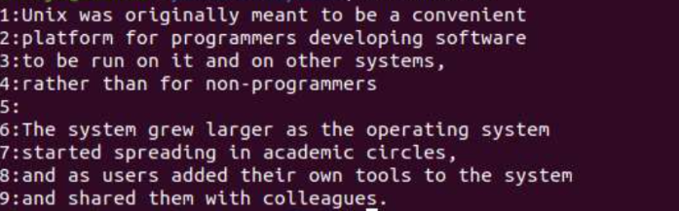

2.Write a shell script to count the number of directories and files in the current directory using find command.

