-> M O N G O D B <-

>> Basics

-------------------------------------------------------------------------------
MongoDB is a source-available cross-platform document-oriented database program. Classified as a NoSQL database program, MongoDB uses JSON-like documents with optional schemas.

* majority part of the mongo in c++ , python and in js
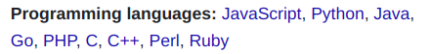

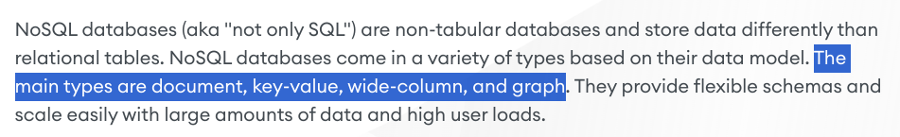

* difference between nosql and sql <relational db’s is what is the underlying structure in which they are going to store the data
- it doesn’t matter what are the data they are going to store like
- mongo uses json like documents which is nosql while postgresql also have a type of json data which can be stored in the column, which is a rdbms.

-> so mongodb is a nosql, documents based database.

: tables -> collection
: rows -> document

< Here we have ODM not ORM < as r -> relational >

<< user : superAdmin >

----------------------------------------
* MONGO Client : is db driver that is used when we don’t use mongoose,
then first we need to connect mongo client and then
used to write the raw mongo queries
----------------------------------------

* no sql has the flexibility that if it had a column then it is not mandatory that you must have to assign some value, like relational databases <in sql you must have to assign or it gives you null or you assign null values when you fetch or store >

* although we create a schema in nosql but with flexibility < it might be required or not >

* it is

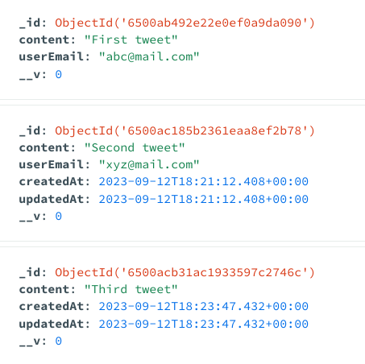
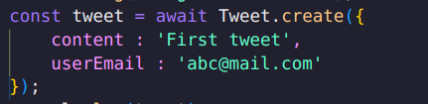

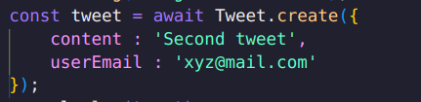

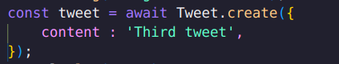

-> the createdat and updatedat properties comes when we add timestamps
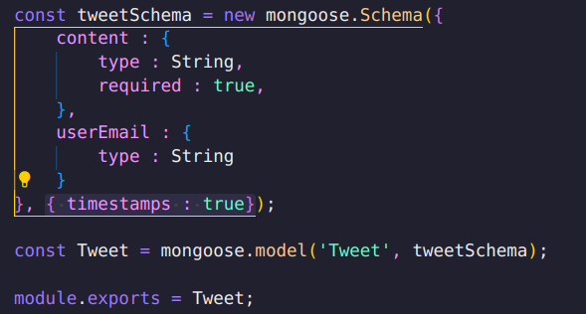

- and you can note that in third tweet that we didn’t pass the email still it
doesn’t throw error .

NOTE : schema is the class and models are the actual instances using which we execute a lot of instances
< schema is just for blueprinting while models are for actual connection and creation of the db’s

------------------------------------------------------------------------------
=> now you can query also like
- first find the item using id and then update the email
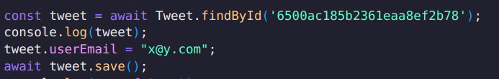

-> initially email was xyz@mail.com and it changed to x@y.com
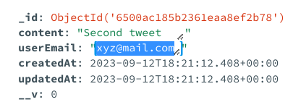
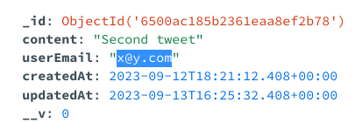

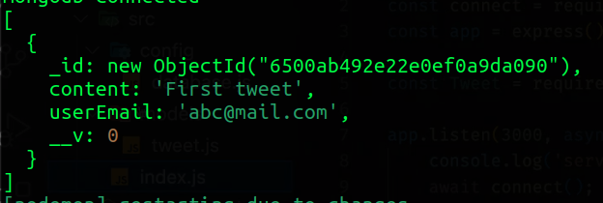
-> similarly you can find one or multiple documents at the same time
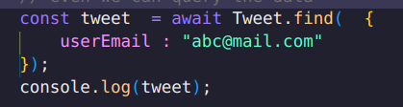

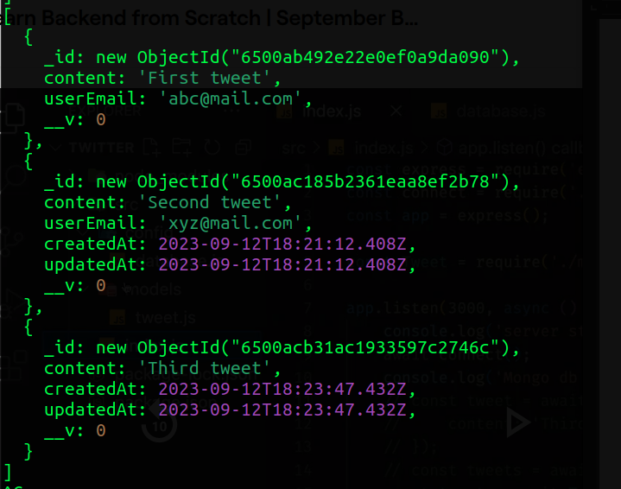
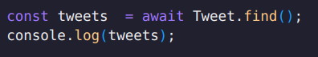

* and the type of tweets is
Object
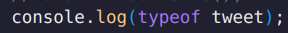

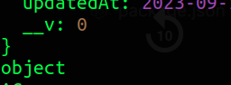

-------------------------------------------------------

=> let’s create the CRUD for the tweet :-
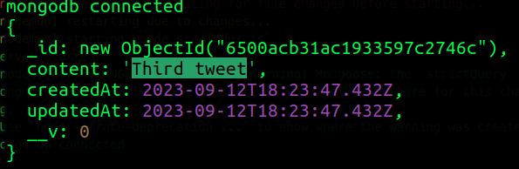
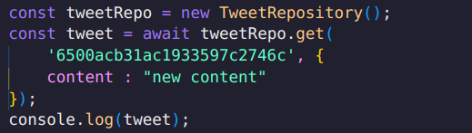

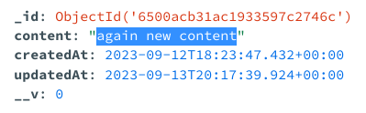
-> although i updated the content but it is not getting reflected, while it have changed in database

** but in terminal it is showing previous one let’s update one more time

-> now it is showing previous updated value

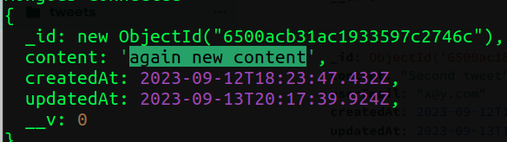
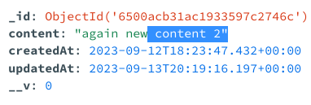

-> while database is updated instantly

Q : what is the reason that it is getting updated late by one ?

- when we use findByIdandUpdate then it update the document properly but it
returns the previous value <old document> : not updated value

?? how can we get the letest data
- we can pass some option like
m1> pass the new : true with tweetid and data

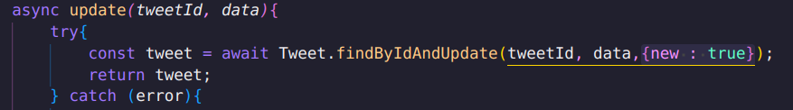
m2> or use returnOriginal = false

-> and it is reflecting the document after updation
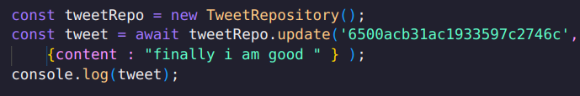

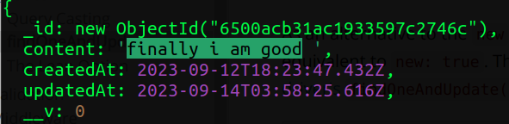
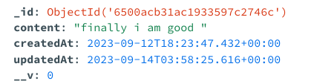

---------------------------------------------------------------------------

=> how to update the schema like : add comments also in the schema ->
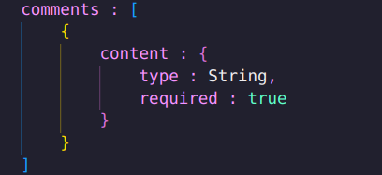
:

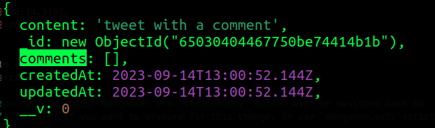
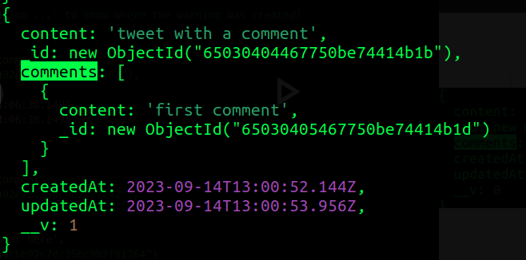
-> so this is how tweet without comments and with comments

** now you can see that we can store the comments inside a tweet itself
-> now you can see the flexibility of the no-sql databases;
#NOTE : here you can see that comment has also it’s unique id

----
=> so in this way we can nest the things and how flexible no sql is :)
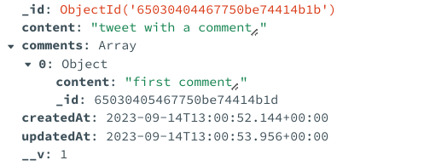

-> this is how nested data is stored : nested structures are possible beyond
imaginations : wowwww

-> if you want to store the metadata ? How cool is to use mongoDB.

------------------------------------------------------------------------------

:) if we want to saggregate the comments then this is how we can do that ??
=> make new model comment
: and associate it with tweet
i> comment schema
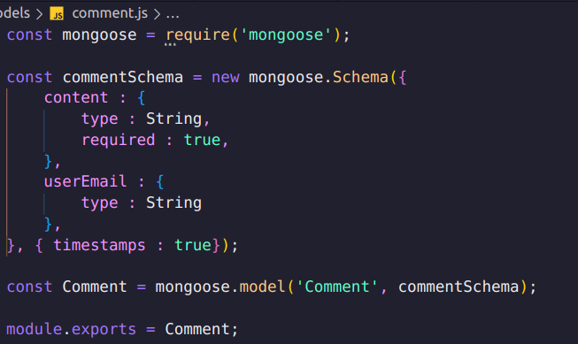

-> to associate with tweet we use the id of the comment
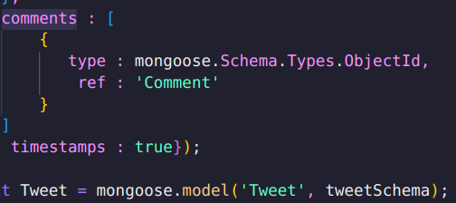
and refered as tweet model
Comment

-> and now we can create the comment and push it inside the comment array of the
tweet
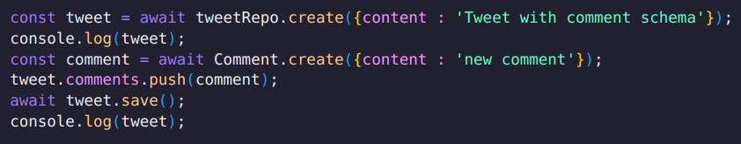
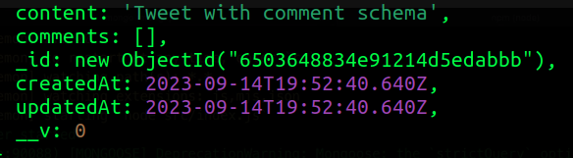
- before we push comment
inside the schema

-> after we push the comment
in the array of tweet

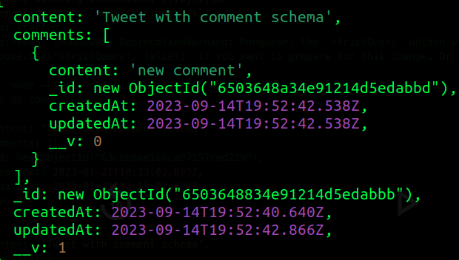

-> and now you can see the two models inside the twitter_Dev
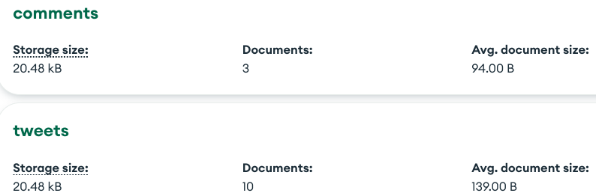
- and you can see the data also
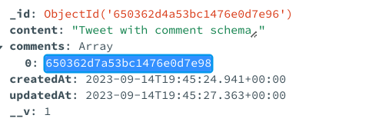

- -------------------------------------------------------------------------

=> let’s get the tweet :

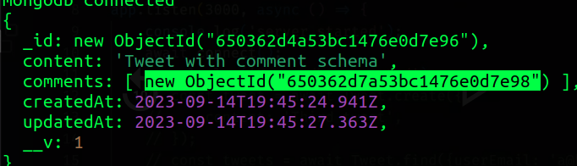
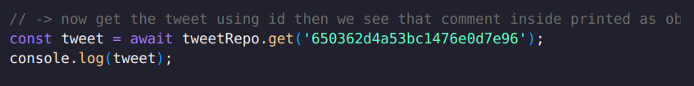

- so you can see that we are getting id not actual content of the comment.
Ques : how to get the comment content instead of the id ??

- for populating the value of comment we can use populate function :
- like
< create a new function in repository getWithComments >
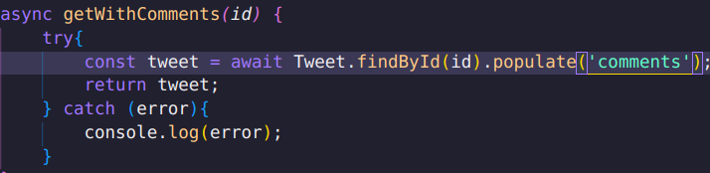

-> you can also do this : instead of just passing the comments you can pass it
with the path
- and now you can see that we are getting the content of the comment also
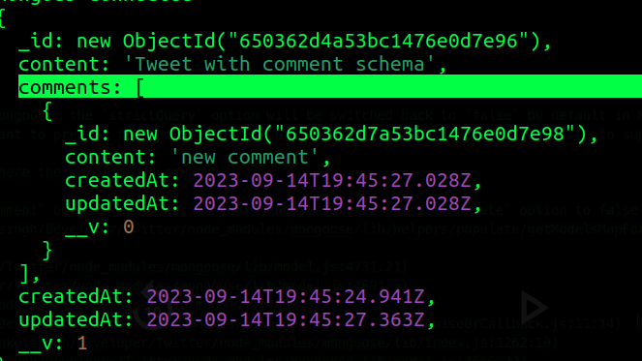

-> if we have direct association then we don’t need to populate but if
if it have some array like or nested things then we need to populate them

->--------------------------------------------------------------------
=> similarly if we have user schema and every tweet belongs to a user <mail> then similarly we can do it and can populate also
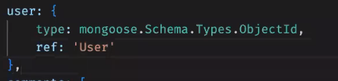

- and it is easy to query the data inside the mongo using mongoose

< mongoose >>>> easy >>>> sequelize >
< this time we are not using any cli we are manually doing and managing all the
schemas >

-------------------------------------------------------------------------------

>>> why this is complex while we have just tweets and comments
1> imagine comments on the tweet and comments associated to comment
2> like can be done on tweet and also can be associated to comment

---> how do we handle
---> design :>

=> we are making general like on social media as comment is also a tweet so
we can think general social media where post and comments are different

-------------------------------------------------------------------------------
< concurrency issues in | transaction >
< design >
< we first count all the transaction then minus it from total instead of just calculating each time total - each transaction >
like here two intances of total seats are there so it might be changed in between so it will create problem >



