MongodbII :

** problem with mongoose queries is that when it queries the mongodb then it returns an Object
- it’s just a js object ???
=> no it’s mongoose object that we get < not a plain js object
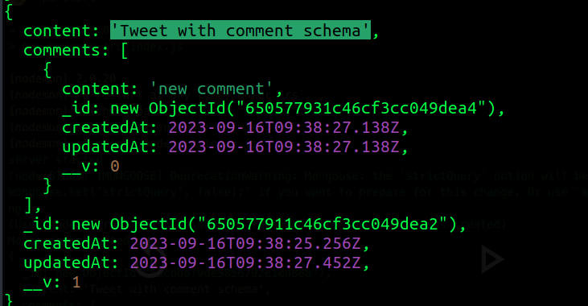

-> we can create a small optimization here :-
=> we can avoid creation of the mongoose object here
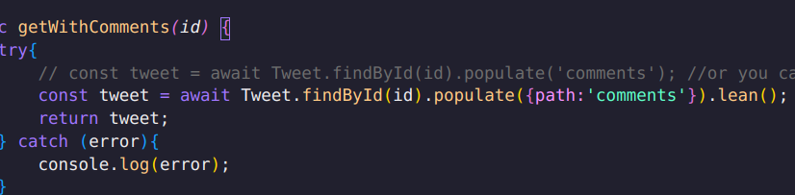


- we can use a function call lean()
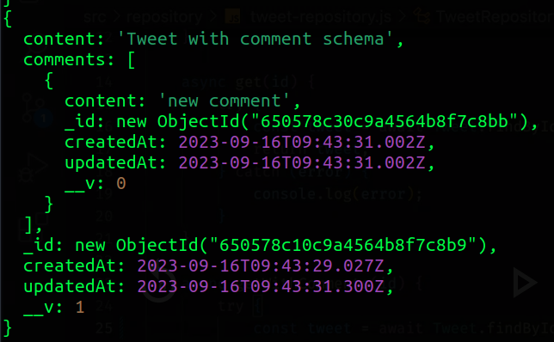

-> it might not feel much change but now it is not mongoose object, now it is going to be act like plain js object
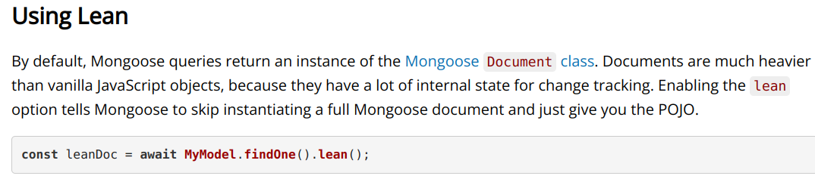


-> although if you are not going to use the getter setter and save method
then it is the optimized method to avoid the mongoose object

=> there are other functions also like tojson()

->----------------------------------------------------------------------------<-

P A G I N A T I O N

- in sequelize we have done pagination <limit and option>
-> now we have 8 tweets
-> how to do pagination using mongoose

-> we have some methods like skip(offset) and limit(limit)
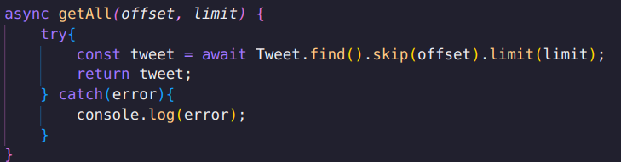

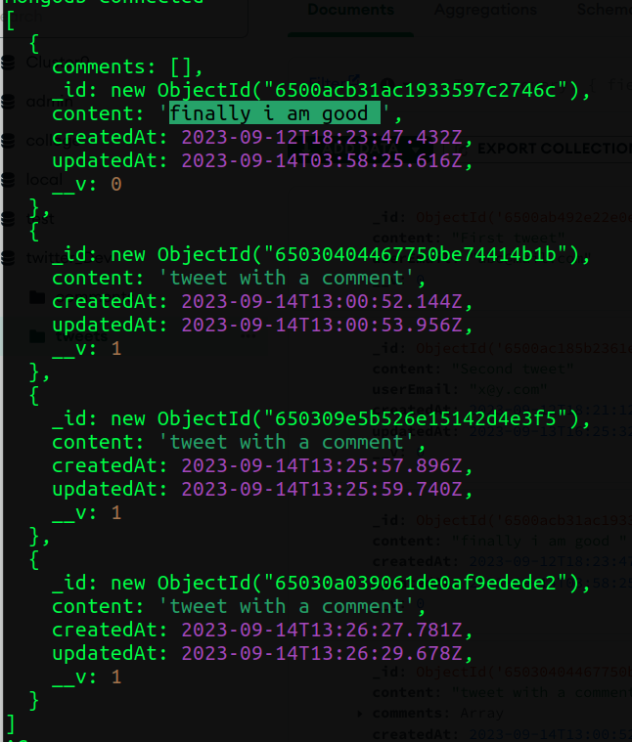
-> and here you can see that it have skipped top 2 tweets and showing only 4 tweets
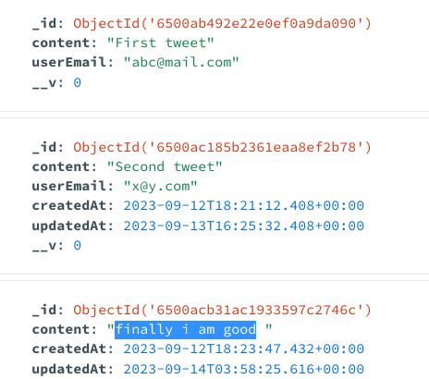

- finally i am good is third one and first tweet and second tweet are skipped
because we have pass the offset as 2 and limit 4 that’s why it is showing the
only 4 tweets
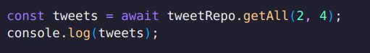

--------------------------------------------------------------------------------

=> mongoose gives feature called virtuals :
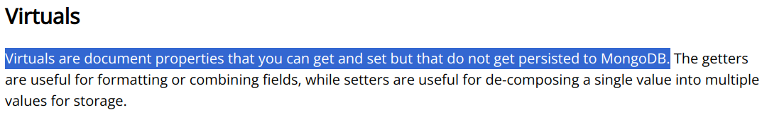

- in this concept of virtuals we don’t get/find these types of the properties in
mongoDB like you can see that
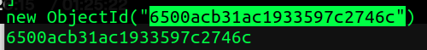
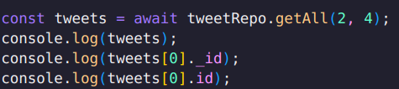

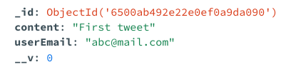

- here we are getting id from both _id and id
=> but there is no id property in mongodb

-> mongodb have _id not id
-> so id is not existing in documents so id is acting as virtuals

-> where we define the schema we can also put the virtuals there like in the tweet model -
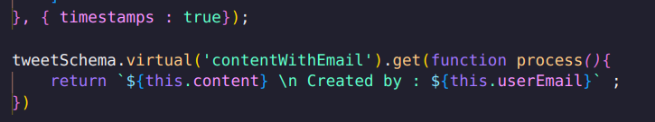
- we have defined the virtual contentWithEmail and
-> you can see that we are getting the data as
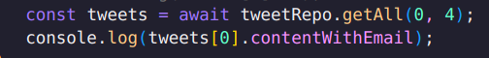


- it helps you to write the some custome queries in form of virtuals
-> while this property doesn’t persist inside the database , even it doesn’t
exist anywhere, instead of this it get computed during runtime

-> these are virtuals **

=> in other ways also you can defined as like if you want to fetch full name then fetch first name and last name and then return after adding them

--- for more explore documentation ---
-> basically used for custom logics

--------------------------------------------------------------------------------

T R I G G E R S

-previously in our auth service model
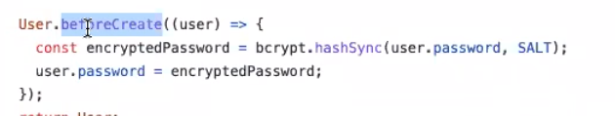

- it was a hook that was used as triggers

-> how can we implement something like hooks in mongo ??
=> mongoose also gives us hooks

: when we create some documents inside the mongo then there are some lifecycle
events that happens like
> before the creation : you want to do something
> after the creation
> before deletion > after deletion ----

=> so triggers are the events that get executed on a particular time
[ relational databases have triggers while with orm’s like sequelize have
these hooks and odm’s like mongoose have middlewares which are also called as
pre and post hooks ]

- like we have pre
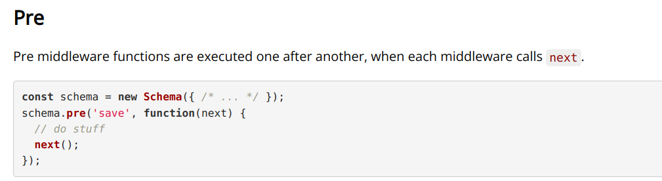
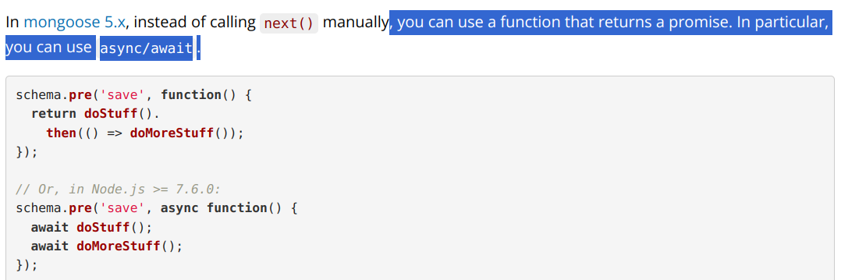
- there are multiple type of hooks are there
=> let’s see
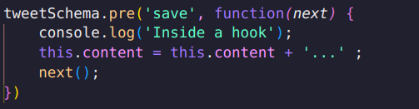

- now we are using pre before saving the new data in db (creating )
-> so you can see that
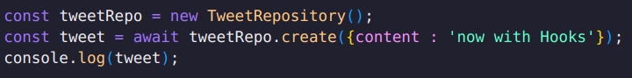

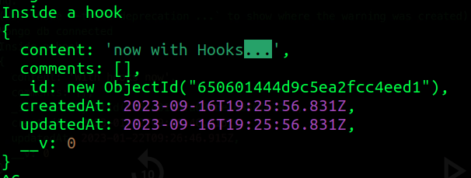

- before creating the tweet it is printing the message and also updating the
content before creating the tweet

- so we can add validations also like before creation of the tweet : check this
check that or similar type of the things < like irrelevant words like abuses
or it could be : you have seen on youtube and other it cancel when you use
words like suicide murder .. like length of message .. a lot of things

- in this way we can attatch the lifecycle events

=> next() :
suppose we have multiple hook functions < then these functions< which will be
executed in the sequence :and can be clubbed and called as middlewares >
attatched and after completing one you want to get executed other then we use
next function, which points to the next middleware

-: so if you want to store the encrypted password of the user then you can use
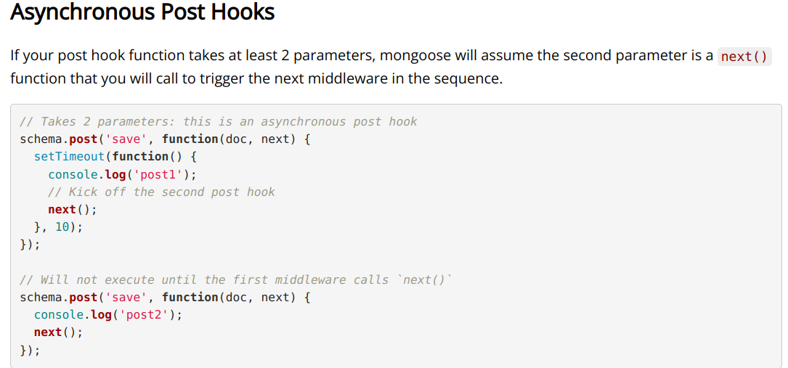
the hooks < pre hooks like before storing encrypt them >
- so there are both types of the hooks are there in the mongoose , if
post hooks function takes more than two args then it auto assumes that it is
async hooks
- so both sync and async hooks are in mongoose

-------------------------------------------------------------------------------

Q: How about if user get’s deleted from the db then all of it’s tweets
get deleted ??
=> like we can use post removal hooks < cascade deletion >

--------------------------------------------------------------------------------

I N D E X

DATA STRUCTURES AND DATABASES
- have you ever seen uses of binary search and hashmaps in dev ??

=> databases very heavily uses datastructures and algos internally

:- indexes exist in both type of databases like relational and document based db
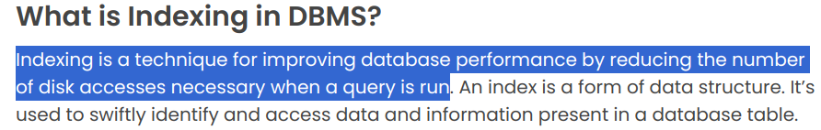
ex : suppose there is an array and you want to delete an element :
-> then first you need to search that element so if we improove the searching
time then we can improove the overall performance of the deletion
> you can create hashmap or
> or if array is sorted :>

=> mongo db also supports the indexes
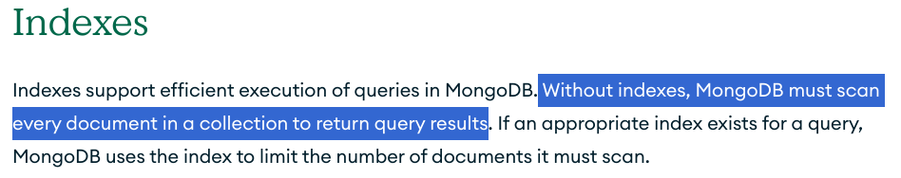
without indexes it search every document which is linear search
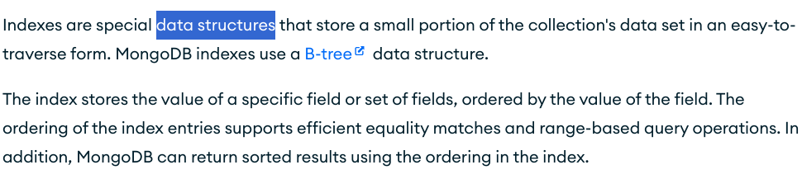
- like there is B+ trees data structures
< some times tries are also used >

< space & time tradeoff >
: like indexes are also data structures which are separately stored : so although it uses extra space but overall functionality of time waste managed so this is also a space time tradeoff

=> there are functions like createIndex

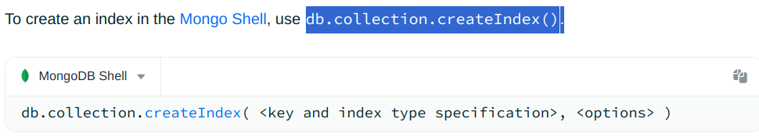
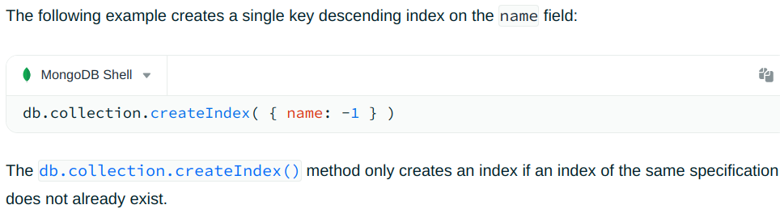
-> and there are different types of indexes are there
1> single field and < one field only>
2> compound indexes < more than one field >
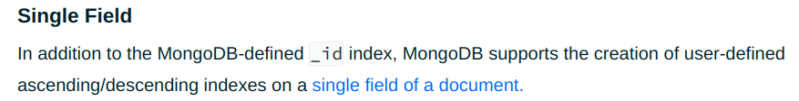
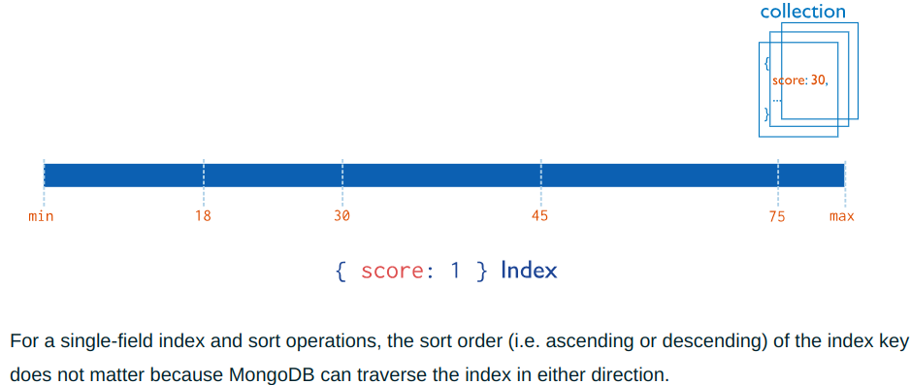
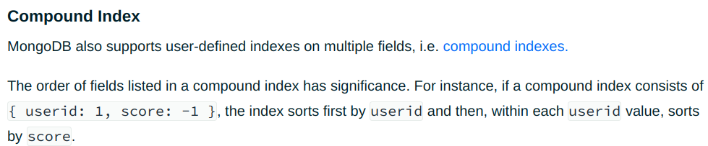

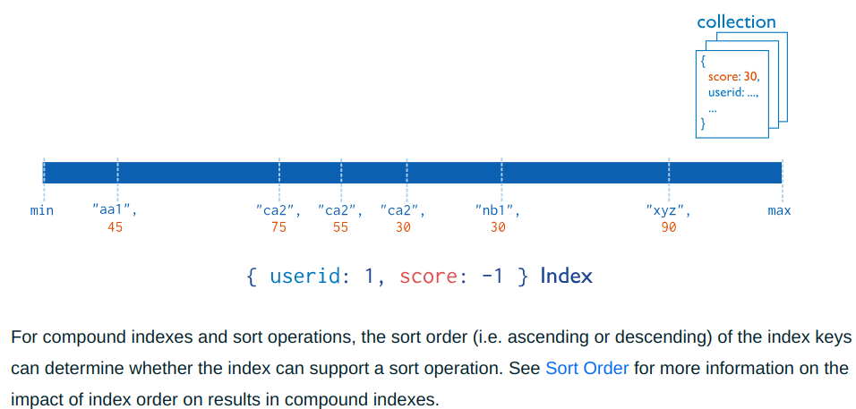
ex : single field
=> : at any point suppose you say this content is unique then we are going to make this content as index like < so unique : true > property also helps us to create index like in mongoose if you pass as :
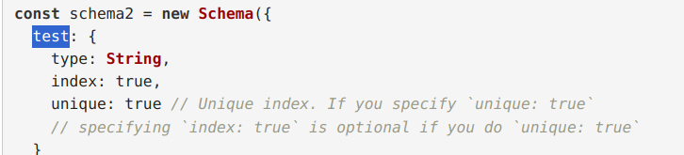
- so if you say index : true then it is going to make test automatically as
index and datatype for creating this index is determined by mongodb/mongoose
itself < so we don’t need to bother too much for choosing the datastructure
for the corresponding data for which we are creating the index >

[ mysql also have indexes so you can explore them btree, tries, hash based]

- - - - - - - - - - - - - - - - -- - - - - - - - - - - - - - - - - - - - - - -

=> similarly mongodb also have different type of indexes


-> so choose that data for indexing which is not going to get updated again and
again otherwise it’ll create performance issues

--------------------------------------------------------------------------------

- similarly you can make compound indexes : uses multiple field

--------------------------------------------------------------------------------
** on the personal level indexes not much needed as we don’t have much load
and data so it doesn’t make much sense for implement indexes

=> id is by default index < predefined index >
- here we were talking about custom indexes

-------------------------------------------------------------------------------

