


Application for Authorisation
Owners and influencers appendix notes

This appendix will help us understand who influences the applicant firm. We need to know who owns the applicant firm and about any relationships the applicant firm might have with other individuals and entities.
In this appendix, we look at:
- controllers
- close links
- third country banking/investment groups
- financial conglomerates
For guidance on which firms these requirements do not apply to, please refer to the Supervision Manual: https://www.handbook.fca.org.uk/handbook/SUP/11/

Please take time to read these notes carefully. They will help you fill in the owners and influencers appendix form correctly.

When completing the application forms you will need to refer to the Handbook: https://www.handbook.fca.org.uk/handbook/SUP/11/

If after reading these notes you need more help please:
- check our website
- consult the Handbook: https://www.handbook.fca.org.uk/
- call the Firm Contact Centre: 0300 500 0597
- email the Firm Contact Centre: Firm.Queries@fca.org.uk
- call the PRA Firm Enquiries: 020 3461 7000
- email the PRA Firm Enquiries: pra.firmenquiries@bankofengland.co.uk

These notes, while aiming to help you, do not replace the rules and guidance in the Handbook.

Terms in this form
These notes use the following terms:
- 'you' refers to the person(s) signing the form on behalf of the applicant firm
- 'the applicant firm' refers to the firm applying for authorisation
- ‘we’, ‘us’ or ‘our’ refers to the appropriate regulator
- ‘the FCA' refers to the Financial Conduct Authority
- ‘the PRA’ refers to the Prudential Regulation Authority
- FSMA refers to the Financial Services and Markets Act 2000
Important information
At the point of authorisation we expect the applicant firm to be ready, willing and organised to start business.

1 | Who controls (ie owns) the applicant firm?
1.1 – 1.2
This information will help us understand who owns the applicant firm and has control or influence over its business.
Our approval is required before a person can become a controller of an authorised firm. The controllers of the applicant firm will include the ultimate beneficial owners, who may be individuals or firms with an indirect shareholding in the applicant firm – for example, through their controlling interest in a parent of the applicant firm.
You must complete the information we ask for in the spaces provided or provide a structure chart so we can determine who the applicant firm's controllers are. The controller(s) will then need to complete the appropriate Appendix providing their own details. This is a requirement of the Act (Part XII Control over authorised persons).
Chapter 11 of the Supervision Manual (SUP) in the Handbook gives further information about controllers. In particular, SUP 11.3 sets out the information which a controller or proposed controller must provide to us before becoming a controller.
You can use this link to access it: https://www.handbook.fca.org.uk/handbook/SUP/11/

For these purposes, a controller is, broadly speaking, an individual or firm that:
(1) holds 10% or more (20% or more for an insurance and mortgage intermediaries) of the shares in the applicant firm or its parent
(2) is able to exercise significant influence over the management of the applicant firm through a controlling interest in the applicant firm or its parent
(3) is entitled to control or exercise control of 10% or more (20% or more for an insurance and mortgage intermediaries) of the voting power in the applicant firm or its parent
(4) is able to exercise significant influence over the management of the applicant firm through their voting power in it or its parent
Controllers of Partnerships
- Partnership applicants should note that some (or sometimes all) individual partners may be controllers of the partnership. Usually this will depend on the number of partners and the terms of the partnership agreement, especially regarding voting power or significant influence. For example, in a 5 person partnership where each partner has equal voting power, each partner will have 20% of the voting power and so will be a controller.
- In a 5 person partnership where two senior partners each have 40% of the voting power (and the same level of significant influence) and the remaining 20% is equally split between the other 3 partners (meaning that each of them has less than 10% of the voting power and significant influence), only the 2 senior partners would be deemed controllers.
- In a ten person partnership where each partner has equal voting power, each partner will have 10% of the voting power and will be a controller.
- In an eleven-person partnership where all have equal voting power it might appear that none of the partners will be a controller (as no individual partner will have 10% or more of the voting power). However, one of the partners can still exercise significant influence - if the partnership agreement required significant decisions to be taken unanimously by the partners, a dissenting partner could exercise significant influence over the firm's management despite having less than 10% of the voting power. Applicant firms should have this is mind when considering whether a partner with less than 10% voting power could exercise significant influence over the firm's management.
Please remember that this information will probably be set out in your partnership agreement.
1.3 Applicant firms must submit with this application the appropriate Controller Forms for each of its controllers.
You do not need to submit an individual controller form for any individual controller who has also submitted a Form A to hold a Controlled function with the applicant firm.

Definitions of the following terms can be found in the Handbook Glossary:-
https://www.handbook.fca.org.uk/handbook/glossary/
- Controller
- Control
- Control function
- Shares
- Voting power
- Aggregation of shares and acting in concert guidance
- Parent undertaking
- Firm
- Regulatory body

2 | Close links

This section is likely to affect only a small minority of firms.
2.1 Does the applicant firm have close links?
You must notify us about any other firms or individuals that an applicant firm may have close links with – whether directly, or through a parent or a subsidiary – so we can be sure that we can supervise you effectively. You will find below:
- a diagram (1) which sets out the types of relationships between firms and individuals that we consider to be close links
- a flowchart (2) which will help you in deciding if you have close links
(1)

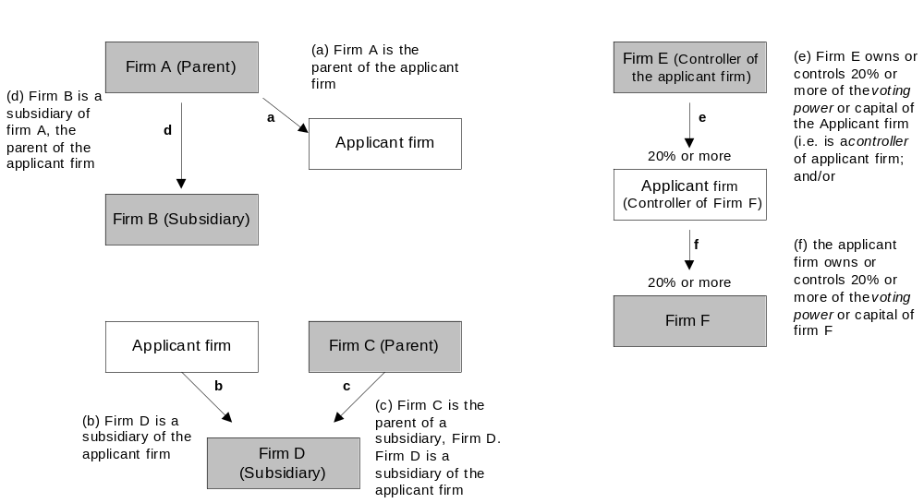

(2)

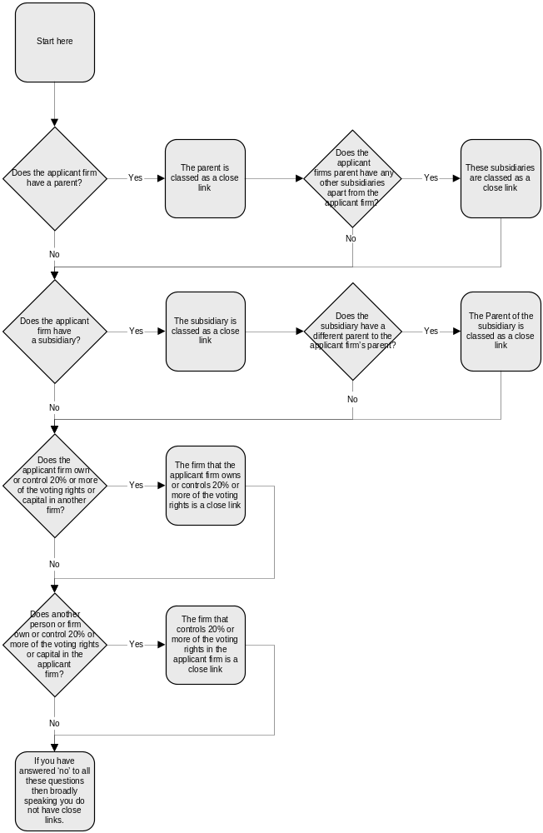

For further guidance on close links please see:
- SUP 11: https://www.handbook.fca.org.uk/handbook/SUP/11/
- Handbook Glossary: https://www.handbook.fca.org.uk/handbook/glossary/

Overlap between controllers and close links (this applies to applicant firms completing both Owners & Influencers and Controllers appendices)
There is often an overlap between an applicant firm's controllers and its close links. For example, an organisation that owns 20% of the voting power or capital of the applicant firm is both a controller and a close link. If you are asked to provide a structure chart for controllers and for close links, you can provide a single structure chart showing both.
2.2 You must provide a structure chart to show the nature of the relationship between the applicant firm and each close link. If you are already providing a structure chart to illustrate the applicant firm's controller(s) or group, that chart should include all the applicant firm's close link(s).
The structure chart should show clearly:
(i) the close link(s)'s name(s)
(ii) the close link(s)'s address(es)
(iii) the category of each close link – a, b, c, d, e or f (please see diagram (1) above)
(iv) the details of any regulatory body that regulates each close link. Please include the address, telephone number, email address and a contact name at the regulator. (If a close link is regulated by us, please provide the firm’s reference number wherever possible)

Please note you will need to complete the appropriate Controller Appendix (please see Question 1.3 of this appendix) for any close links falling into category e (please see diagram (1)).
2.3 Are you aware of any information to suggest that any close link is likely to prevent our effective supervision of the applicant firm?
Possible examples of the kind of issues that might impinge on our effective supervision include anything that might:
- affect your ability to provide adequate information to us at any time
- hinder the flow of information from the applicant firm or the applicant firm's close link(s) to us at any time
- prevent us from being able to assess the overall financial position of the applicant firm or your close link(s) at any time

Please consider in particular if such issues may arise because the close link is subject to the laws of a state outside the EEA. A list of EEA member states is provided at the beginning of this section.

3 | Third country banking/investment groups

3.1 Is the applicant firm a BIPRU firm?
For glossary definitions please see https://www.handbook.fca.org.uk/handbook/glossary/
3.2 Is the applicant firm a member of a third-country banking and investment group?
Third-country banking and investment group – ie a group headed by a bank, asset management company, investment firm or financial holding company outside the EEA and not part of a wider EEA banking/ investment group.

4 | Financial conglomerates

4.1 Is the applicant firm a member of a group?
Broadly speaking, an applicant firm is part of a group if it is:
- a parent company
- a subsidiary company
- a subsidiary company of a parent company
- a parent company of a subsidiary company
In relation to consolidated financial supervision and financial conglomerates, please note the guidance in the Handbook under SUP 11.5.4 and 11.5.4A.
4.2 In relation to the activities of the controller, or the group the controller is part of, is the controller or any firm in the group (as defined in paragraph 5 of schedule 3 of FSMA) an EEA investment firm, an EEA credit institution, an EEA insurance undertaking, an EEA management company or the parent of any such firm?
No additional notes
4.3 Is the applicant firm a member of a financial conglomerate according to ‘Classification of groups’ form?
In relation to consolidated financial supervision and financial conglomerates, please see the guidance in the Handbook under SUP 11.5.4 and 11.5.4A. The Handbook Glossary definition of a financial conglomerate refers to a decision tree in GENPRU 3 Annex 4:
https://www.handbook.fca.org.uk/handbook/GENPRU/3/Annex4.html
4.4 Is the applicant firm a member of a third-country financial conglomerate?
Third-country financial conglomerate – ie a financial conglomerate headed by a regulated entity or a mixed financial holding company that has its head office outside the EEA. The questionnaire in GENPRU 3 Annex 3 G and its explanatory notes will help you to assess this:
https://www.handbook.fca.org.uk/handbook/GENPRU/3/Annex3.html

