Annex A

Report of the Currency Board Operations

This report covers the period from 9 November to 31 December 1998. During the reporting period, changes in the size of the Monetary Base were fully matched by corresponding changes in the Foreign Reserves in accordance with the Monetary Rule of the Currency Board arrangements.

Hong Kong Dollar Exchange Rate and Interest Rate Movements

Hong Kong dollar exchange rate
Chart 1
HK$ Exchange Rate and EERI
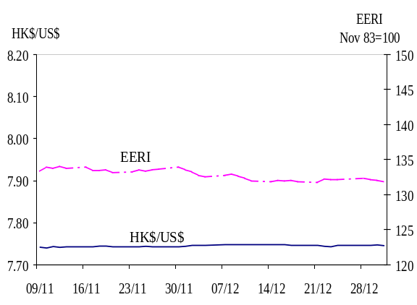
1 The Hong Kong dollar exchange rate remained stable during the reporting period, trading between 7.740 and 7.748. Probably driven by improved sentiment in local financial markets, there was some inflow of funds in early November. The HK$ strengthened to a high of 7.740 on 10 November. On the same day, the HKMA sold HK$193.4 mn for US dollar. The exchange rate then eased back to around 7.744. Thereafter, the HK$ exchange rate remained stable at around 7.743 to 7.748 (Chart 1).
Chart 2
1-month and 3-month HIBORs
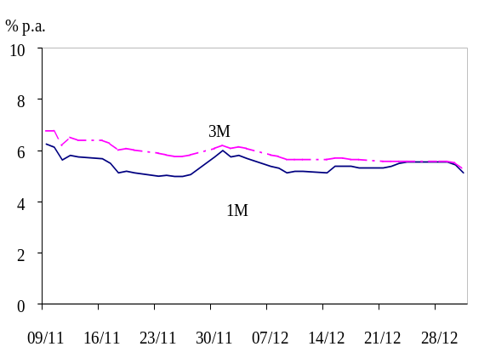

Interest rate

2 Interest rates in Hong Kong continued to fall in November along with the decline in US interest rates. The US Fed Funds Target Rate was further lowered by 25bp on 17 November, following two successive cuts in September and October. In response, HK dollar interest rates fell across the board. 1-month and 3-month HIBORs declined markedly from 6.25% and 6.75% respectively on 9 November to 5.00% and 5.75% on 26 November (Chart 2). Overnight HIBOR briefly firmed to an intraday high of 6.13% on 30 November due to month-end effects. But the seasonal tightening quickly subsided. Overnight HIBOR softened to 4.0% in early December, while 1-month HIBOR eased to around 5.4% and remained stable until the end of the reporting period.
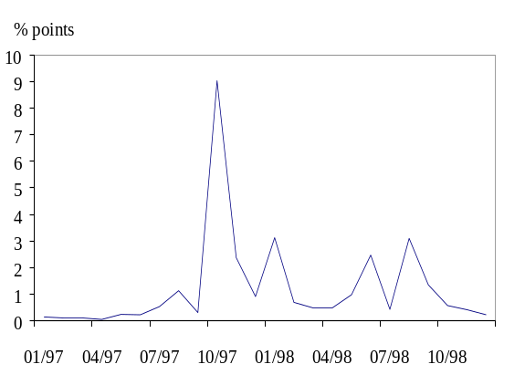
Chart 3
Standard Deviation of the 1-month HIBOR
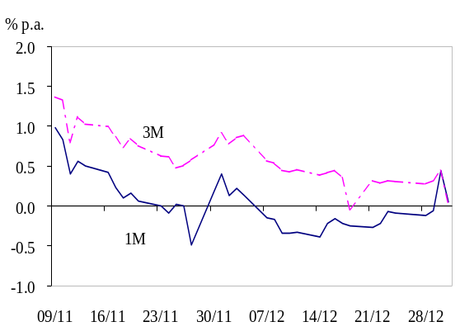
3 Interest rate volatility has declined significantly since August this year (Chart 3). The standard deviation of 1-month HIBOR (as a measure of interest rate volatility) fell from the peak of 9.0 percentage points in October 1997 to only 0.2 percentage points in December 1998, close to pre-crisis levels in 1997.
Chart 4
Differential between HK$
and US$ Interest Rates

4 Reflecting improved confidence in the HK dollar, the HK$ and US$ interest rate spreads narrowed significantly during the review period. The differential in terms of the 1-month interbank rate fell from a positive 98bp on 9 November to 7bp on 31 December. The gap in the 3-month rate also narrowed from 136bp to 19bp during the same period (Chart 4).
Chart 5
Yield Curves of Exchange Fund Paper
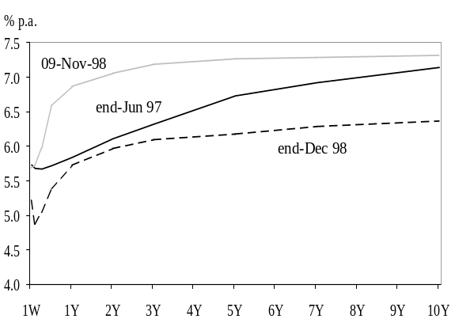
5 Longer term interest rates, represented by yields on Exchange Fund paper, fell significantly during the review period. The entire yield curve has shifted downwards since early November. Yields of 5-year and 10-year Exchange Fund paper fell by 109bp and 95bp to 6.17% and 6.36% respectively. These were lower than the pre-crisis levels at end June 1997 (Chart 5).

6 As yields on Exchange Fund paper fell more than those on US Treasuries, yield spreads narrowed for all maturity. On the longer end of the yield curve, the yield differential between 5-year and 10-year paper decreased significantly from 259 bp and 229 bp to 156 bp and 163 bp respectively during the period covered by this report (Table 1).
Table 1
Yield Spreads between Exchange Fund Paper
and US Treasuries (basis points)
 | 27-Jun-97 | 09-Nov-98 | 31-Dec-98
3-month | 56 | 116 | 54
1-year | 21 | 211 | 122
3-year | 3 | 242 | 139
5-year | 27 | 259 | 156
10-year | 54 | 229 | 163

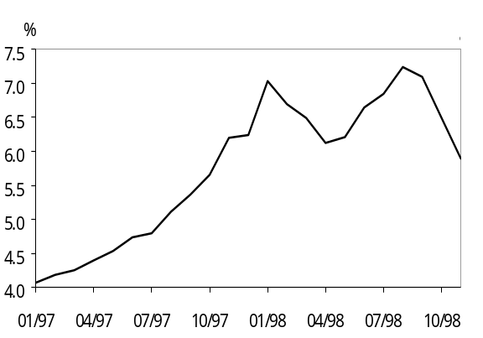
7 In the retail market, the HKAB lowered the savings rate under the Interest Rate Rules three times by a total of 75 bp during the review period. Along with the easing of interbank interest rates, the weighted average deposit rates offered by 44 major authorised institutions for 1-month time deposits (which are outside the Interest Rate Rules) dropped by 29bp from early November to 6.47% on 24 December 1998. In recent months, there has been a notable shift from HK$ time deposits to demand and savings deposits. HK$ demand and savings deposits increased by 5.5% and 9.9% respectively during November, while time deposits fell by 3.2%. It has been roughly estimated that the effective deposit rate (measured as the average of deposit rates weighted by type and maturity of deposits) has fallen from 7.24% in August 1998 to 5.90% in November 1998 (Chart 6). The best lending rate offered by major banks also fell by 75 bp from 9.75% to 9.0% in the review period.
Chart 6
HK$ Effective Deposit Rate
Table 2
Real Interest Rates (%)
 | 27-Jun-  97 | 09-Nov-98 | 31-Dec-98
Best lending rate | 3.15 | 10.45 | 9.70
1M HIBOR | 0.46 | 6.95 | 5.83
1M deposit rate | -0.11 | 5.73 | 5.44

8 Real interest rates measured in terms of best lending rate and 1-month HIBOR decreased by 75bp and 112bp to 9.70% and 5.83% respectively in the review period, largely due to the decline in nominal interest rates (Table 2). However, real interest rates were still significantly higher than pre-crisis levels.

Base Rate

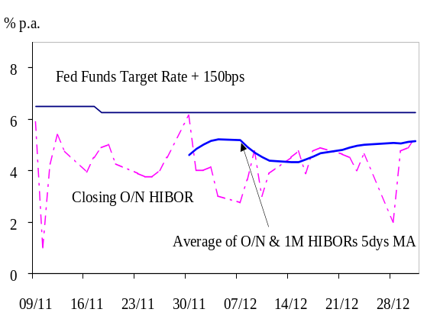
9 The Base Rate was lowered on 18 November from 6.5% to 6.25% following the 25bp cut in the US Fed Funds Target Rate (Chart 7). On 26 November, the HKMA announced the formula for determining the Base Rate. Under this formula, the Base Rate is set at either 150 basis points above the prevailing US Fed Funds Target Rate or the average of the 5-day moving averages of the overnight and 1-month HIBORs for the last 5 trading days, whichever is higher. Since then, the Base Rate has remained at 6.25% (i.e. the US Fed Funds Target Rate + 150 bp). Experience so far suggests that the Base Rate has not constrained downward movements of the overnight interbank interest rate.
Chart 7
Base Rate and O/N HIBOR

Monetary Base

10 The Monetary Base, comprising the outstanding amount of Certificates of Indebtedness, coins in circulation, the Aggregate Balance, and the outstanding amount of Exchange Fund Bills and Notes, increased from HK$188.73 bn on 9 November to HK$ 192.47 bn on 31 December (Table 3). Movements of individual components are discussed below.
Table 3
The Monetary Base
(HK$ bn) | 9-Nov | 31-Dec
CI | 83.01 | 86.47
Coins in Circulation | 5.95 | 6.03
Aggregate Balance | 2.33 | 2.52
Outstanding EFBNs | 97.45 | 97.45
Monetary Base | 188.73 | 192.47

Certificates of Indebtedness
Chart 8
Certificate of Indebtedness

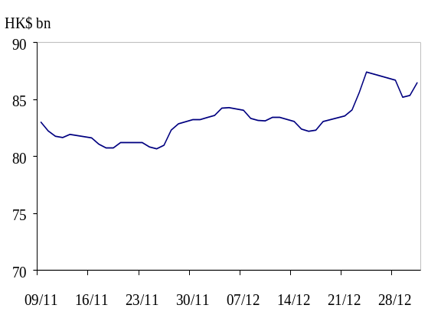
11 The outstanding amount of Certificates of Indebtedness (CI) picked up in late November, largely due to month-end effects (Chart 8). During 26 November to 7 December, the three note-issuing banks submitted to the Exchange Fund a total of US$394 mn in exchange for an increase in the CI (from around HK$80.99 bn on 26 November to HK$84.06 bn). Ahead of Christmas and New Year holidays, the three banks further submitted US$494 mn during 21-24 December in return for HK$3.85 bn worth of additional CI.

Coins
Chart 9
Coins in Circulation

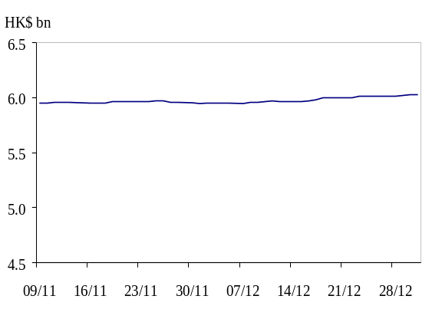
12 The total amount of coins in circulation (adjusted for the face value of commemorative gold coins issued in 1997) remained stable at HK$ 6.03bn as at 31 December (Chart 9).

Aggregate Balance

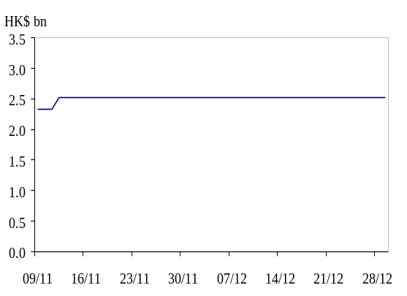
13 In compliance with the Monetary Rule of the currency board system, the Aggregate Balance of the banking system varies in accordance with the flows of funds into and out of the Hong Kong dollar. In response to some inflow of funds, the HKMA sold HK$193.4 mn for US dollar on 10 November. As a result, the Aggregate Balance increased from HK$2.33 bn on 11 November to HK$2.52 bn on 12 November and remained at that level for the rest of the reporting period (Chart 10).
Chart 10
Aggregate Balance

14 The HKMA announced on 26 November the plan to move the exchange rate under the Convertibility Undertaking in respect of the Aggregate Balance from the present level 7.75 to 7.80. As from 1 April 1999, the exchange rate under the Convertibility Undertaking in respect of the Aggregate Balance will move by 1 pip (i.e. HK$ 0.0001) each calendar day. It will then take 500 calendar days to complete the move to 7.80. The announcement had no impact on money and currency markets.

Outstanding Exchange Fund Bills and Notes

15 Adhering to the Currency Board discipline, the HKMA has undertaken to issue additional Exchange Fund paper only when there is persistent inflow of funds, enabling the additional paper to be fully backed by the Foreign Reserves. During the period under review, no additional issue of Exchange Fund paper was launched. The total outstanding amount of the Exchange Fund paper remained at HK$97.45 bn. During the period under review, 20 maturing issues of Exchange Fund Bills and 1 issue of Exchange Fund Notes were rolled over. These issues were well received by the market (Table 4). The banking sector has continued to increase their holding of Exchange Fund paper, from HK$ 78.36bn (80.4% of the total outstanding amount) on 9 November to HK$ 81.03bn on 31 December (83.2%).
Table 4
Tender Results of EF paper
(9 Nov 98-31 Dec 98)
 | No. of issues launched | Over-subscription ratio
1-month EFB | 6 | 1.15-2.82
3-month EFB | 8 | 0.51-2.02
6-month EFB | 4 | 1.25-2.58
1-year EFB | 2 | 3.43-3.98
2-year EFN | 1 | 1.41
Total | 21 | --

Discount Window Activities
Chart 11
Daily Amount Borrowed through Discount Window
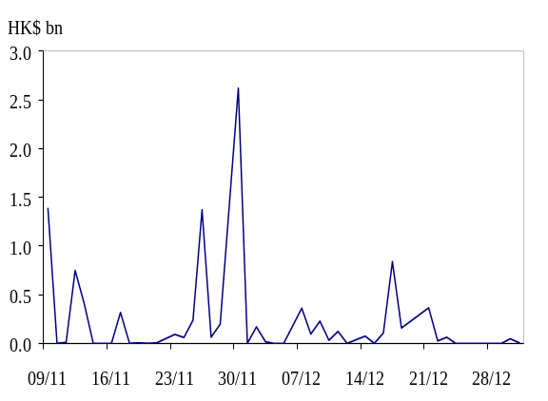
16 Banks borrowed a total of around HK$10.22 bn from the HKMA through the Discount Window from 9 November to 31 December. The usual daily amount involved was less than HK$500 mn. When money market conditions tightened on 30 November due to month-end settlement, banks borrowed some HK$2.6 bn through the Discount Window (Chart 11).

17 An overwhelming majority (HK$9.69 bn or 94.8% of total) of the borrowings made during the period were collateralized against Exchange Fund Bills and Notes. On 4 occasions (HK$89 mn), the amount which banks borrowed exceeded 50% of their holdings of Exchange Fund paper. Hence, these banks were charged at the Base Rate plus 5%.
Table 5
Frequency of Individual Banks
Access to Discount Window
Frequency of using Discount Window  (9/11-31/12) | No. of banks
1 | 25
2 | 3
3 | 2
4 | 0
>4 | 2
Total | 32

18 During the reporting period, a total of 32 banks borrowed overnight liquidity through the Discount Window and only 2 of them borrowed for more than 4 times (Table 5).

Backing Portfolio

19 Starting from 1 October 1998, specific US dollar assets of the Exchange Fund have been designated to back the Monetary Base. During the period under review, the increase in the Monetary Base was fully matched by a corresponding increase of US dollar assets in the backing portfolio.

