Annex A

Report on Currency Board Operations
(1 March – 26 March 1999)

During the reporting period, the HK dollar exchange traded within a narrow range of 7.748-7.750. Interest rate spreads narrowed further from mid-February levels. Mainly due to the redemption of Certificates of Indebtedness after the Chinese New Year, the monetary base decreased from HK$ 203.64 bn to HK$ 195.85 bn. The changes in the size of the monetary base were fully matched by corresponding changes in the foreign reserves in accordance with the rules of the Currency Board arrangements.

Hong Kong dollar exchange rate

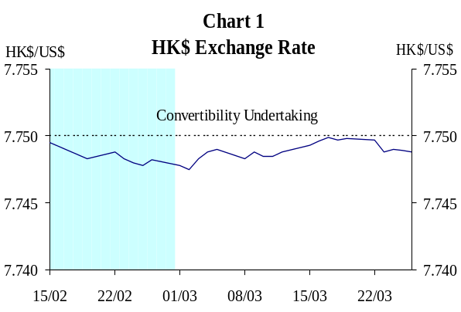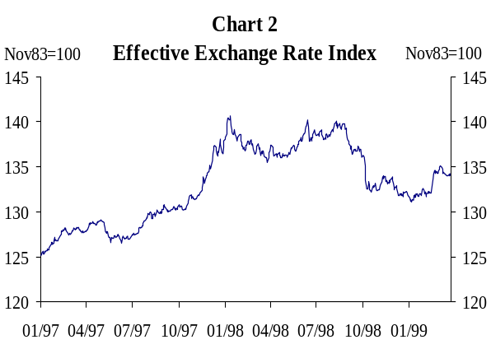1 The Hong Kong dollar exchange rate remained stable during the reporting period, trading within a narrow range between 7.748 and 7.750. There was a slight strengthening of the exchange rate in early March; In response to offers from a few banks, the HKMA sold some HK dollars for US dollars. The resultant increase in the Aggregate Balance led to an easing in interbank interest rates. In mid-March, the exchange rate weakened briefly to the convertibility rate of 7.75. Interbank liquidity tightened as the HKMA bought HK dollars under the Convertibility Undertaking, after which the exchange rate strengthened to 7.749 and stayed near that level until the end of the reporting period (Chart 1 and Chart 2).

Interest rates

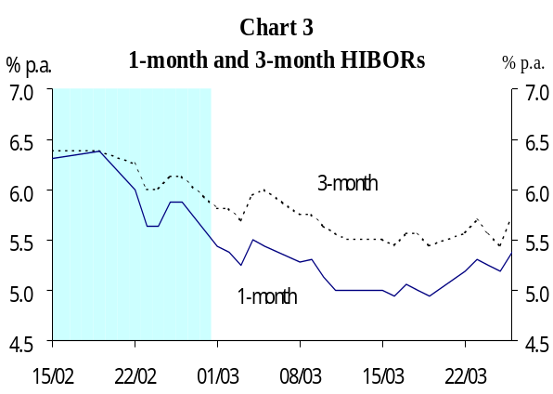2 Along with an increase in the Aggregate Balance in late February and early March, interbank interest rates eased gradually. 1-month and 3-month HIBORs softened to 4.94% and 5.44% respectively by mid-March. Relatively low short-term interest rates induced some outflow of funds on 19 March, as a result of which interbank liquidity tightened and interbank interest rates edged up. On 26 March, affected by month-end effects and an expected increase in the movement of funds among banks associated with the tax rebate, liquidity conditions tightened. 1-month HIBOR closed at 5.38%, marginally lower than the 5.44% level on 1 March (Chart 3).

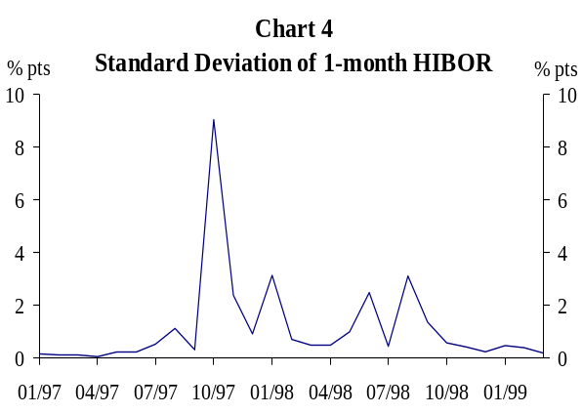3 Notwithstanding these minor movements, interbank interest rates remained relatively stable during the reporting period. Interest rate volatility measured in terms of the standard deviation of 1-month HIBOR further declined from 0.39 percentage points in February to 0.18 percentage points in March (up to 26 March) (Chart 4).

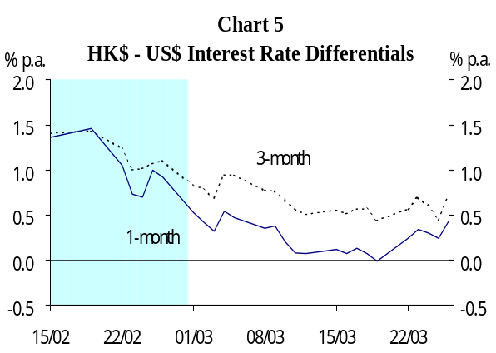4 The differential between Hong Kong dollar and US dollar interest rates narrowed gradually in the first half of March. The interest rate gap in terms of 1-month HIBOR was completely closed in mid-March. However, as interbank interest rates edged up in response to the shrinkage of the Aggregate Balance on 23 March, the spread in terms of 1-month rate widened briefly. When HK dollar interest rates edged up again on the back of tightened liquidity on 26 March, the 1-month interest spread rose to 43 bp. This was still lower than the 53 bp spread at the beginning of the reporting period (Chart 5).

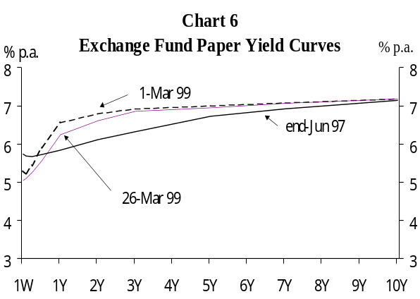5 Longer-term interest rates remained almost unchanged during the review period. The yields on 5-year and 10-year Exchange Fund Notes stood at 6.95% and 7.18% respectively on 26 March, similar to those at the beginning of the reporting period (Chart 6). Yield spreads of 5-year and 10-year Exchange Fund paper over US Treasuries stood at 174 bp and 188 bp respectively, roughly the same as the levels on 1 March (Table 1).

Table 1
Yield Spreads between Exchange Fund Paper and US Treasuries (basis points)
 | 27-Jun 97 | 1-Mar 99 | 26-Mar 99
3-month | 56 | 84 | 69
1-year | 21 | 173 | 146
3-year | 3 | 171 | 162
5-year | 27 | 177 | 174
10-year | 54 | 187 | 188

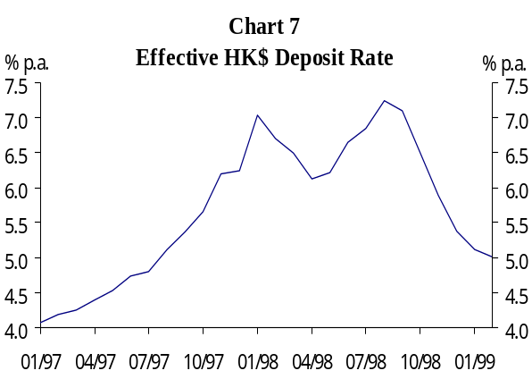6 In the retail market, the savings rate under the Interest Rate Rules of the HKAB remained unchanged at 4% during the reporting period. The weighted average deposit rate offered by 44 major authorised institutions for 1-month time deposits (which are outside the Interest Rate Rules) rose marginally from 6.5% on 26 February to 6.7% on 5 March, before declining to 5.8% on 19 March. The effective deposit rate (measured as the average of deposit rates weighted by type and maturity of deposits) continued to fall, from 5.12% in January to 5.01% in February (Chart 7).

Base Rate

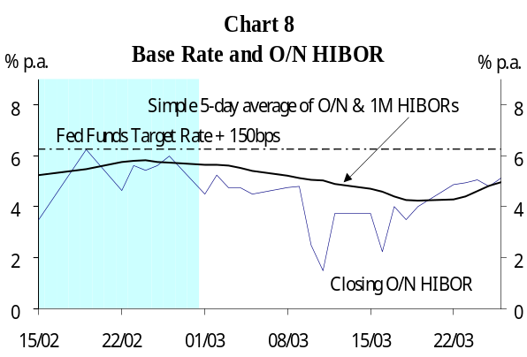7 The Base Rate remained unchanged at 6.25% (150 basis points above the US Fed Funds Target Rate) throughout the reporting period (Chart 8).

Monetary Base

8 The Monetary Base, which comprises the outstanding amount of Certificates of Indebtedness, coins in circulation, the Aggregate Balance and the outstanding amount of Exchange Fund Bills and Notes, decreased from HK$203.64 bn on 1 March to HK$195.85 bn on 26 March (Table 2). The redemption of Certificates of Indebtedness after the Chinese New Year contributed to most of the decrease. Movements of individual components are discussed below.
Table 2
Monetary Base
(HK$ bn) | 1-Mar | 26-Mar
CIs | 95.97 | 88.75
Coins in Circulation | 6.18 | 6.06
Aggregate Balance | 3.45 | 2.91
Outstanding EFBNs* | 98.04 | 98.13
Monetary Base | 203.64 | 195.85
* The nominal value of outstanding EFBNs remained unchanged at HK$97.45 bn.

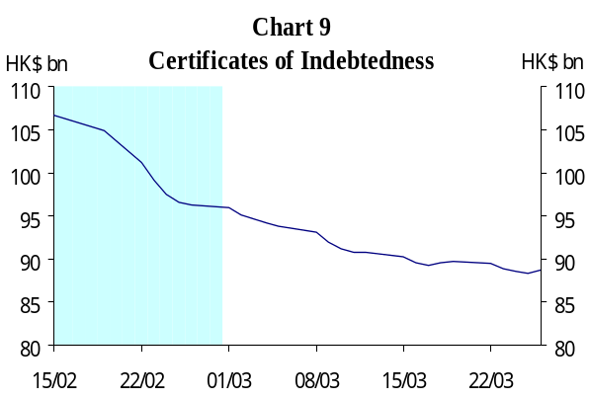Certificates of Indebtedness

9 As the public continued to return surplus bank notes to the three Note Issuing Banks (NIBs) after the Chinese New Year holidays, the NIBs redeemed a total of HK$7.22 bn of Certificates of Indebtedness in exchange for US$0.93 bn during the reporting period. As a result, the outstanding amount of CIs decreased from HK$95.97 bn on 1 March to HK$88.75 bn on 26 March (Chart 9).

Coins

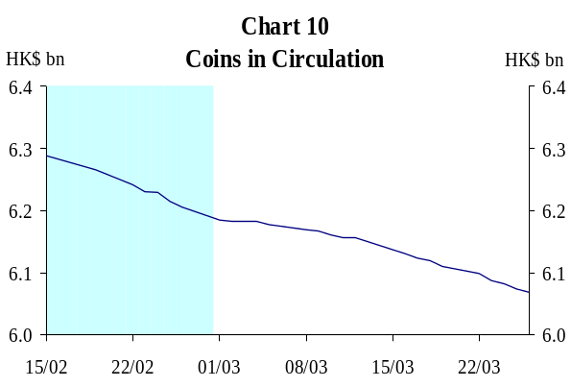10 The total amount of coins in circulation decreased slightly from HK$6.18 bn on 1 March to HK$6.06 bn on 26 March, representing a marginal decrease of HK$0.12 bn (Chart 10).

11 The new arrangements for coins in circulation, under which the issue and withdrawal of coins in circulation will be settled against US dollar value at the fixed exchange rate of HK$7.80 to US$1, will take effect on 1 April.

Aggregate Balance

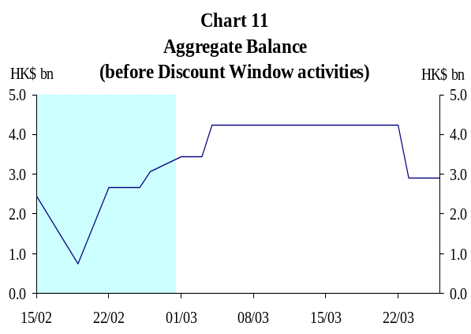12 As the HK dollar exchange rate remained firm in early March, the HKMA sold HK$775 mn for US dollars on 2 March. As a result, the Aggregate Balance (before Discount Window activities) increased from HK$3.45 bn to HK$4.23 bn on 4 March. Subsequently, in response to an outflow of funds, the HKMA bought on 19 March HK$1.32 bn for US$0.17 bn under the Convertibility Undertaking. The Aggregate Balance shrank to HK$2.91 bn accordingly when the foreign exchange transaction settled on 23 March, and remained at that level for the rest of the reporting period (Chart 11 and Table 3).
Table 3
HKMA HK$/US$ FX Transactions*
(1 Mar – 26 Mar)
Trade Date | Net HK$ purchase (+) / sale (-)  (HK$ mn)
2 Mar | -775
19 Mar | 1,318
* FX transactions may be due for settlement today, on the next business day, or the day after, at which point it would affect the Aggregate Balance.

Outstanding Exchange Fund Bills and Notes

13 During the period under review, no additional issue of Exchange Fund paper was launched. The market value of outstanding Exchange Fund paper increased marginally from HK$98.04 bn on 1 March to HK$98.13 bn on 26 March. 10 maturing issues of Exchange Fund Bills were rolled over. These issues were all well received by the market (Table 4). Holdings of Exchange Fund paper by the banking sector (in terms of nominal value) increased marginally from HK$78.52 bn (80.6% of the total outstanding amount) on 1 March to HK$79.86 bn (82.0% of the total) on 26 March.
Table 4
Issuance of EF paper
(1 Mar – 26 Mar)
 | No. of issues launched | Over-subscription ratio
1-month EFB | 3 | 1.22-2.93
3-month EFB | 4 | 1.48-2.37
6-month EFB | 2 | 3.12-3.73
1-year EFB | 1 | 5.62

14 The new arrangement to allow the outstanding size of the Exchange Fund Bills and Notes to rise in line with interest payments on outstanding Exchange Fund paper will commence on 1 April.

Discount Window Activities

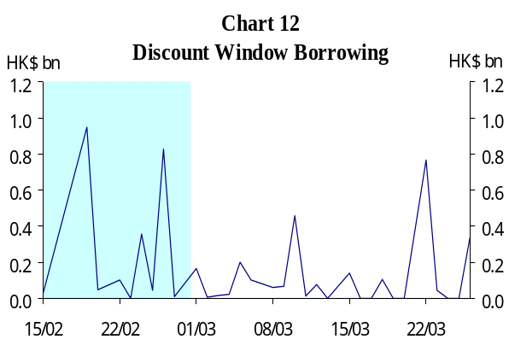15 The Discount Window provides banks access to overnight liquidity to facilitate their cash flow management, and hence helps to ensure the smooth functioning of the interbank payment system. Banks’ access is unrestricted in respect of borrowings collateralized against Exchange Fund paper. During the reporting period, banks borrowed a total of HK$2.58 bn from the HKMA through the Discount Window from 1 March to 26 March. The daily amount involved was generally less than HK$500 mn (Chart 12).

16 During the period under review, a total of 18 banks borrowed overnight liquidity through the Discount Window (Table 5). Most banks used the Discount Window facility only infrequently and only three of them borrowed more than twice.

17 An overwhelming majority (HK$2.52bn or 97.9% of total) of the borrowings made during the period were collateralized against Exchange Fund Bills and Notes. There was no occasion in which banks borrowed an amount exceeding 50% of their holdings of Exchange Fund paper.
Table 5
Frequency of Individual Banks
Access to the Discount Window
(1 Mar – 26 Mar)
Frequency of using Discount Window | No. of banks
1 | 14
2 | 1
3 | 2
4 | 1
Total | 18

Backing Portfolio

18 The monetary base and the backing assets of the Backing Portfolio both increased by 3.3% in February. As a result, the backing ratio remained virtually unchanged at 109% at end-February. Under the linked exchange rate system, although specific Exchange Fund assets have been designed for the Backing Portfolio, all Exchange Fund assets are available to support the HK dollar exchange rate.

