**Topics: Descriptive Statistics and Probability**

1. Look at the data given below. Plot the data, find the outliers and find out $μ, σ, σ^{2}$

|  |  |
| --- | --- |
| **Name of company** | **Measure X** |
| Allied Signal | 24.23% |
| Bankers Trust | 25.53% |
| General Mills | 25.41% |
| ITT Industries | 24.14% |
| J.P.Morgan & Co. | 29.62% |
| Lehman Brothers | 28.25% |
| Marriott | 25.81% |
| MCI | 24.39% |
| Merrill Lynch | 40.26% |
| Microsoft | 32.95% |
| Morgan Stanley | 91.36% |
| Sun Microsystems | 25.99% |
| Travelers | 39.42% |
| US Airways | 26.71% |
| Warner-Lambert | 35.00% |

**Mean** = 33.271

**Variance** = 287.146

**Standard Deviation** = 16.94

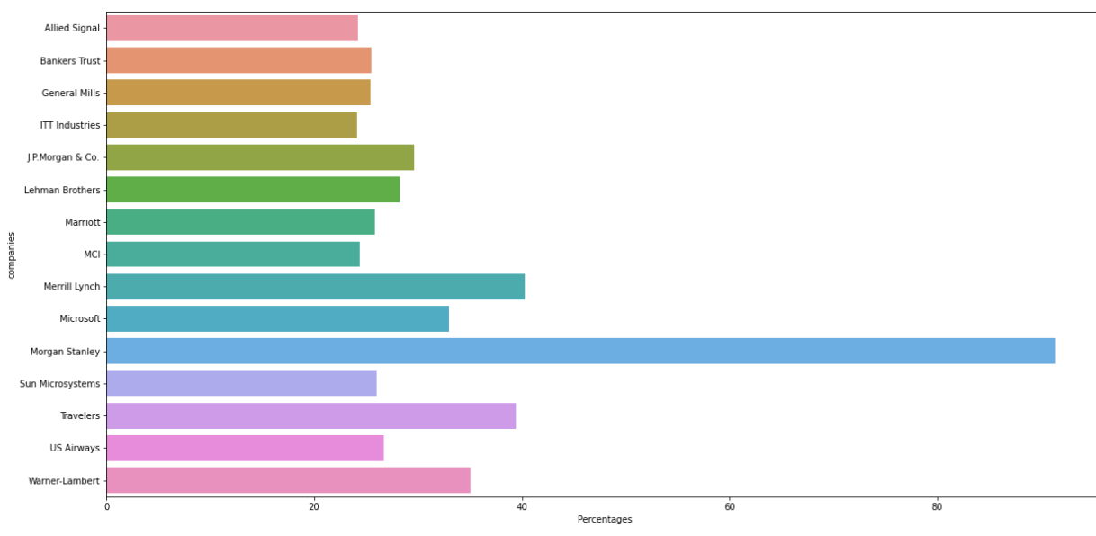

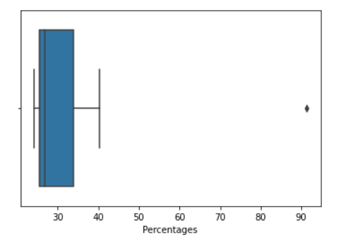



Answer the following three questions based on the box-plot above.

1. What is inter-quartile range of this dataset? (please approximate the numbers) In one line, explain what this value implies.

Ans: inter-quartile range = Q3-Q1 = 12.5 – 5 = 7.5(approx.)

1. What can we say about the skewness of this dataset?

Ans: We can say that the data is positively skewed where median<mean

1. If it was found that the data point with the value 25 is actually 2.5, how would the new box-plot be affected?

Ans: The datapoint 25 which is an outlier, if the value 25 is 2.5 then it reduces the positive skewness of the data, and maybe the data will transform into normal distribution



Answer the following three questions based on the histogram above.

1. Where would the mode of this dataset lie?

Ans: mode of the dataset is maximum between 5 to 10(where mode is said to be the most frequent number)

1. Comment on the skewness of the dataset.

Ans: Skewness of the dataset is positively skewed(Right skewed)

1. Suppose that the above histogram and the box-plot in question 2 are plotted for the same dataset. Explain how these graphs complement each other in providing information about any dataset.

Ans: Coming to the complement we can be sure of median and outliers which are easily visualized through it

1. AT&T was running commercials in 1990 aimed at luring back customers who had switched to one of the other long-distance phone service providers. One such commercial shows a businessman trying to reach Phoenix and mistakenly getting Fiji, where a half-naked native on a beach responds incomprehensibly in Polynesian. When asked about this advertisement, AT&T admitted that the portrayed incident did not actually take place but added that this was an enactment of something that “could happen.” Suppose that one in 200 long-distance telephone calls is misdirected. What is the probability that at least one in five attempted telephone calls reaches the wrong number? (Assume independence of attempts.)

Ans: The question follows a binomial distribution function

P = 1/200=0.05

Q = 1-p=0.995

n = 5

x = 1

after applying binomial function formula

probability of atleast one in five attempted telephone calls reaches the wrong number = 0.245

1. Returns on a certain business venture, to the nearest $1,000, are known to follow the following probability distribution

|  |  |
| --- | --- |
| x | P(x) |
| -2,000 | 0.1 |
| -1,000 | 0.1 |
| 0 | 0.2 |
| 1000 | 0.2 |
| 2000 | 0.3 |
| 3000 | 0.1 |

1. What is the most likely monetary outcome of the business venture?

Ans: the most likely monetary outcome P(x)=0.3=2000$, where it has the maximum probability compare to other

1. Is the venture likely to be successful? Explain

Ans: By multiplying the probabilities of positive independent event i.e.,P(x)=0.2*0.3*0.1=0.6 venture likely to be successful

1. What is the long-term average earning of business ventures of this kind? Explain

Ans: The long-term average earning E(x)=x.P(x) = 800$

1. What is the good measure of the risk involved in a venture of this kind? Compute this measure

Ans: Variance = E(x^2) – [E(x)]^2 = 2640000$(spread is very high)

Standard deviation = 1624$(Risk is high)