Home Tutors

**By:-**

Shivakrishna Bujunoori

F00442378

Wednesday, December 7, 2016

Table of Contents

Overview: 2

Business Goals: 3

Application Goals: 4

Design Choices: 5

Users 6

Login Screen: 7

Registration Screen: 8

Student Home: 9

Quick Request 10

Scheduled Request: 11

Tutor Home: 12

Tutor Session completion Request: 12

Student Completion status: 14

Admin home: 14

Admin Session completion: 16

Admin Report generation: 17

User History screen: 18

Tutor History view:- 19

Work Flow Diagram: 20

# Overview:

In the present world, Education is the most important right for any kid for their bright future. In the scenario of helping students to get the assistance, a System design in the form of bringing available Instructors as a service to demand paradigm. For this, Creating a System for registering Instructors, students and also service providers which are already holding few Instructors or private Unit who can provide support to students by providing home tutors. Requesting an Instructor with respect to the subject and the desired slot by a student, Acceptance or denied status maintenance by the Instructors or service providers, managing payment gateway between Instructors and Students by keeping standard accounts along with registration details of all parties, admin module to take care of maintaining status of each session and feedbacks on each sessions along with payment management.

When a student requests a subject tutor at the desired time slot, a request with all the details will be generated which is pushed to the registered Instructors. By looking at the request, Instructor can be able to accept or decline the request. Once the request is accepted by the Instructor, a notification is sent back to the student and a session is created with all the details in the admin interface to be tracked. Once the session is completed, Instructor will sent a completed request to the student, upon confirmation from the student payment gateway request is generated and completed at the backend. Each session and its details are available at the admin interface which will be useful to generate reports and to make feedback efficiently to the Instructors.

# Business Goals:

* Saving time and cost reduction for users.
* Our service defines on demand supply of available resources.
* User time can be saved instead of waiting for a single Instructor to get respond.
* Online transactions on the sessions will cost less than the vocal sessions in which cost for service may varied.
* Revenue generation for System can be done by increase in business to service of the user requests and feedback management.

# Application Goals:

* Making feasible and easily understandable screens which allow user to select the education level, entering school details and card details for future transactions.
* Making certain fields in the registration page are mandatory to enter and providing respective error messages while mistakes in filling registration form.
* Authentication security and error validations in all the screens
* Secure payments and Data consistency in all transactions.
* Screen flow design should be clear and ability to back track the flow of any transaction.
* Ability to retrieve weekly or monthly report generations with respect to subject and instructor.

# Design Choices:

Mobile application would be a better design choice for the system we are developing.

* Now a day’s each student and almost every person does have a mobile with the internet access in this tech world.
* In the field of mobile computing, rapid growth in the internet connectivity usages, application usages lead us to develop an on demand service providing application.
* As Android play store and apple store are great resources to get any kind of new applications. Mobile application for this kind of request – response system would be a better chance.
* As mobile is handy enough to carry everywhere and the increased computing capabilities also count for increasing in usages of the mobile devices.
* These applications can be run in a small mobile device with utilization of small amount of power and in an efficient way.
* As a request response flow consists of 2 way communication with push notifications and these notifications has to be viewed and responded quickly which cannot be possible easy in desktop application.
* Easy to update with the new features compared to desktop applications which is rare to develop and use them in the market.
* Now a day, all the payment transactions can be done through mobile APIs rather than wasting time to use banking websites every time.
* For Current System, I have chosen Mobile Application (IPhone 6) as design choice.

Users:

In the Home Tutors application, students will be application customers, Tutors will be service providers and there exists an administration department to handle all types of transactions and sessions between customers and service providers.

|  |  |  |  |
| --- | --- | --- | --- |
| **Screen Name** | **Student** | **Tutor** | **Admin** |
| Login Screen | X | X | X |
| Registration screen | X | X | X |
| Student Home screen | X |  |  |
| Quick Request Screen | X |  |  |
| Scheduled Request | X |  |  |
| Tutor home Screen |  | X |  |
| Tutor completion screen |  | X |  |
| Student completion screen | X |  |  |
| Admin home |  |  | X |
| Admin session tracking screen |  |  | X |
| Reports screen |  |  | x |
| Student history | X |  |  |
| Tutor history |  | X |  |

Login Screen:

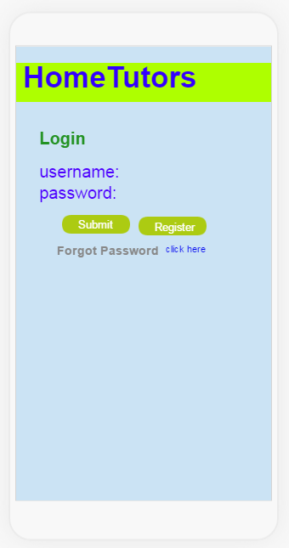

This screen is login screen for the application “Home Tutors”. If a person does not have an account in the application, they can create an account by clicking on Register button and filling the following screen with their details. A parent or student can be registered as Student as they want to get a particular skill as service based on their request. Tutors can be registered as Tutors with available skill set. click here- will direct user to password recovery flow.

Registration Screen:

# D:\Buddy\Fall2016\CSC520\reg.PNG

In this interface Student/parent will check the student radio button and Tutor will select them appropriately with their personal information. When Register is clicked, User profile record will be saved into database and directed to home screen based on choice as user or tutor. If the person has account and forgot password or remembered that they have an account in the process of registration, they will click on “click here” this link will direct the user to forget password screen.

Student Home:

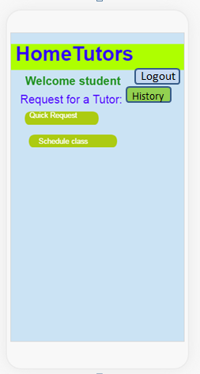

After login into system as student, the home interface will look like this. It consists of History with all the tracking of previous requests. 2 features which are

* Quick Request:- which is used to request a tutor as on demand with the desired skill set.
* Schedule Request: scheduling a request to get served by a tutor at desired time slot based on the skill requirement.
* By clicking on History, the user will be redirected to screen with previous requests and their status.

Quick Request:

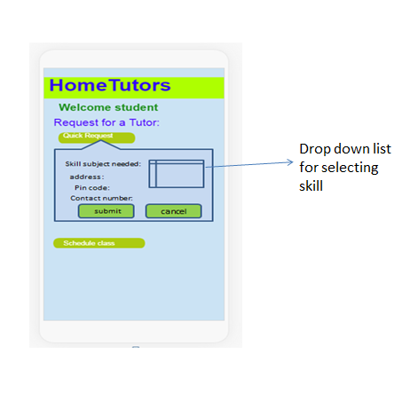

In this screen, by clicking on “Quick request” button, student can able to push a request by selecting the particular skill, address, contact number to all the tutors with similar skill set.

* Submit- on clicking will push a request to the available instructors in the database and directed back to student home screen.
* Cancel will direct the student to home screen by closing the pop up screen.

Scheduled Request:

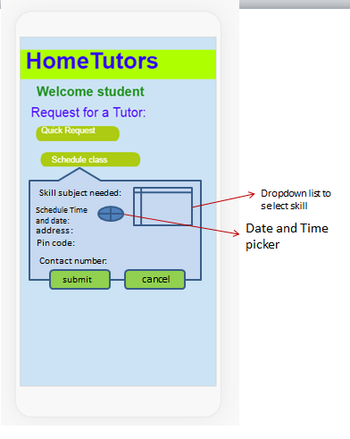

* In this screen, by clicking on “Schedule class” button, student can able to push a request by selecting the particular skill, address, Date along with time slot using picker available in the screen contact number to all the tutors with similar skill set.
* Submit- on clicking will push a request to the available instructors in the database and directed back to student home screen.
* Cancel will direct the student to home screen by closing the pop up screen.

Tutor Home:

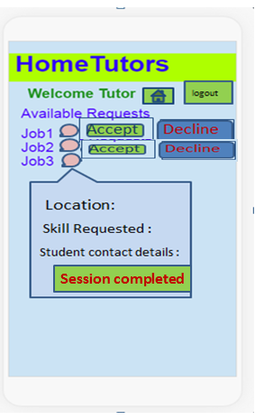

After receiving a notification onto the screen of tutor home page, the available jobs with accept or decline buttons are available.

* If there is an already running session is present, for example job3 in the above screen, by clicking on the details icon will show a pop up of details about that session and a button to raise the session completion request.
* Accept – refers to accepting request and push a notification to student about acceptance of their request.
* Decline – by clicking on this button will result deletion of the request from the screen and tutor will be redirected to home screen.

Tutor Session Completion Request:

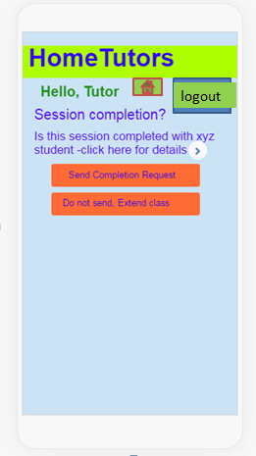

By clicking on “session completed” button in the running session (which is previous screen job3 ) of tutor home screen, This interface will be loaded with necessary details of session, raising a completing session request to student or extending session with student.

* Send Completion Request: will send a completion request push notification to the student.
* Do not Send, Extend class: will keeps on maintaining the session as usual with sending an extra notification to student that “tutor extended class” as a notification.

Student Completion status:

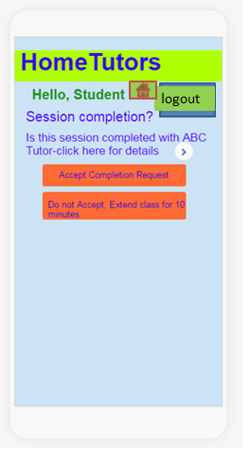

By receiving the session completion request from the tutor, student can able to close the session. Student can also extend the session using the button available.

Accept Completion– refers to submitting completion and directed to home screen.

DO not Accept– refers to directing user to running session with extra 10 minutes to be served by tutor.

Admin home:

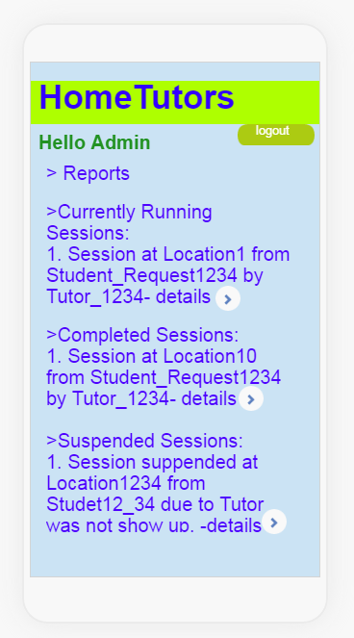

This is the home interface of admin. This interface consist 3 stages of session details and the reports generation button is available. 3 sessions are currently running, completed, and suspended categories. Once the report is selected, it will be opening a pop up with the details of it as below screen for currently completed session list. Once the particular session is clicked under completed sessions section the below screen will appear.

Admin Session completion:

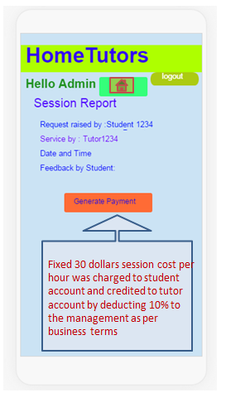

This is the screen, after session completion done from both student and tutor. When admin clicks on any session item under completed session section, this screen will appear to generate payment for the tutor and charge the student.

* As notified under the button, an amount is charged from student card and credited to business amount and into instructor card. Admin will be redirected to home screen.

Admin Report generation:

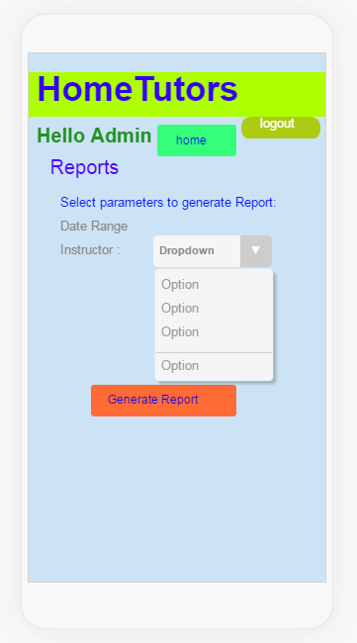

Admin has the feasibility to generate reports based on the date range like any start date to till date along with instructor selection, if No instructor is selected Report will be generated including all the instructors within the date range by including all the states of sessions like completed, suspended. This screen consists of Generating reports from the range between dates and the inclusivity of tutor selections. In those date range which contradicts to whole report with empty selection of the instructor.

* Generate report: will create a pdf of session details based on selection criteria and the pdf can be downloaded into local storage. Admin will be directed back to reports stage.
* Home- on clicking this will redirect user to home screen.

User History screen:

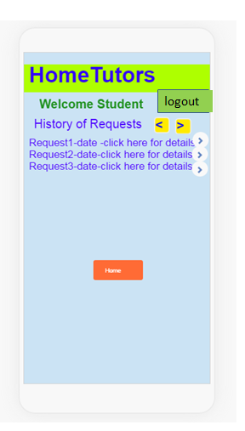

Students/parents previous requests list will be displayed in this interface after clicking on history on their home screen. This interface will show sufficient list of previous requests along with a button to pop up the entire details of the request and in case of large amount of requests, screen is built in with movements of next and previous list view buttons.

* Home- on clicking this will redirect user to home screen.

Tutor History view:-

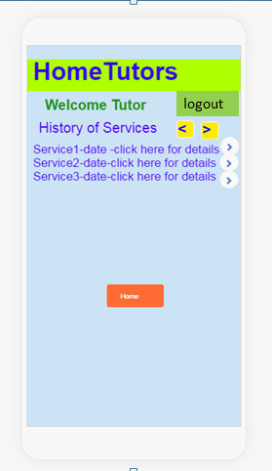

Tutor previous requests list will be displayed in this interface after clicking on history on their home screen. This interface will show sufficient list of previous requests along with a button to pop up the entire details of the request and in case of large amount of requests, screen is built in with movements of next and previous list view buttons.

* Home- on clicking this will redirect user to home screen.

Work Flow Diagram:

