PY-650卷筒平压平模切机
Roll Die Cutting Machine

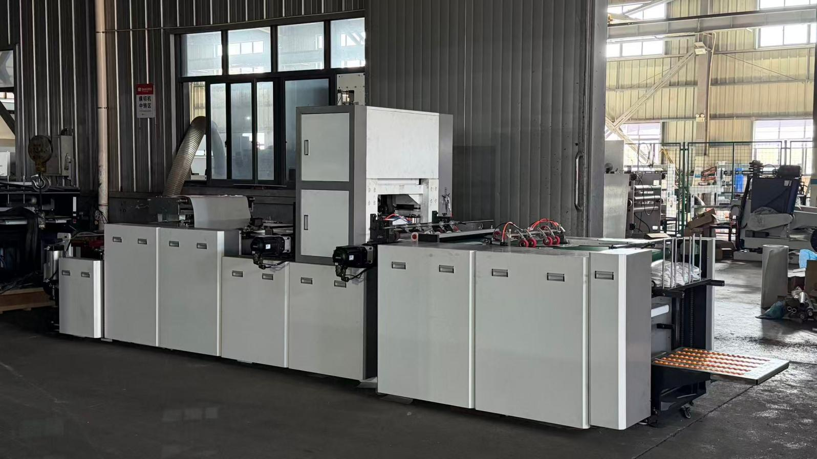

QUOTATION 卷筒平压平模切机报价表
TO:
NO. | Description产品描述 | Quantity数量 | HS.CODE | Unit Price单价 | Total总价
The quotation is valid for 180days

Remarks附注:
- Price Term: FOB NINGBO
- Payment: T/T (30% for deposit, 70% before delivery) or L/C
- Load time: 40 working days at sight the deposit.
- Packaging: Wooden packing applies to export
- After sale service:
1. Spare parts guarantee for one year in machine arrival.
2.Send the technician for installation & training. Buyer bears the cost (round tickets, accommodation, and allowance of 150 USD per day).

产品介绍Machine description:
PY-650卷筒平压平模切机全自动卷筒料平压平模切设备，专为卷筒不干胶标签、彩色印刷标签、IML膜内标、薄膜类卷材定制研发，广泛适用于食品、日化、注塑膜内贴、包装印刷等行业卷材高精度模切生产。
PY-650 Roll die cutting machine is a fully automatic flatbed die-cutting equipment specially developed for roll self-adhesive labels, printed labels, and IML (In-Mold Label) film rolls. It is widely used in high-precision die-cutting production for food, daily chemical, injection molding in-mold labeling and packaging industries.
技术参数Technical Specification
型号 Type | PY-650
模切机械速度 Mechanical running speed | 150-260切/分钟 punch/min
送纸宽度 Paper Convey Width | 100-650mm
最 大 模 切 面 积 Maximum cutting size | 650*280mm
重量 Total Weight: | 1800kgs
包 装 尺 寸 Overall Dimension: | 6600*2150*1900mm
适 用 材 料 Suitable Material:
总 功 率 和 气 Total Power and Air source: | 6KW;0.2m³/min,0.6Mpa
最大放卷直径 Max Roll paper diameter | 700mm
模切精度 Cut Precision: | ±0.15mm
d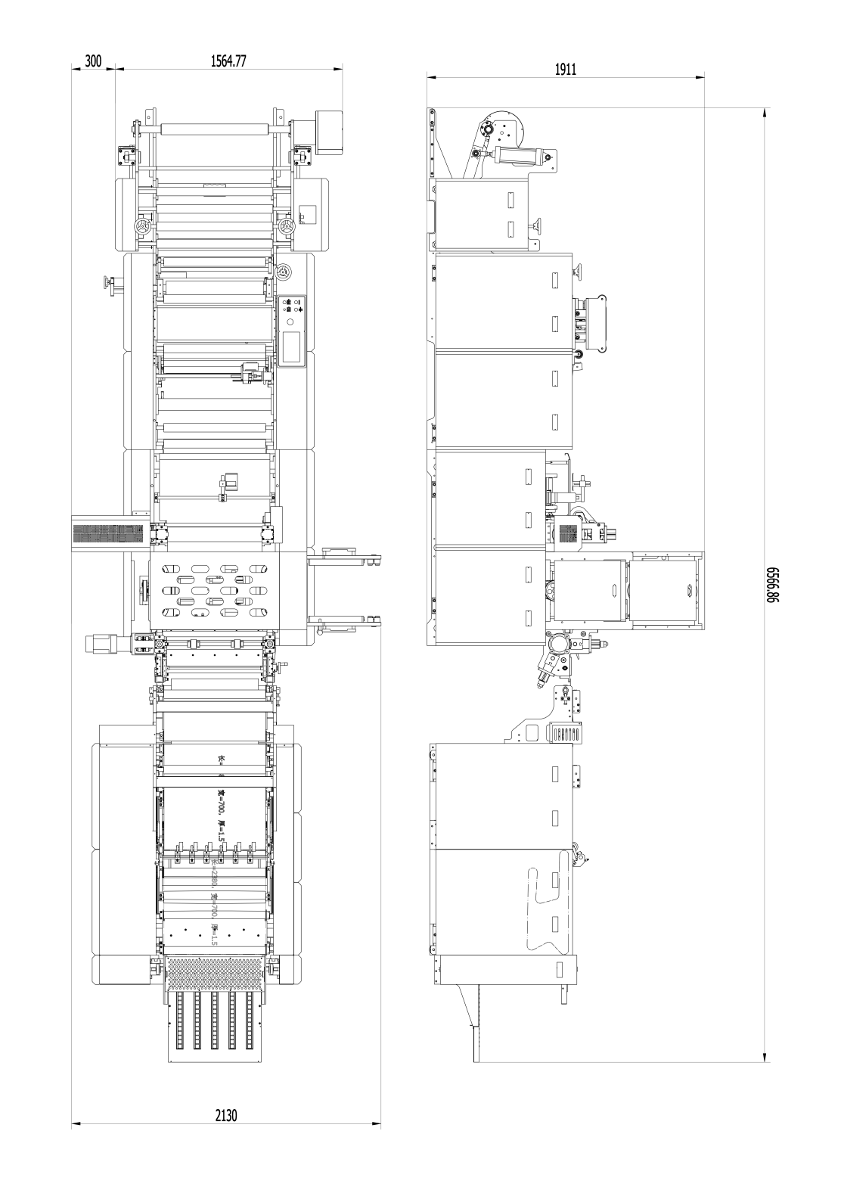
机器优势Machine Advantages:
- 采用PLC控制，人机界面触摸屏系统，为机器高速稳定运转提供了精确的保障。Adopts PLC control system with human-machine touch screen, providing precise guarantee for high-speed and stable operation of the machine.
- 主机采用伺服电机驱动，运行平稳，安全、节能。The main machine is driven by servo motor, featuring stable operation, safety and energy efficiency.
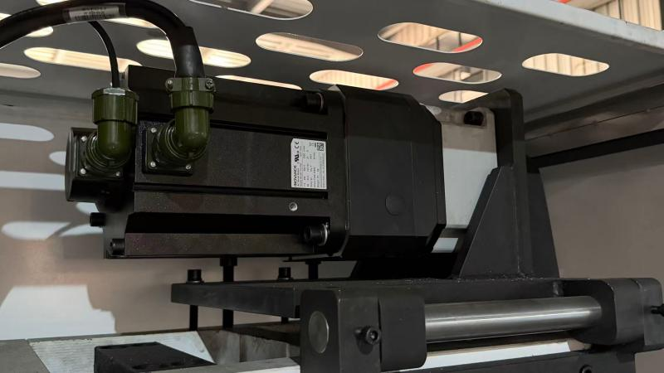

- 自动张力控制系统，有效消除材料在输送过程中的松弛与偏移。Equipped with automatic tension control system, which effectively eliminates slack and deviation of materials during conveying
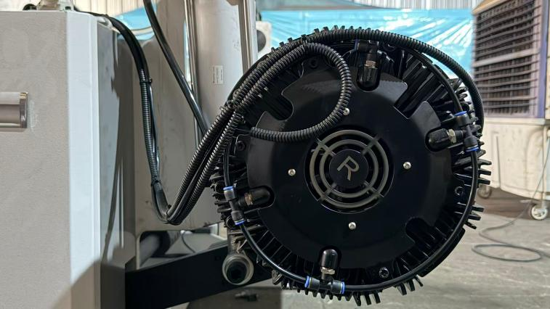
- 配备CDD纠偏装置，实时监测并修正卷材位置，大幅降低废品率。Fitted with CCD web guiding device to monitor and correct the position of coiled materials in real time, greatly reducing the reject rate.
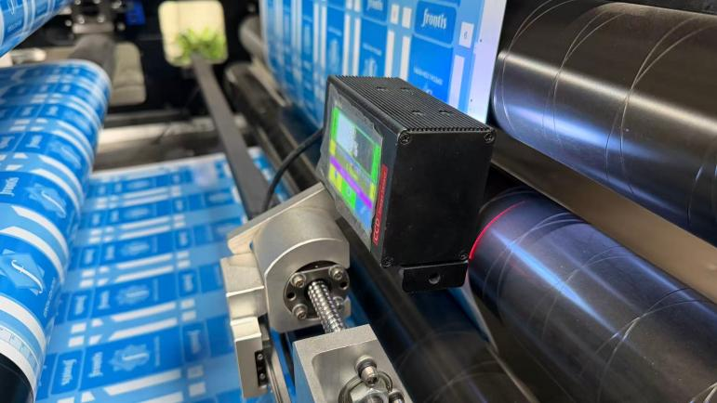
- 送料、出料由伺服电机同步控制，送料进准，调节方便。Feeding and discharging are synchronously controlled by servo motors, delivering accurate feeding and convenient adjustment.
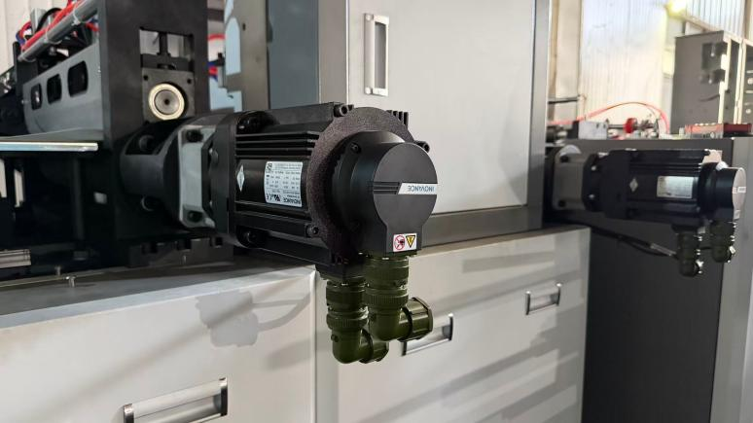
- 色标跟标定位，定位精准，提升模切精度。Color-mark tracking positioning ensures high positioning accuracy and improves die cutting precision.
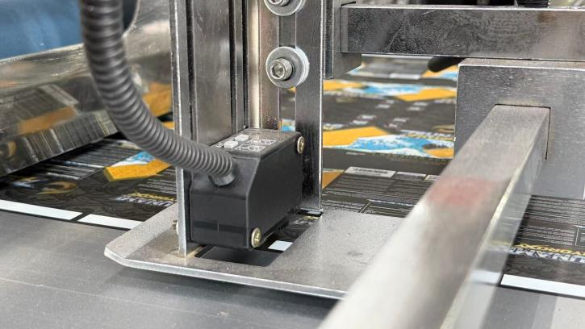
- 配备自动清废功能，废料卷筒收集，省去了手动清废。Comes with automatic waste removing function and waste winding collection, eliminating manual waste cleaning.
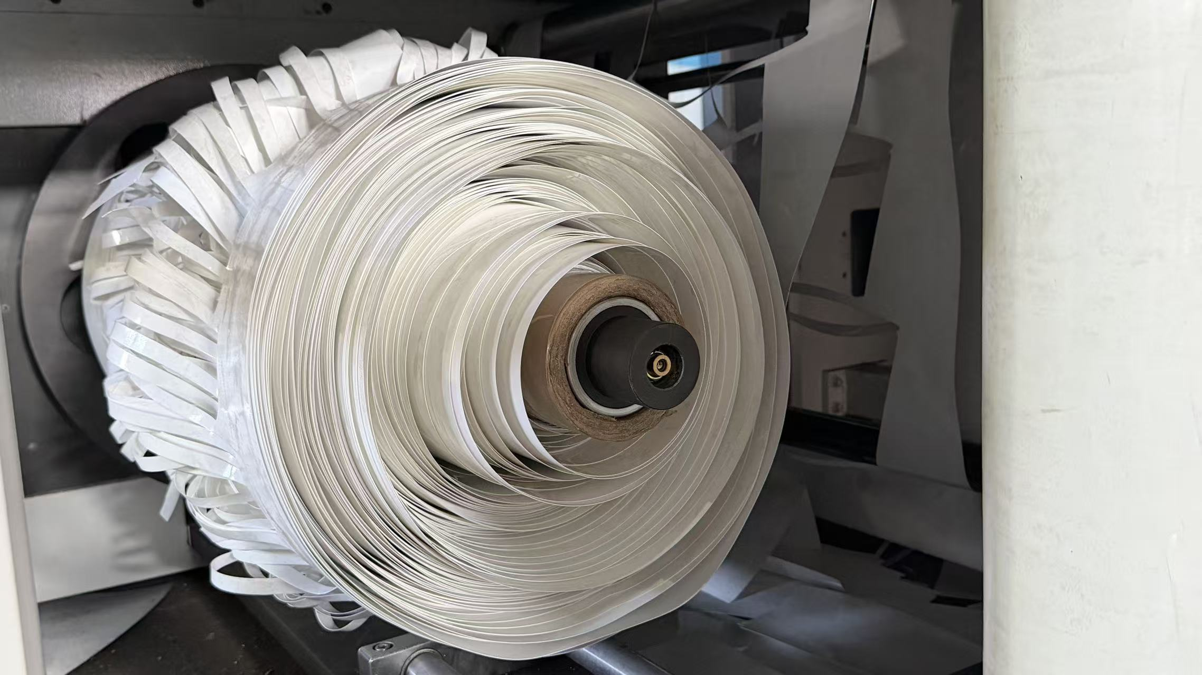
- 成品输送配备分批，记数功能。The finished product conveyor is equipped with batch separation and counting functions.

电器配件Machine Components

电机Motor | 主电机Main motor | 中国GONGTAI（CHINA）
电机Motor | 伺服电机Servo motor |   中国汇川INOVANCE
电器  Electric elements | 伺服驱动Servo driver | 中国汇川INOVANCE
电器  Electric elements | 伺服驱动Servo driver
电器  Electric elements | 可编程控制器PLC
电器  Electric elements | 变频器Frequency converter
电器  Electric elements | 低压电器All other electrical parts | 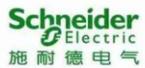  法国施耐德 SCHNEIDER
电器  Electric elements | 继电器relay |   日本欧姆龙
电器  Electric elements | 按钮 bottom |   韩国AUTONICS(KOREA)
电器  Electric elements | 编码器encoder
电器  Electric elements | 光电/接近开关Photoelectric switch
电器  Electric elements | 色标光电photoelectric color mark |   日本 PANASONIC(JAPAN)
气动  Pneumatic | 主要气动部分Main air cylinder |   台湾AIRTAC(TAIWAN)
气动  Pneumatic | 其他气动部分Solenoid valve and other parts
气动  Pneumatic | 气动离合器pneumatic clutch

团队风采Our Team
品质体现我们的尊严，出类拔萃的品质拒绝平庸，一丝不苟，千锤百炼，标准化的管理体系和系统化的品质保证体系，大桥人通过与合作者们卓有成效的努力，促使大桥产品达到无可挑剔的品质。
The Standardized management system and the systematic quality assurance system prompt DAKIOU products become one of the world's most impeccable products.Our company successfully certified by IS09001 :2008 and products are approved CE certificate. We offer
360°service from advice to assembly, know-how meet technology for global customers
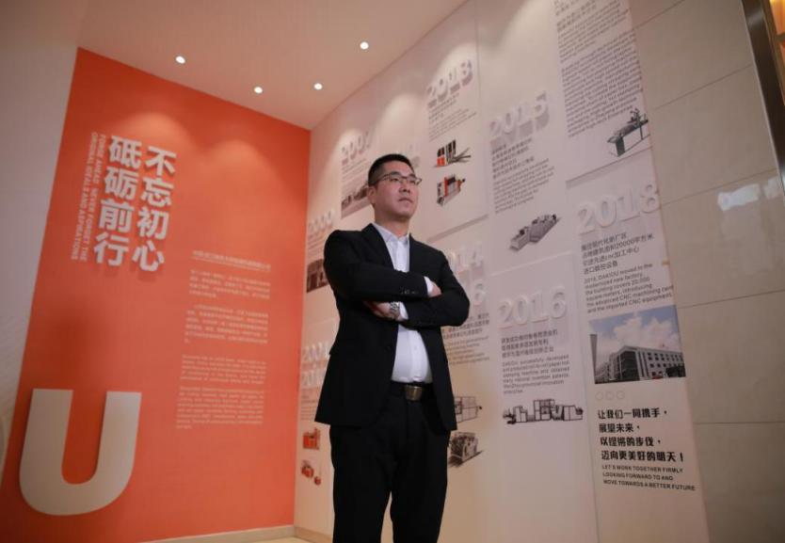



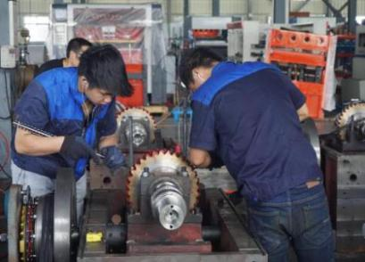

证书Certificate

