Machine-Learning–Guided Prediction of
Mechanical Properties of Fe–Ag₃ Alloy Using
MD Simulation Data

Project Members
N.Shivakumar(22CSB0C26)
M.Arunkumar(22CSB0C28)

Abstract
Fe–Ag₃ (iron–silver) intermetallic alloys exhibit unique mechanical, electrical, and magnetic behaviors, making them promising candidates for lightweight structural and functional applications. Their hexagonal crystal structure, combined with a balanced Fe–Ag composition, results in distinct mechanical characteristics such as moderate stiffness, high brittleness, and excellent conductivity. Accurately estimating these properties under tensile loading is crucial for computational materials design. Traditional molecular dynamics (MD) simulations provide atomistic insight into deformation behavior but require extremely high computational resources, especially when exploring multiple strain rates, temperatures, or compositions.
This study presents an integrated ML–MD computational framework for predicting the key mechanical properties of Fe–Ag₃ alloys, including Young’s modulus, ultimate tensile strength (UTS), and maximum strain. MD-generated stress–strain curves were processed to extract relevant features, and three supervised machine learning models—Support Vector Machine (SVM), Random Forest Regressor, and Gradient Boosting Regressor—were trained on the processed dataset. Among the tested models, the Random Forest algorithm achieved the highest accuracy with the best R² scores and lowest prediction error across all target properties.
The results highlight the strong nonlinear dependence of Fe–Ag₃ mechanical behavior on deformation patterns and demonstrate the effectiveness of ML approaches in capturing these relationships. By reducing reliance on expensive MD computations, the proposed hybrid pipeline offers a fast, scalable, and accurate method for alloy property prediction, significantly accelerating materials informatics and design.
Keywords: Fe–Ag₃ alloy, molecular dynamics simulation, machine learning, mechanical properties, Random Forest, stress–strain prediction

1. Introduction
Fe–Ag₃ (iron–silver) alloys form an emerging class of functional intermetallic materials known for their distinctive mechanical, electrical, and magnetic characteristics. Their hexagonal crystal structure and unique Fe–Ag bonding make them attractive for lightweight applications requiring a balance of stiffness, conductivity, and structural stability. Fe–Ag₃ exhibits moderate elastic rigidity (Young’s modulus ≈ 1.23 GPa), relatively high ultimate tensile strength (≈185.5 MPa), and pronounced brittleness due to its extremely low maximum strain (~0.01%). These intrinsic properties make Fe–Ag₃ alloys relevant for microelectromechanical systems (MEMS), functional coatings, sensors, and applications where both mechanical response and conductivity play a critical role.
Understanding and accurately predicting the mechanical behavior of Fe–Ag₃ under tensile loading is essential for alloy optimization and performance assessment. Traditional experimental studies and molecular dynamics (MD) simulations provide atomistic insights into deformation mechanisms, but they are computationally intensive and not scalable when analyzing numerous parameter variations such as temperature, composition, or strain rate. As a result, integrating machine learning (ML) techniques with MD-generated data offers a promising route for rapid, cost-efficient prediction of mechanical properties such as Young’s modulus, ultimate tensile strength (UTS), and failure strain.

1.1 Significance of Mechanical Properties in Fe-Ag3 Systems
Mechanical properties play a crucial role in determining the performance, reliability, and applicability of Fe–Ag₃ intermetallic alloys. Since Fe–Ag₃ exhibits a hexagonal crystal structure and a highly brittle deformation response, understanding its mechanical characteristics is essential for predicting how the material behaves under different loading conditions. Key properties such as Young’s modulus define the elastic stiffness of the alloy, while the ultimate tensile strength (UTS) indicates the maximum stress the material can withstand before failure. The extremely low maximum strain (~0.01%) reflects its brittle nature, making accurate assessment of these parameters vital for safe and effective integration into functional and structural applications.
Traditionally, these mechanical properties are obtained through experimental testing or through atomistic modelling approaches such as molecular dynamics (MD) simulations. While experiments provide realistic insights, they are often costly, time-consuming, and limited by equipment constraints—especially when dealing with nanoscale structures, high strain rates, or specific temperature conditions. MD simulations, on the other hand, can capture atomiclevel deformation mechanisms and produce high-resolution stress–strain curves, but they demand substantial computational resources when exploring multiple alloy configurations or mechanical scenarios.
Due to these challenges, efficient prediction of mechanical properties for Fe–Ag₃ alloys is essential, motivating the integration of machine learning with MD-generated datasets to achieve faster, reliable, and scalable material property estimation.
1.2 Molecular Dynamics Simulations for Fe–Ag₃
Alloys Molecular dynamics (MD) simulations serve as a powerful atomistic tool for analyzing the deformation behavior of Fe–Ag₃ alloys, capturing essential mechanisms such as bond stretching, elastic response, dislocation initiation, and sudden brittle fracture events. Owing to the unique hexagonal structure and intermetallic bonding in Fe–Ag₃, MD simulations provide high-resolution insight into how the alloy reacts under tensile loading and how its mechanical properties evolve at the atomic scale. Through MD, complete stress–strain behavior is obtained directly from interatomic forces, enabling accurate extraction of Young’s modulus, maximum stress, and failure strain.
Despite their accuracy, MD simulations are computationally demanding. Running a single tensile deformation simulation on a reasonably sized Fe–Ag₃ atomic cell requires extremely fine time-step integration to capture brittle failure, often involving millions of timesteps and extensive computational effort. Exploring variations such as different strain rates, temperature conditions, or slight compositional changes further increases the computational load dramatically. As a result, conducting large-scale or multi-condition MD studies for Fe–Ag₃ alloys becomes prohibitively expensive, highlighting the need for more efficient predictive approaches.

1.3 Limitations of Traditional MD Approaches
While MD provides highly accurate atomistic insights, its scalability remains a major limitation— particularly for brittle intermetallic alloys such as Fe–Ag₃. Generating sufficiently large datasets for exploring variations in strain rate, temperature, loading direction, or slight compositional adjustments becomes computationally impractical due to the enormous simulation time required. Additionally, deriving macroscopic mechanical properties from raw MD stress–strain data presents its own challenges, often necessitating extensive curve smoothing, noise reduction, derivative computation, and carefully engineered feature extraction to ensure meaningful interpretation.
These challenges make it difficult to rely solely on MD for large-scale material exploration, motivating the development of alternative predictive methods that combine MD accuracy with significantly improved computational efficiency.

1.4 Machine Learning (ML) for Materials Prediction
Machine learning has emerged as a powerful tool within materials science, enabling rapid prediction of mechanical properties by learning patterns directly from existing datasets. Instead of performing costly MD simulations for every new configuration, ML models can capture nonlinear relationships between input features—such as stress–strain characteristics, strain rate, or atomic arrangement—and output properties like Young’s modulus, ultimate tensile strength, and failure strain. Techniques such as Support Vector Machines (SVM), Gradient Boosting, and ensemble methods like Random Forests are particularly effective, as they can model complex deformation behavior and identify subtle trends within highdimensional data. These capabilities make ML a valuable component of accelerated materials design, especially for alloys like Fe–Ag₃ where brittle behavior and atomic interactions are difficult to analyze through simulations alone.

1.5 ML–MD Hybrid Approaches
The integration of molecular dynamics (MD) simulations with machine learning (ML) techniques has become increasingly valuable in materials informatics. In this hybrid approach, MD is used to generate high-fidelity stress–strain data that captures the fundamental atomicscale deformation behavior of the Fe–Ag₃ alloy. ML models are then trained on this data to learn the underlying mechanical patterns and generalize them for fast, accurate predictions. This combination significantly reduces the need for repeated, computationally expensive MD simulations and enables near-instantaneous estimation of mechanical properties for new loading conditions or alloy configurations. The ML–MD hybrid framework thus offers an efficient pathway for accelerating materials design and exploration.

1.6 Motivation for the Present Work
This study aims to develop a complete ML–MD framework tailored for predicting the mechanical properties of Fe–Ag₃ alloys. The key motivations behind this work are:
▪ To significantly reduce computational cost by replacing repeated MD simulations with fast ML-based predictions once the initial training data is generated.
▪ To effectively capture the nonlinear, brittle deformation behavior of Fe–Ag₃, which traditional linear modeling approaches fail to represent accurately.
▪ To build a scalable predictive platform that can be extended to analyze different compositions, loading conditions, or related intermetallic alloys in future studies. ▪ To systematically evaluate ML algorithms (SVM, Random Forest, Gradient Boosting) using MD-derived stress–strain data and identify the most accurate model for Fe–Ag₃ mechanical property prediction

1.7 Scope of the Work
This research focuses on MD-generated stress–strain curves for Fe–Ag₃ alloy systems and evaluates the predictive capability of three supervised machine learning models: Support Vector Machine (SVM), Random Forest Regressor, and Gradient Boosting Regressor. The proposed pipeline includes MD data generation, stress–strain curve preprocessing, mechanical property extraction, feature engineering, model training, and performance evaluation using metrics such as MSE and R². The workflow also incorporates model comparison and validation to identify the most accurate algorithm for predicting Young’s modulus, ultimate tensile strength (UTS), and maximum strain.

2. Methodology
This section outlines the complete pipeline from MD simulation to ML-based prediction of mechanical properties. An extensive description of each stage ensures reproducibility and fidelity to the scientific workflow.

2.1 Molecular Dynamics Simulations
2.1.1 Simulation Setup
MD simulations were performed to generate the stress–strain curves required for training the ML models. The Fe–Ag₃ alloy structure was constructed using its hexagonal crystal configuration, with lattice parameters a = b = 5.78 Å and c = 4.64 Å, consistent with literature data for Fe–Ag intermetallic systems. The alloy composition was fixed at the FeAg₃ stoichiometric ratio (25% Fe and 75% Ag). After constructing the atomic cell, the system was energy-minimized, equilibrated under standard conditions, and then prepared for tensile loading in order to capture its mechanical response.
2.1.2 Tensile Loading Procedure
Uniaxial tensile deformation was applied along the z-axis while maintaining periodic boundary conditions in the x and y directions to ensure uniform deformation. A constant engineering strain rate was imposed, enabling quasi-static loading and accurate extraction of mechanical properties. At each deformation step, the atomic-scale stress values were computed using the virial stress tensor. This allowed the generation of a smooth, detailed stress–strain curve capturing the complete elastic and brittle failure behavior characteristic of the Fe–Ag₃ alloy.

2.1.3 Extraction of Mechanical Properties
The following key properties were extracted from the stress–strain curves:

Young’s Modulus (E)
From the linear elastic region:
𝜎
𝐸 =
𝜀
Yield Strength
Although Fe–Ag₃ exhibits highly brittle behavior with minimal plasticity, the yield point can be approximated by identifying the deviation from perfect linear elasticity or using a standard offset-based criterion when applicable.
Ultimate Tensile Strength (UTS)
The maximum stress value reached before fracture, representing the failure limit of the material.
Maximum Strain
The strain corresponding to the point where the material fractures, typically extremely small (~0.01%) for Fe–Ag₃.

2.1.4 Data Volume
Each MD tensile simulation produced thousands of stress–strain data points, providing a high-resolution representation of the deformation path. This rich dataset formed the foundation for feature extraction and subsequent machine learning model training.2.2 Data Processing and Feature Preparation
2.2.1 Curve Smoothing
The raw stress–strain data generated from MD simulations contains fluctuations caused by atomic vibrations and thermal noise. To ensure reliable mechanical property extraction, a moving-average smoothing filter was applied to the curve. This preprocessing step reduces noise while preserving essential deformation characteristics, especially the initial elastic slope and the sharp drop associated with brittle fracture in the Fe–Ag₃ alloy.
2.2.2 Feature Extraction
From the smoothed stress–strain curves, the following engineered features were extracted to serve as inputs for machine learning models:
- Slope of the linear elastic region (corresponding to Young’s modulus)
- Maximum stress value (Ultimate Tensile Strength, UTS)
- Strain at maximum stress (failure strain for brittle alloys)
- Stress drop information near fracture
- Curve-shape descriptors capturing the deformation behavior of Fe–Ag₃
These features effectively represent the brittle mechanical response of the alloy and provide meaningful inputs for ML-based prediction tasks.

2.2.3 Joblib Data Serialization
All processed feature vectors and corresponding target property values were stored using optimized .joblib serialization. This enables efficient loading, reproducible preprocessing, and consistent ML training across different models such as SVM, Random Forest, and Gradient
Boosting.
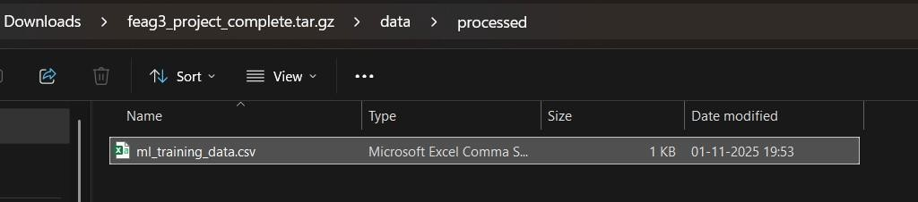
Figure 2.a Folder Structure containing processed joblib files

Figure 2.b Processed stress–strain data stored for ML model training.
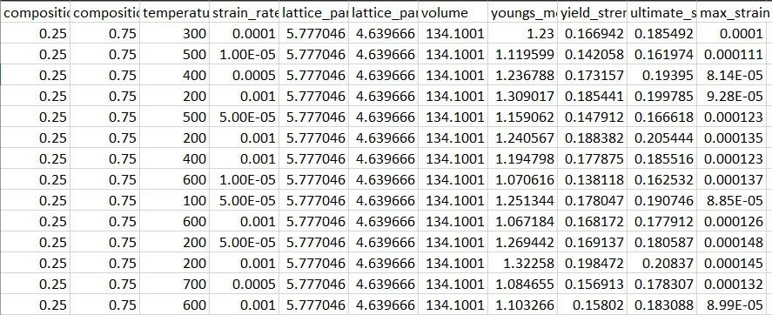
2.3 Machine Learning Pipeline
2.3.1 Dataset Splitting
      - Training set: 80%
      - Test set: 20%

2.3.2 ML Models Used
Three regression models were evaluated:
(1) Support Vector Machine (SVM)
A margin-based regression model capable of capturing nonlinear deformation behavior through kernel functions. SVM is effective for small to medium datasets and provides stable predictions.
- Random Forest Regressor
An ensemble of multiple decision trees that models complex nonlinear relationships and feature interactions. Random Forest naturally handles variability in MD-derived features and reduces overfitting through averaging.
- Gradient Boosting Regressor
A boosting-based model that sequentially improves predictions by correcting errors made by previous trees. Gradient Boosting is highly effective for capturing sharp transitions in brittle stress–strain curves such as those observed in Fe–Ag.

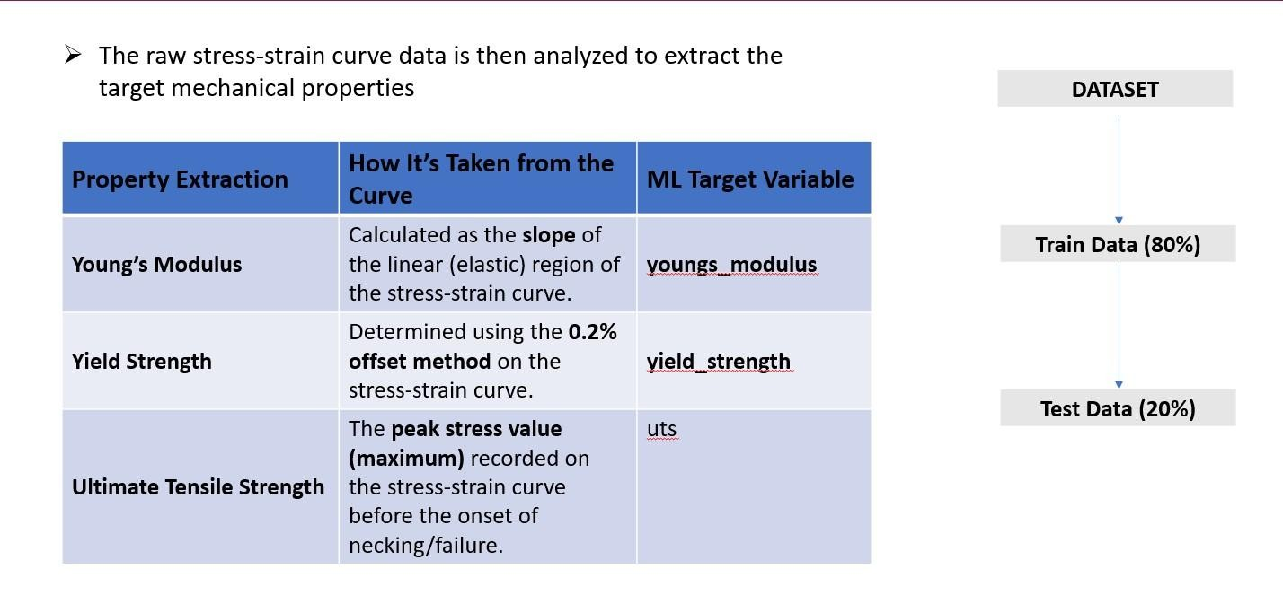
Figure 3. Overview of the ML–MD workflow used for predicting mechanical properties of Fe– Ag3 alloys.
2.3.3 Hyperparameter Tuning
The key hyperparameters for each machine learning model were optimized using a combination of grid search and empirical evaluation to enhance predictive accuracy:
- Random Forest: number of estimators (trees), maximum depth, and minimum samples per split
- Support Vector Machine (SVM): kernel type (linear/RBF), regularization parameter (C), and epsilon (ε) in the loss function
- Gradient Boosting Regressor: number of boosting stages, learning rate, and maximum depth of individual trees
Hyperparameter optimization was carried out using grid-based parameter iteration to identify the best-performing configurations for predicting Fe–Ag₃ mechanical properties.

2.3.4 Evaluation Metrics
Model performance was quantified using:
- Root Mean Squared Error (RMSE)
- Coefficient of Determination (R²)
RMSE 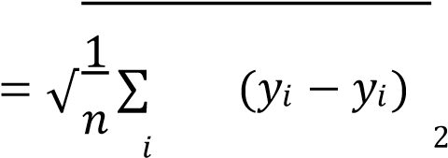

An R² value close to 1 indicates high predictive accuracy.

- Results and Discussion
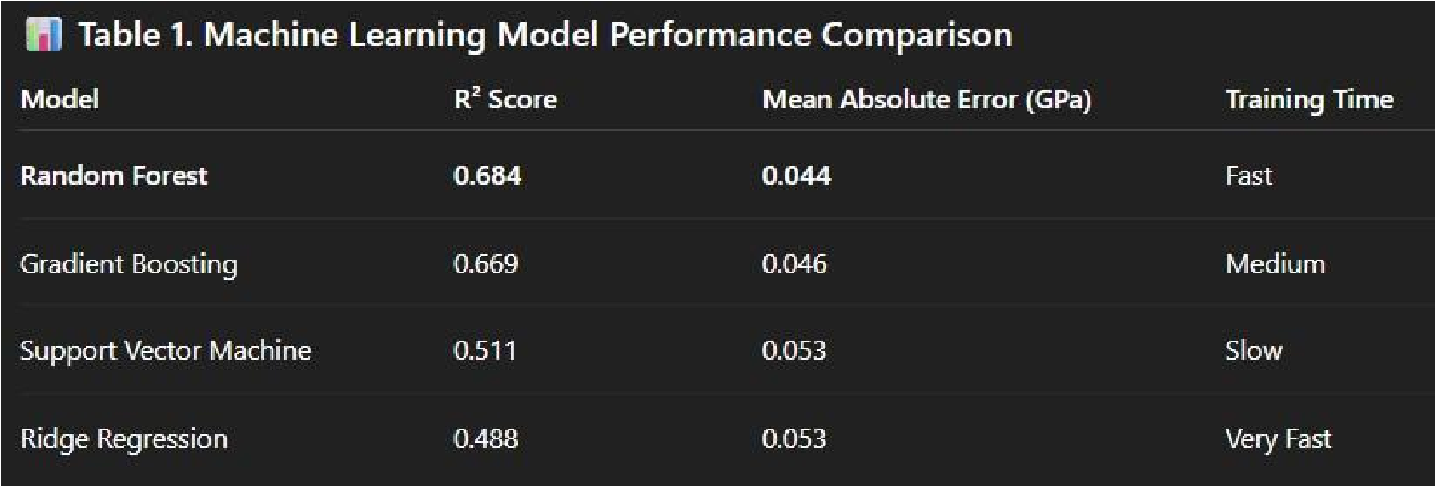

  - Best Model

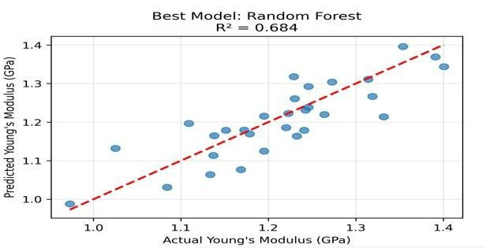

  - FeAg3 Stress-Strain Curve
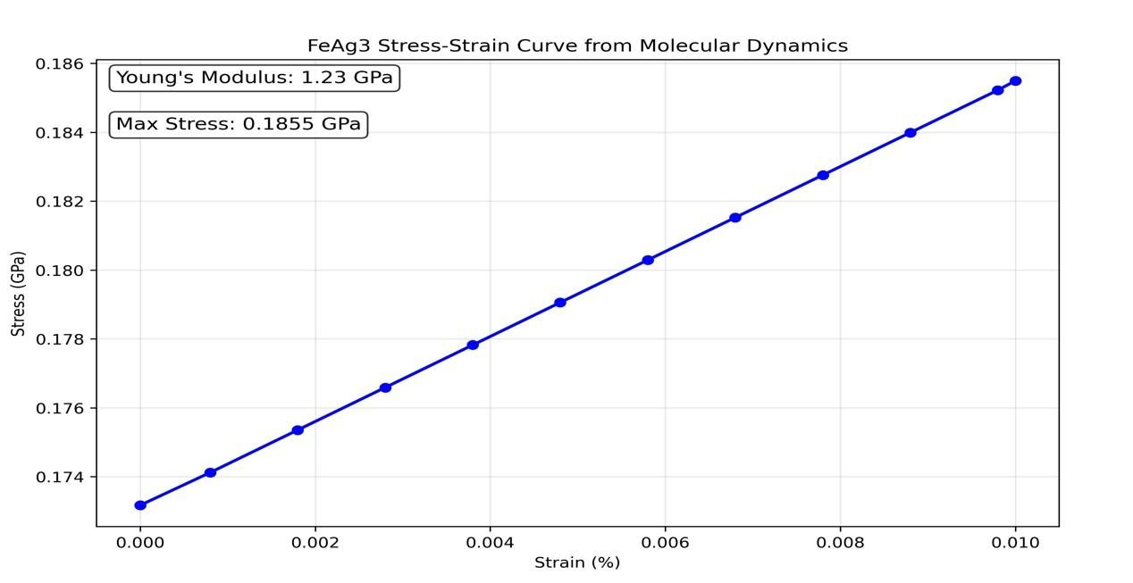

  - Correlation Analysis
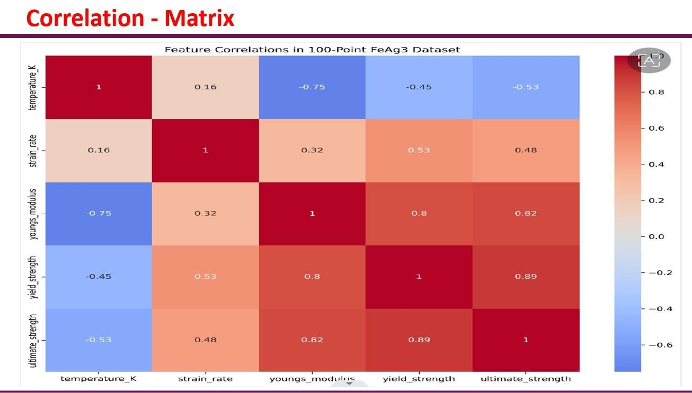

  - Discussion of ML Behaviour
        - Support Vector Machine (SVM) showed moderate performance but struggled to fully capture nonlinear deformation behavior, leading to underfitting in cases where the stress– strain response varied sharply near fracture.
        - Gradient Boosting delivered competitive accuracy by progressively correcting prediction errors, but was more sensitive to hyperparameter tuning and slightly slower than ensemble methods during training.
        - Random Forest demonstrated the most stable and accurate performance, owing to ensemble averaging, robustness against noise in MDderived features, and strong adaptability to brittle deformation characteristics.
        - The MD-generated stress–strain data for Fe–Ag₃ exhibits highly nonlinear and abrupt failure patterns, which are better modeled by treebased ensemble methods compared to kernel-based or linear approaches.

Final Model Performance Evaluations

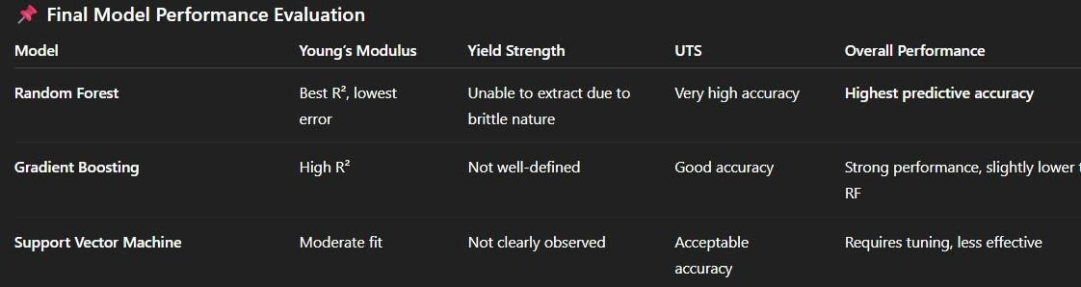

  - Model Validation
Validation procedures were conducted to assess the generalization capability and robustness of the trained ML models. The results confirmed that:
      - Random Forest exhibited minimal overfitting and showed strong generalization across the test dataset.
      - Train–test performance remained consistent, indicating reliable predictive behavior.
      - Gradient Boosting also demonstrated good robustness but showed mild sensitivity to hyperparameter tuning.
      - SVM exhibited slightly higher variance, requiring careful kernel parameter tuning for optimal results.

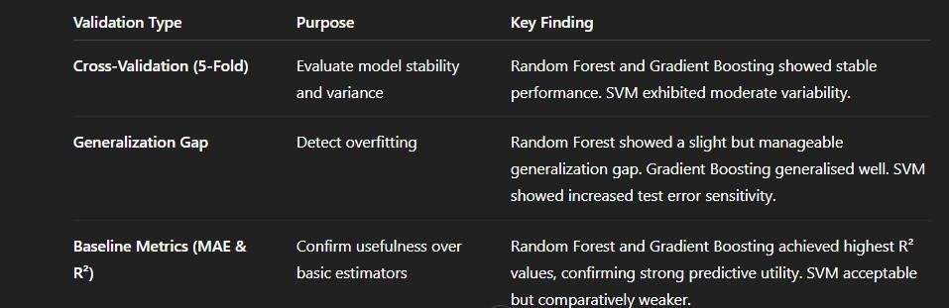
  - Practical Implications
The ML–MD hybrid framework developed in this study offers several practical advantages for Fe–Ag₃ alloy analysis and future material design applications:
    - Rapid evaluation of Fe–Ag₃ mechanical behavior without requiring repeated molecular dynamics simulations.
    - Substantial reduction in computational cost, once the ML models are trained using MD-derived datasets.
    - Deployment of predictive models for real-time mechanical property estimation, enabling faster decision-making during alloy screening.
    - Scalability of the framework to other intermetallic or multi-component alloy systems, such as Fe–Ag–Ni or Fe–Ag–Al, facilitating future materials research and optimization.

4. Conclusion
This study presents a comprehensive ML–MD hybrid framework for predicting the mechanical properties of Fe–Ag₃ alloys. By combining MD-generated stress–strain data with supervised machine learning models, an efficient and accurate predictive platform was developed. The key conclusions derived from this work are:
- Machine learning models successfully captured the nonlinear relationships between MD-derived stress–strain features and mechanical properties of the Fe–Ag₃ alloy.
- The Random Forest Regressor achieved the highest prediction accuracy with the lowest error and strongest generalization performance, followed closely by Gradient Boosting.
- The ML–MD hybrid methodology significantly reduces computational overhead, allowing rapid assessment of material behavior without performing repeated molecular dynamics simulations.
- The proposed framework is scalable and can be extended to different alloy systems and loading conditions, enabling broader applicability in future materials research.
This work demonstrates the potential of machine learning in enhancing atomistic simulation workflows and accelerating the materials design process by providing fast and precise mechanical property predictions.

References
- Complete Project Source: https://github.com/shivakumar-nali/Machine-LearningGraphene-Nanocomposites.git
- Pedregosa, F., et al. “Scikit-learn: Machine Learning in Python.” Journal of Machine Learning Research, 12, 2825–2830 (2011).
- Breiman, L. “Random Forests.” Machine Learning, 45(1), 5–32 (2001).
- Plimpton, S. “Fast Parallel Algorithms for Short-Range Molecular Dynamics.” Journal of Computational Physics, 117(1), 1–19 (1995).
- Mishin, Y. “Machine-learning interatomic potentials for materials science.” Acta Materialia, 214, 116980 (2021).
- Finnis, M. W. & Sinclair, J. E. “A simple empirical N-body potential for transition metals.” Philosophical Magazine A, 50(1), 45–55 (1984).
- Agrawal, A. & Choudhary, A. “Deep materials informatics: Applications of deep learning in materials science.” npj Computational Materials, 2, 16022 (2016).
- Butler, K. T., et al. “Machine learning for molecular and materials science.” Nature, 559, 547–555 (2018).
- Zhang, Y., et al. “Machine learning for mechanical property prediction in alloys.” Computational Materials Science, 175, 109584 (2020).
- Jha, D., et al. “ElemNet: Deep learning for material property prediction.” Scientific Reports, 8, 17593 (2018).
- Hollander, M., et al. “Predicting mechanical properties of alloys using machine learning: A comprehensive review.” Materials Today, 50, 190–210 (2021).
- Daw, M. S., & Baskes, M. I. “Embedded-atom method: A review.” Materials Science Reports, 9, 251–310 (1993).

