**What is Power BI?**

Power BI is an Analytical and Reporting Tool.

Power BI is a powerful business analytics tool developed by Microsoft.

Data Visualization: Create stunning and interactive reports and dashboards from multiple data sources.

BI stands for -- Business Intelligence

**ETL Process:**

**Extraction data:**

You can import data from various sources like Excel, CSV, SQL Server, etc., using the "Get Data" option in Power BI.

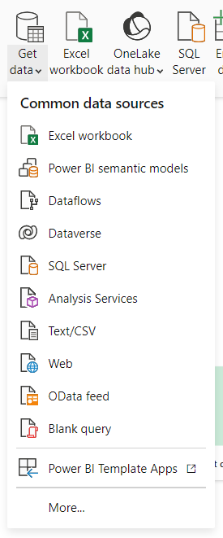

**Transform Data**: Transforming the date involves data processing or data cleaning.

**Load Data**: Making ready for analysis.

**Analysis**:

Once your data is transformed and loaded into Power BI, you can perform various types of analysis to uncover insights. Here are some steps to help you get started with data analysis in Power BI

**Downloading Power BI:**

You can download Power BI from Microsoft store or Microsoft website.

**Power BI Desktop:**

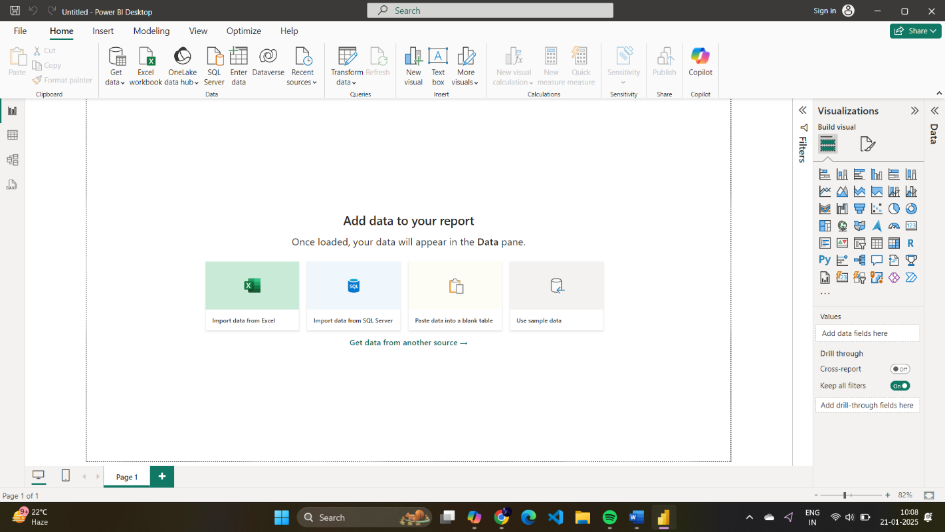

**Power BI Canva:**

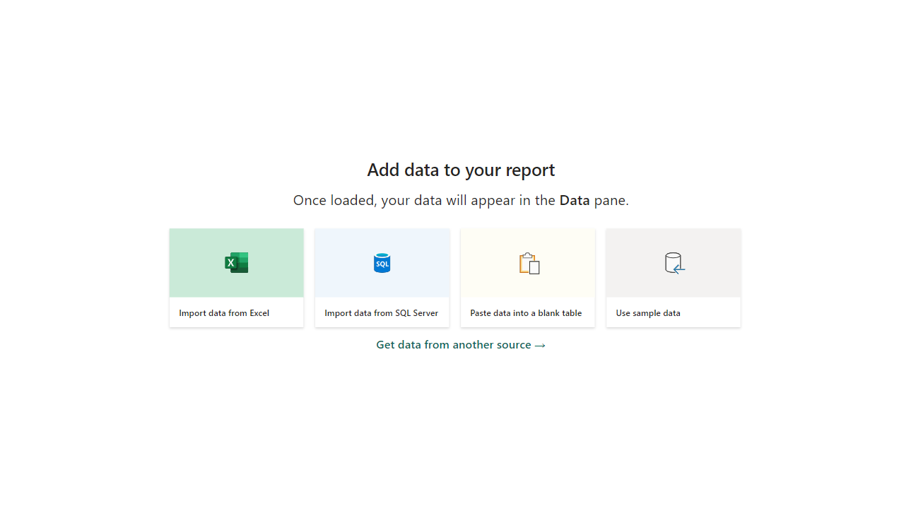

**Loading the data from csv file:**

By clicking get data option and select Text/CSV.

You can Load or Transform data.

**Types of Views:**

* Report view: For Visualization of the Data.
* Table view: See the Data and cleaning the data.
* Model view: For joining the data and Creating a Relation between the data.

**Table view:**

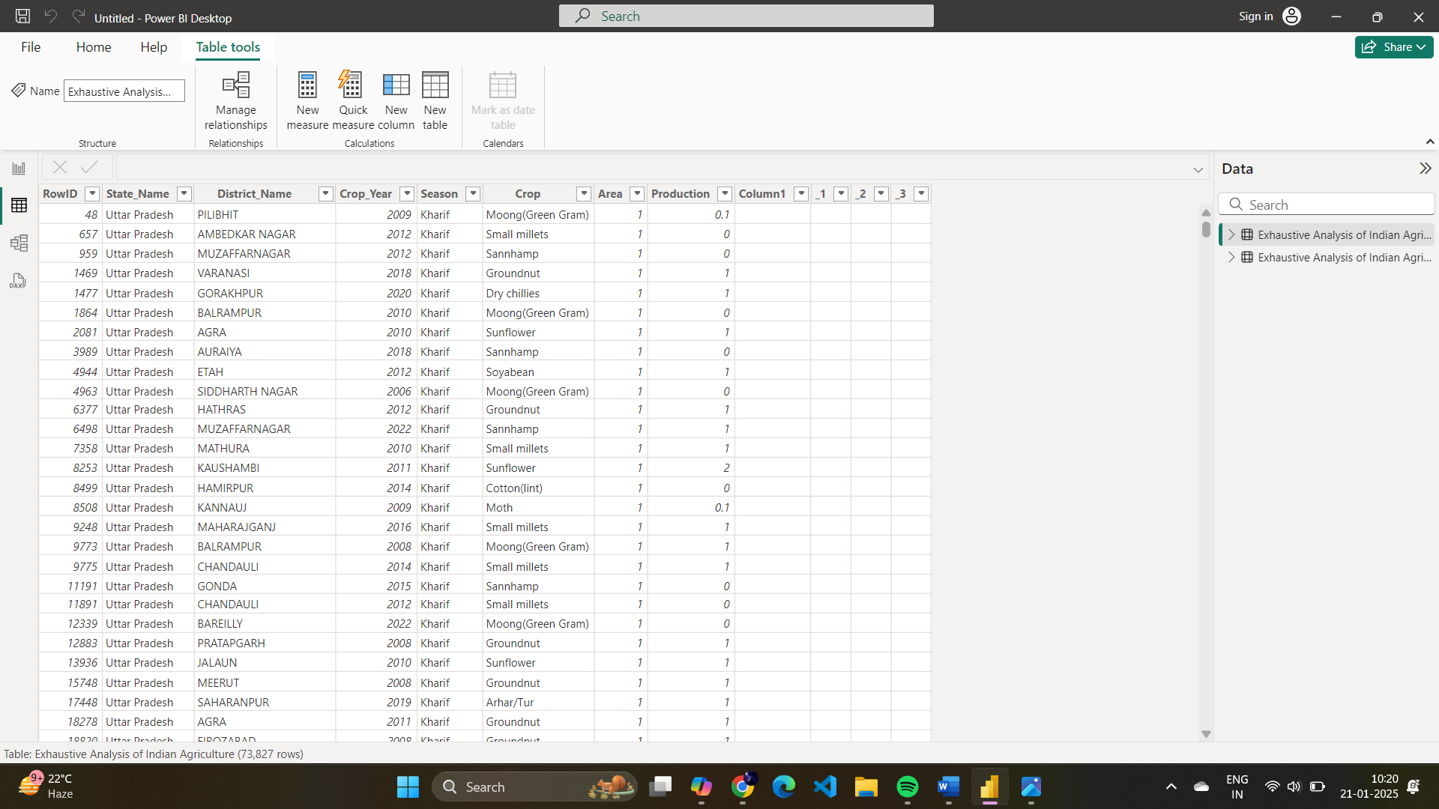

**Model View:**

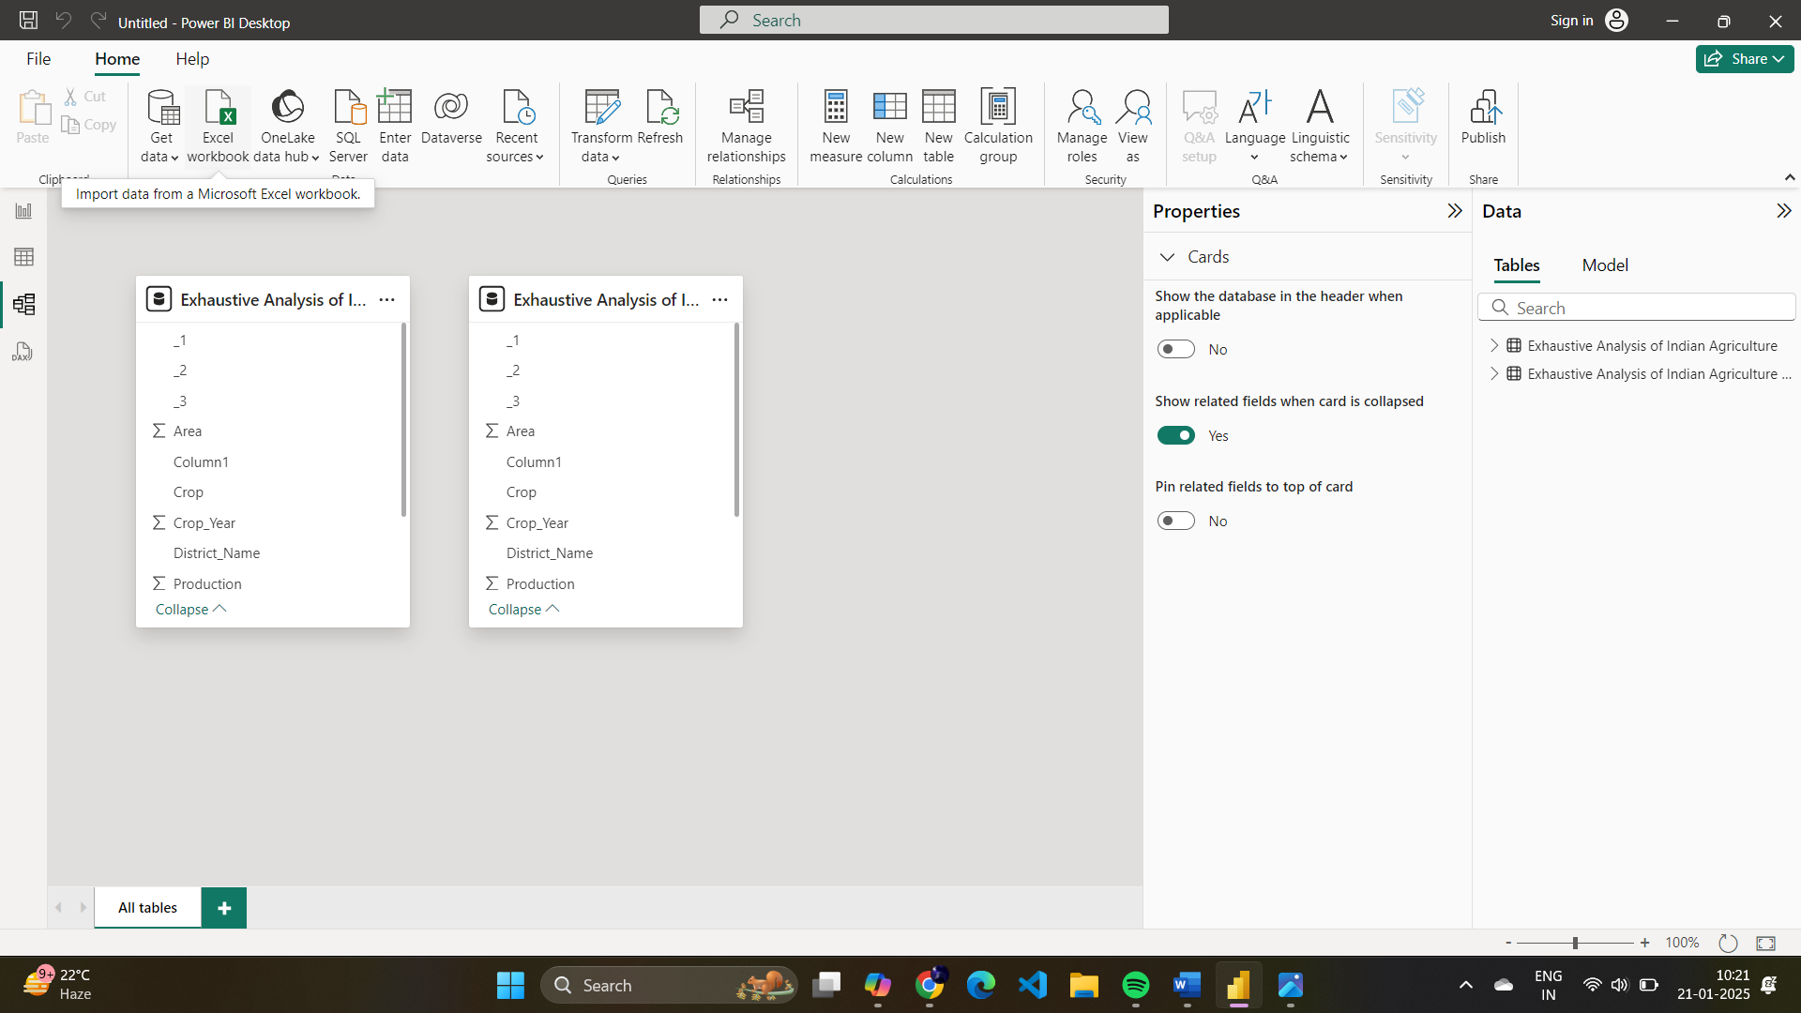

**Removing the Column:**

Select the header of the column and right click on the Header, then select the remove.

Remove Unnecessary columns from data.

You can remove Null Values, Duplicate data.

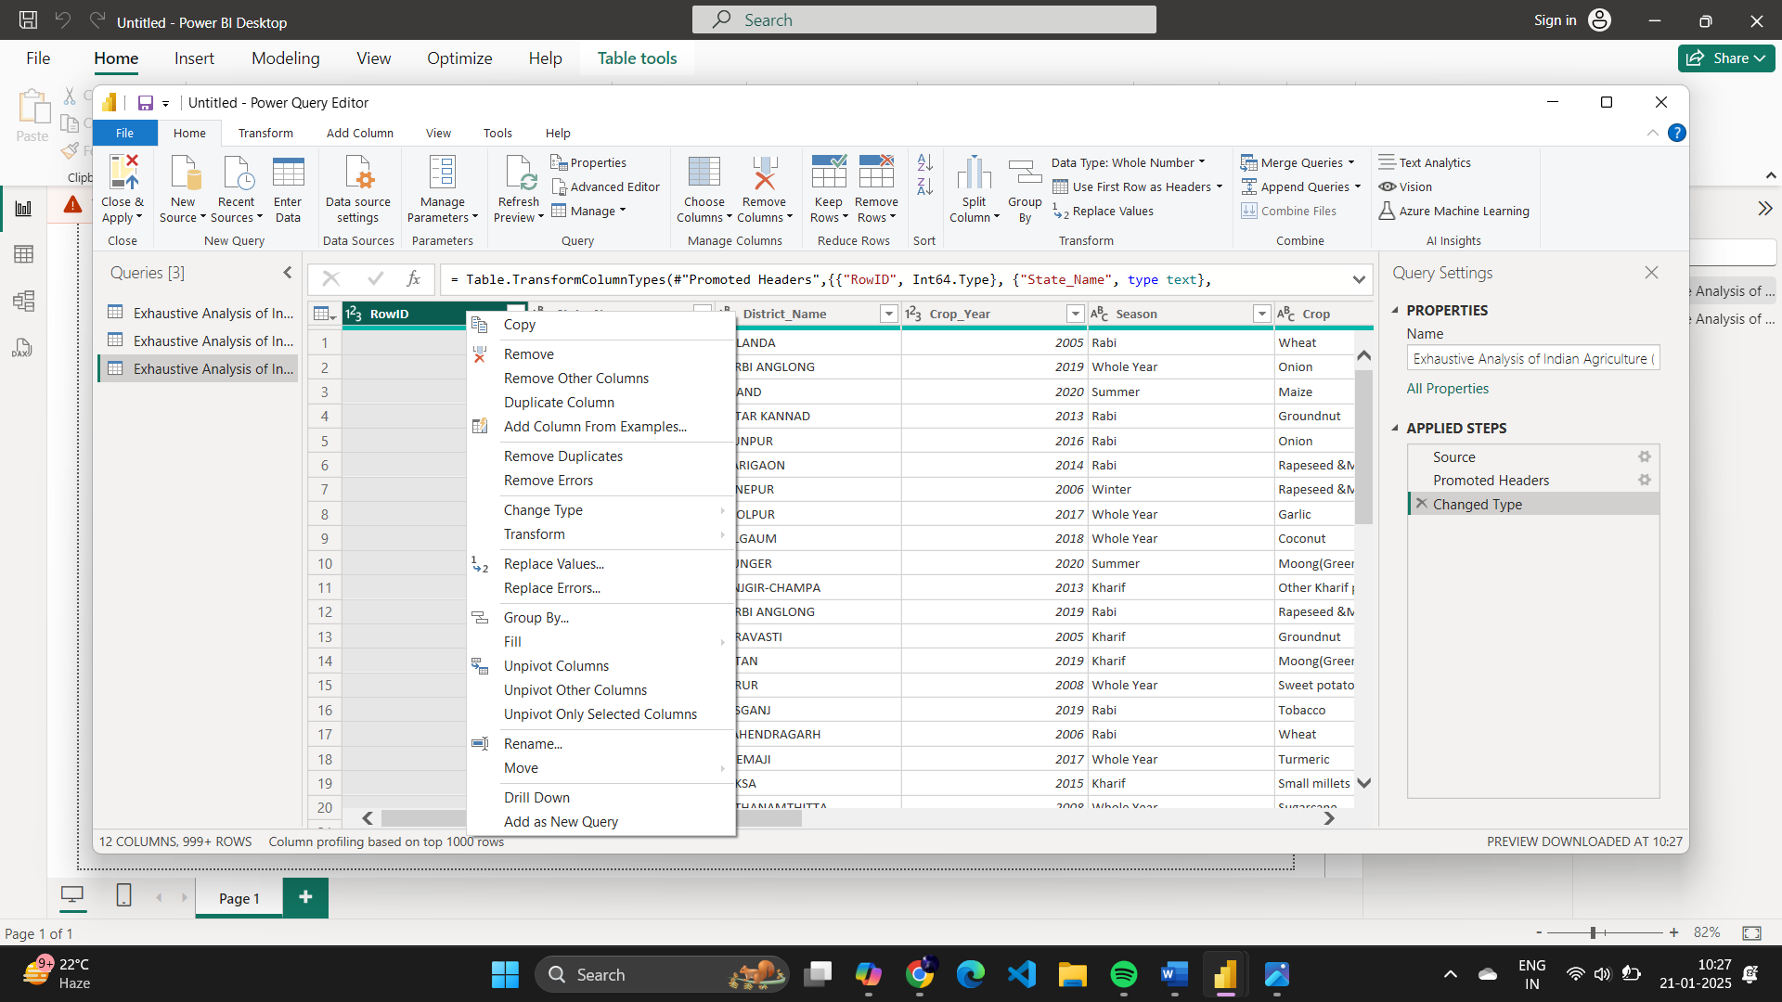

**View of the data:**

Click on view, then click on Column Quality .you can know the error and Empty data.

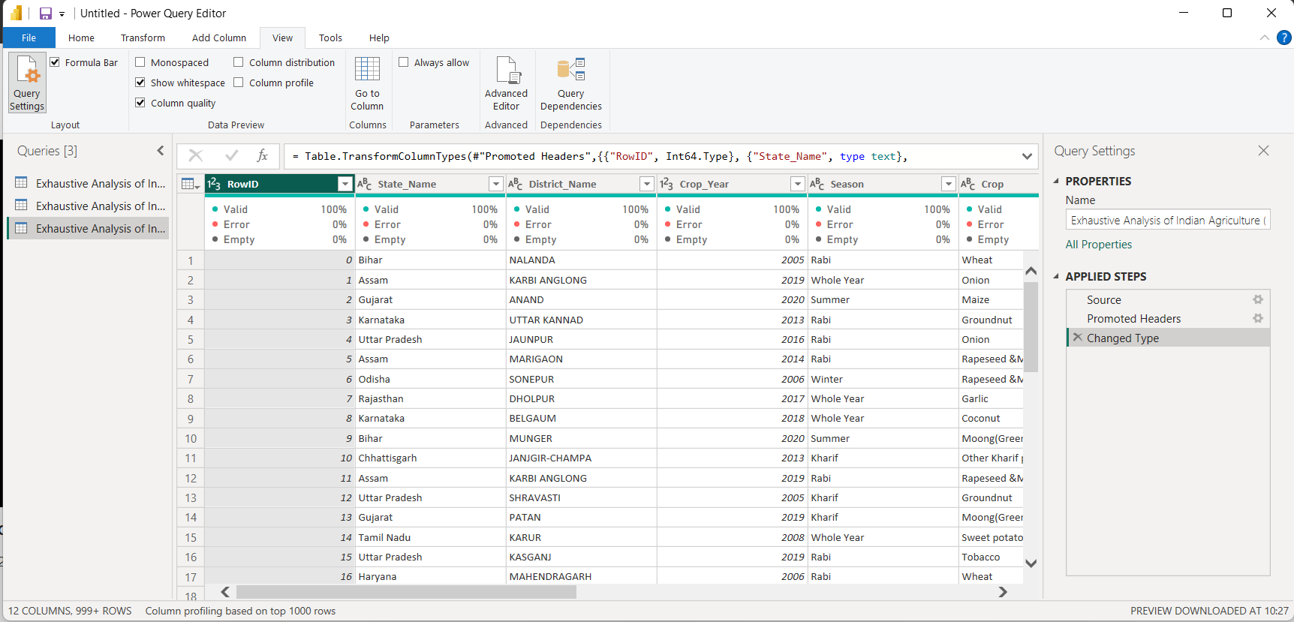

**To remove Duplicate data:**

In Home click remove column and click it. It shows different options select remove duplicate data.

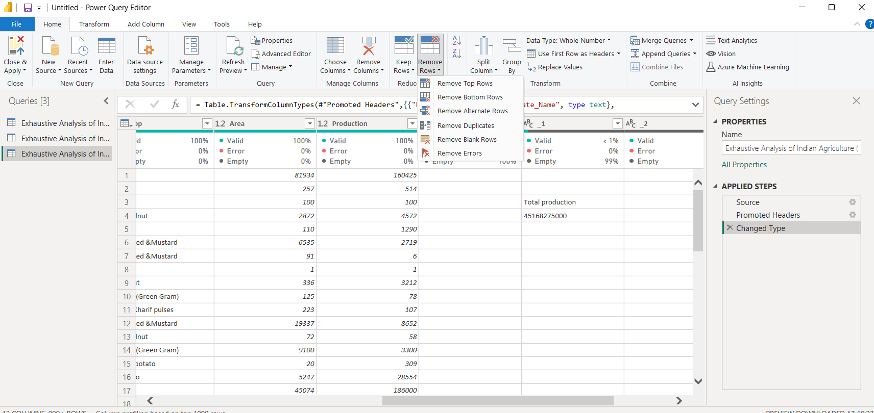

**Difference between Error and Empty.**

Error: Cell data having different data from assigned column data.

Empty: No value in the cell.

Datatypes in Power BI:

