**Portal for Addrressal and Solution for Social Issues**

A

Case Study Report

Submitted in partial fulfilment of the

Requirements for the Course of

**THEAM BASED PROJECT - LAB**

IN

**BE ¾ (IT) VI-SEMESTER**

By

**K.Shiva Kumar - 1602-16-737-104**

**A.Vamsi - 1602-16-737-114**

**Sumera Firdous - 1602-16-737-322**



**Department of Information Technology**

**Vasavi College of Engineering (Autonomous)**

**Ibrahimbagh, Hyderabad-31**

**2019**

**Vasavi College of Engineering (Autonomous)**

**Ibrahimbagh, Hyderabad-31**

**Department of Information Technology**



**DECLARATION BY THE CANDIDATE**

We team hereby declare that the Case study report entitled **“Portal for Addrressal and Solution for Social Issues”** under the guidance of **Mrs K.Madhuri ,** Assistant Professor, Department of Information Technology, VCE, Hyderabad is submitted in partial fulfilment of the requirement for the course of **Theme Based Project Lab** in BE ¾ (IT) VI-Semester.

This is a record of bonafide work carried out by us and the Design embodied in this project report has not been submitted by any other.

**K.Shiva Kumar - 1602-16-737-104**

**A.Vamsi - 1602-16-737-114**

**Sumera Firdous - 1602-16-737-322**

**Vasavi College of Engineering**

**(Autonomous)**

**Ibrahimbagh, Hyderabad-31**

**Department of Information Technology**



**BONAFIDE CERTIFICATE**

This is to certify that the project entitled **“Website to share public grievances"** being submitted by **our team** in partial fulfilment of the requirement for the course of **Theme Based Project - Lab** in BE ¾ (IT) IV-Semester is a record of bonafide work carried out by him/her under my guidance.

**Mrs. K.Madhuri, Pravalika,**

**Assistant professor, 1602--15-737-075,**

**Internal Guide. Mentor.**

**External Examiner**

**TABLE OF CONTENTS**

1. ABSTRACT------------------------------------------------------------------------5

2. LIST OF FIGURES----------------------------------------------------------------6

3. INTRODUCTION AND PROBLEM STATEMENT ---------------------------------------------------07

5. PROPOSED WORKS---------------------------------------------------------------------08

1. USE CASES------------------------------08
2. U.I PROTOTYPES OR SCREENSHOTS----------------------09
3. ARCHITECTURE AND TECH STACK USED-------------------------13
4. DESIGNS-------------------------------14

6. CONCLUSION------------------------------------------------------15

ABSTRACT ::

**portal for addrressal and solution for social issues**

“a web application that collects social issues posted by people and analyse and post the issue to the repective ministeries” .

The problems are first collected from victimized people through their post in our portal .. The post contains a form with their genuine details ( validation is done), the problem statement attached with pictures and clips of the incident .

This information is analysed in our software thoroughly and sent to the respective ministry (govt. or private) for obtaining the solution or physical response(service) .

If the problem is not solved for ages... It will be highlighted and posted in the social media for further processing , including polls whether the problem is that vital or not or asking for helps from NGO’s and social service clubs , or to obtain a solution from people .

**LIST OF FIGURES**

|  |  |  |
| --- | --- | --- |
| S. No | Figures | Page No |
| 1 | Uml static | 09 |
| 2 | Runtime uml diagram- database architecture | 09 |
|  |  |  |

**1.INTRODUCTION**

**PROBLEM STATEMENT** : Portal for addrressal and solution for social issue is a web site to solve issues online which we see in our daily life.We see many public problems in our daily life around us like broken roads, not glowing streetlights, non-proper drainage or seepage issues and so on which are to be solved with in a limited time, but or not these days.Even the complaints are registerd officially take a lot of time to get solved because of improper addrresal to correct ministry.

The main aim of our website is to make public issues solving easier for the people. Here ,the problems are first collected from victimized people through their post in our portal.The post contains a form with their genuine details,the problem statement attached with picture and clips of the incident.This information is analysed in our software thoroughly and sent to the respective ministry(govt or private) for obtaining the solution or physical response.If the problem is not solved for ages,it will be highlighted and posted in the social media for further processing,including polls whether the problem is that vital or not a or for helps from NGO's and social service clubs,or to obtain a solution from people.

So going deep about the addressal of the problem ..in the point of view of the users ,there will be 4 stages

1. Not verified
2. Verified
3. Posted
4. Solved
5. Not verified stage – first stage of the post ,where the user just posts the data(pictures along with description) and the data just reaches us(the admin).
6. Second stage is the actual verification done by us . Here we check for the vitality of the problem and see for the sentimental analysis (if the problem is in the need of the hour or not and the number of posts related to the problem are high or not) is seen .

And the data is filtered and posted to the correct ministery .

1. Posted is the stage where the post reaches the minestery
2. Solved

PROPOSED WORKS

A.) USE CASE :

***Name:*portal for addrressal and solution for social issues**

***Brief Description :*** a web application that collects social issues posted by people and analyse and post the issue to the repective ministeries .

***Actors : public , respective ministeries.***

***Alternate Flows*** *: If the problem is not solved for ages... It will be highlighted and posted in the social media for further*

*processing , including polls whether the problem is that vital or not or asking for helps from NGO’s and social service clubs*

*, or to obtain a solution from people .*

B.) U.I PROTOTYPES OR SCREENSHOTS :

Login page :

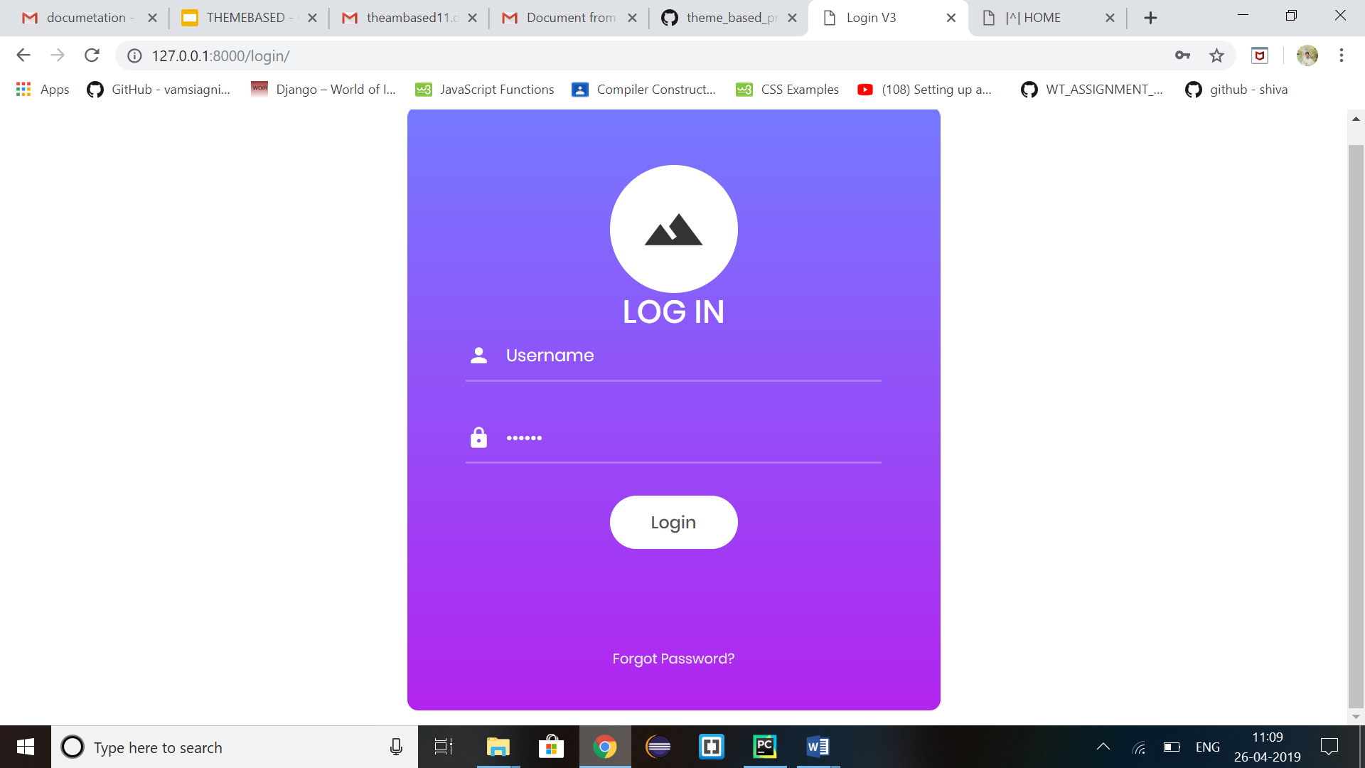

Landing page : (1)

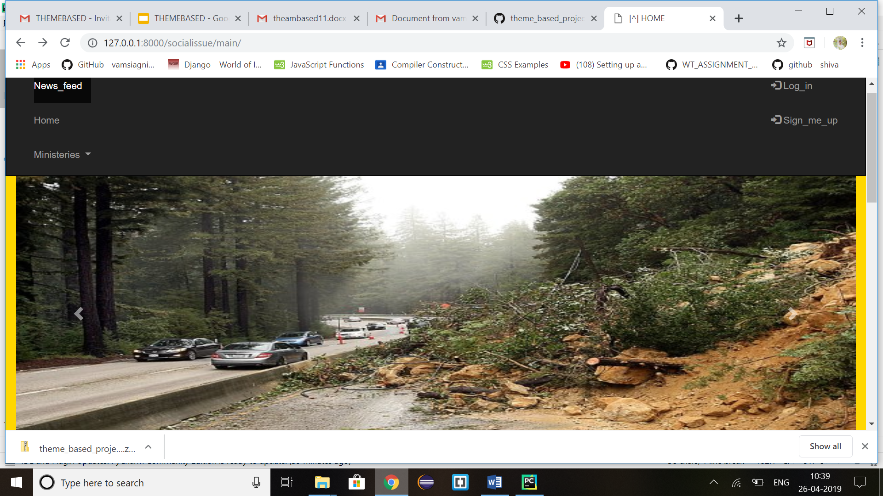

(2)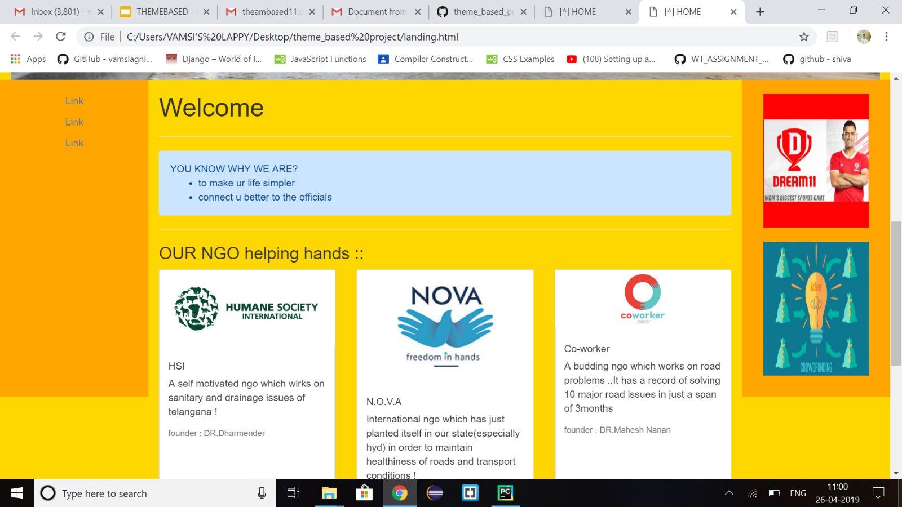

(3)

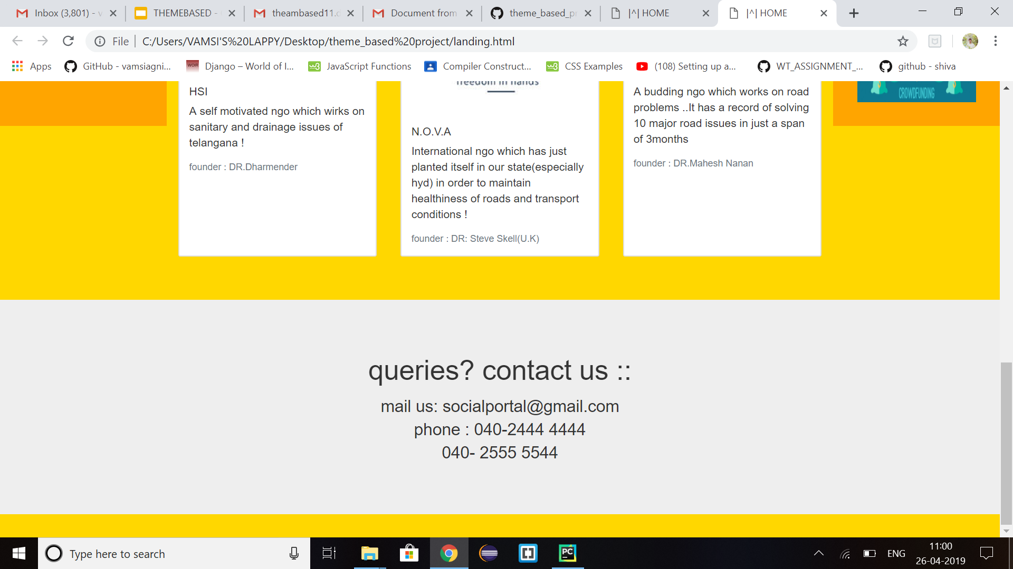

Upload page 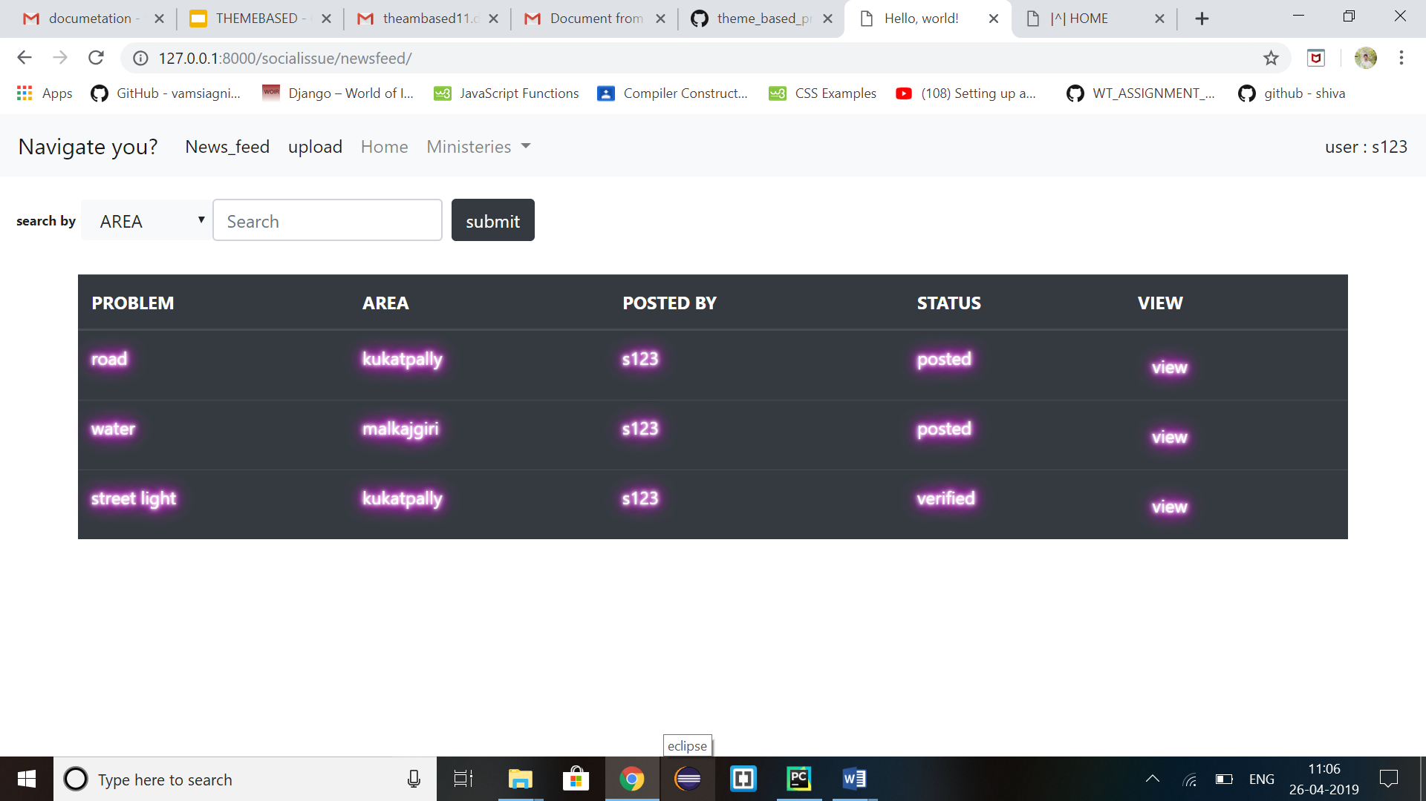

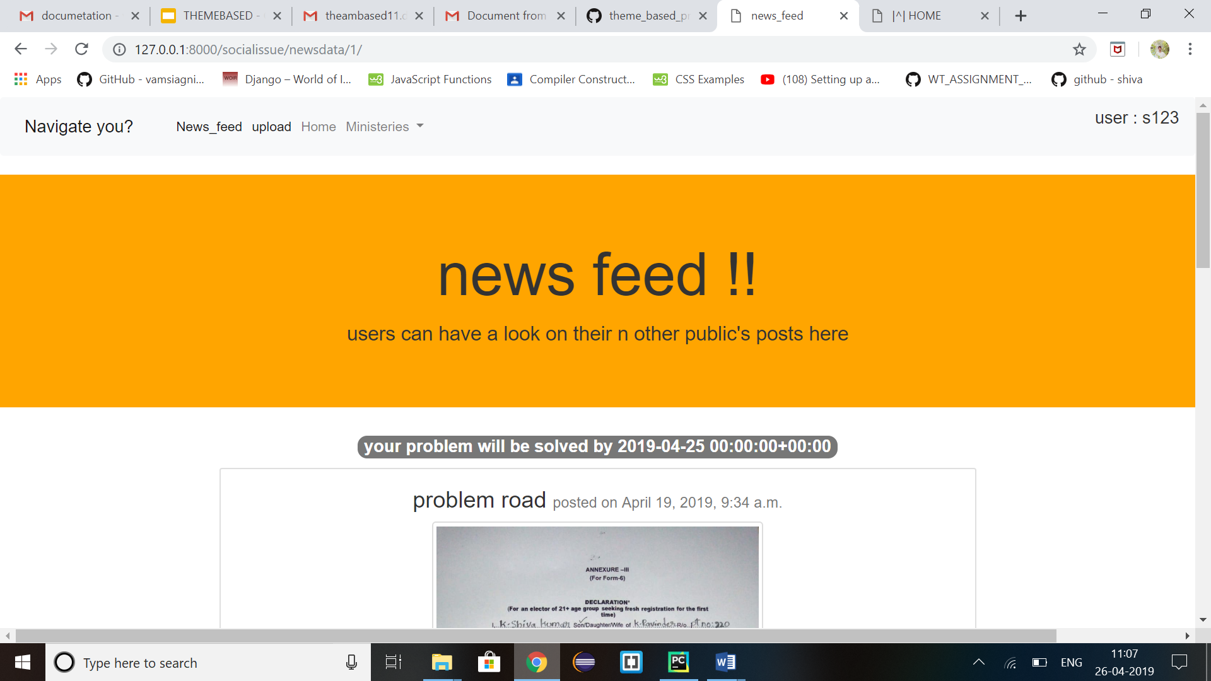

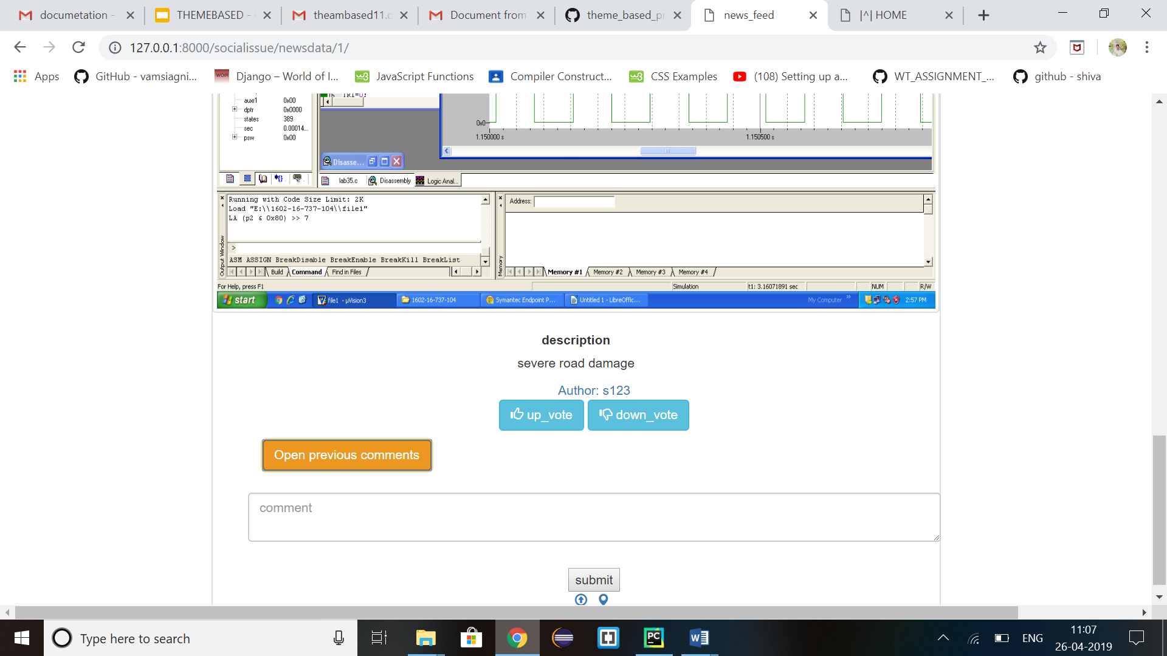

COMMENTS SECTION::

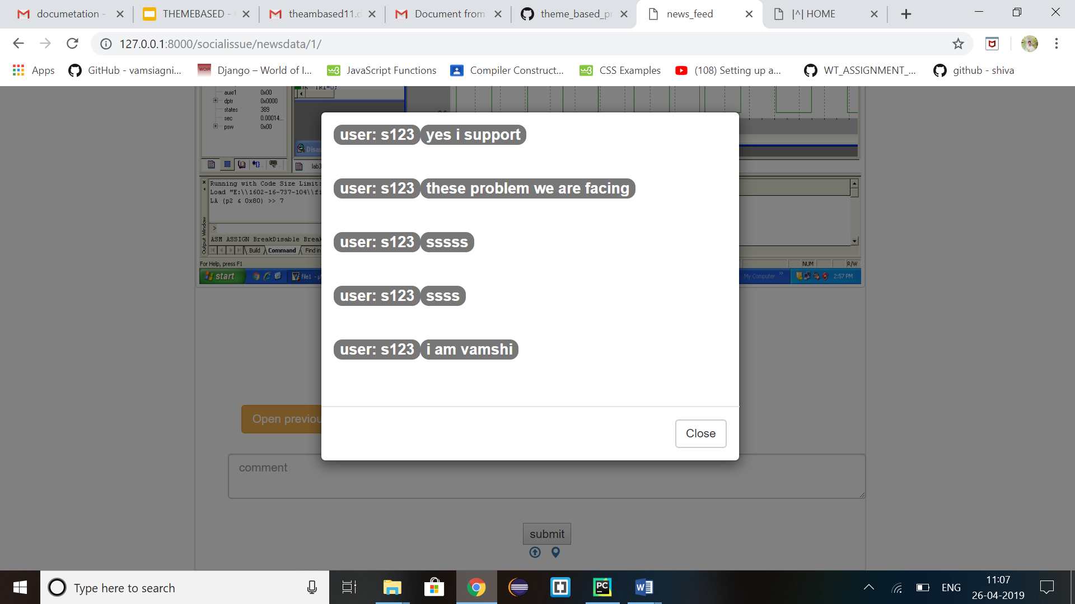

UPLOAD PAGE::

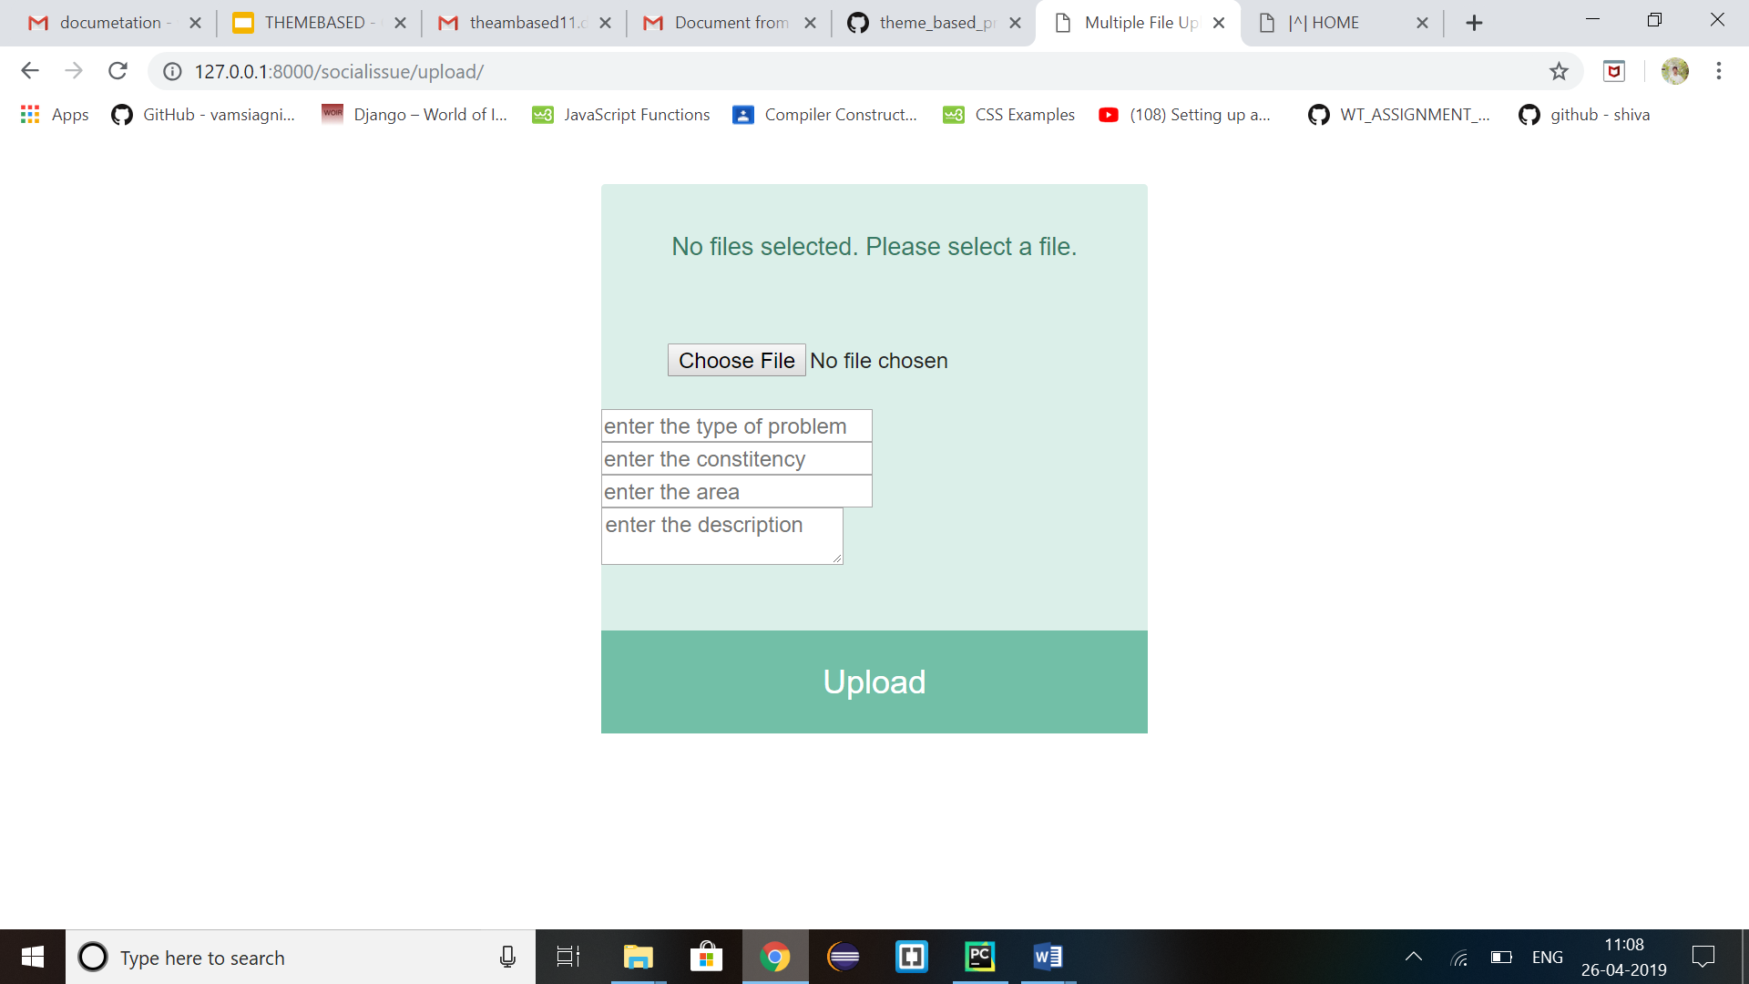

C.) ARCHITECTURES AND TECHNOLOGY STACK USED :

**Software stack that we used:**

**Front-end**

1. HTML
2. CSS
3. JAVA SCRIPT

Back-end:

1. Django for connectivity

2.Database (sqlite)

D.)DESIGN ::

1. UML static :

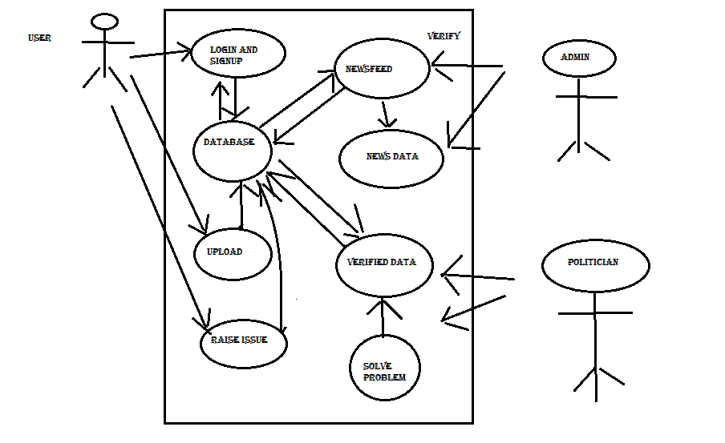

1. UML runtime:

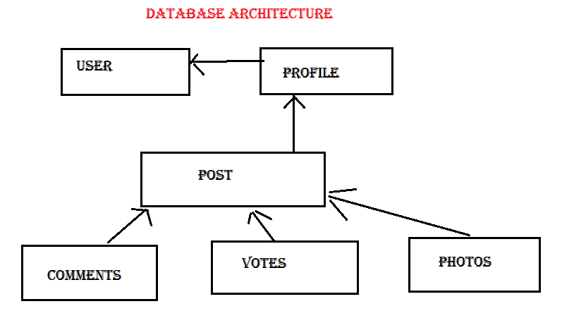

Conclusion::

AS WE KNOW GOVERNMENT NEGLECT IN SOLVING PROBLEMS IN OUR SOCIETY.

SO THE MAIN MOTTO HERE IS PRIVATIZE THE WORK SO THAT GOVERNMENT HAVE SOME PRESSURE FROM PEOPLE AND FROM NGOS THAT MAKES PROBLEM SOLVE.