Project 3: SDC Constraints and check_timing Cleanup
Complete GitHub project: every folder, every file and every image in one document.
Author: Gunti Siva Kumar, B.Tech ECE, Narasaraopeta Engineering College (JNTUK)

1. Folder structure
project3_sdc_check_timing/
├── README.md
├── LICENSE
├── .gitignore
├── constraints/
│ ├── before.sdc
│ └── after.sdc
├── scripts/
│ └── run_check_timing.tcl
├── rtl/
│ └── README.md
├── reports/
│ └── README.md
└── docs/
├── debug_notes.md
└── images/
├── clock_divider_diagram.png
├── 01_check_timing_before.png (your screenshot)
└── 02_check_timing_after.png (your screenshot)

2. Images

2.1 docs/images/clock_divider_diagram.png
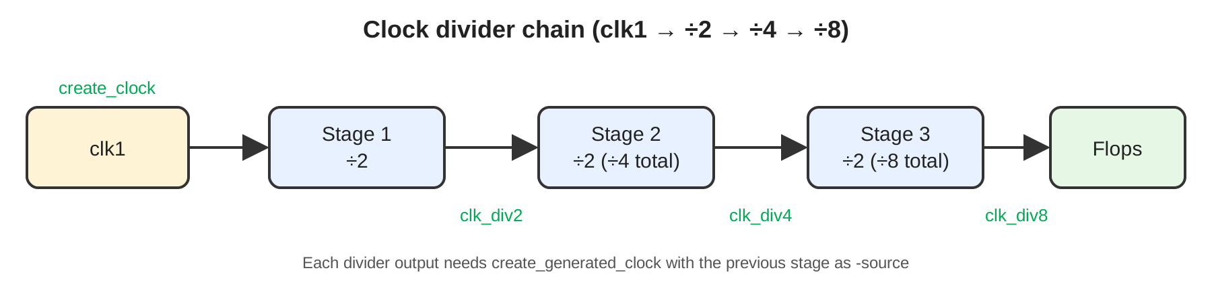

2.2 docs/images/01_check_timing_before.png
[ paste your "before warnings" screenshot here ]

Take it from your original Project 3 .docx.

2.3 docs/images/02_check_timing_after.png
[ paste your "after, warnings cleared" screenshot here ]

Take it from your original Project 3 .docx.

3. All files with full content

3.1 README.md
# Project 3: SDC Constraints and `check_timing` Cleanup

**Tool:** Synopsys Design Compiler | **Language:** Tcl / SDC

## Objective
Clear the `check_timing` warnings of a multi-stage clock-divider design by fixing its SDC.

## Design
Master clock `clk1` feeds stage 1 (divide by 2). Its output is the clock of stage 2 (divide by 2, so ÷4 total). The stage 2 output is the clock of stage 3 (divide by 2, so ÷8 total).

![Clock divider chain](docs/images/clock_divider_diagram.png)

## Problem
`check_timing` reported warnings because the divider outputs were used as clocks without being defined as generated clocks.

![check_timing before](docs/images/01_check_timing_before.png)

## Solution
Define a generated clock (divide by 2) on each stage output, with the previous stage as its source, so the clock propagates through all three stages. All `check_timing` warnings were cleared.

![check_timing after](docs/images/02_check_timing_after.png)

## Repository Structure
```
project3_sdc_check_timing/
├── README.md
├── LICENSE
├── .gitignore
├── constraints/ before.sdc, after.sdc
├── scripts/ run_check_timing.tcl
├── rtl/
├── reports/
└── docs/ debug_notes.md, images/
```

## How to Run
```bash
DESIGN=<top_module> SDC=constraints/before.sdc dc_shell -f scripts/run_check_timing.tcl
DESIGN=<top_module> SDC=constraints/after.sdc dc_shell -f scripts/run_check_timing.tcl
```

## Key Learnings
- A flop-divided clock is a new clock net and must be declared with `create_generated_clock`.
- Generated clocks in a chain are defined in order, each sourced from the previous stage.
- Run `check_timing` before synthesis or PnR.

## Author
**Gunti Siva Kumar**, B.Tech ECE, Narasaraopeta Engineering College (JNTUK)

## License
MIT

3.2 LICENSE
MIT License

Copyright (c) 2026 Gunti Siva Kumar

Permission is hereby granted, free of charge, to any person obtaining a copy
of this software and associated documentation files (the "Software"), to deal
in the Software without restriction, including without limitation the rights
to use, copy, modify, merge, publish, distribute, sublicense, and/or sell
copies of the Software, and to permit persons to whom the Software is
furnished to do so, subject to the following conditions:

The above copyright notice and this permission notice shall be included in all
copies or substantial portions of the Software.

THE SOFTWARE IS PROVIDED "AS IS", WITHOUT WARRANTY OF ANY KIND, EXPRESS OR
IMPLIED, INCLUDING BUT NOT LIMITED TO THE WARRANTIES OF MERCHANTABILITY,
FITNESS FOR A PARTICULAR PURPOSE AND NONINFRINGEMENT. IN NO EVENT SHALL THE
AUTHORS OR COPYRIGHT HOLDERS BE LIABLE FOR ANY CLAIM, DAMAGES OR OTHER
LIABILITY, WHETHER IN AN ACTION OF CONTRACT, TORT OR OTHERWISE, ARISING FROM,
OUT OF OR IN CONNECTION WITH THE SOFTWARE OR THE USE OR OTHER DEALINGS IN THE
SOFTWARE.

3.3 .gitignore
*.log
*.svf
*.ddc
*.mr
*.pvl
*.syn
work/
alib-52/
command.log
filenames.log
*.db
*.lib
*.lef
*.tf
.DS_Store
*.swp

3.4 constraints/after.sdc
# after.sdc: fixed constraints (check_timing warnings cleared).
# Paste your final SDC here. Structure used in this project:
#
# create_clock clk1 (master clock)
# create_generated_clock stage 1 output -divide_by 2 (clk1 / 2)
# create_generated_clock stage 2 output -divide_by 2 (clk1 / 4)
# create_generated_clock stage 3 output -divide_by 2 (clk1 / 8)
#
# Each stage's -source is the previous stage's output pin.

3.5 constraints/before.sdc
# before.sdc: original constraints (check_timing reported warnings).
# Paste your original SDC here.
# Issue: master clock clk1 only; divider outputs not declared as generated clocks.

3.6 docs/debug_notes.md
# Debug Notes: Project 3

- Symptom: `check_timing` warnings.
- Cause: divider outputs (÷2, ÷4, ÷8) used as clocks without generated clock definitions.
- Fix: one `create_generated_clock -divide_by 2` per stage, chained through `-source`.
- Result: warnings cleared (see docs/images).

3.7 reports/README.md
# reports/
check_timing and report_clock outputs (before and after the SDC fix).

3.8 rtl/README.md
# rtl/
Design RTL files (.v) for the clock-divider design.

3.9 scripts/run_check_timing.tcl
# Usage: DESIGN=<top> SDC=constraints/after.sdc dc_shell -f scripts/run_check_timing.tcl
# Libraries come from your own .synopsys_dc.setup (not committed).
set design $::env(DESIGN)
set sdc $::env(SDC)
analyze -format verilog [glob ./rtl/*.v]
elaborate $design
current_design $design
link
source $sdc
check_timing
report_clock
exit

