# Business-Requirement: SBA -1

## Problem Statement:

The purpose of this application is to allow the visitors to create and order a customized Corona Prevention Kit.

### Visitor Module:

**The Visitor Module** allows you to:

1. Access Portal’s home page
2. Will be required to provide details before creating the kit.
3. Allow to enlist multiple items available to be added to kit (eg: Face mask, Sanitizers, immunity boosters medicines etc )
4. Allow to create the kit and add selected items in kit
5. Visitors shall be allowed to define the quantity of each item in the kit
6. Calculation of total amount for kit will be done automatically
7. Visitor shall be able to place order of the kit by providing his/her details with address
8. Visitor shall be able to view the order summary

### Admin Module:

**The AdminModule of application** allows you to:

1. Login with predefined/hardcoded credentials
2. Admin will be able to add new items (with description, cost , name etc) to be shown to visitors, which they will use to create the prevention kit.
3. Admin will be able to edit and delete product as well

# 2. Resources Available:

|  |  |  |
| --- | --- | --- |
| Description | View Pages Name | Remarks |
| Common UI |  |  |
| Home Page | index.jsp | Contains Login form for Admin and link to new user page |
| Error Page | errorPage.jsp |  |
| Header | header.jsp |  |
| Footer | footer.jsp |  |
| Not Found Page | notfound.jsp |  |
|  |  |  |
| Admin Services UI |  |  |
| Shall contain Entry Form for new product entry | newproduct.jsp | Must use input field names as pname, pcost, pdesc |
| Shall contain Entry Form for editing product detail | editproduct.jsp |  |
| Shall use to show all products | listproducts.jsp |  |
|  |  |  |
|  |  |  |
| User Services UI |  |  |
| Shall contain Entry Form for new user entry | newuser.jsp | Must use input field names as pname, pemail, pcontact |
| Shall show list of products available to add to kit | showproductstoadd.jsp |  |
| Shall show list of products added to kit | showkit.jsp |  |
| Shall contain Entry Form to input address to place order | placeorder.jsp | Must use input field name address |
| Shall show the final Order Summary | ordersummary.jsp |  |
|  |  |  |
|  |  |  |
| Admin Login Id | admin |  |
| Admin Password | admin |  |

# Page Flow:

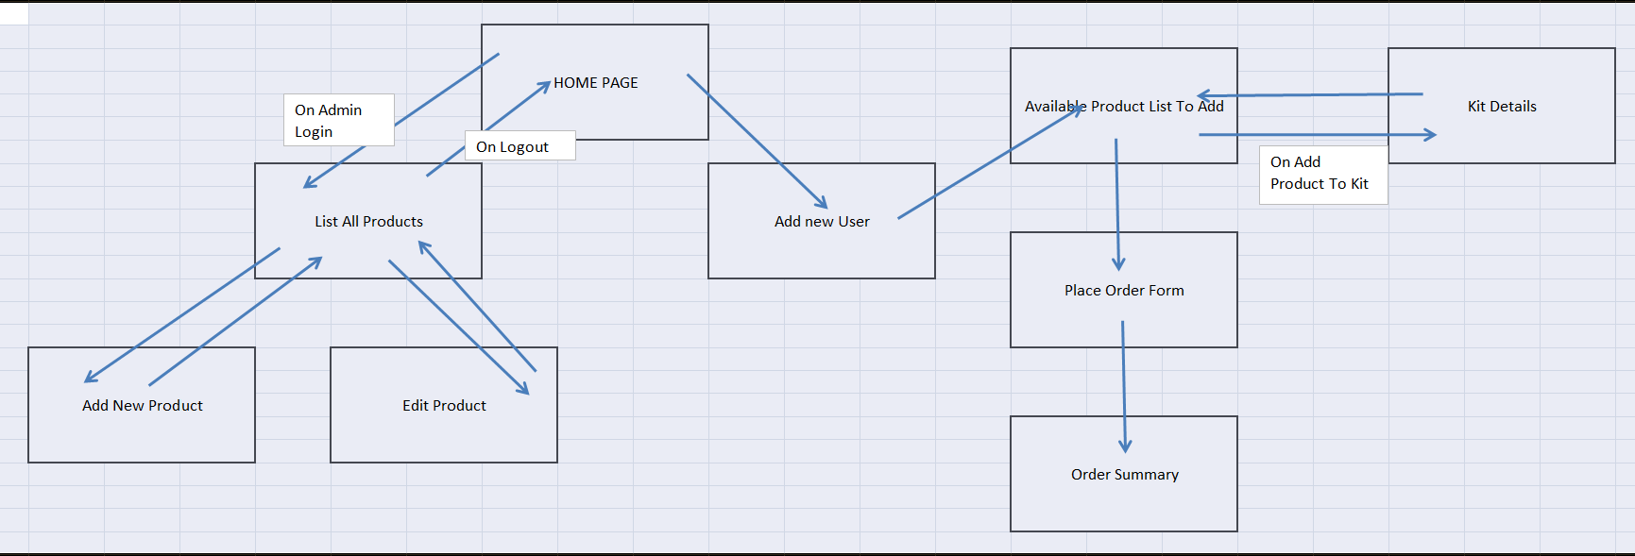

# Commands:

Commands to run:

From inside of Project Folder run the following command on command terminal

* + - 1. mvn clean package

# GIT Template:

Git link for Template code: <https://github.com/Navin-Gupta/sba1-coronakit.git>