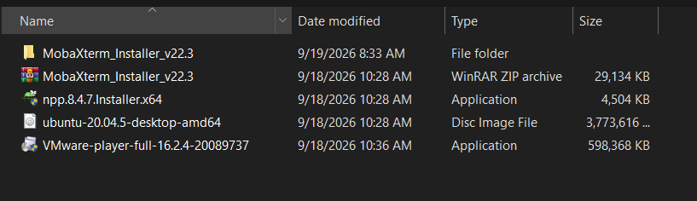

Installation of VM ware

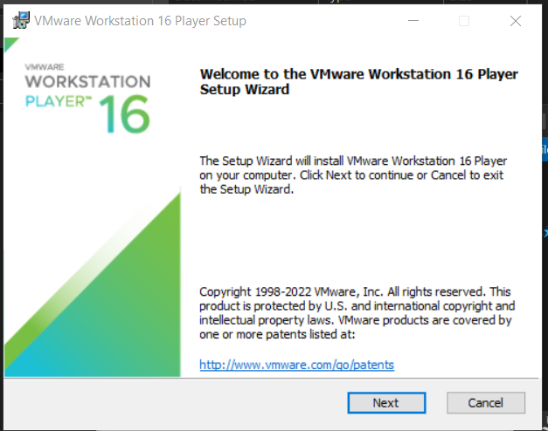

Accepting the terms

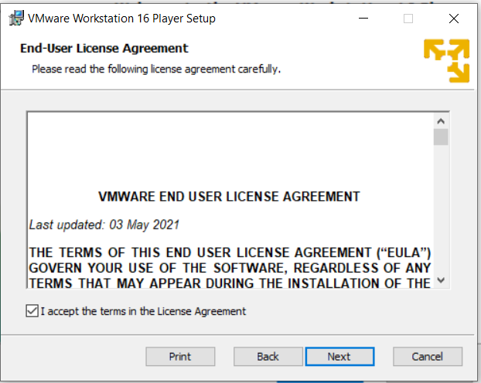

Waiting for the installation

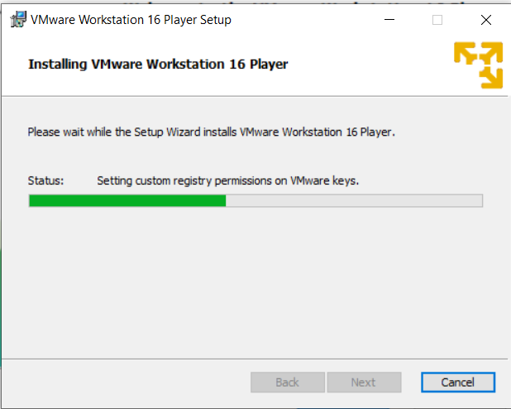

Installation Completed

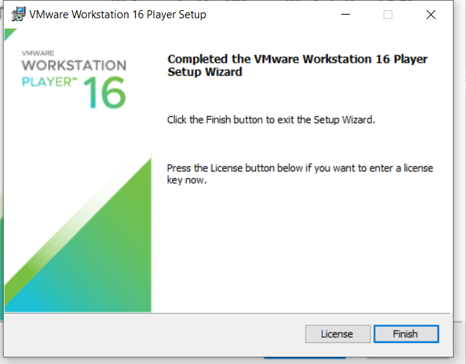

Ubuntu Installation - Creating Virtual Machine

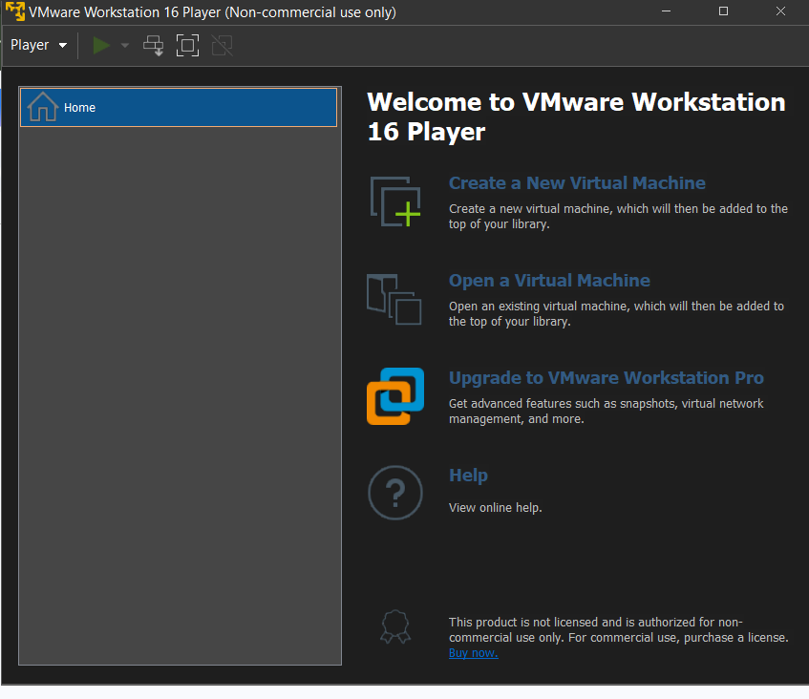

Selected ISO file

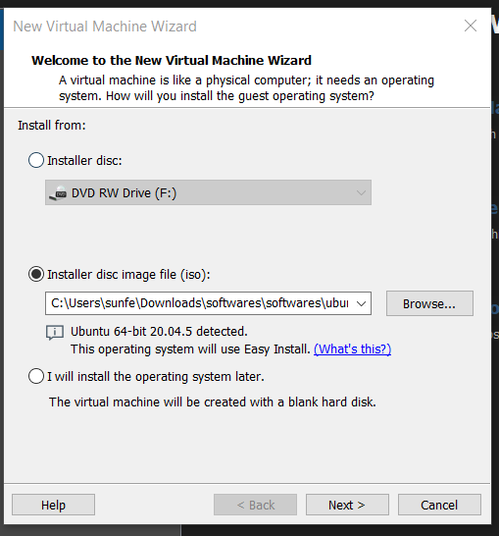

Unpacking

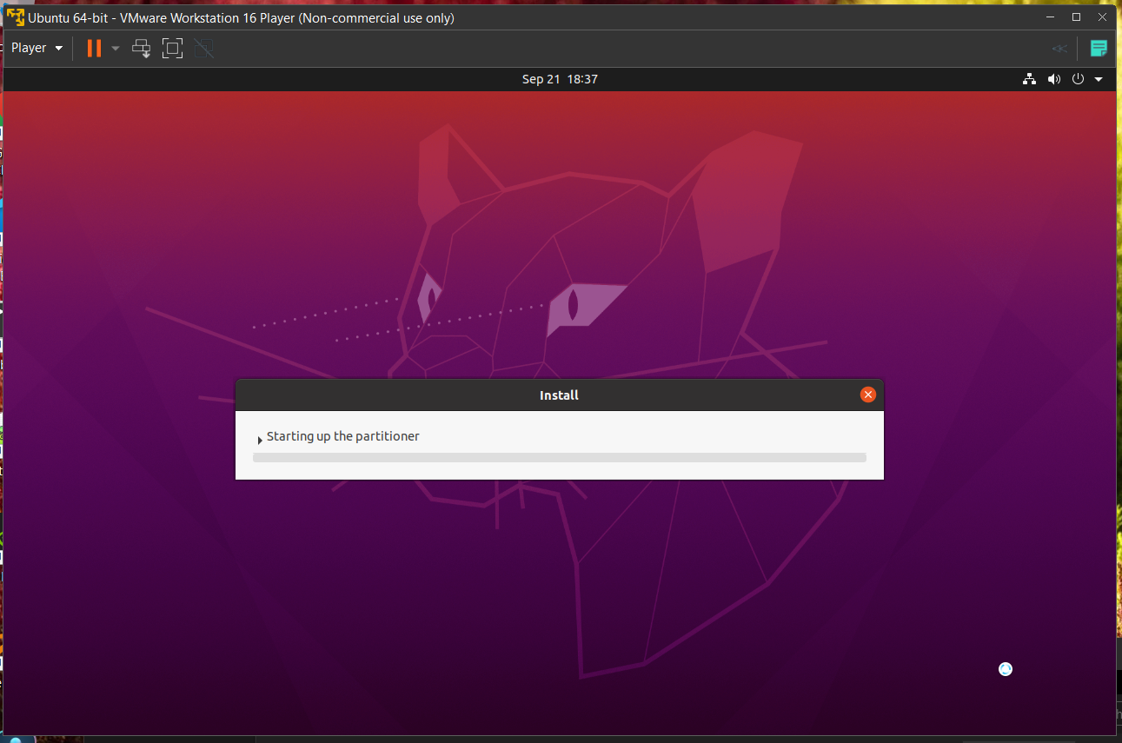

Installed and ready to use
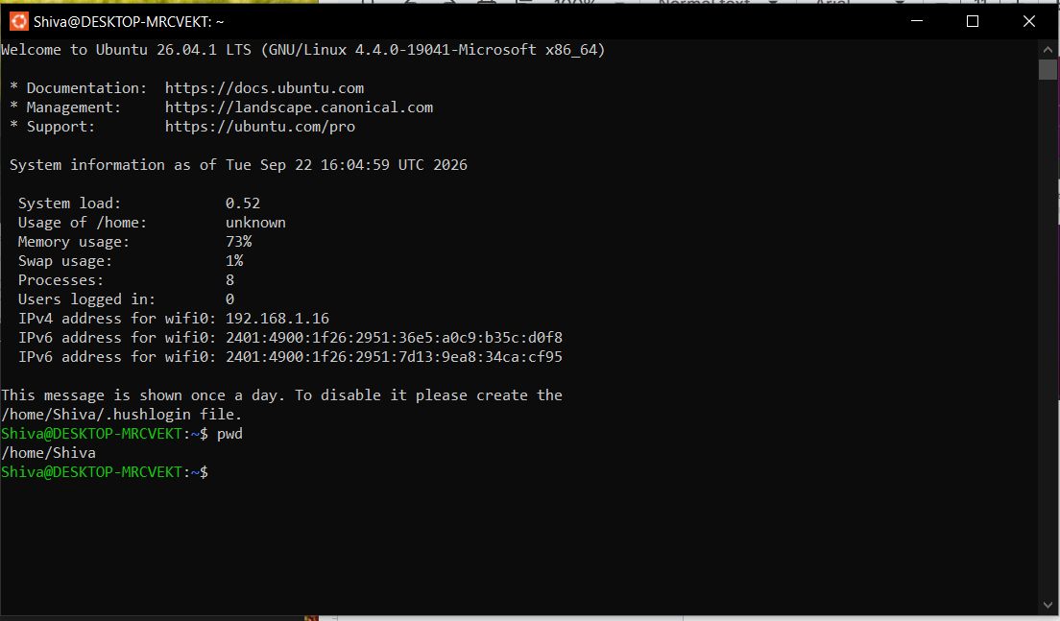

Remarks - I am primarily a MacBook user. Since the trainers use Windows, I managed to get a Windows laptop and install Ubuntu on it. Hence the delay in submitting the task.

