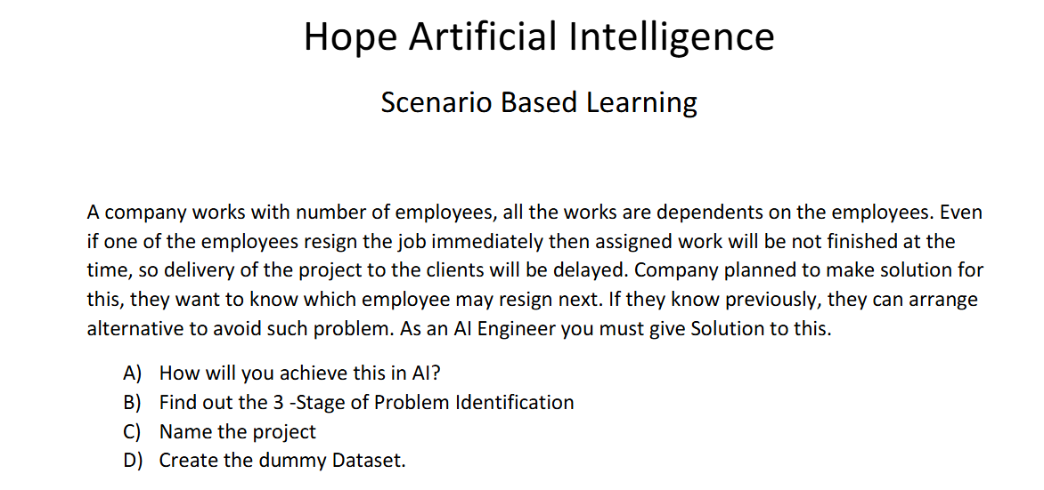

- The 3 stages of the Problem Identification are
Stage 1 – Machine Learning
Stage 2 – Supervised – as it contains predefined input and output
Stage 3 – Classification – as for each employee we predict if the Project is required to be reassigned to different person if an employee is planned to resign
- Project Name – Project Reassignment Prediction
- Below is the sample dataset.

