
SVKM’s NMIMS
School of Technology Management & Engineering,
Navi Mumbai Campus

Year:-II | Program:- MBA Tech CE D1 | Semester:- IV

Subject:- Object-Oriented Programming through JAVA

Algorithmic Volatility Pattern Detection and Behavioral Market Simulation in Java
Team Details
Name | Shivali Agarwal | Arth Agarwal | Anushree Balaji
Roll No | N002 | N003 | N006
SAP ID | 70472400139 | 70472400153 | 70472400107

Under the guidance of: Prof. Radhika Patil
Second Year, Semester IV
Faculty: Name of the faculty
AY 2025-26

INDEX
Sr. No. | Topic | Page No.
1 | Introduction | 3
2 | Requirement Analysis | 3
3 | Development Technologies | 4
4 | Modelling Classes | 4
5 | Progress Review (Week 10/11) | 7
5 | Implementation and Output | 7
7 | Observations and Learnings | 11
8 | Future Scope | 12
9 | Conclusion | 12

1. Introduction

The project focuses on building a Java-based system that analyses stock market data to detect volatility patterns and simulate trader behaviour. The system reads historical stock data, computes returns and volatility, identifies market events such as spikes and crashes, and simulates trading decisions based on these patterns.
Unlike purely theoretical models, this project emphasises practical implementation using object-oriented design and integrates a graphical user interface (GUI) to visualise results. The system also tracks portfolio performance over time, enabling users to observe how trading strategies behave under varying market conditions.

2. Requirement Analysis
Functional Requirement
- Load stock data from CSV files
- Calculate daily returns and volatility
- Detect patterns such as:
  - Spike (positive return)
  - Crash (negative return)
  - Stable movement
- Simulate trader decisions (buy/sell/hold)
- Track portfolio value over time
- Display results in a GUI (JavaFX)
- Provide summary statistics (spikes, crashes, returns, etc.)

Non-Functional Requirements
- Modular and maintainable code structure
- Efficient handling of large datasets
- Clear separation between backend logic and UI
- Easy to extend for future improvements

3. Development Technologies
Component | Technology Used
Language | Java
IDE | IntelliJ IDEA
UI Framework | JavaFX
Data Source | CSV file
Version Control | GitHub

4. Modelling Classes
The project follows a modular structure with separation of concerns:

- Model Layer
StockData
- Stores price and date
- Represents one data entry
Trader
- Maintains cash and stock holdings
- Executes buy/sell operations
- Calculates total portfolio value

- Service Layer
DataLoader
- Reads CSV file
- Extracts selected stock column
VolatilityCalculator
- Computes overall volatility using variance
RollingVolatilityCalculator
- Calculates moving (window-based) volatility
- Used for dynamic decision making
PatternDetector
- Classifies returns:
  - Spike
  - Crash
  - Stable
Simulator
- Core logic of the system
- Simulates trading decisions
- Tracks:
  - Portfolio value
  - Trade count
  - Event logs
SummaryGenerator
- Generates summary:
- Total days
- Spikes / crashes / stable counts
- Max spike/crash
VolatilityLabeler
- Converts numeric volatility into:
  - LOW
  - MODERATE
  - HIGH
- UI Layer
App
- Entry point for JavaFX
- Dashboard
- GUI interface
- Allows:
  - Stock selection (dropdown)
  - Running simulation
  - Viewing output + graph

5. Progress Review (Week 10/11)

- Week 1–2: Data loading and return calculation
- Week 3–4: Volatility computation
- Week 5–6: Pattern detection logic
- Week 7–8: Trading simulation implementation
- Week 9: Summary generation and improvements
- Week 10–11: GUI integration using JavaFX

6. Implementation and Output
6.1 System Workflow
The system follows a structured pipeline where raw stock data is transformed into meaningful trading insights and simulation results.
CSV Data → DataLoader → Returns → Volatility → Pattern Detection → Simulation → UI Output
Each stage is modular and handled by separate classes, ensuring clean design and maintainability.
6.2 Data Loading and Preprocessing
The system begins by reading historical stock data from a CSV file.
The DataLoader class extracts the selected stock (e.g., AAPL).
Each row is converted into a StockData object containing the date and price, which is stored in a list for further processing.
6.3 Return Calculation
Daily returns are computed using the formula:
Return = (Today’s Price − Yesterday’s Price) / Yesterday’s Price.
This step converts raw price data into relative movement, which is essential for detecting patterns and computing volatility.

6.4 Volatility Computation
Two types of volatility are used in the system.
Overall volatility: calculated using standard deviation of returns to represent general market uncertainty.
Rolling volatility: calculated over a moving window (e.g., 5 days) to capture short-term fluctuations and support dynamic decision making.
6.5 Pattern Detection
Each daily return is classified using thresholds: Returns greater than +0.02 are labeled as spikes, returns less than -0.02 are crashes, and all others are considered stable.
Condition | Classification
Return > +0.02 | Spike
Return < -0.02 | Crash
Otherwise | Stable

6.6 Trading Simulation Logic
he Simulator class models a simple rule-based trading strategy.
Decision Rules:
- High Volatility + Spike → Aggressive Buy
- High Volatility + Crash → Panic Sell
- Moderate Volatility → Controlled Buy
- Low Volatility → Hold Position
Trader Model:
The Trader class maintains:
- Cash balance
- Number of stocks held
- Total portfolio value
Simulation Flow:
For each day:
- Identify pattern (Spike / Crash / Stable)
- Check volatility level (LOW / MODERATE / HIGH)
- Execute trading decision
Update:
- Cash
- Holdings
- Portfolio value
6.7 Backend Output Handling (Key Enhancement)
Initially, results were printed directly to the console. This was improved by restructuring the output.
Changes Implemented:
- Replaced System.out.println() with StringBuilder
- Introduced structured return data using Map<String, Object>
Final Output Structure:
Map<String, Object> result = new HashMap<>();
result.put("log", output.toString());
result.put("portfolio", portfolioValues);
6.8 Portfolio Tracking
During simulation, portfolio value is recorded daily:
portfolioValues.add(trader.getTotalValue(price));
This enables:
- Visualization of growth trends
- Performance analysis over time
6.9 Graphical User Interface (JavaFX)
The project includes a GUI built using JavaFX.
It features a dropdown for stock selection, a button to run simulations, an output panel for logs and summaries, and a line chart to visualise portfolio growth over time.
Data Flow to UI:
Simulator → Map (log + portfolio) → Dashboard → UI display
6.10 Sample Output
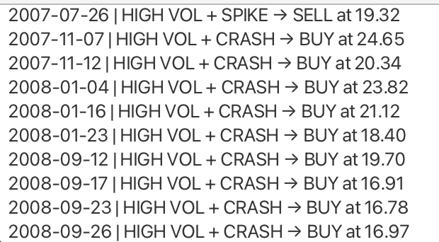
Trade Events:

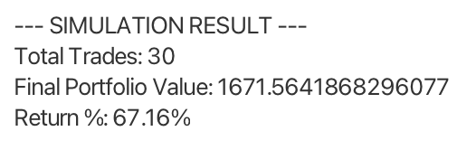
Simulation Summary:

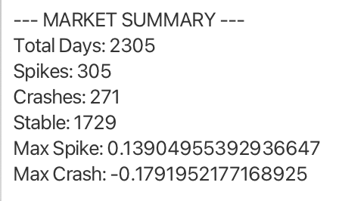
Market Summary:

6.11 Volatility Interpretation in UI
Value range | Label
> +0.02 | HIGH
0.01 - 0.02 | MODERATE
<0.01 | LOW
to improve readability, volatility values are labeled:

7. Observations and Learnings
- High volatility leads to more frequent trading decisions
- Even with many stable days, extreme spikes/crashes dominate volatility
- Simple rule-based strategies can produce large returns but may not be realistic
- Separating backend and UI improves scalability
- Handling real-world data requires careful debugging

8. Future Scope
- Improve trading strategy using risk management
- Add multiple traders (aggressive vs conservative)
- Integrate real-time stock APIs
- Enhance UI with better graphs and filters
- Add machine learning for prediction

9. Conclusion
The project successfully demonstrates how stock market data can be analysed using Java to detect volatility patterns and simulate trading behaviour. It combines object-oriented design with practical financial logic and user interface integration.
The system provides insights into how volatility affects trading decisions and portfolio performance, making it a strong foundation for further development in financial analytics and simulation systems.

