This project report includes the construction of a database system for a fitness studio, business rules for the fitness studio, features of the database system,

INFO610 PROJECT

Sukanya Sundaram

Shivali Sharma

# **EXECUTIVE SUMMARY**

This project work is a part of our curriculum for INFO610 – Analysis and Design of Database System at Virginia Commonwealth University. This project involves a brief description of SS Fitness Studio, their current issues or problems, construction of a Database Management System (DBMS), re-defining its business rules & user requirements, potential benefits of the DBMS, demonstrating features for the DBMS by writing PL/SQL statements which will form solutions for the issues faced by the current management.

In the first part of the project, a detailed entity relationship diagram along with the definitions of the entities and their relationships have been established. Also, the relational diagrams have been formed and converted into their third normalised form. Re- defining of business rules and establishing new features will also form a part of this report.

In the second part of the project, we have given a detailed description of our database along with the tables, and identified primary and foreign keys in the table. We have also demonstrated how the features would work in the database using PL/SQL codes in Oracle Apex.

The main objective of this project is to develop a database that facilitates data storage, data maintenance and data retrieval for the fitness studio in an igneous way.

# **INTRODUCTION**

SS Fitness Studio, an existing fitness entity located in the Richmond downtown area, currently works with almost 400 clients per month and growing at a rate of 20% annually. SS Fitness Studio, Fitness Studio is a health club that creates personalized environment for men and women to pursue their fitness goals. Since its inception in 2012, the fitness studio has been providing elite training, nutritional guidance, and athletic development services. Its growing client base and existing customers have proven it to be a regimen that delivers tangible results.

For the last five year’s this fitness studio has been dependent on its employees to keep a manual database for its services, members, employees, and other related entities. However, with the growing client base, the management realized its need for Database Management System. Also, the management plans to open another branch in the next few years and it would be become challenging to maintain all that data manually.

**Objectives of SS Fitness Studio’s DBMS**:

* Develop software that facilitates the data storage, maintenance, and retrieval.
* Store record of the clients (members), employees, suppliers, equipment, facilities, and any other related entity of the fitness studio.
* Grant specific access to the administrative staff to manage the DBMS.
* Provide adequate training and skills to make sure the administrative staff can manage the DBMS effectively.

**Need for SS Fitness Studio’s DBMS:**

* Dependency on employees to manage a manual database
* Growth in client base since inception
* Future plans of expansion of business
* Existing manual database is time consuming

**Potential Benefits of SS Fitness Studio’s DBMS:**

* Elimination of manual database
* Security of data
* Ensuring data accuracy
* Speedy process of data maintenance, processing, and retrieval.
* Greater efficiency and better service
* Cost efficient management

**Users of SS Fitness Studio’s DBMS:**

* Members
* Employees (Administrative Staff and Instructors)

# **BUSINESS RULES AND USER REQUIREMENTS**

* There are two kinds of Employees in the Fitness Studio i.e. Instructors and Admin-Staff.
* An Instructor can teach one or many classes, a class can be taught by one and only one instructor. The instructor can be replaced by another if he is not available. The Instructors are part time employees so they will not be allowed to work beyond 30 hours a week.
* Instructor may also be training some members personally. A personal trainer trains many members at different times. But trains one member at one time slot. Only one personal trainer trains a member.
* Admin Staff are full time employees that maintain the backend of the fitness studio like placing purchase orders and maintaining the database of the customers.
* Members may enrol for one or many classes. A class is scheduled only when 5 members have enrolled for it. A class may have only 20 members at most signed up for a class at any moment. Members who have signed up for an unscheduled class will be notified when the minimum requirement has been met.
* Members will not be allowed to register for 2 classes which are scheduled at the same time and day to avoid misuse of the system.
* Members pay a standard fee of $25 for monthly, $100 for semi-annual and $180 for an annual membership. An extra $30 per month will have to be paid if the member chooses to have a personal training.
* Members make many payments but one payment can be made by only one member. Members can choose to pay by “Cash”, “Credit” or “Debit”.
* An equipment is supplied by one and only one supplier, a Supplier may supply one or many equipment. Supplier will be in charge of maintenance of the equipment during the warranty period.
* Maintenance is done by one or many Maintenance teams. One Maintenance Team may maintain more than one equipment. An equipment can be maintained by only one maintenance team. Maintenance Team takes over the maintenance when the equipment is out of the warranty period.
* Every Equipment belongs to a facility. The purchase order sent to the Supplier is placed by the Admin staff is approved and paid for by the Facilities.

**The User Requirements can be summarised as follows:**

* Facilitate and manage the business operations
* Manage employees and payroll
* Manage membership and membership dues
* Schedule classes and teachers
* Keep track of equipment and facilities
* Schedule special events
* Allow members to renew memberships, sign up for classes and pay dues on-line

# **ENHANCED ENTITY RELATIONSHIP DIAGRAM**



# **ENTITIES & RELATIONSHIPS**

* Employee (EID, E_Name, E_PhNo, E_Address, E_EmailID, E_joindate, E_Enddate, E_Type)
* Instructor (EID, Hours_worked, Specialization, Certification_Level)
* Admin_Staff (EID, Type_Speed, Qualification)
* Salary (SSN, Compensation, Bonus, EID)
* Member (MID, M_Name, M_PhNo, M_Address, M_EmailID, M_joindate, M_enddate, M_fees, membership_Type, Status,EID)
* Member_Payment (Transaction_ID, Payment_Type, Amount_Paid, Date_of_payment, MID)
* Suppliers (SID, S_Name, S_PhNo, S_Address, S_EmailID)
* Maintenance_team (MT_ID, MT_Name, MT_Address, MT_PhNo)
* Facilities (FID, F_Name, F_expenditure)
* Equipment (Eq_ID, Eq_Name, Last_Serviced,SID, MT_ID,FID, Maintained_by)
* Purchase_Order(Purchase_ID, Purchase_Amt, EID, FID, SID )
* Class (Class_ID, C_Name, C_Day, Member_count, EID, Instructor_Name, Available, Backup_Instructor)
* Enroll_class (Class_ID,MID, EID)

|  |  |  |
| --- | --- | --- |
| **Name of Relationship** | **Relationship Type** | **Names of Participating Entities/Categories** |
|  | Subtype-Supertype  relationship | Employee, Instructor, Admin_Staff |
| Teaches | M:1 | Instructor, Class |
| Supplies | M:1 | Equipment, Supplier |
| Maintains | 1:M | Maintenance_team, equipment |
| Makes | M:1 | Member_Payment and member |
| Pays | 1:M | Facilities and Purchase order |
| Scheduled in | M:1 | Enroll_Class and Class |
| Registers for | M:1 | Enroll_Class and Member |
| Sent to | M:1 | Purchase order and Supplier |
| Belongs to | M:1 | Equipment and Facility |
| Paid to | 1:1 | Salary and Employee |
| Uses | 1:M | Member and Equipment |
| Trains | M:1 | Member and Instructor |
| Places | 1:M | Admin-Staff and Purchase_Order |

|  |  |  |  |
| --- | --- | --- | --- |
| **Table** | **Primary Key** | **Foreign Key** | **Table Referenced** |
| Employee | EID | NA | NA |
| Instructor | EID | EID | Employee |
| Admin_Staff | EID | EID | Employee |
| Member | MID | EID | Instructor |
| Equipment | Eq_ID | SID, MT_ID, FID | Suppliers, Maintenance_Team, Facilities |
| Suppliers | SID | NA | NA |
| Salary | SSN | EID | Employee |
| Facilities | FID | NA | NA |
| Class | Class_ID | EID | Instructor |
| Member_Payment | Transaction_ID | MID | Member |
| Maintenance_Team | MT_ID | NA | NA |
| Enroll_Class | MID, Class_ID | EID, MID, Class_ID | Instructor, Member, Class |
| Purchase_Order | Purchase_ID | SID, EID, FID | Supplier, Admin_Staff, Facilities |

|  |  |  |  |
| --- | --- | --- | --- |
| **Name of Entity** | **Identifier/ PK** | **List of Attributes** | **Classification** |
| Employee | EID | E_Name, E_PhNo, E_Address, E_EmailID, E_joindate, E_Enddate, E_Type | Supertype |
| Instructor | EID | Hours_worked, Specialization, Certification_Level | Subtype |
| Admin_Staff | EID | Type_Speed, Qualification | Subtype |
| Member | MID | M_Name, M_PhNo, M_Address, M_EmailID, M_joindate, M_enddate, M_fees, membership_Type, Status |  |
| Equipment | Eq_ID | Eq_Name, Last_Serviced, Maintained_by |  |
| Suppliers | SID | S_Name, S_PhNo, S_Address, S_EmailID |  |
| Salary | SSN | Compensation, Bonus |  |
| Facilities | FID | F_Name, F_expenditure |  |
| Class | Class_ID | C_Name, C_Day, Member_count, Instructor_Name, Available, Backup_Instructor |  |
| Member_Payment | Transaction_ID | Payment_Type, Amount_Paid, Date_of_payment |  |
| Maintenance_Team | MT_ID | MT_Name, MT_Address, MT_PhNo |  |
| Enroll_Class | Class_ID, MID |  | Weak entity |
| Purchase_Order | Purchase_ID | Purchase_Amt |  |

# **RELATIONAL DATABASE MODEL**

Employee (EID, E_Name, E_PhNo, E_Address, E_EmailID, E_JoinDate, E_EndDate, E_Type)

Instructor (EID, Hours_Worked, Specialization, Certification_Level)

Admin_Staff (EID, Type_Speed, Qualification)

Salary (SSN, Compensation, Bonus, EID)

1NF

Salary (SSN, EID, Compensation, Bonus)

2NF

Salary (SSN, Compensation, Bonus)

Salary_Details (EID, Compensation, Bonus)

3NF

Salary_Details (EID, Compensation, Bonus)

Salary (SSN, Compensation, Bonus)

Bonus (Compensation, Bonus)

MEMBER (MID, M_Name, M_PhNo, M_Address, M_EmailID, M_JoinDate, M_EndDate, M_Fees, Membership_Type)

1NF

Member (MID, M_Name, M_PhNo, M_Address, M_EmailID, M_JoinDate, M_EndDate, M_Fees)

2NF

Member_Details (MID, M_Name, M_PhNo, M_Address, M_EmailID, M_Fees)

Member_Joining (MID, M_JoinDate, M_EndDate)

3NF

Member_Details (MID, M_Name, M_PhNo, M_Address, M_EmailID)

Member_Joining (MID, M_JoinDate, M_EndDate)

Member_Fees (MID, M_Fees)

Mem_Add (M_Zip, M_City, M_State, M_Address)

MID, MName, M

Member_Payment (Transaction_ID, Payment_Type, Amount_Paid, Date_of_Payment)

Equipment (Eq_ID, Eq_Name, Last_Serviced)

Suppliers (SID, S_Name, S_PhNo, S_Address, S_EmailID)

Facilities (FID, C_Time, F_Name, F_Expenditure)

Maintenance_Team (MIT_ID, MIT_Name, MIT_Address, MIT_PhNo)

Purchase_Order (Purchase_ID, Purchase_Amount, SID)

Purchase_Order (Purchase_ID, Purchase_Amount, SID)

Class (Class_ID, C_Name, C_Day, C_Time)

Enroll_Class (Roster_ID, MID, CID)

**FEATURES:**

We have established the following features for SS Fitness Studio DBMS. The screenshots have been used to demonstrate how the features would work and what the output would look like.

1. Member checks facilities offered by the gym. Facilities are displayed for the member to choose from.

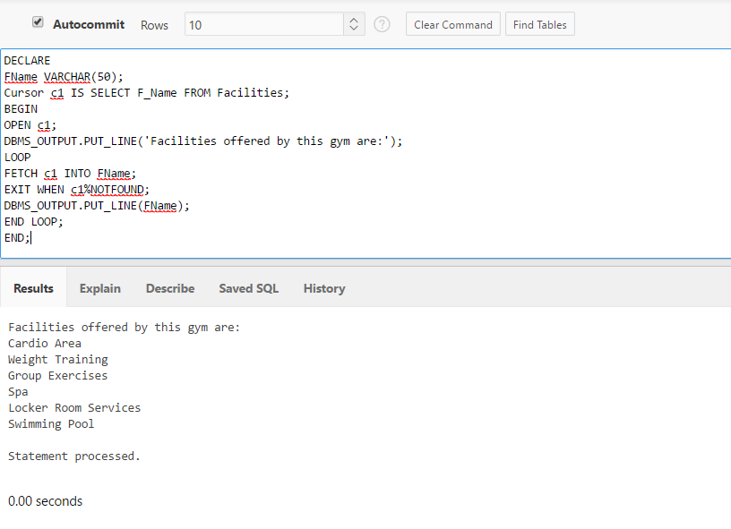

2. No duplicate memberships allowed for the same person. Admin-staff checks if he/she has been a member of the gym using the phone number supplied by the member.  If phone number is found in the records, the name of the person is tallied. If the same name appears, we allocate same MID. if not, new MID is created.

Person is a returning member:

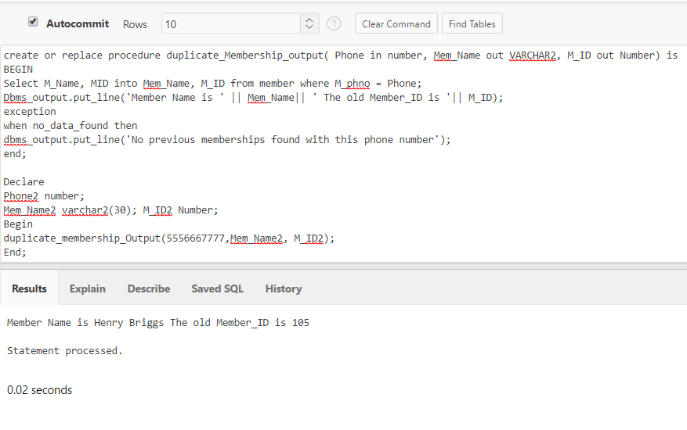

New Customer: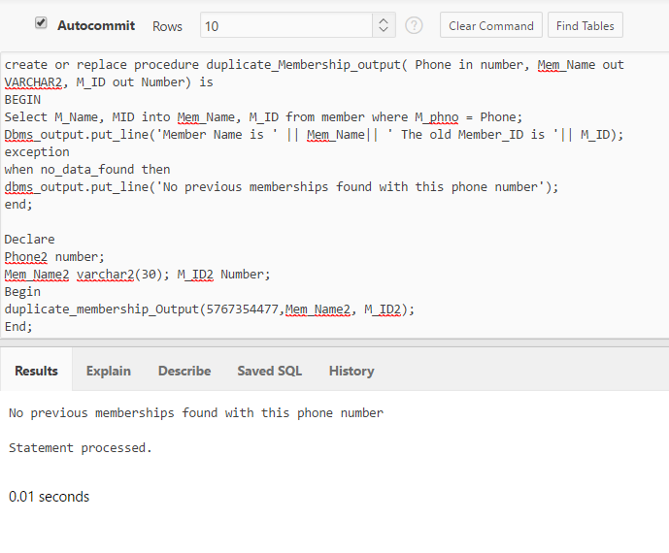

3. Member registers for class. If class has 20 members already registered, member is not allowed to register for the class, else member is allowed to register and member count is updated for the class.

Class having less than 20 members:

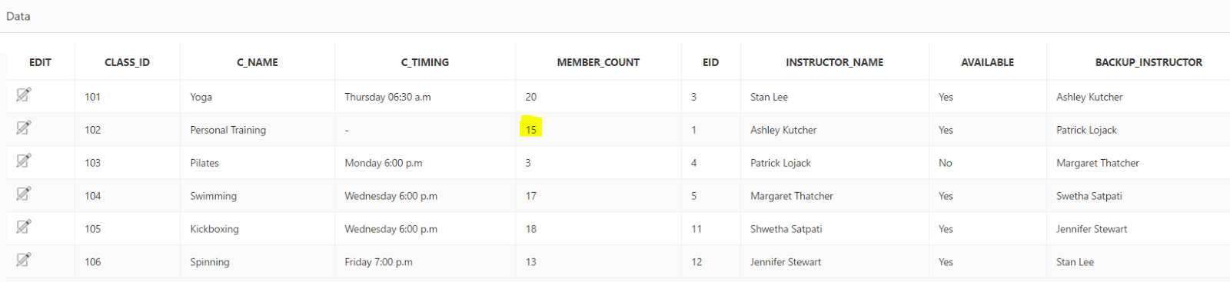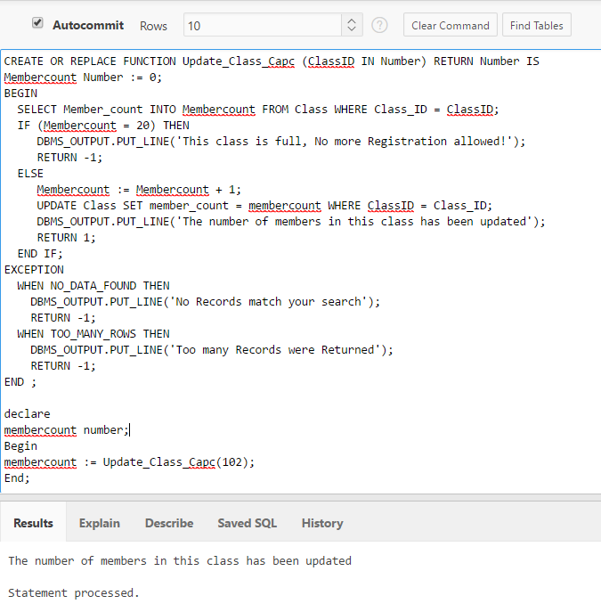

Member_Count increased after registration:

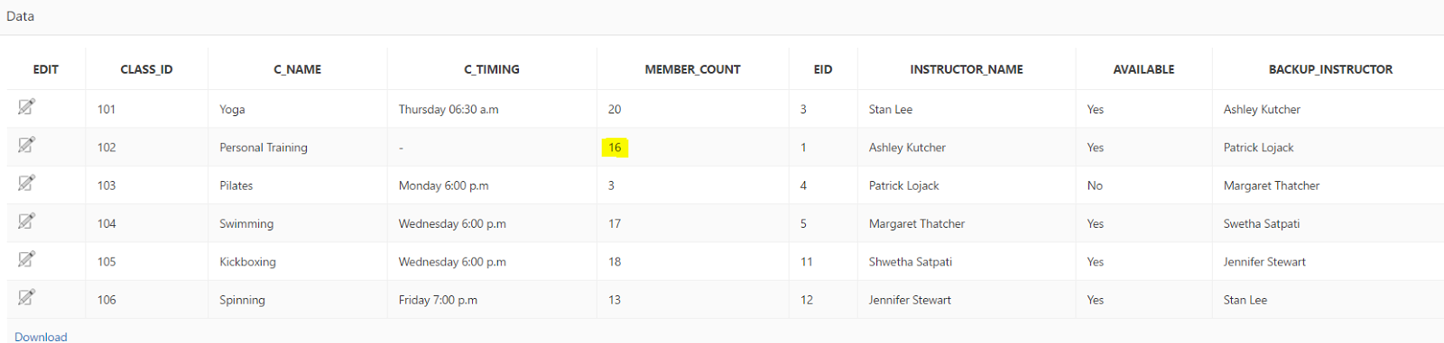

Class having 20 members: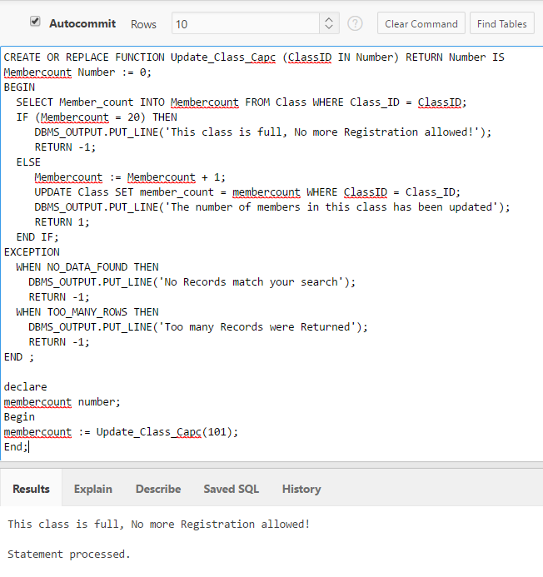

4. Check if assigned instructor is available for the particular class, if not then back up instructor takes the class and the Instructor Name for that week is updated.

The instructor for Class_ID=102 is not available:

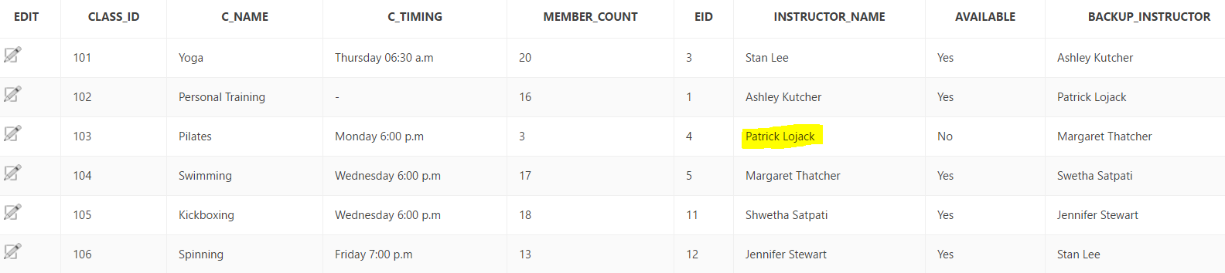

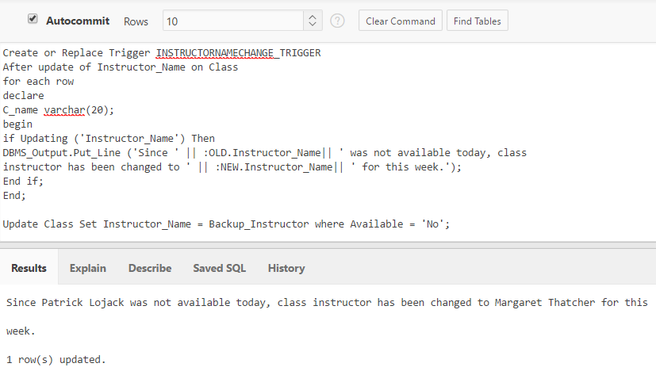

New instructor assigned:

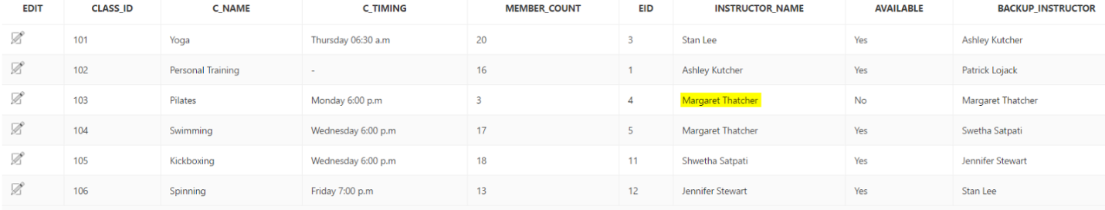

5. Check if instructor is working for more than 30 hours a week. If yes, then the instructor is not allowed to work, if not the instructor is scheduled to work.

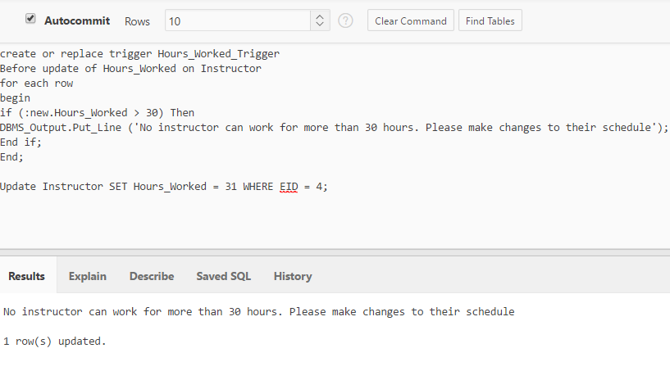

6. Calculate bonus for the employee’s Bonus= 15% of the salary. Every year the raise (7% of the salary) for an employee is calculated. Display salary difference for that employee.

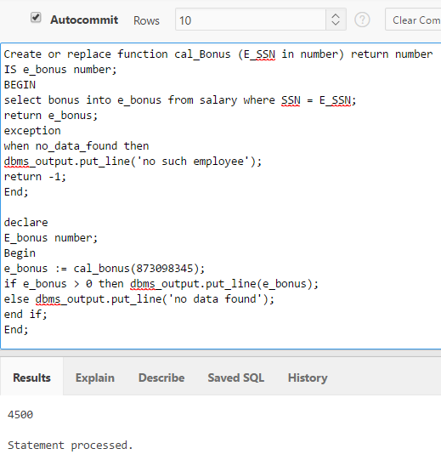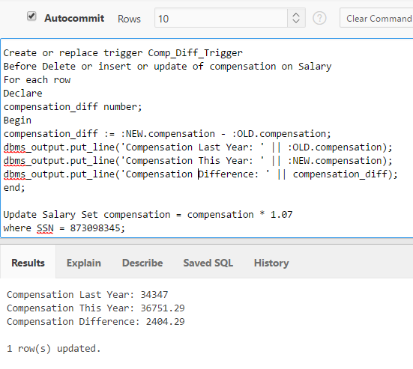

7. Admin staff places PO. Every facility is allocated a budget of $10,000 per annum. No facility should exceed the budget allocated.

Facility hasn’t crossed the budget:

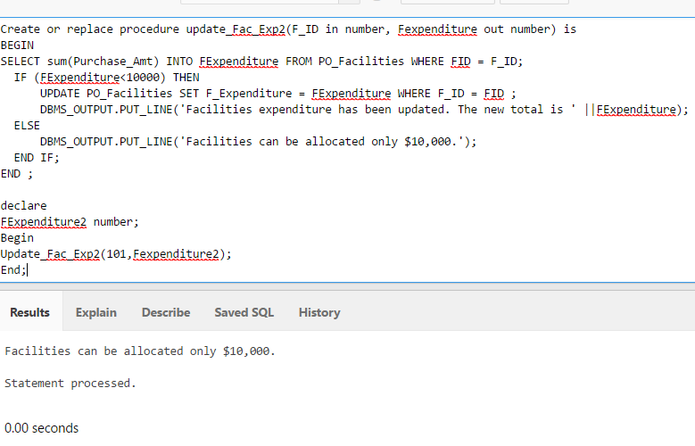

Purchase Amounts are added and Facility Expenditure updated:

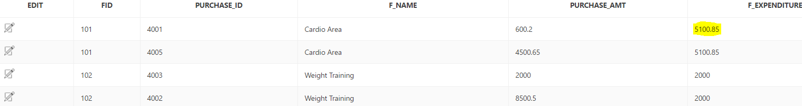

Facility has crossed the budget:

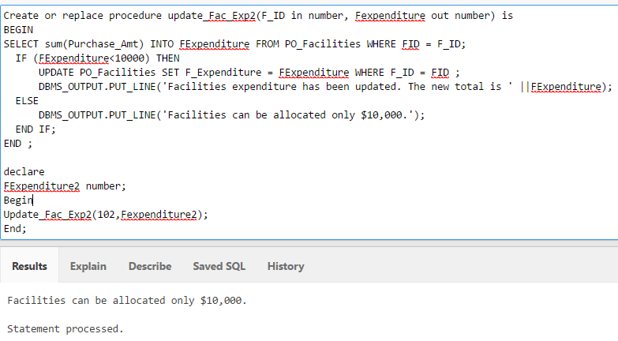

Facility Expenditure is not updated when budget is crossed:

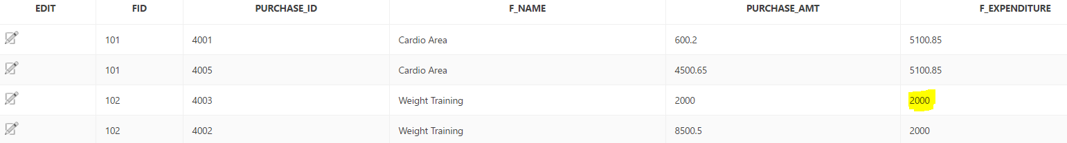

8. Renewal of membership can be done up till 5 days of expiration. After which the status becomes inactive and user will be charged new fee on return.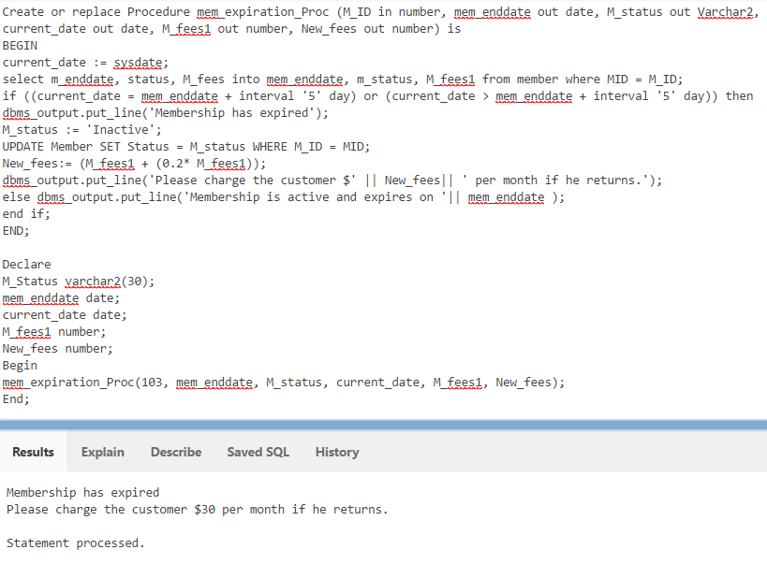

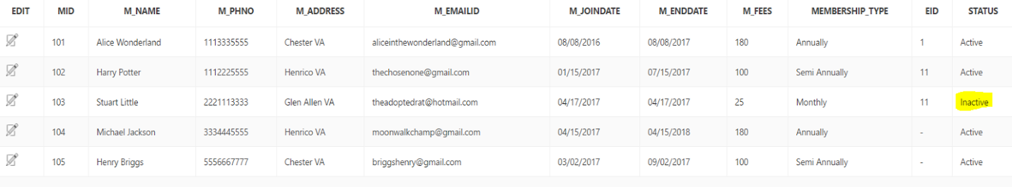

9. Minimum number of students for a class is 5. If less than 5 members, then cancel class.

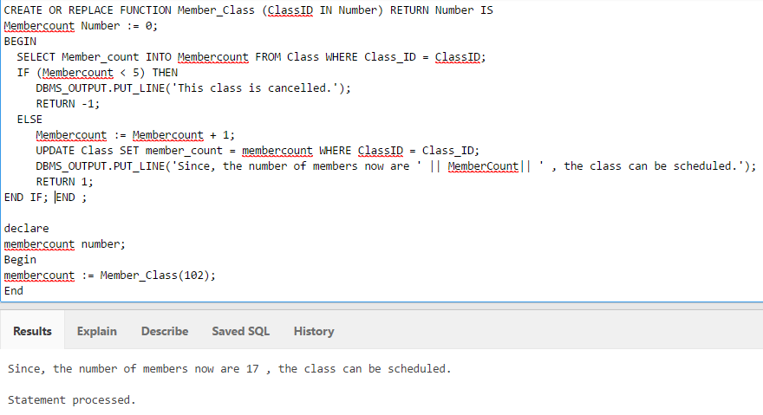

10. Two different classes cannot be registered by the same member at the same time.

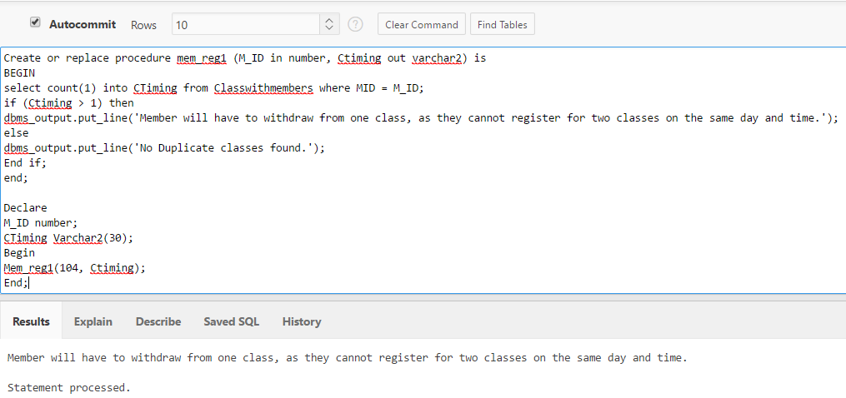

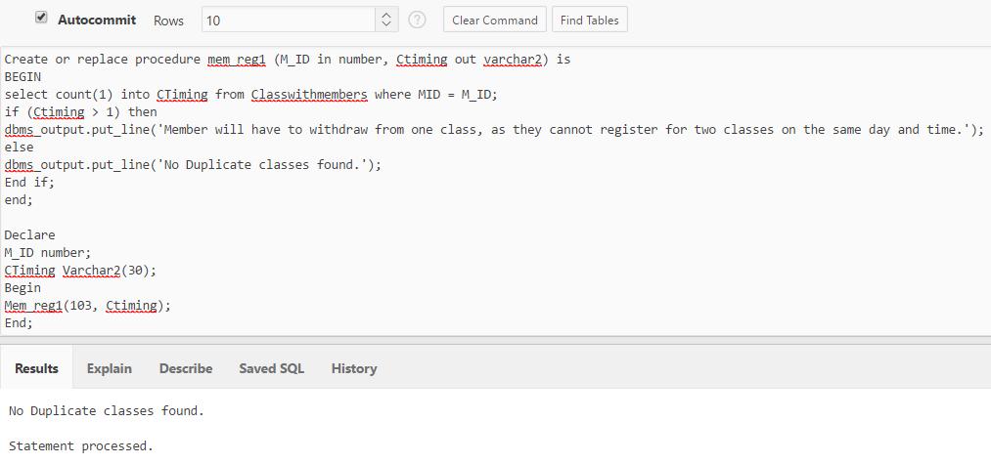

11. Check last serviced date and service it, if it has been more than one year.

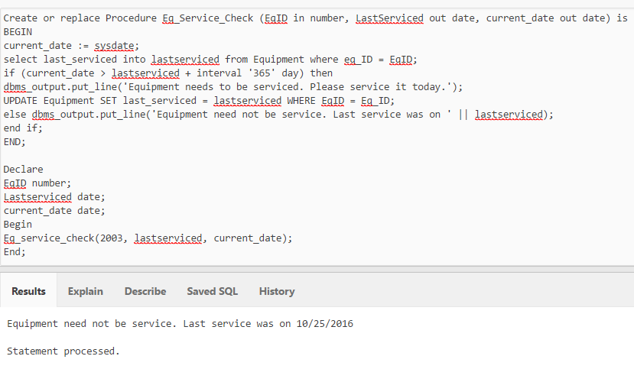

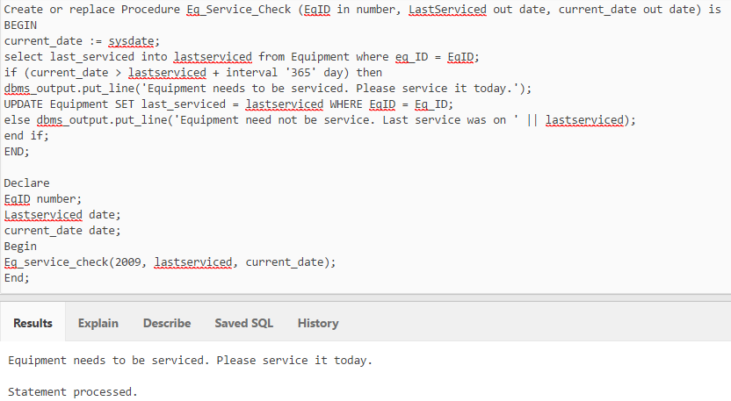

12. Member is charged a fine if he pays the fees beyond seven days of the due date. Seven days are given as a grace period.

Member is charged a fine:

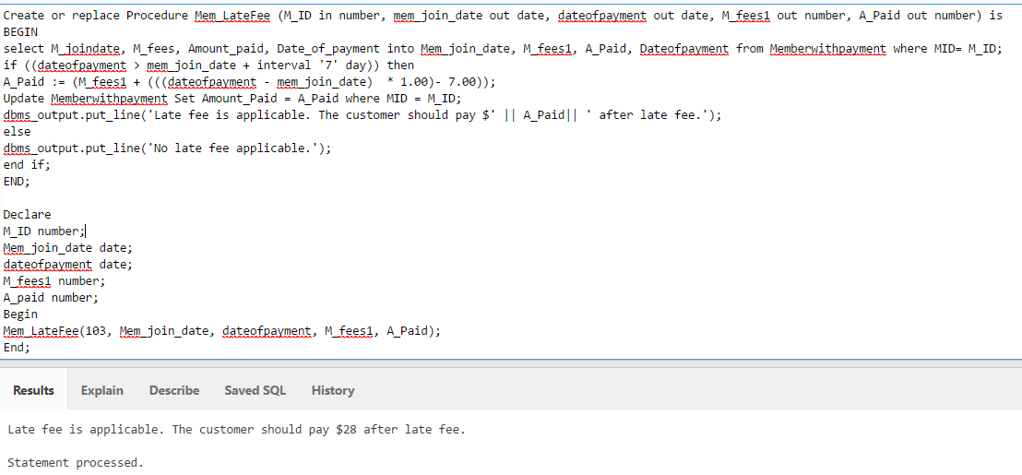

No fine Applicable:

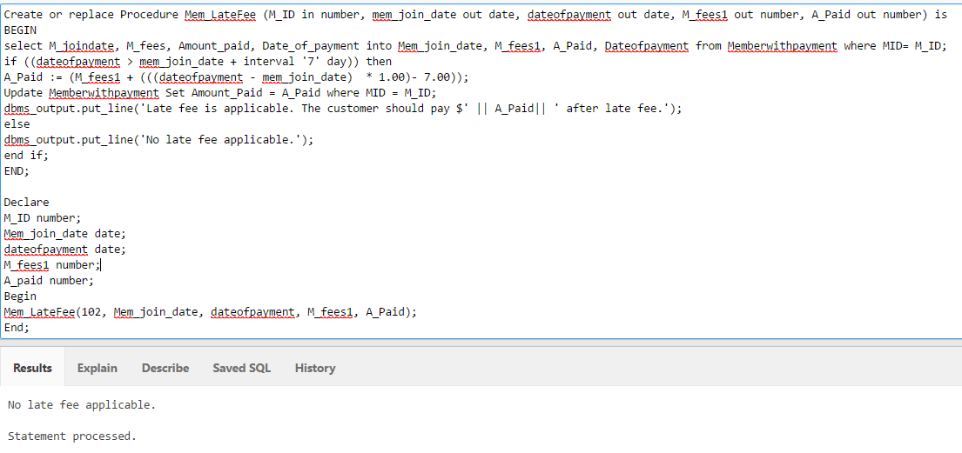

13. If member pays full fee within 3 days of joining the gym by cash, they get 10% discount on their member fee.

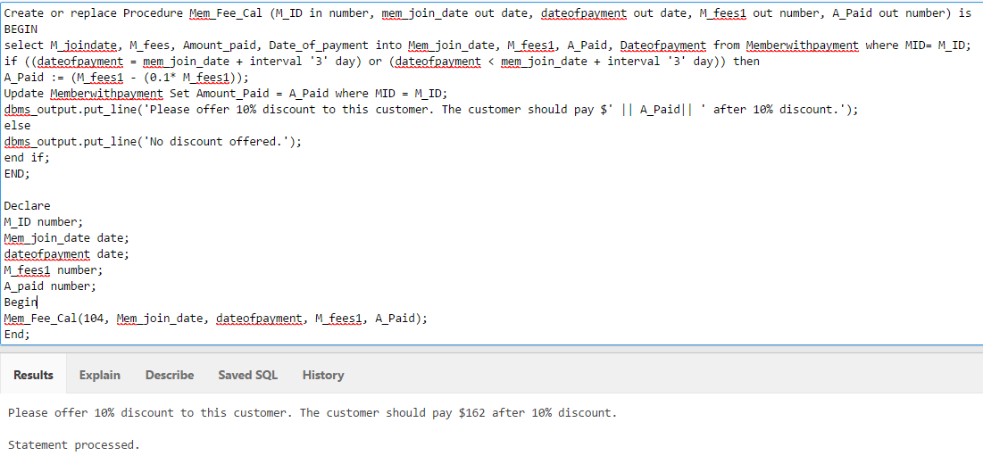

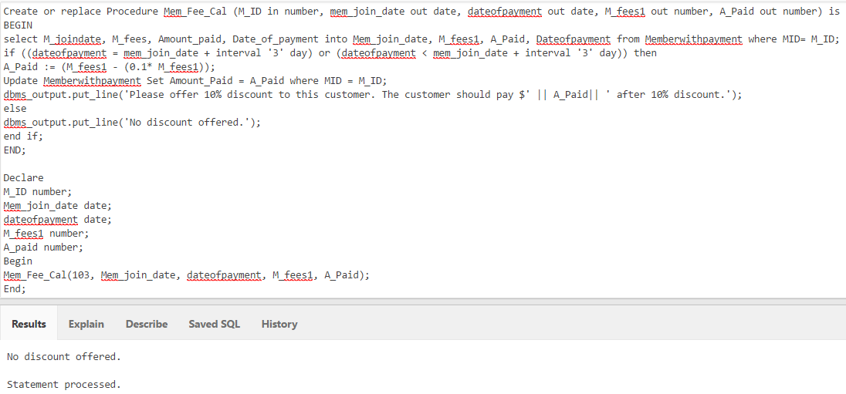

14. Supplier gives free one year warranty, after that maintenance team takes over.

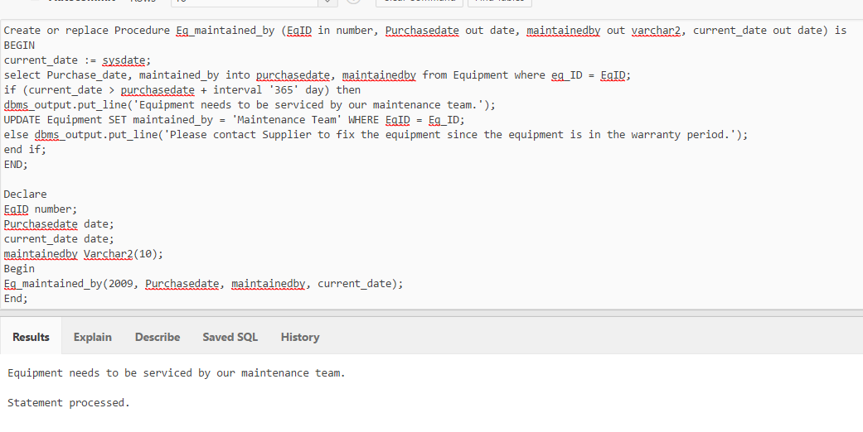

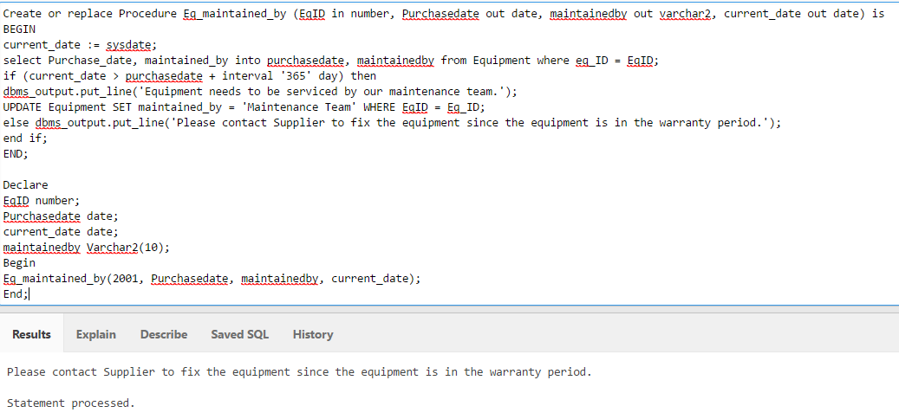

15. If two or more equipment are bought from the same supplier, then supplier gives 10% discount.

