December 4, 2017

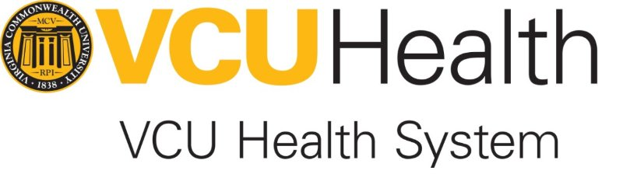

**INFO630 FINAL REPORT**

**Chuan Li**

**Shivali Sharma**

**Sukanya Sundaram**

# Table of Contents

Table of Contents 1

Executive Summary 3

Project Description 4

Context Diagram 6

Use case diagram 7

Class Diagram 8

Normalized Data Model 9

Screen Copies of the Application 10

Usability Testing 31

Conclusion 32

# Executive Summary

The Virginia Commonwealth University Health System (VCUHS) is an urban, comprehensive academic medical center in central Virginia established to preserve and restore health for all people, to seek the cause and cure of diseases through innovative research, and to educate those who serve humanity. VCUHS aims at committing to excellent patient care and education as the most superior academic medical center in mid-Atlantic Region. In this report we have defined and demonstrated the project requirements for the intranet website of VCUHS along with a few screenshots of a functioning prototype application. Before developing the intranet website, we construed context diagram, activity diagrams, use case model, class diagram, data model, state charts, project plan, sequence diagrams and interface design. However, the following have been illustrated in this report:

* Context Diagram
* Class Diagram
* Use-case Model
* Data Model

The intranet was developed as per the above-mentioned requirements and was tested by two users who are not current employees or students of VCU. The feedback and comments were documented as a part of the usability testing report. The constructive feedback was successfully implemented in the intranet website construction and the screenshots functioning prototype application have been incorporated in this report. The intranet website has been developed on a local server. Once the prototype application has been approved it maybe migrated to a web host.

# 

# 

# Project Description

VCUHS does not have a centrally located and easily navigated website to access data or information from Quality Safety Service (QSS) program groups such as process improvement committees, Department/Program Quality Groups or projects. As of now, there is no transparency of information or ability to search current or completed projects that would allow association between groups, reduce duplication of effort, or avoid conflicting efforts. The tools and templates that VCUHS has are not readily available to team members or departments.

The intranet website is required to have all information or data or minutes from programs and projects that maybe needed by CMS, TJC, or any other external entity. The intranet website will facilitate efficiency and effectiveness of survey activities by making them available electronically and centrally located. This will even prevent in duplication of work by the residents, faculty and hospital groups as they were not able to locate the previous and current information or data.

The goal of this project is to design a user-friendly intranet website for VCUHS employees for them to have access to information from QSS Program groups and projects. The development of this site will ensure that information from QSS Program groups and projects will be connected and define standards & maintenance structures. The site would also not create any undue burden for information suppliers.

All QSS Program improvement initiatives and projects are for VCUHS. These programs and projects are listed in the organization chart reporting through Quality Executive Committee: Process Improvement Committees, Program Excellence Committees, Quality Safety and Service Priorities, Cause Analysis program, QAPI Committee, and Department Quality/Safety Committees. QSS also manages related efforts by other departments. Project management, process improvement, PDSA tools, templates and materials to promote coordination of QSS work will also be housed on this site.

# 

# Project Description

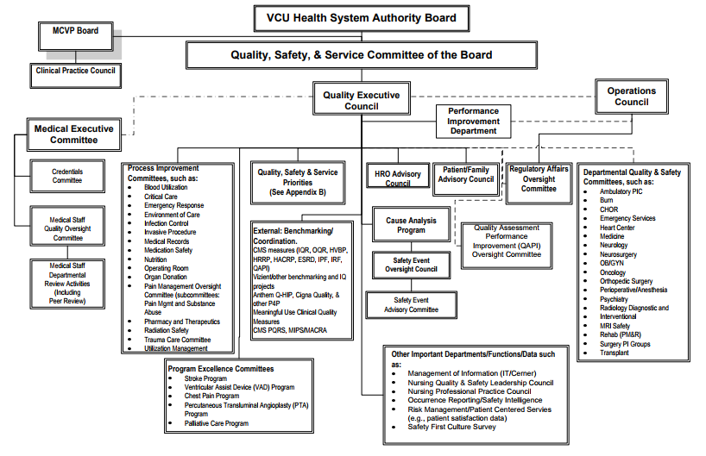

# Context Diagram

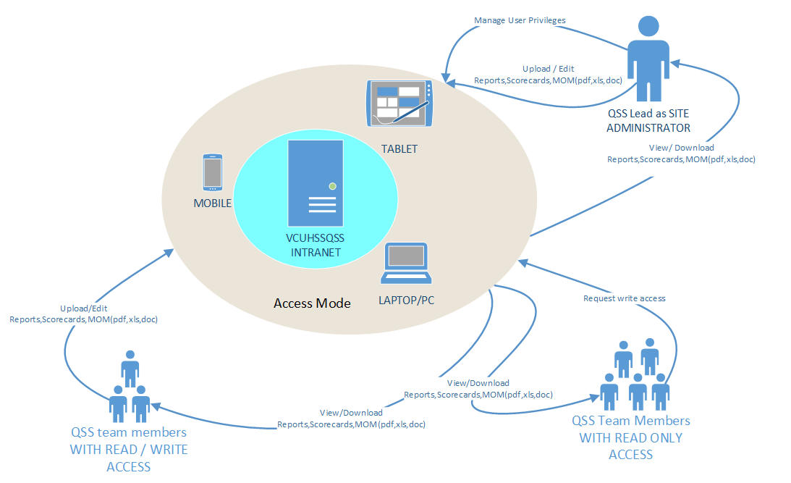

# 

# 

# Use case diagram

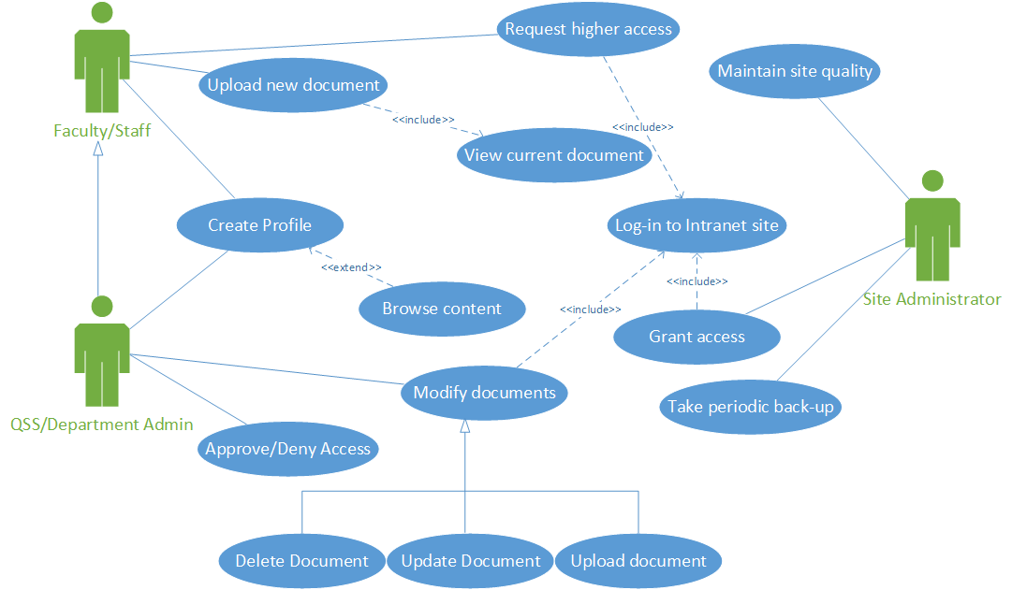

# Class Diagram

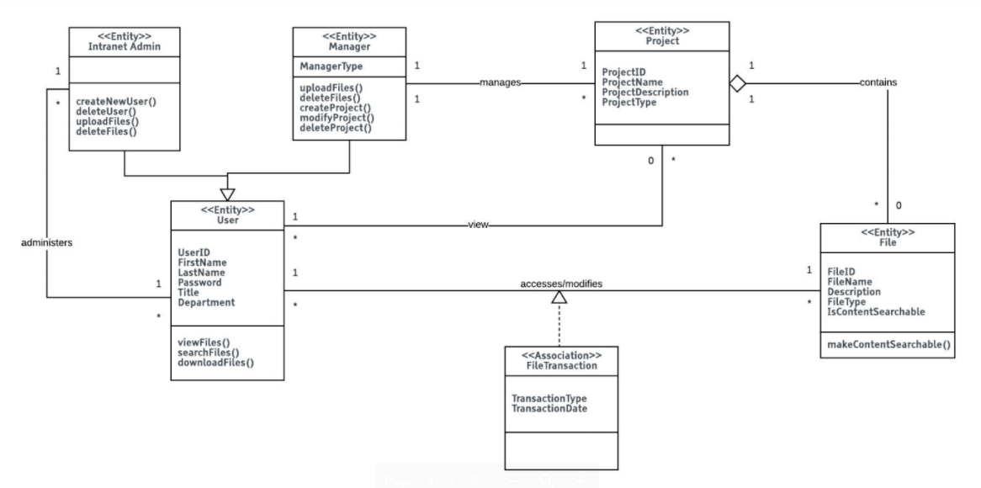

# Normalized Data Model

# 

# Screen Copies of the Application

This section illustrates the functionality of the prototype application along with the responses and reports generated by it.

Login page: Enter user credentials.

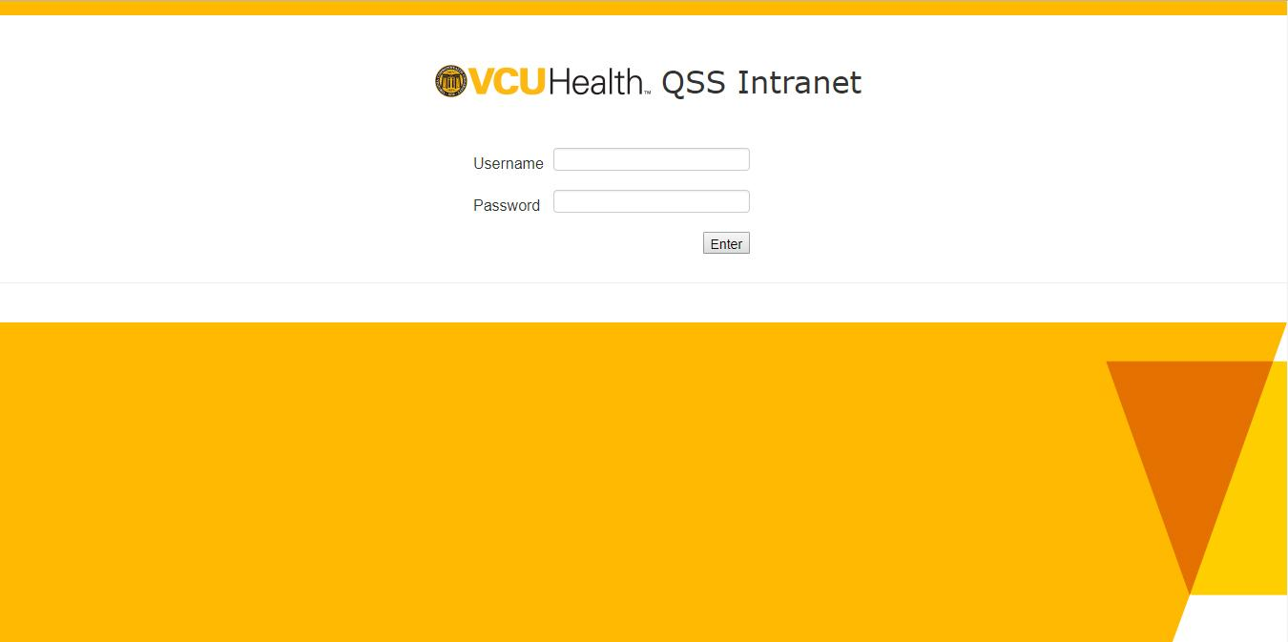

Login Page: Incorrect credentials

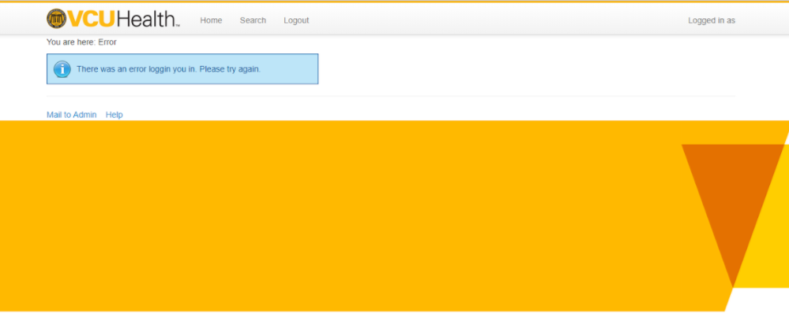

Home Page: Click on Document 1 to get the details of the document.

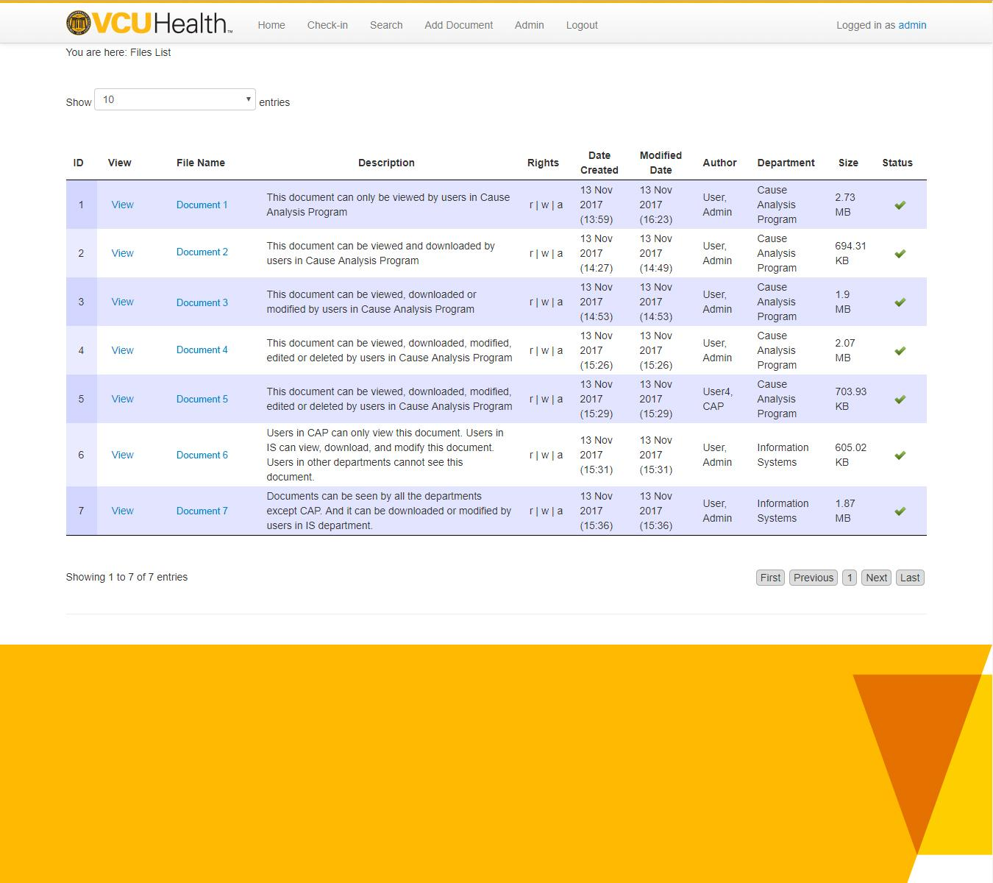

Document Details: User can either View, Check-in, edit, Delete or view the history of this document.

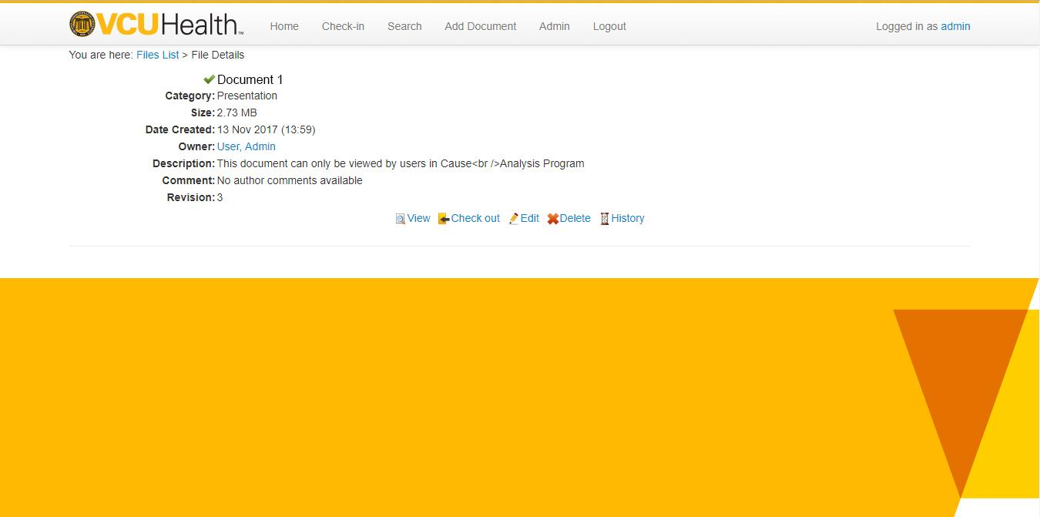

Navigation for different users:

This User can only search for a document.



This User who can check-in and search the document.

This User can check-in, search and upload a document.

Search Screen: Type in a search term and click search.

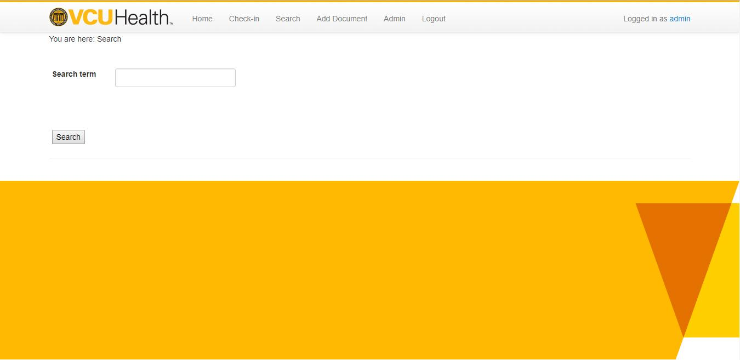

Search Screen: No results found

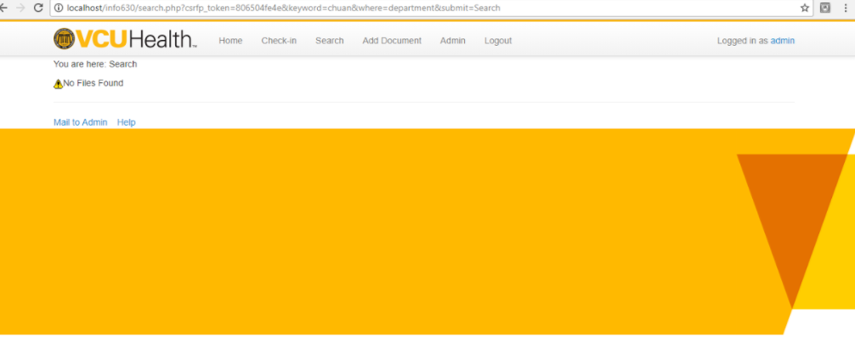

Upload Document: Click on choose files and select a document from your local drive that needs to be uploaded.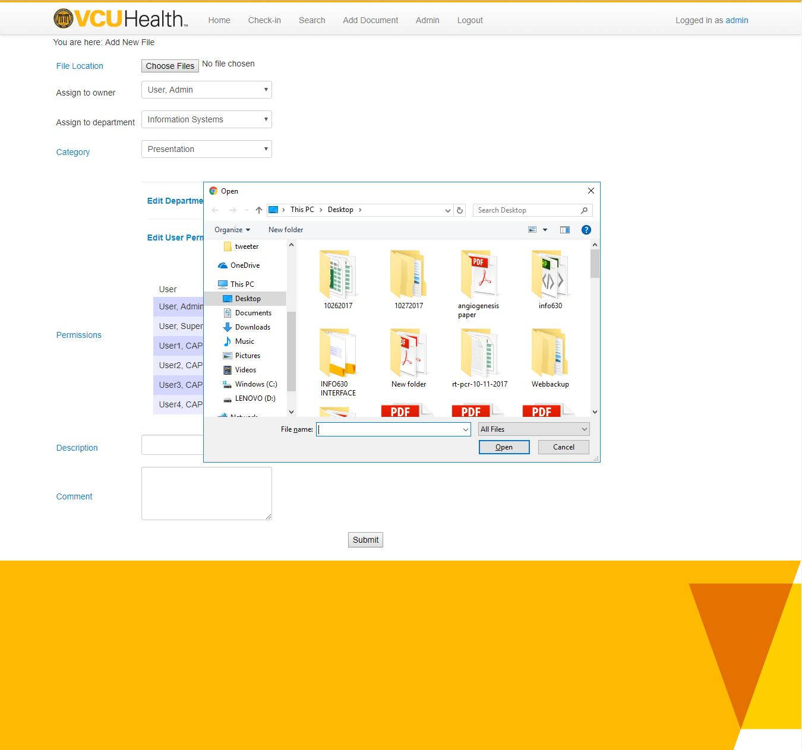

Upload Document: Assign to an owner and department. Choose the level of access to be provided for each department by clicking on **Edit Department Permissions**.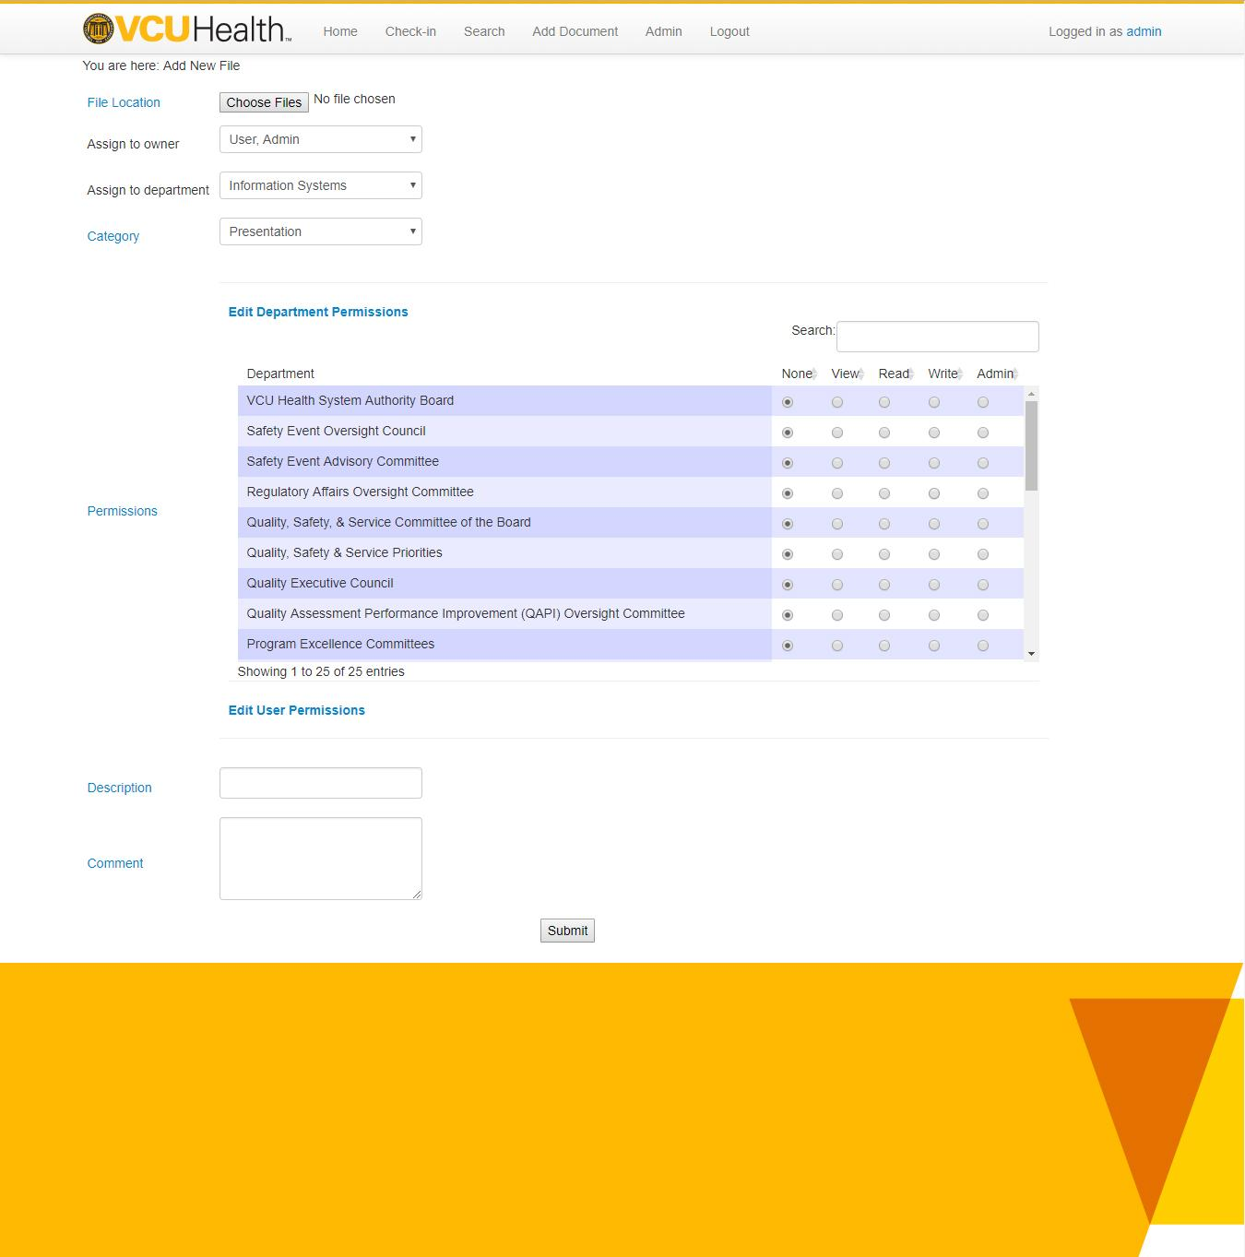

Upload Document: Choose access for use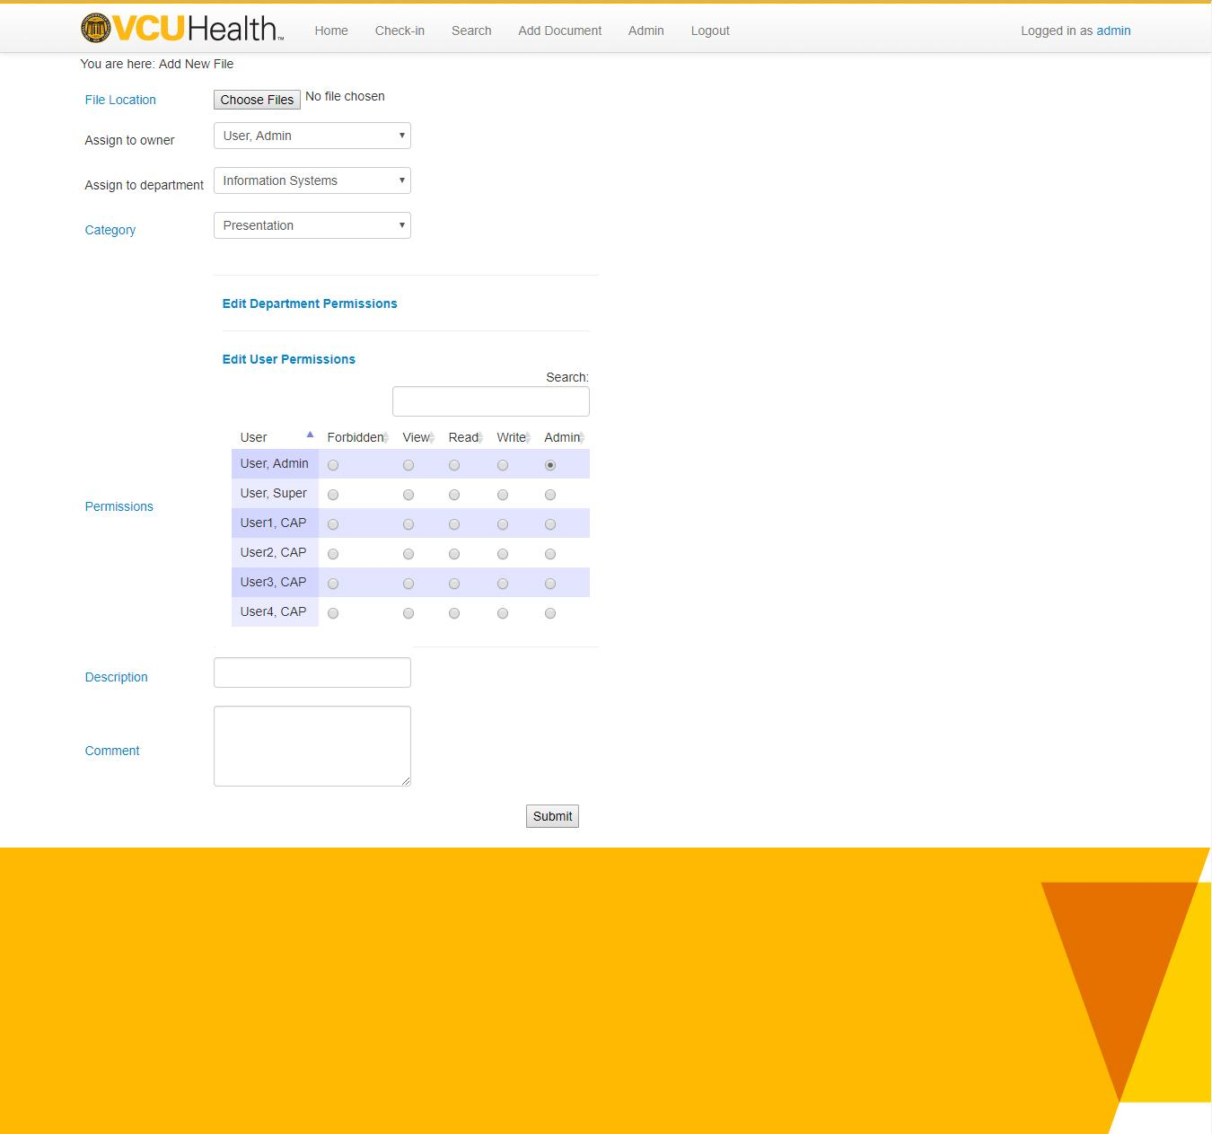

Admin Control Panel

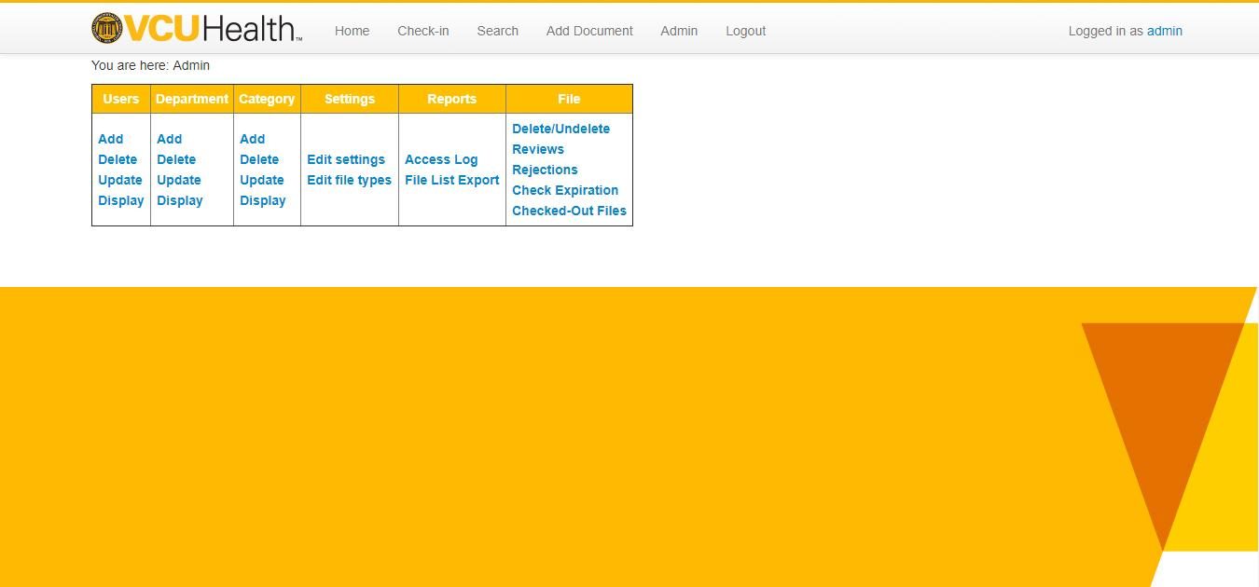

Add User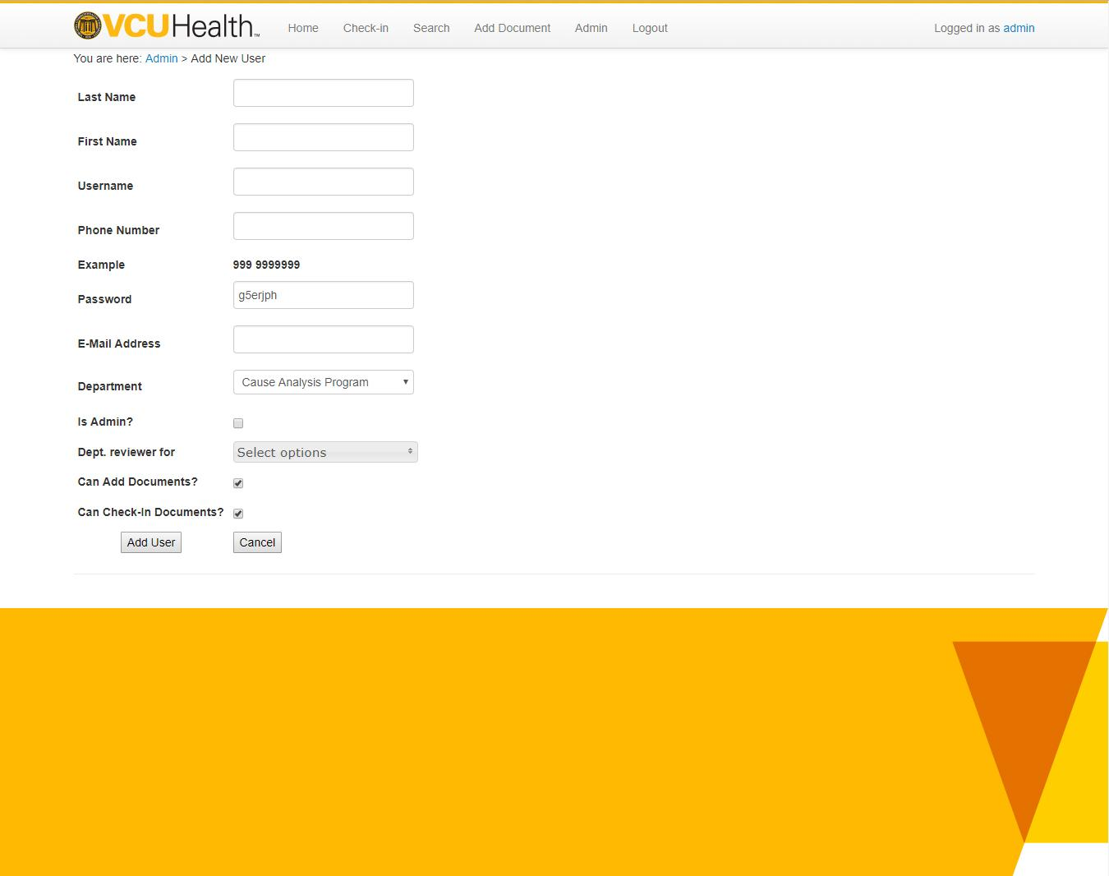

User Successfully Added

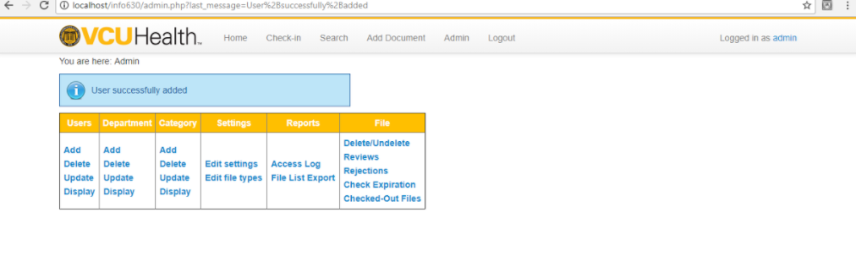

Delete User

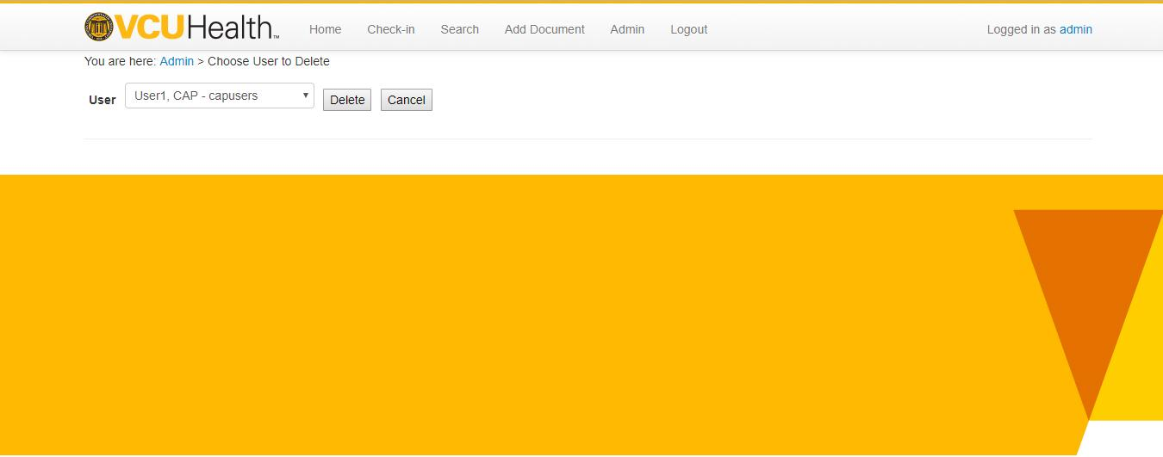

Modify User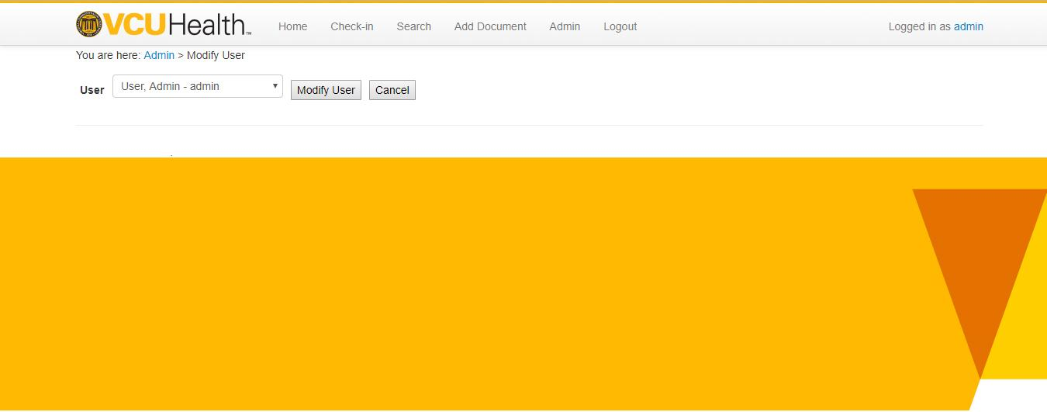

Modify User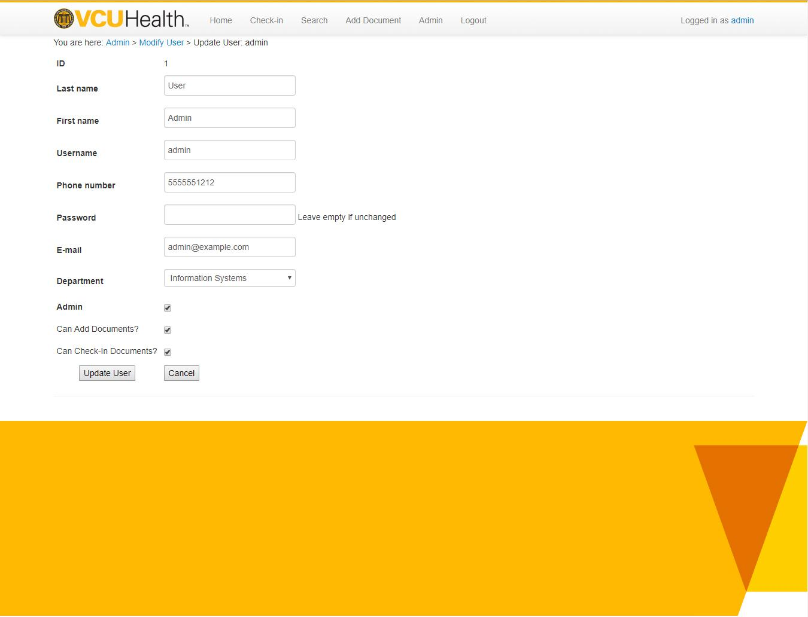

View User

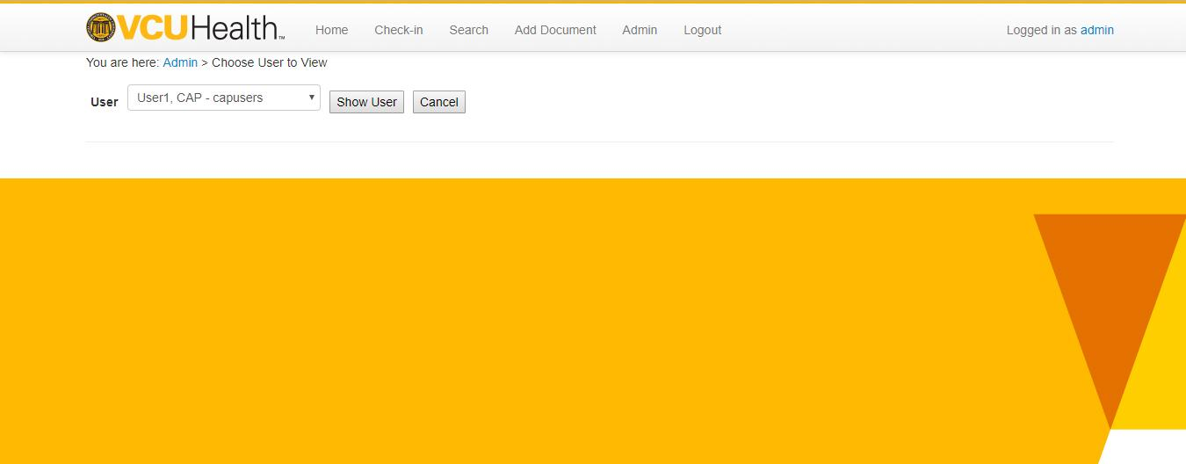

View User:

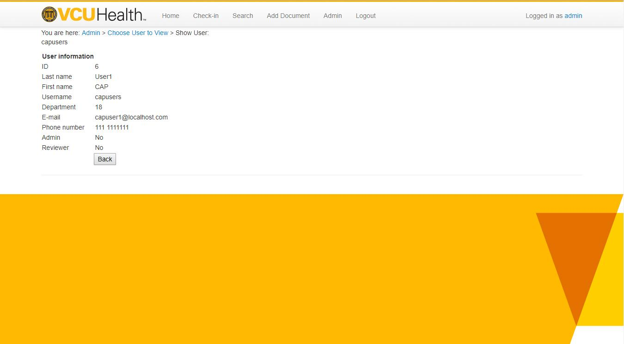

Admin Control Panel



Add Department

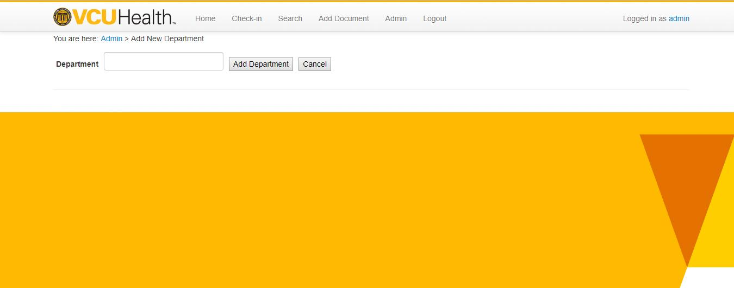

Delete Department

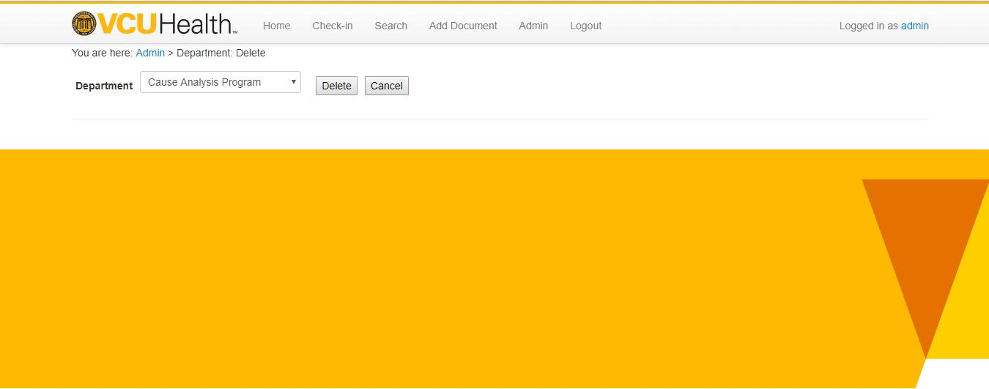

Modify Department

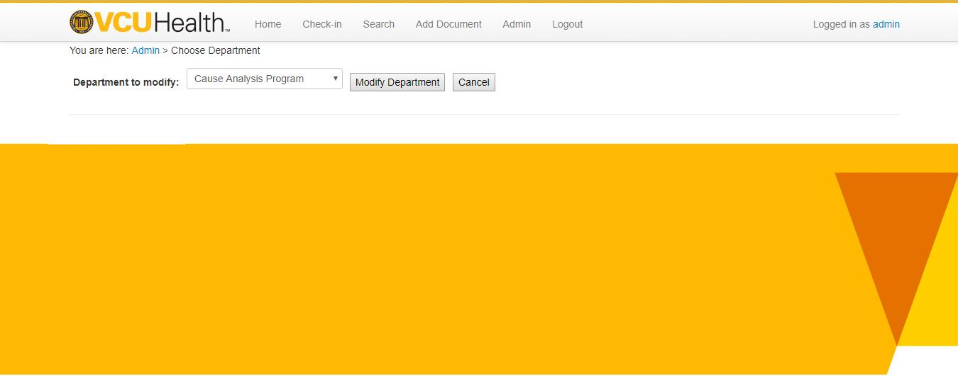

Modify Department

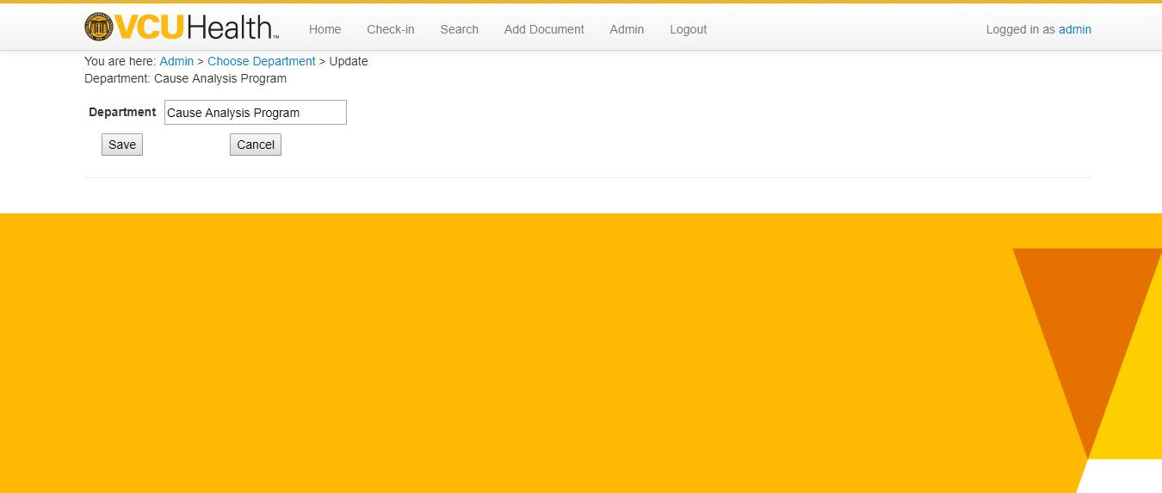

View Department

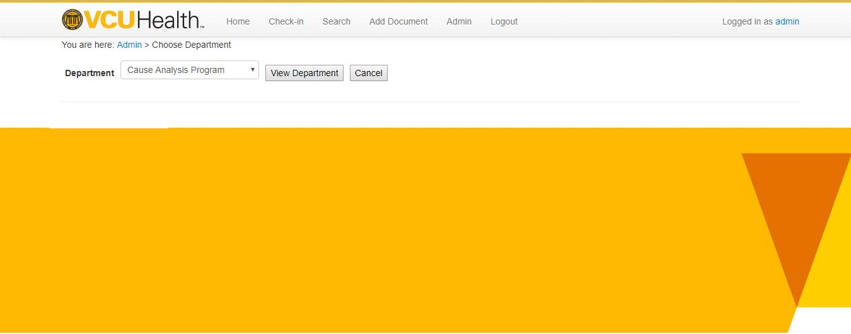

View Department

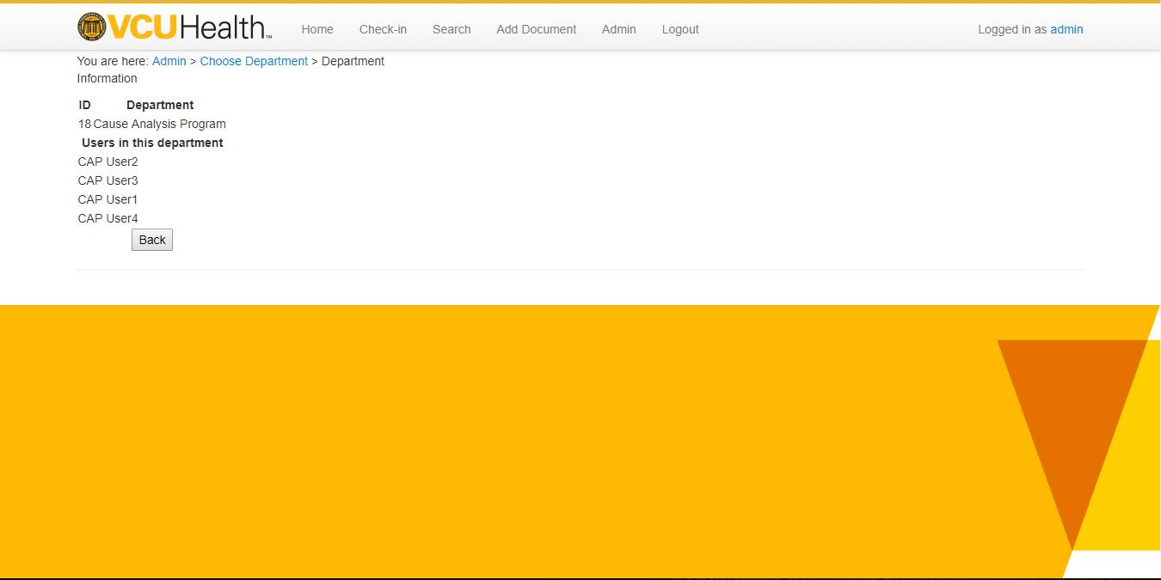

Admin Control Panel



Add category

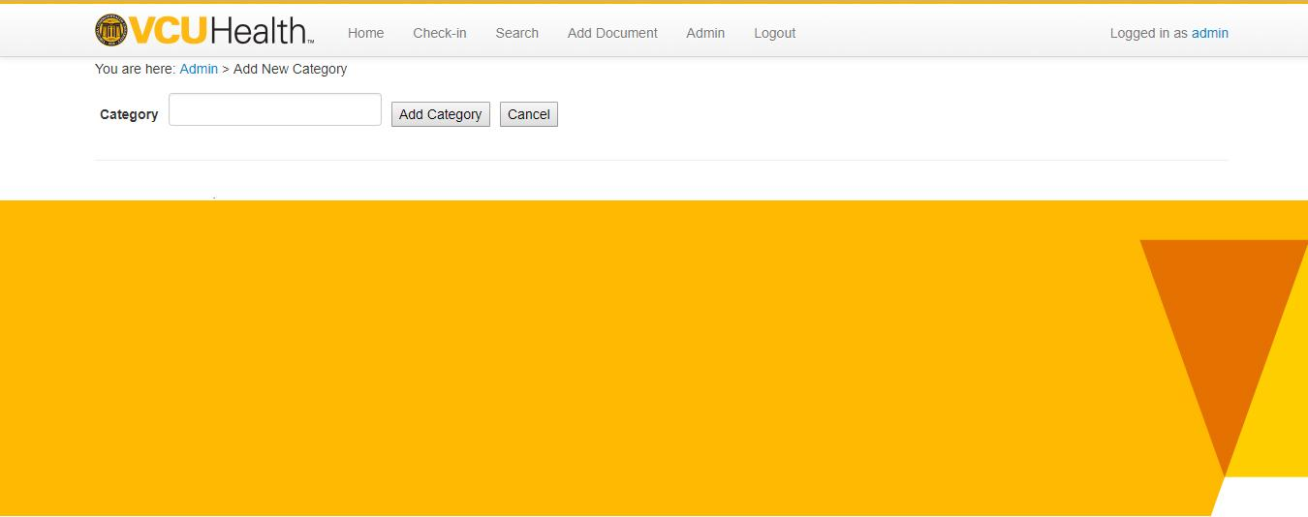

Delete category

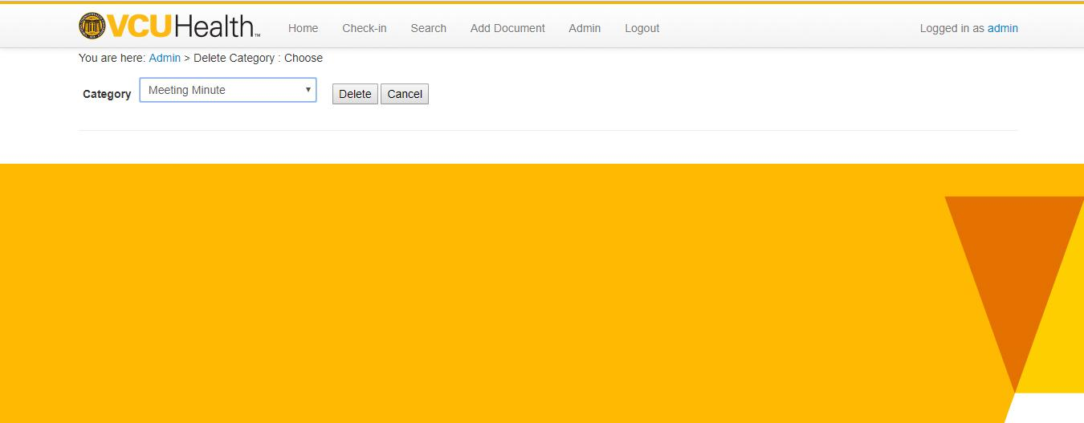

Modify category

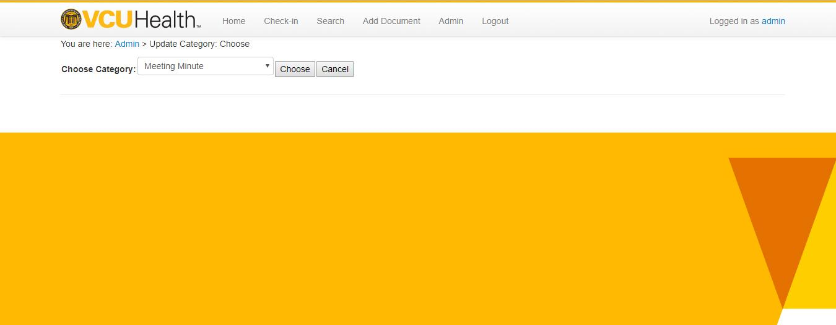

Modify category

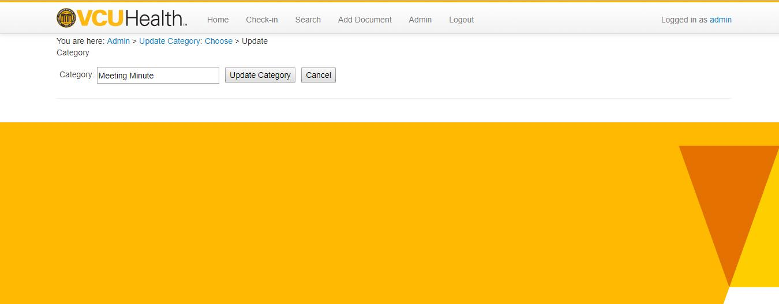

View category

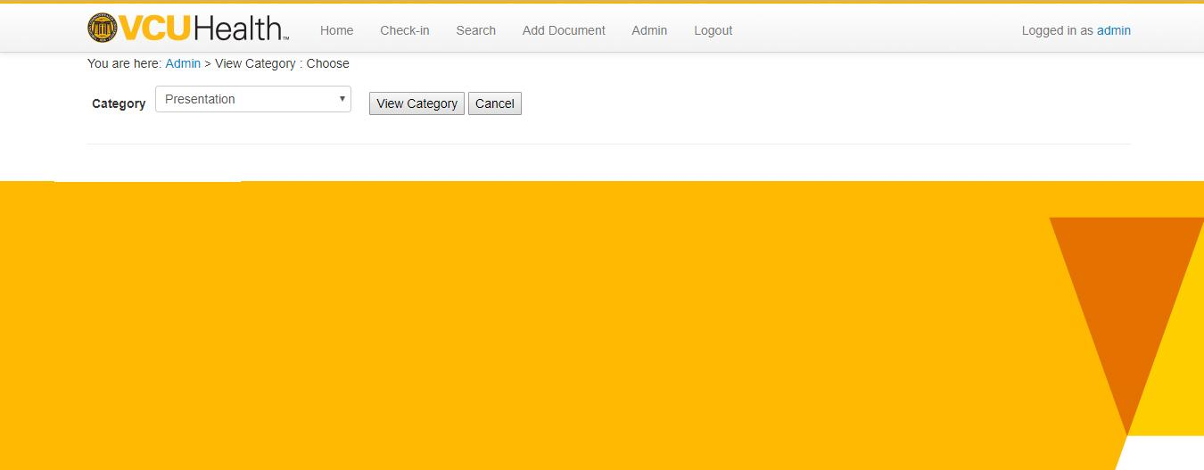

View category

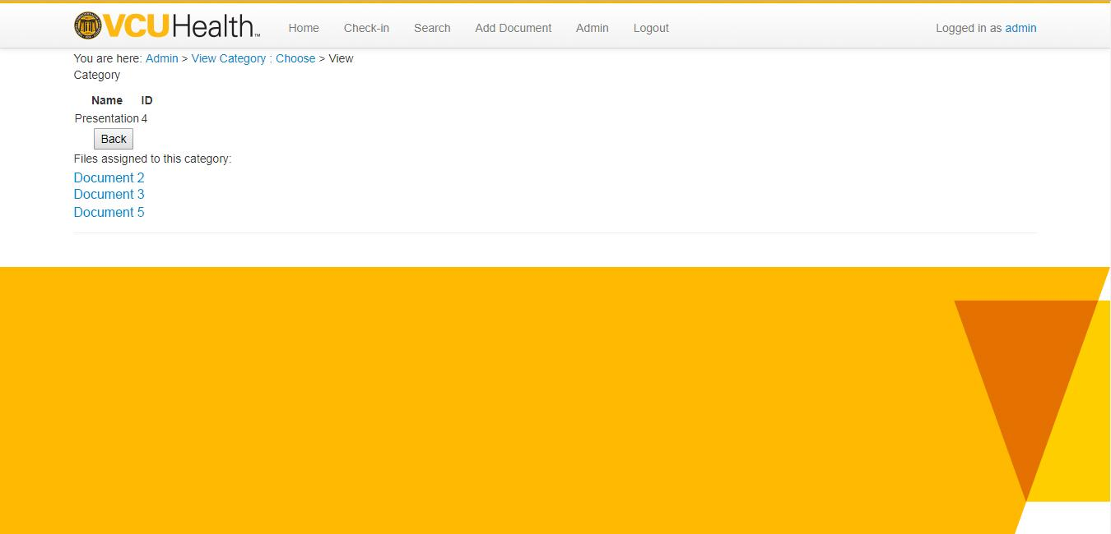

Admin Control Panel



Select File types

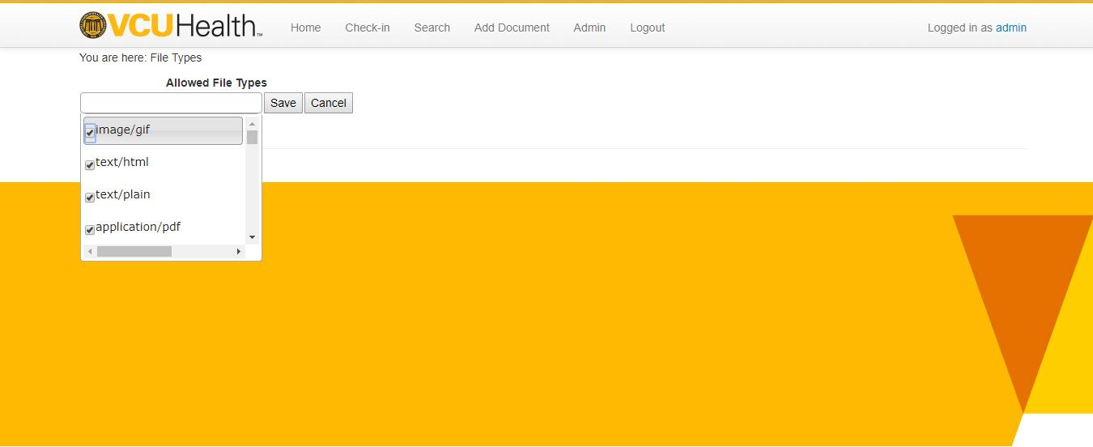

Admin Control Panel



View Access Log

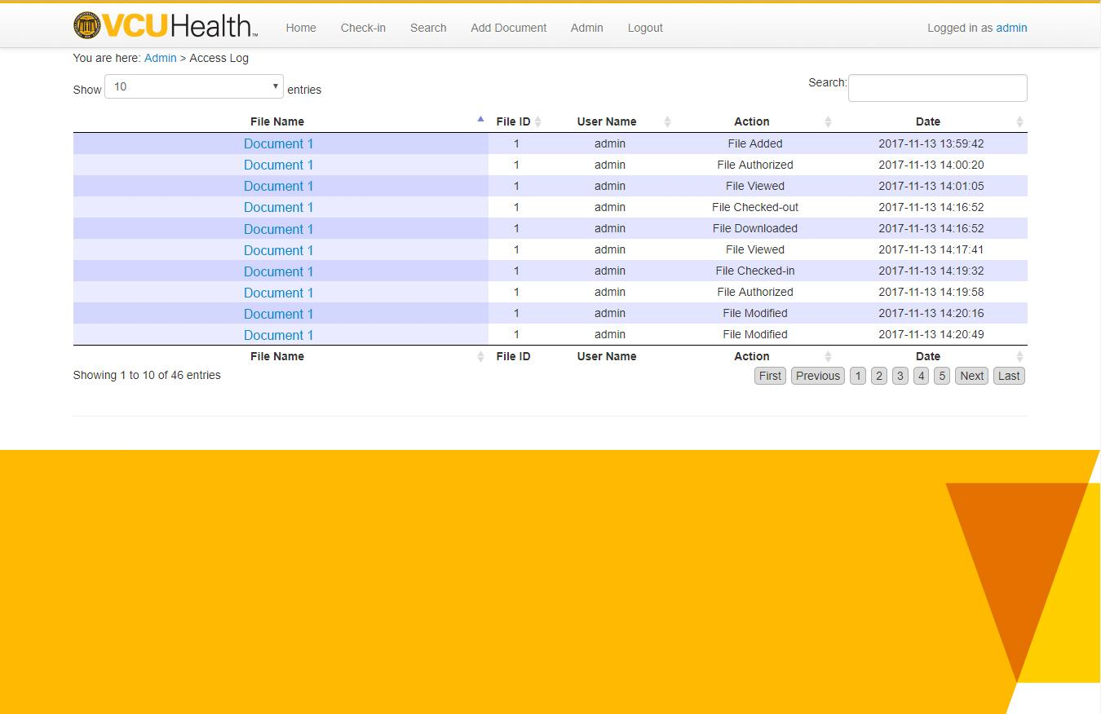

Reports: File List Export

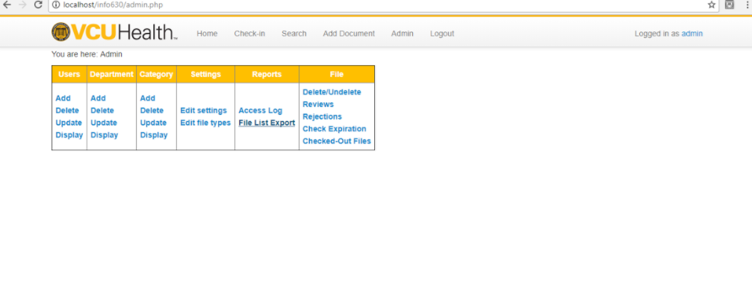

Reports: File List Export

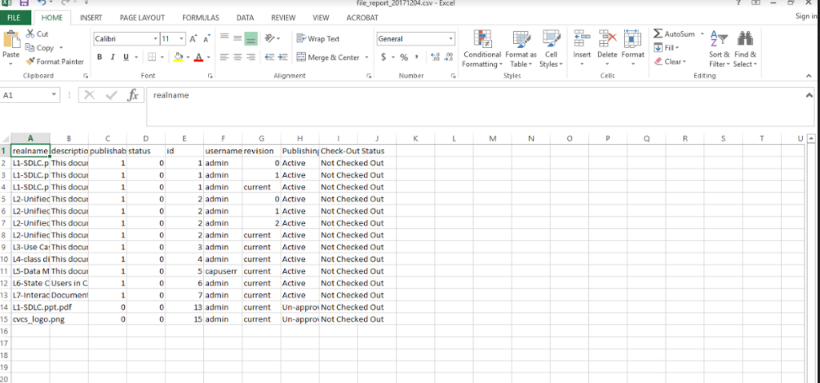

Admin Control Panel



Recycle Bin

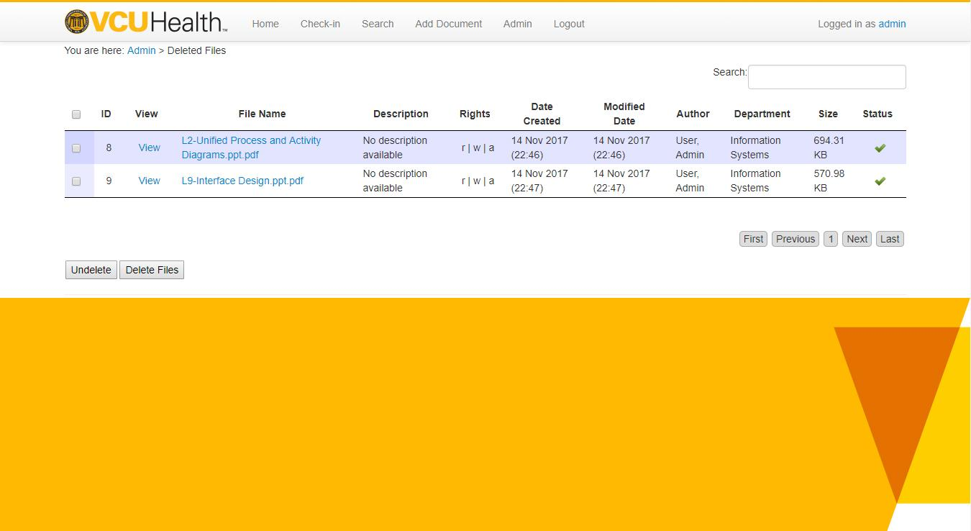

Review uploaded documents

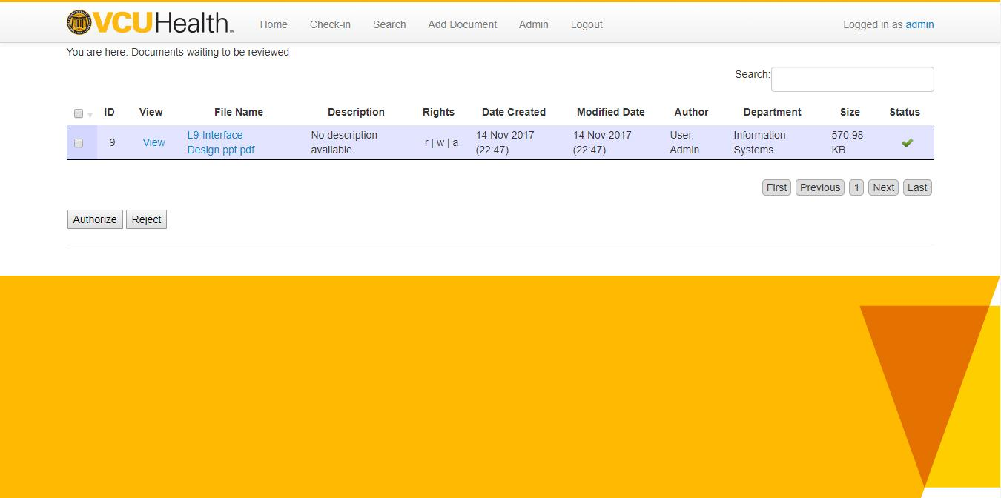

View check-out documents

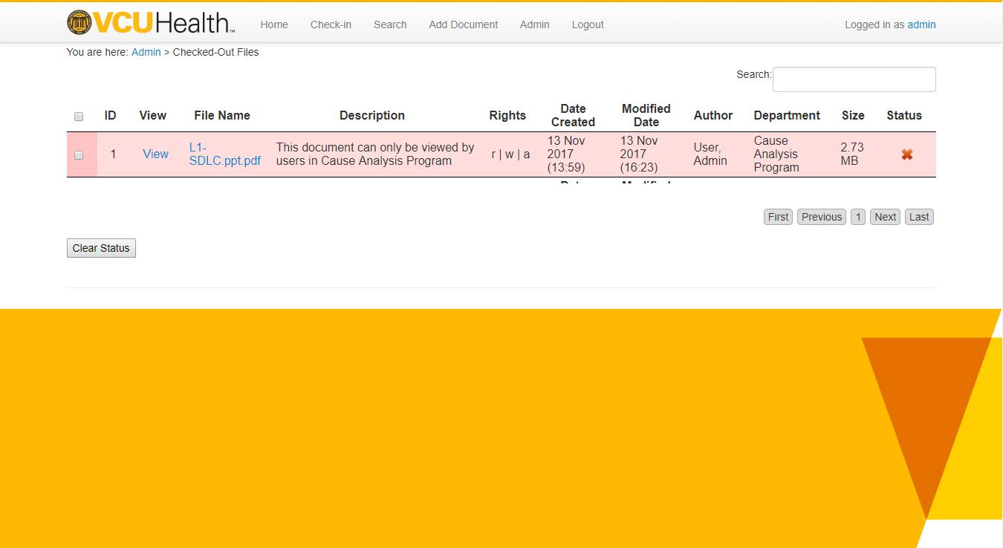

Check-out documents

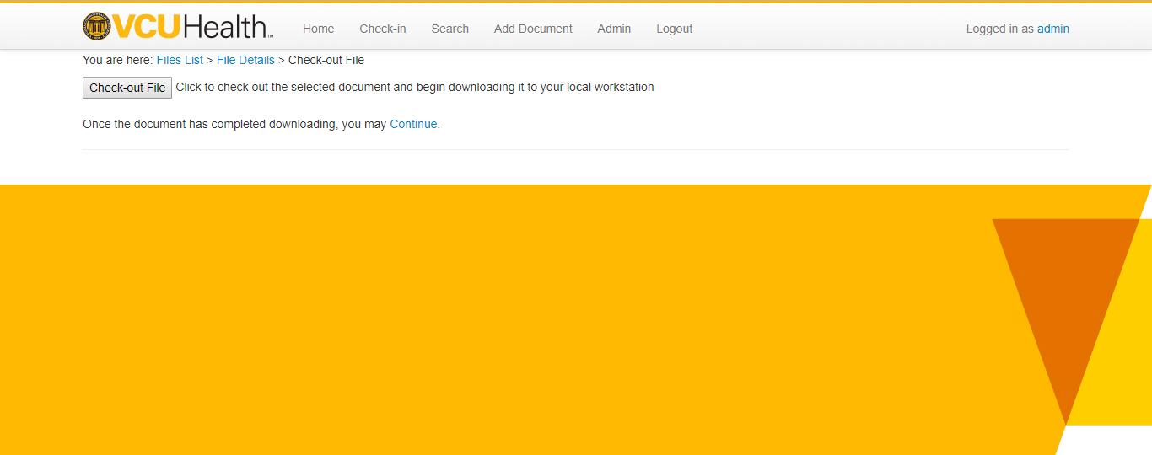

Check-in documents

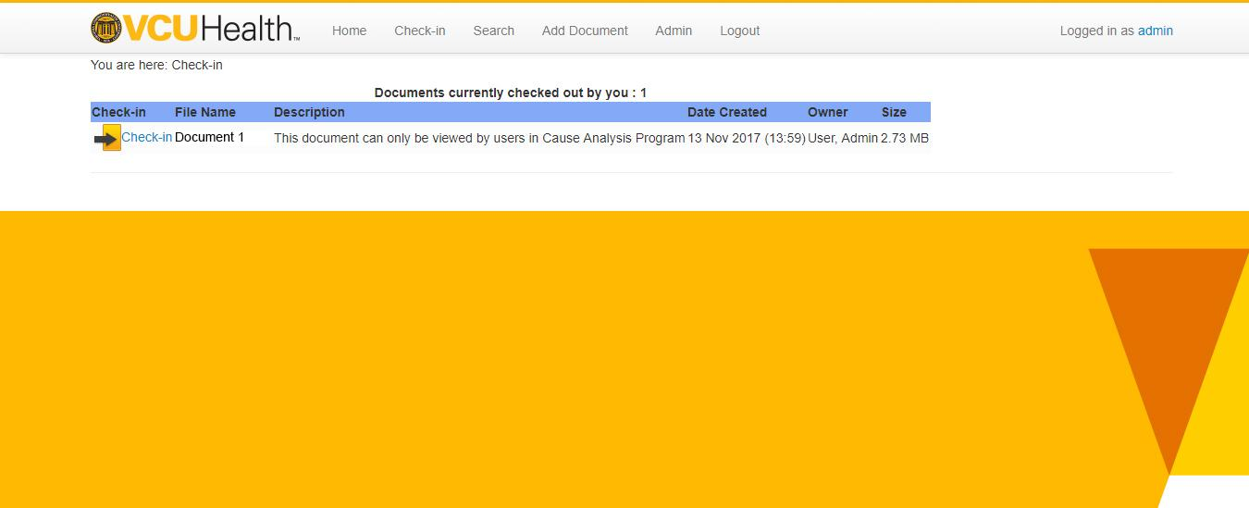

Check-in documents

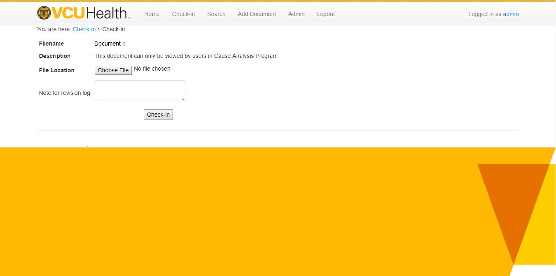

## 

## 

# Usability Testing

The webpages were demonstrated to two people who are neither current students nor employees of Virginia Commonwealth University. Our team asked them to test the usability of the webpages that have been created for Virginia Commonwealth University Health Services. The purpose of this usability testing is to understand how the real users would interact with the website and advance or improve the web page design based on their feedback and reactions. In this usability testing our team constructed a scenario where the users were asked to carry out a few tasks, which the users would be performing when the website goes live. Each user took approximately 40-45 minutes to go through all the webpages and give their feedback.

**Test Subject1**: Sukhman Virk, works full time as an Optometric Technician and preparing for her Optometry Admission test and looking forward to attending an Optometry school next year. Sukhman’s comments:

* The web pages look professional and functionally sound.
* The search option could have more parameters or filters which would make it easier for the user.
* The main page looked good and has necessary features in it.

Sukhman asked us if the server was under maintenance, would there be any prior notification about it.

**Test Subject 2**: Ali Haiderali, works as an electronics sales technician for a mobile company. Below are the comments and feedback from him.

* The web pages are closely designed to VCU website.
* The font size and type were consistent in all the pages.
* The web pages could have error or confirm messages when user commits an action.
* The web pages could have undo and redo options.
* The web pages were easy to navigate and understand.

Ali wanted more clarification on check in and check out of documents.

Based on feedback from the test subjects, we added search parameters to our web pages. The users would now be able to filter their search results which would eventually make the search easier. We have also added error and confirm messages to our web pages. For instance, if a user deletes a document, they would receive a confirmation message and once they click yes, the document would get deleted from the website.

# Conclusion

The project went through different phases and had deliverables every week. Some of the deliverables have been illustrated above. These deliverables were developed along with the prototype application, keeping in the mind the requirements given by VCUHS. This prototype is available on our local server and can be migrated onto a web host once it's approved by the committee members. Other diagrams such as, activity diagrams, state charts, project plan, sequence diagrams and interface design were construed before the final application was developed but these deliverables have not been included in this report.