WasteWise AI - Website Prototype

Intelligent Household Waste Classification using Artificial Intelligence

Home Page
The Home page is the entry point of the application. It introduces users to WasteWise AI and provides two options for classifying household waste: uploading an image or using the live camera.
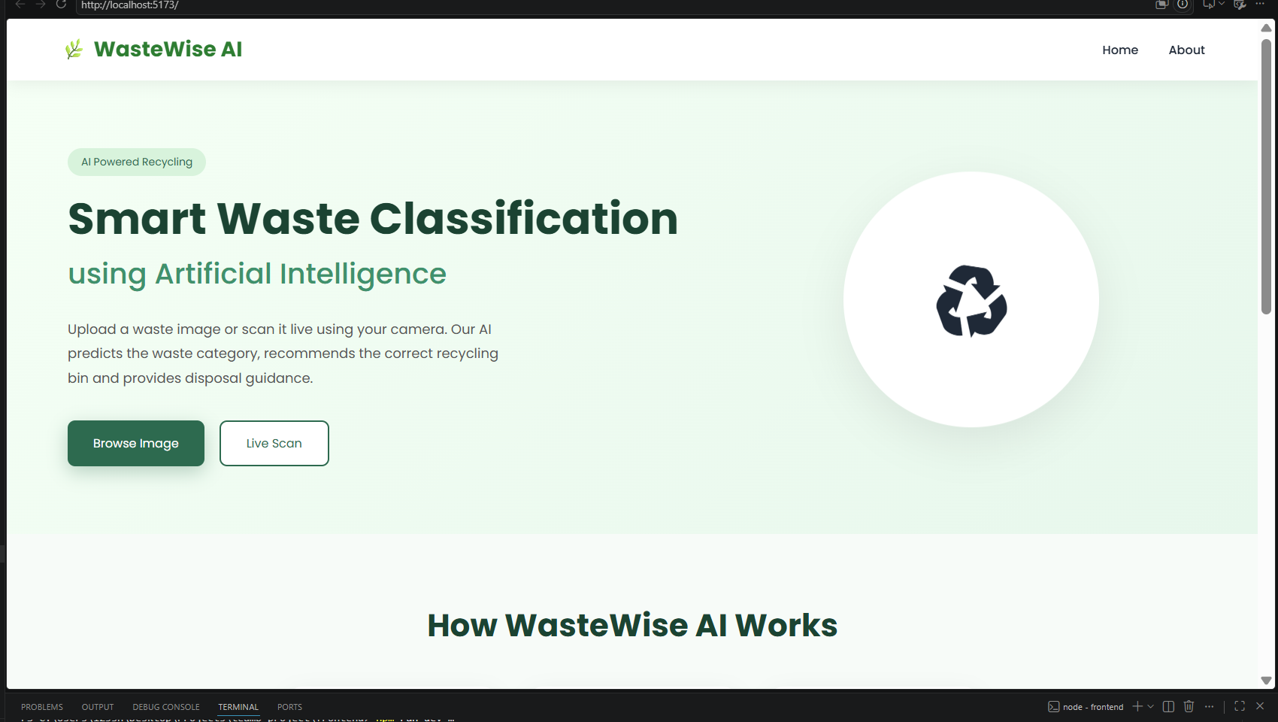

Browse Image
The Browse Image page enables users to upload an image of household waste for AI-based classification.
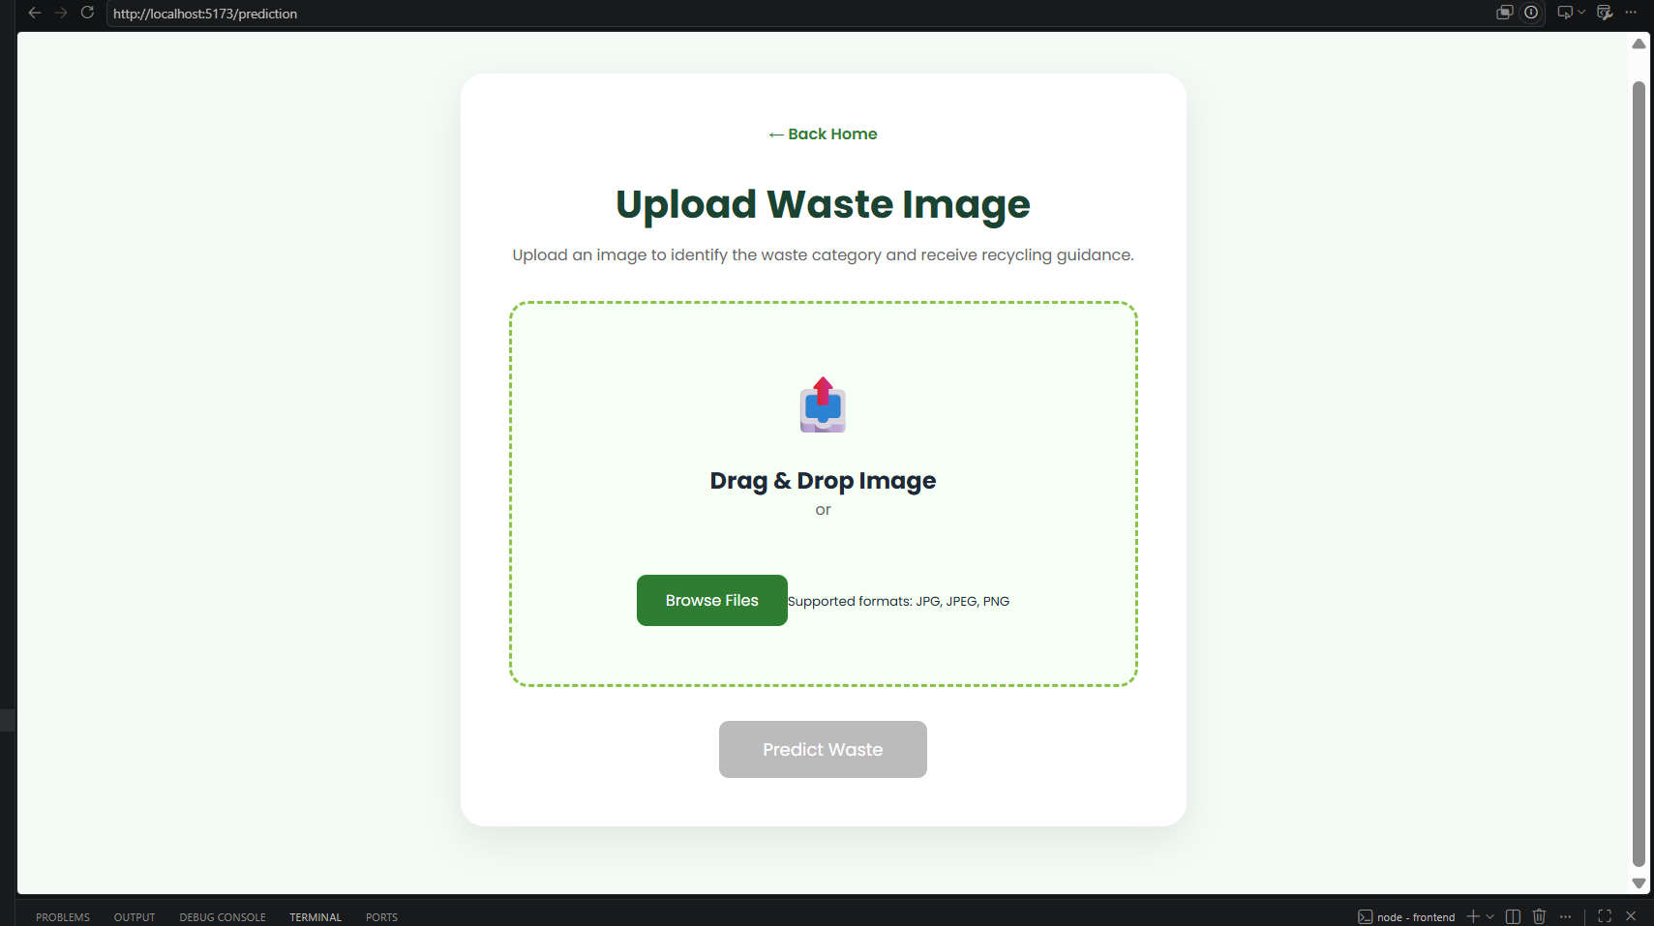

Loading Image
The Loading page provides visual feedback while the AI model analyses the uploaded image. This reassures users that the request is being processed.
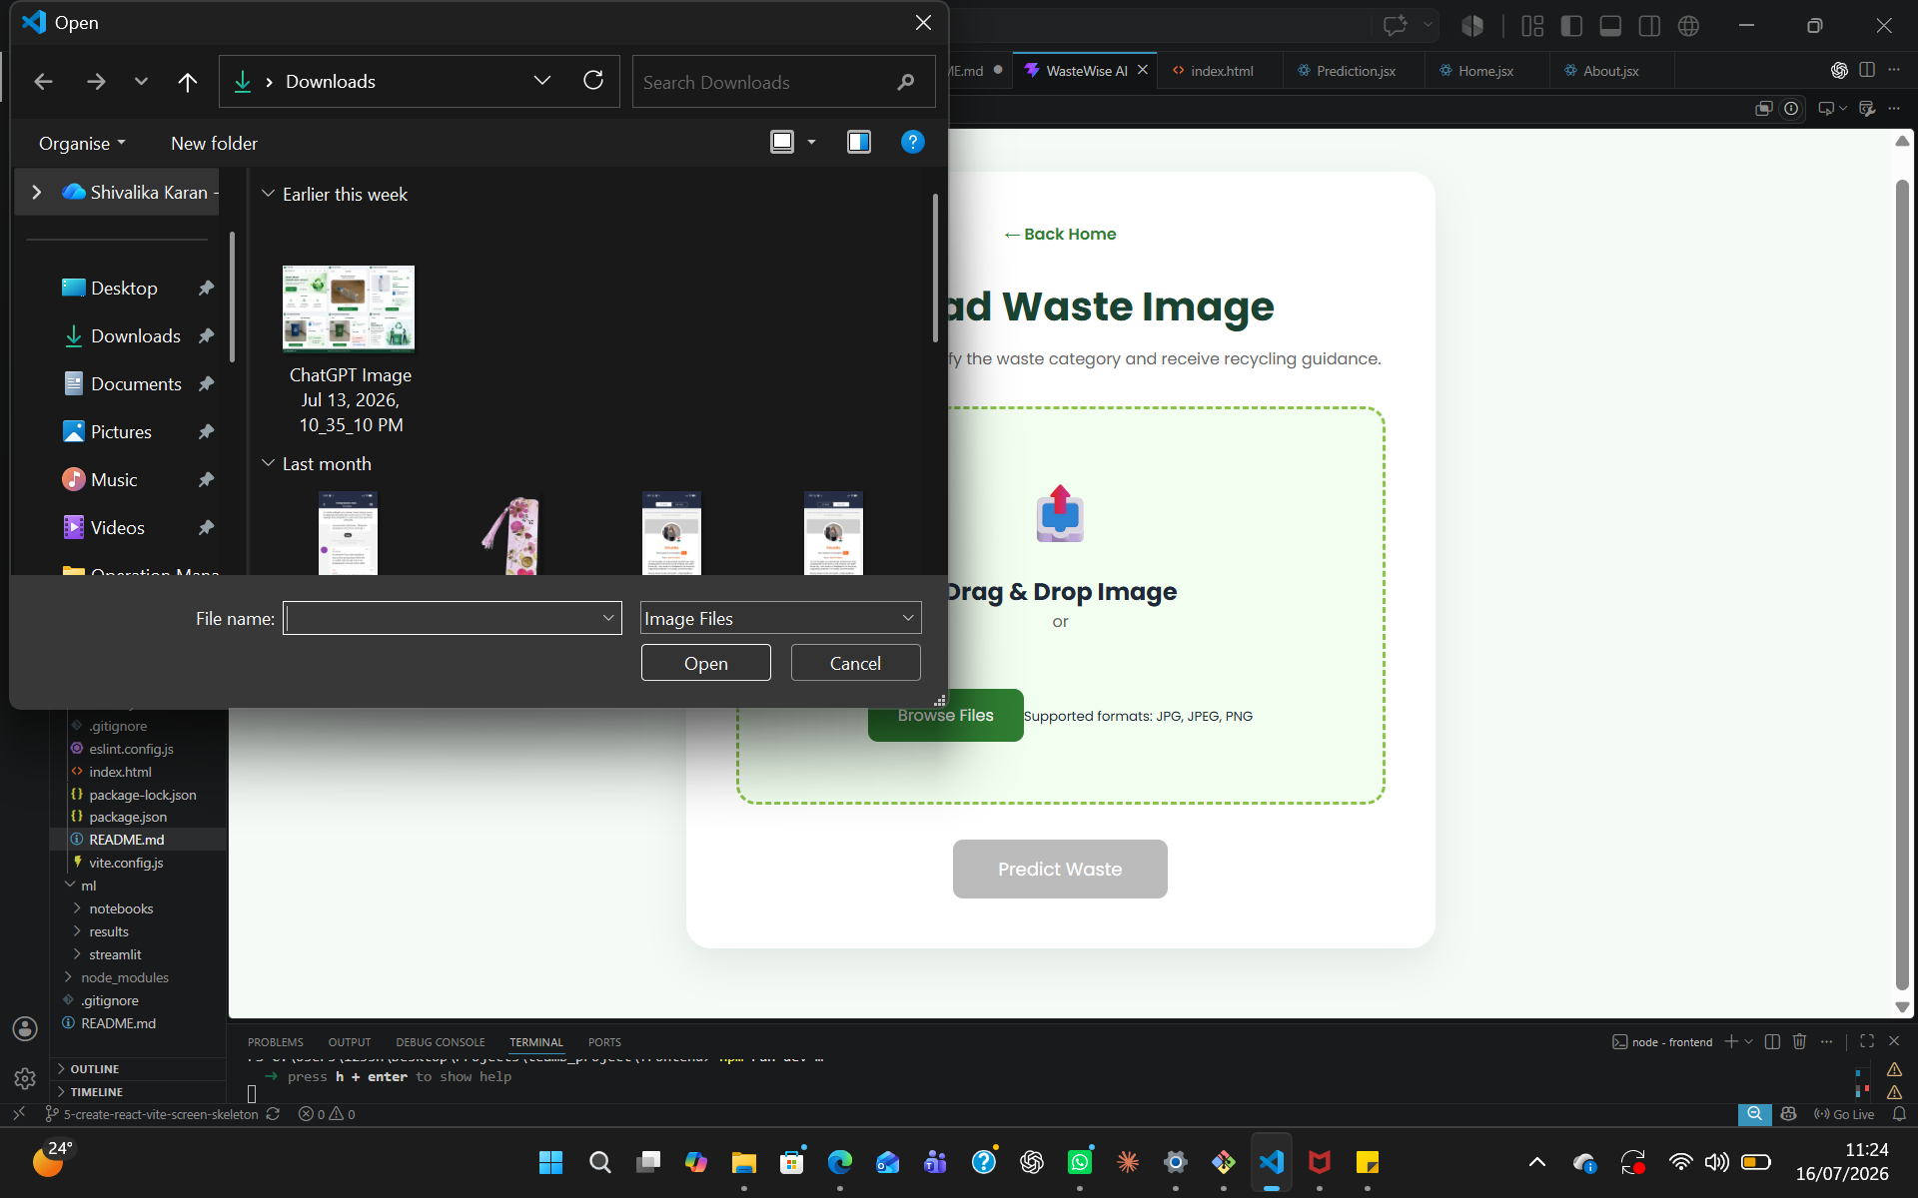

Live Camera
The Live Scan page enables users to capture waste using the device camera for real-time classification.
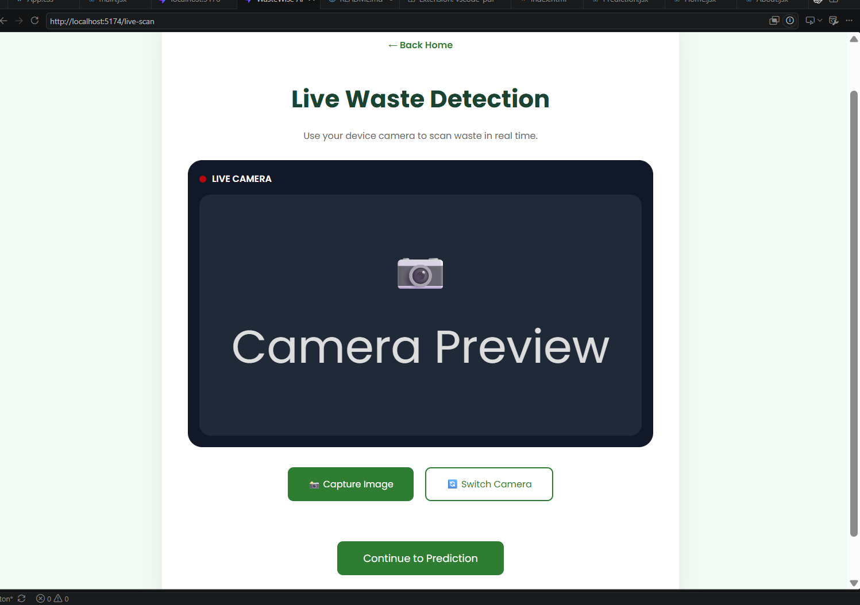

Prediction Result
The Prediction Result page displays the waste classification generated by the AI model together with recycling recommendations.

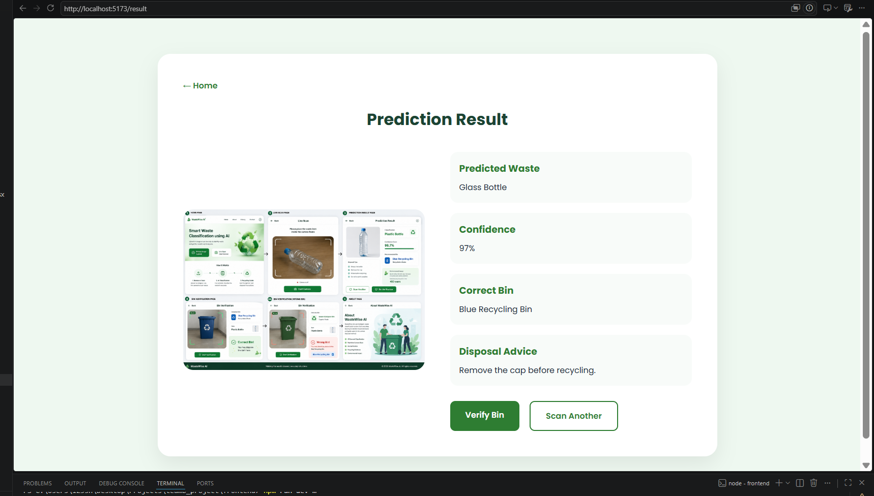

Bin Verfication
The Bin Verification page helps users confirm that they have selected the correct recycling bin after receiving the AI prediction.

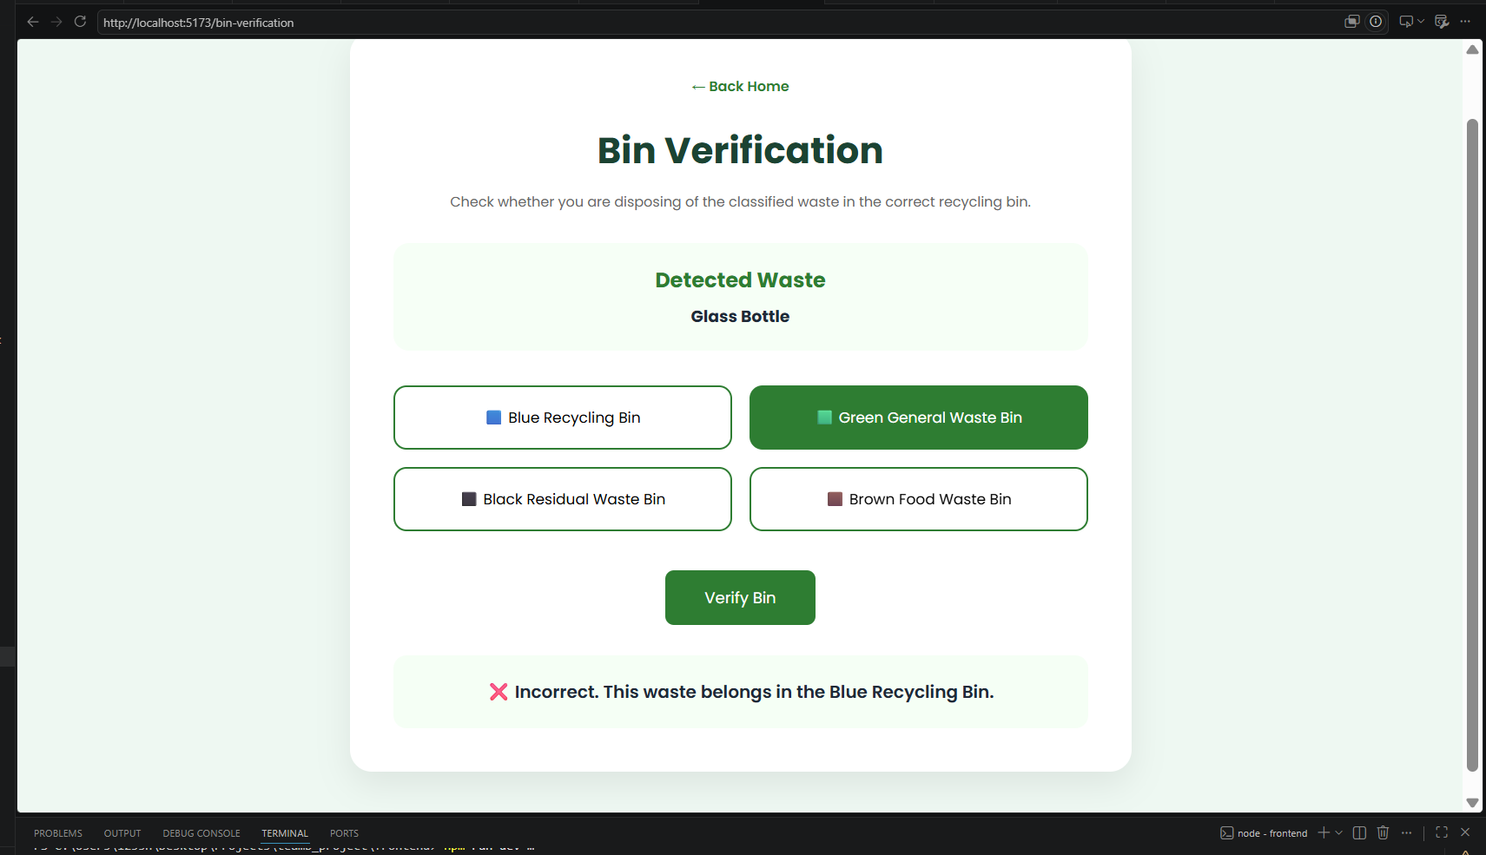

About
The About page provides users with information about the WasteWise AI project.
Information Will Include
- Project overview
- Objectives
- Technology stack
- Machine learning model
- Future improvements

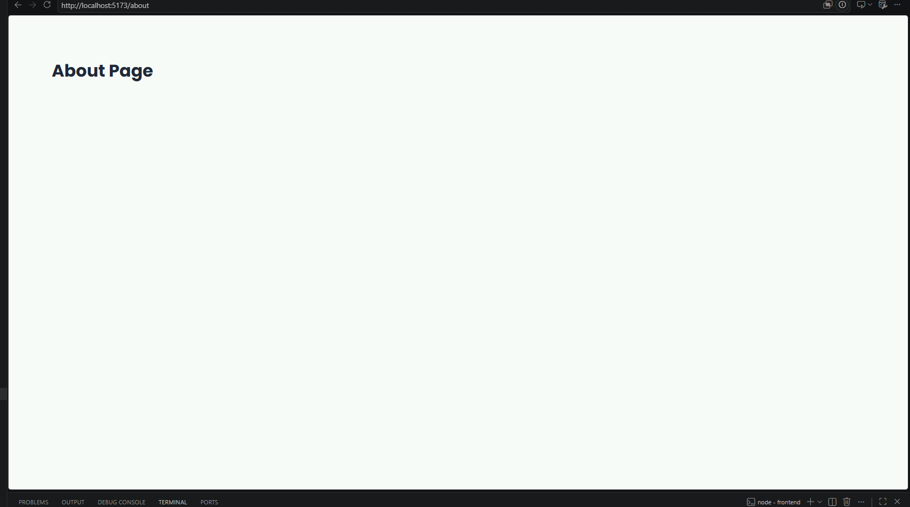

Website Flow
