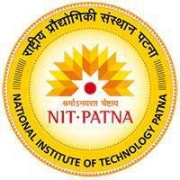SAURAV KUMAR +91-9471641481

B. Tech sauravkumarnhrt@gmail.com

ECE

National Institute of Technology (NIT) , Patna

# EDUCATION

* National Institute of Technology, Patna 2024-2028

(B. Tech) ECE

* 12th Triveni Satyabhama College , Hisua 2023

Bihar Board of Secondary Education 86.6%

* 10th Inter School , Narhat(Nawada) 2021

Bihar Board of Secondary Education 91.3%

# PERSONAL PROJECTS

* ARDUINO BASED SOLAR STREET LIGHT

A solar street light powered by Arduino is a sustainable and energy-efficient solution for outdoor lighting. It consists of a solar panel, rechargeable battery, and LED bulb. The system is controlled by an Arduino microcontroller.

* SOLIDITY LOTTERY SMART CONTRACT

Developed a basic decentralized lottery smart contract using Solidity. Implemented participant entry via Ether transfer, manager-controlled winner selection using pseudo-randomness based on block data, and automated prize distribution.

# TECHNICAL SKILLS AND INTERESTS

Programming Language: C, C++, Video Editing

Soft Skills: Problem solving, Leadership, Team work

Languages known: Hindi, English

Interests: Badminton, Coding,

# ACHIEVEMENTS

* I have secured a seat in an institute of national importance, NIT-PATNA.
* I have secured 5th rank in 10th in allover District.