Assignment 1 (Linux commands)
Q.1)
- mkdir
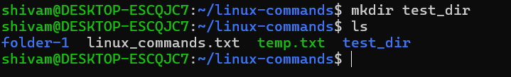
Use: mkdir command use to create a directory or folder.
- touch
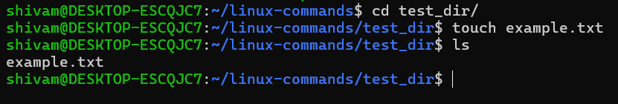
Use: touch command is used for create an empty text file.
- mv
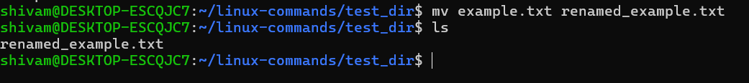
Use: mv is used to renaming or move a file, here it is used for renaming a text file.
Q.2)
1. cat
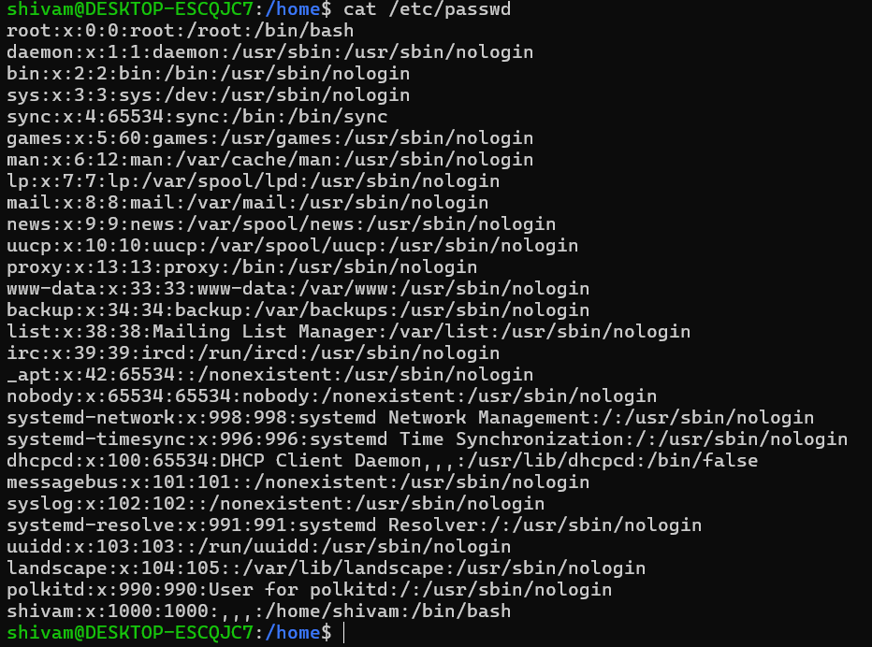
Use: cat command is used to display content of a file.
2. head
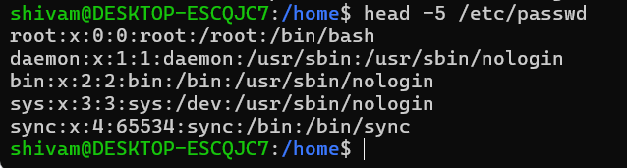
Use: head is used to print first few lines (shows first 10 lines), but here want to print only first 5 lines, so used (head -5) command.
3.tail
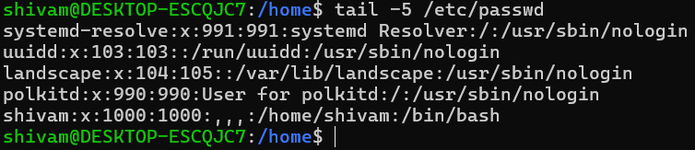
Use: tail is used to display last few lines (shows last 10 lines), but here want to print only last 5 lines, so used (tail -5) command.
Q.3)
grep
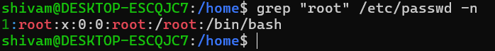
Use: grep used to find any string from a file.
Q.4)
1. zip
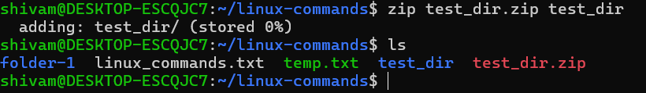
Use: zip used to compress any folder.
2. unzip
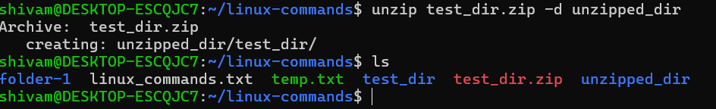
Use: unzip used to decompress or unzip any folder.
Q.5)
1.wget
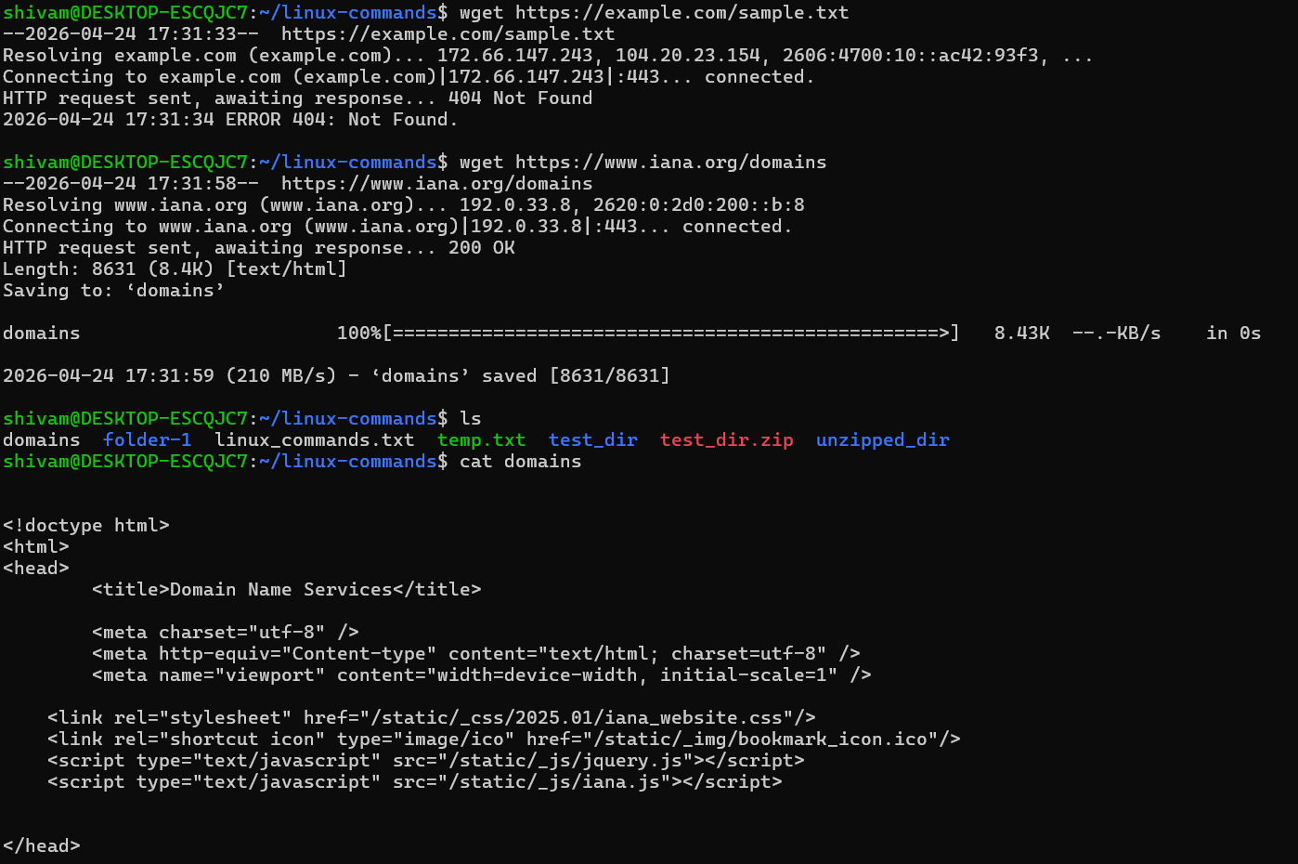
Use: wget used to download a file from URL, the given URL showing error so downloaded another file.
Q.6)
1. chmod
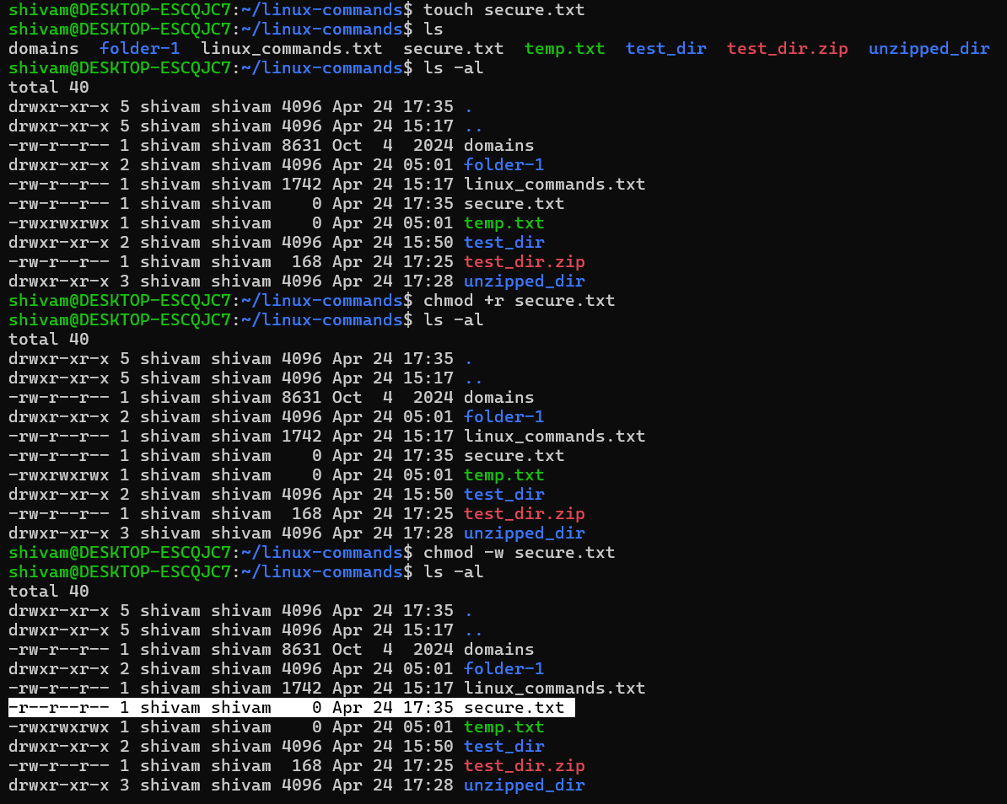
Use: chmod used to change the permission of a file.
Q.7)
1. export
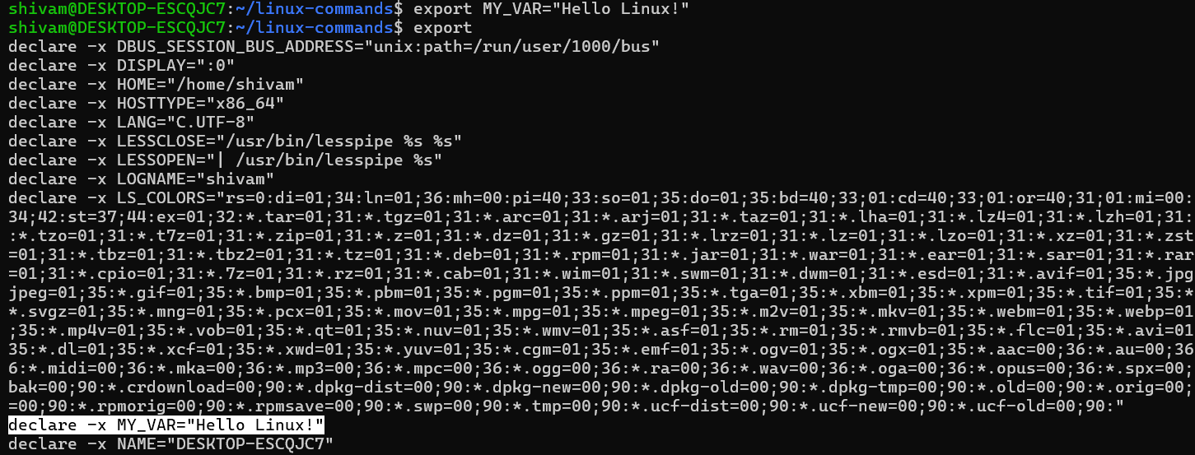
Use: export used to set a new environment variable.

