Experiment 1.1: Library Management System using SQL

AIM
To design and implement a Library Management System database using SQL with appropriate tables, constraints, and relationships, and to perform DDL, DML, and DCL operations for secure database management.

SOFTWARE REQUIREMENTS
MySQL, SQL Server.

OBJECTIVE
- To understand database creation and table design
- To implement primary keys, foreign keys, and constraints
- To perform insert, select, and delete operations
- To create database users and manage privileges using GRANT and REVOKE

PRACTICAL / EXPERIMENT STEPS
1. Create and select the database
2. Create required tables with constraints
3. Insert records into tables
4. Retrieve data using SELECT queries
5. Create a database user
6. Grant and revoke privileges
7. Verify database operations

PROCEDURE OF THE PRACTICAL
i. Start the system and open MySQL
ii. Create and use the database
iii. Write SQL commands for table creation
iv. Insert sample records
v. Execute queries to view data
vi. Create a database user
vii. Grant and revoke privileges
viii. Verify the results

SQL PROGRAM
USE library_db;
DROP TABLE IF EXISTS BOOK_ISSUE;
DROP TABLE IF EXISTS LIBRARY_VISITORS;
DROP TABLE IF EXISTS BOOK_S;
CREATE TABLE BOOK_S (
BOOK_ID INT PRIMARY KEY,
BOOK_NAME VARCHAR(20) NOT NULL,
AUTHOR_NAME VARCHAR(20) NOT NULL,
BOOK_COUNT INT NOT NULL CHECK (BOOK_COUNT > 0)
);
INSERT INTO BOOK_S VALUES
(101, 'HARRY POTTER', 'DAVID', 3);
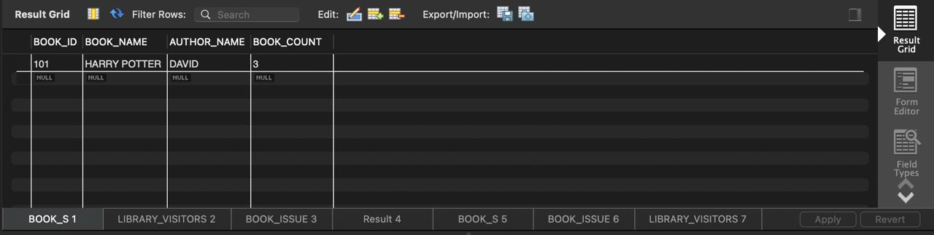
CREATE TABLE LIBRARY_VISITORS (
USER_ID INT PRIMARY KEY,
NAME VARCHAR(20) NOT NULL,
AGE INT NOT NULL CHECK (AGE >= 17),
EMAIL VARCHAR(50) NOT NULL UNIQUE
);
INSERT INTO LIBRARY_VISITORS VALUES
(501, 'VANSH SHARMA', 18, 'vansh08@gmail.com'),
(502, 'VANI', 19, 'vani08@gmail.com');
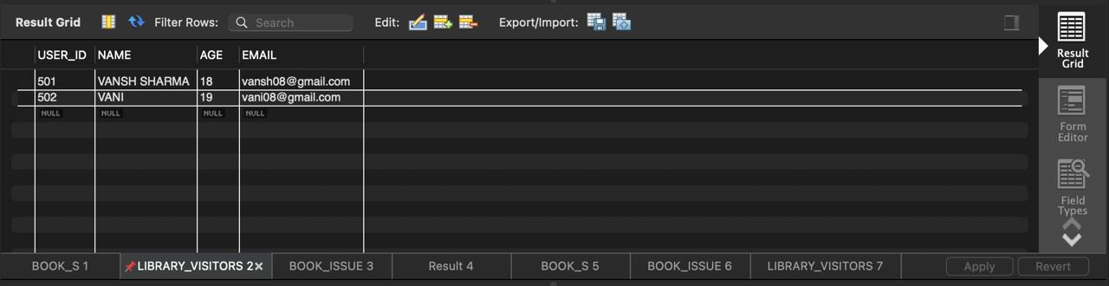
CREATE TABLE BOOK_ISSUE (
BOOK_ISSUE_ID INT PRIMARY KEY,
USER_ID INT NOT NULL,
BOOK_ID INT NOT NULL,
ISSUE_DATE DATE,
FOREIGN KEY (USER_ID) REFERENCES LIBRARY_VISITORS(USER_ID),
FOREIGN KEY (BOOK_ID) REFERENCES BOOK_S(BOOK_ID)
);
INSERT INTO BOOK_ISSUE VALUES
(1001, 501, 101, '2026-01-08');
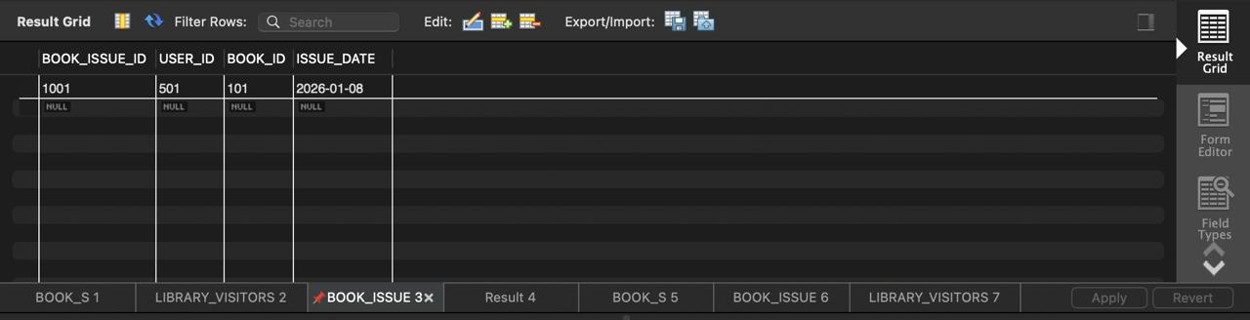
CREATE USER IF NOT EXISTS 'LIBRARIAN'@'localhost'
IDENTIFIED BY 'ShivamDBMS3819';
GRANT SELECT, INSERT, UPDATE, DELETE
ON library_db.BOOK_S TO 'LIBRARIAN'@'localhost';
GRANT SELECT, INSERT, UPDATE, DELETE
ON library_db.BOOK_ISSUE TO 'LIBRARIAN'@'localhost';
GRANT SELECT, INSERT, UPDATE, DELETE
ON library_db.LIBRARY_VISITORS TO 'LIBRARIAN'@'localhost';
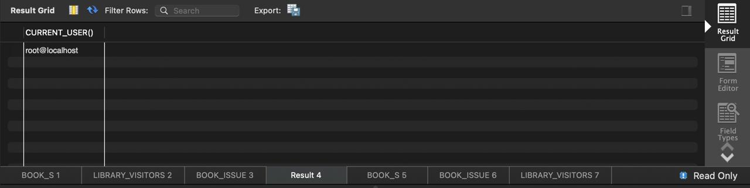
REVOKE SELECT, INSERT, UPDATE, DELETE
ON library_db.BOOK_S FROM 'LIBRARIAN'@'localhost';
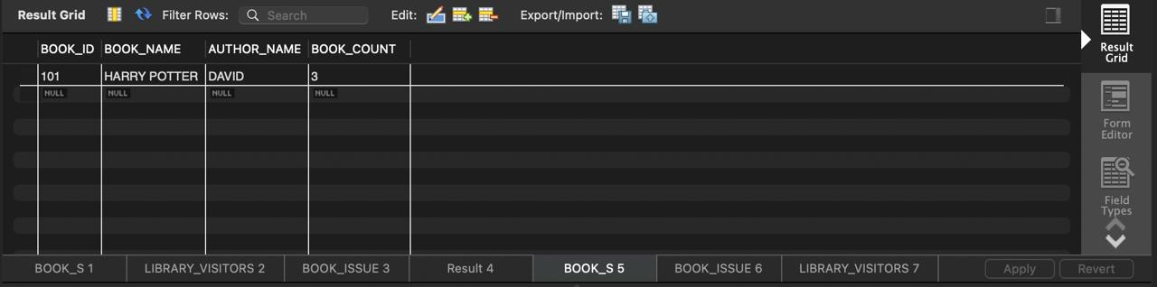
REVOKE SELECT, INSERT, UPDATE, DELETE
ON library_db.BOOK_ISSUE FROM 'LIBRARIAN'@'localhost';
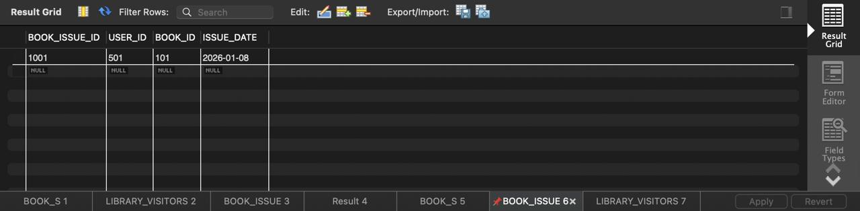
REVOKE SELECT, INSERT, UPDATE, DELETE
ON library_db.LIBRARY_VISITORS FROM 'LIBRARIAN'@'localhost';
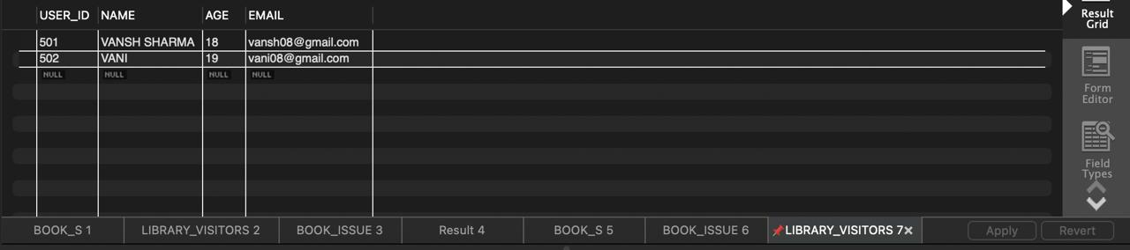
DROP TABLE BOOK_ISSUE;

1.2(Experiment):
INSERT INTO books (id, name, author_name, count)
VALUES (3, 'The Philosopher's Stone', 'J.K. Rowling', 5);
SELECT
table_name,
privilege_type
FROM
information_schema.table_privileges
WHERE
grantee = 'librarian';

INPUT / OUTPUT ANALYSIS
Input: SQL commands for creating tables, inserting records, and managing users.
Output: Successfully created tables, inserted records, and managed user privileges.

LEARNING OUTCOME
Through this experiment, students learned:
- Database schema design
- Use of constraints and relationships
- Execution of DDL, DML, and DCL commands
- Role-based access control in databases

