Experiment: SQL Aggregate Functions and GROUP BY Clause

Aim of the Session
To study and implement SQL aggregate functions along with GROUP BY, HAVING, and ORDER BY clauses to analyse student data city-wise.

Objectives of the Session
- To create and populate a Students table in SQL.
- To use aggregate functions like COUNT, AVG, MIN, MAX, and SUM.
- To group records using the GROUP BY clause.
- To filter grouped data using the HAVING clause.
- To sort aggregated results using the ORDER BY clause.

Practical / Experiment Steps
1. Create the Students table with appropriate fields.
2. Insert sample student records into the table.
3. Count the number of students in each city.
4. Sort cities based on the number of students.
5. Find cities having at least three students.
6. Calculate the average marks of students city-wise.
7. Use other aggregate functions like SUM, MIN, and MAX.

Procedure of the Experiment
1. Start the system and open the SQL environment.
2. Create the Students table using the CREATE TABLE command.
3. Insert records using INSERT INTO statements.
4. Execute SELECT queries using GROUP BY and aggregate functions.
5. Apply the HAVING clause for filtering grouped data.
6. Sort results using the ORDER BY clause.
7. Verify the output after execution.
8. Save the results.

SQL Queries Used(Input/Output)
CREATE TABLE Students (
id NUMERIC PRIMARY KEY,
name VARCHAR(50),
city VARCHAR(30),
marks NUMERIC(10,0)
);
INSERT INTO Students VALUES (1, 'Shivam', ‘Ludhiana', 85);
INSERT INTO Students VALUES (2, 'Jaskaran', 'Ludhiana', 78);
INSERT INTO Students VALUES (3, 'Yuvraj', ' Ludhiana ', 92);
INSERT INTO Students VALUES (4, 'Kartik', 'Chandigarh', 88);
INSERT INTO Students VALUES (5, 'Anhad', 'Mohali', 75);
-- Count students in each city
SELECT city, COUNT(*) AS count_students
FROM Students
GROUP BY city;
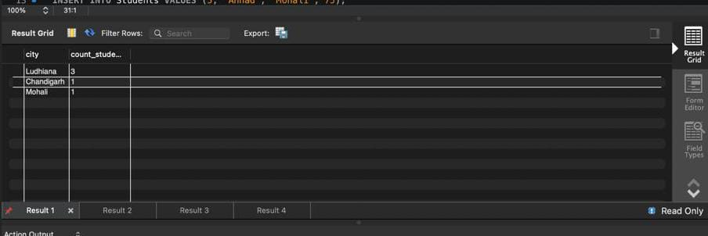
-- Sort based on count
SELECT city, COUNT(*) AS count_students
FROM Students
GROUP BY city
ORDER BY count_students ASC;
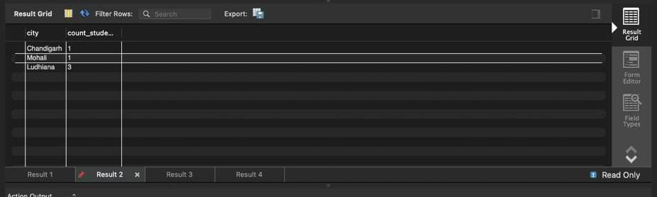
-- Cities having at least 3 students
SELECT city, COUNT(*) AS count_students
FROM Students
GROUP BY city
HAVING COUNT(*) >= 3
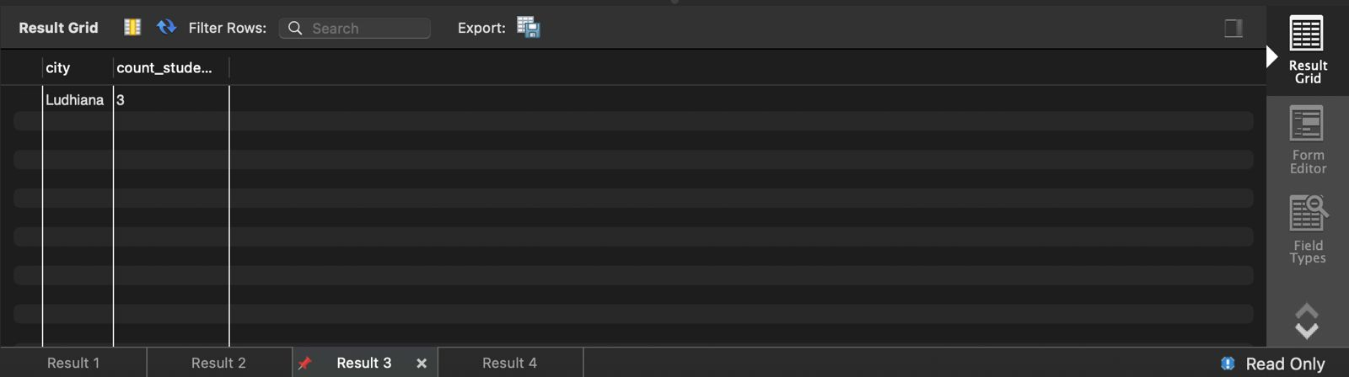
-- Average marks of each city
SELECT city, AVG(marks):: NUMERIC(10,2) AS average_marks
FROM Students
GROUP BY city;
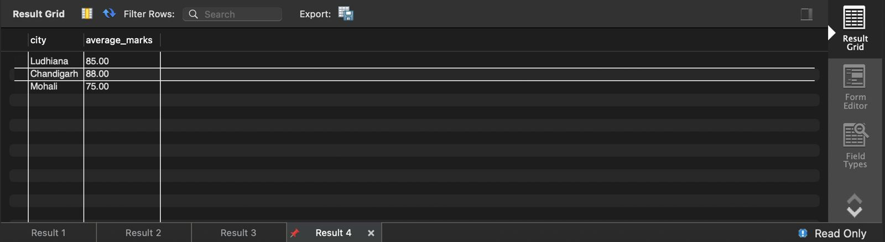

Learning Outcome
It will be able to:
- Understand and apply SQL aggregate functions.
- Use GROUP BY and HAVING clauses effectively.
- Analyse grouped data.
- Perform sorting on aggregated results.
- Gain practical exposure to SQL data analysis.

