## **KLiC C Programming**

**Detailed Syllabus:**

**KLiC C Programming**

1. **Getting Started**

* Brief Introduction
* Programming Language
* About C Programming
* C Character Set
* Constants, Variables & Keywords
* Constants in C
* Variables in C
* Writing a C Program
* Instructions and Assignments
* Basic Operators in C Programming

1. **The Decision Control Structure**

* Decisions Control Structure & the If Statement
* The if-else Statement
* Use of Logical Operators
* Different types of Operators
* Points to remember

1. **Loop Control Structure**

* Loops and the While loop
* While Loop
* For Loop
* Operators in Loop
* The Odd Loop
* Break Statement
* Continue Statement
* do-while loop
* Tips to remember

1. **Case Control Structure**

* Decisions using switch
* The Tips and Traps
* Switch versus if-else Ladder
* The goto keyword

1. **Functions and Pointers**

* About Functions
* Passing Values between Functions
* Scope Rule of Functions
* Calling Convention
* One Dicey Issue
* Advanced Features of Functions
* Function Declaration and Prototypes
* Call by Value or Call by Reference
* An Introduction to Pointers
* Pointer Notation
* Function Calls
* Basics of Call by value and call by reference
* Conclusions
* Recursion
* Recursion and Stack
* Adding Functions to the Library

1. **Data Types Revisited**

* Data type
* Integer number variables
* Integers, signed and unsigned
* Chars, signed and unsigned
* Floats and Doubles
* Issues related to Data types
* Storage Classes in C
* Automatic Storage Class
* Register Storage Class
* Static Storage Class
* External Storage Class
* To study the Ground rules for the Storage Class

1. **The C Preprocessor**

* Features of C Preprocessor
* Preprocessor and Macro Directives
* Macros with Arguments and Macros versus Functions
* Various Directives

1. **Arrays**

* About Array
* Usage of Arras
* Pointers and Arrays
* Passing an Entire Array to a Function
* Two Dimensional Arrays
* Initializing a 2-Dimensional Array
* Memory Map of a 2-Dimensional Array
* Pointers and 2-Dimensional Arrays
* Pointer to an Array 295
* Passing 2-D array to a Function
* Array of Pointers
* Three Dimensional Array

1. **Pupating on Strings**

* What are Strings?
* Pointers and Strings
* Standard Library String Functions
* Two-Dimensional Array of Characters
* Array of Pointers to Strings
* Limitations of Array of Pointers to Strings

1. **Structures**

* Why Use Structures?
* Declaring a Structure
* Accessing Structure Elements
* Array of Structures
* Additional Features of Structures
* Uses of Structures

1. **Console Input/output**

* Types of I/O
* Formatted Console I/O Functions
* sprintf( ) and sscanf( ) Functions
* Unformatted Console I/O Functions

1. **File Input/Output**

* Data Organization
* File Operations
* Opening a File
* Reading from a File
* Trouble in Opening a File
* Closing the File
* Counting Characters, Tabs, Spaces
* A File-copy Program
* Writing to a File
* File Opening Modes
* String (line) I/O in Files
* The Awkward Newline
* Record I/O inFiles
* Text Files and Binary Files
* Record I/O Revisited
* Database Management
* Low Level Disk I/O
* A Low Level File-copy Program
* I/O Under Windows

1. **More Issues in Input/output**

* Using argc and argv
* Detecting Errors in Reading/Writing
* Explanation
* Standard I/O Devices
* I/O Redirection
* Redirecting the Output
* Redirecting the Input & Both Ways at Once

1. **Operations on Bits**

* Binay System & Bitwise Operators
* Bitwise AND Operator
* Bitwise OR Operator
* Bitwise XOR Operator
* One's Complement Operator
* Shift Operator
* The showbits( ) Function

1. **Miscellaneous Features**

* Enumerated Data Type and its uses
* Understanding with a Program
* Renaming Data Types with typedef
* Typecasting
* Bit Fields
* Pointers to Functions
* Functions Returning Pointers
* Functions with Variable Number of Arguments
* Unions & Union of Structure

1. **Under Windows 535**

* Uses of Windows
* Integers
* The Use of typedef
* Pointers in the 32-bit World
* Memory Management & Device Access
* DOS Programming Model
* Windows Programming Model
* Event Driven Model & Windows programming
* The First Windows Program
* Hungarian Notation

1. **Windows Programming**

* The Role of a Message Box
* Here Comes the windows
* More Windows
* A Real-World Window
* Creation and Displaying of Window
* Interaction with Window
* Reacting to Messages
* Program Instances

1. **Graphics under Windows**

* Graphics fundamentals
* Device Independent Drawing
* Hello Windows program
* Drawing Shapes
* Types of Pens
* Types of Brushes
* Code and Resources
* Freehand Drawing, the Paintbrush Style
* Capturing the Mouse
* Device Context, a Closer Look
* Displaying a Bitmap
* Animation at Work
* WM_CREATE and On Create( )
* WM_TIMER and On Timer( )
* Points to remember

1. **interaction with Hardware**

* Hardware Interaction
* Hardware Interaction, DOS Perspective
* Hardware Interaction, Windows Perspective
* Communication with Storage Devices
* The Read Sector( ) Function
* Accessing Other Storage Devices
* Communication with Keyboard
* Dynamic Linking
* Windows Hooks
* Caps Locked, Permanently
* Mangling Keys
* Key Logger

1. **Under Linux**

* What is Linux
* C Programming Under Linux
* The ‘Hello Linux’ Program
* Processes
* Parent and Child Processes
* More Processes
* Zombies and Orphans

1. **More Linux Programming**

* Communication using Signals
* Handling Multiple Signals
* Registering a Common Handler
* Blocking Signals
* Event Driven Programming

1. **memory Mapping**

* Introduction to Memory Map
* Memory Organization
* Segmentation
* Loading OS & Booting Process
* The resident and transient memory area
* Program memory area at run time
* Memory representation of data & function objects

1. **C Traps & Pitfall**

* Introduction
* Lexical pitfalls
* Exceptions, String & characters
* Understanding Declaration
* Exceptions in Operators' precedence
* Use of Semicolons
* The Switch statement
* Calling functions
* The Dangling else problem
* Linkages
* External Types
* Expression evaluation sequence
* Issues related to actual parameters
* Eshew Synecdoche
* Library Function
* Preprocessor
* Portability pitfalls
* Signed & Unsigned characters
* Random numbers
* Portability problems

Prime Numbers

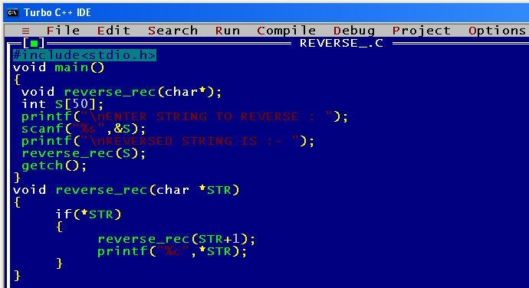

Reversing an integer

