Smart Traffic Control System Using Vehicle Density Analysis
Madhav Goel  Dept. of Information Technology  Ajay Kumar Garg Engineering College  Ghaziabad, India | Akash Varshney  Dept. of Information Technology  Ajay Kumar Garg Engineering College  Ghaziabad, India | Abhisekh Chaudhary  Dept. of Information Technology  Ajay Kumar Garg Engineering College  Ghaziabad, India
Shivam Goel  Dept. of Information Technology  Ajay Kumar Garg Engineering College  Ghaziabad, India | Ruchi Gupta  Dept. of Information Technology  Ajay Kumar Garg Engineering College  Ghaziabad, India

Abstract—Fixed-time signals give every approach the same green regardless of demand. This paper presents a density-aware controller for an isolated four-arm junction and evaluates it in a seeded microscopic simulation against the fixed plan and four re-implemented alternatives: a Webster-optimized plan, vehicle-actuated, max-pressure and three-level density control. Each approach is scored by class-weighted vehicle counts in which a queued vehicle counts three times a moving one; green is extended between 8 s and 45 s while the served direction dominates, change intervals are never shortened, and an emergency preemption layer keeps full yellow and all-red. Below capacity the controller reduced mean stopped delay by 35.3–36.1% relative to a 20 s fixed plan (p < 0.001), but the Webster, actuated and max-pressure strategies did as well (37.5–39.7%, 37.2–39.9%, 37.3–39.8%). Near capacity, density-only switching ended greens too early and lost 18.9% of capacity; a discharge-hold rule that keeps green while the served queue is at the stop line restored it (+9.8%). The queued/moving distinction, not the class weights, drives the score's benefit. The findings hold with kinematics calibrated to field saturation headways once the hold's zone is re-tuned, but with the present Haar detector (4% precision, 8% recall) every controller would be worse than fixed timing near capacity. A per-step audit of 3,524 runs found no conflicting greens or shortened change intervals.
Index Terms—adaptive traffic signal control, vehicle density, actuated control, max-pressure control, emergency preemption, oversaturation, microscopic simulation
I. Introduction
Many junctions, especially in smaller cities, still run fixed-time plans dimensioned for average flows; when demand is uneven, green is wasted on empty approaches while queues build on busy ones. SCATS and SCOOT adapt timings from loop detectors but need dedicated infrastructure [3], [4], and low-cost alternatives estimate density with infrared sensors, image-based density classes or camera detectors [1], [5], [6], [8]–[10].
Motivation. Such low-cost systems are usually shown on a prototype or a few scenarios, reporting an average gain over a fixed plan. Rarely answered are whether variable greens keep safe change intervals, how emergency priority interacts with density timing, how the controller behaves at and above capacity, and how much of the gain is due to density logic rather than to replacing an untuned plan with any responsive one.
Novelty. Rather than a new detector, this paper studies the timing logic of a density-based controller under statistically paired conditions against re-implementations of the strategies of existing approaches (Webster [2], actuated [23], max-pressure [11] and three-level density control [1]) on identical traffic. It exposes a capacity loss of density-only switching and corrects it with a discharge hold. The controller is a transparent rule, not a learned policy; machine learning enters through the pre-trained detector, whose accuracy is measured, and a data-driven calibration of the score on held-out seeds. Contributions:
- a class-weighted, queue-aware density score with bounded green extension, a discharge-hold rule, and an emergency preemption wrapper, all keeping full change intervals and a closed-form maximum red;
- a reproducible paired evaluation below, at and up to 1.5 times capacity against four strategies, with an ablation, a peak-period test and a per-step safety audit of every run;
- validation against external values: Haar-cascade detection and tracking against exact ground truth, queue discharge against the Highway Capacity Manual with a calibrated reaction time, imperfect sensing, and a held-out calibration of the score weights.
All results are from simulation; the simulator, controllers and experiment scripts are public and regenerate every table (github.com/shivam-G05/Smart-Traffic-Management).
II. Related Work
Fixed plans are commonly timed with Webster's cycle formula [2]; SCATS and SCOOT adapt splits and cycles over networks [3], [4]. Actuated control extends green while stop-line detectors register vehicles and ends it on a gap ("gap-out") within green limits [23]. Max-pressure control chooses phases from queue differences with throughput guarantees [11]; reinforcement-learning controllers are widely studied but must be trained in simulation and are harder to bound [12]. Among low-cost systems, Nsofwa and Tembo set green from low, medium or high image-based density [1]; Kamble et al. use YOLO [7] on IP cameras to prioritize the busiest lane [6]; Pardeshi et al. use infrared sensors on an ESP32 [5]; others adapt timing to density [9], [10], estimate it from surveillance cameras [8], or add incident alerts [13], AI-based light design [14] or traffic prediction [15]. These mainly report gains over fixed timing; this paper adds strong baselines on identical traffic, demand up to 1.5 times capacity and a per-step safety check. Haar cascades [16] remain cheap on embedded hardware; ByteTrack [17] combines Kalman prediction [18] with Hungarian assignment [19]; Nellore and Hancke give emergency vehicles visual-sensing priority [20].
III. System and Methods
A. Architecture and Workflow
The system is a set of Python 3.12 packages with one-directional dependencies: the simulation core imports no decision or web code, and every controller implements one interface, so controllers are interchangeable. A FastAPI backend streams the junction at 10 Hz to a React dashboard, logs metrics to SQLite and runs side-by-side controller comparisons on the same seed; the code has 119 automated tests (Fig. 1). Fig. 2 shows the method. Every 50 ms step the controller reads vehicle positions, speeds and classes, scores each approach, and decides whether the green may end; the preemption layer protects every transition with full yellow and all-red before the signal heads change. A vision pipeline (Section III-G) runs alongside; its output is evaluated but not used for control.
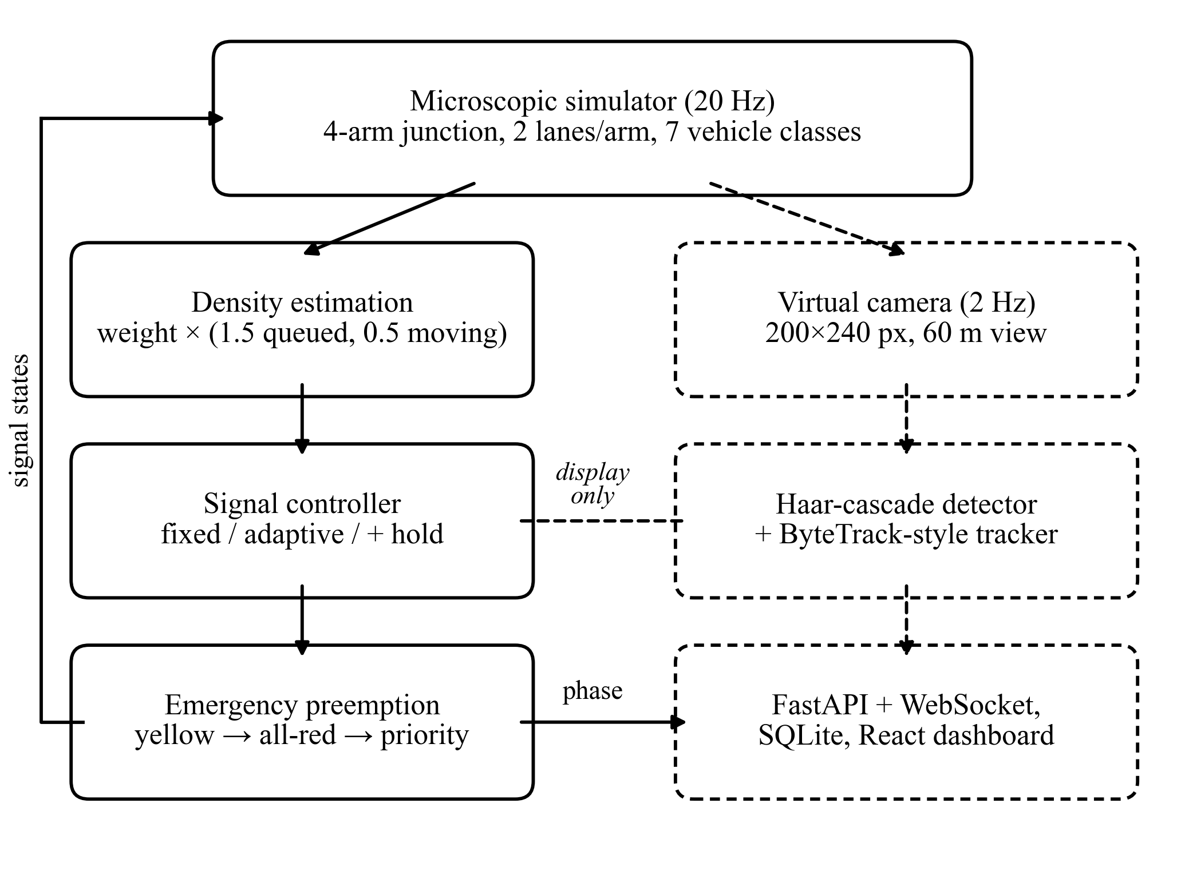
Fig. 1. Software architecture. Solid boxes form the control loop; dashed boxes form the vision pipeline, evaluated but not used for control.
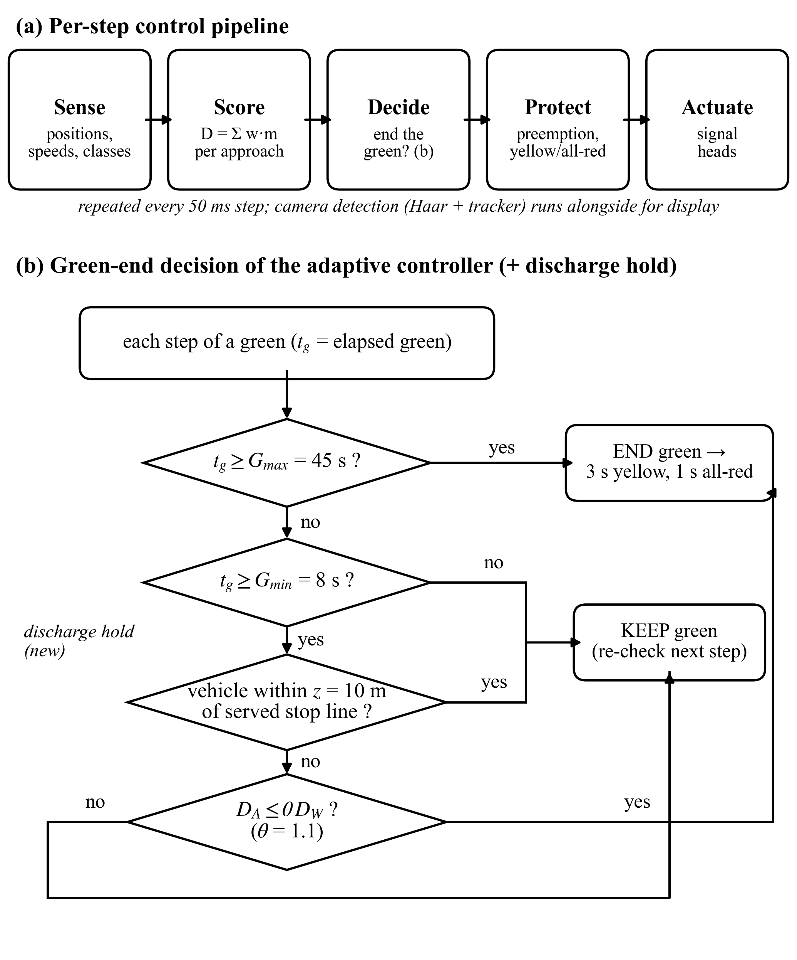
Fig. 2. Method workflow. (a) Per-step control pipeline. (b) Green-end decision; the "discharge hold" test (Section III-D) is the extension added in this revision.
B. Junction and Traffic Model
Four approaches each have two lanes on a 330 m link (stop line at 200 m, junction exit at 218 m); vehicles go straight, without turns, lane changes or pedestrians. Arrivals on each approach have deterministic headways at a rate λ redrawn every 15 s as λ·U(0.4, 1.6); a vehicle enters at rest and is dropped if the entry is blocked. For the above-capacity runs, blocked arrivals instead wait in an entry queue (so unserved demand is measured) and enter at the highest safe speed. Table I lists the vehicle classes. Motion follows a Gipps-type safe speed [21],
TABLE I
Vehicle classes and parameters
Class | Share (%) | Length (m) | v_{max} (m/s) | a (m/s²) | b (m/s²) | Weight w
Car | 55 | 4.5 | 14 | 2.5 | 4.5 | 1.0
Motorcycle | 25 | 2.0 | 15 | 3.5 | 5.0 | 0.5
Auto-rickshaw | 10 | 3.2 | 11 | 2.0 | 4.0 | 0.8
Bus | 5 | 10.0 | 10 | 1.2 | 3.0 | 3.0
Truck | 4 | 9.0 | 9 | 1.0 | 2.8 | 2.5
Ambulance | 0.5 | 5.5 | 16 | 3.0 | 5.0 | 6.0
Fire truck | 0.5 | 10.5 | 12 | 1.5 | 3.5 | 6.0
a, b: maximum acceleration and deceleration; w: density weight in (2).
u_{safe} = [2b(g + u_{l}²/(2b_{l}) − s₀)]^{1/2} (1)
where g is the gap to the leader, u_{l} and b_{l} its speed and deceleration, and s₀ = 2 m. On yellow or red a vehicle brakes once its braking distance reaches the stop line. Rule (1) has no reaction time; Section IV-G adds one and repeats the main comparisons.
C. Density Score and Green Extension
For approach r with vehicles V_{r} the score is
D_{r} = Σ_{v∈Vr} w_{c(v)} · m(v) (2)
with class weight w (Table I) and m(v) = 1.5 if v is queued (upstream of the line, below 0.5 m/s), else 0.5: a queued vehicle needs green now. The weights are heuristic and are tested in Sections IV-E and IV-I. The plan has two phases (north–south, east–west), each green followed by yellow Y = 3 s and all-red A = 1 s; only green adapts. With elapsed green t_{g} and summed scores D_{A}, D_{W} of the active and waiting direction, the green ends when
t_{g} ≥ G_{max} or (t_{g} ≥ G_{min} and D_{A} ≤ θD_{W}) (3)
with G_{min} = 8 s, G_{max} = 45 s and θ = 1.1. Since change intervals are fixed and green capped, the red of any approach is bounded by
R_{max} = A + G_{max} + Y + A = 50 s (4)
so no approach starves. The fixed baseline uses a 20 s green (48 s cycle).
D. Discharge Hold
When both directions are saturated, vehicles moving off on green score 0.5 while the queue on red scores 1.5, so rule (3) ends greens soon after G_{min}; each change costs Y + A = 4 s of lost service, so capacity drops when it is scarcest (Section IV-C). The hold adds actuated control's gap-out test [23]:
t_{g} ≥ G_{max} or (t_{g} ≥ G_{min} and n_{z} = 0 and D_{A} ≤ θD_{W}) (5)
where n_{z} counts served vehicles within z = 10 m of the stop line (chosen from 10–30 m on a separate tuning seed). A discharging queue keeps a vehicle at the line and holds green, while a cleared queue still hands over early; bound (4) still holds.
E. Comparison Controllers
Four strategies were re-implemented with the same phases, change intervals, 8–45 s green limits and exact vehicle states, so only the switching decision differs and bound (4) holds for all. Webster: a fixed plan with cycle C₀ = (1.5L + 5)/(1 − Y), lost time L = 8 s and measured saturation flow 6000 veh/h per approach, given the true mean demand of each run (which favors it). Actuated: past the minimum, green ends when the served direction gaps out (no vehicle within 10 m of the line) and a vehicle waits [23]. Max-pressure: switch when the waiting phase's upstream count exceeds the served one's [11]; this also represents busiest-lane-first control [6]. Density levels: green of 10, 20 or 30 s for low, medium or high density at green start [1].
F. Emergency Vehicle Preemption
Preemption wraps any phase-based controller (Fig. 3). When an ambulance or fire truck is upstream of the junction exit, a conflicting green first completes a full 3 s yellow and 1 s all-red (a green younger than 5 s is not cut); the emergency direction then has green until the vehicle has left or for at most 20 s, and the release again passes through full yellow and all-red before the inner controller resumes. An emergency vehicle thus waits at most 9 s. Detection is assumed perfect, e.g. from vehicle-to-infrastructure messages.
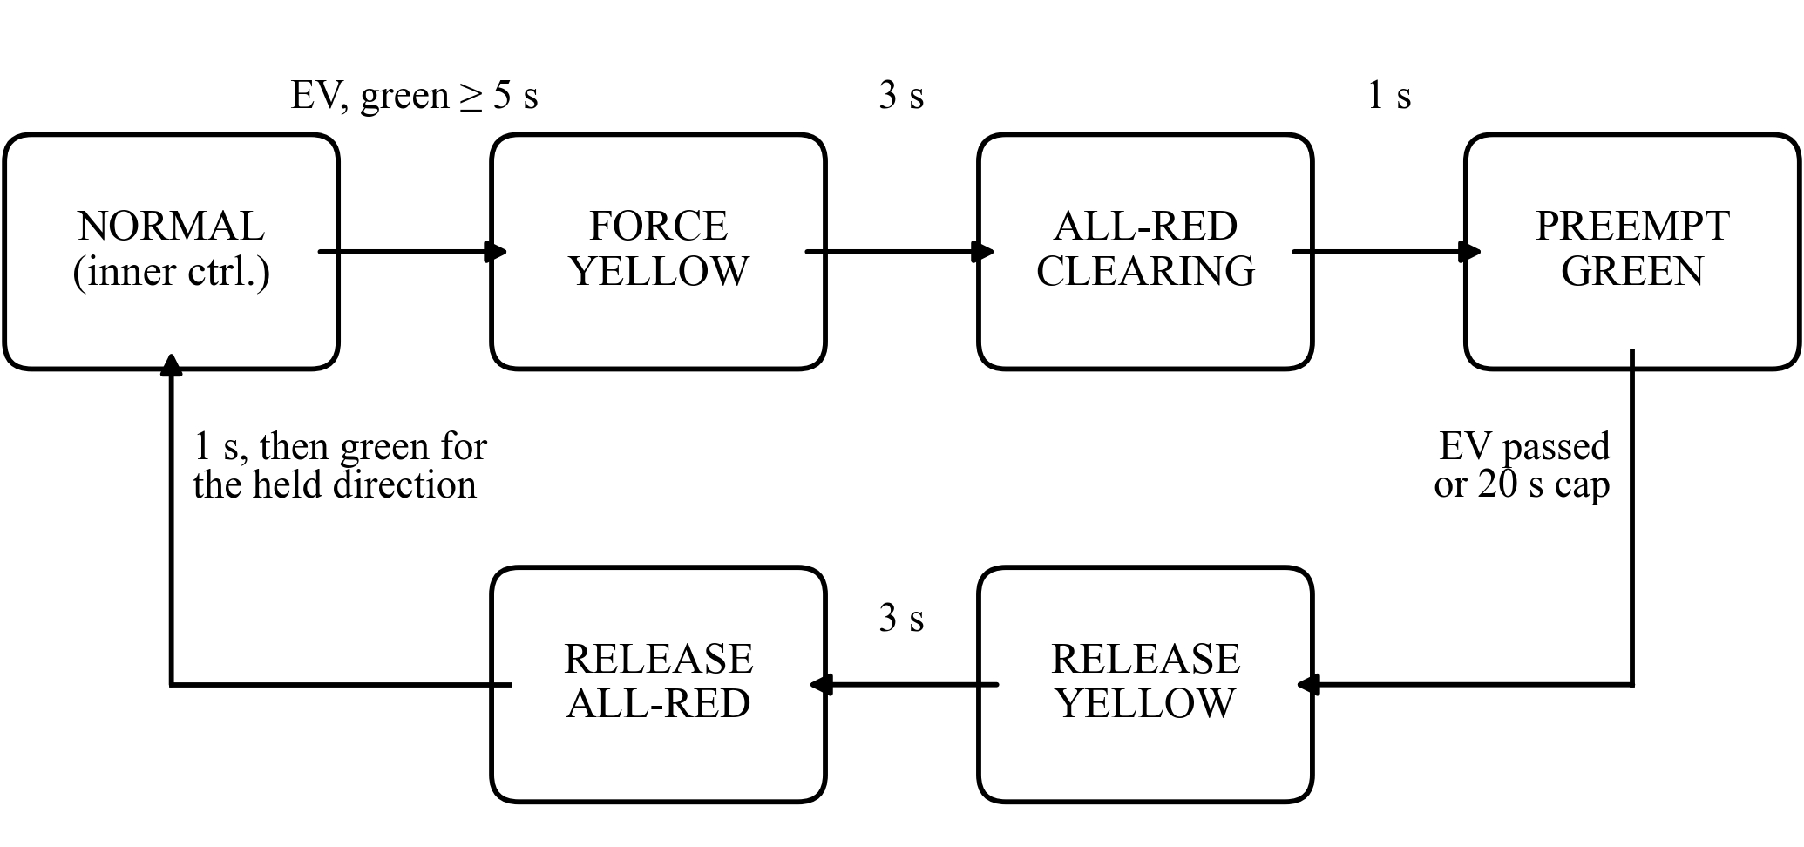
Fig. 3. Emergency preemption states. Every path from one direction's green to the other's passes through a full yellow and all-red interval.
G. Vision Pipeline
A virtual camera per approach renders the 60 m before the stop line at 4 px/m and 2 Hz. The detector equalizes, upscales three times and applies OpenCV's pre-trained vehicle Haar cascade; it localizes but does not classify vehicles. A ByteTrack-style tracker matches Kalman-predicted boxes to high- then low-confidence detections by Hungarian assignment on IoU. Data and annotation: no real images are used; frames and exact ground-truth boxes are both generated from the simulator state, so there is no manual labelling. Nothing is trained, so there is no training split: parameters were fixed in unseeded development runs, and seeds 1–4 are used only for evaluation. A detection is correct if its center lies in a ground-truth box enlarged by 4 px.
IV. Experimental Evaluation
A. Setup and Safety Audit
Three demand levels below capacity were simulated: λ = 0.08, 0.12 and 0.18 veh/s per approach (1152–2592 veh/h). Each controller and level ran ten seeds for 1800 s; a seed gives every controller the same arrivals, so runs are paired. After a 60 s warm-up, stopped delay (time upstream of the line below 0.5 m/s) is measured for vehicles entering until 1650 s. Results give 95% confidence intervals and paired t-tests; preemption is on unless stated. Seed 1000 was used for tuning, 101–105 for capacity and 1–10 for reported results. In total 3,524 runs (1,797 simulated hours) were made. Every step of every run was audited for conflicting greens, missing yellows and yellow or all-red shorter than 3 s or 1 s: no violation occurred, across all seven controllers and 1,830 preemptions in the main runs. The audit caught an earlier preemption version that resumed without a release interval.
B. Comparison Below Capacity
In Table II the adaptive controller reduced delay by 35.3–36.1% relative to the fixed plan, in all seeds at every level (p < 0.001). Yet the Webster plan, actuated and max-pressure control did as well (37.5–39.7%, 37.2–39.9%, 37.3–39.8%; between −6.8% and −2.9% relative to adaptive): below capacity the gain comes from replacing an untuned plan with short responsive greens. Three-level density control was worse than fixed timing at medium and high demand (+29.0%, +28.9%), as its 20–30 s greens outlast the queue. The hold changed delay by between −1.2% and +2.5%, and throughput by at most 0.9%, as all levels are far below capacity.
TABLE II
Mean stopped delay below capacity (s)
Controller | Low | Medium | High | High vs fixed | Green (s)
Fixed (20 s) | 6.96 ± 0.17 | 7.20 ± 0.20 | 7.36 ± 0.22 | — | 19.3
Webster fixed | 4.29 ± 0.18 | 4.34 ± 0.15 | 4.60 ± 0.29 | −37.5% | 8.7
Actuated | 4.19 ± 0.21 | 4.36 ± 0.13 | 4.63 ± 0.17 | −37.2% | 8.8
Max-pressure | 4.22 ± 0.14 | 4.33 ± 0.17 | 4.62 ± 0.18 | −37.3% | 8.9
Density levels | 7.35 ± 0.37 | 9.29 ± 0.33 | 9.49 ± 0.15 | +28.9% | 26.9
Adaptive | 4.49 ± 0.10 | 4.60 ± 0.14 | 4.76 ± 0.12 | −35.3% | 9.5
Adaptive + hold | 4.44 ± 0.10 | 4.62 ± 0.16 | 4.89 ± 0.23 | −33.7% | 9.7
Mean ± 95% CI, ten paired seeds, preemption on. All changes vs fixed are significant (p < 0.001) except density levels at low demand (p = 0.06). Green: mean at high demand.
C. Operation Near and Above Capacity
Table II's levels are only 12–26% of the fixed-time capacity. Table III gives each controller's capacity (all approaches flooded); these runs and Table IV use preemption off, since at these demands emergency vehicles would trigger a preemption every 15–30 s. The original adaptive rule lost 18.9% of capacity (p < 0.001) as its saturated greens fell to 8.1 s; the hold raised them to 37.6 s and capacity to +9.8%. Max-pressure lost capacity like the original rule (−18.8%); actuated control (+9.6%) and the Webster plan (+11.6%, maximum green above capacity) did not.
TABLE III
Capacity of each controller (veh/h)
Controller | Preemption off | vs fixed | Green (s) | Preemption on
Fixed (20 s) | 10008 ± 89 | — | 20.0 | 9701 ± 197
Webster fixed | 11168 ± 32 | +11.6% | 45.0 | 9977 ± 224
Actuated | 10971 ± 75 | +9.6% | 37.3 | 10018 ± 223
Max-pressure | 8128 ± 136 | −18.8% | 8.1 | 8876 ± 296
Density levels | 10637 ± 55 | +6.3% | 30.0 | 9976 ± 193
Adaptive | 8112 ± 155 | −18.9% | 8.1 | 8861 ± 321
Adaptive + hold | 10988 ± 41 | +9.8% | 37.6 | 10012 ± 222
Every approach flooded at 1.5 arrivals/s; five seeds; mean saturated green.
TABLE IV
Delay including vehicles still waiting (s)
Controller | 0.6× | 0.8× | 0.9× | 1× | 1.2× | 1.5×
Fixed (20 s) | 6.4 | 7.7 | 8.9 | 12.2 | 115.3 | 312.2
Webster fixed | 4.8 | 8.2 | 11.5 | 17.1 | 50.6 | 240.4
Actuated | 4.4 | 6.5 | 8.1 | 10.6 | 52.8 | 245.7
Max-pressure | 4.6 | 9.7 | 25.6 | 132.0 | 292.9 | 438.8
Adaptive | 4.6 | 10.1 | 41.5 | 148.7 | 298.2 | 440.1
Adaptive + hold | 4.3 | 6.4 | 8.2 | 10.6 | 48.7 | 245.6
Demand as a multiple of fixed-time capacity; ten paired seeds; preemption off. Values above capacity are lower bounds.
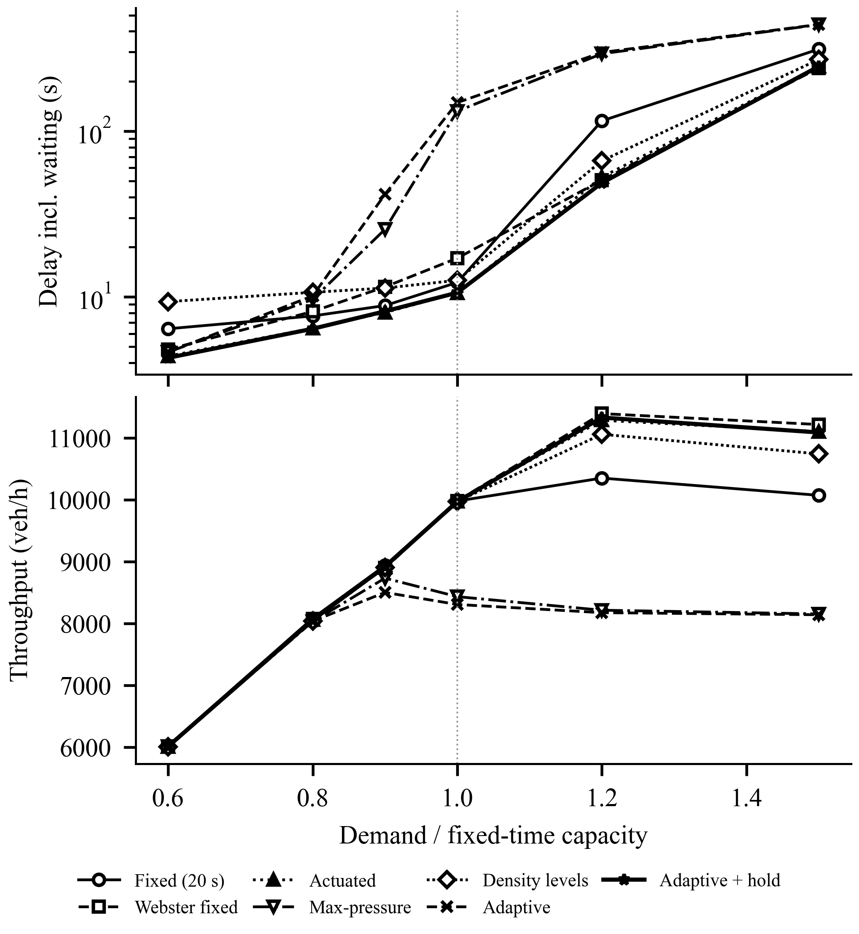
Fig. 4. Delay (top, log scale) and throughput (bottom) against demand, preemption off; dotted line: fixed-time capacity.
In Table IV and Fig. 4 the original rule beat fixed timing only at 0.6×; at capacity its delay was 148.7 s against 12.2 s, its queue grew by 28.9 veh/min, and queues spilled back to the link entry during 78% of approach-time. With the hold, delay was below fixed timing at every level (−33.2%, −16.3%, −7.6%, −13.3%, −57.7%, −21.3% from 0.6× to 1.5×; not significant at 1.0×, p = 0.14) and throughput rose by +9.5% and +10.1% at 1.2× and 1.5×. Actuated control behaved like the hold; max-pressure degraded like the original rule. With preemption on the pattern held with smaller margins (capacity −8.7% and +3.2%).
In a 60-minute peak, demand ramped from 0.6 to 1.2 times capacity, held for 15 min and fell back (Fig. 5; ten seeds, preemption off). The queue peaked at 495 vehicles under fixed timing, 255 with the hold, 254 with actuated and 1214 with the original rule. Time to recover the pre-peak queue was 13.9 min (fixed), 7.3 min (hold), 7.4 min (actuated) and not within the hour (original rule). Entries were blocked for 68, 36 and 172 approach-minutes (fixed, hold, original); peak throughput was 10574, 11394 and 8244 veh/h; total delay changed by −57.3% with the hold and +356.1% with the original rule relative to fixed timing.
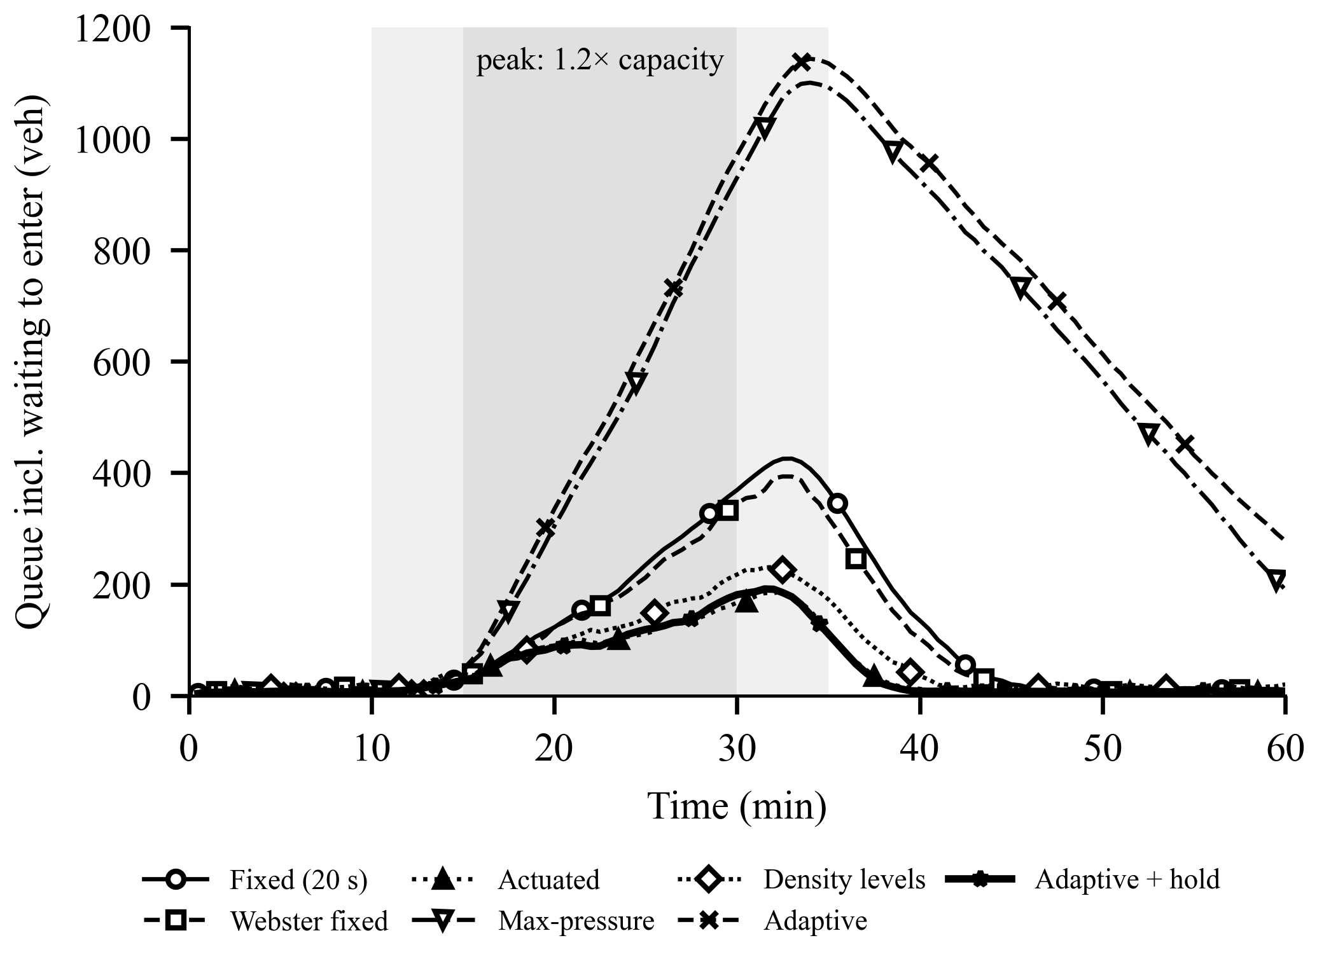
Fig. 5. Queue including vehicles waiting to enter during the 60-minute peak (mean of ten seeds, 2-min moving average). Shading: ramp (light) and 1.2× capacity (dark).
D. Emergency Preemption
Emergency vehicles (1% of arrivals) triggered 12.4–23.4 preemptions per hour. Preemption cut their mean stopped delay from 8.87 s to 0.28 s under fixed timing and from 3.65 s to 0.35 s under adaptive control at medium demand (p < 0.001). The cost to other vehicles was +3.1% (p 0.08) under fixed timing but +9.3% under adaptive control and +7.2% with the hold, because each preemption discards the responsive timing; real emergency traffic is far rarer, so the real cost would be smaller.
E. Ablation
Table V changes one part of the controller at a time on the same seeds. Counting vehicles plainly raised delay by 22.7% and 26.6%; removing the queued/moving distinction raised it by 35.1% and 33.0%, whereas equal class weights changed it by −3.9% and −3.2%. The score's benefit thus comes from the queued/moving distinction, not the class weights. θ = 1.5 lowered delay slightly, and the hold, with any zone, left delay unchanged below capacity.
TABLE V
Ablation: change in mean delay (p)
Variant | Medium | High
Unweighted count | +22.7% (< 0.001) | +26.6% (< 0.001)
No class weights | −3.9% (0.07) | −3.2% (0.04)
No queued/moving distinction | +35.1% (< 0.001) | +33.0% (< 0.001)
θ = 1.0 | +1.3% (0.39) | −0.3% (0.84)
θ = 1.5 | −4.9% (0.005) | −4.1% (0.06)
+ discharge hold, 10 m zone | +0.4% (0.82) | +2.5% (0.17)
+ discharge hold, 20 m zone | +1.3% (0.44) | +2.2% (0.06)
+ discharge hold, 30 m zone | +0.2% (0.92) | +3.6% (0.09)
Preemption off | −7.8% (< 0.001) | −11.4% (< 0.001)
Ten paired seeds, relative to the adaptive controller (4.60 s and 4.76 s); preemption on unless stated.
F. Vision Pipeline
On seeds 1–4 (9,600 frames, 14,874 vehicle instances) the generic cascade reached 4.1% precision and 8.2% recall (Table VI). 98.6% of false positives recur at the same spot, i.e. fire on background texture. Recall varied by class (car 7.1%, motorcycle 11.8%, auto 7.6%, bus 7.2%, truck 7.7%, fire_truck 3.7%, ambulance 14.3%) and distance (0-20 m 5.4%, 20-40 m 16.9%, 40-60 m 17.4%), lowest near the line where queued vehicles stand close. Only 0.6% of instances carried a confirmed track (Table VII). Tracked speed had a mean absolute error of 0.53 m/s against vehicles moving at only 0.56 m/s, since tracks are confirmed almost only on queued vehicles: a negative result, as the pipeline gives no usable kinematics for moving traffic. Removing the low-confidence matching stage or the motion model changed little, because recall is the limit. In two single-process runs of 400 frames on an Intel Core i5-12450H laptop CPU, detection took 103 and 171 ms per frame on average (it varies with the CPU's power state), against 0.002–0.004 ms per control decision.
TABLE VI
Detector accuracy and ablation (synthetic frames)
Detector variant | Precision (%) | Recall (%) | Det./frame
Default (3x upscale, equalized) | 4.1 | 8.2 | 3.30
2x upscale | 63.3 | 3.7 | 0.09
No upscaling | — | 0.0 | 0.00
No histogram equalization | — | 0.0 | 0.00
Seeds 1–4. —: too few detections for a meaningful precision.
TABLE VII
Tracking quality and tracked-speed error
Tracker variant | Coverage (%) | Confirmed (%) | ID sw./100 veh. | Speed MAE (m/s)
ByteTrack-style (two-stage, Kalman) | 0.6 | 1.5 | 0.2 | 0.53
Single stage (low-confidence dropped) | 0.5 | 1.0 | 0.2 | 0.16
No motion model (last box) | 0.6 | 1.5 | 0.2 | n/a
Confirm after 1 match | 2.3 | 35.9 | 6.6 | 0.53
Coverage: vehicle instances in view with a confirmed track. Speed MAE: confirmed tracks on real vehicles.
G. Validation of the Simulated Kinematics
Queue discharge was measured as in the field: headways of queued vehicles crossing the line in saturated fixed-time runs, from the fifth vehicle on. The Highway Capacity Manual base is 1900 veh/h/lane (1.89 s) with about 2 s start-up lost time [24]. The model above discharges cars every 0.51 s (7,102 veh/h/lane; Table VIII), because without a reaction time a follower may trail by the 2 m standstill gap. Adding a reaction time τ to (1), as in Krauss's model [25], with τ = 1.6 s gives 1.92 s (1,877 veh/h/lane), within 1.2% of the reference; start-up lost time (−0.8 s) stays below field values. Repeating all comparisons with τ = 1.6 s (Webster re-timed for 3600 veh/h), delay reductions below capacity were 33.7–35.4% for the adaptive controller and 31.9–39.2%, 35.0–39.5% and 34.7–38.9% for Webster, actuated and max-pressure. Relative to fixed-time capacity (6,148 veh/h) the original rule reached −14.6% and Webster +6.3%, but the hold with its 10 m zone only −3.7%: with a reaction time, discharging vehicles spread to about 20 m gaps, so a 10 m zone empties between them. Like an actuated controller's passage time, the zone depends on local kinematics; re-tuned on the tuning seed to 20 m, the hold reached +6.1% and actuated control +6.1%, against +6.3% for Webster.
TABLE VIII
Queue discharge against field reference values
Model | Headway, cars (s) | Sat. flow, cars (veh/h/ln) | Sat. flow, all (veh/h/ln) | Start-up lost (s)
Simulator, τ = 0 | 0.51 | 7,102 | 3,164 | 2.1
Simulator, τ = 1.6 s | 1.92 | 1,877 | 1,798 | −0.8
HCM base values [24] | 1.89 | 1,900 | — | ≈ 2.0
Saturated fixed-time runs, five seeds; headway averaged from the fifth queued vehicle on.
H. Imperfect Sensing
To measure the cost of the exact-state assumption, the vehicle-reading controllers were run behind a sensor model that reports only what a camera would: vehicles within 60 m, refreshed at 2 Hz, without classes, each detected with a given recall, optionally with phantom detections at fixed spots, and finally the measured pipeline (recall 8%, 3 phantoms); preemption reads true flags. Table IX gives delay at medium demand and 0.9 times capacity. Below capacity missed detections cost little, as they only shorten greens. Near capacity the hold's delay rose from 7.8 s (exact) to 8.5 s (perfect camera) and 14.4 s (50% recall), against 8.8 s for fixed timing. Phantoms were worst for gap-out rules: a phantom in the zone never moves, so green runs to the maximum (medium demand 11.9 s, +64.8% vs fixed). With the measured pipeline, every controller was worse than fixed timing near capacity. At medium demand max-pressure and adaptive still beat it, as phantoms on both directions largely cancel, while actuated and adaptive + hold were held at long greens by phantoms in the zone. Closing the loop with the present detector would harm traffic; a detector must suppress static false positives near the stop line, and recall matters most near capacity.
TABLE IX
Delay under imperfect sensing (s): medium demand / 0.9× capacity
Sensing | Actuated | Max-pressure | Adaptive | Adaptive + hold
Exact states | 4.4 / 8.1 | 4.3 / 27.2 | 4.6 / 35.6 | 4.6 / 7.8
Camera | 4.4 / 8.5 | 4.3 / 30.1 | 4.3 / 45.0 | 4.4 / 8.5
recall 90% | 4.4 / 8.4 | 4.4 / 32.3 | 4.3 / 45.4 | 4.3 / 8.3
recall 70% | 4.3 / 9.0 | 4.3 / 36.4 | 4.3 / 45.4 | 4.4 / 9.4
recall 50% | 4.4 / 11.3 | 4.3 / 33.0 | 4.3 / 45.4 | 4.3 / 14.4
recall 30% | 4.4 / 20.6 | 4.4 / 35.7 | 4.4 / 48.6 | 4.4 / 23.2
2 phantoms | 11.9 / 15.1 | 4.3 / 30.1 | 4.3 / 45.0 | 11.9 / 15.1
Haar (recall 8%, 3 phantoms) | 11.9 / 163.3 | 4.7 / 33.2 | 4.3 / 45.2 | 11.9 / 162.9
Ten paired seeds. Fixed plan: 7.2 / 8.8 s. 0.9×: preemption off, delay includes waiting to enter.
I. Calibration of the Density Weights
The hand-set weights were calibrated by a random search over the class weights, the queued/moving ratio and θ of the hold controller (14 candidates on tuning seeds 1001–1002, medium, high and 0.9× demand). The best setting (motorcycle 1.89, auto-rickshaw 3.02, bus 1.67, truck 0.93, emergency 1.91, queued/moving ratio 2.94, θ = 1.37) was compared with the hand-set weights on held-out seeds 1–10 (Table X): delay changed by −2.0% (p 0.374, medium), −4.9% (p 0.036, high), +2.2% (p 0.014, 0.9x capacity), while a plain count was +23.2%, +22.7%, +13.4%. Calibration thus gives modest, condition-dependent gains, and the parameters must be re-fitted on field data before deployment; the search is a reproducible procedure, not a learned controller.
TABLE X
Held-out delay with calibrated score parameters (s)
Condition | Hand-set | Calibrated | Plain count
medium | 4.62 | 4.53 (−2.0%) | 5.69 (+23.2%)
high | 4.89 | 4.64 (−4.9%) | 5.99 (+22.7%)
0.9x capacity | 7.85 | 8.03 (+2.2%) | 8.90 (+13.4%)
Held-out seeds 1–10, ten paired seeds; change relative to the hand-set weights.
V. Discussion
Two results qualify the usual claim that density control beats fixed timing. Below capacity, the gain over an untuned plan is matched by Webster, actuated and max-pressure control. Near capacity, density-only switching is worse than fixed timing because it ends greens while the queue is still discharging. With the hold, the controller matches the best strategies below capacity and nears the highest capacity measured (Webster's, +11.6%), while its rule fits in one line, its red time is bounded and its safety is audited. Its results are, however, close to plain actuated control: the gap-out test does most of the work, and the score's role is to decide when a cleared green hands over. Resuming after preemption with the higher-scoring direction is a direct improvement to test.
Limitations. Results are from simulation only, without turns, lane changes, pedestrians or driver variability, so absolute delays are not field predictions. The main model has no reaction time and discharges queues too fast; the calibrated model fixes the headway but still underestimates start-up lost time, which would make short greens costlier, and the hold's zone must be tuned to local spacing. Arrivals are not Poisson, and emergency vehicles are far more frequent than in reality. The baselines are re-implementations with ideal sensing, and Webster knows the true demand. Control uses exact states and perfect emergency detection; the vision pipeline was tested only on synthetic frames and is far too weak to drive control. The calibrated weights fit this simulator, not field data. A Raspberry Pi 4 deployment (about INR 6,000–8,000 in parts, estimated 5–10 times slower detection than the laptop) remains to be verified.
VI. Conclusion
A density-aware signal controller with a queue-aware score, bounded green extension, a discharge hold and safe emergency preemption was compared with a fixed plan and four re-implemented strategies on identical traffic. It reduced delay below capacity by 35.3–36.1%, as did Webster, actuated and max-pressure control. Near capacity the original rule lost 18.9% of capacity; the hold restored it (+9.8%) and lowered delay from 0.6 to 1.5 times capacity. The findings hold under calibrated kinematics with a re-tuned zone, no run violated a change interval, and the queued/moving distinction, not the class weights, carries the score's benefit. Future work will close the loop with a class-aware detector trained on real footage, test in SUMO [22] with turning traffic and stochastic arrivals, improve resumption after preemption, and measure the controller on embedded hardware at a real junction.
Acknowledgment
The authors thank the Department of Information Technology, Ajay Kumar Garg Engineering College, Ghaziabad, for its support. An AI assistant (Anthropic's Claude) was used in developing parts of the software and in drafting and editing this manuscript; the authors reviewed the content and take responsibility for it.
References
[1] K. Nsofwa and S. Tembo, "Density based traffic control system," Int. J. Traffic Transp. Eng., vol. 14, no. 1, pp. 1–8, 2025.
[2] F. V. Webster, "Traffic signal settings," Road Research Laboratory, London, U.K., Road Res. Tech. Paper no. 39, 1958.
[3] A. G. Sims and K. W. Dobinson, "The Sydney coordinated adaptive traffic (SCAT) system philosophy and benefits," IEEE Trans. Veh. Technol., vol. 29, no. 2, pp. 130–137, May 1980, doi: 10.1109/TVT.1980.23833.
[4] P. B. Hunt, D. I. Robertson, R. D. Bretherton, and M. C. Royle, "The SCOOT on-line traffic signal optimisation technique," Traffic Eng. Control, vol. 23, no. 4, pp. 190–192, 1982.
[5] K. Pardeshi, P. Bable, M. Bhalerao, and M. Desai, "Adaptive traffic signal control system using density-based prioritization algorithm on ESP 32 platform," Int. J. Eng. Res. Technol., vol. 15, no. 5, May 2026, doi: 10.5281/zenodo.20205923.
[6] V. B. Kamble, O. N. Mundhe, C. M. Walunjkar, and G. A. Kale, "AI-driven smart traffic management system," Int. J. Multidiscip. Sci. Manage., vol. 2, no. 2, pp. 66–72, 2025.
[7] J. Redmon, S. Divvala, R. Girshick, and A. Farhadi, "You only look once: Unified, real-time object detection," in Proc. IEEE Conf. Comput. Vis. Pattern Recognit. (CVPR), Las Vegas, NV, USA, 2016, pp. 779–788, doi: 10.1109/CVPR.2016.91.
[8] Z. Hu, W. H. K. Lam, S. C. Wong, A. H. F. Chow, and W. Ma, "Turning traffic surveillance cameras into intelligent sensors for traffic density estimation," Complex Intell. Syst., vol. 9, no. 6, pp. 7171–7195, Dec. 2023, doi: 10.1007/s40747-023-01117-0.
[9] S. V. Patil, S. Kureshi, and A. Gaikwad, "Vehicle density based traffic signal control system," Int. J. Novel Res. Develop., vol. 9, no. 5, pp. g284–g288, May 2024.
[10] C. M. Thomas, A. B. Nair, A. E. Varghese, A. B. Kumar, and A. P. Seena, "Adaptive traffic signal control using real-time vehicle density," in AIP Conf. Proc., vol. 3260, Art. no. 020031, 2025, doi: 10.1063/5.0263715.
[11] P. Varaiya, "Max pressure control of a network of signalized intersections," Transp. Res. C, Emerg. Technol., vol. 36, pp. 177–195, Nov. 2013, doi: 10.1016/j.trc.2013.08.014.
[12] H. Wei, G. Zheng, V. Gayah, and Z. Li, "Recent advances in reinforcement learning for traffic signal control," ACM SIGKDD Explor. Newsl., vol. 22, no. 2, pp. 12–18, Jan. 2021, doi: 10.1145/3447556.3447565.
[13] O. Alzamzami, Z. Alsaggaf, R. AlMalki, R. Alghamdi, A. Babour, and L. Al Khuzayem, "Passable: An intelligent traffic light system with integrated incident detection and vehicle alerting," Sensors, vol. 25, no. 18, Art. no. 5760, Sep. 2025, doi: 10.3390/s25185760.
[14] T. G. Phakathi, M. Sumbwanyambe, and T. S. Hlalele, "Designing intelligent traffic light system with the application of artificial intelligence," in Proc. Int. Conf. Artif. Intell., Big Data, Comput. Data Commun. Syst., 2025, pp. 1–9, doi: 10.1145/3759023.3759090.
[15] M. Tolani et al., "Machine learning based adaptive traffic prediction and control using edge impulse platform," Sci. Rep., vol. 15, Art. no. 17161, May 2025, doi: 10.1038/s41598-025-00762-4.
[16] P. Viola and M. Jones, "Rapid object detection using a boosted cascade of simple features," in Proc. IEEE Comput. Soc. Conf. Comput. Vis. Pattern Recognit. (CVPR), Kauai, HI, USA, 2001, pp. I-511–I-518, doi: 10.1109/CVPR.2001.990517.
[17] Y. Zhang et al., "ByteTrack: Multi-object tracking by associating every detection box," in Computer Vision – ECCV 2022, Cham, Switzerland: Springer, 2022, pp. 1–21, doi: 10.1007/978-3-031-20047-2_1.
[18] R. E. Kalman, "A new approach to linear filtering and prediction problems," J. Basic Eng., vol. 82, no. 1, pp. 35–45, Mar. 1960, doi: 10.1115/1.3662552.
[19] H. W. Kuhn, "The Hungarian method for the assignment problem," Naval Res. Logist. Quart., vol. 2, nos. 1–2, pp. 83–97, Mar. 1955, doi: 10.1002/nav.3800020109.
[20] K. Nellore and G. P. Hancke, "Traffic management for emergency vehicle priority based on visual sensing," Sensors, vol. 16, no. 11, Art. no. 1892, Nov. 2016, doi: 10.3390/s16111892.
[21] P. G. Gipps, "A behavioural car-following model for computer simulation," Transp. Res. B, Methodol., vol. 15, no. 2, pp. 105–111, Apr. 1981, doi: 10.1016/0191-2615(81)90037-0.
[22] P. A. Lopez et al., "Microscopic traffic simulation using SUMO," in Proc. 21st Int. Conf. Intell. Transp. Syst. (ITSC), Maui, HI, USA, 2018, pp. 2575–2582, doi: 10.1109/ITSC.2018.8569938.
[23] P. Koonce et al., "Traffic signal timing manual," Federal Highway Administration, Washington, DC, USA, Rep. FHWA-HOP-08-024, 2008.
[24] Highway Capacity Manual 2010. Washington, DC, USA: Transportation Research Board, 2010.
[25] S. Krauß, "Microscopic modeling of traffic flow: Investigation of collision free vehicle dynamics," Ph.D. dissertation, Univ. of Cologne, Cologne, Germany, 1998.

