Docker
- Topics covered
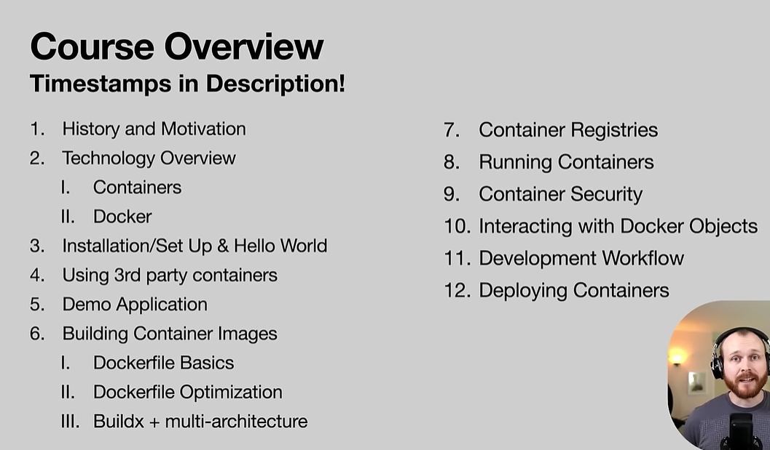

Development | Deployment
To get the development environment setup and install postgres, mongodb and run this 5 scripts. Also change the configuration  run docker compose up | To deploy application, provision server running ubuntu, run

Docker :-
It is platform that helps the developers to build, share and run applications with the container.
Example :-
Single Developer work on a project with is running on x version and if another developer joins him after two year and he make a setup of the project, then he faces the version issue because in 2 years, the version of software gets change, etc.

Docker is the solution :- docker container has everything about the project like code, runtime, system tools, system libraries and settings with the specific version.
We use this container to build, run and share the code or project.

Container
Node js 16
Npm 13.2
Angular 14

Now if any developer have to setup the project even after many years, he just has to run the container. It is responsibility of the container to install the necessary software which are mention inside the container.
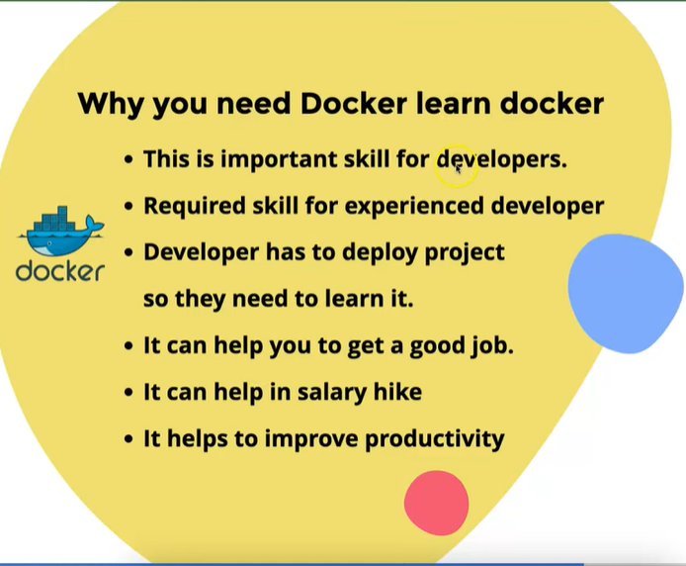\
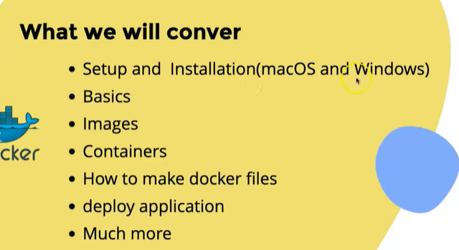
- Install docker in windows
- Download docker from official website
- Install docker
- Check docker is installed or not

- What is image and container?
Images :- image are template of the project
Container :- running instance of the image

- Docker Image :
- It is kind of ready to use software read-only template.
- Image is made with the source code, library, external dependencies and tools.
- Image cannot be updated
- If we want to make change in the image then we have to make new image
- Image cannot run directly
- We can say that image is the template of the project.

- Docker Container
- It is process that runs the applications with the images
- Container is isolated process [it does not dependent on the version installed on our system.
Eg. If our project requires node 16 and node 20 is installed on our pc then it will run on node 16 only. It does care whether node is installed on our pc or not which version is installed]
- It run independently on computer.

- Docker tool and docker Desktop
Docker hub mainly contains the image which we have to use.
There are two types of the images:-
- The image that we create for our project
- The parent image require in some cases
Docker desktop gives more options than docker hub.

- Base Image Or Parent Image
The image is template of the project. [Library, code, tools, etc.]
Sometimes, project needs another image of programming language or other Library.
Eg. Node js project needs a base image of the node js.

How is image build?

Docker File [Build] Docket Image [Run] Docker Container
Eg. We cannot make node image, node image can only build by those who have made node.
We can just pull the node image and add that image to our image.
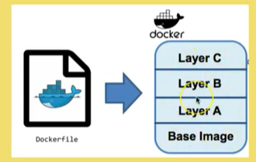

- Pull image and run container
Image pull or download image is same thing.
Pull or download image :- using docker hub Or Docker desktop

We can do all the stuff using docker command or using Docker desktop.
We don’t have to worry about the path where we write the command in cmd because we can write docker command and where as it is globally installed.

- docker pull node :- it is used to pull image of node
- docker run -it node /bin/bash :- it is used to run the image on container

Make docker file and make docker image :-
- Create a file for docker
- Add docker extension
- Write code in docker file for image
- Run the docker file and build the image
- Check image in the docker desktop

- Create dockerfile
# Start with Java base image
FROM openjdk:17-jdk-slim

# Set working directory inside the container
WORKDIR /app

# Copy the jar file
COPY target/*.jar app.jar

# Run the jar file
ENTRYPOINT ["java", "-jar", "app.jar"]

- Build docker image
docker build -t my-springboot-app .

- Container with project image
How to run container with project image
Assign port to container
Random port and no port on container
Test running app in container

- Docker Ignore file :-
If we create docker image and if we want that specific file or folder is should not be add to the docker image then we can add it to .dockerignore file.

- Delete docker image and docker container
Delete image with docker desktop
Delete container with docker desktop
Delete operation with terminal and cmd
Delete image and container forcefully :-
docker image/container rm imagename/containername -f [respectively]
remove -f to not remove image or container forcefully

- Manage versions of the images
- What is image version?

- How to make image version
docker build -t appname:versionname
docker build -t springoauth:v2

- Delete all image and container :- docker system prune -a
- Run docker container from terminal with version
- docker run --name any-container-name-we wish-v1 -p imageport:ourapplicationport
- docker run --name basic-app-comtainer-v1 -p 5500:5500
- Volume in docker
- What is volume in docker
- Continues change in the container with volume.
- Add nodemon and update docker file
- Create volume and update container

- Compose File in docker
- What is use of compose file?

- How to make compose file
- Write commands in file
- Run compose file

- Docker hub
- What is docker hub
- Make account and login
- Make image and push on docker hub
- How to pull image from docker hub.

docker run -it 8080:8080 imagename
docker run -it -p portinsidecontainer:exposeportintomymachine imagename

docker run -it -p 8080:8080 imagename

Docker compose file :-

