Jenkins
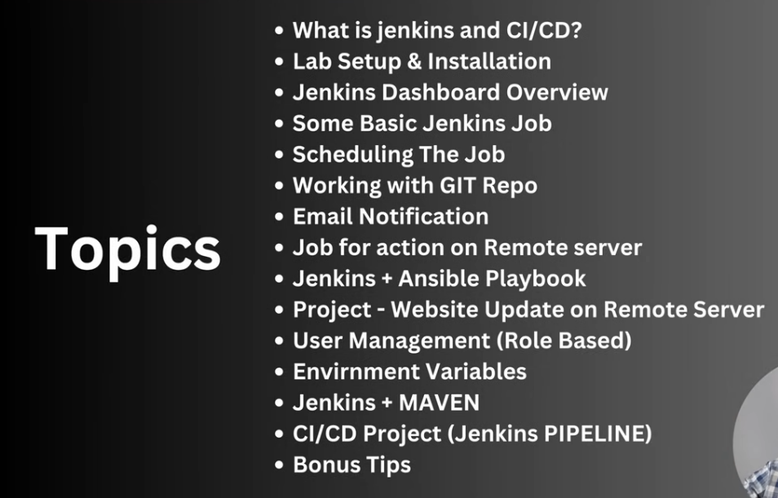
- What is Jenkins :-
- it is am open source automation server.
Automate various part of the software development.
Deploy
Testing
Building

- Features of Jenkins
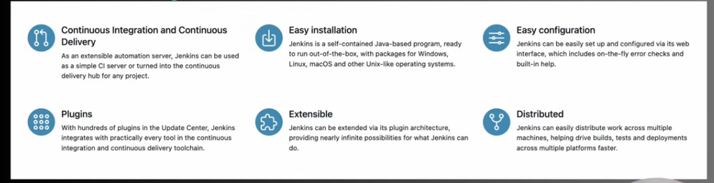

- What is CI/CD ?
- It is method of frequently delivering apps to the customers by introducing automation into stages of the app development.
