TRI CLOUD ESSENTIALS
- Topic: Azure I — Cloud Fundamentals and Storage
- Date: 21st October 2026

1. Azure Subscriptions, Resource Groups, and Cloud Concepts
Cloud computing means renting computing power, storage, and software over the internet instead of buying and running your own servers.
Azure is Microsoft's cloud platform, a large collection of such services running in Microsoft data centers around the world.
Cloud idea | What it means in simple words
On-demand | You create what you need in minutes by clicking or running a command, with no waiting for hardware to be delivered.
Scalability and elasticity | You can add more power when the load is high and remove it when the load drops, so you are not stuck with too little or too much.
Pay-as-you-go | You are billed for what you actually use, such as hours of compute or gigabytes stored. This turns a large up-front hardware cost into a running cost.
High availability | Services are built so that one failed machine or building does not stop your application.
Global reach | You can place resources in many regions around the world, close to your users or your rules about where data must stay.
Service models. Cloud services are often grouped by how much the provider manages for you. The more the provider manages, the less you have to operate yourself.
Model | You manage | Azure example
IaaS (Infrastructure as a Service) | The operating system, software, and data. The provider manages the physical hardware. | Azure Virtual Machines
PaaS (Platform as a Service) | Only your application and data. The provider manages the servers and operating system. | Azure App Service, Azure SQL Database
SaaS (Software as a Service) | Just your own use of the finished software. | Microsoft 365
Where Azure runs. A region is a geographic area that contains one or more data centers, for example Central India or East US. Many regions also have availability zones, which are separate data center locations inside the same region, each with its own power, cooling, and network. Spreading a service across zones protects it if one location fails. When you create a resource you choose its region, and that choice affects cost, speed, and where your data physically lives.
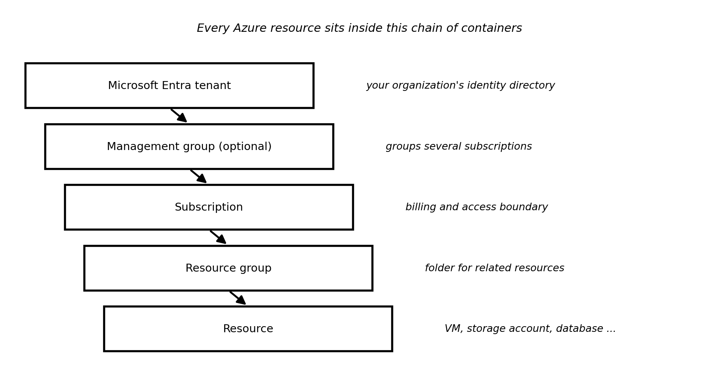
Diagram 1: The Azure organization chain, from the identity directory down to a single resource.
Term | Simple meaning
Tenant | Your organization's own private space in Microsoft Entra ID, which holds its users and groups. A subscription trusts exactly one tenant.
Management group | An optional folder that groups several subscriptions, so one policy or permission can be applied to all of them.
Subscription | The agreement under which you use Azure. It is the unit that is billed, and it is a boundary for access and limits. Companies often use separate subscriptions for development and production.
Resource group | A folder that holds related resources, such as everything for one project. Each resource lives in exactly one resource group, and deleting the group deletes everything inside it. Resource groups cannot be nested.
Resource | One actual service instance you create, such as a virtual machine, a storage account, or a database.
Tag | A small label (a name and a value, such as env = dev) attached to a resource or group, used to track cost, owner, or purpose.
Azure Resource Manager (ARM) | The management layer behind Azure. The portal, the command line, and templates all send requests through it, which is why they all behave the same way.
You can work with Azure in several ways: the Azure portal (a web page), Azure Cloud Shell (a command line in the browser), the Azure CLI (the az command), PowerShell, and infrastructure-as-code files such as Bicep. The commands below show the first steps with the CLI.
- Remember the order. Tenant, then subscription, then resource group, then resource. Cost is billed at the subscription, but you can read it per resource group or per tag.
- Use resource groups to clean up. Putting everything for one experiment in one resource group means a single delete removes it all, which stops surprise charges.
- Names and regions matter. A resource's region is chosen when it is created and usually cannot be changed later, so pick it deliberately.
Free account. A new Azure account usually includes a limited credit and some always-free services. The details change, so check the current offer on the Azure website, and delete unused resources to avoid charges.

2. Azure Compute and Storage Services
Compute in simple words. Compute is the part of the cloud that runs your code: it is the processors and memory. Azure offers several kinds, from full virtual computers that you manage to services where you only provide code.
Service | Simple meaning | Typical use
Virtual Machines | A computer in the cloud that you configure and manage like a physical one (IaaS). | Running software that needs full control of the operating system.
App Service | A managed home for websites and APIs; you upload code and Azure runs it (PaaS). | Web apps and back-end services.
Azure Functions | Small pieces of code that run only when triggered, and you pay only while they run. This is called serverless. | Reacting to events, such as a new file arriving.
Containers (Container Apps, Container Instances) | A container packs an application with everything it needs so it runs the same anywhere. | Running packaged applications without managing servers.
Azure Kubernetes Service (AKS) | A managed service for running and coordinating many containers. | Large applications made of many parts.
Azure Batch | Runs a large number of jobs in parallel on a pool of machines. | Heavy calculations, rendering, simulations.
Azure Databricks | A managed analytics platform built on Apache Spark, used throughout this document set. | Data engineering, analytics, and machine learning.
Storage in simple words. Storage is where data is kept. In Azure, most storage services live inside a storage account, which is a single account that groups your storage services and holds the shared settings, such as region, redundancy, and performance. A storage account name must be 3 to 24 characters, using only lowercase letters and numbers, and it must be unique across all of Azure because it becomes part of the web address.
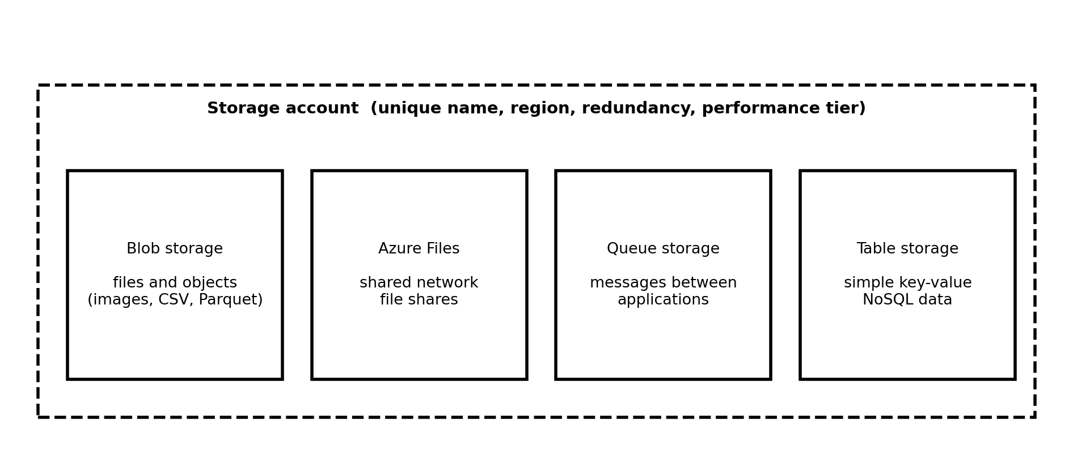
Diagram 2: One storage account can hold four different storage services.
Storage service | Simple meaning
Blob storage | Stores files and other unstructured data such as images, logs, CSV, JSON, and Parquet. This is the service used for data lakes. Blob stands for Binary Large Object.
Azure Files | A shared folder in the cloud that computers can open like a network drive.
Queue storage | A line of small messages that lets one application hand work to another.
Table storage | A simple store for structured key-value data without a fixed schema.
Managed disks | Disks attached to virtual machines. They are a separate resource, not part of a storage account.
Redundancy: keeping copies safe. Azure keeps several copies of your data so that a hardware failure does not lose it. The option you choose decides how far apart the copies are, and how much it costs.
Option | What it means
LRS (Locally redundant) | Three copies inside one data center. The cheapest option, protecting against disk and server failures.
ZRS (Zone redundant) | Copies spread across three availability zones in one region, so the data survives the loss of a whole data center.
GRS (Geo redundant) | LRS in the main region, plus a copy in a paired region far away, protecting against a regional disaster.
GZRS (Geo-zone redundant) | ZRS in the main region, plus a copy in the paired region. The strongest protection of the four.
Access tiers: paying less for cold data. Data that is read often should sit in a tier that is fast to read, and data that is rarely read can sit in a cheaper tier. Hot is for frequent access, Cool for data kept at least about a month, Cold for data kept longer, and Archive for data that is almost never needed. Archive data is stored offline, so it must be moved back to an online tier, which takes hours, before it can be read. You pay for the amount stored, for operations such as reads and writes, and for data that leaves Azure.
- Choose by the job. Use Blob storage for data files and data lakes, Azure Files for a shared drive, Queues for messages, and Functions or App Service when you only want to run code.
- Start with the standard account type. A general-purpose v2 storage account is the usual choice, and it is also the type used for Data Lake Storage Gen2.
- Redundancy is a cost decision. LRS is fine for practice and re-creatable data. Use zone or geo options for data that is hard to rebuild.

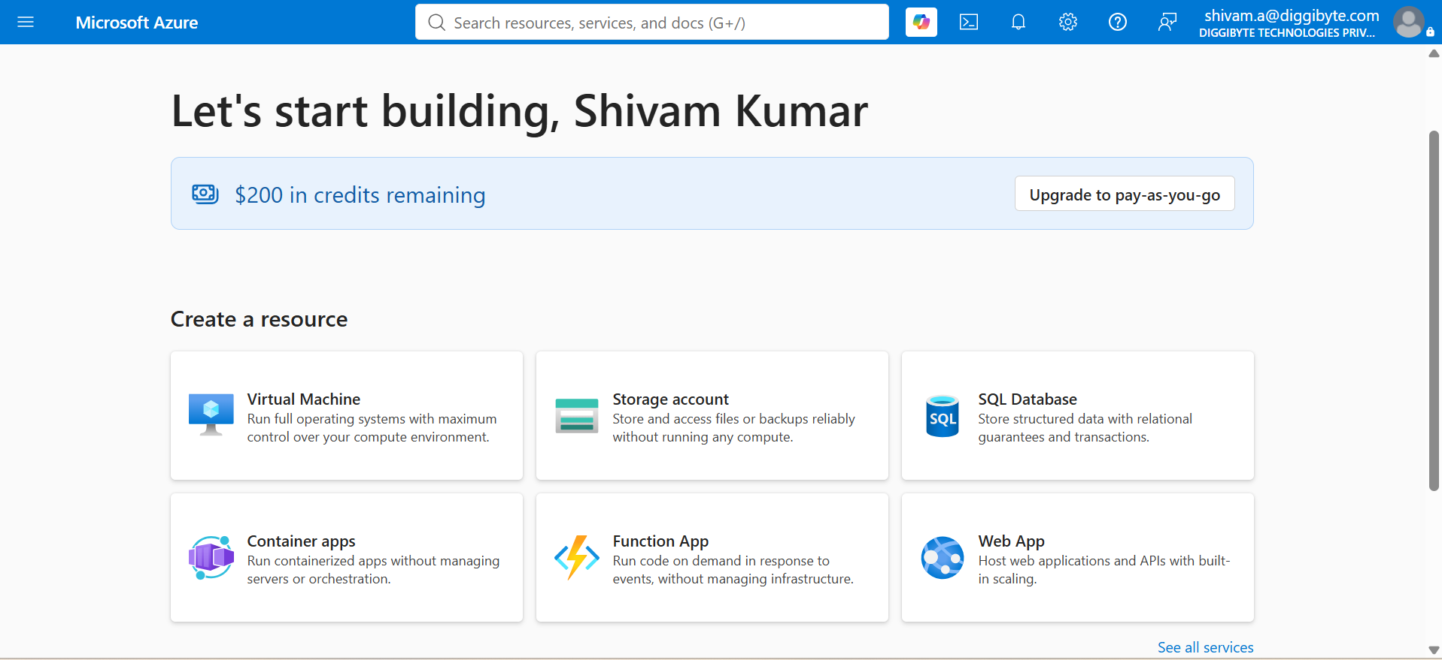

3. ADLS Gen2 Containers and Hierarchical Namespace
In simple words. A data lake is one central place that stores all of an organization's data in its original form, such as files from many systems, so it can be analyzed later. Azure Data Lake Storage Gen2 (ADLS Gen2) is the Azure service for this. It is not a separate product: it is a normal Blob storage account with one feature switched on, the hierarchical namespace.
Container. A container is the top-level box inside a storage account that holds your folders and files, much like a drive letter on a computer. In ADLS Gen2 terms a container is also called a file system, and the two names mean the same thing. A storage account can hold many containers, and permissions can be set on each one.
Hierarchical namespace (HNS). A namespace is the way names are organized. In ordinary Blob storage the namespace is flat: a name such as sales/2026/jan/orders.csv is just one long name that happens to contain slashes, and there are no real folders. With the hierarchical namespace enabled, the folders become real directories, arranged in a tree.
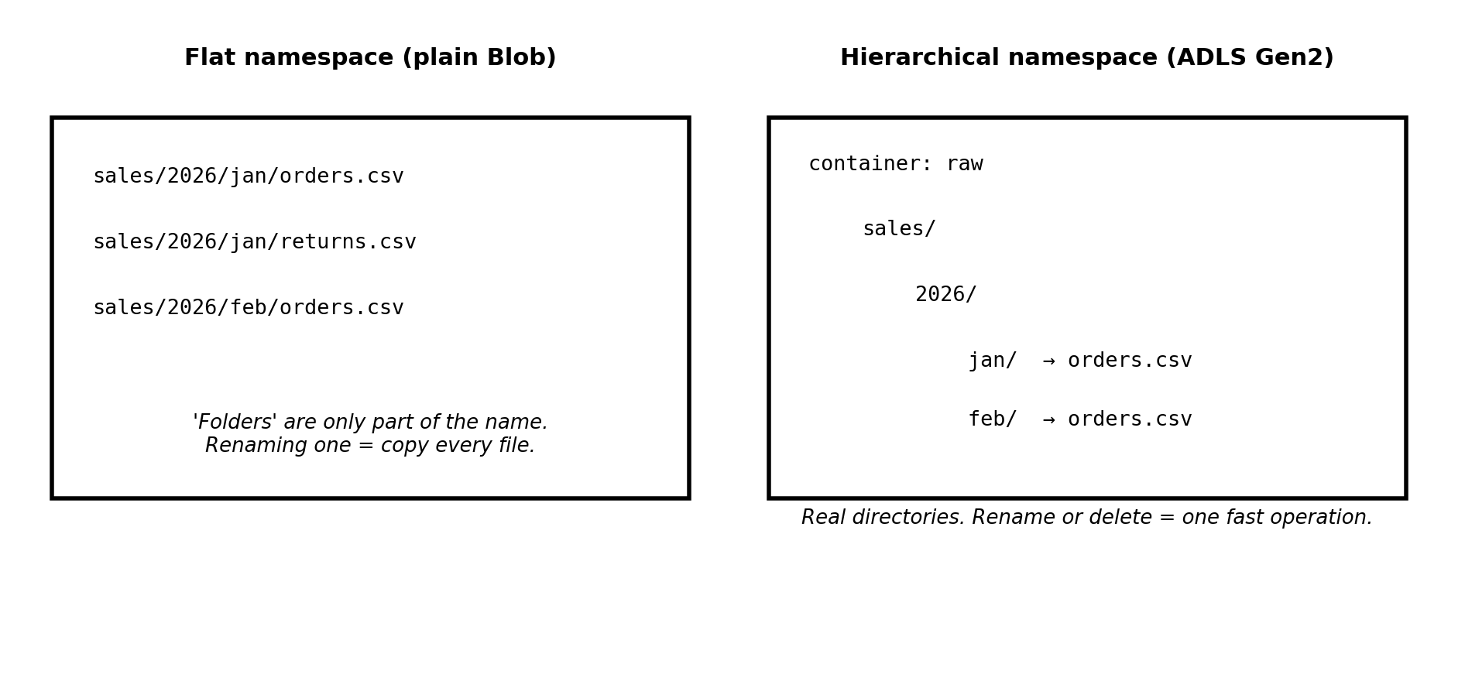
Diagram 3: A flat namespace only imitates folders, while a hierarchical namespace has real ones.
Difference | Flat namespace vs. hierarchical namespace
Rename or move a folder | Flat: every file inside must be copied and then deleted, one by one. Hierarchical: one quick, all-or-nothing operation, however many files the folder holds.
Delete a folder | Flat: each file is deleted separately. Hierarchical: the directory is removed in a single operation.
Analytics speed | Hierarchical is faster and safer for tools such as Spark and Databricks, which rename and move files constantly while writing results.
Permissions | Hierarchical adds POSIX-style access control lists (ACLs) on individual folders and files, on top of Azure's role-based access.
How access is controlled. Two layers work together. Azure role-based access control (RBAC) gives broad access to a whole account or container through roles such as Storage Blob Data Reader (read), Storage Blob Data Contributor (read and write), and Storage Blob Data Owner (full control, including setting ACLs). ACLs then give precise read, write, and execute permission on a particular folder or file. An important beginner point: general management roles such as Owner or Contributor let you manage the storage account itself, but they do not by themselves let you read the data inside. For the data you need one of the Storage Blob Data roles.
Addressing data. Spark, Databricks, and other analytics tools reach ADLS Gen2 through the ABFS driver, using an address of this form: abfss://<container>@<storageaccount>.dfs.core.windows.net/<path>. The s in abfss means the connection always uses encryption. The dfs endpoint is the Data Lake endpoint, while the blob endpoint is the ordinary Blob one, and a hierarchical account can be reached through both.
# Create a storage account with the hierarchical namespace turned on
az storage account create \
--name stdatalakedev001 \
--resource-group rg-tricloud-dev \
--location centralindia \
--sku Standard_LRS \
--kind StorageV2 \
--enable-hierarchical-namespace true \
--allow-blob-public-access false

# Create containers (file systems) and a directory inside one
az storage fs create --name bronze --account-name stdatalakedev001 --auth-mode login
az storage fs create --name silver --account-name stdatalakedev001 --auth-mode login
az storage fs directory create --file-system bronze --name sales/2026 \
--account-name stdatalakedev001 --auth-mode login

# Give a person the right to read and write data in the account
az role assignment create --assignee "<user-or-group-object-id>" \
--role "Storage Blob Data Contributor" \
--scope "/subscriptions/<sub-id>/resourceGroups/rg-tricloud-dev/providers/Microsoft.Storage/storageAccounts/stdatalakedev001"

# Address a file from Spark or Databricks
# abfss://bronze@stdatalakedev001.dfs.core.windows.net/sales/2026/orders.csv
- Decide at creation. Choose hierarchical namespace when the storage account is created. Turning it on later for an existing account is possible only through a special upgrade process with limitations, so it is best planned from the start for analytics data.
- Plan the layout. A common design uses one container per stage, such as bronze, silver, and gold (the medallion layers from the Databricks sessions), with folders by source and by date inside, for example sales/2026/10/.
- Avoid many tiny files. Large numbers of very small files slow analytics down, so data is usually written in fewer, larger files.
- Link to Databricks. In Databricks, a storage credential and an external location (Unity Catalog documentation) are how a workspace is given governed access to exactly this kind of container.
Keep it private. Turn off public blob access and grant access through roles, so data is never open to the internet by accident.

