MERCORA INTERNATIONAL
Consulting · Technology · Business Transformation
Flat No.212, 2nd Floor, Prime Legend, Botanical Garden Road, Kondapur, Hyderabad – 500084

WEBSITE CONTENT MASTER DOCUMENT

Final content brief with real logos, NAC product images & clean team profiles

Prepared for | Web Development Team
Version | V1 — July 2026
Contact | info@mercorainternational.com | +91 76800 77222
Classification | Confidential — Internal / Authorised Partners Only

PAGE 1 — HOME PAGE

1. Home Page

1.1 Hero / Banner
Headline (H1):
Empowering Enterprises. Transforming Communities. Connecting the World.

Brand Tagline (use site-wide):
Consulting · Technology · Business Transformation

Intro line:
Mercora International partners with enterprises, governments, startups, and institutions to engineer scalable, innovation-led solutions across 11 business verticals.

CTA Buttons:
- Primary: Explore Our Services → /services
- Secondary: Get in Touch → /contact

🖼 IMAGE SLOT: HERO BANNER — 3 rotating slides: drone over farmland | consulting boardroom | trade/globe. Size: 1920x700 px JPG.

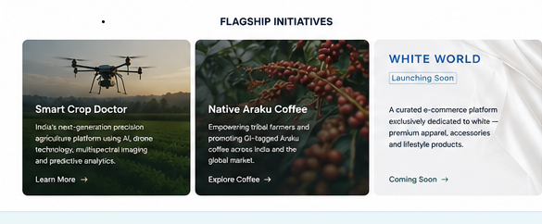

1.2 Business Verticals Strip
Display as 11 icon-tiles. Verticals: AgriTech & Precision Agri · Digital Transformation · Global Trade · Healthcare & Wellness · Education & Skilling · Financial Advisory · Textile & Apparel · NextGen Innovation · Women Empowerment · Arts & Culture · CSR & Sustainability

1.3 About Mercora (Snapshot)
Mercora International is a registered partnership firm (Firm Reg. 2978/2025, Ranga Reddy, Telangana), incorporated 29-Jul-2025, based in Kondapur, Hyderabad.

11+  Business Verticals | 7  Signed MOUs | 18  MOU Engagements

1.4 Featured Highlights
Smart Crop Doctor (AgriTech):
AI + drone + multispectral imaging platform for crop monitoring, disease diagnostics, and yield optimisation. DPIIT recognised (DIPP258473).
WHITE WORLD (Launching Soon):
Curated e-commerce platform for premium white apparel, accessories, and lifestyle products — powered by Mercora's Textile & Apparel vertical.
Native Araku Coffee:
Authorised Franchise Development Partner for India's GI-tagged specialty coffee from the Araku Valley. MOU with SERP, AP for 100 Women-Driven Coffee Shops.

1.5 Partner Logos
8 confirmed signed-MOU partner logos — embedded below. Web developer: extract each logo and use in the partner strip.

 |  |  | 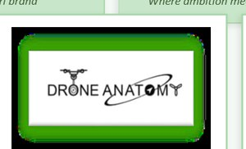
Native Araku Coffee  GI-tagged specialty coffee | KavachApp  SaaS platform partner | APT IT Solutions  ISO 9001:2015 tech partner | Drone Anatomy  Agri drone tech partner
 |  | 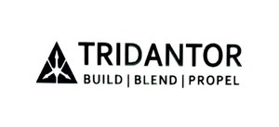 | 
Mindsmith  EdTech collaboration | RishiPal Gupta & Sons  Spices & agri-produce | Tridantor  Defence deep-tech / iDEX | VFS Education Services  Education services partner

On clicking each logo
📌 NOTE: Extract logos from this document or use the source PNG files from the project folder. Display at consistent 60px height on white/light background strip.

1.6 CTA Band

On clicking each logo CTA button: "Explore Drone Solutions" or "Contact Mercora for Drone Services".
Drone Anatomy – Strategic Drone Technology Partner
Mercora International is proud to be associated with Drone Anatomy (Dastrionics Technologies Private Limited), a leading Indian drone technology company and manufacturer of DGCA-approved, type-certified drone solutions. Through this strategic partnership, Mercora International and Drone Anatomy deliver advanced drone spraying services, precision agriculture solutions, drone surveying and mapping, mining surveys, aerial scanning, GIS mapping, orthomosaic generation, volumetric analysis, mine planning support, stockpile measurement, drone-based inspections, and digital monitoring services across agriculture, mining, infrastructure, construction, environmental monitoring, and industrial sectors. The collaboration also supports the establishment of Drone Service Centres, technical training, maintenance support, and drone-enabled project execution for government, enterprise, mining companies, infrastructure developers, and private-sector clients. While Mercora International provides consulting, business development, project management, mining advisory, and client engagement services, Drone Anatomy contributes cutting-edge drone technology, aerial survey expertise, geospatial analytics, and operational capabilities. Together, the partnership is committed to accelerating the adoption of drone technology, precision farming, mining drone surveys, mine monitoring, digital mapping, infrastructure inspections, volumetric analysis, and smart industrial solutions across India.

On clicking each logo CTA button KavachApp – Strategic SaaS Technology Partner
Mercora International is proud to be associated with KavachApp (Arisetty Technologies Private Limited), a leading SaaS technology provider delivering secure, scalable, and business-ready digital solutions. Through this strategic partnership, Mercora International and KavachApp collaborate to provide white-labelled SaaS platforms, digital transformation solutions, business automation software, workflow management systems, enterprise applications, subscription-based software services, client onboarding solutions, and cloud-based business platforms under the Mercosys ecosystem. The partnership enables organizations, startups, SMEs, educational institutions, and enterprises to accelerate digital adoption through innovative technology solutions, seamless implementation, user training, technical support, and ongoing platform enhancement. While Mercora International leads consulting, business development, client engagement, and solution advisory services, KavachApp provides the underlying SaaS technology, platform management, product innovation, and technical expertise. Together, the partnership is committed to driving digital transformation, SaaS adoption, business process automation, cloud solutions, enterprise software implementation, and technology-enabled business growth across diverse industries.

On clicking each logo CTA button APT IT Solutions – Strategic Digital Transformation & Technology Partner
Mercora International is associated with APT IT Solutions, a leading information technology and digital solutions company specializing in custom software development, web and mobile application development, e-commerce solutions, UI/UX design, digital marketing, SEO services, enterprise software development, learning management systems (LMS), and IT consulting services. Through this strategic partnership, Mercora International and APT IT Solutions collaborate to deliver innovative digital transformation solutions, business automation platforms, enterprise applications, cloud-enabled systems, e-governance solutions, website development, mobile applications, and technology consulting services for startups, SMEs, enterprises, educational institutions, and government organizations. While Mercora International leads consulting, business development, project management, and client engagement, APT IT Solutions provides technology expertise, software engineering, application development, digital marketing, and implementation support. Together, the partnership helps organizations accelerate digital transformation, business growth, process automation, customer engagement, operational efficiency, and technology-driven innovation across diverse industries.
On clicking each logo CTA Tridantor – Strategic Defence, Disaster Response & Critical Infrastructure Technology Partner
Mercora International is associated with Tridantor Ideaus Private Limited, a deep-technology company specializing in defence technology, disaster response solutions, critical infrastructure monitoring, AI-powered surveillance, advanced sensing systems, edge computing, intelligent decision support systems, and secure communication technologies. Through this strategic partnership, Mercora International and Tridantor collaborate to deliver innovative solutions for defence modernization, homeland security, disaster management, smart infrastructure monitoring, public safety systems, government technology programs, and critical asset protection. The collaboration includes government advisory, strategic consulting, grant and funding support, institutional partnerships, business development, technology commercialization, investment facilitation, and market expansion initiatives. While Mercora International provides consulting, stakeholder engagement, government liaison, strategic partnerships, and business growth support, Tridantor contributes advanced technology platforms, deep-tech innovation, AI-driven analytics, monitoring systems, and domain expertise. Together, the partnership is focused on advancing defence innovation, disaster resilience, critical infrastructure security, public sector transformation, smart monitoring solutions, and next-generation technology adoption across India and global markets.

On clicking each logo CTA MindSmith – Strategic Mental Health, Wellbeing & AI Innovation Partner
Mercora International is associated with MindSmith Private Limited, an innovative health-tech and wellbeing company specializing in mental health assessments, employee wellbeing programs, behavioral analytics, AI-powered wellness solutions, digital counselling platforms, educational wellbeing programs, and preventive mental healthcare services. Through this strategic partnership, Mercora International and MindSmith collaborate to promote and deliver transformative solutions including Brain Health Profile (BHP), Life Lanes™, SKYE AI, mental wellness assessments, employee assistance programs (EAP), organizational wellbeing initiatives, student wellness programs, and AI-driven behavioural insights for government organizations, public sector enterprises, corporates, educational institutions, and community ecosystems. While Mercora International leads business development, stakeholder engagement, strategic partnerships, market expansion, and client relationship management, MindSmith provides specialized mental health expertise, wellbeing technologies, AI-powered platforms, assessment tools, and service delivery capabilities. Together, the partnership is committed to advancing mental wellness, workforce wellbeing, emotional resilience, educational wellbeing, AI-enabled healthcare innovation, preventive mental healthcare, and holistic human development across India and global markets.

On clicking each logo CTA RishiPal Gupta & Sons – Strategic Spices, Agri-Trade & Global Market Expansion Partner
Mercora International is associated with RishiPal Gupta & Sons (RPGS), a leading spice manufacturing, spice processing, and spice trading company with over seven decades of industry expertise. Through this strategic partnership, Mercora International and RPGS collaborate to drive spice exports, agri-food trade, international market expansion, import-export facilitation, business development, investment advisory, supply chain growth, and global buyer-seller networking across domestic and international markets. The collaboration focuses on market research, export promotion, regulatory compliance, trade consultancy, portfolio development, international partnerships, food and agri-business expansion, trade exhibitions, buyer-seller meets, and women entrepreneurship initiatives within the agri-food sector. While Mercora International provides consulting, trade advisory, global market access, investment facilitation, and business growth support, RPGS contributes its expertise in spice manufacturing, sourcing, processing, quality assurance, distribution, and international trade operations. Together, the partnership is committed to advancing Indian spice exports, agri-business growth, food processing innovation, global trade opportunities, sustainable supply chains, and women-led entrepreneurship across India and international markets.

On clicking each logo CTA button VFS Education Services – Strategic International Education & Study Abroad Partner
Mercora International is associated with VFS Education Services, a global education consulting and student mobility organization specializing in study abroad programs, international admissions, university applications, student counselling, visa assistance, career guidance, document verification, and overseas education services. Through this strategic partnership, Mercora International and VFS Education Services collaborate to support students in accessing international higher education opportunities, STEM programs, university admissions, student visa processing, academic counselling, career planning, scholarship guidance, and global education pathways across leading universities and institutions worldwide. The collaboration focuses on student recruitment, application facilitation, document verification, admission support, visa advisory, pre-departure guidance, accommodation assistance, and end-to-end international education services. While Mercora International provides outreach, student engagement, counselling support, and market development, VFS Education Services contributes educational expertise, university partnerships, admissions processing, visa facilitation, and student success services. Together, the partnership is committed to empowering students through global education opportunities, international career pathways, higher education access, STEM learning programs, and world-class study abroad solutions.

On clicking each logo CTA button Native Araku coffie

Native Araku Coffee – Premium GI-Tagged Specialty Coffee from Araku Valley
Mercora International is the authorised Franchise Development Partner for Native Araku Coffee (NAC), a premium GI-tagged specialty coffee brand from Araku Valley, Andhra Pradesh. Native Araku Coffee is renowned for its single-origin coffee, organic coffee cultivation, shade-grown Arabica and Robusta beans, tribal farmer-sourced coffee, and authentic South Indian filter coffee blends. Through this partnership, Mercora promotes coffee distribution, franchise opportunities, wholesale coffee supply, retail coffee partnerships, corporate gifting solutions, café development, and coffee business expansion across India. This page showcases the Native Araku Coffee product range, subscription plans, distributor opportunities, and customer enquiry options for individuals, retailers, wholesalers, HoReCa businesses, corporate buyers, and aspiring coffee entrepreneurs seeking premium Indian specialty coffee.

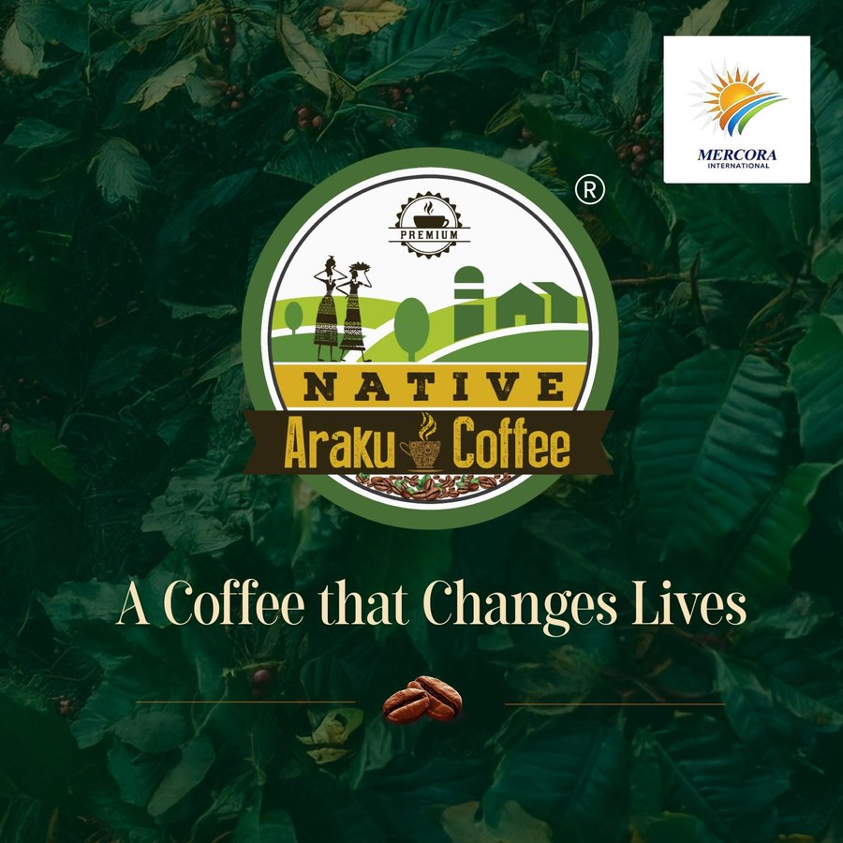
Native Araku Coffee — A Coffee that Changes Lives

About Native Araku Coffee
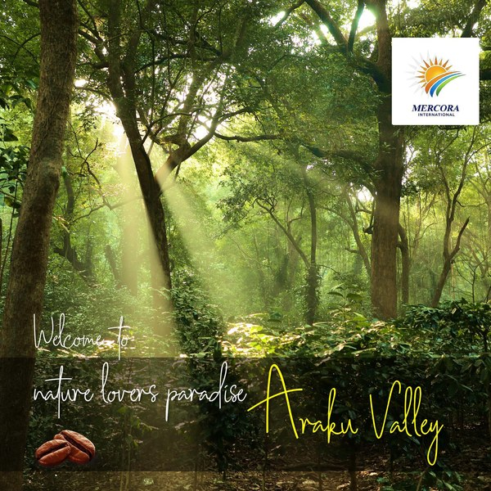
Araku Valley — Where every cup begins

- GI-tagged specialty coffee from Araku Valley, Andhra Pradesh — Arabica & Robusta varieties
- Grown at 800–5,000 MSL by 1,00,000 tribal farming families across 1.5 lakh acres
- 100% shade-grown, organically cultivated; 14,000 metric tons annual production
- Sourced directly from farmers — a % of every sale supports tribal welfare programmes
- MOU with SERP, AP Government — establishing 100 Women-Driven Coffee Shops

Our Selective Collection
The search for perfection — every bean hand-selected for quality, aroma, and flavour.
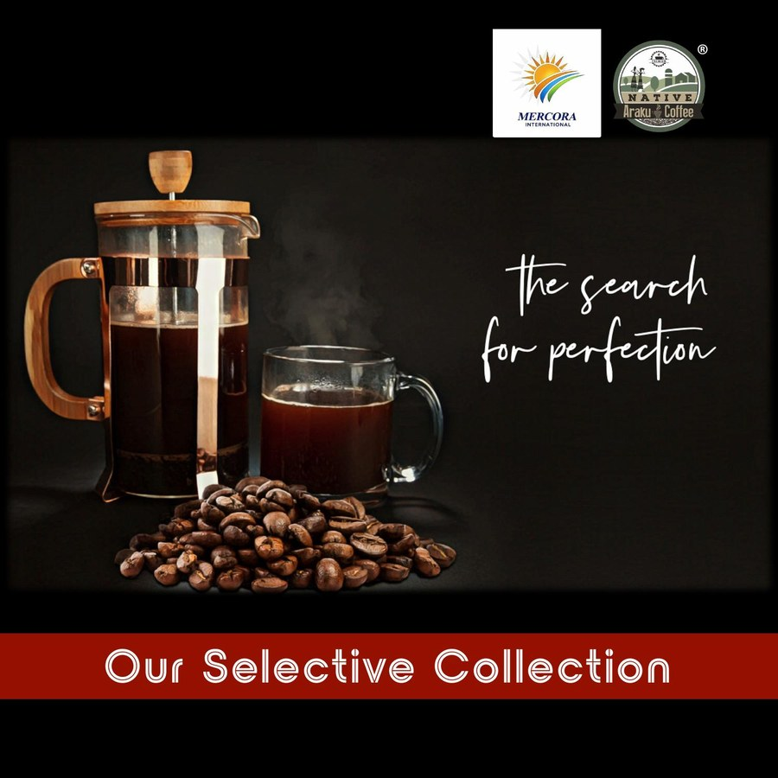
Our Selective Collection — Native Araku Coffee

Our Premium Collection
Available across three signature powders and two bean formats — each roasted to perfection.
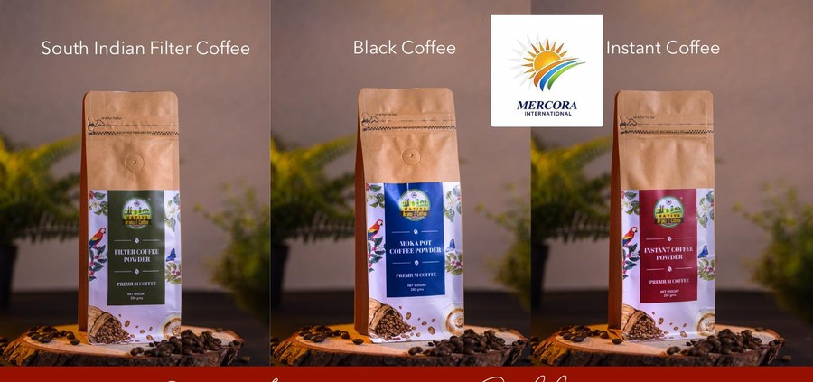
South Indian Filter Coffee · Black Coffee (Moka Pot) · Instant Coffee

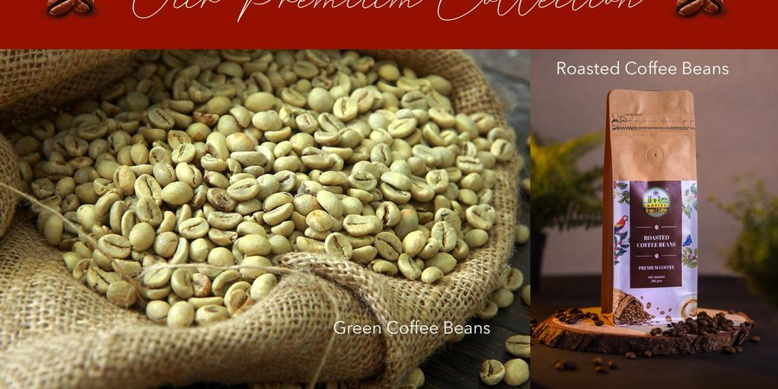
Green Coffee Beans (raw) · Roasted Coffee Beans

Product Catalogue:
Product | Description
South Indian Filter Coffee Powder | Classic medium roast; rich chocolate and caramel notes; ideal for traditional filter preparation
Moka Pot / Black Coffee Powder | Bold, full-bodied dark roast for moka pot and stovetop brewing
Instant Coffee Powder | Premium convenience coffee; smooth and aromatic; dissolves instantly
Green Coffee Beans | Raw, unroasted single-origin beans for home roasters and specialty cafes
Roasted Coffee Beans | Premium whole-bean roast for espresso, pour-over, and drip coffee

Signature Collection
Beyond coffee — a curated range of indulgent coffee-infused delicacies.
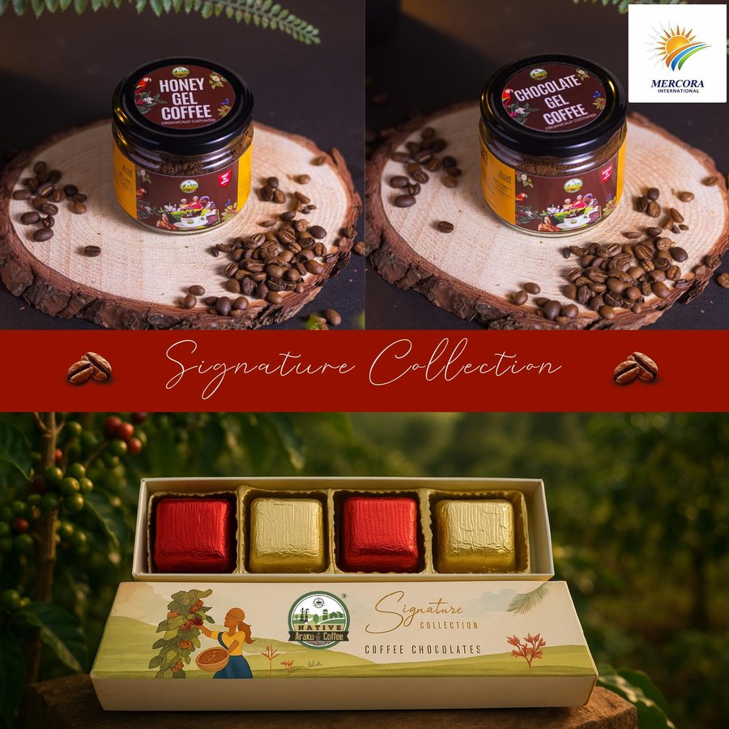
Honey Gel Coffee · Chocolate Gel Coffee · NAC Coffee Chocolates

Product | Description
Honey Gel Coffee | Organically cultivated honey blended with Araku coffee — a natural energy infusion
Chocolate Gel Coffee | Rich coffee-chocolate gel; a unique flavour fusion from the Araku valley
NAC Coffee Chocolates (Signature Box) | Premium coffee chocolates in a gift-ready box — ideal for corporate and personal gifting

Sustainable Collection
Made from coffee and rice waste husk — eco-friendly, durable, and beautifully crafted.
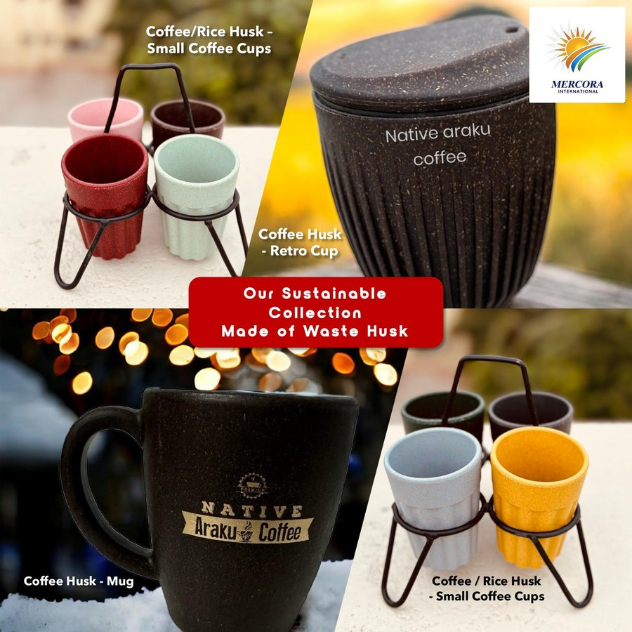
Sustainable Collection — Made of Waste Husk

Product | Description
Coffee/Rice Husk Small Cups | Colourful eco-cups made from agricultural waste husk; set with stand
Coffee Husk Retro Cup (Large) | Branded retro-style tumbler with lid; 100% husk-derived material
Coffee Husk Mug | Classic mug with Native Araku Coffee branding; sustainable everyday use

Distributor / Customer Enquiry
- Full Name * | Business Name | City / State * | Contact * | Email *
- Enquiry Type * [Retail Distributor / Wholesale / HoReCa / Corporate Gift / Personal / Franchise]
- Monthly Volume [<10 kg / 10-50 kg / 50-200 kg / 200 kg+]
- Message / Requirements [Text area]
- Submit — WhatsApp/Email alert to Mercora team

PAGE 2 — ABOUT US

2. About Us Page

2.1 Company Introduction
Mercora International is a multidisciplinary consulting, technology, and business transformation company. We partner with enterprises, government bodies, startups, and institutions to engineer scalable, innovation-led solutions that deliver measurable impact across industries and geographies.
Our integrated service ecosystem spans AgriTech, Digital Transformation, Global Trade, Healthcare, Education, Financial Advisory, Textile & Apparel, NextGen Innovation, Women Empowerment, Arts & Culture, and CSR — positioning Mercora as a trusted catalyst for sustainable development and economic growth.

🖼 IMAGE SLOT: ABOUT HERO — Professional photo of founders together at office/event. Size: 1200x500 px.

2.2 Vision & Mission
Vision:
To be a globally trusted innovation and consulting partner — empowering entities through technology, sustainability, and strategic growth.

Mission:
- Accelerate adoption of emerging technologies
- Build sustainable and scalable ecosystems
- Empower communities through entrepreneurship and skill development
- Deliver measurable business value through innovation, expertise, and operational excellence

2.3 Company Journey
Milestone | Description
29 Jul 2025 | Mercora International incorporated — Partnership Deed signed. Firm Reg. No. 2978/2025, Ranga Reddy, Telangana
24 Aug 2025 | Udyam Registration UDYAM-TS-02-0265208 issued — classified Micro Enterprise
Sep–Oct 2025 | First MOUs signed: MindSmith (EdTech), APT IT Solutions (IT), RishiPal Gupta & Sons (FMCG)
Nov 2025 | Native Araku Coffee MOU signed — Mercora appointed Franchise Development Partner
2025–2026 | Smart Crop Doctor platform built; ALEAP loan confirmed; digital transformation mandates activated
29 Apr 2026 | DPIIT Startup India recognition issued — DIPP258473 (Agriculture/AgriTech); valid to 01-Jul-2035
Apr–May 2026 | Drone Anatomy–Mines (27 Apr), Tridantor Defence/iDEX (04 May), KavachApp (06 May) — all signed
08 Jun 2026 | IEC code ACEFM7191A issued by DGFT Hyderabad — Global Trade vertical activated
Jul 2026 | 11 verticals active · 7 signed MOUs · GSTIN 36ACEFM7191A1ZB confirmed

2.4 Leadership Team
Display as professional profile cards — 2-column grid on desktop. Each card shows photo, name, designation, and bio.

Mrs. D. Jaya Geetha Kiran — Founder & Managing Partner

Mrs. D. Jaya Geetha Kiran — Founder & Managing Partner
An entrepreneur with over 15 years of cross-industry leadership (M.Sc Computer Science) spanning HR, Operations, Pharmaceutical Manufacturing, Compliance, and Strategic Management. She steers Mercora's strategic vision, business ecosystem development, and its commitment to innovation, inclusive growth, and women entrepreneurship across global markets. She promotes farmers to agri-entrepreneurs, drives grassroot-to-global initiatives, and champions renewable energy and waste-to-energy innovations — converting household waste into biofuels and sustainable energy resources.

Ms. A. Manasa Raj — Co-Founder & Partner

Ms. A. Manasa Raj — Co-Founder & Partner
A strategic leader focused on innovation ecosystems, entrepreneurship development, arts, culture, heritage promotion, and scalable business platforms for rural communities and AgriTech initiatives. She drives Mercora's community impact programmes and fosters inclusive, partnership-led growth models across industry and social sectors.

Mr. Subbarao Kalluri — Technology Consultant

Mr. Subbarao Kalluri — Technology Consultant
A Digital Transformation and IT leader with 20+ years of experience in enterprise applications, programme management, quality engineering, and global technology delivery. A PMP®, PRINCE2®, CEH, and ISO-certified professional, he anchors Mercora's technology consulting practice and leads digital modernisation mandates for enterprise clients.

Dr. Tayjaswni Jatiieen Bhilare — Head, Strategic Market Expansion & Business Development

Dr. Tayjaswni Jatiieen Bhilare
A distinguished educationist, social entrepreneur, and community leader holding an M.A., B.Ed., and Doctorate in Education Management (SORBON University). With decades of leadership in education and rural development, she is a multi-award recipient — including the Bhaskar Award (2017), Sakaal Women Idol Award (2022), Jhansi Ki Rani Award (2023), and Satara Pride Award (2025). She brings exceptional expertise in strategic market expansion, stakeholder engagement, and large-scale social impact livelihood programmes.

Mrs. Swarna Prabha — Head, Administration, Strategic Partnerships & FPO Relations
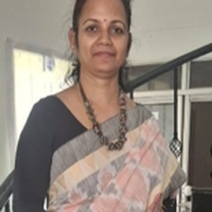
Mrs. Swarna Prabha
An MBA professional with 10+ years of experience in administration, coordination, stakeholder engagement, FPO partnerships, and client relationship management. Experienced in building strategic alliances, managing operations, facilitating business collaborations, and driving sustainable growth through strong industry and community networks.

K. V. R. S. S. Sasanka — Digital Media Operations Consultant

K. V. R. S. S. Sasanka — Digital Media Operations
A Digital Media specialist (BE, Information Technology) who joined Mercora in October 2025. He manages digital media operations, online presence, and content delivery across platforms, supporting all verticals with digital outreach and media strategy.

D. Veda Anjali — Youth Ambassador, White Brand Initiative
🖼 IMAGE SLOT: PHOTO — D. Veda Anjali. 400x400 px PNG, square crop.
A motivated Grade 10 student and Youth Ambassador for the White Brand Initiative at Mercora International. Passionate about sustainable fashion, social impact, and community development, she actively supports initiatives that promote inclusive growth and responsible apparel practices. She is particularly interested in empowering women tailors, tribal artisans, persons with disabilities, and underprivileged youth through skill development and livelihood opportunities. With her enthusiasm, compassion, and commitment to positive change, Veda Anjali represents the values of responsible leadership and community empowerment at the heart of the White Brand Initiative.

2.5 Gallery
- Event photos from ALEAP, Startup India, industry exhibitions
- Certificate images — DPIIT (DIPP258473), Udyam, IEC
- Award ceremony photos — Dr. Bhilare: Bhaskar 2017, Sakaal 2022, Jhansi Ki Rani 2023, Satara Pride 2025
- MOU signing ceremony photos — all 7 signed partners

🖼 IMAGE SLOT: GALLERY — 6–9 images, 3-column grid. JPG/PNG min 800x600 px each. Each image needs a short caption.

PAGE 3 — DIGITAL TRANSFORMATION & IT SERVICES

3. Digital Transformation & IT Services

Mercora architects and delivers end-to-end digital transformation strategies — spanning enterprise application development, cloud migration, AI/ML integration, SaaS platforms, and intelligent process automation.

🖼 IMAGE SLOT: IT SERVICES BANNER — Enterprise tech visual: code dashboard, server room, or consulting team. 1920x500 px.

3.1 Services Offered
Service | Description
Enterprise Program & PMO | End-to-end programme governance, PMO setup, multi-project coordination, reporting dashboards. Frameworks: PMP, PRINCE2, Agile/Scrum.
Software QA & Testing | Functional, regression, UAT, performance, automation testing. ISTQB-aligned. Tools: Selenium, Appium, JIRA.
Enterprise App Development | Custom web & mobile apps, API integration, ERP/CRM customisation, cloud-native solutions.
Cloud Migration & AI/ML | Cloud strategy, migration planning, AI model development, intelligent process automation.
SaaS Platform Delivery | White-label SaaS via Mercosys (KavachApp partnership); custom SaaS architecture & product management.
IT Consulting & Advisory | Technology strategy, digital transformation roadmaps, vendor management, IT governance, architecture reviews.
Intelligent Process Automation | RPA, workflow automation, data pipeline design — eliminating manual processes and unlocking efficiency.
Data Analytics & BI | Power BI dashboards, Excel financial models, SQL reporting, data platform advisory.
Managed IT Services | IT support, infrastructure monitoring, helpdesk for SMEs and mid-market clients.

3.2 Technology Stack
Category | Technologies
Programming & Dev | JavaScript, React, Node.js, Python, Java, SQL
Mobile | React Native, Expo, Android (APK)
Testing & QA | Selenium, Appium, Postman, TestRail, JIRA
Cloud | AWS, Azure (advisory), Google Cloud
Data & Analytics | Excel, Power BI, Python (Pandas/NumPy)
AI / ML | Python ML models, image classification, multispectral crop analytics
Project Management | Jira, MS Project, Confluence, Monday.com
Agriculture Tech | Drone data pipelines, multispectral imaging APIs, IoT integration

3.3 Project Enquiry Form
- Full Name * | Company Name * | Email * | Phone
- Service Required * [QA / Dev / PMO / Cloud / AI-ML / SaaS / Automation / Advisory / Other]
- Project Description * [Text area]
- Budget Range [Below Rs.5L / Rs.5-20L / Rs.20L-1Cr / Above Rs.1Cr / Not decided]
- Expected Start Date | Attach RFP/Brief [File upload]
- Submit — confirmation email auto-reply + CRM notification

3.4 Downloadable Resources
- IT & Digital Services Brochure (PDF) → [ACTION REQUIRED: provide final PDF]
- Smart Crop Doctor Product Sheet (PDF)
- Mercora International Corporate Profile (PDF)

PAGE 4— BUSINESS SOLUTIONS

4. Business Solutions Page

Mercora's Business Solutions vertical helps organisations navigate complexity, unlock new markets, and build sustainable competitive advantage through consulting, trade facilitation, franchise development, and technology advisory.

🖼 IMAGE SLOT: BANNER — Corporate boardroom / strategy discussion. 1920x500 px.

4.1 Services Offered
Service | Description
Franchise Development | End-to-end franchise expansion — market mapping, partner identification, onboarding, monitoring. Active: Native Araku Coffee.
Management Consulting | Strategic reviews, SOP development, go-to-market planning, feasibility studies, pitch preparation.
Global Trade Facilitation | Import/export documentation, Incoterms advisory, buyer-seller matchmaking, FOB/CIF structuring. IEC ACEFM7191A.
Audit, Compliance & Financial Advisory | Internal audits, GRC advisory, ESG framework alignment, financial due diligence.
Investment Facilitation | Investor decks, financial modelling, ROI analysis, government scheme advisory (SISFS, iDEX, SEED Fund).
Startup & MSME Advisory | DPIIT/Startup India recognition, Udyam, grant applications, investor readiness.
CSR & ESG | Programme design, ESG impact measurement, community development, climate action advisory.
White-Label SaaS (Mercosys) | Client-branded SaaS deployment via KavachApp / Arisetty Technologies.
Women's Entrepreneurship | Skill development, financial inclusion, incubation, and leadership acceleration for women entrepreneurs.

4.2 Results
- Smart Crop Doctor: ALEAP loan approved within 6 months of DPIIT recognition
- 7 signed MOUs across 18 partnership engagements
- Native Araku Coffee: franchise activated in Hyderabad; MOU with SERP AP for 100 Women-Driven Coffee Shops
📌 NOTE: [ACTION REQUIRED] Provide 2–3 quantified ROI examples from real engagements.

4.3 Proposal Request Form
- Full Name * | Designation | Company * | Email * | Phone *
- Industry / Sector * [Dropdown]
- Solution Type * [Franchise / Trade / Consulting / Investment / CSR / SaaS / Govt Bid / Other]
- Requirement [300-char text area] | Budget Range | Start Date | Attach Brief [File upload]
- Submit — CRM notification + auto-reply

PAGE 5 — INDUSTRIES WE SERVE
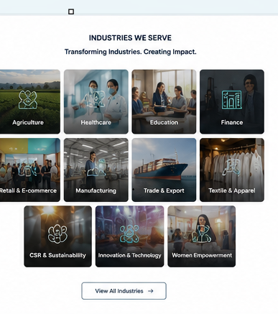

5. Industries We Serve

Mercora's integrated service ecosystem enables measurable impact across 11 industries and community sectors.

🖼 IMAGE SLOT: INDUSTRIES BANNER — Multi-sector collage (farm / hospital / factory / classroom / globe). 1920x500 px.

Agriculture & AgriTech
Smart Crop Doctor (AI + drone + multispectral imaging), Solar Water Pumping Systems (SITC + O&M), farmer-to-agri-entrepreneur transformation programmes.

Healthcare & Wellness
Corporate wellness solutions, preventive health programmes, digital health platform consulting and QA, community health access initiatives.

Finance & BFSI
Internal audits, GRC advisory, ESG alignment, BFSI software QA, regulatory compliance testing, financial due diligence.

Education, Skill & Entrepreneurship
Competency-based training, professional certification, startup incubation, innovation-led curriculum design, EdTech platform QA.

Retail, FMCG & Food & Beverage
Native Araku Coffee franchise & distribution, WHITE WORLD e-commerce (coming soon), retail consulting and SOP development.

Manufacturing & Supply Chain
ERP selection & QA advisory, supply chain consulting, export documentation and trade facilitation.

Textile & Apparel
Fabric innovation, sustainable manufacturing advisory, AI-driven design tools, WHITE WORLD e-commerce platform for premium white apparel.

Global Trade
Import/export facilitation (IEC ACEFM7191A), FOB/CIF documentation, NCNDA & trade contracts, buyer/seller matchmaking.

CSR & Sustainability
CSR programme design, ESG reporting, rural AgriTech deployment, tribal farmer linkage via Native Araku Coffee, waste-to-energy initiatives.

NextGen Startup & Innovation
Innovation labs, business model design, funding access (SISFS, iDEX, DPIIT), go-to-market strategy, venture acceleration.

Women's Empowerment
Entrepreneurial incubation, financial inclusion, leadership acceleration, 100 Women-Driven Coffee Shops initiative with SERP, AP.

🖼 IMAGE SLOT: INDUSTRY CARDS — One image per industry (11 total). 600x400 px JPG with caption.

MERCORA INTERNATIONAL — WEBSITE CONTENT MASTER DOCUMENT v5
Flat No.212, Prime Legend, Botanical Garden Road, Kondapur, Hyderabad – 500084
+91 76800 77222 | info@mercorainternational.com | www.mercorainternational.com

