MERCORA INTERNATIONAL
Website Update Observations
For the Web Team | Each instruction is shown next to the screenshot it refers to

Summary of changes
# | Page / area | Action
1 | Home – hero banner | Replace the hero text with the updated content
2 | Home – Flagship / Featured initiatives | Remove Native Araku Coffee; show Smart Crop Doctor, White World, VetiGo MobiCare (in this order)
3 | Home – Explore CTAs | Open the initiative pages (Annex A–C), not Digital Transformation & IT Services / Industries We Serve
4 | Footer – Key Verticals | Update here also
5 | Authoritative Partnership Dossiers page | Add 4 new partner write-ups with logos
6 | Partnerships / MOU list | Show MOU signed date next to each partner (date order, 11 partners)
7 | Authoritative Partnership Dossiers page | Explore CTAs not redirecting to the actual web content – fix
8 | Home – “8 Confirmed Signed-MOU Partners” and dossier strip | Remove from the home page (already shown in Partnerships)
9 | Team / profile photos and content | Add Sasanka photo; correct name D. VedAnjali + photo; update Jaya Geetha and Subbarao profiles
10 | Home – registrations, chips, credentials, MOU count | Telangana → Hyderabad; remove chips and credentials card; update to 11 signed MOUs
11 | Our Company Journey | Replace the timeline with the data given
A–C | Initiative pages | Smart Crop Doctor, White World, VetiGo MobiCare – content and layout reference

1. Home page – Hero banner content
ACTION
Update the hero content with the text below.

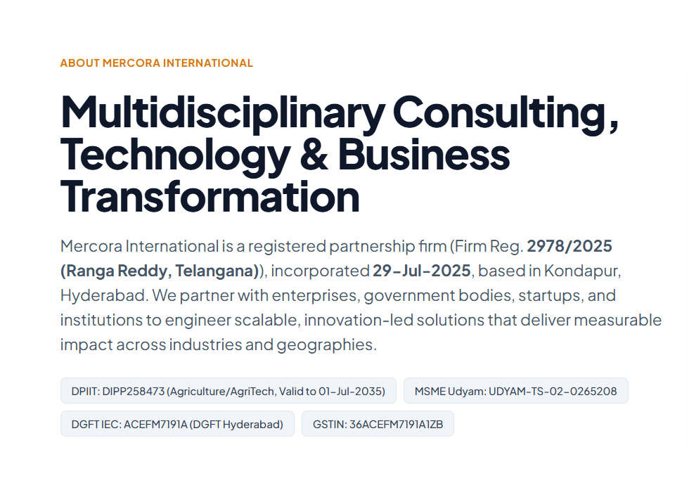
Current hero (for reference)

Updated content
Multidisciplinary Consulting, Technology & Business Transformation
Mercora International is a Hyderabad-based multidisciplinary consulting and business solutions firm, established as a registered partnership in Hyderabad, Telangana on 29 July 2025.
We partner with enterprises, government organisations, startups, MSMEs and institutions to deliver strategic consulting, technology-enabled solutions, business transformation and growth-oriented initiatives across diverse industries and geographies.
Our multidisciplinary business ecosystem spans IT and Digital Transformation, Artificial Intelligence, Robotics and Automation, Drone Technology, Precision Agriculture, Defence and Emerging Technologies, Healthcare and Insurance, Education and Wellbeing, Global Trade, Franchise Development, Testing and Certification, Renewable Energy and Sustainable Development.
Through strategic partnerships and collaborative engagements with specialised organisations, technology providers, industry experts and institutional stakeholders, we facilitate business development, market access, technology adoption, strategic alliances, investment opportunities and enterprise expansion.
We focus on transforming ideas into actionable business opportunities, connecting innovation with industry requirements, empowering entrepreneurs and communities, and enabling organisations to build scalable and sustainable business models.
At Mercora International, our vision is to create meaningful connections between business, technology, innovation and opportunity, delivering long-term value through collaboration, strategic execution and responsible growth.

2. Home page – Flagship / Featured initiatives
ACTION
REMOVE Native Araku Coffee from this section and show VetiGo MobiCare instead.
Follow this order: Smart Crop Doctor → White World → VetiGo MobiCare.
Use the content and images attached for Smart Crop Doctor and White World (see Annex A and B). Page layout and CTAs are attached for reference (FYR).

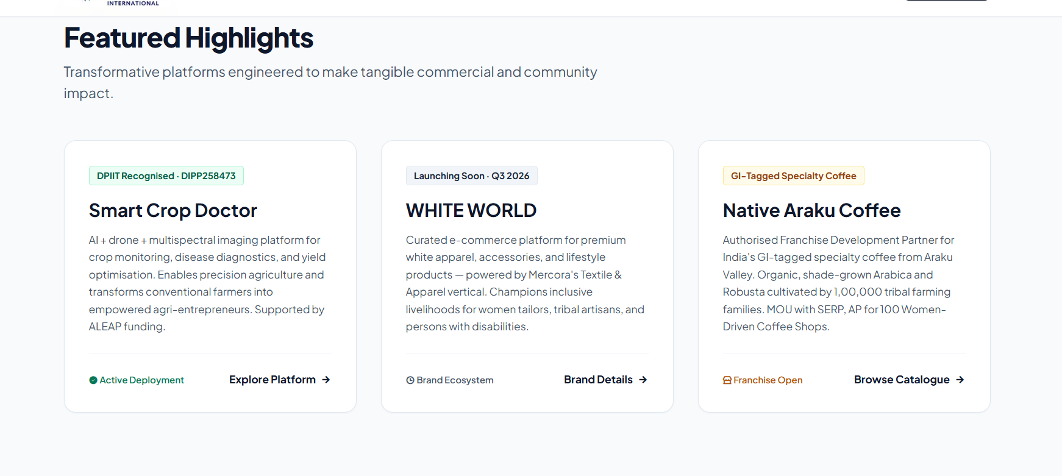  CURRENT – Native Araku Coffee is shown (remove) |   VetiGo MobiCare logo (use in the third card)
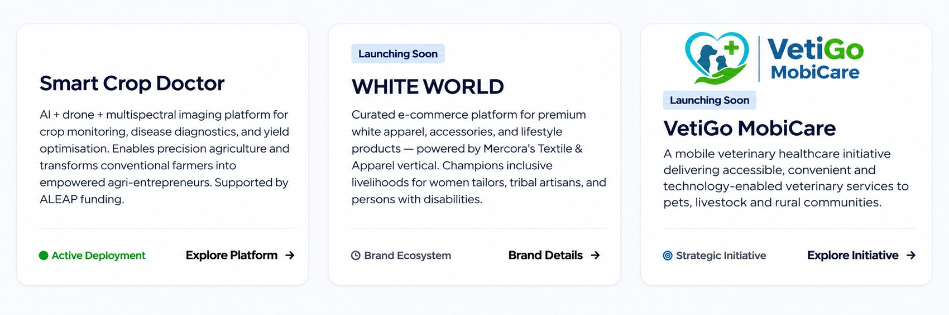
EXPECTED – Smart Crop Doctor, White World, VetiGo MobiCare
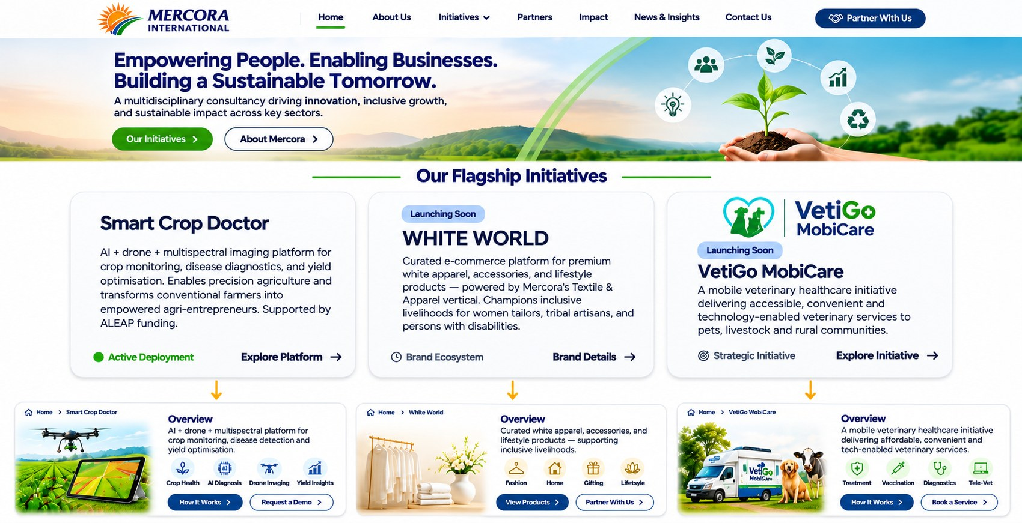
Page layout and CTA flow – reference. Each Explore CTA opens its own initiative page.

3. Explore CTAs – where they should go
ACTION
Below is the description of the content to show on clicking the Explore CTA.
The current demo website redirects to the Digital Transformation & IT Services and Industries We Serve pages. Please change this.
Order: Smart Crop Doctor, White World and VetiGo MobiCare – content and layout are given in Annex A, B and C.

4. Footer – Key Verticals
ACTION
Update here also.

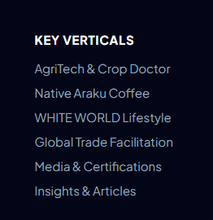
Key Verticals list – update to match the changes above

5. Authoritative Partnership Dossiers page(MOUs) – add partner details
ACTION
Please add these four partner write-ups, each with its logo.

Delhi Test House | Strategic Testing, Inspection & Certification Partner

Mercora International is associated with Delhi Test House (a unit of Delhi Test House Global LLP), an established testing, inspection, calibration and certification organisation with expertise in laboratory testing, quality assurance and regulatory compliance. Through this strategic collaboration, Mercora International and Delhi Test House work together on business development, market access, client introductions, industry partnerships and expansion opportunities across domestic and international markets. The collaboration focuses on connecting manufacturers, exporters, enterprises and institutions with reliable testing and certification services, including product testing, BIS compliance, quality assurance, technical consultancy and certification support.
Agarwood Impex Private Limited | Strategic Agarwood & Premium Oud Trade Partner

Mercora International is associated with Agarwood Impex Private Limited, a Hyderabad-based company specialising in the sourcing, processing, trading and export of premium, naturally formed agarwood and oud-based products. Through this strategic collaboration, also involving Syaam Real Estate Consultant, Mercora International and Agarwood Impex collaborate to strengthen domestic and international market opportunities, facilitate investment and funding arrangements, support trade finance, and explore value-added manufacturing and business expansion. The collaboration brings together business networks, financial facilitation and strategic consulting capabilities to support Agarwood Impex’s growth across the agarwood and premium oud product ecosystem.
CLiQiN Health | Strategic Healthcare Access & Market Expansion Partner

Mercora International is associated with CLiQiN Health, a healthcare-focused organisation working towards expanding access to integrated healthcare solutions. Through this strategic collaboration, Mercora International and CLiQiN Health work together on business development, market access, strategic partnerships, customer acquisition and expansion across India and international markets. The collaboration focuses on facilitating connections with hospitals, diagnostic centres, corporates, government bodies, insurance providers, institutional buyers and other healthcare stakeholders. By combining Mercora’s business network and strategic consulting capabilities with CLiQiN Health’s healthcare solutions, it aims to create new growth opportunities and strengthen the healthcare ecosystem through meaningful partnerships and technology-enabled initiatives.
X Dimension Robotics Private Limited | Strategic Drone, Robotics & AI Technology Partner

Mercora International is associated with X Dimension Robotics Private Limited, a technology company specialising in drone systems, robotics, Artificial Intelligence, automation and IoT solutions. Through this strategic collaboration, Mercora International and X Dimension Robotics work together to facilitate technology deployment and business opportunities across precision agriculture, drone-as-a-service (DaaS), mining surveys, infrastructure monitoring, defence, industrial automation and smart city applications. The collaboration also focuses on drone pilot training and certification, skill development, research and innovation, government and PSU projects, grant and subsidy opportunities, investment facilitation and enterprise solutions, combining Mercora’s market-access capabilities with X Dimension Robotics’ technical expertise to accelerate technology adoption and business growth across India.

6. Partnerships – add MOU signed date
ACTION
Update the MOUs based on these dates and add the MOU date next to each partner. List in date order (11 partners).

# | Partner | MOU signed
1 | MindSmith | 27 Sep 2025
2 | APT IT Solutions | 13 Oct 2025
3 | M/s RishiPal Gupta & Sons | 02 Dec 2025
4 | Native Araku Coffee Pvt Ltd | 31 Jan 2026
5 | Drone Anatomy (Dastronics) | 27 Apr 2026 (date to be confirmed)
6 | Tridantor | 04 May 2026
7 | KavachApp | 06 May 2026
8 | Agarwood Impex Pvt Ltd (tripartite with Syaam Real Estate Consultant) | 22 Oct 2026
9 | Delhi Test House (a unit of Delhi Test House Global LLP) | 22 Oct 2026
10 | CLiQiN Health | Nov 2026
11 | X Dimension Robotics Private Limited | Nov 2026

7. Authoritative Partnership Dossiers – Explore CTAs not working
ISSUE
The Explore CTAs on the Authoritative Partnership Dossiers page are not redirecting to the actual web content. Please fix. Refer 1.6 section web content

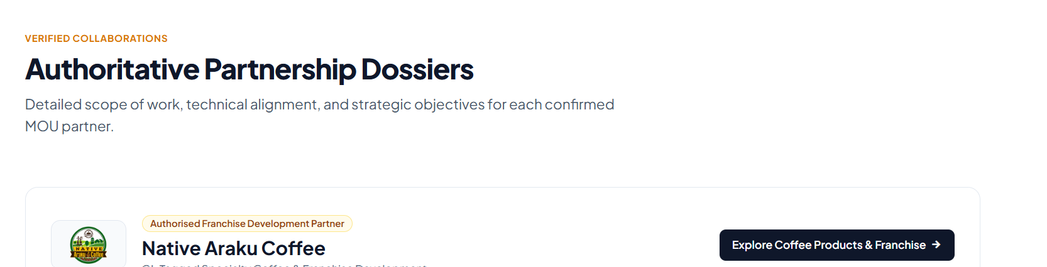
Authoritative Partnership Dossiers section – CTA to be linked to the partner content

8. Home page – remove duplicate MOU content
ACTION
Please REMOVE them from the home page.
The same MOU content is displayed in the Partnerships section – no need to showcase it twice. Update new parents list and logos

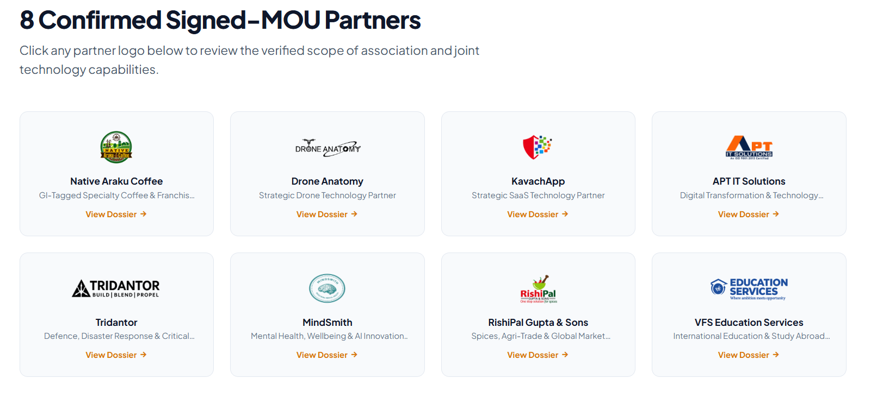
Remove: “8 Confirmed Signed-MOU Partners”
Remove: “Authoritative Partnership Dossiers” strip

9. Team photos and profiles

9a. K. V. R. S. S. Sasanka – update with this photo

K. V. R. S. S. Sasanka

9b. White World – correct name and use this photo
ACTION
Correct the name: D. Veda Anjali → D. VedAnjali
Use the photo below on the White World content page.

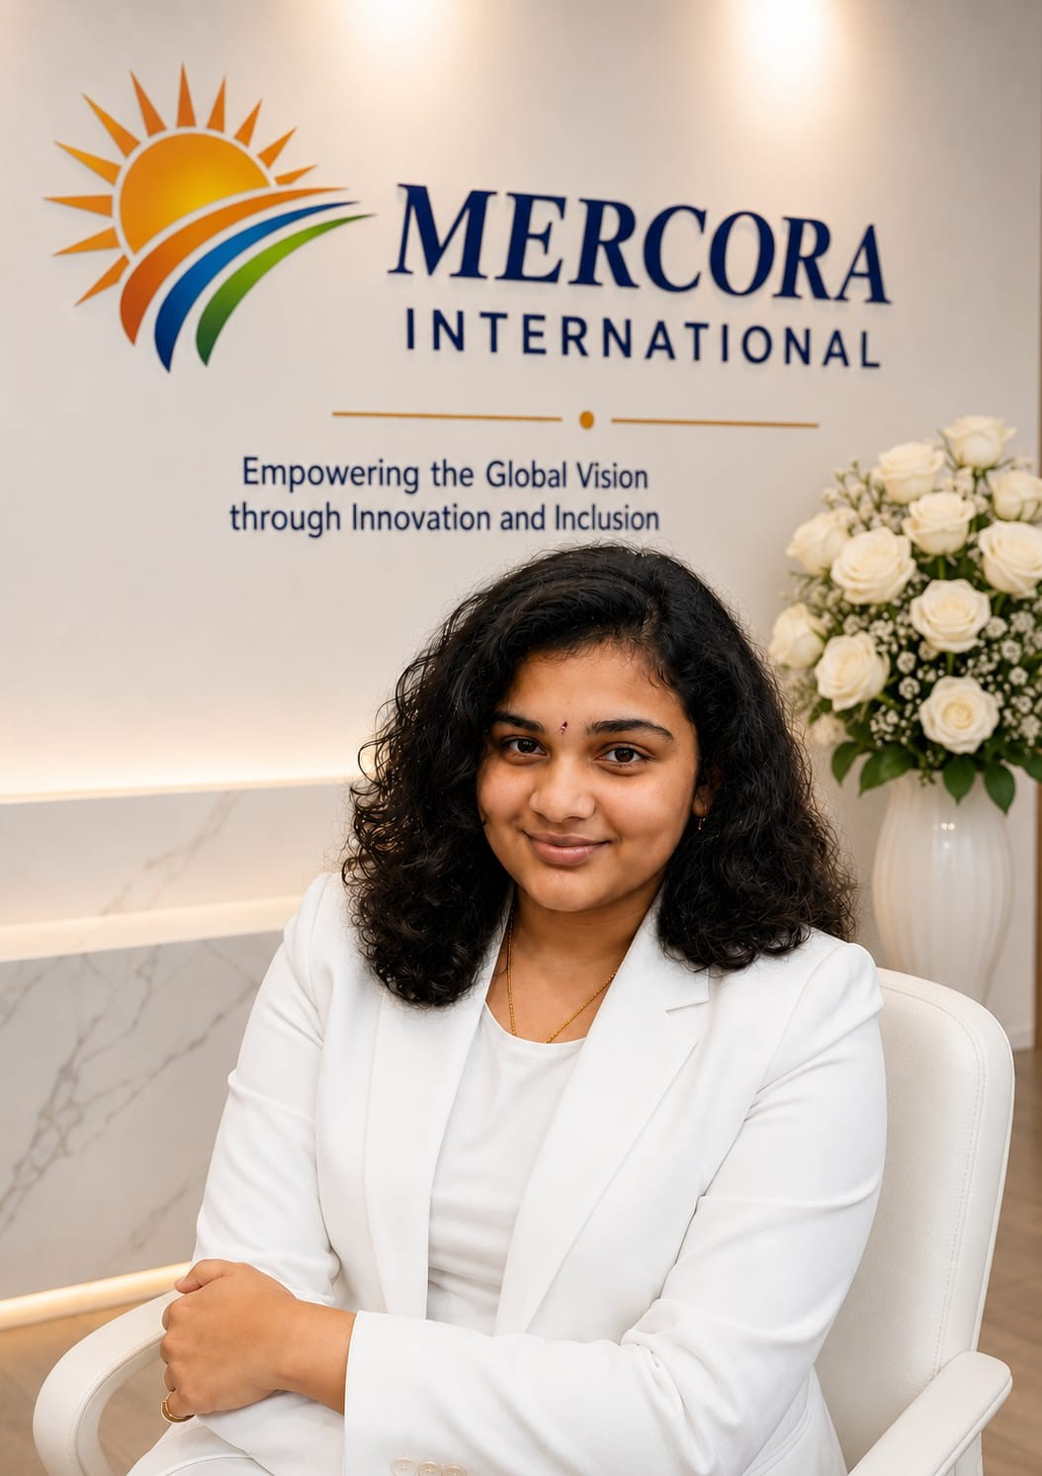
D. VedAnjali – White World page

9c. Update Jaya Geetha and Subbarao profile content
Mrs. D. Jaya Geetha Kiran
Founder & Managing Partner | Independent Director (IICA)
Strategic Visionary | Entrepreneurial Leader | Champion of Inclusive & Sustainable Growth
An accomplished entrepreneur and strategic business leader with over 15 years of cross-industry experience, holding an M.Sc. in Computer Science. Her professional expertise spans Human Resources, Operations, Pharmaceutical Manufacturing, Regulatory Compliance and Strategic Management.
As the Founder & Managing Partner of Mercora International, she provides visionary leadership, drives strategic partnerships and business ecosystem development, and leads Mercora's initiatives focused on innovation, sustainable growth and women-led entrepreneurship across domestic and international markets.
Associated with the Indian Institute of Corporate Affairs (IICA) through its Independent Directors initiative, she brings a strong focus on corporate governance, ethical leadership, strategic oversight and responsible business practices.
A driving force behind Mercora's initiatives for inclusive and sustainable development, she champions the transformation of farmers into agri-entrepreneurs, connects grassroots enterprises with global markets, and drives initiatives in renewable energy and waste-to-energy innovation, including converting household waste into biofuels and sustainable energy resources.

Mr. Subbarao Kalluri
Technology & Digital Transformation Consultant
20+ Years of Experience | CMMI Expert | PMP® | PRINCE2® Practitioner | Certified Ethical Hacker (CEH) | ISO Certified
A technology and digital transformation leader with over 20 years of experience in enterprise applications, programme management, quality engineering and global technology delivery. He leads Mercora International’s technology consulting practice, driving enterprise digital transformation, technology modernisation and strategic IT initiatives.

10. Home page – registrations, chips, credentials and MOU count

10a. Registrations card – Remove “(Telangana)” and add “Hyderabad”
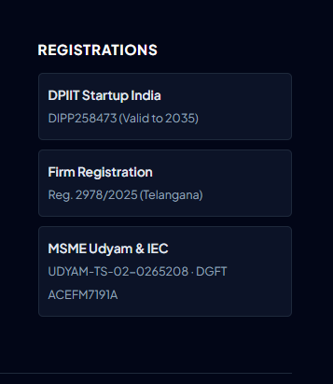  Registrations card – “Reg. 2978/2025 (Telangana)” | 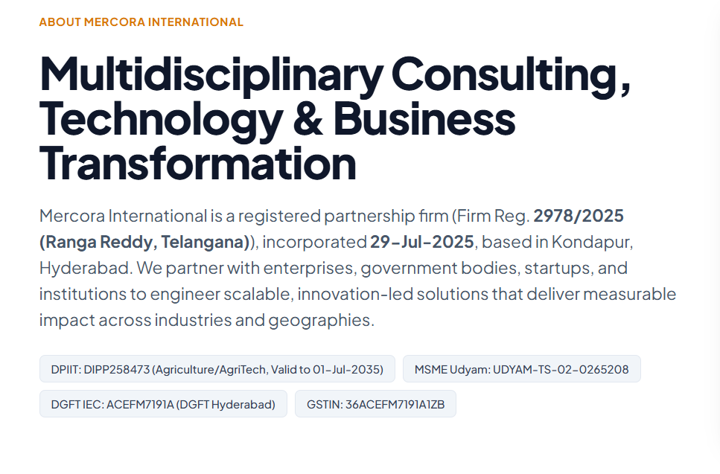  Hero – replace the “Telangana” wording with “Hyderabad”

10b. Registration chips – Remove
ACTION
Remove the registration chips (DPIIT, MSME Udyam, DGFT IEC, GSTIN) from the hero.

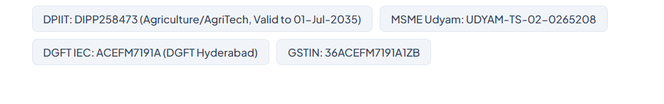
Remove these chips

10c. Official Firm Credentials card – Remove
ACTION
Remove the Official Firm Credentials card.

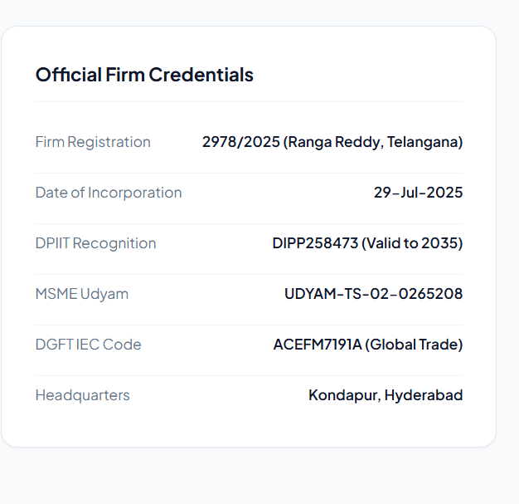
Remove this card

10d. Update with 11 signed MOUs
ACTION
Update the MOU count and button with 11 signed MOUs (currently shows 7).

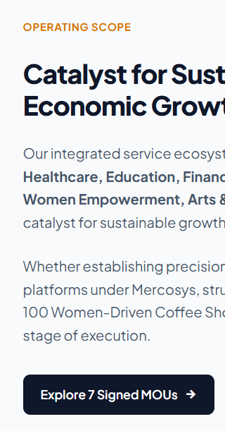
Currently: “Explore 7 Signed MOUs”

11. Our Company Journey – update this data
The legal, commercial, and operational milestones shaping Mercora International.
Date | Category | Milestone
29 Jul 2025 | INCORPORATION | Mercora International Established  Partnership Deed signed and Mercora International established as a registered partnership firm in Hyderabad, Ranga Reddy District, Telangana.
24 Aug 2025 | MSME CERTIFIED | Udyam Registration Issued  Mercora International registered with the Ministry of Micro, Small and Medium Enterprises, Government of India, and recognised as a Micro Enterprise.
27 Sep 2025 | STRATEGIC ALLIANCE | MindSmith Partnership  Strategic MOU signed with MindSmith to explore collaboration opportunities in education technology, learning and wellbeing initiatives.
13 Oct 2025 | DIGITAL TRANSFORMATION | APT IT Solutions Partnership  Strategic MOU signed with APT IT Solutions to explore opportunities in IT services, technology solutions and digital transformation.
02 Dec 2025 | AGRI-TRADE & FMCG | M/s RishiPal Gupta & Sons Partnership  Strategic MOU signed to explore collaboration in agricultural trade, FMCG and related business development opportunities.
31 Jan 2026 | FRANCHISE DEVELOPMENT | Native Araku Coffee Partnership  Partnership formalised with Native Araku Coffee Pvt. Ltd., appointing Mercora International as an Authorised Franchise Development Partner to support franchise expansion and women-led entrepreneurial opportunities.
2025–2026 | INNOVATION & INCUBATION | Smart Crop Doctor – AI-Powered Agriculture  Development of Smart Crop Doctor, an AI-powered precision agriculture platform integrating drone technology and multispectral imaging for crop health monitoring and diagnostics.  Mercora received a Certificate of Acceleration from AIC ALEAP WEHUB, supported by AIM, NITI Aayog, recognising it as a promising startup with seed-fund support of ₹10,00,000 under the Startup India Seed Fund Scheme (SISFS).
27 Apr 2026 | DRONE TECHNOLOGY | Drone Anatomy (Dastronics) Partnership  Strategic partnership signed to explore opportunities in drone technology, agricultural applications and related business development initiatives.
29 Apr 2026 | STARTUP INDIA RECOGNITION | DPIIT Startup Recognition  Mercora International recognised as a startup by the Department for Promotion of Industry and Internal Trade (DPIIT), Government of India, under the Agriculture Industry and Agri-Tech sector.
04 May 2026 | DEFENCE & TECHNOLOGY | Tridantor Partnership  Strategic partnership signed to explore collaboration opportunities in defence-related technology initiatives, including iDEX-linked opportunities.
06 May 2026 | DIGITAL & SAAS ECOSYSTEM | KavachApp Partnership  Strategic MOU signed to explore collaboration in digital platforms, SaaS solutions and technology-enabled business opportunities.
08 Jun 2026 | GLOBAL TRADE | Importer Exporter Code Issued  Importer Exporter Code issued by the Directorate General of Foreign Trade (DGFT), Hyderabad, enabling Mercora International to pursue eligible import and export business opportunities.
Jul 2026 | ECOSYSTEM EXPANSION | 7 Strategic MOUs & 18 Business Engagements  Mercora's business ecosystem expanded across 11 focus verticals, with 7 strategic MOUs signed and 18 business engagements recorded at this milestone. GST registration confirmed.
22 Oct 2026 | TRADE & BUSINESS DEVELOPMENT | Agarwood Impex Pvt. Ltd. Partnership  Tripartite MOU signed with Agarwood Impex Pvt. Ltd. and Syaam Real Estate Consultant to explore opportunities in trade facilitation, market development and business expansion.
22 Oct 2026 | TESTING & CERTIFICATION | Delhi Test House Partnership  Strategic MOU signed with Delhi Test House, a unit of Delhi Test House Global LLP, to explore collaboration in testing, inspection, certification, quality assurance and business development.
Nov 2026 | HEALTHCARE & INSURANCE | CLiQiN Health Partnership  Strategic collaboration to explore business development, market access and partnership opportunities across healthcare and insurance-related services.
Nov 2026 | ROBOTICS & DEEP TECHNOLOGY | X Dimension Robotics Private Limited Partnership  Strategic collaboration to explore opportunities in drones, robotics, AI, automation, smart agriculture, skill development and technology-led solutions.
Dec 2026 | STRATEGIC NETWORK EXPANSION | 11 Strategic MOUs Across Multiple Sectors  Mercora International's strategic partnership network comprises 11 MOU partnerships across IT, digital transformation, agriculture, trade, franchise development, drone technology, defence, healthcare, testing and certification, robotics and automation.
Dec 2026 – Jan 2027 | LIFESTYLE & RETAIL | LAUNCHING SOON | The White World  An upcoming white-themed lifestyle and retail marketplace bringing together fashion, jewellery, home and living, handlooms, wellness, accessories and lifestyle products. The initiative aims to create opportunities for women entrepreneurs, tribal artisans, rural self-help groups and emerging businesses.
Dec 2026 – Jan 2027 | VETERINARY HEALTHCARE | LAUNCHING SOON | VetiGo MobiCare  An upcoming mobile veterinary healthcare initiative designed to bring veterinary consultations, diagnostics and animal healthcare services closer to pets, livestock and farming communities through proposed mobile veterinary clinics.

Annex A. SMART CROP DOCTOR – page content & layout
Page content and layout – for your reference. Follow the order: Smart Crop Doctor, White World, VetiGo MobiCare.
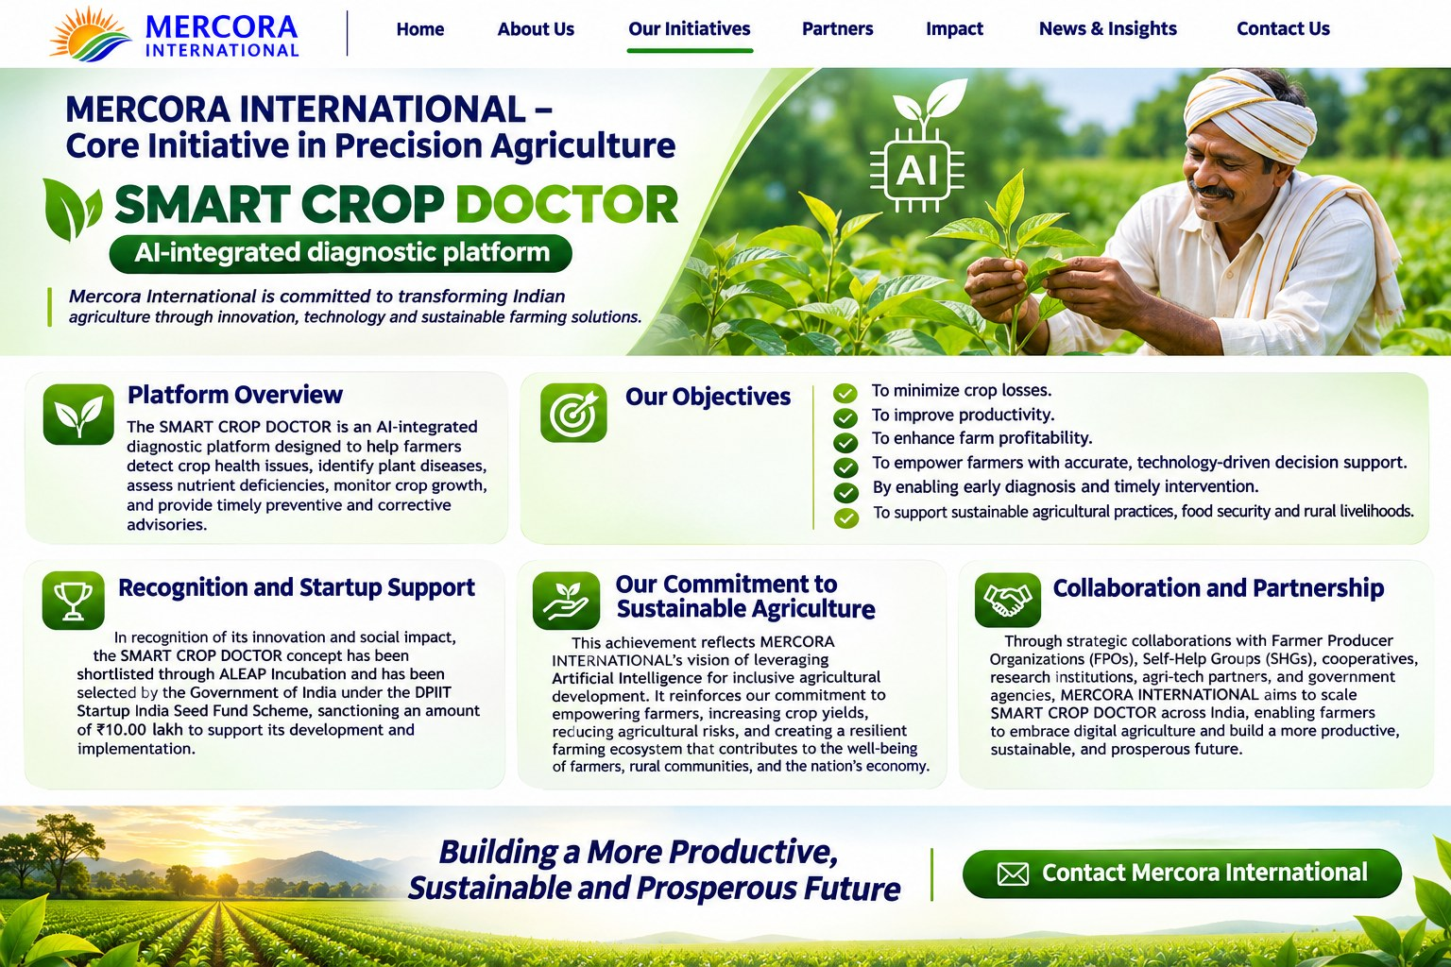
Website visual reference for the development team
SMART CROP DOCTOR
AI-POWERED PRECISION AGRICULTURE INITIATIVE
A Mercora International Core Initiative

PAGE CONTENT

Mercora International – Driving Precision Agriculture
MERCORA INTERNATIONAL is committed to transforming Indian agriculture through innovation, technology and sustainable farming solutions. As part of its core initiative in precision agriculture, Mercora is advancing SMART CROP DOCTOR, an AI-integrated diagnostic platform designed to help farmers identify crop health issues, detect plant diseases, assess nutrient deficiencies, monitor crop growth and receive timely preventive and corrective advisories.

SMART CROP DOCTOR – AI-Powered Crop Intelligence
SMART CROP DOCTOR aims to provide farmers with accurate, technology-driven decision support for better crop management. By enabling early diagnosis and timely intervention, the platform seeks to minimise crop losses, improve productivity, enhance farm profitability and support more informed agricultural practices.

Our Objectives
- Help farmers identify crop diseases and other crop health issues.
- Assess possible nutrient deficiencies and monitor crop growth.
- Provide timely preventive and corrective advisories.
- Minimise crop losses and support improved farm productivity and profitability.
- Promote sustainable agricultural practices and strengthen food security and rural livelihoods.

Recognition and Startup Support
In recognition of its innovation and potential social impact, the SMART CROP DOCTOR concept has been shortlisted through ALEAP Incubation and selected by the Government of India under the DPIIT Startup India Seed Fund Scheme, with a sanctioned amount of ₹10.00 lakh to support its development and implementation.

Our Commitment to Sustainable Agriculture
This achievement reflects MERCORA INTERNATIONAL’s vision of leveraging Artificial Intelligence for inclusive agricultural development. The initiative aims to empower farmers, increase crop yields, reduce agricultural risks and contribute to a resilient farming ecosystem that supports the well-being of farmers, rural communities and the nation’s economy.

Collaboration and Partnership Opportunities
Through strategic collaborations, MERCORA INTERNATIONAL aims to scale SMART CROP DOCTOR across India and support the adoption of digital agriculture. Potential collaboration areas include:
- Farmer Producer Organizations (FPOs)
- Self-Help Groups (SHGs) and cooperatives
- Research institutions and agricultural organisations
- Agri-tech partners and technology providers
- Government agencies and development institutions

Building a More Productive and Resilient Future
Together with farmers and ecosystem partners, SMART CROP DOCTOR seeks to advance a more productive, sustainable and prosperous future for Indian agriculture through accessible, AI-enabled crop intelligence and timely decision support.

Be Part of the Initiative
Interested in collaboration, institutional partnerships or pilot opportunities? Contact Mercora International to explore how you can be part of the SMART CROP DOCTOR initiative.
CONTACT MERCORA INTERNATIONAL (button)

Recommended page sections
- Hero area identifying SMART CROP DOCTOR as a Mercora International core initiative in precision agriculture.
- Platform Overview explaining the AI-integrated diagnostic platform and its stated functions: identifying crop health issues, detecting plant diseases, assessing nutrient deficiencies, monitoring crop growth and providing timely advisories.
- Our Objectives covering minimising crop losses, improving productivity, enhancing farm profitability, empowering farmers with technology-driven decision support, and supporting sustainable agriculture, food security and rural livelihoods.
- Recognition and Startup Support section retaining the supplied ALEAP Incubation and DPIIT Startup India Seed Fund Scheme recognition wording and ₹10.00 lakh sanctioned amount.
- Our Commitment to Sustainable Agriculture.
- Collaboration and Partnership Opportunities covering FPOs, SHGs and cooperatives, research institutions, agri-tech partners and government agencies.
- Closing statement: Building a More Productive and Resilient Future.
- Be Part of the Initiative and Contact Mercora International call to action.

Interaction and accuracy guidance
- Use the supplied SMART CROP DOCTOR brand treatment/logo where approved.
- Do not add crop-detection accuracy percentages, early-detection lead times, acreage coverage, pricing or other metrics unless separately verified and approved.
- Retain the ₹10.00 lakh funding support wording exactly as provided in the approved content.
- The Contact Mercora International button should open the approved contact or enquiry route.

Annex B. THE WHITE WORLD™ – page content & layout
Page content and layout – for your reference.
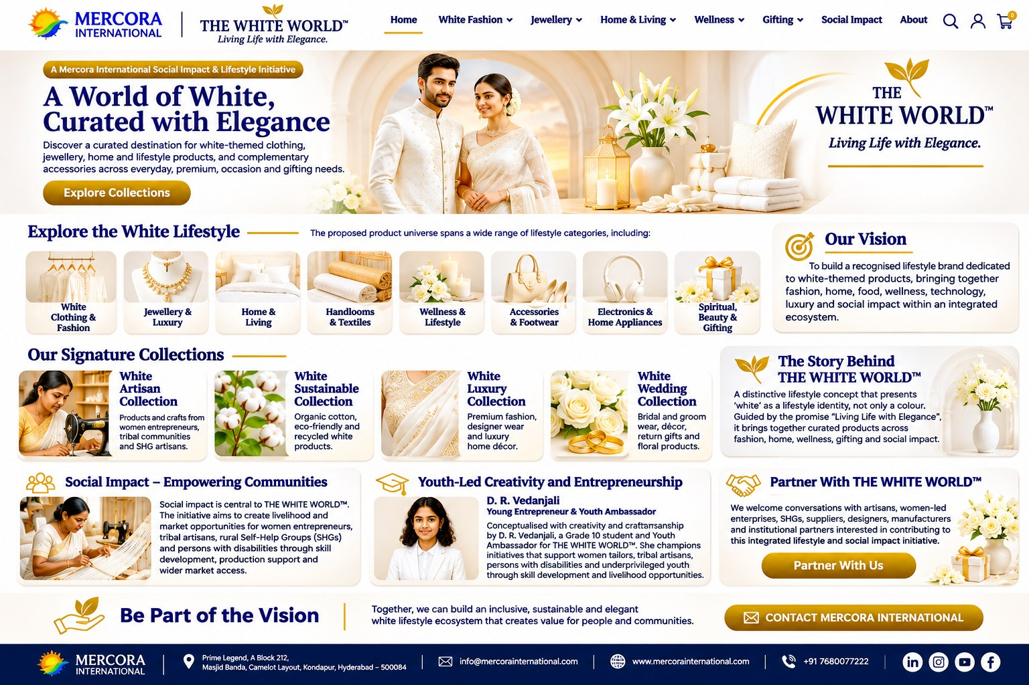
Desktop page design reference | Premium white, navy and gold visual identity
Living Life with Elegance
A Mercora International Social Impact & Lifestyle Initiative

WEBSITE PAGE CONTENT

A World of White, Curated with Elegance
THE WHITE WORLD™ is a white-themed lifestyle marketplace concept that brings together clothing, jewellery, home and lifestyle products, and complementary accessories under one unified brand identity. Guided by the tagline “Living Life with Elegance”, the initiative aims to offer customers a curated destination for white-themed products across everyday, premium, occasion and gifting needs.

Our Vision
To build a recognised lifestyle brand dedicated to white-themed products, bringing together fashion, home, food, wellness, technology, luxury and social impact within an integrated ecosystem.

Explore the White Lifestyle
The proposed product universe spans a wide range of lifestyle categories, including:
- White Clothing & Fashion – sarees, ethnic and formal wear, casual clothing and occasion wear.
- Accessories & Footwear – handbags, wallets, belts, scarves, watches, footwear and travel accessories.
- Home & Living – bed and bath linen, kitchen and dining products, ceramics, furniture and décor.
- Handlooms & Textiles – cotton, linen, silk, khadi, handloom products and craft textiles.
- Wellness & Lifestyle – aromatherapy, bath and body collections, yoga and mindfulness products.
- Jewellery & Luxury – fine jewellery, fashion jewellery and premium accessories.
- Electronics & Home Appliances – consumer electronics, peripherals and selected home and kitchen appliances.
- Spiritual, Beauty & Gifting – pooja products, personal care, gift hampers and corporate gifting.

A Special Focus on Social Impact
Social impact is central to THE WHITE WORLD™ concept. The initiative aims to create livelihood and market opportunities for women entrepreneurs, tribal artisans, rural Self-Help Groups (SHGs), and persons with disabilities. Its proposed Women Empowerment Collection will feature handcrafted apparel, tribal handloom and handicrafts, SHG-made products, sustainable items and products crafted by persons with disabilities.

Our Signature Collections
- White Artisan Collection – products and crafts from women entrepreneurs, tribal communities and SHG artisans.
- White Sustainable Collection – organic cotton, eco-friendly and recycled white products.
- White Luxury Collection – premium fashion, designer wear and luxury home décor.
- White Wedding Collection – bridal and groom wear, décor, return gifts and floral products.

Youth-Led Creativity and Entrepreneurship
THE WHITE WORLD™ was conceptualised with creativity and craftsmanship by D. R. Vedanjali, a Grade 10 student, young entrepreneur and Youth Ambassador for the White World Brand. Her involvement reflects the initiative’s encouragement of youth leadership, creativity and community-led entrepreneurship. As described in the initiative document, her focus includes supporting women tailors, tribal artisans, persons with disabilities and underprivileged youth through skill development and livelihood opportunities.

Building an Inclusive and Sustainable Ecosystem
Through collaboration with women entrepreneurs, artisans, SHGs, suppliers, institutions and other ecosystem partners, THE WHITE WORLD™ aims to connect distinctive white-themed products with customers while supporting inclusive livelihoods, responsible practices and sustainable growth.

Partner with THE WHITE WORLD™
We welcome conversations with artisans, women-led enterprises, SHGs, suppliers, designers, manufacturers, institutions and potential business partners interested in contributing to this integrated lifestyle and social impact initiative.
CONTACT MERCORA INTERNATIONAL (button)

Recommended page sections
- Header with Mercora International identity, THE WHITE WORLD™ brand, category navigation, search, account and cart icons.
- Hero banner with the headline “A World of White, Curated with Elegance”, a short introduction and an Explore Collections button.
- Explore the White Lifestyle category tiles covering clothing and fashion, jewellery and luxury, home and living, handlooms and textiles, wellness and lifestyle, accessories and footwear, electronics and home appliances, and spiritual, beauty and gifting.
- Our Vision panel and a short story introducing the white-themed lifestyle concept.
- Four signature collection cards: White Artisan, White Sustainable, White Luxury and White Wedding.
- Social Impact section highlighting opportunities for women entrepreneurs, tribal artisans, rural SHGs and persons with disabilities.
- Youth-Led Creativity section featuring D. R. Vedanjali with the designation supplied in the approved content.
- Partner With THE WHITE WORLD™ section and Contact Mercora International call to action.

Interaction guidance
- Explore Collections should navigate to the collections/category area or a dedicated collections page.
- Each category tile and signature collection card should open its relevant category or collection page when those pages are available.
- Partner With Us and Contact Mercora International should open the approved enquiry/contact route.

Annex C. VetiGo MobiCare – page content & layout
Page content and layout – for your reference. Use the original VetiGo MobiCare logo supplied from the pitch deck.
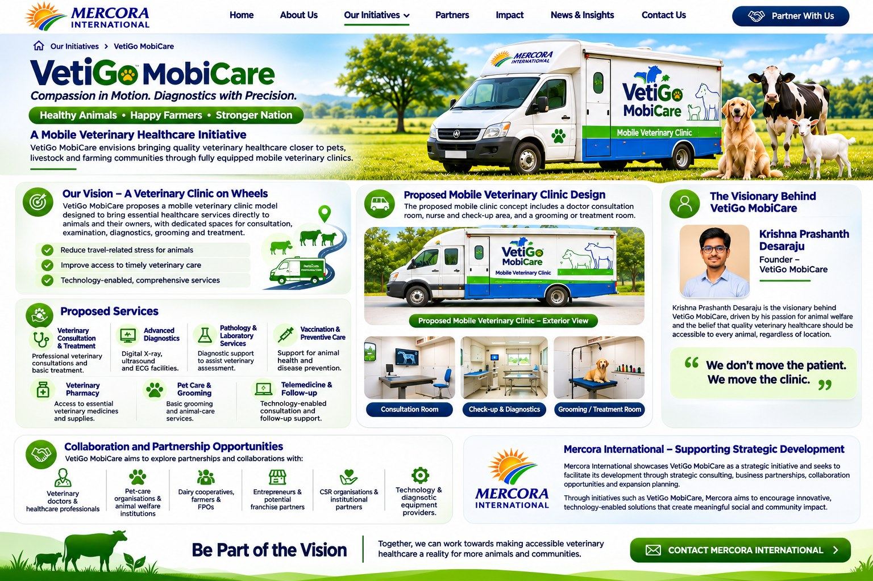
Desktop page design reference | Mobile veterinary healthcare initiative
VetiGo MobiCare
Compassion in Motion. Diagnostics with Precision.
Healthy Animals • Happy Farmers • Stronger Nation
A Mobile Veterinary Healthcare Initiative
VetiGo MobiCare envisions bringing quality veterinary healthcare closer to pets, livestock and farming communities through fully equipped mobile veterinary clinics. The initiative aims to make animal healthcare more accessible, convenient and technology-enabled, particularly in areas where access to veterinary facilities and diagnostic services may be limited.
Showcased as a strategic initiative of Mercora International, VetiGo MobiCare represents a vision for transforming the delivery of veterinary healthcare through mobility, technology and compassionate care.

Our Vision – A Veterinary Clinic on Wheels
VetiGo MobiCare proposes a mobile veterinary clinic model designed to bring essential healthcare services directly to animals and their owners. The proposed mobile clinic is designed with dedicated spaces for veterinary consultation, examination and check-ups, grooming and treatment, along with arrangements for diagnostic equipment and essential veterinary supplies.
The objective is to reduce travel-related stress for animals and improve access to timely veterinary consultation, diagnostics and treatment.

Proposed Mobile Veterinary Clinic Design
The proposed mobile clinic concept includes a doctor consultation room, nurse and check-up area, and a grooming or treatment room. The vehicle design and interior layout are intended to support a coordinated veterinary-care experience at the animal’s doorstep.
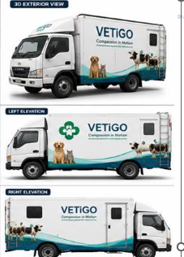  Proposed mobile veterinary clinic – exterior views (USE these images) | 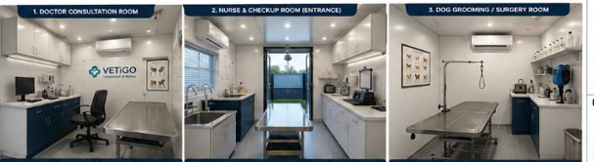  Proposed mobile veterinary clinic – consultation, check-up and grooming/treatment rooms

Proposed Services
- Veterinary Consultation and Treatment: Professional veterinary consultations and basic treatment services.
- Advanced Diagnostics: Proposed access to digital X-ray, ultrasound and ECG facilities.
- Pathology and Laboratory Services: Diagnostic support to assist veterinary assessment.
- Vaccination and Preventive Care: Support for animal health and disease prevention.
- Veterinary Pharmacy: Access to essential veterinary medicines and supplies.
- Pet Care and Grooming: Basic grooming and animal-care services.
- Telemedicine and Follow-up: Technology-enabled consultation and follow-up support.

The Visionary Behind VetiGo MobiCare

Krishna Prashanth Desaraju – Founder, VetiGo MobiCare
Krishna Prashanth Desaraju is the visionary behind VetiGo MobiCare, an initiative driven by his passion for animal welfare and the belief that quality veterinary healthcare should be accessible to every animal, regardless of location.
His personal experience with the challenges of accessing timely veterinary care, particularly during the illness of a beloved pet, inspired him to envision a mobile veterinary healthcare model that brings essential medical services closer to animals and the communities that care for them.
Through VetiGo MobiCare, his vision is to make veterinary healthcare more accessible, convenient and technology-enabled through fully equipped mobile clinics. The proposed model aims to integrate veterinary consultations, diagnostics, treatment, preventive care and follow-up services under one mobile healthcare platform.
His mission is simple yet meaningful: to bring compassionate, accessible and quality veterinary care closer to every animal.
“We don’t move the patient. We move the clinic.”

Collaboration and Partnership Opportunities
VetiGo MobiCare aims to explore partnerships and collaborations with:
- Veterinary doctors and healthcare professionals
- Pet-care organisations and animal welfare institutions
- Dairy cooperatives, farmers and Farmer Producer Organisations (FPOs)
- Entrepreneurs and potential franchise partners
- CSR organisations and institutional partners
- Technology and diagnostic equipment providers

Mercora International – Supporting Strategic Development
Mercora International showcases VetiGo MobiCare as a strategic initiative and seeks to facilitate its development through strategic consulting, business partnerships, collaboration opportunities and expansion planning.
Through initiatives such as VetiGo MobiCare, Mercora aims to encourage innovative, technology-enabled solutions that create meaningful social and community impact.

Be Part of the Vision
Together, we can work towards making accessible veterinary healthcare a reality for more animals and communities.
Interested in collaboration, partnership or franchise opportunities?
Contact Mercora International to explore opportunities to collaborate with VetiGo MobiCare.
CONTACT MERCORA INTERNATIONAL (button)

Recommended page sections
- Hero banner with the VetiGo MobiCare name, approved tagline “Compassion in Motion. Diagnostics with Precision.” and supporting line “Healthy Animals • Happy Farmers • Stronger Nation”.
- Introduction describing the mobile veterinary healthcare initiative and its purpose.
- Our Vision – A Veterinary Clinic on Wheels.
- Proposed Mobile Veterinary Clinic Design with exterior and interior images.
- Proposed Services covering consultation and treatment, diagnostics, pathology and laboratory services, vaccination and preventive care, veterinary pharmacy, pet care and grooming, and telemedicine and follow-up.
- Founder section for Krishna Prashanth Desaraju, using the approved founder photograph and the supplied quote: “We don’t move the patient. We move the clinic.”
- Collaboration and Partnership Opportunities.
- Mercora International – Supporting Strategic Development.
- Be Part of the Vision and Contact Mercora International call to action.

Interaction and accuracy guidance
- Use the original VetiGo MobiCare logo supplied from the pitch deck.
- Keep proposed clinic images and services clearly labelled as proposed until the service is operational.
- The Contact Mercora International button should open the approved contact or enquiry route.

