

**e-Yantra Robotics Competition - 2018**

**Task 3C: Theme and Implementation Analysis HC#3344**

|  |  |
| --- | --- |
| **Team leader name** | Shivam Pandey |
| **College** | Government College of Engineering Nagpur |
| **Email** | [Shivampandey15199@gmail.com](mailto:Shivampandey15199@gmail.com) |
| **Date** | 02/01/1999 |

**Scope and Preparing the Arena**

**Q1 a. State the scope of the theme assigned to you. (2)**

The theme has a robot which has to pick the animals and place it in their respective habitat which are identified by a predefined CNN. The following theme has implementations in various departments of industries such as that of stores where there are items have to arranged in their respective stacks so the bot can go and pick them and place them in proper position. It can also be used in farming where the bots can identify the fruits, pick them and place it in some container to store. These are some of the uses of this robot

1. **Attach the Final Arena Images. (3)**

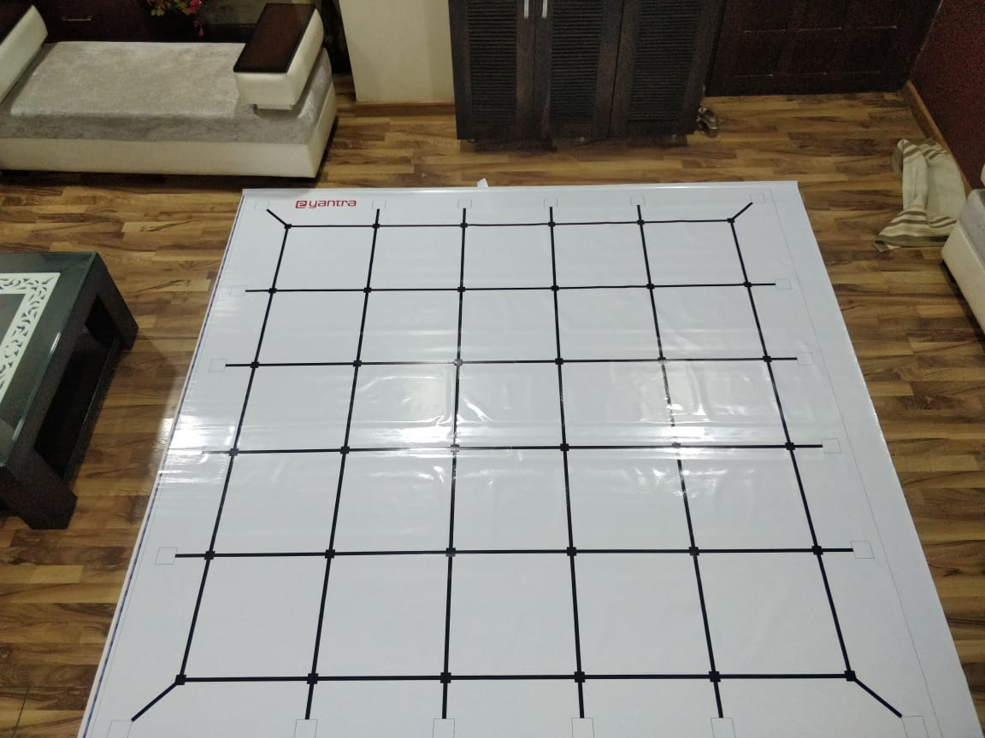

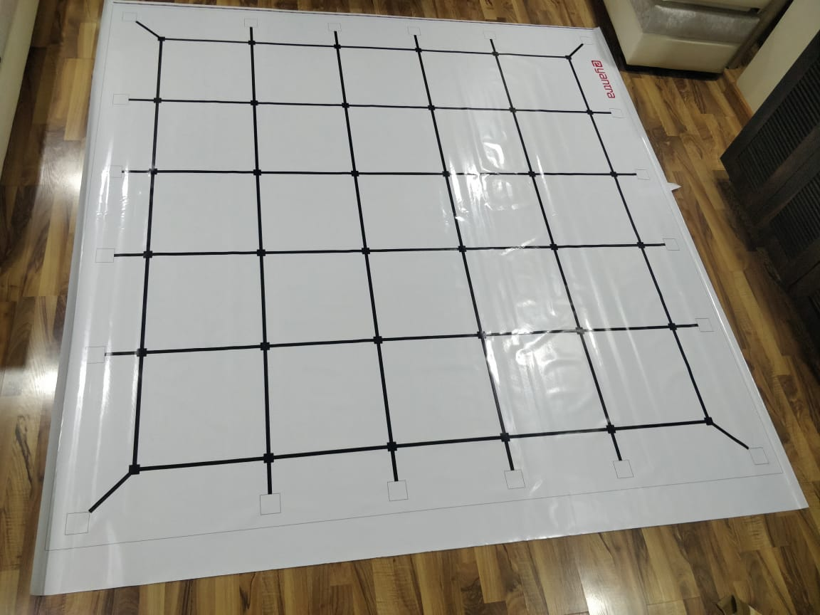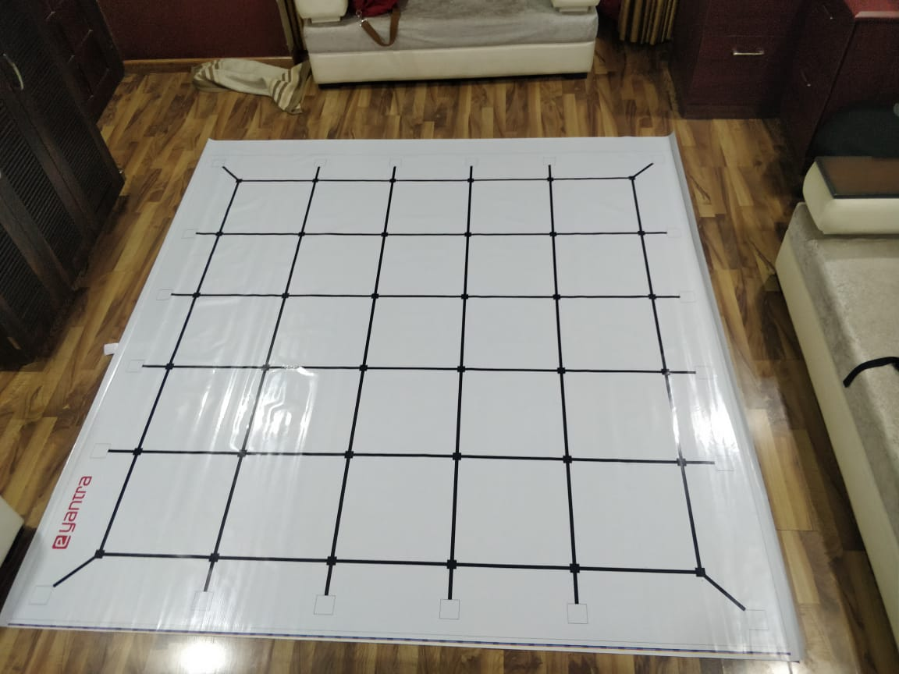

**Building Modules**

**Q2. Identify the major components required for designing the robotic system for the solution of the theme assigned to you. (3)**

1. Mechanical Arm: A mechanical arm will be attached to robot for picking the boxes in animal position.
2. Sensors : To sense the environment for picking the robots and moving from one location to another
3. Servo Motors : To make the mechanical arm.

**Design Analysis**

**Q3.** **Teams have to design an arm mechanism for deposition of the Animals in their respective Habitats.**

1. **Choose an** **option to position this mechanism on the robot and why? (2)**
2. **Front 2. Back 3. Right/Left**

**Answer: Left**

**Since the robot is starting from the start node facing the e-yantra logo, positioning left in left is the best way to reduce the time.**

1. **Explain the design of the mechanism and how it is mounted on the robot. Also explain what challenge/s do you expect to face and how you will overcome them? (6)**

**The mechanism for building the arm will be using servo motors since they will**

**Provide precise control of angle to move the arm of robot we will be using 2 servo motors to rotate the arm and one to use the gripper. The following document helped us with the concept of mechanical arm. The mechanical arm will have predefined rotation for side and diagonal animal position. Hence it will pick the animal. To place the animal it will leave the gripper and go to initial position**

**http://home.iitk.ac.in/~adutta/Manual_serial_arm.pdf**

1. **Choose the actuator/s you will use to design the mechanism. (2)**
2. **DC-Motor 2. Servo Motor 3. Stepper Motor 4. Others**

**Answer: Servo Motor**

The servo motor consists of four things DC motor, a control circuit a gearing set and a potentiometer. Servo motors have three wires named power ground(GND) and control. Power to these motors continually applied, with the servo motor control circuit changing the draw to the servo motor. The rest of the given motors are not that precise as the servo motors so these are the most suitable for the above purpose.

**Environment Sensing**

**Q4. Explain how you will use the provided sensors to implement the theme. (2)**

* + - 1. White line sensor : To move in the black line.
      2. IR sensor : to detect the animal box presence and stop at location

**Testing your knowledge (theme analysis and rulebook-related)**

**Q5. What is the purpose of “activation function” in a Neural Network? How do different type of activation functions affect the network? (5)**

-> Activation function is used to introduce non-linearity.

-> Input of one neuron without activation function will be x*weight

-> If we use activation function then it will not remain in linear only.

-> Activation function activates the neuron in a neural network such as in sigmoid after applying the sigmoid, highest value is predicted as output value

There are many activation function such as :

1.Sigmoid

2.Tanh

3.Relu

Different activation functions have different output values. Since the activation functions are differentiable we choose such activation function which gives the maximum error and can be fine tune in less number of epochs.

**Q6. What are the different hyper-parameters in a CNN that affect its performance? Explain the different parameters and their effects (in bulleted form). (5)**

Learning rate : Learning rate controls how much to update the weight in the optimization algorithm. We can use fixed learning rate, gradually decreasing learning rate, momentum based methods or adaptive learning rates, depending on our choice of optimizer such as SGD, Adam, Adagrad, AdaDelta or RMSProp. In our program we have used lr scheduler to update learning rate after every 7 epochs. A large learning rate can be harmful because it can pass the correct value for the weight. So a small learning rate is preferable

Number of epochs : Number of epochs is the the number of times the entire training set pass through the neural network. We should take the best epoch in training gradually the validation accuracy increases but once the validation accuracy decreases because of overfitting we should save the model at that epoch

#### Batch size: Mini-batch is usually preferable in the learning process of convnet. A range of 16 to 128 is a good choice to test with. A batch size also decides how the speed at which the convent is getting trained.

#### Activation function

Activation function: It introduces non-linearity to the model. Usually, rectifier works well with convnet. Other alternatives are sigmoid, tanh and other activation functions depening on the task.

#### Number of hidden layers and units : It is usually good to add more layers until the test error no longer improves. The trade off is that it is computationally expensive to train the network. Having a small amount of units may lead to underfitting while having more units are usually not harmful with appropriate regularization.

#### Weight initialization: We should initialize the weights with small random numbers to prevent dead neurons, but not too small to avoid zero gradient. Uniform distribution usually works well.

**Q7. Why are the first few layers of a CNN hard to train? (3)**

The first few layer of convent are difficult to train since they are to detect edges and small features which are hard to detect in images because of the limitations of the dataset. We requires a large dataset to find each feature in an image to have a better prediction and since it’s so much difficult to get such type of data. It is therefore hard to train first few layers.

**Algorithm Analysis**

**Q8. Draw a flowchart illustrating the algorithm you propose to use for theme implementation. (12)**

**The animal corresponding habitat dictionary is formed and the outer coordinate are made in dictionary to the animal name ex {‘a1’ ,(0,0) } and the shortest distance is found from starting point and the animal coordinate is appended to the python list. The robot moves from the animal to habitat then from habitat to the next nearest animal is found using distance, this continues untill the task finished. This 2 are passed as the list and the robot keeps its track with speed and coordinate using light sensor**

**Give the habitat matrix as coordinates, ex. Starting node as (0,0) and make the dictionary of animal image to outer picking coordinate.**

**Find the smallest distance from the starting point and pick the animal and keep it to its corresponding habitat.**

Then move to the next shortest Habitat.

Do until all the habitats are done. These list will be passed as a python list to the robot and the robot will move to these points with keeping the coordinate track with the speed and blackline.

**Challenges**

**Q9. What are the major challenges that you can anticipate in addressing this theme and how do you propose to tackle them? (5)**

-> Choosing the right direction for arm motor to animal pick and drop.

-> Reducing the rotation of bot.

-> Choosing the shortest path for the movement.

-> We can face problem during the robot movement due to reflection on light sensor.

-> How to recover if path is lost…..

-> How to ensure that robot is successfully picked up animal to drop on habitat.

-> Which edge is chose on habitat to drop animal.