MediNova
AI-Powered Hospital Management System
A Project Report
Submitted in partial fulfilment of the requirements for
Semester 5 — User Defined Project (UDP)
Bachelor of Science in Information Technology
Submitted by
Shivam Shukla
BSc IT — Semester 5
LJ University, Gujarat
Academic Year 2026
Document Status: DRAFT 1 (Checkpoint)
This is a living checkpoint document, updated as development progresses.

CERTIFICATE
This is to certify that the project report entitled "MediNova — AI-Powered Hospital Management System" is a bona fide record of work carried out by Shivam Shukla, a student of BSc Information Technology, Semester 5, at LJ University, Gujarat, in partial fulfilment of the requirements for the User Defined Project (UDP) component of the semester curriculum.
The work presented in this report is original and has been carried out under the guidance of the assigned faculty mentor, and has not been submitted elsewhere for the award of any other degree or diploma.

_____________________________
Faculty Guide
_____________________________
Head of Department

ACKNOWLEDGEMENT
I would like to express my sincere gratitude to my faculty guide and the Department of Information Technology at LJ University for their continued guidance and support throughout the development of this project. Their feedback at each stage — from initial scoping through system design and implementation — was instrumental in shaping MediNova into a well-considered, defensible piece of academic work.
I would also like to acknowledge the AI-assisted development tools used in the course of this project — GitHub Copilot for backend implementation support and Lovable for frontend scaffolding — which were used under continuous manual review and verification, consistent with responsible use of AI tooling in an academic setting.
Finally, I am grateful to my family and peers for their patience and encouragement throughout this project.

Shivam Shukla

TABLE OF CONTENTS

CHAPTER 1 — INTRODUCTION

1.1 Introduction
MediNova is an AI-powered Hospital Management System developed using the MERN stack (MongoDB, Express.js, React.js, Node.js), supplemented by a dedicated Python-based machine learning microservice. The system is designed for small and mid-sized healthcare facilities that currently rely on manual or partially digitized processes for patient registration, appointment scheduling, consultation records, and billing.
Unlike conventional hospital management systems that primarily digitize records through basic create-read-update-delete (CRUD) operations, MediNova integrates targeted artificial intelligence features at points where hospitals genuinely experience operational friction: routing patients to the correct department and doctor, reducing appointment no-shows, and replacing unrealistic fixed-time scheduling with a queue-based model that reflects how consultations actually unfold.

1.2 Existing System
Most hospital management systems currently in use — including open-source platforms such as OpenMRS and Hospital Run, as well as many custom-built academic and commercial systems — focus on digitizing patient records, appointment booking, and billing as isolated administrative tasks. In these systems:
- Patients typically self-select a department or doctor with no guided triage, often relying on non-medical reception staff.
- Appointments are booked into fixed, rigid time slots regardless of how long a particular consultation is likely to take.
- No-shows are handled reactively, if at all — usually a manual phone call on the day of the appointment, with no data-driven prioritization of which patients are actually at risk of missing their visit.
- Doctor unavailability (leave) is communicated informally, often leaving patients to discover a cancellation only upon arrival.

1.3 Proposed System
MediNova addresses each of the above gaps directly:
- An AI Symptom Triage module recommends a department, doctor, and urgency level based on patient-reported symptoms, assisting rather than replacing patient choice.
- A Predictive Reminder & Confirmation System (PRCS) sends automated reminders, captures patient self-confirmation, and — only when a patient does not respond — computes a no-show risk score that is surfaced exclusively to administrative staff for manual follow-up prioritization. The score never automatically reorders or cancels an appointment.
- A Dynamic Queue Time Estimator replaces fixed slots with an estimated arrival window, computed from each doctor’s real average consultation time and current queue position.
- Emergency and walk-in patients are handled through explicit, transparent queue-insertion rules rather than ad hoc reshuffling.
- Doctor leave — both single-day and extended — triggers proactive, automatic notifications to affected and prospective patients.

1.4 Problem Statement
Small and mid-sized hospitals and clinics, particularly in the Indian healthcare context, face three concrete, recurring problems: patients are frequently misrouted or under-triaged due to the absence of any structured symptom assessment; appointment no-shows go undetected until the scheduled time has already passed, wasting doctor time and clinic capacity; and fixed-slot scheduling systems create either wasted idle time or patient backlogs because they do not account for the natural variability in consultation duration.

1.5 Need for the System
A system that combines administrative digitization with lightweight, responsibly-constrained predictive intelligence offers a meaningful improvement over both fully manual processes and existing digitized-but-unintelligent hospital software. MediNova is needed because it demonstrates that these improvements are achievable without introducing algorithmic unfairness — a concern that is often overlooked in naive applications of predictive scheduling in healthcare settings.

1.6 Objectives
- To design and develop a full-stack hospital management platform covering patient registration, appointment booking, doctor consultation, prescription generation, and billing.
- To integrate an AI-based symptom triage module that recommends department, doctor, and urgency level from patient-reported symptoms.
- To design a fairness-conscious predictive reminder and confirmation system (PRCS) that reduces appointment no-shows without compromising patient equity.
- To implement a dynamic, queue-based scheduling model that reflects real consultation-time variability instead of fixed time slots.
- To handle real-world operational scenarios: emergency walk-ins, regular walk-ins, and doctor leave (both short-term and extended).

1.7 Scope

In Scope (Phase 1)
- Patient, Doctor, and Admin/Reception role-based access and authentication
- AI Symptom Triage
- Predictive Reminder & Confirmation System (PRCS)
- Dynamic Queue Time Estimator
- Emergency and walk-in patient handling
- Doctor leave management (single-day and extended)
- Prescription and billing management
- Admin analytics dashboard

Out of Scope (Phase 1)
- Nurse and paramedical staff role management
- Full medicine inventory management (suppliers, batch/expiry tracking, purchase orders, automated reordering)
Both excluded areas are acknowledged as valid extensions for a future development cycle, deliberately excluded here to keep the current phase focused and achievable within the semester timeline.

1.8 Advantages
- Reduces patient misrouting through structured, AI-assisted triage.
- Reduces wasted doctor time from appointment no-shows through proactive, staff-prioritized follow-up.
- More realistic scheduling through queue-based, data-informed estimated arrival windows.
- Transparent, fairness-constrained use of predictive AI — no automated action is taken against a patient purely on the basis of a probability score.
- Proactive doctor leave communication, reducing wasted patient trips.
- Modular architecture that separates the AI/ML layer from the core application, allowing each to evolve independently.

1.9 Limitations
- The no-show prediction model, in its current form, is trained on a public reference dataset rather than the hospital’s own historical data, since no such data exists yet for a newly deployed system.
- The system does not currently manage nursing staff, paramedical roles, or medicine inventory (see Scope).
- SMS-based reminders depend on a third-party gateway (e.g., Twilio) and are subject to that service’s deliverability and cost constraints.
- The system assumes a single hospital/clinic deployment per instance; multi-branch or multi-tenant hospital chains are not addressed in this phase.

CHAPTER 2 — SOFTWARE REQUIREMENT SPECIFICATION (IEEE 830)

2.1 Purpose
This Software Requirement Specification (SRS) describes the functional and non-functional requirements of MediNova, an AI-Powered Hospital Management System. It is intended to serve as a shared reference between the developer, project guide, and evaluators, defining precisely what the system does, for whom, and under what constraints, in accordance with the structure recommended by IEEE Standard 830.

2.2 Scope
MediNova is a web-based application supporting three user roles — Patient, Doctor, and Admin/Reception. Its scope covers user registration and authentication, AI-assisted symptom triage, appointment booking with dynamic queue estimation, doctor consultation and prescription recording, automated billing, a predictive reminder and confirmation workflow (PRCS), emergency/walk-in handling, and doctor leave management. It excludes nurse/paramedical staff management and full pharmacy inventory management in this phase, as detailed in Section 1.7.

2.3 Definitions, Acronyms, and Abbreviations
Term | Definition
MERN | MongoDB, Express.js, React.js, Node.js — the technology stack used for the core application
PRCS | Predictive Reminder & Confirmation System — the module handling appointment reminders, patient self-confirmation, and no-show risk scoring
JWT | JSON Web Token — used for stateless authentication between client and server
ObjectId | MongoDB’s native unique identifier type used as primary and foreign keys
No-show | An appointment where the patient neither attends nor cancels in advance
Queue Position | A patient’s numeric position in a doctor’s live appointment queue for a given day
Estimated Window | A calculated time range (not a fixed instant) within which a patient is expected to be seen

2.4 Overall Description

2.4.1 Product Perspective
MediNova is a new, self-contained system rather than a modification of an existing product. It is composed of a React-based frontend, a Node.js/Express REST API backend, a MongoDB Atlas database, and an independent Python/FastAPI machine learning microservice that the backend consults for triage and no-show risk predictions.

2.4.2 Product Functions (Summary)
- Role-based registration and login (Patient, Doctor, Admin)
- AI-assisted symptom triage
- Appointment booking with dynamic queue placement
- Automated reminders and self-confirmation (PRCS)
- Staff-facing no-show risk follow-up list
- Doctor consultation, diagnosis, and prescription recording
- Automated billing
- Emergency and walk-in queue handling
- Doctor leave management with cascading notifications
- Admin analytics dashboard

2.4.3 User Classes and Characteristics
User Class | Characteristics
Patient | General public; registers to book appointments, view AI triage recommendations, track prescriptions and bills, and confirm/cancel appointment reminders.
Doctor | Medical professional; views their daily queue, records diagnoses and prescriptions, and manages their own leave.
Admin/Reception | Hospital staff; manages users, appointments, billing, doctor leave entries, and follows up on the PRCS high-risk list.

2.4.4 Operating Environment
The system runs as a web application accessible via any modern browser (Chrome, Firefox, Edge). The backend requires a Node.js runtime and a MongoDB Atlas cloud database connection. The AI/ML microservice requires a Python 3.x runtime.

2.5 Functional Requirements
ID | Requirement
FR-1 | The system shall allow a new user to register as a Patient or Doctor with role-specific fields.
FR-2 | The system shall authenticate registered users via email and password, issuing a JWT on success.
FR-3 | The system shall allow a Patient to submit free-text symptoms and receive an AI-generated department, doctor, and urgency recommendation.
FR-4 | The system shall allow a Patient to book an appointment, either accepting the AI recommendation or selecting a doctor manually.
FR-5 | The system shall compute and display a queue position and estimated arrival window for each booked appointment, rather than a fixed time slot.
FR-6 | The system shall send an automated reminder to the patient two days before, and on the day of, a scheduled appointment.
FR-7 | The system shall allow a patient to confirm or cancel an appointment in response to a reminder.
FR-8 | The system shall compute a no-show risk score for appointments with no patient response by a defined cutoff, and shall surface this score only on an Admin-facing follow-up list.
FR-9 | The system shall not use the no-show risk score to automatically cancel, deprioritize, or reorder any appointment.
FR-10 | The system shall allow Admin/Reception to register an emergency walk-in, inserting the patient at the front of the relevant doctor’s queue.
FR-11 | The system shall allow Admin/Reception to register a regular walk-in, appending the patient to the end of the relevant doctor’s queue.
FR-12 | The system shall allow a Doctor to mark themselves on leave for a single day or a date range, and shall notify affected patients automatically.
FR-13 | The system shall display an advance notice on a doctor’s booking page if that doctor’s leave spans a configurable threshold (e.g., seven or more consecutive days).
FR-14 | The system shall allow a Doctor to record a diagnosis and generate a prescription for a completed consultation.
FR-15 | The system shall automatically generate a bill upon consultation completion.
FR-16 | The system shall provide Admin/Reception with an analytics dashboard summarizing appointments, revenue, and doctor utilization.

2.6 Non-Functional Requirements
ID | Requirement
NFR-1 | Passwords shall be stored using bcrypt hashing; plaintext passwords shall never be persisted or returned in any API response.
NFR-2 | All authenticated requests shall require a valid JWT presented via the Authorization header.
NFR-3 | The login endpoint shall be rate-limited to a maximum of five attempts per fifteen minutes per IP address.
NFR-4 | All user-submitted input shall be validated (format, length, required fields) and sanitized before persistence.
NFR-5 | Cross-Origin Resource Sharing (CORS) shall be restricted to the configured frontend origin rather than left open to all origins.
NFR-6 | The frontend shall be responsive across desktop and mobile viewport sizes.
NFR-7 | The system shall respond to standard API requests within an acceptable interactive latency under normal load for a single-clinic deployment.
NFR-8 | The codebase shall be modular, separating models, controllers, routes, and middleware for maintainability.

2.7 User Stories
ID | As a... | I want to... | So that...
US-1 | Patient | describe my symptoms in my own words | I know which department and doctor to see without guessing
US-2 | Patient | see an estimated arrival window instead of a fixed time | I have a realistic expectation of when I will be seen
US-3 | Patient | confirm or cancel my appointment from a reminder | the clinic knows whether I am actually coming
US-4 | Doctor | see my queue for the day with real patient context | I can prepare for consultations efficiently
US-5 | Doctor | mark myself on leave | my patients are notified automatically instead of discovering it on arrival
US-6 | Admin/Reception | see which unconfirmed appointments are at highest risk of a no-show | I can prioritize my follow-up calls effectively
US-7 | Admin/Reception | register an emergency walk-in | urgent patients are seen without disrupting the fairness of the existing queue
US-8 | Admin/Reception | view a dashboard of appointments and revenue | I can report on the clinic’s daily operations

2.8 Assumptions
- Users have access to a device with a modern web browser and a stable internet connection.
- Patients providing a phone number can receive SMS reminders through the configured gateway.
- A hospital administrator account is provisioned outside of public self-registration, consistent with standard security practice for privileged accounts.

2.9 Constraints
- The system is developed and evaluated within a single academic semester, constraining the depth of features that can be fully implemented and tested.
- The no-show prediction model relies on a public reference dataset in the absence of the hospital’s own historical appointment data.
- The project is developed primarily by a single student developer, with AI-assisted tooling (GitHub Copilot, Lovable) used for implementation acceleration under continuous manual review.

CHAPTER 3 — REQUIREMENT ANALYSIS

3.1 Feasibility Study

3.1.1 Technical Feasibility
The system is built entirely on widely-supported, well-documented open-source technologies (React, Node.js, Express, MongoDB, Python/FastAPI, scikit-learn). All components have mature ecosystems and free-tier hosting/database options (e.g., MongoDB Atlas), making the system technically feasible to build and demonstrate within an academic setting without licensing costs.

3.1.2 Economic Feasibility
Development relies exclusively on free-tier cloud services and open-source libraries. The only potential recurring cost is SMS gateway usage (e.g., Twilio) for PRCS reminders, which offers a free trial tier sufficient for development and demonstration purposes.

3.1.3 Operational Feasibility
The three defined user roles (Patient, Doctor, Admin) map directly onto real hospital staff and patient workflows, and the interface is designed to be usable without specialized technical training, supporting realistic operational adoption in a small clinic setting.

3.2 Requirement Gathering
Requirements were derived through iterative analysis of common inefficiencies in existing hospital management software and documented patterns in healthcare operations research (e.g., published no-show prediction literature), combined with a deliberate emphasis on constraints specific to the Indian healthcare context — such as variable consultation durations, low digitization of historical appointment records, and the practical unreliability of purely automated scheduling decisions.

3.3 Actors
Actor | Description
Patient | Registers, submits symptoms for triage, books appointments, confirms/cancels reminders, views prescriptions and bills.
Doctor | Views assigned queue, records diagnoses and prescriptions, manages personal leave.
Admin/Reception | Manages users, appointments, billing, doctor leave, and PRCS follow-up.
AI/ML System (secondary actor) | Not a human actor; a system-level dependency invoked by Patient and Admin actions to perform symptom analysis, queue time estimation, and no-show risk calculation.

3.4 Modules
Module | Description
Authentication Module | Registration, login, JWT issuance, role-based route protection.
Patient Management Module | Patient profile and medical history management.
AI Symptom Triage Module | Symptom analysis and department/doctor/urgency recommendation.
Appointment Management Module | Booking, cancellation, walk-in registration.
Queue Time Estimator Module | Queue position calculation and estimated arrival window computation.
Doctor Consultation Module | Diagnosis entry and prescription generation.
Billing Module | Automated bill generation and payment status tracking.
PRCS Module | Reminder scheduling, patient confirmation capture, no-show risk scoring, Admin follow-up list.
Doctor Leave Module | Leave recording and cascading patient notifications.
Admin Dashboard Module | Reports and analytics aggregation.

CHAPTER 4 — SYSTEM DESIGN
This chapter presents the complete set of design diagrams for MediNova, covering behavioral views (Use Case, Activity, Sequence), structural views (Class Diagram, Entity Relationship Diagram), and data-flow views (DFD Level 0 and Level 1). Each diagram is accompanied by a brief explanation of its purpose and key elements.

4.1 Use Case Diagram
The Use Case Diagram identifies the three primary actors — Patient, Doctor, and Admin/Reception — along with the AI/ML System as a secondary actor invoked via <<include>> relationships wherever intelligent behavior is triggered by a primary actor’s action.
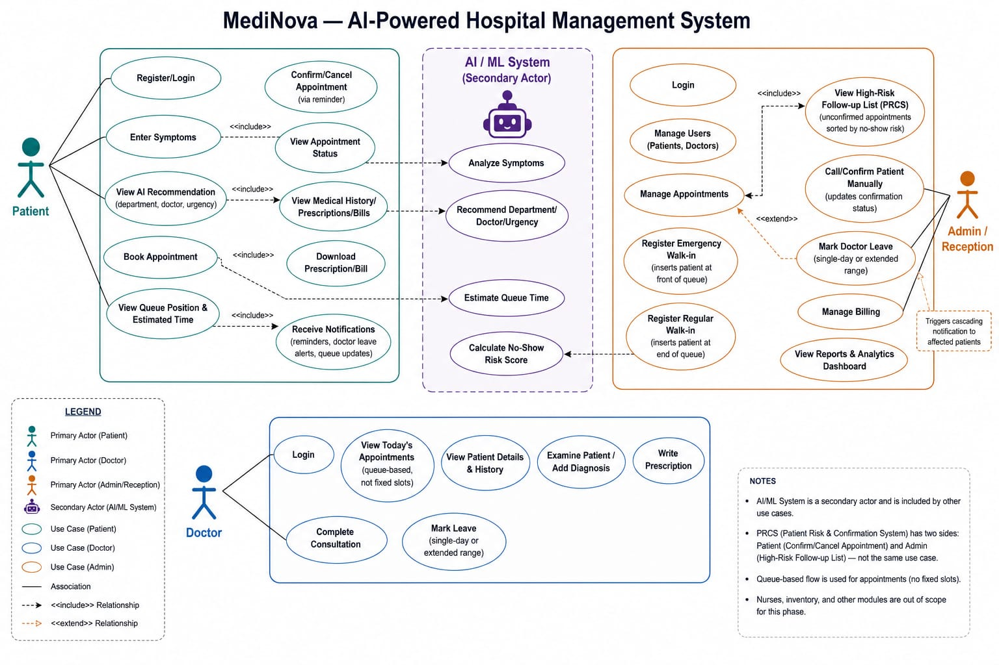
Figure 4.1 — Use Case Diagram

4.2 Data Flow Diagram — Level 0 (Context Diagram)
The Level 0 DFD treats MediNova as a single process and shows only the data flows crossing the system boundary to and from its three external entities. Note that the AI/ML component is deliberately not shown as an external entity, since it is an internal microservice belonging to the system itself, not a third-party dependency.
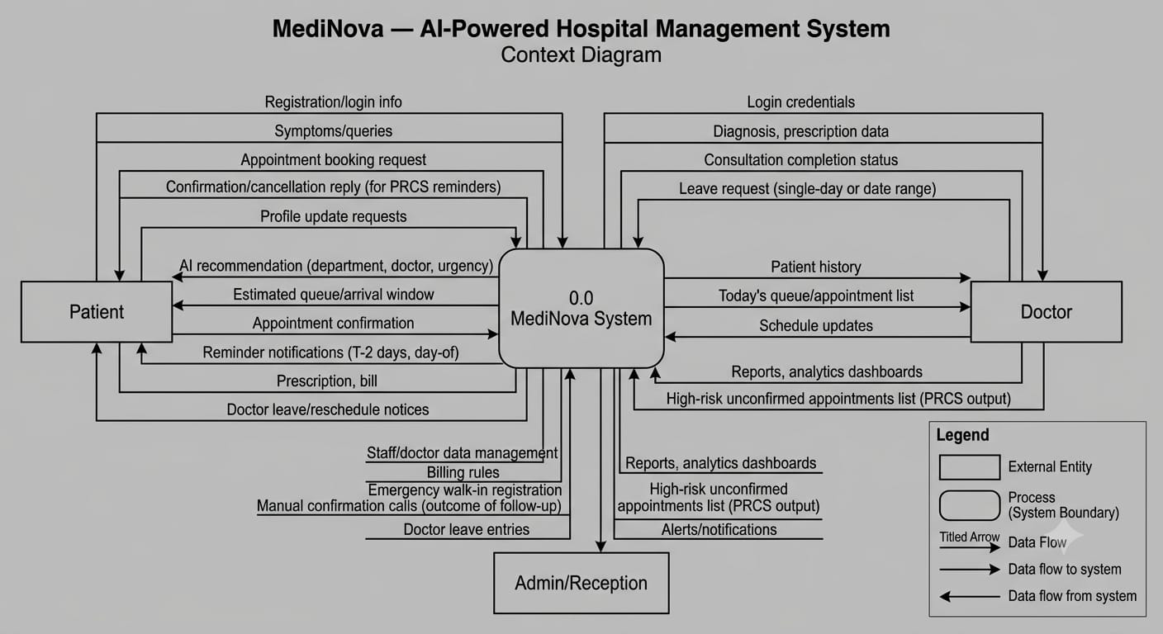
Figure 4.2 — DFD Level 0 (Context Diagram)

4.3 Data Flow Diagram — Level 1
The Level 1 DFD decomposes the system into eleven numbered processes and seven data stores, tracing how data moves between user authentication, AI symptom analysis, appointment management, doctor consultation, prescription/billing, the PRCS reminder-confirmation engine, the queue time estimator, and doctor leave management. The fairness constraint governing PRCS — that risk scores inform staff follow-up only and never reorder the appointment queue — is explicitly annotated on the diagram.
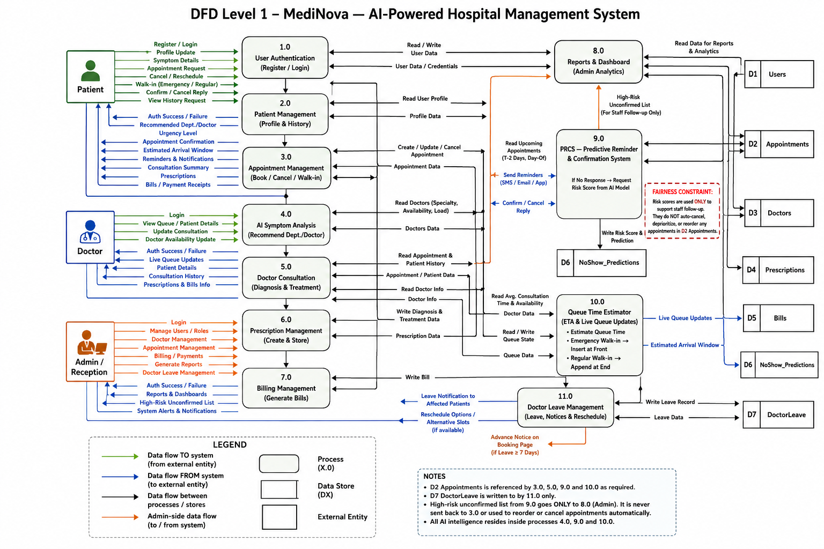
Figure 4.3 — DFD Level 1

4.4 Entity Relationship Diagram
The ER Diagram defines the nine core entities of the system and their relationships. Appointment functions as the central entity, linking Patient and Doctor and generating exactly one Prescription and one Bill per completed consultation. NoShow_Predictions and Doctor_Leave are entities introduced specifically to support the PRCS and Leave Management features.
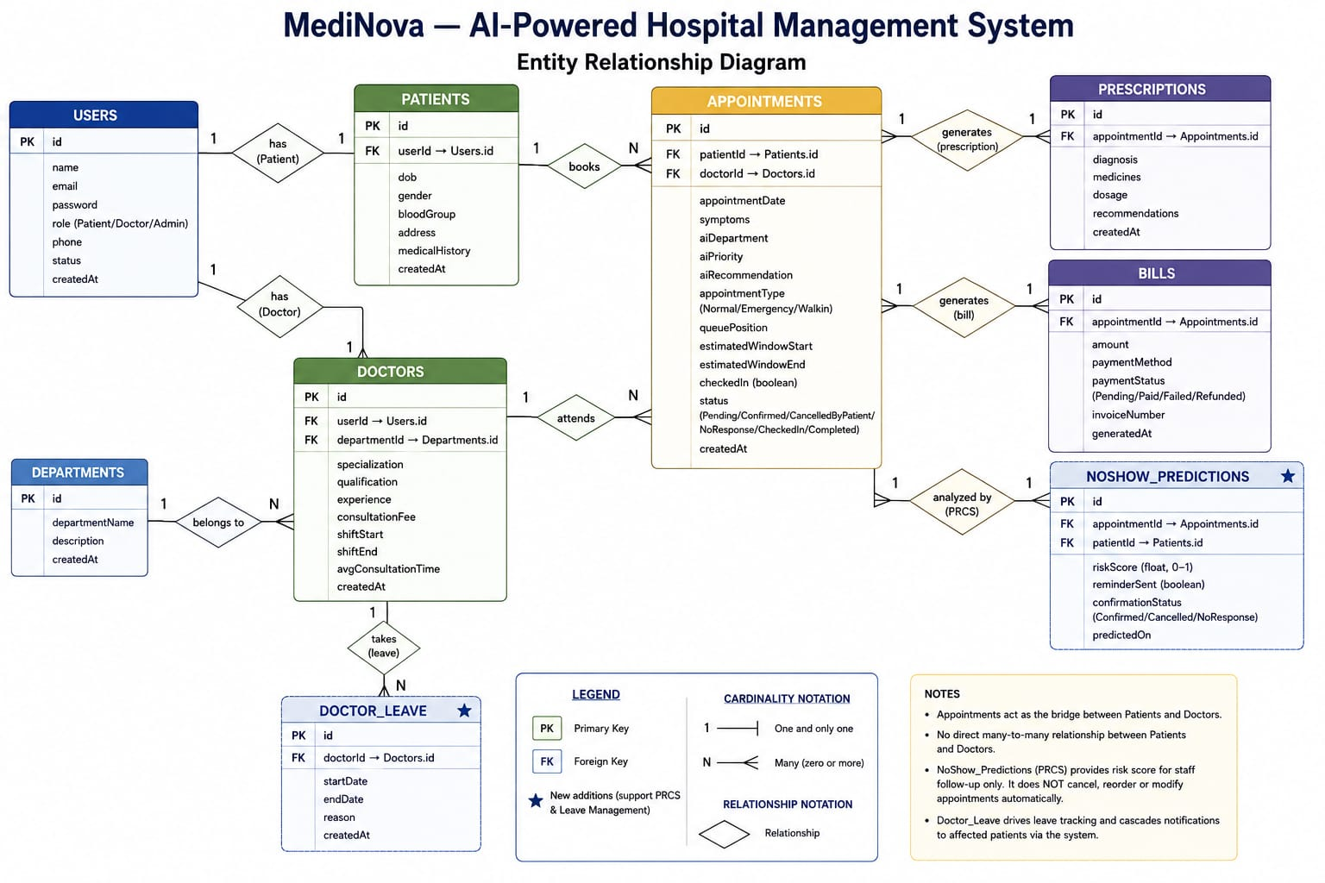
Figure 4.4 — Entity Relationship Diagram

4.5 Class Diagram
The Class Diagram translates the entity structure into an object-oriented view, including class methods and five supporting enumerations (UserRole, AppointmentType, AppointmentStatus, PaymentStatus, ConfirmationStatus) that constrain valid field values at the code level.
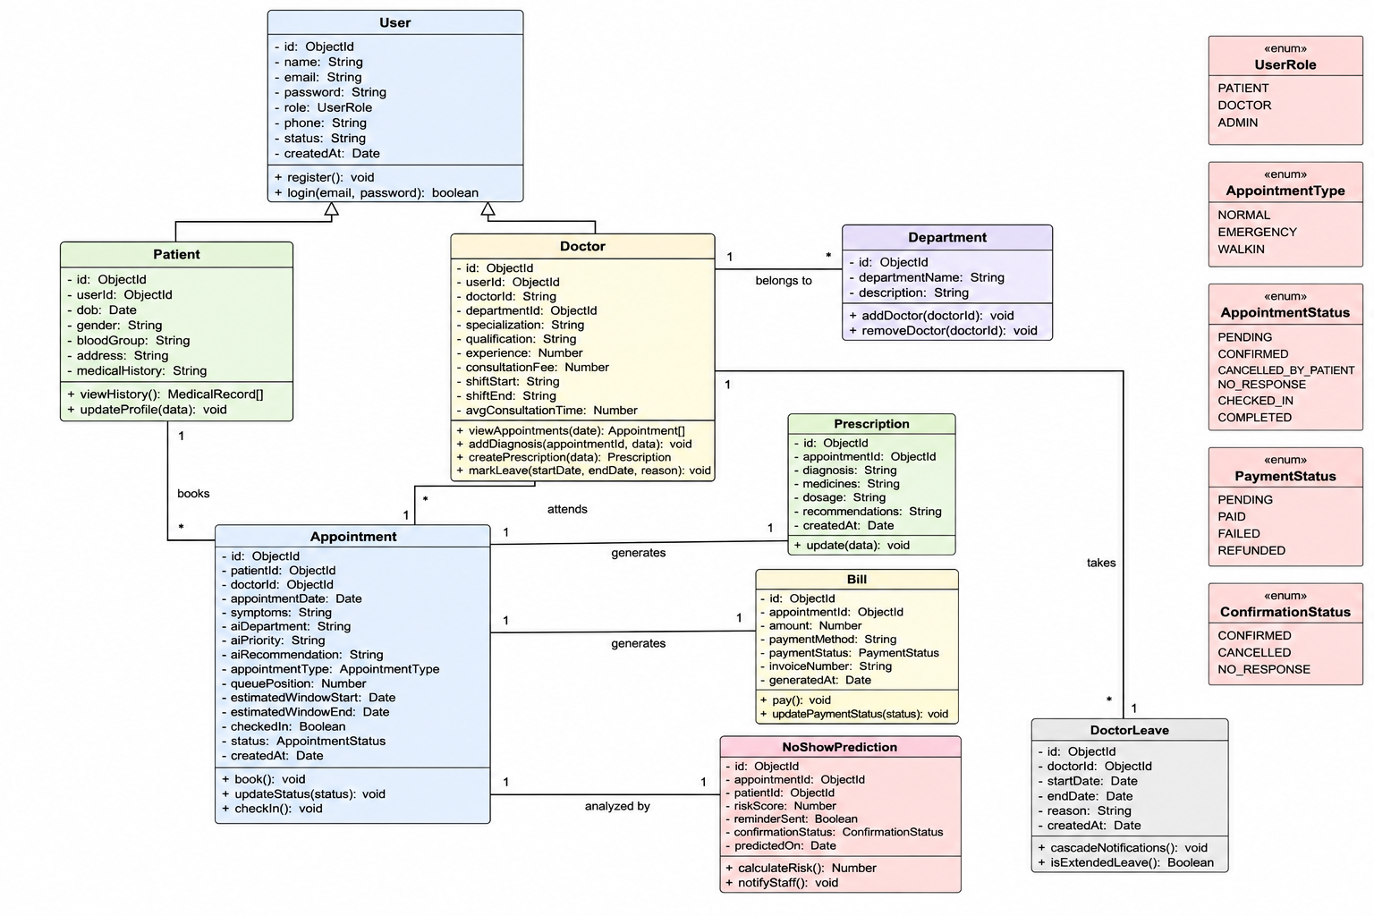
Figure 4.5 — Class Diagram

4.6 Activity Diagram
The Activity Diagram traces the complete patient booking journey, including the concurrent PRCS reminder-confirmation branch and the day-of queue-placement branch (covering pre-booked, emergency, and walk-in patients), before both converge into the consultation, prescription, and billing flow.
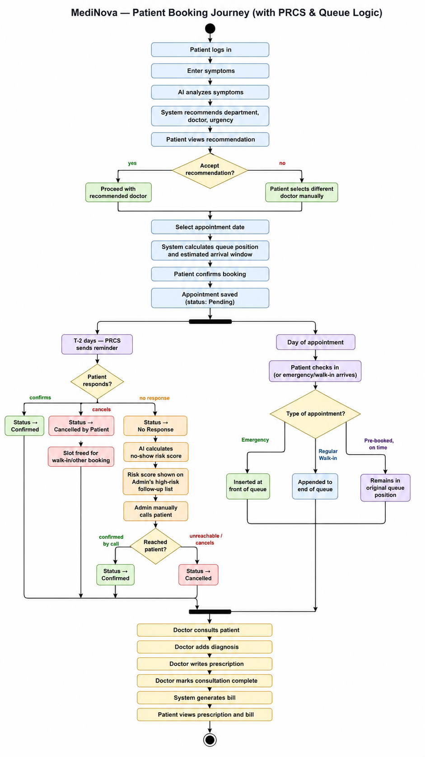
Figure 4.6 — Activity Diagram

4.7 Sequence Diagrams
Two sequence diagrams are presented below, illustrating the precise message flow for the system’s two most distinctive scenarios: AI-assisted appointment booking with queue estimation, and the PRCS reminder-confirmation-risk scoring cycle.
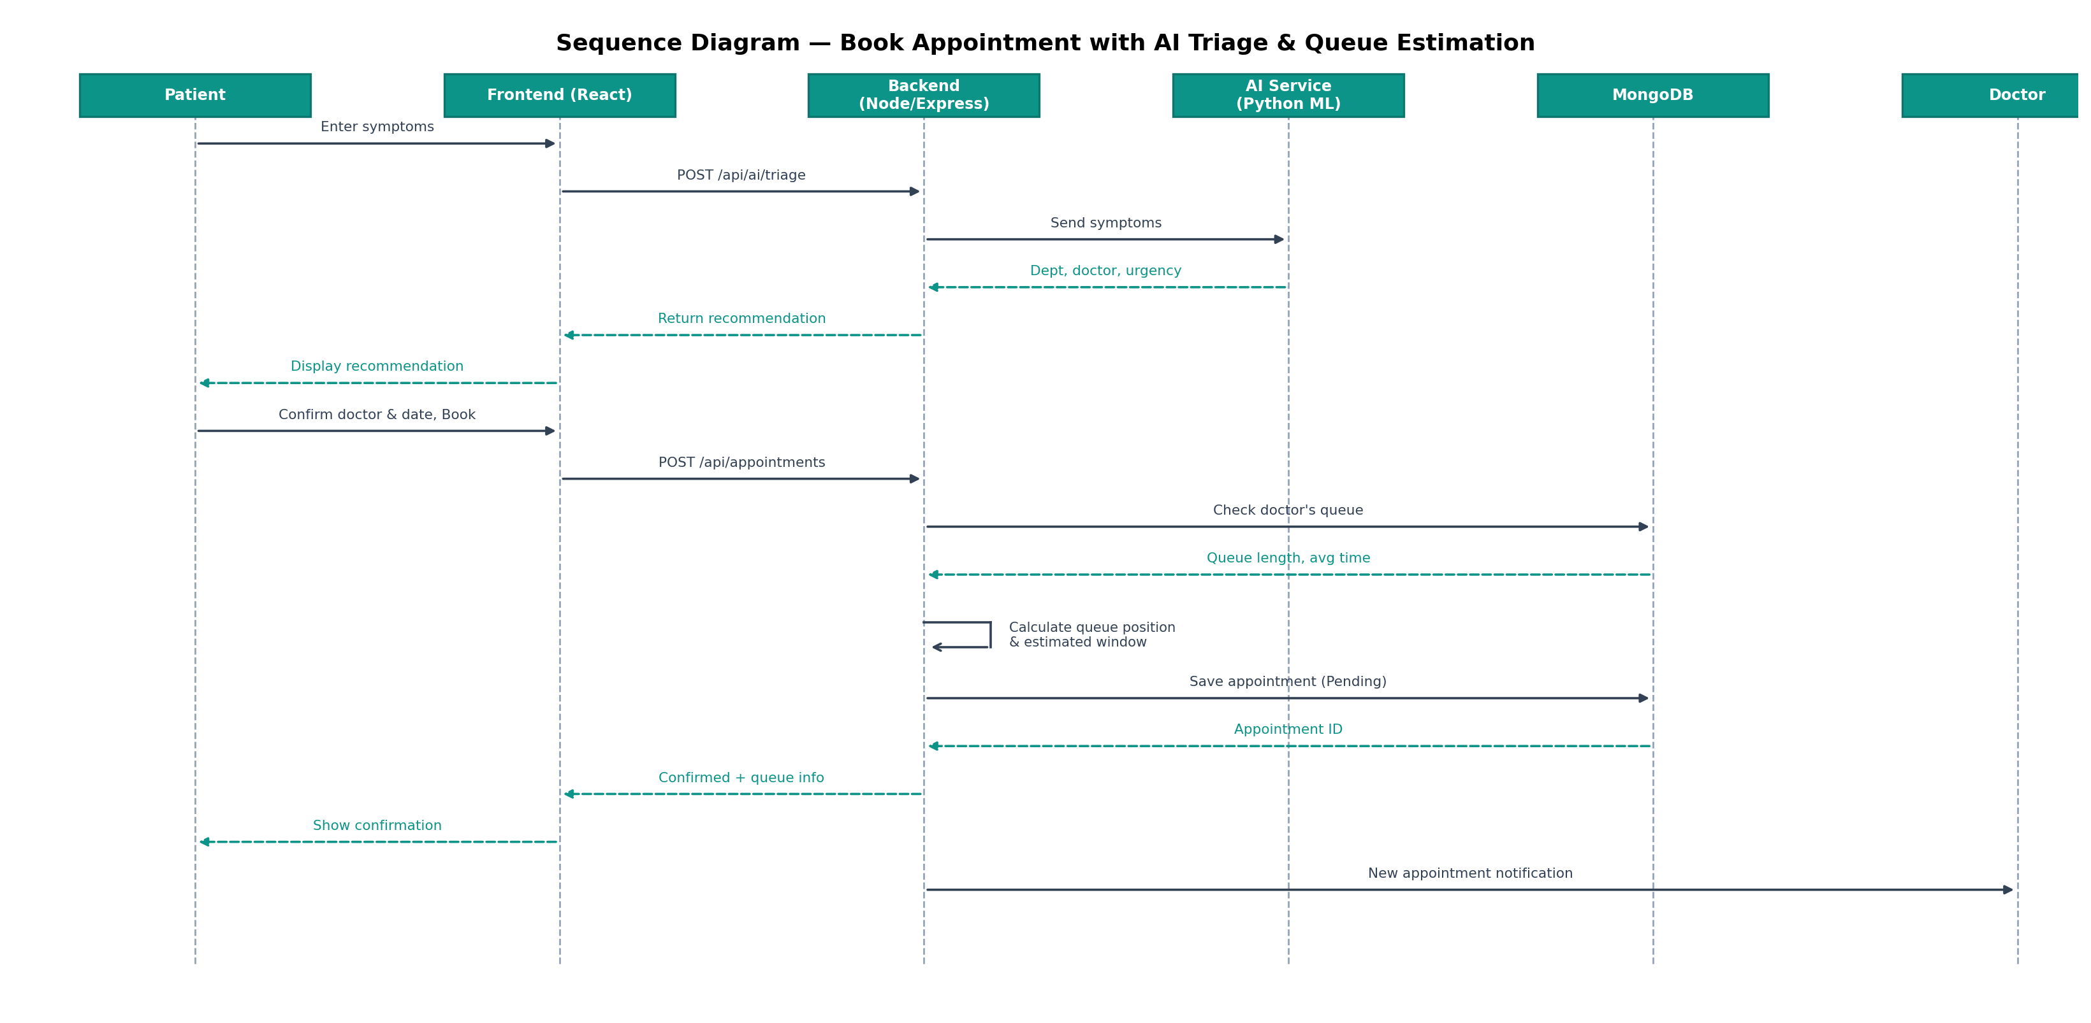
Figure 4.7 — Sequence Diagram: Book Appointment with AI Triage & Queue Estimation
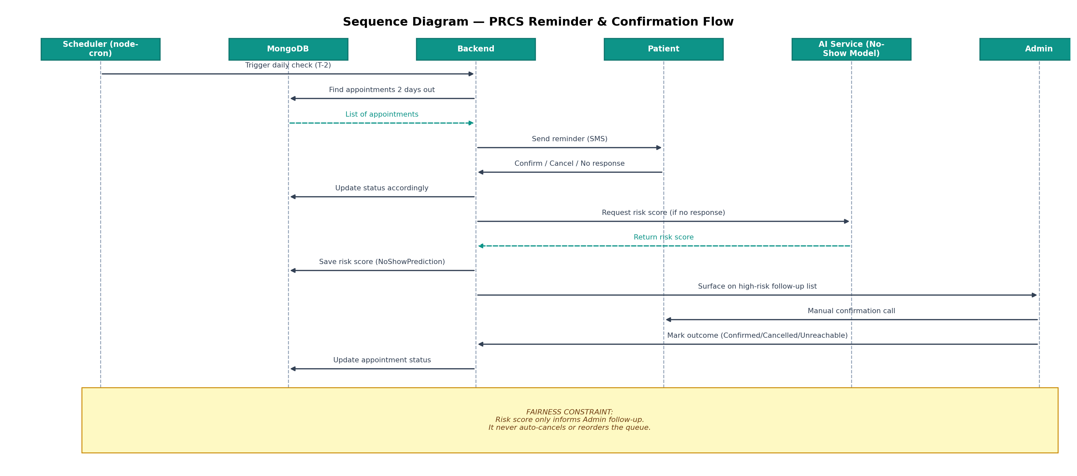
Figure 4.8 — Sequence Diagram: PRCS Reminder & Confirmation Flow

CHAPTER 5 — DATABASE DESIGN
MediNova uses MongoDB (via MongoDB Atlas) as its database, with Mongoose as the Object Data Modeling (ODM) layer. Relationships between collections are implemented using ObjectId references rather than SQL-style foreign keys, with population (join-like retrieval) handled at the application layer. The nine collections below directly correspond to the entities defined in the Entity Relationship Diagram (Chapter 4.4).

5.1 Users
Parent collection for all system accounts. Patient and Doctor collections each hold a reference back to a User document; Admin accounts are represented directly in this collection without a linked profile collection.
Field | Type | Notes
_id | ObjectId | Primary key, auto-generated
name | String | Required
email | String | Required, unique, lowercase, trimmed
password | String | Required; stored as a bcrypt hash, never returned in API responses
role | String (enum) | Patient / Doctor / Admin
phone | String | Required
status | String (enum) | Active / Inactive, default Active
createdAt / updatedAt | Date | Auto-managed timestamps

5.2 Patients
Role-specific profile for users with role = Patient.
Field | Type | Notes
_id | ObjectId | Primary key
userId | ObjectId (ref: User) | Required, unique — one-to-one link to Users
dob | Date | Required
gender | String (enum) | Male / Female / Other
bloodGroup | String | Optional
address | String | Optional
medicalHistory | String | Optional, free text

5.3 Doctors
Role-specific profile for users with role = Doctor, including scheduling parameters used by the Queue Time Estimator.
Field | Type | Notes
_id | ObjectId | Primary key
userId | ObjectId (ref: User) | Required, unique
doctorId | String | Required, unique; auto-generated as {departmentAbbreviation}_{sequence}, e.g. car_001
departmentId | ObjectId (ref: Department) | Required
specialization | String | Required
qualification | String | Required
experience | Number | Years, default 0
consultationFee | Number | Required
shiftStart / shiftEnd | String | Required, e.g. "09:00" / "15:00"
avgConsultationTime | Number | Minutes; default 15, refined over time from real data

5.4 Departments
Reference collection for hospital departments.
Field | Type | Notes
_id | ObjectId | Primary key
departmentName | String | Required, unique
description | String | Optional

5.5 Appointments
Central collection linking Patients and Doctors; the busiest collection in the system, referenced by Prescriptions, Bills, and NoShow_Predictions.
Field | Type | Notes
_id | ObjectId | Primary key
patientId | ObjectId (ref: Patient) | Required
doctorId | ObjectId (ref: Doctor) | Required
appointmentDate | Date | Required
symptoms | String | Patient-submitted free text
aiDepartment / aiPriority / aiRecommendation | String | AI triage output, stored for audit/reference
appointmentType | String (enum) | Normal / Emergency / Walkin, default Normal
queuePosition | Number | Computed at booking / recalculated on queue change
estimatedWindowStart / estimatedWindowEnd | Date | Computed estimated arrival range
checkedIn | Boolean | Default false
status | String (enum) | Pending / Confirmed / CancelledByPatient / NoResponse / CheckedIn / Completed

5.6 Prescriptions
One-to-one with a completed Appointment.
Field | Type | Notes
_id | ObjectId | Primary key
appointmentId | ObjectId (ref: Appointment) | Required, unique
diagnosis | String | Required
medicines | String | Required
dosage | String | Optional
recommendations | String | Optional

5.7 Bills
One-to-one with a completed Appointment.
Field | Type | Notes
_id | ObjectId | Primary key
appointmentId | ObjectId (ref: Appointment) | Required, unique
amount | Number | Required
paymentMethod | String | Cash / Card / UPI / Insurance
paymentStatus | String (enum) | Pending / Paid / Failed / Refunded
invoiceNumber | String | Required, unique
generatedAt | Date | Default: current timestamp

5.8 NoShow_Predictions
Supports the PRCS module; one-to-one with an Appointment that required risk scoring.
Field | Type | Notes
_id | ObjectId | Primary key
appointmentId | ObjectId (ref: Appointment) | Required, unique
patientId | ObjectId (ref: Patient) | Required
riskScore | Number | Range 0–1, ML model output
reminderSent | Boolean | Default false
confirmationStatus | String (enum) | Confirmed / Cancelled / NoResponse
predictedOn | Date | Default: current timestamp

5.9 Doctor_Leave
Supports the Doctor Leave Management module; one Doctor may have many leave records over time.
Field | Type | Notes
_id | ObjectId | Primary key
doctorId | ObjectId (ref: Doctor) | Required
startDate / endDate | Date | Required
reason | String | Optional

5.10 Validation Rules and Relationships — Summary
- Users → Patients and Users → Doctors are strict one-to-one relationships enforced via a unique constraint on userId in each child collection.
- Departments → Doctors is one-to-many; a Doctor cannot be created without a valid, existing departmentId (validated at the application layer before document creation).
- Appointments → Prescriptions, Appointments → Bills, and Appointments → NoShow_Predictions are each one-to-one, enforced via a unique constraint on appointmentId.
- No direct many-to-many relationship exists between Patients and Doctors; all such association is mediated through the Appointments collection.
- Enumerated fields (role, appointmentType, status, paymentStatus, confirmationStatus) are constrained via Mongoose schema enums, preventing invalid values from being persisted.

CHAPTER 6 — HIGH LEVEL DESIGN

6.1 Three-Tier Architecture
MediNova follows a modular, service-oriented three-tier architecture, extended with a dedicated intelligence layer:
- Presentation Layer — a React.js single-page application (built with TanStack Router and Vite) providing role-aware dashboards for Patient, Doctor, and Admin/Reception.
- Application Layer — a Node.js/Express REST API responsible for business logic, authentication (JWT-based), input validation, rate limiting, and orchestration between the data layer and the intelligence layer. A node-cron scheduler within this layer drives the PRCS reminder cycle.
- Data Layer — MongoDB, hosted on MongoDB Atlas, accessed through Mongoose as the Object Data Modeling layer.
- Intelligence Layer — an independent Python/FastAPI microservice hosting the Symptom Triage model and the No-Show Risk Prediction model, queried by the Application Layer over an internal API rather than embedded directly into the Node.js codebase.
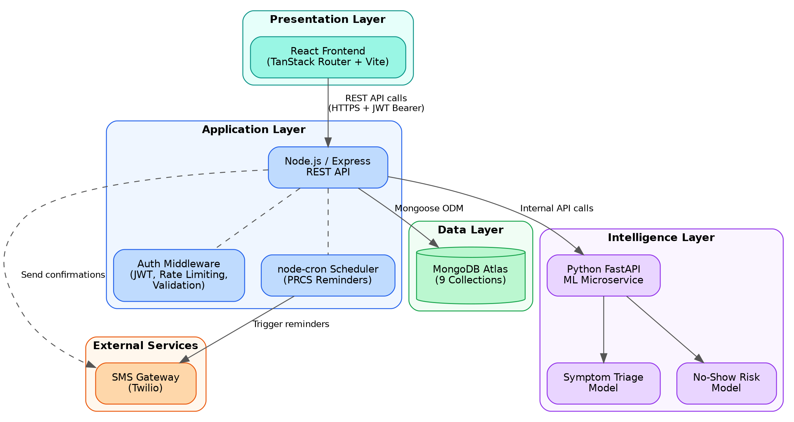
Figure 6.1 — MediNova System Architecture

6.2 Rationale for a Separate Intelligence Layer
The AI/ML functionality is deliberately implemented as an independent microservice rather than embedded within the Node.js backend. Python’s machine learning ecosystem (scikit-learn, pandas, numpy) is substantially more mature than Node.js’s for this class of problem, and isolating this layer allows the triage and no-show models to be developed, retrained, and redeployed independently of the core application, without requiring changes to the Express API surface beyond the internal call contract.

6.3 Communication Flow
- The React frontend communicates with the Express backend exclusively over HTTPS REST calls, authenticated via a JWT Bearer token attached to each request after login.
- The Express backend communicates with MongoDB Atlas via Mongoose, and with the Python ML microservice via internal HTTP calls for triage and risk-scoring requests.
- The node-cron scheduler within the backend triggers the PRCS reminder cycle on a fixed daily schedule, dispatching messages through an external SMS gateway (e.g., Twilio).

CHAPTER 7 — API DOCUMENTATION
This chapter documents the REST API endpoints of MediNova’s backend. Endpoints under Section 7.1 are fully implemented and verified through manual Postman testing and live frontend integration. Endpoints under Section 7.2 are specified as part of the system design and are planned for implementation in the next development phase, following the same authentication and response conventions established below.

7.1 Implemented Endpoints (Authentication Module)
All responses follow a consistent envelope: { success: boolean, message: string, data: object|null }. Authenticated endpoints require an Authorization: Bearer <token> header, where the token is issued at login/registration and expires after 7 days.

POST /api/auth/register
Registers a new Patient or Doctor account. Admin accounts cannot be created through this endpoint; only one hospital admin account exists, provisioned via environment configuration.
Property | Value
Method | POST
Endpoint | /api/auth/register
Auth Required | Not required
Request Body (JSON):
{
"name": "Ananya Rao",
"email": "ananya.rao@example.com",
"password": "Passw0rd123",
"phone": "+919876543210",
"role": "Patient",
"dob": "2000-05-14",
"gender": "Female",
"bloodGroup": "O+",
"address": "12, Nandi Durga Rd, Bengaluru",
"medicalHistory": "Asthma since 2018"
}
Response Body (JSON):
{
"success": true,
"message": "Operation completed successfully",
"data": {
"token": "<jwt_token>",
"user": {
"id": "66a...",
"name": "Ananya Rao",
"email": "ananya.rao@example.com",
"role": "Patient"
}
}
}

POST /api/auth/login
Authenticates a user and issues a JWT. An optional adminId field is required only for the single provisioned hospital administrator account; it is omitted for Patient and Doctor logins.
Property | Value
Method | POST
Endpoint | /api/auth/login
Auth Required | Not required
Request Body (JSON):
{
"email": "ananya.rao@example.com",
"password": "Passw0rd123"
}
Response Body (JSON):
{
"success": true,
"message": "Operation completed successfully",
"data": {
"token": "<jwt_token>",
"user": {
"id": "66a...",
"name": "Ananya Rao",
"email": "ananya.rao@example.com",
"role": "Patient"
}
}
}

GET /api/auth/me
Returns the currently authenticated user’s profile, used by the frontend to revalidate a cached session on load.
Property | Value
Method | GET
Endpoint | /api/auth/me
Auth Required | Required
Request Body (JSON):
(No request body)
Response Body (JSON):
{
"success": true,
"message": "Operation completed successfully",
"data": {
"user": {
"id": "66a...",
"name": "Ananya Rao",
"email": "ananya.rao@example.com",
"role": "Patient"
}
}
}

GET /api/departments
Returns the list of hospital departments, used to populate the department selection dropdown during Doctor registration.
Property | Value
Method | GET
Endpoint | /api/departments
Auth Required | Not required
Request Body (JSON):
(No request body)
Response Body (JSON):
{
"success": true,
"message": "Departments fetched successfully",
"data": {
"departments": [
{
"_id": "6a6514b34259f66e83ecdabf",
"departmentName": "Cardiology",
"description": "Heart and cardiovascular diseases"
}
]
}
}

7.2 Planned Endpoints (Specified, Next Development Phase)
The endpoints below follow the same request/response conventions as Section 7.1 and are specified here as part of the system design; they are scheduled for implementation following the Appointment Booking module.
Method | Endpoint | Purpose
POST | /api/ai/triage | Submit symptoms and receive AI department/doctor/urgency recommendation
POST | /api/appointments | Book a new appointment with queue position and estimated window calculation
GET | /api/appointments/my | Patient: retrieve own appointment history
GET | /api/appointments/doctor | Doctor: retrieve today’s assigned queue
PATCH | /api/appointments/:id/status | Update appointment status (e.g., confirm, cancel, check-in, complete)
POST | /api/appointments/walkin | Admin: register an emergency or regular walk-in
POST | /api/prescriptions | Doctor: create a prescription for a completed consultation
POST | /api/bills | System: auto-generate a bill on consultation completion
GET | /api/prcs/followup-list | Admin: retrieve high-risk unconfirmed appointments, sorted by risk score
PATCH | /api/prcs/:appointmentId/outcome | Admin: record the outcome of a manual follow-up call
POST | /api/doctor-leave | Doctor/Admin: record a leave period and trigger cascading notifications
GET | /api/admin/dashboard | Admin: retrieve aggregated analytics for the reporting dashboard

CHAPTER 8 — UI WIREFRAMES
The following low-fidelity wireframes illustrate the core screens of MediNova across all three user roles. These wireframes correspond directly to the screens implemented in the working frontend (built with React and TanStack Router), and are presented here to document layout intent independent of final visual styling.

8.1 Sign In
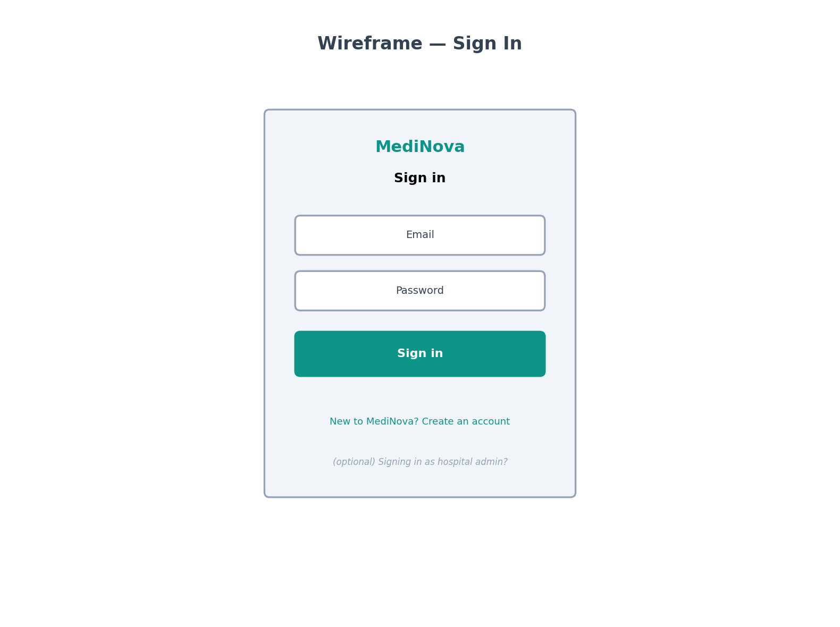
Figure 8.1 — Sign In Screen

8.2 Patient Dashboard
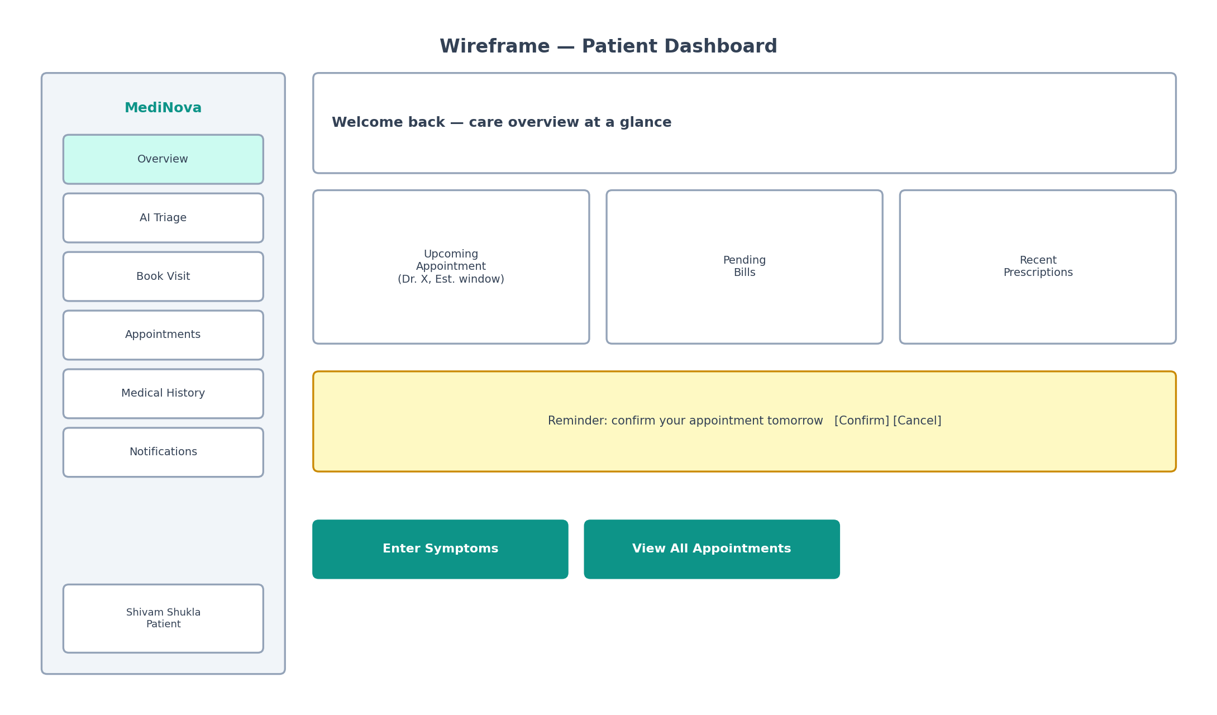
Figure 8.2 — Patient Dashboard

8.3 AI Symptom Triage
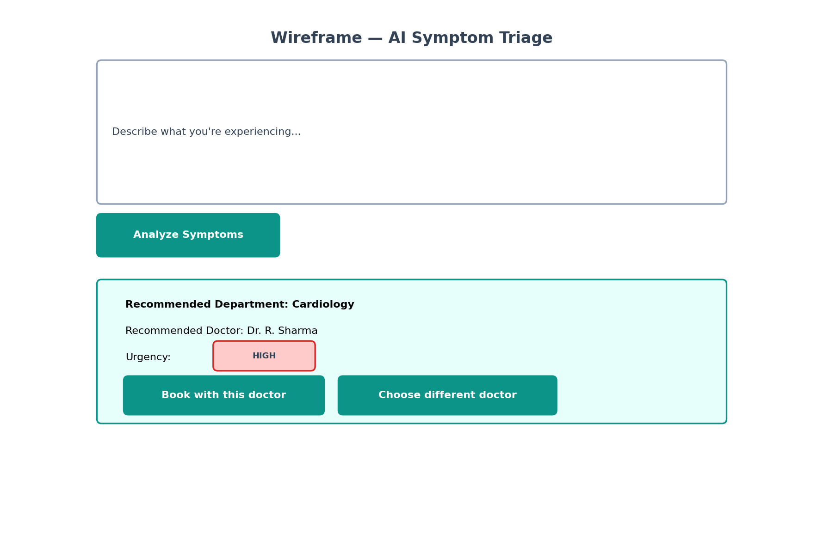
Figure 8.3 — AI Symptom Triage Screen

8.4 Book Appointment
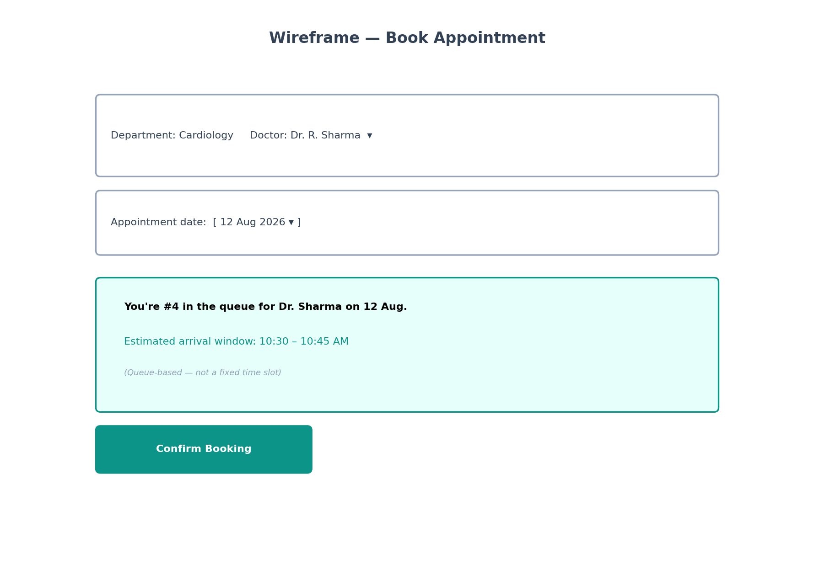
Figure 8.4 — Book Appointment Screen (Queue-Based)

8.5 My Appointments
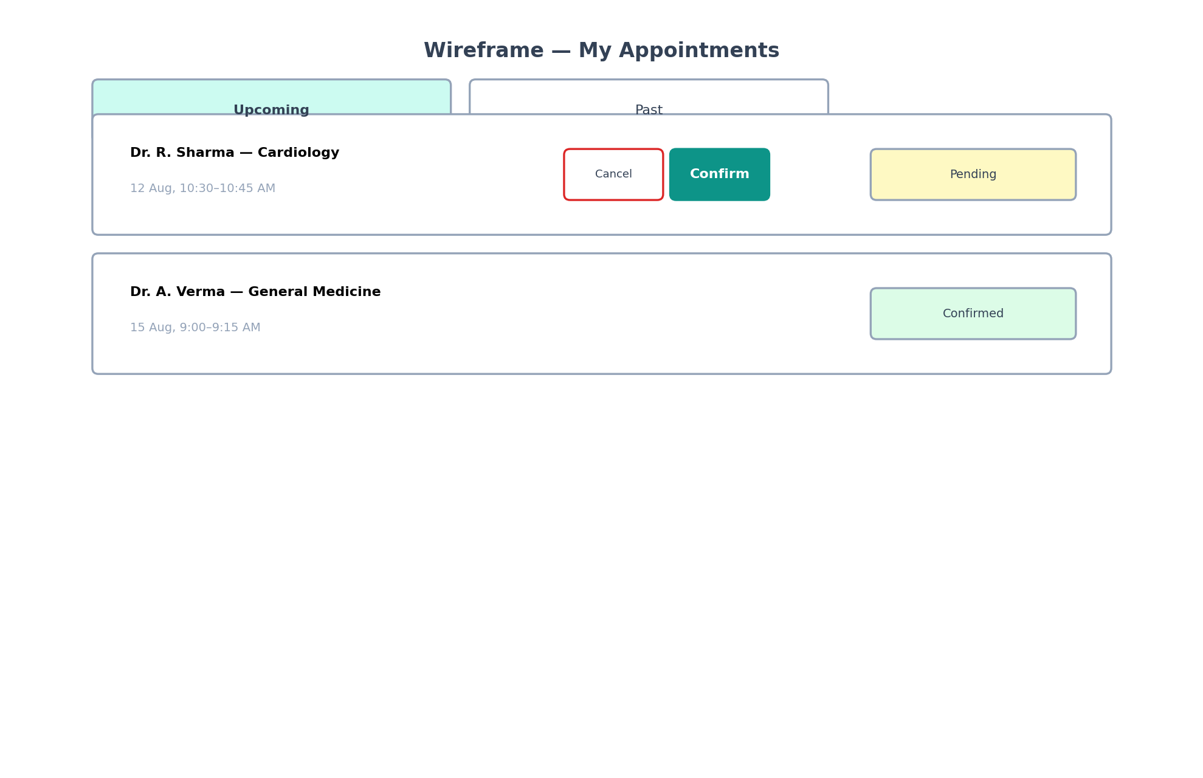
Figure 8.5 — My Appointments Screen

8.6 Admin — High-Risk Follow-up List (PRCS)
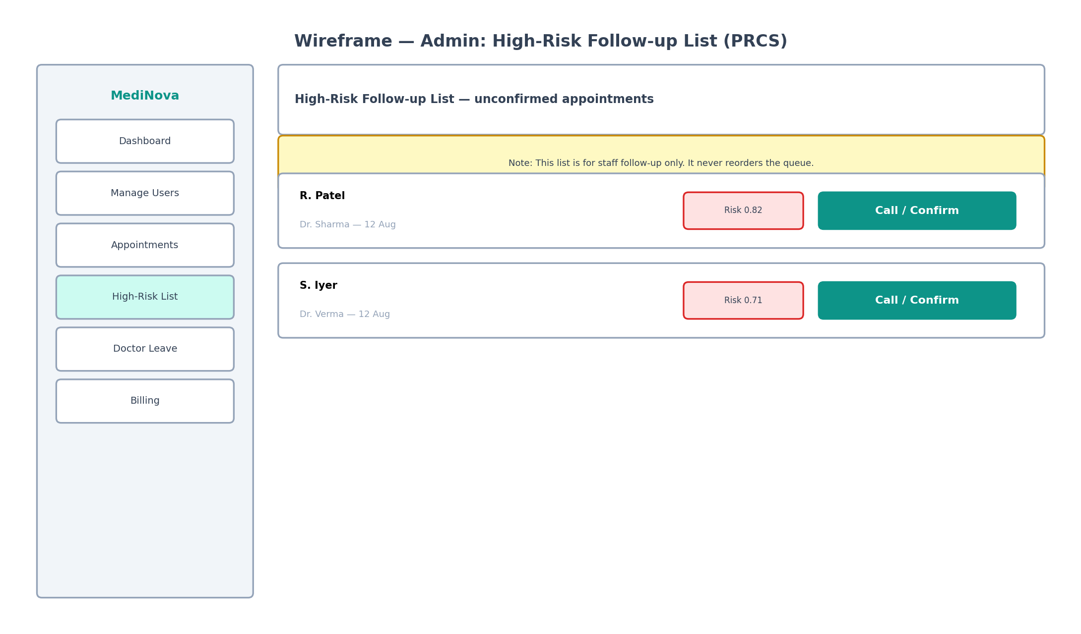
Figure 8.6 — Admin: High-Risk Follow-up List

8.7 Doctor Leave Management
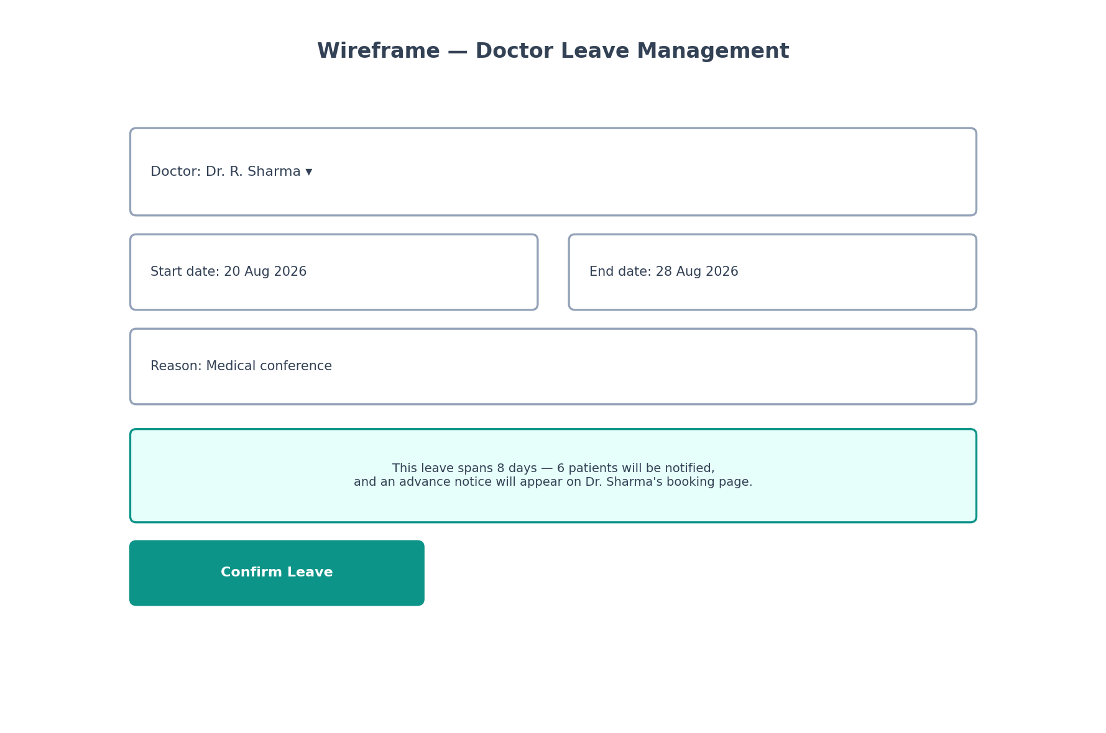
Figure 8.7 — Doctor Leave Management Screen

CHAPTER 9 — TESTING
Testing has been conducted manually to date, focused on the Authentication module, which is the only module fully implemented and integrated end-to-end (backend, database, and live frontend) at the time of this draft. Test cases for subsequent modules (Appointment Booking, AI Triage, PRCS, Queue Estimator, Doctor Leave) are specified below as planned test cases, to be executed once each module is implemented.

9.1 Testing Types Applied
- Black Box Testing — verifying API responses against expected outputs for given inputs, without reference to internal implementation, primarily via Postman.
- White Box Testing — reviewing controller and middleware logic directly (e.g., confirming password hashing occurs before persistence, confirming validation middleware executes before controller logic).
- Unit-level Testing — verifying individual functions in isolation (e.g., token generation, password comparison) behave correctly for valid and invalid inputs.
- Integration Testing — verifying the complete request path from the live React frontend through the Express backend to MongoDB Atlas and back, confirmed via browser Network tab inspection.
- System Testing — end-to-end verification of full user journeys (registration through login through session persistence) as a complete flow rather than isolated units.

9.2 Executed Test Cases — Authentication Module
TC ID | Description | Input | Expected Result | Status
TC-01 | Register a new Patient with valid data | Valid name, email, password (8+ chars, letter+number), phone, Patient-specific fields | 201 response; User and Patient documents created; JWT issued | Pass
TC-02 | Register a new Doctor with valid data | Valid fields including a real departmentId | 201 response; User and Doctor documents created; doctorId auto-generated | Pass
TC-03 | Register with a duplicate email | Email already present in Users collection | 400 response, "A user with that email already exists"; no duplicate document created | Pass
TC-04 | Register Doctor with invalid departmentId | departmentId not present in Departments collection | 400 response, "Invalid departmentId — department does not exist" | Pass
TC-05 | Register with weak password | Password under 8 characters or missing a letter/number | 400 response from validation middleware; no document created | Pass
TC-06 | Login with correct credentials | Valid email and password | 200 response; JWT and user data returned, password field absent | Pass
TC-07 | Login with incorrect password | Valid email, wrong password | 401 response, "Invalid credentials" | Pass
TC-08 | Repeated failed login attempts (rate limiting) | 6 consecutive failed login attempts within 15 minutes | 429 response after the 5th attempt, "Too many login attempts..." | Pass
TC-09 | Access protected route with valid token | GET /api/auth/me with valid Authorization header | 200 response with correct user data | Pass
TC-10 | Access protected route without token | GET /api/auth/me with no Authorization header | 401 response, "Not authorized, token missing or invalid" | Pass
TC-11 | Password persistence check | Inspect Users collection directly in MongoDB Atlas after registration | Password field stored as a bcrypt hash, not plaintext | Pass
TC-12 | Frontend-to-backend CORS integration | Submit registration form from the live React frontend | Request succeeds without CORS rejection; response correctly parsed by frontend | Pass

9.3 Planned Test Cases — Subsequent Modules
The following test cases are specified in advance and will be executed as each corresponding module is implemented.
TC ID | Module | Description | Expected Result
TC-13 | Appointment Booking | Book an appointment and verify queue position/estimated window calculation | Correct queue position assigned; estimated window reflects doctor’s average consultation time
TC-14 | AI Triage | Submit symptoms and verify a department/doctor/urgency recommendation is returned | Non-empty, structurally valid recommendation returned within acceptable latency
TC-15 | PRCS | Simulate an unconfirmed appointment past the response cutoff | Risk score computed and appears on Admin follow-up list; appointment status/queue position unchanged
TC-16 | Emergency Walk-in | Register an emergency walk-in for a doctor with an existing queue | Walk-in patient placed at the front of the live queue; other patients’ estimated windows shift accordingly
TC-17 | Doctor Leave (extended) | Mark a doctor on leave for 8 consecutive days | Existing affected appointments cancelled with notice; advance notice appears on booking page for new patients

CHAPTER 10 — FUTURE SCOPE
Beyond the features implemented and specified in this document, several extensions are identified as valuable future directions for MediNova, several of which involve deeper applications of artificial intelligence:

10.1 AI-Based Food/Diet or Care Recommendations
An extension of the existing AI triage engine could provide post-consultation lifestyle or care recommendations based on diagnosis history, complementing rather than replacing the doctor’s own advice.

10.2 AI Chatbot for Patient Queries
A conversational assistant could handle routine, non-urgent patient queries (appointment status, general clinic information, prescription refill requests), reducing the load on reception staff while escalating anything requiring human judgment.

10.3 QR-Based Check-In
Patients could check in for their appointment by scanning a QR code at reception, automatically updating their checkedIn status and improving the accuracy of live queue tracking used by the Queue Time Estimator.

10.4 Sales and Revenue Prediction
Applying time-series forecasting to historical billing data could help administrators anticipate revenue trends and staffing needs across departments.

10.5 Inventory Prediction (Pharmacy Module)
Should the pharmacy/inventory module (explicitly out of scope in this phase) be added in a future cycle, demand-forecasting techniques similar to those used in the no-show prediction model could predict medicine stock depletion and suggest reorder timing.

10.6 Model Retraining on Real Hospital Data
As MediNova accumulates its own appointment history, the no-show prediction model — currently informed by a public reference dataset — can be retrained on the hospital’s own data, improving prediction accuracy specific to that clinic’s actual patient behavior.

10.7 Nurse/Paramedical Staff and Full Inventory Management
As noted in Chapter 1, nurse/paramedical role management and full medicine inventory management (suppliers, batch/expiry tracking, automated reordering) remain valid, planned extensions once the core patient-flow and AI modules are fully validated.

CHAPTER 11 — CONCLUSION
MediNova demonstrates that a hospital management system can move meaningfully beyond basic record-keeping by incorporating targeted, responsibly-designed artificial intelligence features that address genuine, well-documented operational inefficiencies in healthcare administration: patient misrouting, appointment no-shows, and unrealistic fixed-slot scheduling.
Each intelligent feature in this system was grounded in a specific real-world problem rather than added for its own sake, and the design of the Predictive Reminder & Confirmation System in particular reflects a deliberate constraint — that predictive outputs may inform human decision-making but must never independently determine a patient’s access to care. This distinction, arrived at through explicit consideration of the practical and ethical risks of naive predictive scheduling, is intended to represent a technically sound and thoughtfully constrained approach to applying AI within a healthcare context.
At the current stage of development, the Authentication module — including registration, login, JWT-based session management, and a full set of security hardening measures (input validation, rate limiting, CORS restriction, sanitization) — has been implemented, tested, and integrated end-to-end with a live frontend. The remaining modules specified in this document (Appointment Booking, AI Symptom Triage, PRCS, Dynamic Queue Time Estimator, Emergency/Walk-in handling, and Doctor Leave Management) are fully designed, diagrammed, and scoped, and represent the implementation roadmap for the remainder of the development cycle.

REFERENCES
- Kaggle: "Medical Appointment No Shows" Dataset — referenced for no-show prediction model design approach.
- OpenMRS and Hospital Run — referenced as examples of existing open-source hospital management systems.
- scikit-learn Documentation — Logistic Regression and Random Forest Classifier reference.
- MongoDB and Mongoose Official Documentation.
- Express.js Official Documentation.
- React.js and TanStack Router Official Documentation.
- IEEE Std 830-1998 — IEEE Recommended Practice for Software Requirements Specifications.

End of Document — Draft 1 (Checkpoint)

