MediNova
AI-Powered Hospital Management System
Project Documentation — Draft 1
Submitted for: Semester 5 — User Defined Project (UDP)
Institution: LJ University, Gujarat
Student: Shivam Shukla
Program: BSc IT — Semester 5
Document Status: DRAFT 1 (Checkpoint)
This is a living checkpoint document. Sections will be expanded and updated as development progresses.

Table of Contents

1. Abstract
MediNova is an AI-powered Hospital Management System built on the MERN stack (MongoDB, Express.js, React.js, Node.js) with a dedicated Python-based machine learning microservice. Unlike conventional hospital management systems that merely digitize patient records through basic CRUD operations, MediNova integrates intelligent decision-support features at points where hospitals — particularly small and mid-sized clinics in India — genuinely struggle: patient routing, appointment reliability, and realistic queue management.
The system introduces three core intelligent modules: an AI-driven Symptom Triage system, a Predictive Reminder & Confirmation System (PRCS), and a Dynamic Queue Time Estimator, alongside operational features for emergency handling and doctor leave management. A central design principle underlying this project is that predictive intelligence should inform human decision-making, not replace fairness or patient autonomy — a principle reflected concretely in how the no-show prediction model is used only to prioritize staff follow-up, never to reorder or bump patients automatically.

2. Introduction
Healthcare administration in India, especially at small and mid-sized clinics, continues to rely heavily on manual or semi-digitized processes. Patients often lack clarity on which doctor to consult or how urgent their condition is; hospitals lose valuable doctor time to appointment no-shows; and fixed appointment slot systems fail to reflect the natural variability of real consultations. MediNova was conceived to address these specific, observable inefficiencies through a combination of full-stack web development and applied machine learning, while remaining grounded in the practical realities of how Indian healthcare facilities currently operate.

3. Problem Statement
Three concrete problems motivate this project:
- Misrouted and undifferentiated patient care: Patients typically self-diagnose or rely on non-medical reception staff to determine which department or doctor to see, and how urgently. This leads to inefficient use of specialist time and inconsistent triage of urgent cases.
- Appointment no-shows and wasted clinical time: Clinics generally have no proactive way of identifying which upcoming appointments are at risk of a no-show, resulting in reactive, last-minute handling (or no handling at all) of missed slots.
- Unrealistic fixed-slot scheduling: Most existing hospital systems assign fixed time slots regardless of the fact that real consultation durations vary significantly by patient and condition, leading to either wasted doctor time or patient backlogs.

4. Objectives
- To design and develop a full-stack hospital management platform covering patient registration, appointment booking, doctor consultation, prescription generation, and billing.
- To integrate an AI-based symptom triage module that recommends department, doctor, and urgency level from patient-reported symptoms.
- To design a fairness-conscious predictive reminder and confirmation system (PRCS) that reduces appointment no-shows without compromising patient equity.
- To implement a dynamic, queue-based scheduling model that reflects real consultation-time variability instead of fixed time slots.
- To handle real-world operational scenarios: emergency walk-ins, regular walk-ins, and doctor leave (both short-term and extended).

5. Scope of the Project

In Scope (Phase 1)
- Patient, Doctor, and Admin/Reception role-based access
- AI Symptom Triage
- Predictive Reminder & Confirmation System (PRCS)
- Dynamic Queue Time Estimator
- Emergency and walk-in patient handling
- Doctor leave management (single-day and extended)
- Prescription and billing management
- Admin analytics dashboard

Out of Scope (Phase 1)
- Nurse/paramedical staff role management
- Full medicine inventory management (suppliers, batches, purchase orders, auto-reordering)
Both excluded areas are acknowledged as valid extensions for a future development cycle, but were deliberately excluded to keep the current phase focused and achievable within the semester timeline.

6. Literature / Existing System Review
Most existing hospital management systems, including widely used platforms like OpenMRS and Hospital Run, focus primarily on digitizing patient records, scheduling, and billing. Appointment booking in these systems is typically a static, fixed-slot process with no mechanism to account for real consultation-time variability or to intervene proactively when a booking is at risk of being missed.
Separately, academic work on appointment no-show prediction — much of it built around public datasets such as the Kaggle "Medical Appointment No Shows" dataset — has shown that simple, interpretable models like Logistic Regression or Random Forest can predict no-shows reasonably well using features like booking lead time, day of week, and prior attendance history. However, this research generally stops at prediction and rarely addresses how such predictions should be used operationally without compromising fairness.
MediNova builds on both areas — using standard, interpretable classification techniques for no-show prediction, while extending typical HMS functionality with AI-assisted triage and a deliberate constraint that predictions only support staff follow-up, never automated scheduling decisions.

7. Proposed System Overview
MediNova operates as a three-tier web application supplemented by a dedicated AI/ML microservice:
- Presentation Layer: React.js-based dashboards tailored to Patient, Doctor, and Admin roles
- Application Layer: Node.js/Express.js REST API handling business logic, authentication, and orchestration
- Data Layer: MongoDB (via MongoDB Atlas) storing all persistent records
- Intelligence Layer: A Python (FastAPI) microservice hosting the symptom triage and no-show risk prediction models
This separation allows the system to leverage Python’s mature machine learning ecosystem (scikit-learn, pandas) without compromising the JavaScript-based development consistency of the core application.

8. System Requirements

Functional Requirements
- User registration and role-based authentication (Patient, Doctor, Admin)
- Appointment booking with AI-assisted recommendation
- Real-time queue position and estimated arrival window
- Automated reminder and confirmation workflow
- Doctor consultation, diagnosis, and prescription recording
- Automated billing generation
- Admin dashboard for reports, staff management, and follow-up prioritization

Non-Functional Requirements
- Secure authentication using hashed passwords (bcrypt) and JWT-based sessions
- Input validation and sanitization on all user-submitted data
- Rate-limited authentication endpoints to prevent brute-force attempts
- Responsive frontend usable across desktop and mobile browsers
- Modular, maintainable codebase separated by concern (models, controllers, routes, middleware)

Hardware/Software Requirements
- Node.js runtime environment
- Python 3.x runtime environment
- MongoDB Atlas cloud cluster
- Modern web browser (Chrome, Firefox, Edge)
- Development tools: VS Code, Postman, Git

9. System Architecture
A text-based architecture overview is provided below. A polished visual architecture diagram is optional and can be added here later if time permits.
MediNova follows a modular, service-oriented architecture:
React (Frontend)
|
v
Node.js / Express (Backend API)
|
+----------+-----------+
| |
v v
MongoDB Atlas Python ML Microservice (FastAPI)
(data persistence) |
+-- Symptom Triage Model
+-- No-Show Risk Prediction Model

The backend acts as the orchestration layer, mediating between the client, the persistent data store, and the intelligence layer, ensuring that AI predictions never directly manipulate core business data (such as appointment order) without passing through business-logic safeguards.

10. Core Features — Detailed Explanation

10.1 AI Symptom Triage
Patients enter symptoms in natural language. The AI/ML microservice analyzes this input and returns a recommended department, suggested doctor, and an urgency classification. This recommendation assists — but does not override — patient choice; patients may proceed with an alternative selection if desired.

10.2 Predictive Reminder & Confirmation System (PRCS)
PRCS sends automated reminders at two intervals (two days prior, and on the day of the appointment) and captures patient self-confirmation or cancellation. For appointments where the patient does not respond, a machine learning model computes a no-show risk score based on historical patterns. Critically, this score is used exclusively to help administrative staff prioritize manual follow-up calls — it does not automatically reorder, deprioritize, or cancel any appointment.

10.3 Dynamic Queue Time Estimator
Rather than assigning fixed appointment slots, MediNova assigns each patient a queue position and computes an estimated arrival window based on the doctor’s average consultation duration (refined over time using real recorded data) and current queue length.

10.4 Emergency and Walk-in Handling
Emergency cases are inserted at the front of a doctor’s live queue, as this reordering is based on observed, real-time medical urgency rather than a probabilistic prediction. Regular walk-in patients (without prior booking) are appended to the end of the day’s queue, maintaining fairness for pre-booked patients.

10.5 Doctor Leave Management
Single-day doctor leave triggers automatic rescheduling notices to affected patients. Extended leave (a configurable threshold, e.g. seven or more consecutive days) additionally triggers a proactive advance notice visible on the doctor’s booking page, preventing new patients from booking into an unavailable period.

11. Design Philosophy
A recurring principle across MediNova’s intelligent features is that prediction should inform human decisions, not replace fairness or patient autonomy. This is most clearly demonstrated in the PRCS module, where no-show risk scores are deliberately withheld from any automated queue-reordering logic and are instead surfaced only as a prioritization aid for hospital staff. This reflects a considered position on the responsible use of predictive AI in healthcare settings, where acting on a probability as though it were a certainty carries real risk of unfairness to patients.

12. Database Design
The system is modeled around nine core entities: User, Patient, Doctor, Department, Appointment, Prescription, Bill, NoShow_Prediction, and Doctor_Leave. The Appointment entity functions as the central hub, linking Patients and Doctors and generating exactly one Prescription and one Bill per completed consultation. NoShow_Prediction and Doctor_Leave are entities introduced specifically to support the PRCS and Leave Management features respectively. See the Entity Relationship Diagram in Section 13.4 for full attribute-level detail.

13. Diagrams

13.1 Use Case Diagram
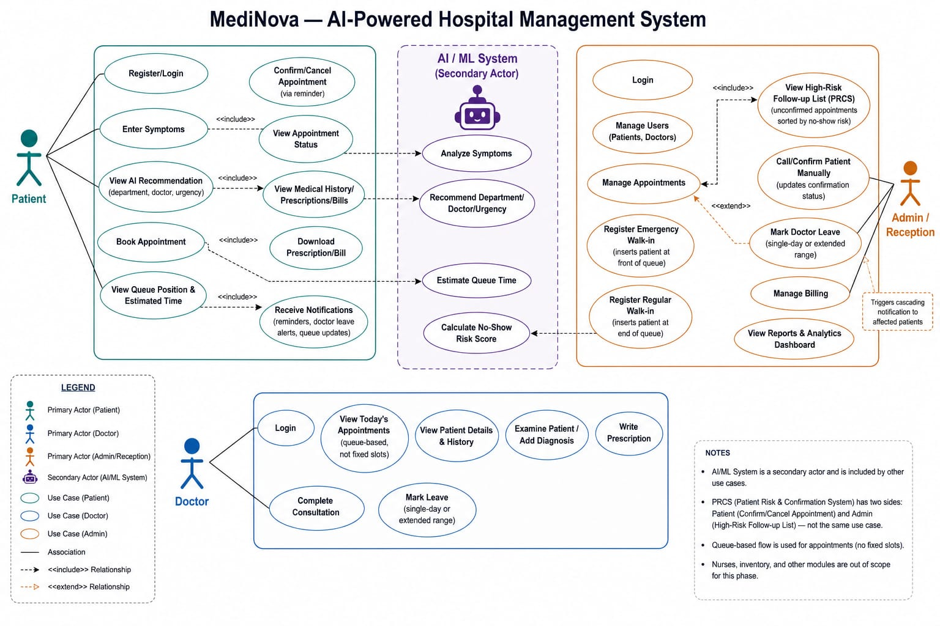

13.2 Data Flow Diagram — Level 0 (Context Diagram)
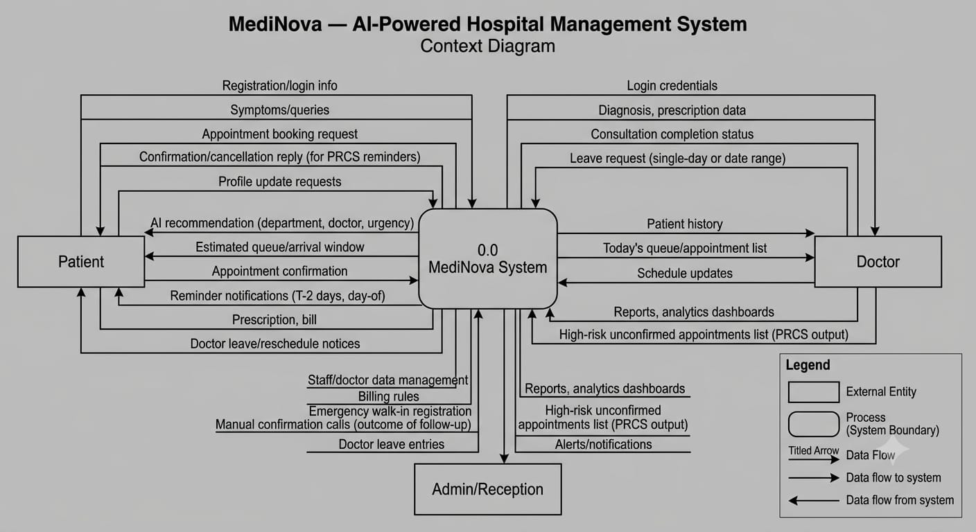

13.3 Data Flow Diagram — Level 1
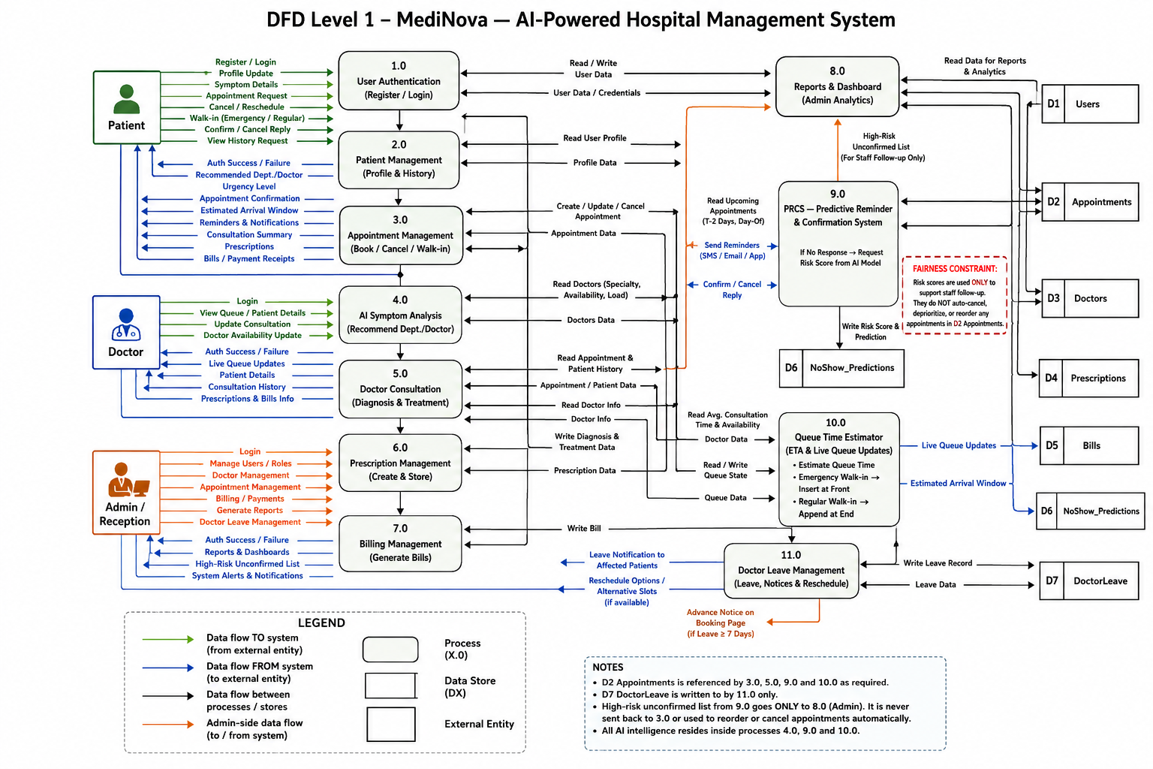

13.4 Entity Relationship Diagram
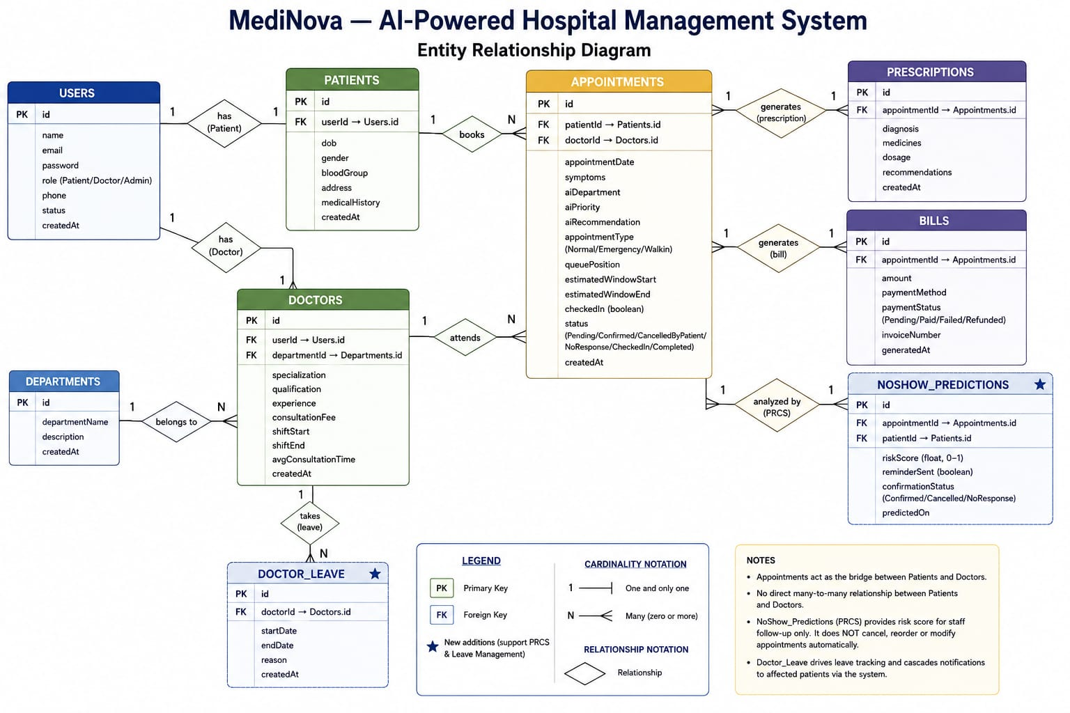

14. Technology Stack

Frontend
- React.js (via Vite)
- Tailwind CSS
- Axios (API communication)

Backend
- Node.js with Express.js
- Mongoose (MongoDB ODM)
- JSON Web Token (JWT) for authentication
- bcryptjs for password hashing
- express-validator for input validation
- express-rate-limit for brute-force protection
- node-cron for scheduled reminder jobs

Database
- MongoDB (hosted on MongoDB Atlas)

AI/ML Microservice
- Python, FastAPI
- scikit-learn (Logistic Regression / Random Forest for no-show prediction)
- pandas, numpy (data preprocessing)
- NLP-based or rule-based classifier for symptom triage

Communication / Notifications
- SMS gateway integration (e.g., Twilio) for appointment reminders and confirmations

Development & Collaboration Tools
- Visual Studio Code
- GitHub Copilot (AI-assisted development)
- Postman (API testing)
- Git and GitHub (version control)

15. Development Pipeline / Methodology
The project follows an incremental, layer-by-layer development approach:
- Database Layer: Mongoose schema definitions for all nine entities, matching the finalized ER diagram exactly. (Completed)
- Authentication Layer: Role-based registration and login, JWT-based session management, and middleware-based route protection — including input validation, rate limiting, department-existence checks, and CORS restriction. (Completed)
- Core CRUD Layer: Appointment booking, doctor/patient profile management, and prescription/billing logic. (In Progress)
- Intelligence Layer: AI Symptom Triage, PRCS, and Dynamic Queue Time Estimator, layered on top of the working core system. (Planned)
- Operational Features: Emergency/walk-in handling and doctor leave management. (Planned)
This order was chosen deliberately so that each layer has a stable, tested foundation to build upon, reducing the risk of compounding errors across dependent features.

16. Testing Approach
This section will be expanded as further features are implemented and tested.
To date, authentication has been manually verified for: duplicate email rejection, password hashing confirmation (via direct database inspection), incorrect password handling, JWT validation on protected routes (with and without valid tokens), rate-limiting behavior on repeated failed logins, and input validation edge cases (invalid email format, weak passwords, non-existent department references).

17. Future Scope
- Integration of nurse/paramedical staff role management
- Full medicine inventory and pharmacy management module (stock tracking, supplier management, automated reordering)
- Multi-language support for symptom entry, given India’s linguistic diversity
- Integration with government health ID systems (e.g., ABHA) for interoperability
- Retraining the no-show prediction model on the hospital’s own accumulated data once sufficient historical records exist

18. Conclusion
MediNova demonstrates that a hospital management system can move meaningfully beyond basic record-keeping by incorporating targeted, responsibly-designed AI features that address genuine operational inefficiencies. By grounding each intelligent feature in a real-world problem — and by deliberately constraining how predictive outputs are used to preserve patient fairness — the project aims to present a technically sound and ethically considered approach to applied AI in a healthcare context.

19. References
To be completed with full citations.
- Kaggle: Medical Appointment No Shows Dataset (referenced for no-show prediction model design approach)
- OpenMRS and Hospital Run — referenced as examples of existing open-source hospital management systems
- scikit-learn documentation (Logistic Regression, Random Forest classifiers)
- MongoDB / Mongoose official documentation
- Express.js and React.js official documentation

End of Draft 1 — Document Status: Checkpoint

