DSA Mastery Project Report
Submitted by: [Your Info]
Subject: Data Structures and Algorithms

1. Aim
To create an interactive and student-friendly platform, 'DSA Mastery', that helps users visualize and understand complex Data Structures and Algorithms (DSA) concepts through real-time animations, while tracking their learning progress.

2. Description
DSA Mastery is a Web Application designed to bridge the gap between theoretical DSA concepts and practical implementation. It features a robust Sorting Visualizer that demonstrates algorithms like Bubble Sort, Quick Sort, and Merge Sort step-by-step. The platform includes a user profile system for tracking progress, powered by MongoDB, and potentially Google Authentication. The user interface is built with Next.js and Tailwind CSS, focusing on a modern, responsive, and engaging design with glassmorphism effects.

3. What is the Design?
Tech Stack: Next.js 14, Tailwind CSS, MongoDB, NextAuth.
User Interface: Modern 'Glassmorphism' aesthetic with dark mode, smooth framer-motion animations, and responsive layouts.
Core Logic: React Hooks (useState, useEffect) manage the visualizer state, where array values are mapped to bar heights and colors indicate state changes (Compare/Swap).

4. Implementation Code
Below are key snippets from the project source code:

SortingVisualizer.jsx (Core Logic)
"use client";
import { useState, useEffect, useRef } from "react";
import Button from "./ui/Button";
import { RefreshCw, Play, Settings, Square, GraduationCap, StepForward } from "lucide-react";
import { useSearchParams } from "next/navigation";
import { ALGO_INFO } from "@/lib/algo-data";
// Sort Algorithms
const ALGORITHMS = {
BUBBLE: "Bubble Sort",
SELECTION: "Selection Sort",
INSERTION: "Insertion Sort",
MERGE: "Merge Sort",
QUICK: "Quick Sort",
BINARY_SEARCH: "Binary Search",
DIJKSTRA: "Dijkstra's Algorithm",
};
const SortingVisualizer = () => {
const searchParams = useSearchParams();
const algoParam = searchParams.get('algo');
const initialAlgo = algoParam && ALGORITHMS[algoParam] ? algoParam : "BUBBLE";
// Reduced size for better visibility
const generateArray = () =>
Array.from({ length: 12 }, () => Math.floor(Math.random() * 85) + 10);
const [array, setArray] = useState([]);
const [sorting, setSorting] = useState(false);
const [visitedIndices, setVisitedIndices] = useState([]);
const [swappedIndices, setSwappedIndices] = useState([]);
const [selectedAlgo, setSelectedAlgo] = useState(initialAlgo);
const [instruction, setInstruction] = useState("Welcome to class! Select an algorithm and click 'Sort' to start the lesson.");
// Speed control state (ms)
const [delay, setDelay] = useState(800);
// Ref to control stopping the animation
const shouldStopRef = useRef(false);
const isAutoRef = useRef(true);
const stepResolverRef = useRef(null);
// State for UI to know if we are in auto mode or step mode
const [isAuto, setIsAuto] = useState(true);
useEffect(() => {
setArray(generateArray());
}, []);
const resetArray = () => {
if (sorting) return;
setArray(generateArray());
setVisitedIndices([]);
setSwappedIndices([]);
setInstruction("Fresh data generated. Ready to learn?");
shouldStopRef.current = false;
stepResolverRef.current = null;
isAutoRef.current = true;
setIsAuto(true);
};
const delayRef = useRef(delay);
useEffect(() => { delayRef.current = delay; }, [delay]);
const verifyStop = () => {
if (shouldStopRef.current) throw new Error("Stopped");
};
const sleep = async (ms) => {
verifyStop();
if (isAutoRef.current) {
return new Promise((resolve, reject) => {
setTimeout(() => {
if (shouldStopRef.current) reject(new Error("Stopped"));
else resolve();
}, ms);
});
} else {
return new Promise((resolve, reject) => {
stepResolverRef.current = () => {
if (shouldStopRef.current) reject(new Error("Stopped"));
else resolve();
};
});
}
};
const handleNextStep = () => {
if (stepResolverRef.current) {
stepResolverRef.current();
stepResolverRef.current = null;
}
};
const switchToAuto = () => {
isAutoRef.current = true;
setIsAuto(true);
handleNextStep(); // Release any holding step
};
// --- Sorting Algorithms with "Teaching" mode ---
const bubbleSort = async (arr) => {
setInstruction("Starting Bubble Sort! We'll bubble the largest values to the right.");
await sleep(delayRef.current);
for (let i = 0; i < arr.length - 1; i++) {
for (let j = 0; j < arr.length - i - 1; j++) {
setVisitedIndices([j, j + 1]);
setInstruction(`Comparing ${arr[j]} and ${arr[j+1]}. Is ${arr[j]} > ${arr[j+1]}?`);
await sleep(delayRef.current);
if (arr[j] > arr[j + 1]) {
setSwappedIndices([j, j + 1]);
setInstruction(`Yes! ${arr[j]} is larger, so we swap them.`);
[arr[j], arr[j + 1]] = [arr[j + 1], arr[j]];
setArray([...arr]);
await sleep(delayRef.current);
} else {
setInstruction(`No, ${arr[j]} is smaller or equal. Moving on.`);
await sleep(delayRef.current / 2);
}
setSwappedIndices([]);
}
setInstruction(`Excellent! The largest remaining value (${arr[arr.length - 1 - i]}) is now sorted at the end.`);
await sleep(delayRef.current);
}
setInstruction("Sort complete! All elements are in order.");
};
const selectionSort = async (arr) => {
setInstruction("Starting Selection Sort! We'll efficiently find the smallest value and move it to the front.");
await sleep(delayRef.current);
for (let i = 0; i < arr.length; i++) {
let minIdx = i;
setInstruction(`Looking for the smallest value starting from index ${i}...`);
await sleep(delayRef.current);
for (let j = i + 1; j < arr.length; j++) {
setVisitedIndices([i, j, minIdx]);
setInstruction(`Current minimum is ${arr[minIdx]}. Checking if ${arr[j]} is smaller...`);
await sleep(delayRef.current);
if (arr[j] < arr[minIdx]) {
minIdx = j;
setInstruction(`Found a new smaller value: ${arr[j]}!`);
await sleep(delayRef.current);
}
// ... (Methods for other algorithms like Quick/Merge Sort) ...

App/Page.js (Home Design)
import Link from "next/link";
import { ArrowRight, Code2, Database, Zap } from "lucide-react";
import Button from "@/components/ui/Button";
export default function Home() {
return (
<div className="flex flex-col items-center justify-center min-h-[calc(100vh-6rem)] px-6 text-center relative overflow-hidden">
{/* Background Elements */}
<div className="absolute top-0 left-1/4 w-96 h-96 bg-purple-600/20 rounded-full blur-[128px] -z-10" />
<div className="absolute bottom-0 right-1/4 w-96 h-96 bg-cyan-600/20 rounded-full blur-[128px] -z-10" />
<h1 className="text-5xl md:text-7xl font-extrabold tracking-tight mb-8">
<span className="bg-clip-text text-transparent bg-linear-to-br from-white via-white to-gray-500">
Visualize.
</span>
<br />
<span className="bg-clip-text text-transparent bg-linear-to-r from-purple-400 to-cyan-400">
Master Algorithms.
</span>
</h1>
<p className="max-w-2xl text-lg md:text-xl text-gray-400 mb-10 leading-relaxed">
The most advanced platform to learn Data Structures & Algorithms.
Interactive visualizations, code playgrounds, and progress tracking powered by
<span className="text-white font-semibold mx-1">MongoDB</span>.
</p>
<div className="flex flex-col sm:flex-row gap-4 w-full sm:w-auto">
<Link href="/learn">
<Button size="lg" className="w-full sm:w-auto bg-white text-black hover:bg-gray-200 shadow-xl shadow-white/10">
Start Learning
</Button>
</Link>
<Link href="/visualizer">
<Button variant="outline" size="lg" className="w-full sm:w-auto border-gray-700 bg-transparent text-white hover:bg-white/10">
Try Visualizer
</Button>
</Link>
</div>
<div className="mt-20 grid grid-cols-1 md:grid-cols-3 gap-8 text-left max-w-5xl w-full">
{[
{ icon: Zap, title: "Real-time Viz", desc: "See bubbles sort and graphs traverse in real-time." },
{ icon: Database, title: "Persistent Progress", desc: "Your journey is saved locally using MongoDB." },
{ icon: Code2, title: "Modern Stack", desc: "Built with Next.js 14, Tailwind, and Framer Motion." }
].map((feature, i) => (
<div key={i} className="glass-card p-6 rounded-2xl border border-white/5 hover:border-purple-500/30 transition-colors">
<feature.icon className="w-10 h-10 text-purple-400 mb-4" />
<h3 className="text-xl font-bold text-white mb-2">{feature.title}</h3>
<p className="text-gray-400">{feature.desc}</p>
</div>
))}
</div>
</div>
);
}

5. Results
The following screenshots demonstrate the application in action:

Home Page


Sorting Visualizer Action
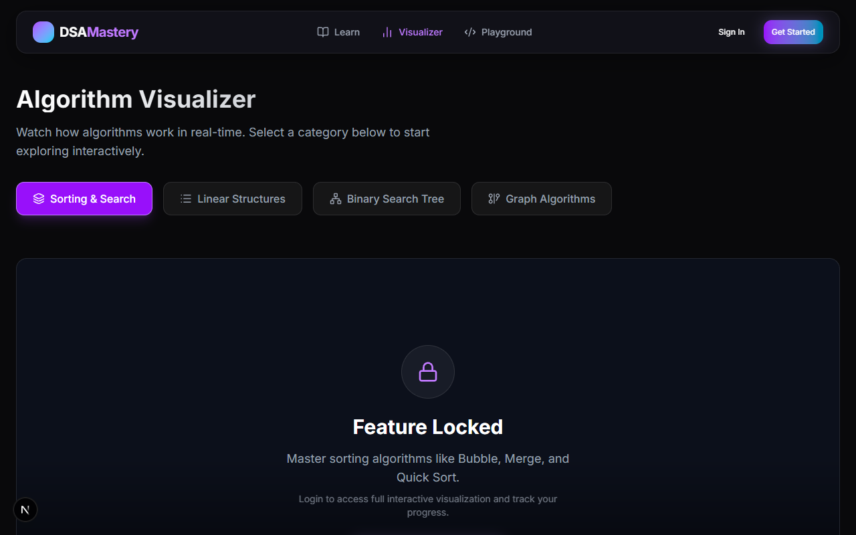

User Profile Page

