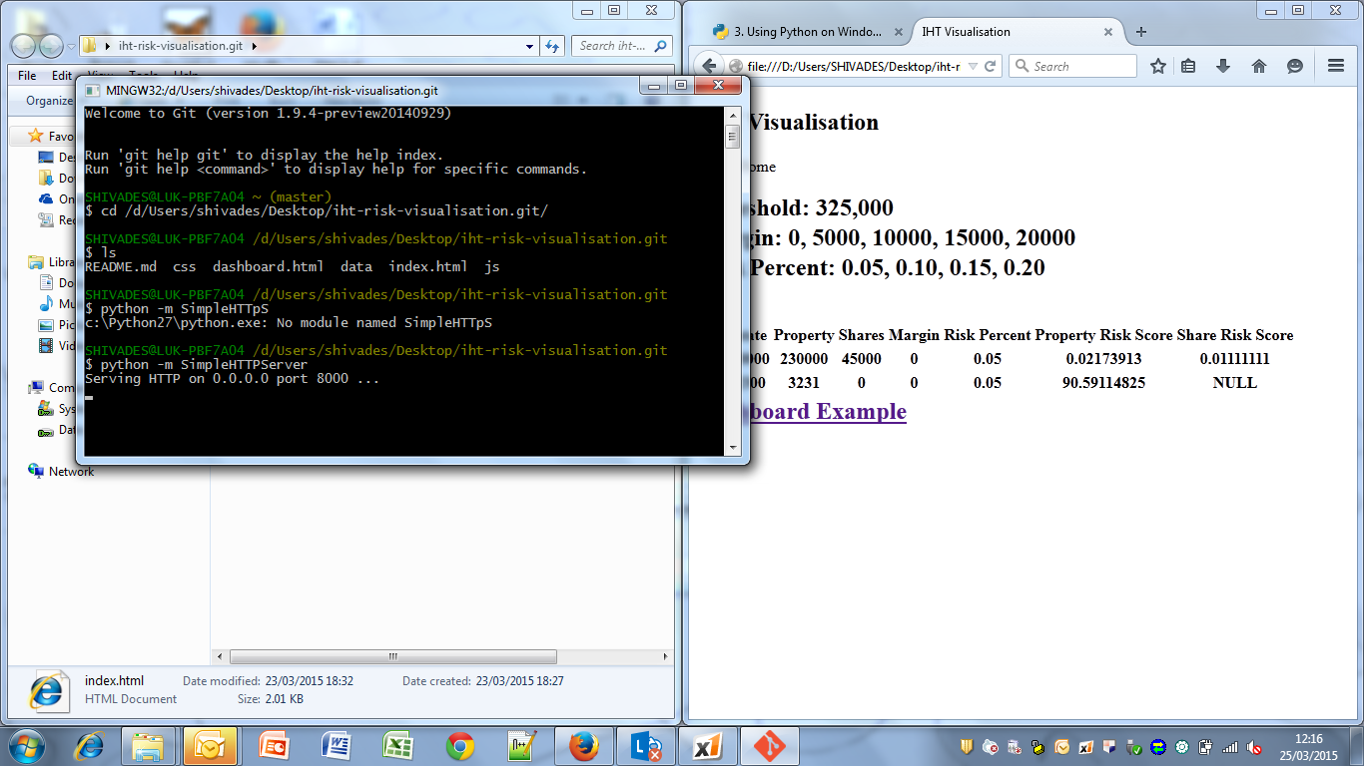
http://localhost:8000/dashboard.html

