**Roll No: 5117060**

**EXPERIMENT NO 1**

**Aim:** To implement Sampling and Reconstruction.

**Theory:**

**Sampling:**

Sampling is the process of recording the values of a signal at given points in time. For A/D  converters, these points in time are equidistant. The number of samples taken during one second  is called the sample rate. Keep in mind that these samples are still analogue values. The mathematic  description of the ideal sampling is the multiplication of the signal with a sequence of direct pulses.  In real A/D converters the sampling is carried out by a sample-and-hold buffer. The sample-and hold buffer splits the sample period in a sample time and a hold time. In case of a voltage being  sampled, a capacitor is switched to the input line during the sample time. During the hold time it  is detached from the line and keeps its voltage.

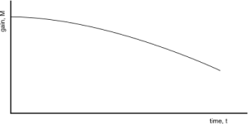

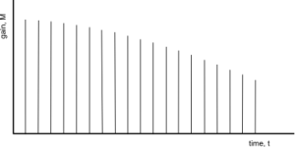

**Reconstruction:**

Reconstruction is the process of creating an analog voltage (or current) from samples. A digital to-analog converter takes a series of binary numbers and recreates the voltage (or current) levels  that corresponds to that binary number. Then this signal is filtered by a lowpass filter. This process  is analogous to interpolating between points on a graph, but it can be shown that under certain  conditions the original analog signal can be reconstructed exactly from its samples. Unfortunately,  the conditions for exact reconstruction cannot be achieved in practice, and so in practice the  reconstruction is an approximation to the original analog signal.

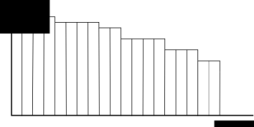

**Sampling** is defined as, “The process of measuring the instantaneous values of continuous-time  signal in a discrete form.”

**Sample** is a piece of data taken from the whole data which is continuous in the time domain.

When a source generates an analog signal and if that has to be digitized, having **1s** and **0s** i.e.,  High or Low, the signal has to be discretized in time. This discretization of analog signal is called  as Sampling.

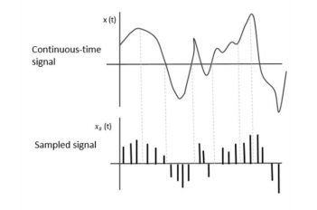

The following figure indicates a continuous-time signal **x** tt and a sampled signal **xs** tt.  When **x** tt is multiplied by a periodic impulse train, the sampled signal **xs** tt is obtained.

**Conclusion:**

Thus we have successfully implemented sampling and reconstruction.

**Code:**

clear;

clc ;

close ;

t=0:0.01:2;

x1=2*exp(-2*t);

subplot(1,2,1);

plot(t,x1);

xlabel('t');

ylabel('x(t)');

title('CONTINUOUS TIME PLOT');

n=0:0.2:2;

x2=2*exp(-2*n);

subplot(1,2,2);

plot2d3(n,x2);

xlabel('n');

ylabel('x(n)');

title('DISCRETE TIME PLOT');

**Output:**

